Security and Privacy for Machine Learning
Internal Assessment 2 — Implementation, Evaluation and Technical Outcomes

PrivBench-Adult
A Unified Privacy–Utility Evaluation of Differential, Local, Syntactic and Compressive Privacy for Tabular Machine Learning

Student name | Disha Kataria
Roll number | 16014223034
Programme | B.Tech Honours — Semester VII
Course | Security and Privacy for Machine Learning
Course faculty | Ashwini Dalvi
Department | Department of Information Technology
Institute | K. J. Somaiya School of Engineering
Submission date | 22/10/2026

Contents
Abstract 4
Rubric compliance map 4
1. Problem Refinement and Objectives 5
1.1 Summary of IA-1 findings 5
1.2 Revised problem statement 5
1.3 Changes since IA-1 and their justification 5
1.4 Final objectives 6
1.5 Research questions 6
1.6 Technical requirements 6
2. Background and Related Work 6
3. Integration of Course Concepts 7
3.1 Final module-mapping table 7
3.2 Architecture 8
3.3 How each module contributes 8
3.4 Concepts treated analytically 9
4. Dataset Finalisation and Implementation 9
4.1 Provenance record 9
4.2 Preparation pipeline 10
4.3 Algorithms 10
4.4 Code and reproducibility 11
4.5 Verification 11
5. Evaluation, Comparison and Critical Analysis 12
5.1 Experimental setup 12
5.2 E1 — Non-private baselines 12
5.3 E2/E3 — DP-SGD (central DP) 12
5.4 E4 — Central vs local DP for statistics release (RQ2) 14
5.5 E5 — Training on LDP-collected records (M3) 14
5.6 E6 — k-anonymity and l-diversity (RQ3) 15
5.7 E7 — Compressive privacy and D-DCA (RQ4) 16
5.8 E8 — Hybrid compressive + DP-SGD (RQ5) 17
5.9 Unified comparison 18
5.10 Answers to the research questions 19
5.11 Limitations and threats to validity 19
5.12 Proposed improvements 19
6. Conclusion 20
7. Individual Contribution Statement 20
8. Research and IP Development 20
References 20
Appendix A — Metric definitions and worked calculations 22
Appendix B — Hyper-parameters 22
Appendix C — File hashes (SHA-256) 23
Appendix D — Execution environment 23

Abstract
Privacy-preserving machine learning offers mechanisms for every stage of the data pipeline — local differential privacy (LDP) at collection, k-anonymity at publication, DP-SGD at training and compressive (lossy-projection) privacy at feature release — but they are usually evaluated in isolation, with incomparable metrics. This work presents PrivBench-Adult, a reproducible framework that applies one mechanism from each of the course's Modules 2–5 to the same data (UCI Adult, 45,222 records), trains the same model on each protected output, and attacks every result with the same Module-1 suite: membership inference, sensitive-attribute inference and re-identification. All mechanisms, including a Rényi-DP accountant (validated against Opacus) and closed-form per-example gradients for DP-SGD, are implemented from first principles and covered by 30 unit tests. We further propose Desensitised DCA (D-DCA), a privacy-penalised discriminant projection, and a hybrid D-DCA → DP-SGD pipeline.
Results over 3–5 seeds show that: DP-SGD keeps accuracy within 0.2 points of the non-private model (85.0%) down to ε = 0.5 and costs 6.6 points at ε = 0.05; at equal ε, removing the trusted curator (LDP) costs two to three orders of magnitude in histogram accuracy and, for full-record collection, needs ε ≈ 64–128 to approach non-private utility, at which point the sensitive attribute is again inferable; Mondrian k-anonymity eliminates unique records at almost no utility cost but leaves sex fully inferable and discloses income for 30.2% of records at k = 10 unless l-diversity is enforced; and D-DCA (m = 5) reduces a linear attacker to chance and a gradient-boosting attacker from 1.000 to 0.706 balanced accuracy while keeping 84.9% accuracy. Contrary to our IA-1 hypothesis, the hybrid does not raise accuracy over DP-SGD: it matches it within one standard deviation for ε ≤ 0.1 and trails by ≈ 1.0 points for ε ≥ 0.5, but it is the only configuration that pairs a formal guarantee for the model with attribute protection for released features. No single mechanism protects against all three attacks; the framework makes these gaps measurable.
Keywords: differential privacy, local differential privacy, DP-SGD, k-anonymity, l-diversity, compressive privacy, discriminant component analysis, membership inference, attribute inference, privacy–utility trade-off.

Rubric compliance map
Table 1. Mapping of IA-2 assessment stages to sections of this report.
IA-2 stage | Where addressed | Evidence
1. Problem refinement & objectives | Section 1 | Revised problem statement, Table 2 (changes since IA-1), objectives, RQ1–RQ5, technical requirements
2. Integration of course concepts | Section 3 | Final module-mapping table, architecture figure, per-module integration, analytical treatment
3. Dataset finalisation & individual implementation | Section 4 | Provenance record (all checklist items), hashes, sizes, preprocessing, algorithms, code, run instructions, contribution
4. Evaluation, comparison & critical analysis | Section 5 | E1–E8 results, comparison tables/plots, metric definitions, interpretation, validity threats, improvements
5. Final documentation & research/IP | Sections 6–8, Appendices | Complete report, reproducibility, references, manuscript draft (separate file), IP note

1. Problem Refinement and Objectives

1.1 Summary of IA-1 findings
IA-1 established the problem, dataset and code base, and produced five observations (O1–O5): average-case membership inference is weak on well-generalising models but strong for high-capacity or small-data models (O1); DP-SGD is almost free on Adult for ε ≥ 0.5 (O2); k-anonymity removes uniqueness but leaves many homogeneous classes (O3); PCA retains the sensitive attribute (O4); and local DP is far less accurate than central DP at equal ε (O5).

1.2 Revised problem statement
Revised problem statement. For a tabular personal-data classification task, quantify — under one pipeline, one model and one attack suite, and in both a data-rich and a data-scarce regime — the privacy–utility trade-off of local DP at collection, k-anonymity (with and without l-diversity) at publication, DP-SGD at training and privacy-aware compressive projection at feature release, including the strong-privacy regime ε < 0.5; and test whether a hybrid of compressive privacy and DP-SGD dominates either mechanism alone.

1.3 Changes since IA-1 and their justification
Table 2. Changes made since IA-1.
Change | Evidence that motivated it | Effect on the study
ε grid extended from {0.5…8} to {0.05…8, ∞} | O2: < 0.3 pt utility loss for ε ≥ 0.5 | Exposes the real trade-off region (E2, E8)
Small-data regime (n = 1,000, high-capacity MLP) added to baselines and DP-SGD | O1: MIA only bites when the generalisation gap is large | Makes DP's effect on MIA measurable (E1, E2)
TPR at 1% FPR added to MIA reporting | Low-FPR metric recommended by Carlini et al. [21] | Guards against averaging away rare but confident leaks
l-diversity, t-closeness and attribute inference added to k-anonymity | O3: 30% homogeneity at k = 10 | Separates identity, attribute and value disclosure (E6)
New method: Desensitised DCA (D-DCA) | O4: PCA keeps sex; DCA only covers utility | Privacy-aware projection (E7)
Explicit sensitive columns suppressed before projection | IA-2 exploration: a linear projection of the one-hot sex column stays non-linearly decodable | D-DCA removes proxies; suppression removes the attribute
Joint (sex × relationship) privacy label tested as a variant | relationship is a near-perfect proxy of sex (IA-1 Fig. 2) | Negative result reported: costs utility (E7)
New method: hybrid D-DCA → DP-SGD | O2 + O4: DP noise scales with dimension; projection hides sex | Tests whether combining modules dominates (E8)
LDP training experiment, with a features-only ablation | O5: large LDP estimation error | Quantifies LDP cost on learning and isolates label noise (E5)
Seeds increased from 3 to 5 (3 for slower sweeps) | IA-1 limitation: wide intervals | Mean ± sd for every reported number

1.4 Final objectives
Table 3. Final objectives and completion status.
ID | Objective | Status
O1 | Quantify exposure of raw data and non-private models (both regimes) | Done — E1, Section 5.2
O2 | Implement and test one mechanism per module (M2–M5) from first principles | Done — Section 4, 30 tests
O3 | Evaluate all mechanisms with the same model and attack suite | Done — unified table, Section 5.9
O4 | Characterise each trade-off across its parameter (ε, k, m, γ) | Done — E2–E7
O5 | Propose and evaluate a privacy-aware projection and a hybrid | Done — D-DCA (E7), hybrid (E8)

1.5 Research questions
Table 4. Research questions.
RQ | Question
RQ1 | How much does each mechanism reduce membership, attribute and re-identification risk, and at what utility cost?
RQ2 | What does removing the trusted curator cost: central DP vs local DP at the same ε?
RQ3 | Does k-anonymity (with/without l-diversity) protect attributes and values, or only identities?
RQ4 | Can a privacy-penalised projection (D-DCA) hide a sensitive attribute while preserving utility better than PCA/DCA?
RQ5 | Does D-DCA compression before DP-SGD improve the privacy–utility trade-off over DP-SGD alone?

1.6 Technical requirements
Table 5. Functional and non-functional requirements.
ID | Requirement | How it is met
FR1 | Reproducible data acquisition with integrity check | Scripted download + SHA-256 in provenance.json; test re-hashes files
FR2 | Formal (ε, δ) accounting for every DP model | RDP accountant; ε recorded per run; matches Opacus
FR3 | Identical utility model across mechanisms | One MLP class (87→64→1) for all mechanisms
FR4 | Identical attack suite across mechanisms | attacks.py used by every experiment
FR5 | No private statistic leaks via preprocessing | Encoder and projections fitted on the public split
NFR1 | Runs on a laptop CPU | Full IA-2 run ≈ 13 min; no GPU or deep-learning framework
NFR2 | Deterministic, seeded, tested | Explicit seeds; 30 unit tests

2. Background and Related Work
Attacks. Shokri et al. [19] introduced shadow-model membership inference; Yeom et al. [20] linked it to over-fitting via a simple loss-threshold attack; Carlini et al. [21] argued for reporting TPR at low FPR. Linkage attacks on quasi-identifiers [11, 22] motivated syntactic anonymisation. Central DP [1] gives a worst-case guarantee; DP-SGD [2] with Rényi-DP accounting [3–5] is the standard way to train private models, though it may harm minority groups disproportionately [28]. Local DP [6–10] removes the trusted curator at the cost of accuracy, which is why multi-dimensional collection [9] remains challenging. PPDM offers k-anonymity [11], efficiently realised by Mondrian [12], and its refinements l-diversity [13] and t-closeness [14]. Compressive privacy [17, 18] (Kung) frames privacy as a lossy projection that retains utility-relevant and discards privacy-relevant signal, with DCA as the utility-supervised projection; related representation-level defences include nullspace projection [29].
Gap. Comparative studies typically stay within one family, e.g. different DP optimisers, or different anonymisation algorithms. They rarely subject mechanisms from different stages and guarantee types to the same attacks on the same data and model, and they rarely examine combining compressive privacy with DP-SGD. This work fills that gap at a reproducible, laptop-scale level.

3. Integration of Course Concepts

3.1 Final module-mapping table
Table 6. Final module-mapping table.
Module | Concepts used | Role in this project | Treatment | Evidence
M1 Privacy considerations | Threat model (Kerckhoffs); loss-threshold MIA; attribute inference (LR & GBM attackers); prosecutor re-identification risk; proxy-attribute analysis | Common yardstick for every mechanism | Implemented, evaluated | attacks.py; E1; all tables
M2 Differential privacy | (ε, δ)-DP; Laplace & Gaussian mechanisms; sensitivity; composition; DP-SGD with Poisson sampling + clipping; RDP accountant; noise calibration | Training-stage protection with formal guarantee; central baseline for M3 | Implemented, evaluated | dp.py; E2, E3, E4, E8
M3 Local DP | Randomised response; GRR; OUE; Piecewise mechanism; unbiased estimators; budget splitting across attributes | Collection-stage protection without trusted curator | Implemented, evaluated | ldp.py; E4, E5
M4 PPDM | Quasi-identifiers; Mondrian k-anonymity; distinct l-diversity; t-closeness; NCP information loss; homogeneity attack | Publishing-stage protection of microdata | Implemented, evaluated; SMC/HE analytical | ppdm.py; E6
M5 Compressive privacy | PCA; DCA (Kung); proposed Desensitised DCA; reconstruction error; hybrid with DP-SGD | Feature-release protection; dimensionality reduction for DP | Implemented, evaluated, extended | compressive.py; E7, E8

3.2 Architecture
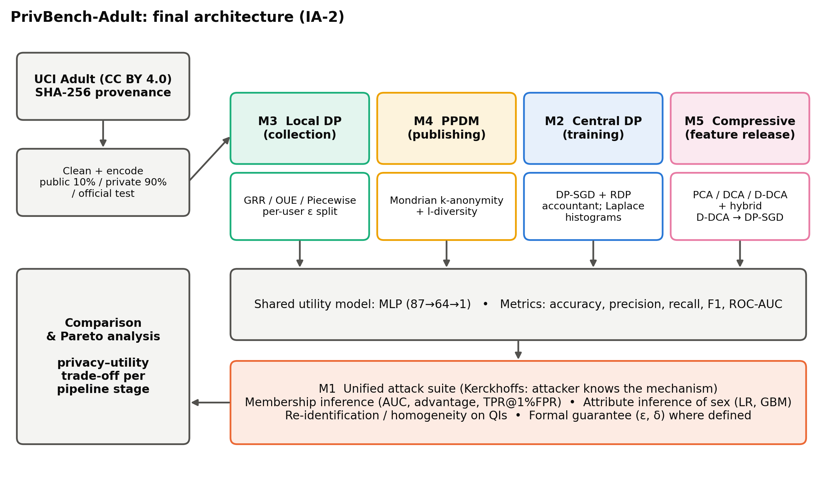
Figure 1. Final architecture. Each module protects one pipeline stage; the hybrid chains M5 into M2. Every output is consumed by the same utility model and the same Module-1 attack suite.

3.3 How each module contributes
- M1 — the yardstick. Without a common attack suite, ε, k and m are incomparable. M1 converts every mechanism's output into the same three empirical risks. The attacker is always given the mechanism and the public split (Kerckhoffs's principle), e.g. for LDP the attacker simulates the perturbation on public data before training its classifier.
- M2 — formal training-time privacy. DP-SGD bounds the influence of any single record on the model; the accountant reports the exact (ε, δ). The Laplace histogram provides the central baseline against which LDP is measured (RQ2).
- M3 — collection without trust. Each record's 13 attributes are perturbed on the user side (PM for numeric, GRR for categorical and the label), with ε_total split equally (sequential composition). The collector trains on perturbed data only.
- M4 — sanitised publication. Mondrian partitions the 7 QIs; generalised cells become ranges/sets that the model consumes as means/fractional one-hots. l-diversity is enforced inside the partitioning (a cut is allowed only if both halves stay 2-diverse in income).
- M5 — data minimisation at source. Only an m-dimensional projection is released. D-DCA chooses directions that separate income classes but not sex classes; the hybrid then runs DP-SGD on these m features, so the model is DP and the features are desensitised.

3.4 Concepts treated analytically
Table 7. Techniques justified through analysis rather than implementation.
Concept | Why not implemented | Analytical treatment
Secure multi-party computation / homomorphic encryption (M4) | Protects computation across parties, not the released output; Adult has a single owner | Orthogonal to the release-stage threats studied: SMC hides inputs during training but the trained model still leaks membership, so it would be combined with DP-SGD rather than replace it
Enforcing t-closeness (M4) | Binary sensitive attribute and 7 QIs make strict t-closeness at small t collapse to very coarse classes | t is measured for every k (Section 5.6); we show values remain ≈ 0.6–0.75, i.e. class income rates deviate strongly from the population
Shuffle model / amplification (M3) | Requires a trusted shuffler infrastructure | Would reduce the central–local gap in E4; noted as future work
Shadow-model and LiRA MIAs (M1) | Many shadow models per configuration × ~300 configurations | Loss-threshold MIA is a lower bound; IA-2 adds TPR@1%FPR to partly compensate

4. Dataset Finalisation and Implementation

4.1 Provenance record
Table 8. Dataset provenance record (IA-2 checklist).
Checklist item | Record
Dataset / source name | Adult (Census Income) — UCI Machine Learning Repository
URL / access reference | https://archive.ics.uci.edu/dataset/2/adult ; archive https://archive.ics.uci.edu/static/public/2/adult.zip ; DOI 10.24432/C5XW20
Collection date and method | Original: 1994 Current Population Survey (US Census Bureau); extraction by Becker (1996) with filters AGI>100, AFNLWGT>1, AHRSWK>0. Retrieved for this study on 2026-10-20 via HTTPS download of the official UCI archive by scripts/01_prepare_data.py (urllib).
Author / publisher | Barry Becker, Ronny Kohavi (extracted from the 1994 US Census database); UCI Machine Learning Repository, University of California, Irvine
Licence / usage terms | Creative Commons Attribution 4.0 International (CC BY 4.0) — reuse permitted with attribution (cited as [23])
Original size | 48,842 rows (32,561 train + 16,281 test), 14 attributes + label
Final size | 45,222 rows: public 3,016 / private 27,146 / test 15,060; 12 features (87 encoded) + label
Relevant fields / labels | Utility label: income > 50K (24.9% positive). Sensitive attribute: sex (67.6% male). QIs: age, sex, race, marital-status, native-country, education-num, workclass
Preprocessing operations | Strip whitespace; remove '.' from test labels; drop 3,620 rows with missing values; drop fnlwgt and education; binarise label; seeded 10% public split; standardise/one-hot (fitted on public split)
Version / release identifier | UCI static release id 2 (donated 1996-04-30)
File hashes (SHA-256) | adult.zip 7537312dd56c2b98…; adult.data 5b00264637dbfec3…; adult.test a2a9044bc167a35b… (full values in Appendix C)
Access restrictions | None — openly downloadable; no login or data-use agreement
Privacy safeguards | Data contains no direct identifiers; it is already public, so the study simulates a private dataset; no attempt is made to link records to real individuals; derived artefacts contain only aggregate metrics
Known limitations | 1994 US population; missing-value deletion bias; binary sex coding; widely used benchmark (risk of benchmark-specific conclusions) [25]

4.2 Preparation pipeline
Table 9. Data preparation log.
# | Step (verbatim from scripts/01_prepare_data.py)
1 | Loaded raw files: train=32561 rows, test=16281 rows, 15 columns
2 | train: 2399 rows with missing values ('?') in {'workclass': 1836, 'occupation': 1843, 'native-country': 583}
3 | test: 1221 rows with missing values ('?') in {'workclass': 963, 'occupation': 966, 'native-country': 274}
4 | Dropped incomplete rows: train 32561->30162, test 16281->15060
5 | Exact duplicate rows in train: 23 (kept: duplicates are distinct census respondents with identical attributes)
6 | Dropped columns ['fnlwgt', 'education']; binarised target income>50K -> 1
7 | Positive rate: train 0.2489, test 0.2457
8 | Split official train into public=3016 / private=27146 (seed 0); official test kept as test=15060
9 | Encoded feature dimension: 87 (5 standardised numeric + one-hot categoricals)

4.3 Algorithms

DP-SGD with closed-form per-example gradients (M2)
input: data {(x_i, y_i)}_{i=1..n}, target (eps, delta), epochs E, batch B, clip C, lr eta
q <- B / n ; T <- round(E / q)
sigma <- smallest value with RDP->DP(T * RDP_sampledGaussian(q, sigma), delta) <= eps (bisection)
for t = 1..T:
S <- { i : u_i < q }, u_i ~ U(0,1) # Poisson sampling
forward: a = X_S W1 + b1, h = relu(a), p = sigmoid(h w2 + b2), e = p - y_S
delta_i = e_i * w2 ⊙ 1[a_i > 0]
g_norm_i = sqrt(|x_i|^2 |delta_i|^2 + |delta_i|^2 + e_i^2 |h_i|^2 + e_i^2)
c_i = min(1, C / g_norm_i) # per-example clipping factor
G = { W1: X_S^T (c ⊙ Delta), b1: Σ c_i delta_i, w2: h^T (c ⊙ e), b2: Σ c_i e_i }
G <- (G + N(0, sigma^2 C^2 I)) / (q n)
momentum-SGD step with G # post-processing: still DP
return model, (eps, delta)

Mondrian k-anonymity with optional l-diversity (M4)
partitions <- [all records]; done <- []
while partitions not empty:
P <- pop(partitions)
for QI in QIs sorted by normalised span in P (widest first):
(L, R) <- median split (numeric) or frequency-ordered set split (categorical)
if |L| >= k and |R| >= k and (l is None or both have >= l distinct incomes):
push L, R; break
else: done.append(P) # no allowable cut
generalise each class: numeric QI -> [min, max] (mean for training); categorical QI -> set

Desensitised DCA (proposed, M5)
Let S_B^u and S_B^p be the between-class scatter matrices of the utility label (income) and the privacy label (sex), and Σ the total covariance, all computed on the public split after suppressing the explicit sex columns. D-DCA returns the top-m generalised eigenvectors of
(S_B^u + β Σ) w = λ (γ S_B^p + Σ + ρ I) w, β = 0.1, γ = 10, ρ = 0.01
The numerator rewards income-discriminant power (β·Σ supplies m > 1 informative directions for a binary label); the denominator penalises sex-discriminant directions. γ = 0 recovers a variance-regularised DCA. Because eigenvectors are Σ-orthogonal and the privacy scatter is rank one, large γ drives the projected class-mean difference of sex towards zero, removing the signal a linear classifier relies on. This is a design property, not a formal guarantee; E7 verifies empirically that a linear attacker is reduced to chance.

4.4 Code and reproducibility
Table 10. Repository structure.
Path | Purpose
scripts/01_prepare_data.py | Download UCI archive, SHA-256 hashing, cleaning, provenance record
scripts/02_run_ia1.py | IA-1 preliminary experiments P1–P6
scripts/03_run_ia2.py | IA-2 full experiments E1–E8 (--quick for smoke test)
scripts/04_make_figures.py | All figures from the result CSVs
scripts/05_build_reports.py | Regenerates these Word reports from results
src/privml/data.py | Schema, cleaning, public/private/test splits, encoder fitted on public split
src/privml/attacks.py | M1: membership inference, attribute inference, re-identification risk
src/privml/dp.py | M2: Laplace/Gaussian mechanisms, DP histogram, RDP accountant, DP-SGD
src/privml/ldp.py | M3: GRR, OUE, Piecewise mechanism, LDP record perturbation
src/privml/ppdm.py | M4: Mondrian k-anonymity, l-diversity, NCP, homogeneity, t-closeness
src/privml/compressive.py | M5: PCA, DCA, Desensitised DCA (D-DCA), reconstruction error
src/privml/models.py | NumPy MLP with closed-form per-example gradients; LR/RF baselines
src/privml/experiments.py | Experiment definitions shared by IA-1 and IA-2 runners
tests/ | 30 unit tests (accountant vs Opacus, estimator unbiasedness, k-anonymity, gradients)

pip install -r requirements.txt
python scripts/01_prepare_data.py # data + provenance (~10 s)
python scripts/02_run_ia1.py # IA-1 experiments (~1 min)
python scripts/03_run_ia2.py # IA-2 experiments E1-E8 (~13 min; --quick for 4 min)
python scripts/04_make_figures.py # figures/ia1, figures/ia2
python scripts/05_build_reports.py # reports/*.docx
python -m pytest # 30 unit tests

All randomness is seeded (data split seed 0; model seeds 0–4). Results are written to results/ia2/*.csv with an environment.json (library versions) and a timestamped run_log.txt. Every number in Section 5 is read from these CSVs by the report generator, so text, tables and figures cannot drift apart.

4.5 Verification
Table 11. Unit-test coverage (30 tests, all passing).
Test group | What is verified
Accountant | ε matches Opacus 1.5.2 for 4 settings (|Δ| < 10⁻³); closed form for q = 1; monotone in σ; calibration is near-minimal
DP-SGD | Analytic per-example gradients and norms equal finite differences; private training reaches > 80% on a toy task with ε ≤ 2
Mechanisms | Laplace scale; GRR keep-probability; GRR, OUE and Piecewise estimators unbiased
k-anonymity | Disjoint cover; every class ≥ k; max risk ≤ 1/k; l-diversity eliminates homogeneous classes; NCP bounds
Projections / attacks | PCA full-rank reconstruction exact; D-DCA removes a linear privacy signal while keeping utility signal; MIA detects a memorising model
Data | Raw and processed file hashes match the provenance record; split sizes; encoder statistics

5. Evaluation, Comparison and Critical Analysis

5.1 Experimental setup
Table 12. Experimental configuration.
Setting | Value
Utility model | MLP 87→64→1 (ReLU), Adam lr 1e-3, batch 128, 30 epochs (identical for raw, k-anon, LDP and CP inputs)
Small-data regime | random 1,000-record training subset per seed; MLP with 256 hidden units, 200 epochs; DP-SGD batch 64, 50 epochs, δ = 10⁻⁴
DP-SGD (full) | batch 256 (q = 0.0094), 20 epochs (2,121 steps), C = 1, momentum-SGD lr 0.05, δ = 10⁻⁵
ε grid | 0.05, 0.1, 0.25, 0.5, 1, 2, 4, 8, ∞ (clipping only)
LDP | ε_total ∈ {1, 2, 4, 8, 16, 32, 64, 128} split over 13 attributes (12 features + label)
k-anonymity | k ∈ {2, 5, 10, 25, 50, 100, 250}; l ∈ {none, 2}; 7 QIs
Compressive | m ∈ {2, 3, 5, 10, 20, 40}; γ ∈ {0, 1, 10, 100, 1000} at m = 5
Seeds | 5 for E1, E2, E8; 3 for E3, E5, E6, E7; histogram release 50 repetitions
Attacks | MIA on 5,000 members + 5,000 non-members (1,000 each in small regime); attribute attackers trained on the public split processed by the same mechanism

5.2 E1 — Non-private baselines
Table 13. Non-private baselines (5 seeds).
Model | Accuracy | Prec. | Recall | F1 | AUC | MIA AUC | MIA adv. | TPR@1%
LR (full) | 0.847 ± 0.000 | 0.729 | 0.602 | 0.659 | 0.903 | 0.500 ± 0.008 | 0.010 | 0.009
RF (full) | 0.841 ± 0.001 | 0.702 | 0.612 | 0.654 | 0.889 | 0.599 ± 0.007 | 0.172 | 0.013
MLP (full) | 0.850 ± 0.002 | 0.721 | 0.633 | 0.674 | 0.907 | 0.503 ± 0.010 | 0.020 | 0.009
LR (n = 1,000) | 0.844 ± 0.002 | 0.717 | 0.606 | 0.656 | 0.896 | 0.504 ± 0.012 | 0.030 | 0.012
RF (n = 1,000) | 0.836 ± 0.003 | 0.694 | 0.599 | 0.642 | 0.878 | 0.645 ± 0.011 | 0.251 | 0.015
MLP (n = 1,000) | 0.821 ± 0.005 | 0.648 | 0.599 | 0.622 | 0.867 | 0.558 ± 0.014 | 0.162 | 0.010

The MLP is the strongest non-private model (85.0%). Membership leakage is governed by over-fitting: negligible for LR/MLP on full data, substantial for the random forest (advantage 0.172) and for every high-capacity model in the small-data regime (MLP 0.162, RF 0.251). TPR at 1% FPR stays close to 1% for all models, i.e. the loss-threshold attacker cannot single out individuals with high confidence; leakage is diffuse rather than concentrated on a few outliers.

5.3 E2/E3 — DP-SGD (central DP)
Table 14. DP-SGD across privacy budgets, full (n = 27,146) and small (n = 1,000) regimes; 5 seeds.
ε | σ (full) | Acc. (full) | F1 | MIA adv. | σ (small) | Acc. (small) | F1 | MIA adv.
0.05 | 27.96 | 0.784 ± 0.022 | 0.534 | 0.006 | 91.80 | 0.676 ± 0.070 | 0.349 | 0.011
0.1 | 14.82 | 0.815 ± 0.013 | 0.593 | 0.013 | 49.73 | 0.709 ± 0.056 | 0.422 | 0.013
0.25 | 6.41 | 0.843 ± 0.003 | 0.649 | 0.010 | 21.92 | 0.745 ± 0.037 | 0.507 | 0.020
0.5 | 3.45 | 0.849 ± 0.002 | 0.660 | 0.012 | 11.78 | 0.765 ± 0.024 | 0.546 | 0.027
1 | 1.93 | 0.851 ± 0.001 | 0.663 | 0.010 | 6.37 | 0.784 ± 0.012 | 0.580 | 0.030
2 | 1.19 | 0.851 ± 0.001 | 0.662 | 0.010 | 3.51 | 0.811 ± 0.004 | 0.620 | 0.040
4 | 0.85 | 0.851 ± 0.001 | 0.662 | 0.011 | 2.03 | 0.834 ± 0.004 | 0.646 | 0.045
8 | 0.66 | 0.851 ± 0.001 | 0.662 | 0.011 | 1.27 | 0.842 ± 0.003 | 0.653 | 0.046
∞ (clip) | 0.00 | 0.851 ± 0.000 | 0.662 | 0.011 | 0.00 | 0.847 ± 0.002 | 0.660 | 0.042

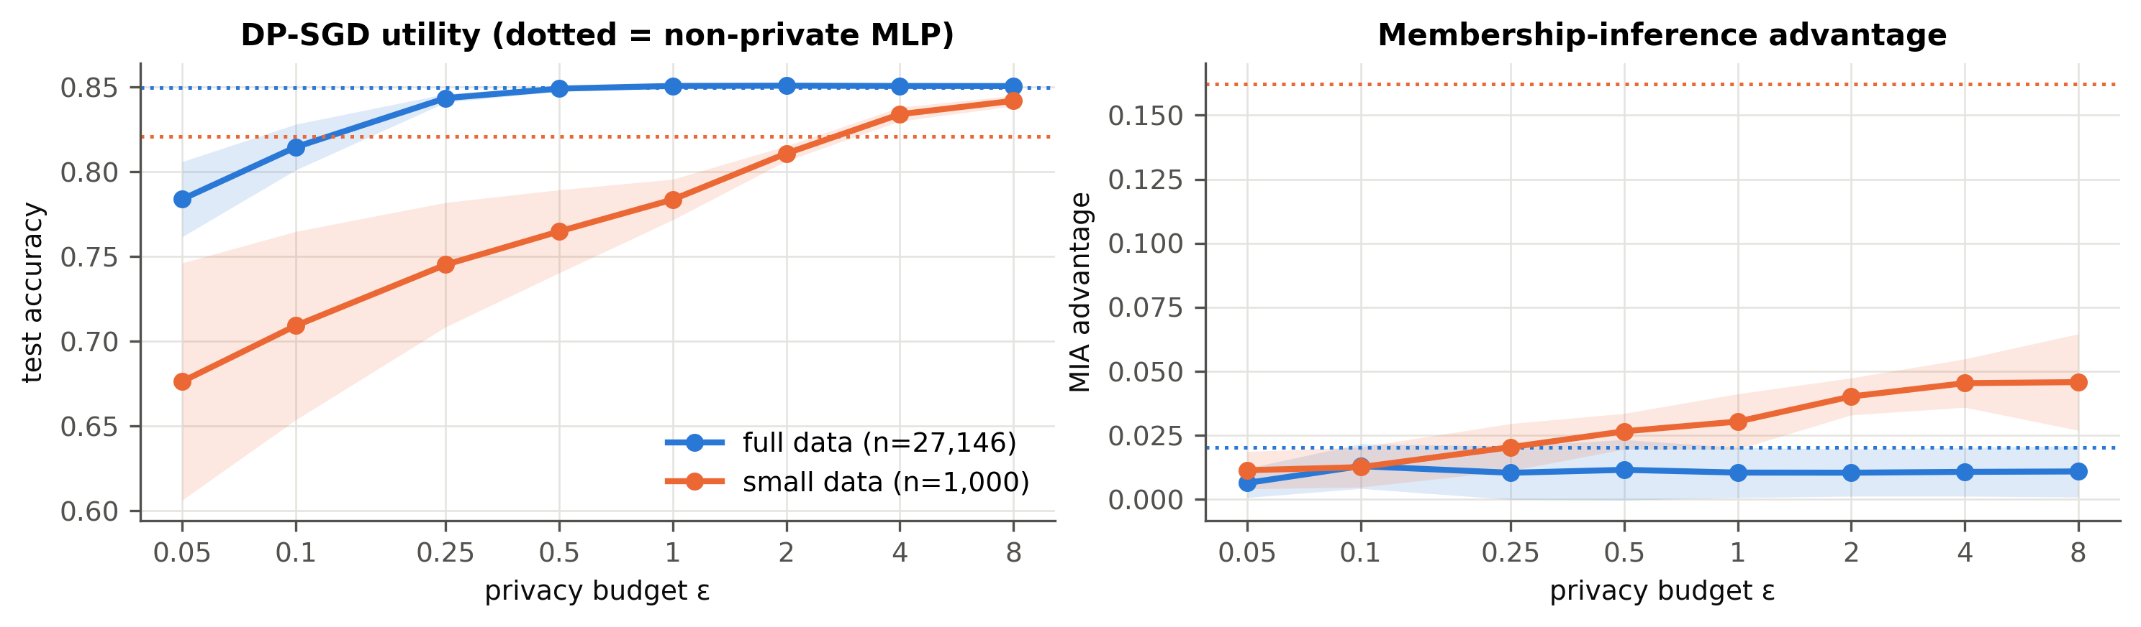
Figure 2. DP-SGD utility and membership-inference advantage across ε. Dotted lines: non-private MLP in the same regime. Bands: ±1 sd.
Utility. With 27k records DP-SGD is remarkably cheap: accuracy stays within 0.2 points of the clipping-only model down to ε = 0.5, drops to 81.5% at ε = 0.1 and 78.4% at ε = 0.05, where variance across seeds also grows (sd 0.022). With 1,000 records the same ε requires 1.9–3.4× more noise (σ = 6.4 vs 1.9 at ε = 1) because each record is a larger share of every batch, and accuracy falls steadily below ε ≈ 4. Privacy amplification by sub-sampling is what makes DP-SGD cheap on large datasets. F1 degrades faster than accuracy: noise first erodes the minority (>50K) class [28].
Membership inference. In the small regime the non-private MLP has advantage 0.162; DP-SGD reduces it to 0.046 at ε = 8 and 0.011 at ε = 0.05. However, the clipping-only model (ε = ∞) already has advantage 0.042. Most of the empirical MIA reduction therefore comes from clipping and the shorter, noisier training (implicit regularisation), not from the noise level. This is a critical point. The value of a small ε is the worst-case guarantee against any attacker and any record, which an average-case empirical attack cannot show. Empirical leakage alone would wrongly suggest ε is irrelevant.
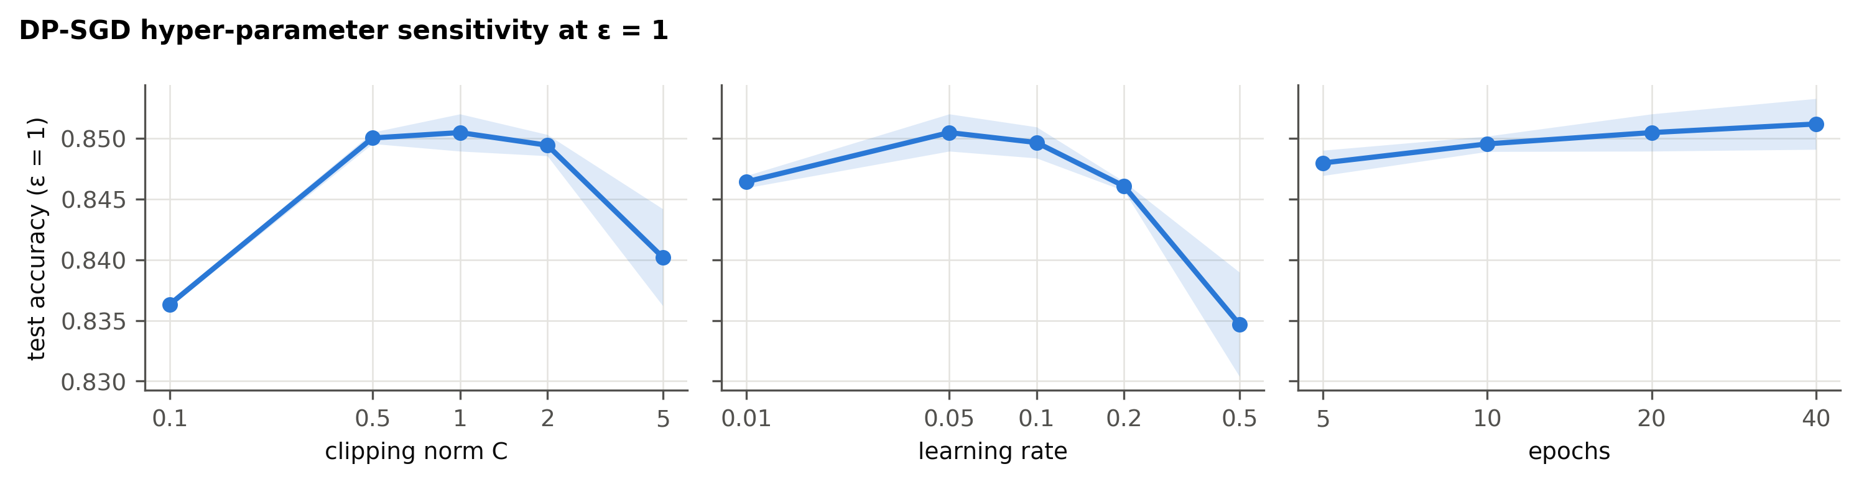
Figure 3. DP-SGD hyper-parameter sensitivity at ε = 1 (3 seeds).
Ablation (E3). Clipping norm is the most sensitive parameter: C = 0.1 loses 1.4 points (gradients over-clipped, bias) and C = 5 loses 1.0 points (noise σC dominates). Learning rate shows a similar optimum at 0.05–0.1. Training longer at fixed ε helps only slightly (84.8% → 85.1% from 5 to 40 epochs) because σ grows with T. The default (C = 1, lr = 0.05, 20 epochs) lies on the plateau. Note: choosing hyper-parameters on private data itself leaks information [27]; see Section 5.11.

5.4 E4 — Central vs local DP for statistics release (RQ2)
Table 15. Mean L1 error of released histograms (50 repetitions). Domain sizes: workclass 7, marital-status 7, occupation 14, native-country 41.
Attribute (k) | ε | Central Laplace | Local GRR | Local OUE | Best local / central
workclass | 0.5 | 0.00059 | 0.1394 | 0.1378 | 234×
workclass | 1 | 0.00029 | 0.0607 | 0.0684 | 206×
workclass | 4 | 0.00007 | 0.0061 | 0.0152 | 83×
marital-status | 0.5 | 0.00056 | 0.1323 | 0.1384 | 235×
marital-status | 1 | 0.00028 | 0.0594 | 0.0675 | 211×
marital-status | 4 | 0.00007 | 0.0060 | 0.0162 | 84×
occupation | 0.5 | 0.00106 | 0.3901 | 0.2926 | 277×
occupation | 1 | 0.00053 | 0.1566 | 0.1379 | 259×
occupation | 4 | 0.00013 | 0.0135 | 0.0256 | 101×
native-country | 0.5 | 0.00334 | 1.9642 | 0.7955 | 238×
native-country | 1 | 0.00167 | 0.7590 | 0.3826 | 229×
native-country | 4 | 0.00042 | 0.0398 | 0.0592 | 94×

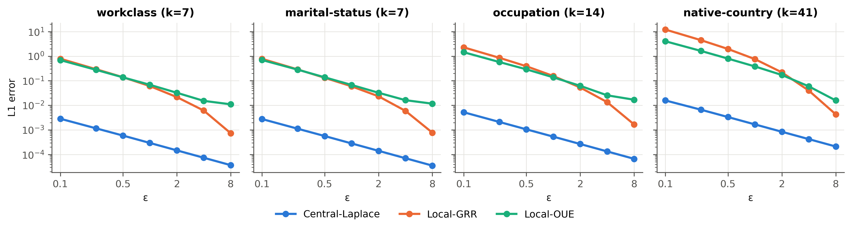
Figure 4. Central vs. local DP histogram error across four attributes.
Central Laplace error is O(k/(nε)); local error is O(√(k)/(√n·ε)) at best, so the ratio grows with √n. At n = 27,146 the best local mechanism is 20–277× worse across all attributes and ε. The best local oracle depends on domain size, as theory predicts: OUE wins for the 41-value native-country attribute at ε ≤ 2, whereas GRR wins for small domains and large ε. RQ2 answer: removing the trusted curator costs one to three orders of magnitude in statistical accuracy at equal ε.

5.5 E5 — Training on LDP-collected records (M3)
Table 16. Models trained on LDP-perturbed records (3 seeds). 'Sex inference' = balanced accuracy of a GBM attacker recovering the true sex from the perturbed record. Features-only: label kept exact (ablation; weaker guarantee).
ε_total | ε / attribute | Accuracy | F1 | AUC | Sex inference | Acc. (feat.-only) | F1 (feat.-only)
1 | 0.077 | 0.583 | 0.214 | 0.521 | 0.501 | 0.754 | 0.000
2 | 0.154 | 0.610 | 0.179 | 0.574 | 0.504 | 0.754 | 0.000
4 | 0.308 | 0.745 | 0.090 | 0.575 | 0.516 | 0.754 | 0.000
8 | 0.615 | 0.761 | 0.161 | 0.709 | 0.570 | 0.778 | 0.261
16 | 1.231 | 0.772 | 0.465 | 0.816 | 0.723 | 0.800 | 0.608
32 | 2.462 | 0.821 | 0.623 | 0.867 | 0.917 | 0.824 | 0.639
64 | 4.923 | 0.831 | 0.673 | 0.894 | 0.994 | 0.829 | 0.676
128 | 9.846 | 0.847 | 0.679 | 0.905 | 1.000 | 0.847 | 0.676

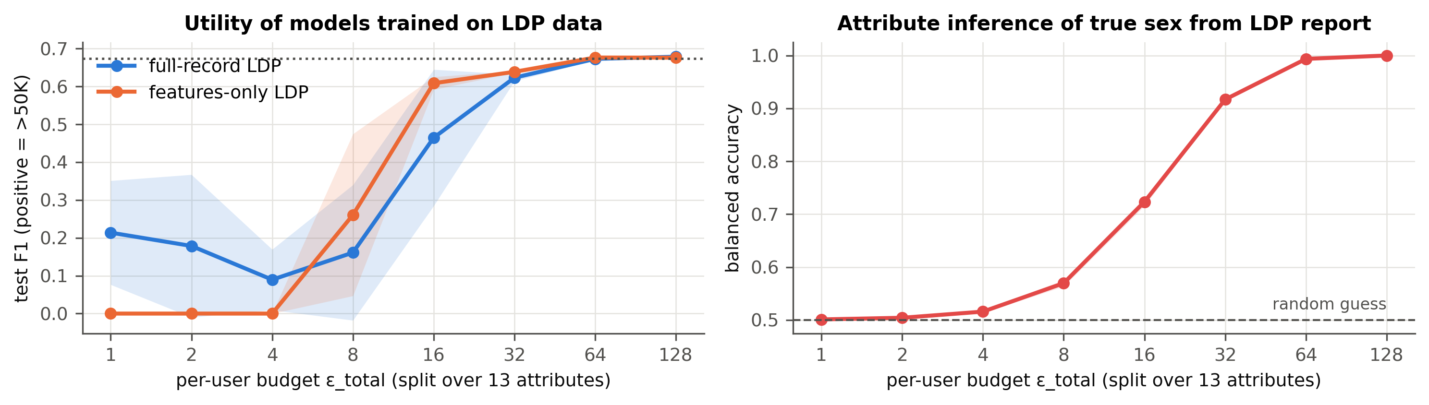
Figure 5. Left: utility of models trained on LDP data; dotted = non-private F1. Right: how well the true sex can be recovered from an LDP report.
Splitting the budget over 13 attributes leaves each attribute with very little privacy budget. Below ε_total = 8 the model is worse than predicting the majority class (75.4%), because label flipping (at ε/attribute ≈ 0.08 the label is flipped 48.1% of the time) makes its predictions close to random. Removing label noise (features-only) recovers majority-class accuracy but still yields F1 = 0 until ε_total = 8. Utility approaches the non-private model only at ε_total = 128 (accuracy 84.7%). The tension is direct. At ε_total = 16 (F1 0.465) sex is already recoverable with balanced accuracy 0.723; at ε_total = 32 (F1 0.623) with 0.917. MIA is at chance throughout, since the model never sees an exact record. Per-record LDP for many attributes is therefore poorly suited to supervised learning on a dataset of this size; it is better suited to the aggregate statistics of E4.

5.6 E6 — k-anonymity and l-diversity (RQ3)
Table 17. Mondrian anonymisation of the private training split (model results: 3 seeds).
Release | l | NCP | Avg re-id risk | Unique | Income disclosed | t | Sex inference | Accuracy | F1
raw (k = 1) | — | 0.000 | 0.381 | 26.5% | 0.0% | — | 1.000 | — | —
k = 2 | — | 0.005 | 0.212 | 0.0% | 51.4% | 0.75 | 1.000 | 0.849 | 0.675
k = 10 | — | 0.032 | 0.054 | 0.0% | 30.2% | 0.75 | 1.000 | 0.849 | 0.676
k = 50 | — | 0.095 | 0.013 | 0.0% | 12.6% | 0.68 | 1.000 | 0.848 | 0.679
k = 250 | — | 0.234 | 0.003 | 0.0% | 4.1% | 0.60 | 0.569 | 0.847 | 0.632
k = 2 | 2 | 0.051 | 0.078 | 0.0% | 0.0% | 0.71 | 1.000 | 0.849 | 0.677
k = 10 | 2 | 0.061 | 0.039 | 0.0% | 0.0% | 0.71 | 1.000 | 0.849 | 0.678
k = 50 | 2 | 0.110 | 0.011 | 0.0% | 0.0% | 0.68 | 1.000 | 0.848 | 0.680
k = 250 | 2 | 0.237 | 0.003 | 0.0% | 0.0% | 0.60 | 0.569 | 0.847 | 0.635

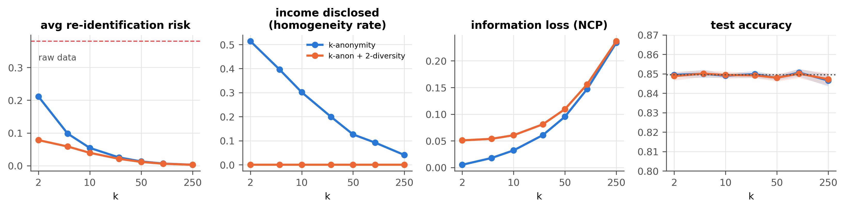
Figure 6. Effect of k (with and without 2-diversity) on identity risk, value disclosure, information loss and utility.
Identity. Mondrian removes all unique records and reduces average re-identification risk from 0.381 to 0.054 at k = 10, at almost no utility cost: accuracy is flat at ≈ 84.9% up to k = 100, because most predictive signal sits in non-QI attributes (occupation, capital gain, hours) and generalised QIs keep their means.
Values. Without l-diversity, 30.2% of records at k = 10 belong to classes where everyone has the same income, so linking the target to their class reveals the target's income with certainty. 2-diversity removes this at k = 10 for an NCP increase from 0.032 to 0.061 and no utility loss. t-closeness stays high (≈ 0.6–0.75): class income rates remain far from the population rate, so probabilistic inference is still possible.
Attributes. Sex remains perfectly inferable (balanced accuracy 1.0) up to k = 100. Sex is a binary QI that Mondrian splits early and therefore almost never generalises; it is only generalised at k = 250. RQ3 answer: k-anonymity protects identity, l-diversity additionally protects against certain disclosure of the sensitive value, and neither protects other attributes or provides a formal guarantee.

5.7 E7 — Compressive privacy and D-DCA (RQ4)
Table 18. Compressive projections (3 seeds). Sex columns = balanced accuracy of the attacker (0.5 = no information). Recon. NMSE = error of the best linear reconstruction (1 = nothing recoverable).
Release | m | Accuracy | F1 | Sex: LR | Sex: GBM | Recon. NMSE
Raw (all 87 features) | — | 0.850 | 0.667 | 1.000 | 1.000 | 0.000
Raw (sex column dropped) | — | 0.850 | 0.666 | 0.838 | 0.813 | 0.000
PCA (all features) | 2 | 0.820 | 0.573 | 0.641 | 0.652 | 0.691
PCA (sex suppressed) | 2 | 0.813 | 0.556 | 0.559 | 0.578 | 0.680
DCA (sex suppressed) | 2 | 0.839 | 0.631 | 0.530 | 0.612 | 0.950
D-DCA (proposed) | 2 | 0.830 | 0.595 | 0.500 | 0.560 | 0.828
D-DCA (joint label) | 2 | 0.798 | 0.437 | 0.500 | 0.543 | 0.833
PCA (all features) | 5 | 0.839 | 0.619 | 0.784 | 0.860 | 0.355
PCA (sex suppressed) | 5 | 0.841 | 0.626 | 0.592 | 0.666 | 0.332
DCA (sex suppressed) | 5 | 0.838 | 0.635 | 0.530 | 0.701 | 0.950
D-DCA (proposed) | 5 | 0.849 | 0.646 | 0.500 | 0.706 | 0.506
D-DCA (joint label) | 5 | 0.819 | 0.518 | 0.500 | 0.605 | 0.636
PCA (all features) | 10 | 0.849 | 0.658 | 1.000 | 0.996 | 0.186
PCA (sex suppressed) | 10 | 0.848 | 0.654 | 0.720 | 0.758 | 0.181
DCA (sex suppressed) | 10 | 0.838 | 0.642 | 0.530 | 0.726 | 0.950
D-DCA (proposed) | 10 | 0.851 | 0.661 | 0.500 | 0.754 | 0.361
D-DCA (joint label) | 10 | 0.841 | 0.625 | 0.500 | 0.707 | 0.536

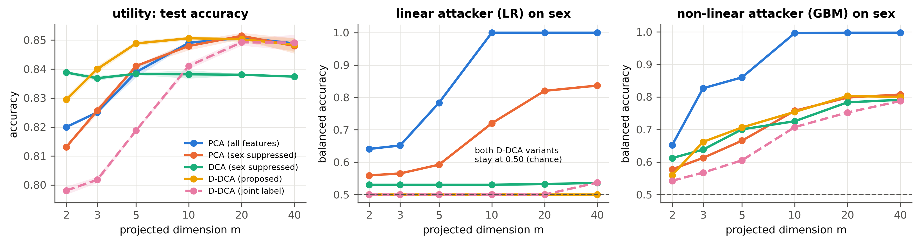
Figure 7. Utility and sensitive-attribute leakage of projections across target dimension m.
PCA is not a privacy mechanism. On all features PCA retains sex perfectly from m = 10. D-DCA (proposed) drives the linear attacker to exactly chance (0.500) for every m, at m = 5 keeping 84.9% accuracy (raw: 85.0%) and reducing the non-linear GBM attacker to 0.706, below the 0.813 obtained by merely dropping the sex column. The trade-off is not one-sided: at m = 5, PCA on the suppressed features leaks slightly less to the GBM attacker (0.666) but retains linear leakage (0.592) and 0.8 points less accuracy. At m = 2 the GBM attacker falls to 0.560 while accuracy stays at 83.0%, better than PCA at the same m on both axes. DCA (utility-only) discards almost everything (NMSE ≈ 0.95, the strongest reconstruction privacy) but keeps more sex information than D-DCA for m ≤ 3. The joint (sex × relationship) label removes more non-linear signal but costs up to 3 points of accuracy, because relationship also predicts income — a negative result we report deliberately.
Table 19. Effect of the privacy weight γ in D-DCA (m = 5).
γ | Accuracy | Sex: LR | Sex: GBM | Recon. NMSE
0 | 0.853 | 0.617 | 0.680 | 0.453
1 | 0.853 | 0.496 | 0.686 | 0.489
10 | 0.849 | 0.500 | 0.706 | 0.506
100 | 0.847 | 0.500 | 0.711 | 0.509
1000 | 0.847 | 0.500 | 0.709 | 0.510

γ acts as a switch for linear leakage: γ = 1 already removes it at no measurable utility cost. Larger γ costs ≈ 0.5 points and even raises GBM leakage slightly, because the rank-one privacy scatter is already nulled and extra weight only distorts the remaining directions. γ = 1 would therefore be a better default than the γ = 10 used in E7/E8 — a tuning insight this analysis revealed. RQ4 answer: yes for linear adversaries (by construction, confirmed empirically); partially for non-linear adversaries, where leakage is governed mainly by m. Linear projections cannot remove non-linearly encoded information, which is the main limitation of this family.

5.8 E8 — Hybrid compressive + DP-SGD (RQ5)
Table 20. Test accuracy of DP-SGD with and without compression (5 seeds, δ = 10⁻⁵).
ε | DP-SGD (87 features) | PCA-5 + DP-SGD | D-DCA-5 + DP-SGD | D-DCA-10 + DP-SGD
0.05 | 0.784 ± 0.022 | 0.782 ± 0.033 | 0.779 ± 0.024 | 0.766 ± 0.021
0.1 | 0.815 ± 0.013 | 0.816 ± 0.010 | 0.816 ± 0.006 | 0.811 ± 0.010
0.25 | 0.843 ± 0.003 | 0.832 ± 0.002 | 0.838 ± 0.003 | 0.842 ± 0.003
0.5 | 0.849 ± 0.002 | 0.835 ± 0.001 | 0.840 ± 0.001 | 0.847 ± 0.001
1 | 0.851 ± 0.001 | 0.834 ± 0.001 | 0.841 ± 0.001 | 0.849 ± 0.001
2 | 0.851 ± 0.001 | 0.835 ± 0.001 | 0.841 ± 0.002 | 0.849 ± 0.001
4 | 0.851 ± 0.001 | 0.834 ± 0.001 | 0.841 ± 0.002 | 0.849 ± 0.001
8 | 0.851 ± 0.001 | 0.834 ± 0.001 | 0.841 ± 0.001 | 0.849 ± 0.001
∞ (clip) | 0.851 ± 0.000 | 0.835 ± 0.001 | 0.842 ± 0.001 | 0.849 ± 0.001

Table 21. Privacy side of the hybrid.
Variant | F1 @ ε = 1 | MIA adv. @ ε = 1 | Sex inference from released features
DP-SGD (all features) | 0.663 | 0.010 | n/a (no features released)
PCA-5 + DP-SGD | 0.609 | 0.013 | 0.666
D-DCA-5 + DP-SGD (proposed) | 0.626 | 0.011 | 0.706
D-DCA-10 + DP-SGD | 0.646 | 0.013 | 0.754

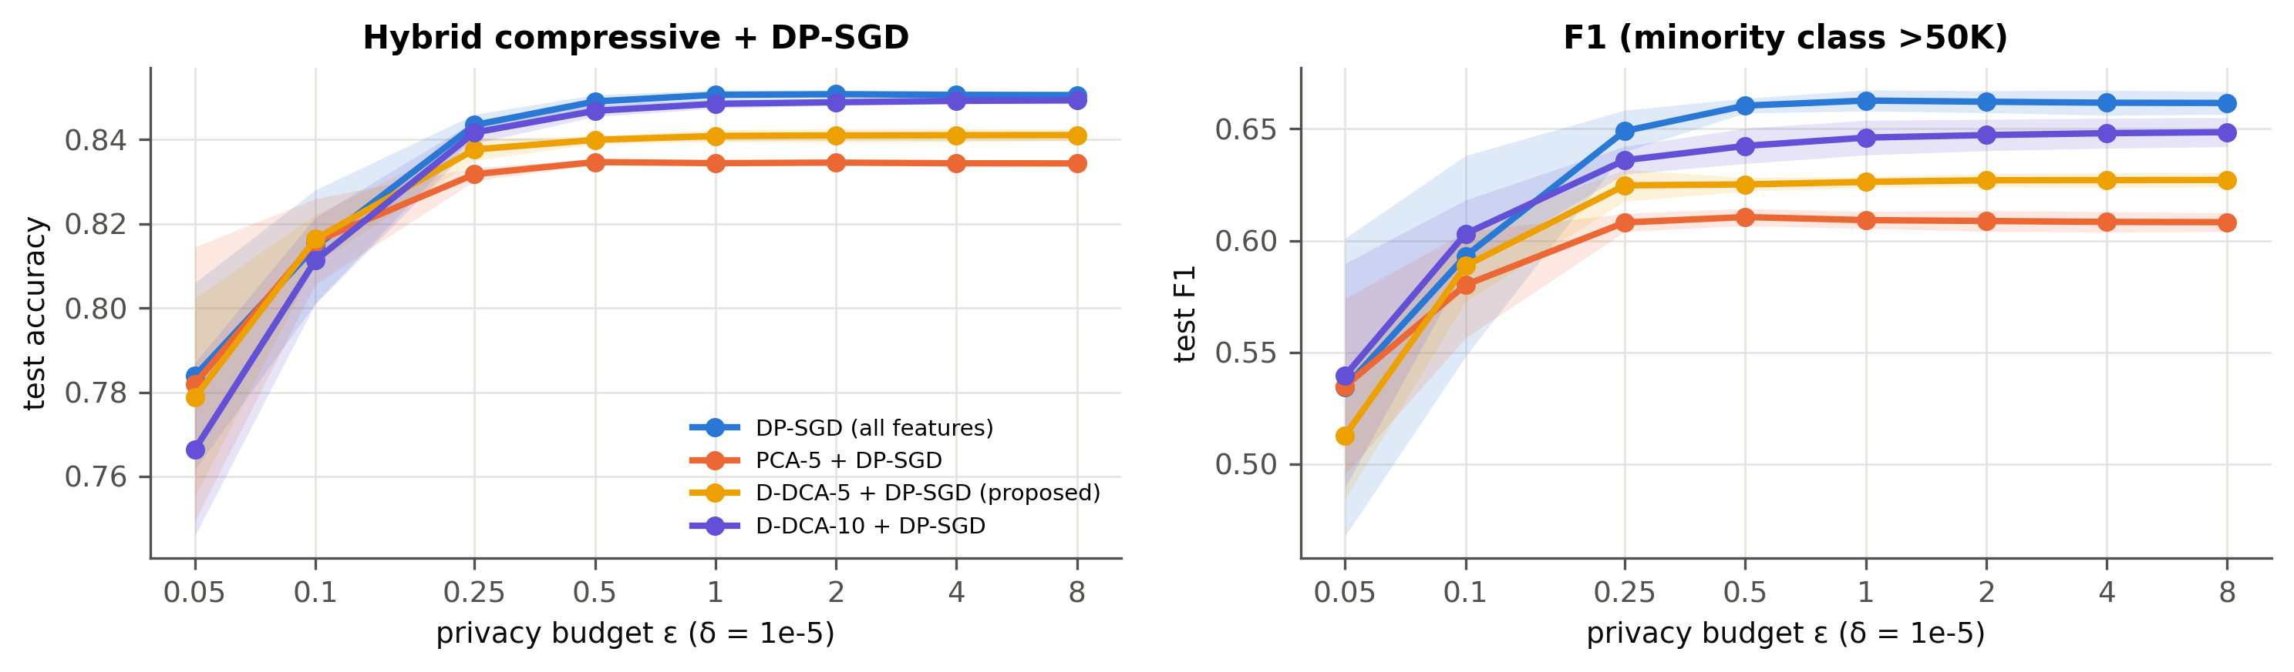
Figure 8. Hybrid compressive + DP-SGD versus DP-SGD on all features.
Hypothesis (from IA-1). Compression should help DP-SGD: fewer input dimensions mean fewer parameters to perturb, and D-DCA concentrates the utility signal into the retained directions. Outcome. The hypothesis is not supported for accuracy. At ε ≤ 0.1 the hybrid and DP-SGD on all features are statistically indistinguishable (difference within one sd; e.g. ε = 0.1: 81.6% vs 81.5%). The hybrid is more stable there (sd 0.006 vs 0.013). For ε ≥ 0.5 it trails by ≈ 1.0 points: the 5-dimensional representation caps accuracy at ≈ 84.2% even without noise, so its cost dominates once DP noise is small. An earlier two-seed exploration had suggested a gain at ε = 0.05; with five seeds this vanished — a reminder of why multi-seed reporting matters. D-DCA-10 recovers most of the large-ε accuracy, but with weaker attribute protection, and PCA-5 is worse than D-DCA-5 for ε ≥ 0.25, so which directions are kept matters.
Where the hybrid earns its place is the privacy column. It is the only configuration with a formal (ε, δ) guarantee for the model and attribute protection for released features (sex balanced accuracy 0.706 vs 1.000 if raw features were released). In the strong-privacy regime, this extra protection comes at no measurable accuracy cost. RQ5 answer: compressing before DP-SGD does not improve accuracy. It is worthwhile when features must be released or the budget is very small (ε ≤ 0.1); otherwise plain DP-SGD is preferable.
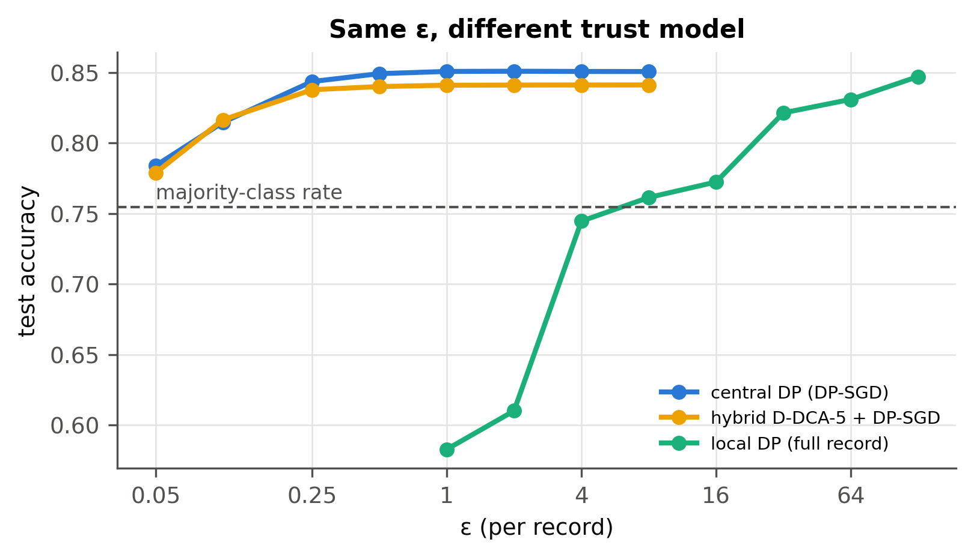
Figure 9. Accuracy at the same nominal ε under different trust models: central DP, hybrid, and local DP. The x-axis is ε per record; for LDP this is the total budget over 13 attributes.

5.9 Unified comparison
Table 22. Unified comparison of representative configurations (full-data regime). Sex inference is measured on whatever is released. *LDP reports are randomised per attribute, so exact linkage is not defined. †No records are released, only m-dimensional projections.
Configuration | Stage | Guarantee | Accuracy | F1 | MIA AUC | Sex inference (GBM) | Re-id risk
Non-private MLP | — | none | 0.850 | 0.674 | 0.503 | 1.000 | 0.381
LDP ε_total = 16 | collection | 16-LDP | 0.772 | 0.465 | 0.498 | 0.723 | n/a*
LDP ε_total = 64 | collection | 64-LDP | 0.831 | 0.673 | 0.506 | 0.994 | n/a*
k = 10, l = 2 | publication | syntactic | 0.849 | 0.678 | 0.505 | 1.000 | 0.039
DP-SGD ε = 0.1 | training | (0.1, 10⁻⁵) | 0.815 | 0.593 | 0.499 | n/a | n/a
DP-SGD ε = 1 | training | (1, 10⁻⁵) | 0.851 | 0.663 | 0.499 | n/a | n/a
D-DCA m = 5 | feature release | empirical | 0.849 | 0.646 | 0.500 | 0.706 | n/a†
Hybrid ε = 0.1 | release + training | (0.1, 10⁻⁵) + D-DCA | 0.816 | 0.589 | 0.497 | 0.706 | n/a†
Hybrid ε = 1 | release + training | (1, 10⁻⁵) + D-DCA | 0.841 | 0.626 | 0.498 | 0.706 | n/a†

No configuration wins on every column. DP-SGD gives the strongest formal guarantee at the lowest utility cost, but it protects only the model. k-anonymity is the only one that addresses linkage of released records, yet it leaves attributes exposed. D-DCA protects attributes in released features without a formal guarantee. LDP protects even against the collector, but at a prohibitive utility cost for record-level training. The choice of mechanism must follow what is released and whom the data owner must trust, and the hybrid shows that combining stages can cover more threats than any single mechanism.

5.10 Answers to the research questions
Table 23. Answers to the research questions.
RQ | Answer (evidence)
RQ1 | Each mechanism reduces a different risk: DP-SGD membership (formal), Mondrian identity, l-diversity value disclosure, D-DCA attribute inference, LDP all of them but at large utility cost (Section 5.9).
RQ2 | Local DP costs 20–277× in histogram L1 error at equal ε (E4) and needs ε_total ≥ 64 for useful record-level training (E5).
RQ3 | k-anonymity protects identities only; 2-diversity removes certain income disclosure; sex remains inferable up to k = 100 (E6).
RQ4 | D-DCA removes linear leakage completely and beats PCA/DCA on the utility–attribute-privacy frontier at small m; non-linear leakage persists (E7).
RQ5 | No accuracy gain: the hybrid ties DP-SGD for ε ≤ 0.1 (with lower variance) and trails by ≈ 1 point at larger ε, but uniquely adds attribute protection for released features (E8).

5.11 Limitations and threats to validity
Table 24. Threats to validity.
Type | Threat | Mitigation / consequence
Internal | DP-SGD hyper-parameters were chosen on private data (sanity run + E3); tuning leaks privacy [27] | Plateau in E3 shows results are insensitive near the default; a private tuning procedure is future work
Internal | Small-regime DP-SGD uses fewer epochs than the non-private MLP | Clip-only (ε = ∞) run isolates this confound and is reported explicitly
Internal | Public split assumed non-sensitive and from the same distribution | Standard assumption; DP-PCA/DP-scatter estimation would remove it
Construct | Loss-threshold MIA and GBM attacker are lower bounds on leakage | TPR@1%FPR added; stronger attacks (LiRA) future work
Construct | Re-identification uses the prosecutor model (target known to be in data) | Conservative (upper) estimate of linkage risk
External | Single, dated tabular dataset; one model family | Framework is dataset-agnostic; ACS-based datasets [25] are a natural extension
Conclusion | 3–5 seeds; full-data MIA differences are within noise | All tables report mean ± sd; claims restricted to effects larger than the sd

5.12 Proposed improvements
- Non-linear compressive privacy: kernel D-DCA or iterative nullspace projection [29] to address the residual GBM leakage.
- Remove the public-data assumption: fit D-DCA from DP-noised scatter matrices, then account the projection's ε together with DP-SGD's.
- Better LDP learning: attribute sampling instead of budget splitting [9], and loss correction for known label-flip rates [30].
- Stronger attacks: LiRA [21] and subgroup-level MIA to test disparate leakage [28].
- Private hyper-parameter selection with RDP accounting [27].

6. Conclusion
PrivBench-Adult shows that privacy mechanisms from different course modules are not interchangeable. They protect different stages against different adversaries. Evaluating them under one model and one attack suite exposes facts that per-mechanism evaluation hides. Empirical MIA reduction under DP-SGD comes largely from clipping. k-anonymity leaves sensitive attributes untouched. PCA is not a privacy mechanism. Record-level LDP for many attributes is a poor fit for supervised learning at this scale. The proposed D-DCA eliminates linear attribute leakage at negligible utility cost, and combining it with DP-SGD yields the only configuration that gives both a formal guarantee for the model and attribute protection for the released features. In the strong-privacy regime this costs no measurable accuracy, although, contrary to our initial hypothesis, it does not improve accuracy either. The framework, data provenance and all results are reproducible from a single command sequence on a laptop.

7. Individual Contribution Statement
This is an individual project. My contributions are: (i) formulation of the stage-wise comparison problem, threat model and research questions; (ii) dataset selection, provenance documentation and the public/private/test split design that prevents preprocessing leakage; (iii) implementation of the complete src/privml package — attack suite, RDP accountant, DP-SGD with closed-form per-example gradients, GRR/OUE/Piecewise LDP, Mondrian k-anonymity with l-diversity, PCA/DCA; (iv) the methodological enhancements — the Desensitised DCA projection, the suppression-before-projection design, and the hybrid D-DCA → DP-SGD pipeline; (v) the experimental design E1–E8 and comparative analysis; (vi) 30 unit tests, figures, and the automated report generation.

8. Research and IP Development
- Manuscript draft: reports/Research_Manuscript_Draft.docx — a conference-style paper (abstract, introduction, method, experiments, results, discussion) built from this work, suitable for development towards a venue such as a national privacy/security conference or a student track.
- Software copyright (optional): the src/privml code and the report generator are original works that could be registered as a computer programme (literary work) with the Copyright Office, Government of India. Evidence of authorship: dated run logs, environment records and result CSVs in results/.
- Novelty claim, stated conservatively: the D-DCA objective and the hybrid pipeline are extensions of Kung's DCA/DUCA framework [17, 18]. A literature search should be completed before any novelty claim is made in a submission.

References
[1] C. Dwork and A. Roth, “The Algorithmic Foundations of Differential Privacy,” Foundations and Trends in Theoretical Computer Science, vol. 9, no. 3–4, pp. 211–407, 2014.
[2] M. Abadi, A. Chu, I. Goodfellow, H. B. McMahan, I. Mironov, K. Talwar and L. Zhang, “Deep learning with differential privacy,” in Proc. ACM CCS, 2016, pp. 308–318.
[3] I. Mironov, “Rényi differential privacy,” in Proc. IEEE CSF, 2017, pp. 263–275.
[4] I. Mironov, K. Talwar and L. Zhang, “Rényi differential privacy of the sampled Gaussian mechanism,” arXiv:1908.10530, 2019.
[5] B. Balle, G. Barthe, M. Gaboardi, J. Hsu and T. Sato, “Hypothesis testing interpretations and Rényi differential privacy,” in Proc. AISTATS, 2020.
[6] S. L. Warner, “Randomized response: A survey technique for eliminating evasive answer bias,” J. American Statistical Association, vol. 60, no. 309, pp. 63–69, 1965.
[7] P. Kairouz, K. Bonawitz and D. Ramage, “Discrete distribution estimation under local privacy,” in Proc. ICML, 2016.
[8] T. Wang, J. Blocki, N. Li and S. Jha, “Locally differentially private protocols for frequency estimation,” in Proc. USENIX Security, 2017, pp. 729–745.
[9] N. Wang, X. Xiao, Y. Yang, J. Zhao, S. C. Hui, H. Shin, J. Shin and G. Yu, “Collecting and analyzing multidimensional data with local differential privacy,” in Proc. IEEE ICDE, 2019, pp. 638–649.
[10] Ú. Erlingsson, V. Pihur and A. Korolova, “RAPPOR: Randomized aggregatable privacy-preserving ordinal response,” in Proc. ACM CCS, 2014.
[11] L. Sweeney, “k-anonymity: A model for protecting privacy,” Int. J. Uncertainty, Fuzziness and Knowledge-Based Systems, vol. 10, no. 5, pp. 557–570, 2002.
[12] K. LeFevre, D. J. DeWitt and R. Ramakrishnan, “Mondrian multidimensional k-anonymity,” in Proc. IEEE ICDE, 2006.
[13] A. Machanavajjhala, D. Kifer, J. Gehrke and M. Venkitasubramaniam, “l-diversity: Privacy beyond k-anonymity,” ACM TKDD, vol. 1, no. 1, 2007.
[14] N. Li, T. Li and S. Venkatasubramanian, “t-closeness: Privacy beyond k-anonymity and l-diversity,” in Proc. IEEE ICDE, 2007.
[15] J. Xu, W. Wang, J. Pei, X. Wang, B. Shi and A. W.-C. Fu, “Utility-based anonymization using local recoding,” in Proc. ACM KDD, 2006.
[16] R. Agrawal and R. Srikant, “Privacy-preserving data mining,” in Proc. ACM SIGMOD, 2000.
[17] S. Y. Kung, “Compressive privacy: From information/estimation theory to machine learning,” IEEE Signal Processing Magazine, vol. 34, no. 1, pp. 94–112, 2017.
[18] S. Y. Kung, “A compressive privacy approach to generalized information bottleneck and privacy funnel problems,” Journal of the Franklin Institute, vol. 355, no. 4, pp. 1846–1872, 2018.
[19] R. Shokri, M. Stronati, C. Song and V. Shmatikov, “Membership inference attacks against machine learning models,” in Proc. IEEE S&P, 2017.
[20] S. Yeom, I. Giacomelli, M. Fredrikson and S. Jha, “Privacy risk in machine learning: Analyzing the connection to overfitting,” in Proc. IEEE CSF, 2018.
[21] N. Carlini, S. Chien, M. Nasr, S. Song, A. Terzis and F. Tramèr, “Membership inference attacks from first principles,” in Proc. IEEE S&P, 2022.
[22] A. Narayanan and V. Shmatikov, “Robust de-anonymization of large sparse datasets,” in Proc. IEEE S&P, 2008.
[23] B. Becker and R. Kohavi, “Adult” [Dataset], UCI Machine Learning Repository, 1996. doi:10.24432/C5XW20.
[24] R. Kohavi, “Scaling up the accuracy of naive-Bayes classifiers: A decision-tree hybrid,” in Proc. KDD, 1996.
[25] F. Ding, M. Hardt, J. Miller and L. Schmidt, “Retiring Adult: New datasets for fair machine learning,” in Proc. NeurIPS, 2021.
[26] A. Yousefpour et al., “Opacus: User-friendly differential privacy library in PyTorch,” arXiv:2109.12298, 2021.
[27] N. Papernot and T. Steinke, “Hyperparameter tuning with Rényi differential privacy,” in Proc. ICLR, 2022.
[28] E. Bagdasaryan, O. Poursaeed and V. Shmatikov, “Differential privacy has disparate impact on model accuracy,” in Proc. NeurIPS, 2019.
[29] S. Ravfogel, Y. Elazar, H. Gonen, M. Twiton and Y. Goldberg, “Null it out: Guarding protected attributes by iterative nullspace projection,” in Proc. ACL, 2020.
[30] N. Natarajan, I. S. Dhillon, P. Ravikumar and A. Tewari, “Learning with noisy labels,” in Proc. NeurIPS, 2013.
[31] Government of India, The Digital Personal Data Protection Act, 2023 (Act No. 22 of 2023).
[32] European Parliament and Council, Regulation (EU) 2016/679 (General Data Protection Regulation), 2016.

Appendix A — Metric definitions and worked calculations
Table 25. Metric definitions.
Metric | Definition
Accuracy / Precision / Recall / F1 | (TP+TN)/N; TP/(TP+FP); TP/(TP+FN); 2PR/(P+R) with positive class = income > 50K
ROC-AUC | Probability that a random positive is scored above a random negative
MIA advantage | max over thresholds τ of TPR(τ) − FPR(τ), where the score is −loss and members are positives
Balanced accuracy | ½(TPR + TNR); 0.5 means the attacker learned nothing beyond the prior
Prosecutor risk | 1/|EC(r)| for record r; reported as mean and max over records
NCP | numeric: (max−min)/(domain range); categorical: (|set|−1)/(|domain|−1); averaged over QIs and records
Reconstruction NMSE | ‖X − X̂‖²_F / ‖X − X̄‖²_F with X̂ = Z W⁺ + μ

Worked example 1 — DP-SGD accounting. n = 27,146, batch 256 ⇒ q = 0.00943; 20 epochs ⇒ T = round(20/q) = 2,121. For target ε = 1, δ = 10⁻⁵, bisection gives σ = 1.931; the per-step RDP at the optimal order is composed over T steps and converted with ε = RDP_T(α) + log((α−1)/α) − (log δ + log α)/(α−1).
Worked example 2 — GRR estimator. occupation has k = 14. At ε = 1, p = e/(e + 13) = 0.1729 and q = (1 − p)/13 = 0.0636. If 9.0% of reports say 'Sales', the unbiased estimate is (0.090 − 0.0636) / (0.1729 − 0.0636) = 0.2413.
Worked example 3 — NCP. A class with ages 32–37 (domain 17–90) and marital-status set of 4 of 7 values contributes (37−32)/73 = 0.068 for age and (4−1)/(7−1) = 0.5 for marital status.

Appendix B — Hyper-parameters
Table 26. Hyper-parameters.
Component | Hyper-parameters
Non-private MLP | hidden 64, Adam lr 1e-3, batch 128, 30 epochs, no weight decay, PyTorch-style uniform init
Random forest | 200 trees, min_samples_leaf = 1 (fully grown)
Logistic regression | L2, C = 1, max_iter 2000
DP-SGD | hidden 64, C = 1, momentum 0.9, lr 0.05, batch 256, 20 epochs, Poisson sampling, RDP orders 2–255
GBM attacker | HistGradientBoosting, 200 iterations
D-DCA | β = 0.1, γ = 10, ρ = 0.01 (γ sweep in E7)
DCA | ρ = 0.01, ρ′ = 0.001

Appendix C — File hashes (SHA-256)
Table 27. Raw and processed file hashes.
File | Bytes | SHA-256
adult.zip | 620,237 | 7537312dd56c2b98035880805ce99e68183a30ee468aa5329d6df0fbb3cc21bb
adult.data | 3,974,305 | 5b00264637dbfec36bdeaab5676b0b309ff9eb788d63554ca0a249491c86603d
adult.test | 2,003,153 | a2a9044bc167a35b2361efbabec64e89d69ce82d9790d2980119aac5fd7e9c05
adult.names | 5,229 | c248284c0b5de30c9e1958d6cdd168a34a654758b620e68f46aefa83fc0a576a
adult_train_clean.csv | 3,025,912 | 094ec205f47049ee98736e66094b62b26d746246fb1aad1fbd1897aaa667633a
adult_test_clean.csv | 1,511,603 | 0d8531d85189f76105836f7ec8647c41fc957455767805eddeb681828113563a

Appendix D — Execution environment
{
"python": "3.12.4",
"platform": "Windows-11-10.0.26300-SP0",
"numpy": "2.5.3",
"pandas": "2.2.2",
"scipy": "1.18.1",
"scikit-learn": "1.8.0",
"started": "2026-10-20 13:31:36"
}

