A Unified Privacy–Utility Evaluation of Differential, Local, Syntactic and Compressive Privacy for Tabular Machine Learning
Disha Kataria¹, Ashwini Dalvi¹
¹ Department of Information Technology, K. J. Somaiya School of Engineering, Mumbai, India — disha.kataria@somaiya.edu

Abstract
Privacy mechanisms for machine learning act at different pipeline stages — local differential privacy (LDP) at collection, k-anonymity at publication, DP-SGD at training and compressive projections at feature release — and are usually evaluated in isolation with incomparable metrics. We present PrivBench-Adult, a reproducible framework that subjects one mechanism per stage to the same model and the same attack suite (membership inference, sensitive-attribute inference and re-identification) on the UCI Adult census data (45,222 records). We also propose Desensitised Discriminant Component Analysis (D-DCA), a privacy-penalised generalised-eigenvector projection, and a hybrid D-DCA → DP-SGD pipeline. Across 3–5 seeds we find: DP-SGD stays within 0.2 points of non-private accuracy down to ε = 0.5, but its empirical membership-inference reduction stems largely from gradient clipping; Mondrian k-anonymity removes unique records at no utility cost but leaves income disclosed for 30.2% of records at k = 10 without l-diversity, and leaves sex fully inferable; record-level LDP for 13 attributes needs ε_total ≥ 64 for useful utility, where sensitive attributes become inferable again; D-DCA reduces a linear attacker to chance at 84.9% accuracy. The hybrid does not improve accuracy over DP-SGD, but it uniquely combines a formal guarantee for the model with attribute protection for released features, at no measurable cost for ε ≤ 0.1.
Index Terms — differential privacy, local differential privacy, k-anonymity, compressive privacy, membership inference, attribute inference, privacy–utility trade-off.

I. Introduction
Removing identifiers does not anonymise data [1, 2], and trained models leak membership of their training records [3, 4, 5]. Four families of defences address these risks at different points of the ML pipeline: central differential privacy (DP) [6, 7], local DP [11, 12], syntactic anonymisation [1, 14, 15] and compressive privacy [17, 18]. Each comes with its own guarantee and metric (ε, k, reconstruction error), so practitioners cannot directly compare them, nor see which threats each one leaves open.
Contributions. (1) A unified, open, laptop-scale evaluation framework in which mechanisms from four families are applied at their natural stage and evaluated with one model and one Kerckhoffs-style attack suite. (2) From-scratch, unit-tested implementations, including a Rényi-DP accountant that matches Opacus and closed-form per-example gradients for DP-SGD. (3) D-DCA, a privacy-penalised extension of DCA, and a suppression-before-projection design that defeats proxy leakage. (4) An empirical study of eight experiments that exposes non-obvious gaps between formal guarantees and empirical risk, including a negative result for the hybrid's accuracy.

II. Threat Model and Background
The adversary knows the mechanism and its parameters and holds an auxiliary sample from the same distribution (modelled by a 10% public split). It pursues three goals. Membership inference uses the loss-threshold attack [4], reported as AUC, advantage max(TPR − FPR) and TPR at 1% FPR [5]. Attribute inference of sex uses logistic-regression and gradient-boosting attackers trained on the public split processed by the same mechanism. Re-identification is the prosecutor risk 1/|EC| over seven quasi-identifiers. DP-SGD [7] clips per-example gradients to norm C and adds N(0, σ²C²) noise; privacy is accounted with RDP of the sub-sampled Gaussian [8, 9] and converted to (ε, δ) [10]. GRR and OUE [11, 12] and the Piecewise mechanism [13] provide LDP. Mondrian [14] yields multidimensional k-anonymity, extended here with distinct l-diversity [15] and measured t-closeness [16].

III. Method
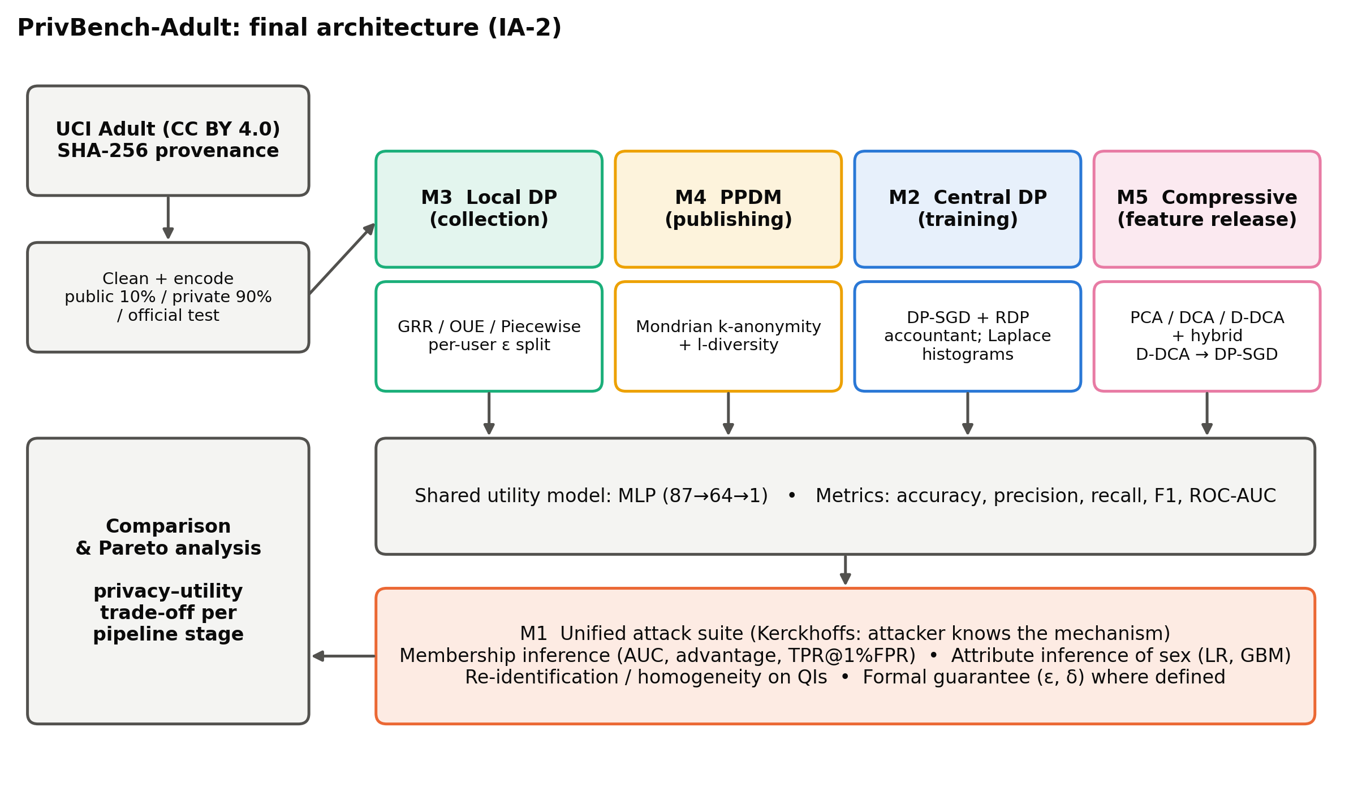
Figure 1. PrivBench-Adult architecture.
Pipeline. The official Adult training file is split (seed 0) into a public split (3,016) and a private training split (27,146); the official test set (15,060) is held out. All preprocessing statistics and projections are fitted on the public split only, so no private statistic leaks outside the mechanisms' accounting. Every protected output trains the same MLP (87→64→1).
D-DCA. Let S_B^u and S_B^p be the between-class scatters of the utility label (income) and the privacy label (sex), and Σ the covariance. D-DCA solves the generalised eigenproblem
(S_B^u + β Σ) w = λ (γ S_B^p + Σ + ρ I) w
and keeps the top-m eigenvectors. The β-term yields m > 1 informative directions for a binary label; the γ-term penalises sex-discriminant directions. γ = 0 recovers a variance-regularised DCA [17]. We apply D-DCA after suppressing the explicit sex columns. A linear projection of a binary one-hot column leaves a bimodal component that a non-linear attacker can decode, so suppression removes the attribute and D-DCA removes its linear proxies. Hybrid. DP-SGD is trained on the standardised D-DCA features; since the projection is fitted on public data, the model's (ε, δ) is unchanged.

IV. Experimental Setup
DP-SGD uses batch 256 (q = 0.0094), 20 epochs, C = 1, momentum-SGD with learning rate 0.05 and δ = 10⁻⁵ over ε ∈ {0.05, …, 8}; a small-data regime (n = 1,000) probes over-fitting. LDP perturbs all 13 attributes with ε_total split equally. Mondrian uses k ∈ {2, …, 250}, with and without 2-diversity. Projections use m ∈ {2, …, 40}. Results are means over 5 seeds (3 for the LDP, k-anonymity and projection sweeps). Code, data hashes and logs are released with the paper.

V. Results
Table 1. Representative configurations. Sex inference = balanced accuracy of a GBM attacker on the released data (0.5 = none).
Configuration | Guarantee | Accuracy | MIA AUC | Sex inference | Re-id risk
Non-private MLP | — | 0.850 | 0.503 | 1.000 | 0.381
LDP, ε_total = 32 | 32-LDP | 0.821 | 0.500 | 0.917 | —
Mondrian k = 10 | syntactic | 0.849 | 0.505 | 1.000 | 0.054
Mondrian k = 10, l = 2 | syntactic | 0.849 | 0.505 | 1.000 | 0.039
DP-SGD ε = 1 | (1, 10⁻⁵) | 0.851 | 0.499 | n/a | n/a
DP-SGD ε = 0.1 | (0.1, 10⁻⁵) | 0.815 | 0.499 | n/a | n/a
D-DCA, m = 5 | empirical | 0.849 | 0.500 | 0.706 | —
Hybrid, ε = 0.1 | (0.1, 10⁻⁵) | 0.816 | 0.497 | 0.706 | —

Central DP. Accuracy falls from 85.1% (clipping only) to 81.5% at ε = 0.1 and 78.4% at ε = 0.05. In the small-data regime, the non-private MLP's MIA advantage of 0.162 drops to 0.042 with clipping alone and to 0.011 at ε = 0.05. Empirical attacks thus credit DP-SGD mainly for its regularisation; the formal ε matters for worst-case records that average-case attacks miss.
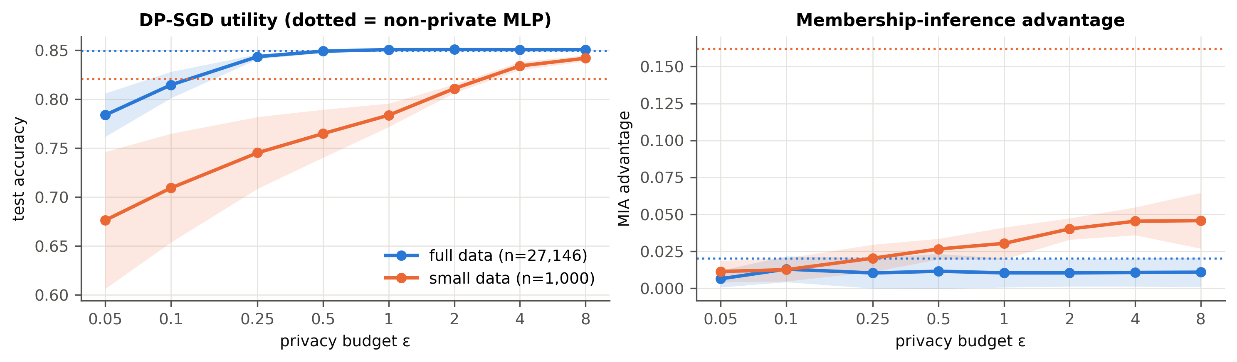
Figure 2. DP-SGD utility and MIA advantage across ε in two data regimes.
Local vs central. At equal ε, LDP histograms are 20–277× less accurate than Laplace histograms. Training on LDP records splits the budget over 13 attributes; at ε_total = 32, F1 reaches 0.623 but sex is recoverable from the reports with balanced accuracy 0.917.
Syntactic anonymisation. Mondrian lowers average re-identification risk from 0.381 to 0.054 (k = 10) without utility loss. Without l-diversity, 30.2% of records have their income disclosed; with 2-diversity, none. Sex remains perfectly inferable up to k = 100: k-anonymity protects identity, not attributes [15, 16].
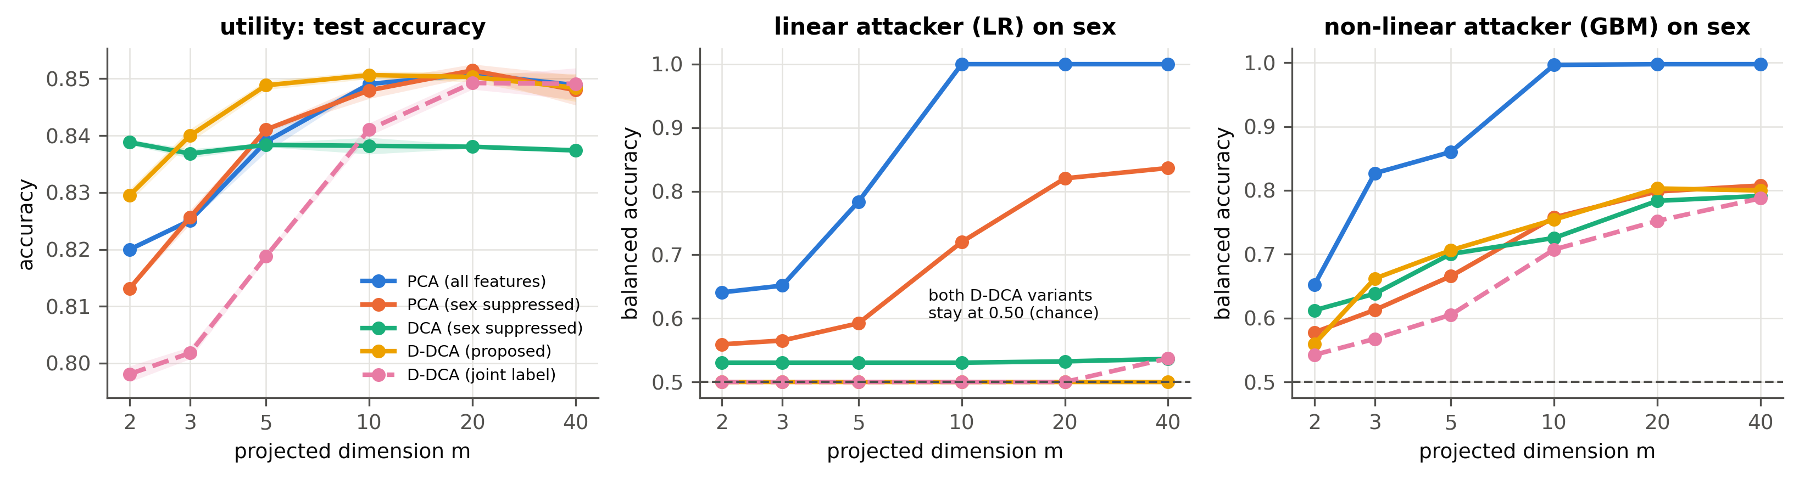
Figure 3. Utility and sex leakage of projections versus dimension m.
Compressive privacy. PCA retains sex completely for m ≥ 10. D-DCA keeps the linear attacker at 0.500 for every m, and at m = 5 reduces the GBM attacker from 1.000 (raw) and 0.813 (sex column dropped) to 0.706, with accuracy 84.9%. At m = 2 it dominates PCA on both axes. A γ sweep shows that γ = 1 already suffices. Residual non-linear leakage is the limit of linear projections [19].
Hybrid. Contrary to our hypothesis, compression does not raise DP-SGD accuracy: differences at ε = 0.05 and 0.1 (-0.5 and +0.2 points) are within one standard deviation, and at ε = 1 the hybrid trails by 1.0 points. Its value is that the released features become attribute-protected while the model keeps its formal guarantee.
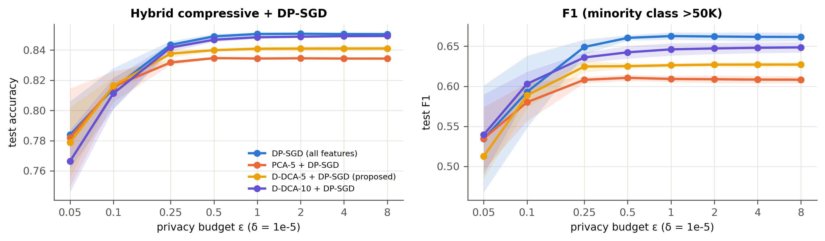
Figure 4. Hybrid D-DCA → DP-SGD versus DP-SGD on all features.

VI. Discussion and Limitations
- Guarantee ≠ empirical risk. Formal ε and empirical MIA can diverge in both directions. Reports should state both.
- Match the mechanism to what is released. DP-SGD protects only models, k-anonymity only identities, D-DCA only attributes of released features, and LDP protects against the collector at a large utility cost.
- Limitations. A single tabular dataset [21]; lower-bound attacks; non-private selection of hyper-parameters [23]; reliance on a public split; possible disparate impact [20] not measured.

VII. Conclusion
A common model and attack suite turns heterogeneous privacy guarantees into comparable evidence. On Adult, no single mechanism covers membership, attribute and identity risk. D-DCA closes the attribute gap for released features at negligible cost, and its combination with DP-SGD offers the broadest coverage. Future work: non-linear desensitisation, DP-estimated projections, LiRA attacks and additional datasets [22].

References
[1] L. Sweeney, “k-anonymity: A model for protecting privacy,” Int. J. Uncertainty, Fuzziness and Knowledge-Based Systems, vol. 10, no. 5, pp. 557–570, 2002.
[2] A. Narayanan and V. Shmatikov, “Robust de-anonymization of large sparse datasets,” in Proc. IEEE S&P, 2008.
[3] R. Shokri, M. Stronati, C. Song and V. Shmatikov, “Membership inference attacks against machine learning models,” in Proc. IEEE S&P, 2017.
[4] S. Yeom, I. Giacomelli, M. Fredrikson and S. Jha, “Privacy risk in machine learning: Analyzing the connection to overfitting,” in Proc. IEEE CSF, 2018.
[5] N. Carlini, S. Chien, M. Nasr, S. Song, A. Terzis and F. Tramèr, “Membership inference attacks from first principles,” in Proc. IEEE S&P, 2022.
[6] C. Dwork and A. Roth, “The Algorithmic Foundations of Differential Privacy,” Foundations and Trends in Theoretical Computer Science, vol. 9, no. 3–4, pp. 211–407, 2014.
[7] M. Abadi, A. Chu, I. Goodfellow, H. B. McMahan, I. Mironov, K. Talwar and L. Zhang, “Deep learning with differential privacy,” in Proc. ACM CCS, 2016, pp. 308–318.
[8] I. Mironov, “Rényi differential privacy,” in Proc. IEEE CSF, 2017, pp. 263–275.
[9] I. Mironov, K. Talwar and L. Zhang, “Rényi differential privacy of the sampled Gaussian mechanism,” arXiv:1908.10530, 2019.
[10] B. Balle, G. Barthe, M. Gaboardi, J. Hsu and T. Sato, “Hypothesis testing interpretations and Rényi differential privacy,” in Proc. AISTATS, 2020.
[11] P. Kairouz, K. Bonawitz and D. Ramage, “Discrete distribution estimation under local privacy,” in Proc. ICML, 2016.
[12] T. Wang, J. Blocki, N. Li and S. Jha, “Locally differentially private protocols for frequency estimation,” in Proc. USENIX Security, 2017, pp. 729–745.
[13] N. Wang, X. Xiao, Y. Yang, J. Zhao, S. C. Hui, H. Shin, J. Shin and G. Yu, “Collecting and analyzing multidimensional data with local differential privacy,” in Proc. IEEE ICDE, 2019, pp. 638–649.
[14] K. LeFevre, D. J. DeWitt and R. Ramakrishnan, “Mondrian multidimensional k-anonymity,” in Proc. IEEE ICDE, 2006.
[15] A. Machanavajjhala, D. Kifer, J. Gehrke and M. Venkitasubramaniam, “l-diversity: Privacy beyond k-anonymity,” ACM TKDD, vol. 1, no. 1, 2007.
[16] N. Li, T. Li and S. Venkatasubramanian, “t-closeness: Privacy beyond k-anonymity and l-diversity,” in Proc. IEEE ICDE, 2007.
[17] S. Y. Kung, “Compressive privacy: From information/estimation theory to machine learning,” IEEE Signal Processing Magazine, vol. 34, no. 1, pp. 94–112, 2017.
[18] S. Y. Kung, “A compressive privacy approach to generalized information bottleneck and privacy funnel problems,” Journal of the Franklin Institute, vol. 355, no. 4, pp. 1846–1872, 2018.
[19] S. Ravfogel, Y. Elazar, H. Gonen, M. Twiton and Y. Goldberg, “Null it out: Guarding protected attributes by iterative nullspace projection,” in Proc. ACL, 2020.
[20] E. Bagdasaryan, O. Poursaeed and V. Shmatikov, “Differential privacy has disparate impact on model accuracy,” in Proc. NeurIPS, 2019.
[21] B. Becker and R. Kohavi, “Adult” [Dataset], UCI Machine Learning Repository, 1996. doi:10.24432/C5XW20.
[22] F. Ding, M. Hardt, J. Miller and L. Schmidt, “Retiring Adult: New datasets for fair machine learning,” in Proc. NeurIPS, 2021.
[23] N. Papernot and T. Steinke, “Hyperparameter tuning with Rényi differential privacy,” in Proc. ICLR, 2022.

