Customer Shopping Behavior – Data and Business analytics project
(Documentation to give insights about data, tools and findings)
Author and created by – ‍DISHA
All docs used in this project :
: Jupyter notebook - index.ipynb
: PowerBI dashboard – Customer.pbix
: SQL findings (attached in this document)
: csv file - Customer_shopping_behavior.csv

1. Project Overview
Project Title : Customer Shopping Behavior Analysis
Project Type : Data Analytics Project
Objective
The objective of this project was to analyze customer shopping behavior and identify patterns in:
- Customer demographics
- Purchase amount
- Product categories
- Number of items purchased
- Subscription status
- Purchase frequency
The analysis was performed using Python, SQL and Power BI, with the final goal of converting raw customer data into business insights and actionable recommendations.
Dataset
The dataset was obtained from Kaggle and contains customer shopping information.
The important columns/features included:
- Gender
- Age/Age Group
- Category
- Purchase Amount
- Purchase Frequency
- Previous Purchases
- Payment Method
- Items Purchased, etc
Dataset size:
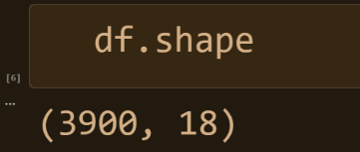

2. Tools & Technologies Used
Tool | Purpose
Python | Data analysis and preprocessing
Pandas | Data cleaning, transformation and analysis
Jupyter Notebook | Executing and documenting Python analysis
SQL | Business-oriented data analysis
SQLAlchemy | Connecting Python/Jupyter with SQL
Power BI | Dashboard and data visualization

3. Project Workflow
My overall workflow was:
Dataset → Data Understanding → Data Cleaning → Data Preprocessing → Exploratory Data Analysis → SQL Analysis → Power BI Dashboard → Insights → Business Recommendations

4. Data Understanding
The first step was to understand the structure of the dataset.
I checked:
- Number of rows and columns : df.shape
- df.info()
- Statistical summary
df.describe()
This provided statistics such as:
- Mean
- Standard deviation
- Minimum
- Maximum
- Quartiles
Initial observations
“The dataset contained approximately 4,000 customer records. Purchase amount and review rating were numeric variables, while category, gender, subscription status and purchase frequency were categorical variables.”
📸 Screenshot — df.isnull().sum()
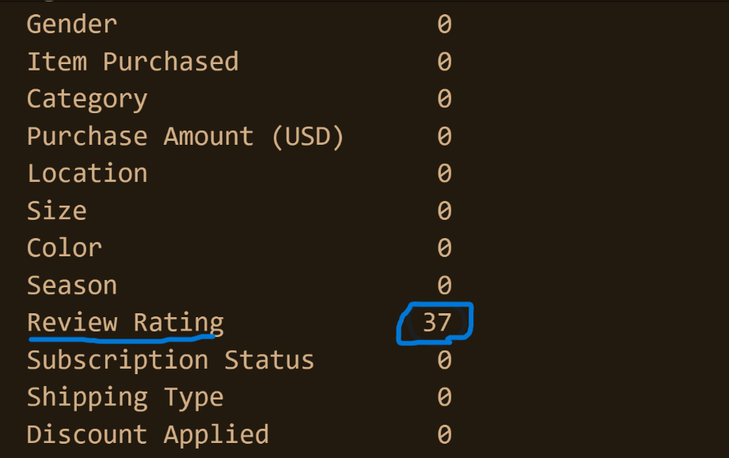
5. Data Cleaning
5.1 Standardizing Column Names
I standardized the column names to make them consistent and easier to work with in Python and SQL.
For example:
df.columns=df.columns.str.lower()
df.columns=df.columns.str.replace(' ','_')
Why?
Consistent column names reduce errors when referencing columns and make SQL/Python analysis easier.
5.2 Handling Missing Values
I found missing values in the review rating column.
Instead of deleting those records, I used median imputation.
df['Review Rating']= df.groupby('Category')['Review Rating'].transform(lambda x: x.fillna(x.median()))
Why Median?
Review ratings are numerical and bounded. The median is less sensitive to unusually high or low valid ratings than the mean.
For example, a rating of 1 or 5 is not automatically an outlier, because both can be valid ratings.
Why didn't I use mean?
Mean can be influenced more strongly by extreme values. Median provides a more robust measure of central tendency when the distribution may contain unusually high or low valid ratings.
📸 Screenshot — Missing values before/after
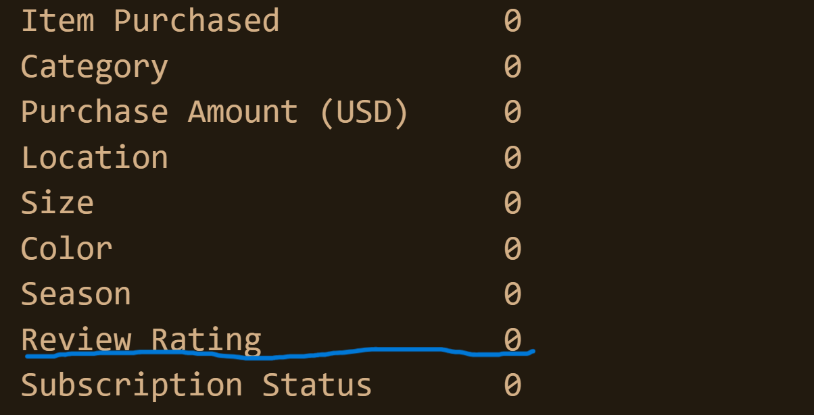
6. Data Preprocessing / Transformation
Some categorical variables needed transformation before analysis.
Purchase Frequency
The original purchase frequency information was converted/standardized into meaningful categories such as:
- Weekly
- Bi-Weekly
- Monthly
- Quarterly
This made the data easier to interpret and visualize.
Instead of analyzing raw/inconsistent values, I could compare customers based on meaningful purchase-frequency groups.
📸 Screenshot — Transformation code
labels=['Young Adult','Adult','Middle-aged','Senior']
df['age_group']=pd.qcut(df['age'],q=4, labels=labels)

7. Exploratory Data Analysis
I then explored the dataset to understand customer behavior.
Some of the questions I investigated were:
- How many customers are there?
- What is the average purchase amount?
- What is the average review rating?
- Which category generates the highest revenue?
- Which category has the highest number of items sold?
- How does purchasing differ by gender?
- How does purchasing differ by age group?
- What percentage of customers have a subscription?
- How does purchase behavior differ between subscribers and non-subscribers?
- What purchase frequencies are most common?
8. SQL Analysis
After the Python analysis, I connected my Jupyter Notebook with SQL using SQLAlchemy.
Query 1 — Average Product rating by item purchased
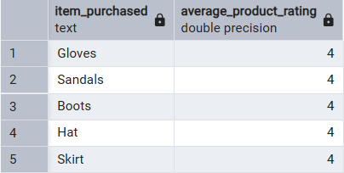
Query 2 — Average purchase amount from shipping category
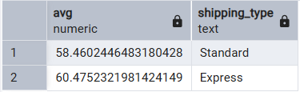
Query 3 - Top 3 Categories by Revenue
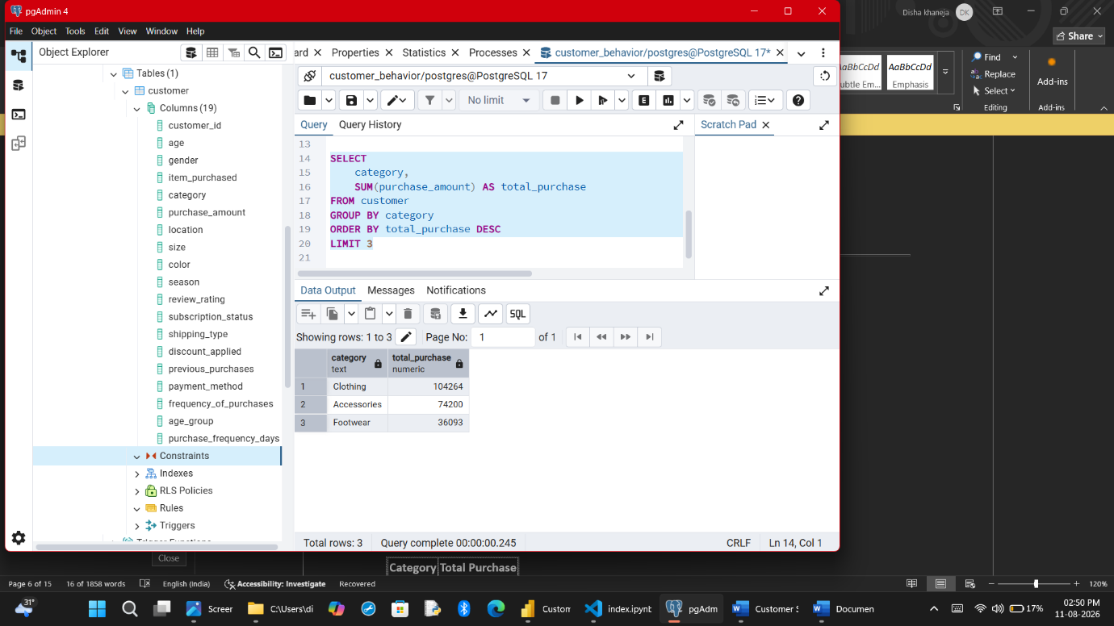
The category with the highest total purchase amount generated : Clothing
However, high revenue does not automatically mean the category is the most profitable, because profit margin/cost data would also be needed.
Query 4 - group customers into new, loyal and returning on basis of frequency of purchase
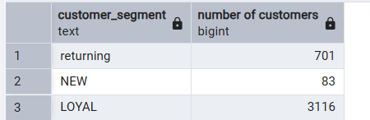
This is an important interview concept from my dashboard.

9. Power BI Dashboard
After completing the analysis, I created an interactive Power BI dashboard.
Main KPIs
1. Number of Customers
Shows the size of the customer base.
Dashboard value: approximately 4K
2. Average Purchase Amount
Shows the average purchase value.
Dashboard value: $59.76
3. Average Review Rating
Shows the average customer rating.
Dashboard value: 3.75

Other Dashboard Visuals
Subscription Status
- Subscribers: 27%
- Non-subscribers: 73%
Revenue by Category
Shows which categories contribute more total purchase value.
Sales by Category
Shows which categories have higher item volume.
Revenue/Sales by Age Group
Helps identify which customer age segments contribute more.
📸 Power BI Dashboard Screenshot
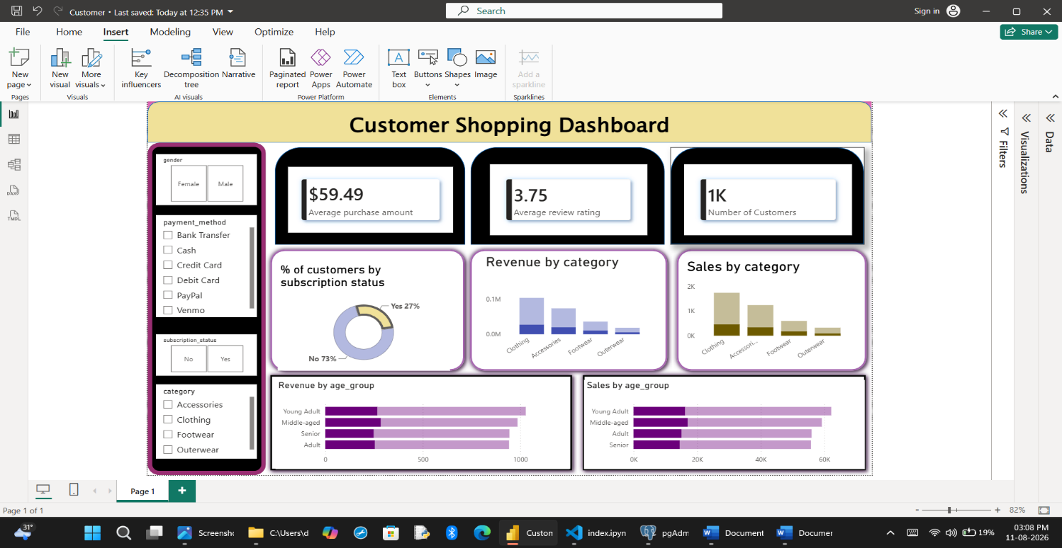
Link : given above :)

10. Important Dashboard Insight — Subscription
One of the areas I found interesting was subscription adoption.
The dashboard showed:
27% subscribed vs 73% non-subscribed
This indicates relatively low subscription adoption.
However, I should not immediately conclude why customers are not subscribing.
I would investigate:
- Average purchase amount
- Purchase frequency
- Category preference
- Review ratings
- Previous purchases
between subscribers and non-subscribers.
Possible Business Recommendation
If the analysis shows that many non-subscribers are already valuable customers, the business could test:
- Targeted subscription offers
- Discounts
- Rewards
- Exclusive benefits
- Loyalty incentives
The effectiveness should then be tested rather than assumed.

11. Key Business Insights
Insight 1 — Subscription Adoption
A majority of customers were non-subscribers.
Business question:
Why are customers who already purchase from the mall not subscribing?

Insight 2 — Category Performance
Some categories contribute more revenue while others may have higher sales volume.
Business question:
Are high-volume categories actually generating high monetary value?

Insight 4 — Customer SpendingAverage purchase amount provides a general picture of spending, but median and distribution should also be considered.
For example:
Mean = $59.76
Median = $45
The higher mean may indicate that some relatively large purchases are pulling the average upward.
12. Business Recommendations
Based on the analysis, possible recommendations include:
Subscription
Investigate why subscription adoption is low and test targeted benefits.
Cross-Selling
If one category performs strongly and another performs weakly, test bundle or voucher-based cross-selling.
Example:
Customers spending above a certain amount on clothing could receive a footwear voucher.
Customer Segmentation
Create targeted offers based on:
- Age
- Gender
- Purchase frequency
- Category preference
- Subscription status
Testing
Recommendations should ideally be validated through experiments such as A/B testing.
13. Concepts that I learned new in this :
Correlation
Measures the strength and direction of association between variables.
Example:
Correlation = 0.72
This indicates a strong positive relationship.
But:
Correlation ≠ Causation
If previous purchases and current purchase amount have correlation 0.72, I can say:
“Customers with more previous purchases tend to have higher current purchase amounts.”
I cannot say:
Previous purchases cause customers to spend more.A/B Testing
What is A/B testing?
A/B testing compares two versions or treatments to determine whether a change affects a business outcome.
Example for my project:
Group A: Existing subscription benefits
Group B: New subscription benefits/discount
Then compare:
- Subscription conversion
- Average purchase amount
- Purchase frequency
- Revenue per customer
The goal is to determine whether the new benefit actually improves the chosen metric.
KPI vs Dimension
KPI
An important measurable business metric.
Examples from my dashboard:
- Number of Customers
- Average Purchase Amount
- Average Review Rating
Dimension
A field used to segment or group the data.
Examples:
- Gender
- Category
- Age Group
- Subscription Status
Short:
KPI = What are we measuring?
Dimension = By what group are we analyzing it?
Something to improve or you have any suggestion or comments, drop at dishabpps@gmail.co

