Assignment1

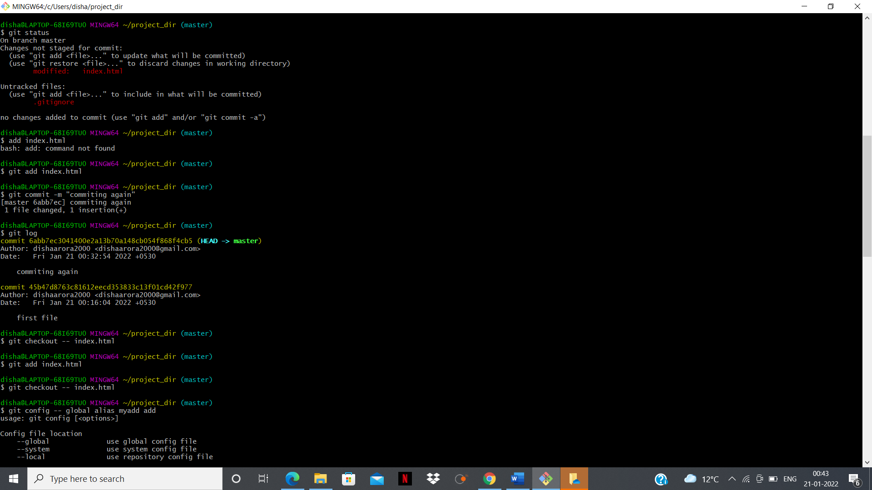

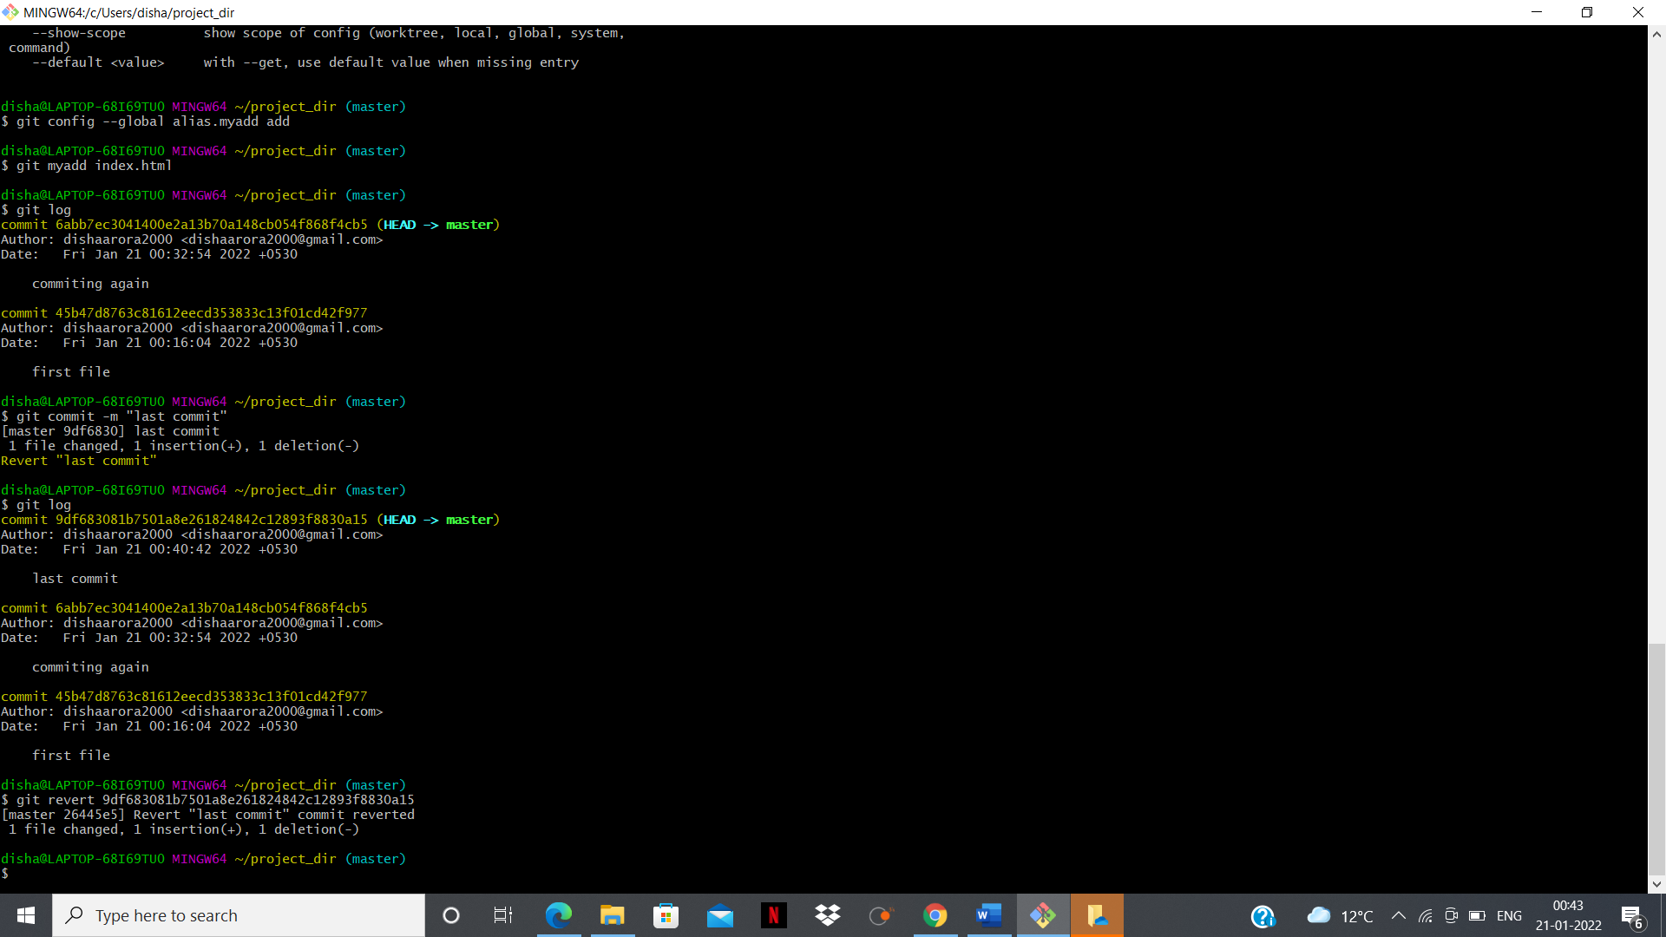

GIT BRANCHING

Section 1

Section 2

Section 3



