InternSpark — UX/UI Design Internship
Task 1 of 3: Mobile App UX Case Study
Larder
Meal planning, simplified — a complete UX case study for a recipe & weekly meal-planning app
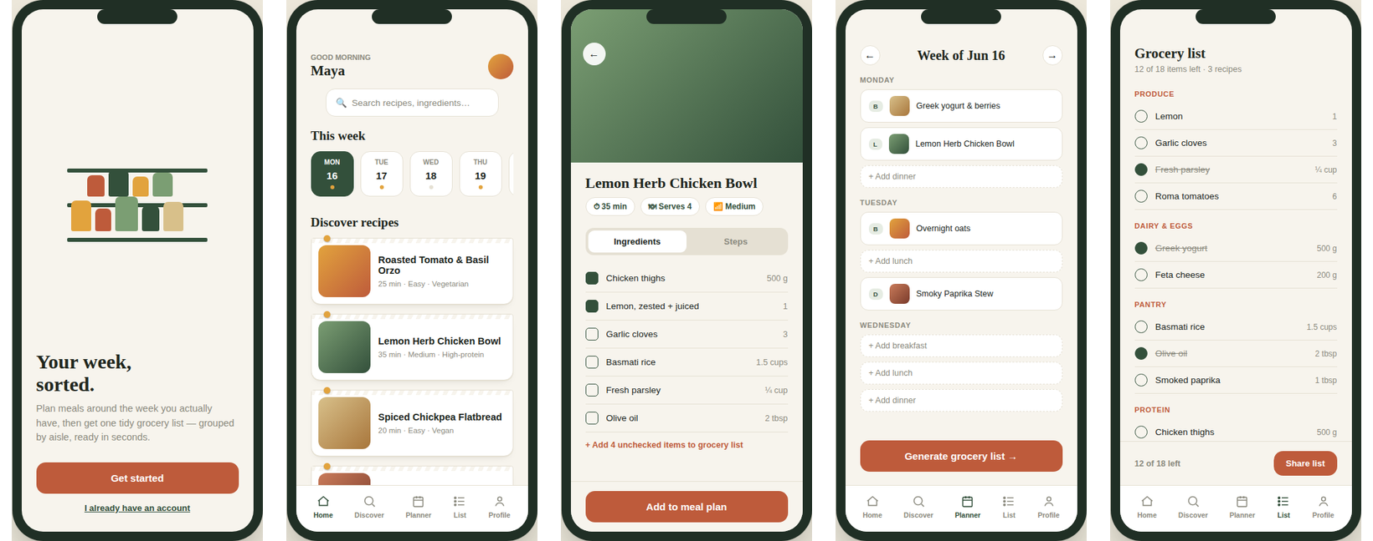
The five core screens of the Larder mobile app, from first launch to a finished grocery list.

1. Project Overview
Larder is a mobile app that helps people plan a realistic week of meals, pull recipes straight into a weekly planner, and turn that plan into one organized grocery list. The goal of this case study is to take the product from a problem statement through to a clickable, high-fidelity prototype.

The problem
Most people who want to cook at home more often don't fail because they can't cook — they fail at the planning stage. Recipes are scattered across bookmarks and screenshots, grocery lists are written from memory (and missing half of what's needed), and by Wednesday the plan has already fallen apart.

Goal of this case study
- Understand who this problem affects most, and why.
- Map the end-to-end flow from discovering a recipe to checking groceries off a list.
- Design and prototype the core screens at low and high fidelity.
- Document the design decisions behind the visual system.

2. User Research Summary
Research approach: this case study uses a lightweight research synthesis — a short round of informal interviews (5 people, ages 24–34, all working professionals who cook at least 3x/week) plus a review of common complaints found in reviews of existing recipe and grocery apps. The goal was to identify the recurring pain points worth designing around, not to produce a statistically rigorous study.

Key findings
- Decision fatigue is the real blocker. “What should I cook this week” is asked more often than “how do I cook this.”
- Grocery lists built from memory consistently miss items, leading to extra store trips.
- Saved recipes (screenshots, bookmarked links, photos of cookbook pages) are rarely looked at again because there's no easy way to act on them.
- People plan in terms of their actual week — a busy Tuesday needs a 15-minute dinner, not a 2-hour braise — so a plan has to flex around a real calendar, not an idealized one.

Primary persona
Name | Maya Patel, 29
Role | Marketing Manager, full-time, lives with partner
Goal | Eat home-cooked meals on weeknights without spending Sunday afternoon planning
Frustration | “I have 40 recipes saved on Instagram and I still ordered takeout three times this week.”
Needs from the app | A plan that fits her actual schedule, and a grocery list she can trust enough to shop from in one trip

3. User Flow
The flow below covers the primary path: arriving in the app, finding a recipe, scheduling it into the week, and generating a grocery list from that plan.
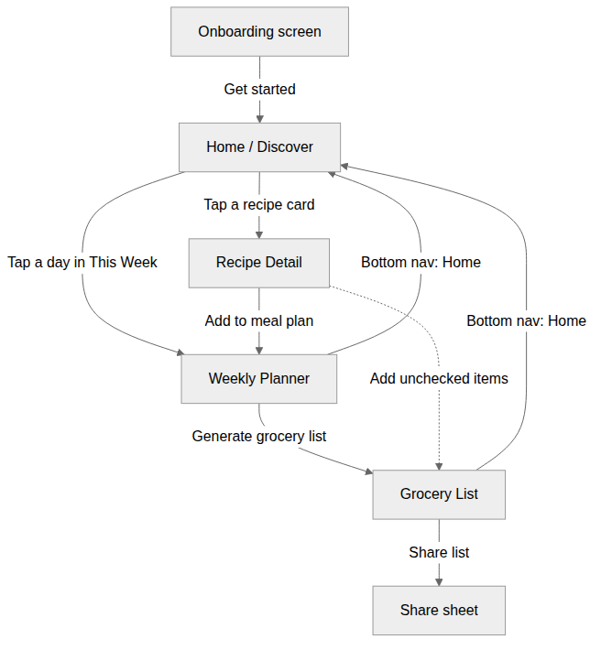
Primary user flow: Onboarding → Home/Discover → Recipe Detail → Weekly Planner → Grocery List.

Why this flow
- Discovery and planning are kept on one tab (Home) so the user never has to remember to go “back” to find more recipes.
- “Add to meal plan” on the recipe screen is the single bridge from inspiration to schedule — no separate save step required.
- The grocery list can be reached two ways — generated from the whole week's plan, or added to directly from a recipe — because both came up in research as natural entry points.

4. Wireframes — Low Fidelity
Before any visual design, each screen was blocked out at low fidelity to settle layout, hierarchy, and navigation before colour or type entered the picture.
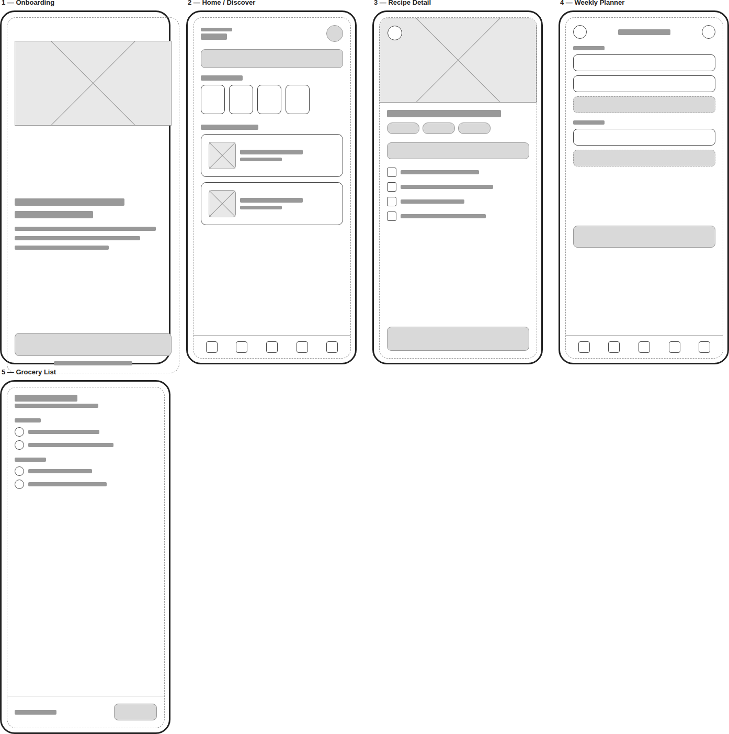
Low-fidelity wireframes for all 5 screens, used to validate structure and flow before visual design.

Layout decisions tested at this stage
- Whether “This Week” belonged on the Home screen or buried in a separate tab — kept on Home, since research showed users check the plan far more often than they browse new recipes.
- Ingredients vs. Steps as tabs rather than one long scrolling page, to keep the cooking-time view scannable.
- A persistent bottom nav across all logged-in screens, so Planner and Grocery List are always one tap away.

5. High-Fidelity Prototype
The high-fidelity screens apply the visual system (see Section 6) to the validated wireframe structure. All five screens are wired together into a clickable prototype — tapping a recipe card opens Recipe Detail, “Add to meal plan” jumps to the Planner, and “Generate grocery list” produces the Grocery List.
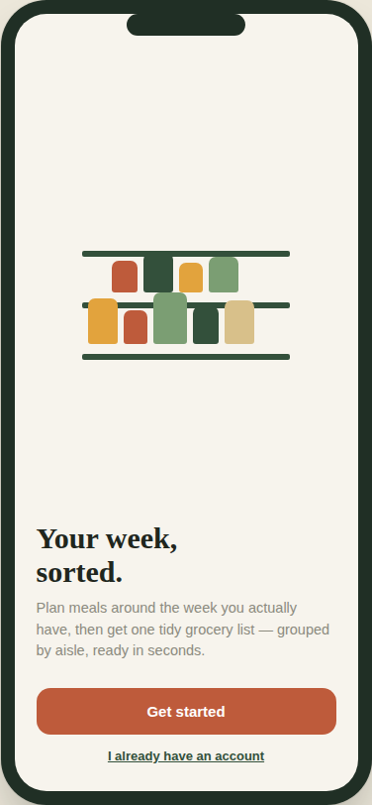
Screen 1 — Onboarding
Sets up the product's promise in one line (“Your week, sorted”) and gets out of the way fast. The pantry-shelf motif previews the warm, kitchen-grounded visual language used throughout.
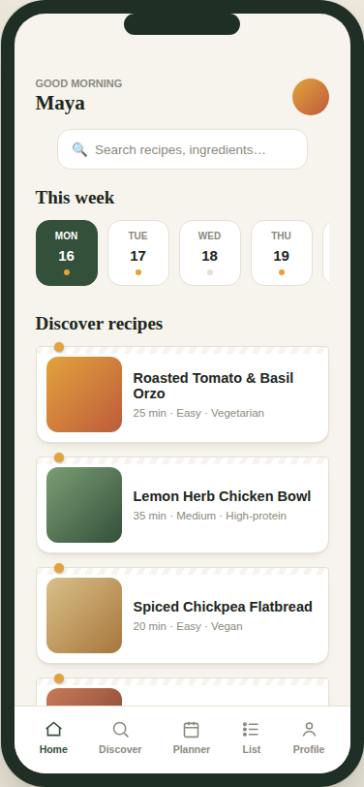
Screen 2 — Home / Discover
Combines the weekly plan (as a horizontally scrolling strip of day-cards) with recipe discovery underneath, so planning and finding new ideas live on the same screen rather than splitting attention across tabs.
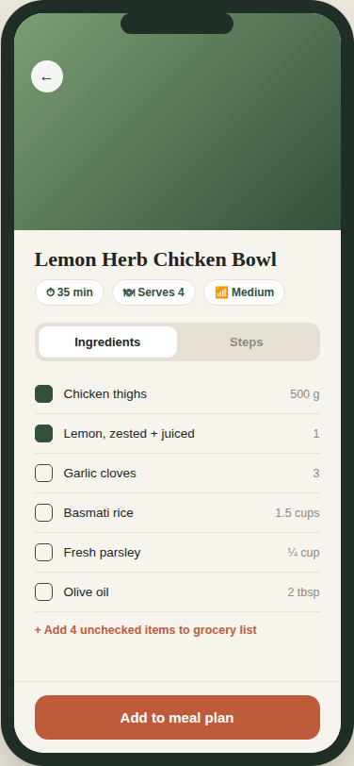
Screen 3 — Recipe Detail
Ingredients are checkable individually, with a shortcut to push only the unchecked items to the grocery list — useful when some ingredients are already in the pantry. “Add to meal plan” is pinned to the bottom so it's reachable from anywhere on the page.
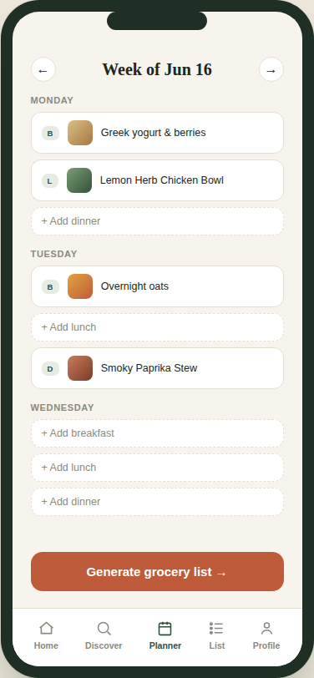
Screen 4 — Weekly Planner
Each day shows three meal slots. Empty slots use a dashed outline and a “+ Add” label so an unplanned meal reads as an invitation, not a gap or an error.
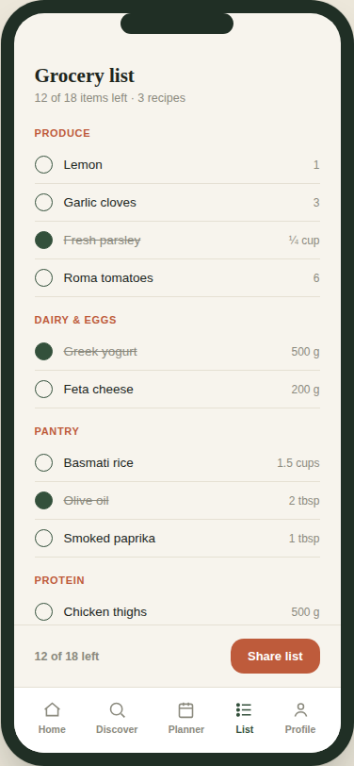
Screen 5 — Grocery List
Items are grouped by aisle (Produce, Dairy & Eggs, Pantry, Protein) rather than by recipe, because that's the order people actually move through a store. Checked items stay visible with a strikethrough rather than disappearing, so a half-finished trip is easy to resume.

6. Design Rationale

Visual identity
- Colour: deep herb green (#33503B) as the primary brand colour, warm amber (#E2A33D) as a light accent, and a rust/terracotta (#BE5B3B) reserved only for primary actions — so the one call-to-action on any screen is never ambiguous.
- Type: a serif display face for headings gives the brand an editorial, recipe-card warmth; a plain grotesque carries all body text and UI labels so the interface itself stays easy to scan.
- Signature motif: recipe and day cards use a torn-paper top edge and a small pin dot, echoing a physical recipe box rather than a generic flat card — a deliberate, on-brand alternative to a plain drop shadow.

Interaction choices
- A persistent bottom nav (Home, Discover, Planner, List, Profile) keeps the four core jobs of the app reachable in one tap from anywhere.
- Checkboxes on both the recipe screen and the grocery list use the same visual language, so checking off an ingredient feels like the same action in both places.
- Empty states (an unplanned meal slot, an empty week) are written as an invitation (“+ Add dinner”) rather than left blank, so the app never feels like it's missing something broken.

7. Deliverables
- Interactive high-fidelity prototype (HTML/CSS/JS, 5 connected screens) — attached separately as prototype.html
- Low-fidelity wireframes — Section 4 of this document
- This case study (PDF/DOCX)

Submission note: paste the public link to the hosted prototype (e.g. uploaded to GitHub Pages or Google Drive) along with this document on the InternSpark Task Submission page, mentioning “Task 1.”

