InternSpark — UX/UI Design Internship
Task 2 of 3: Website Landing Page UI Design
Larder
A marketing landing page for the Larder app, designed responsively for desktop and mobile
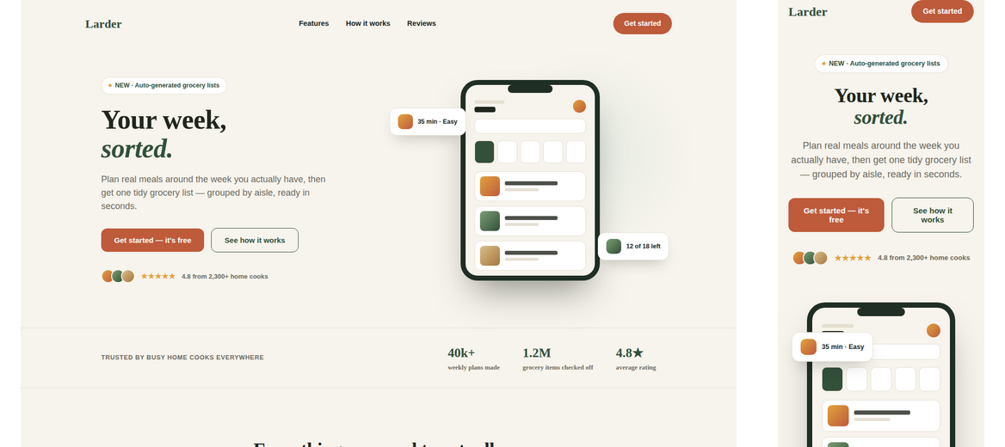
Desktop and mobile hero sections — same brand system as the Task 1 app case study.

1. Project Overview
This task extends the Larder case study from Task 1 into a marketing landing page — the page a visitor would land on before ever opening the app. Its only job is to explain the product fast and get a visitor to tap “Get started.”

Goals for the page
- Communicate the core value (“stop guessing what's for dinner”) within the first screen, with no scrolling required.
- Show, not just tell — use real app-screen previews rather than abstract illustrations.
- Build trust quickly through social proof (ratings, usage stats, testimonials) before asking for a sign-up.
- Work equally well as a one-screen mobile experience and a wide desktop experience, using the same content and visual system as the Task 1 app.

Page structure
- Nav — logo, in-page links, primary CTA
- Hero — headline, sub-copy, two CTAs, social proof line, and an app-screen preview with floating detail cards
- Trust strip — usage stats
- Features — 4 cards covering the core value props
- How it works — 3-step explainer next to a grocery-list preview
- Testimonials — 3 short reviews with star ratings
- CTA band — final conversion push
- Footer — links and brand sign-off

2. Wireframes — Low Fidelity
Layout and content hierarchy were blocked out at low fidelity first, for both breakpoints, before any visual styling was applied.
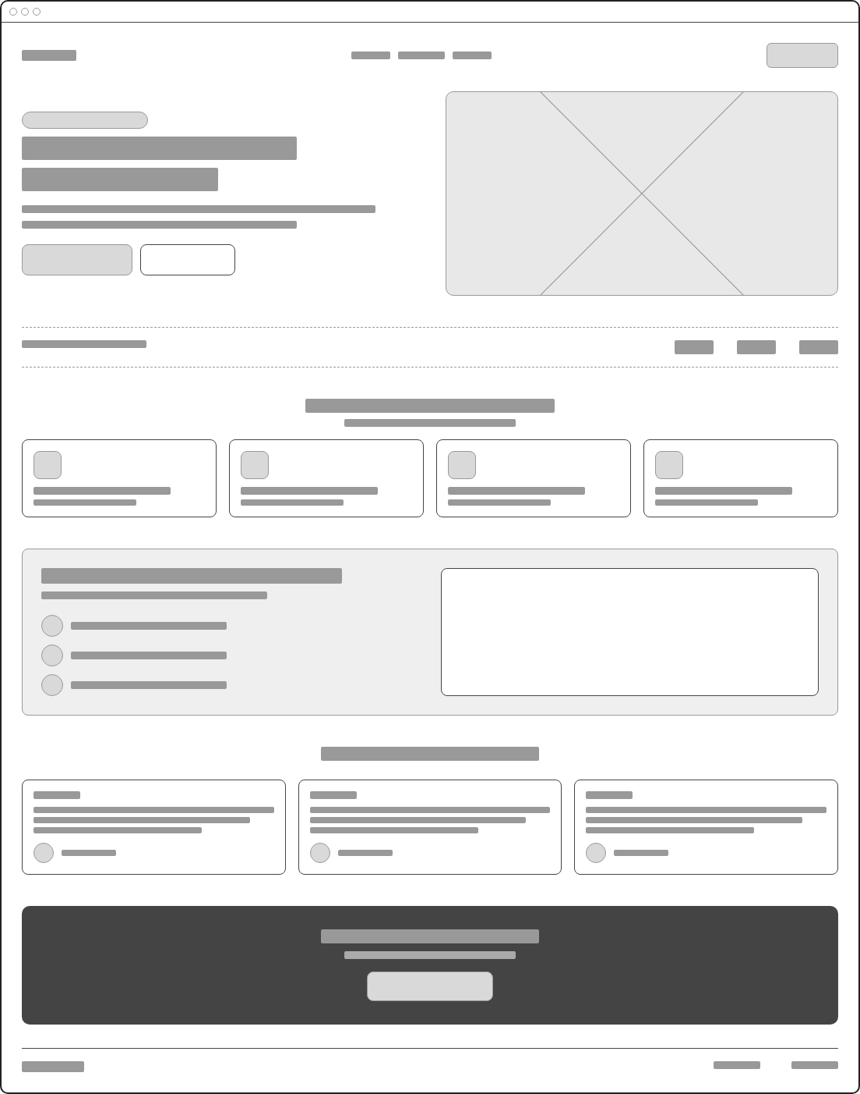
Desktop wireframe — full page structure, hero through footer.

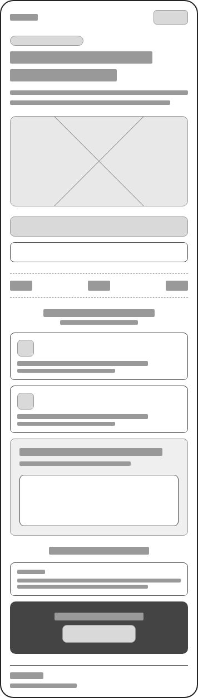
Mobile wireframe — sections stack to a single column; the feature grid drops from 4 columns to 1.

Decisions made at this stage
- The hero visual (app screenshot) was placed beside the headline on desktop, but moved below the copy on mobile — so the value proposition is read before any image loads.
- The 4-column feature grid collapses to a single column on mobile rather than 2x2, keeping each card full-width and easy to read one-handed.
- The “how it works” section keeps its 3 numbered steps in the same order on both breakpoints, with the supporting visual moving from “side-by-side” to “stacked below.”

3. High-Fidelity Design — Desktop
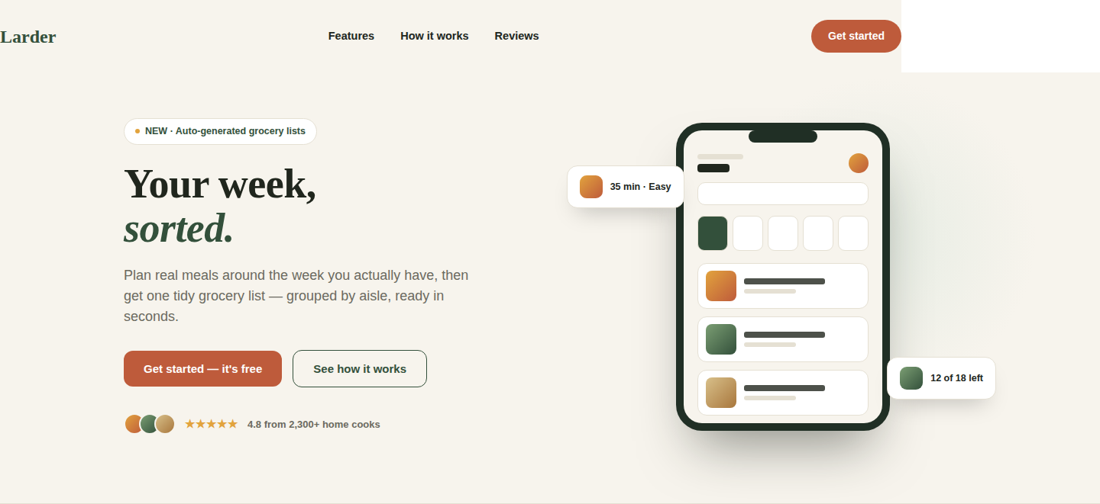
Nav + Hero — desktop
The hero leads with the outcome (“Your week, sorted”) rather than the feature list. The floating detail cards on the phone mockup hint at two concrete features (timing, grocery progress) without requiring any extra copy.
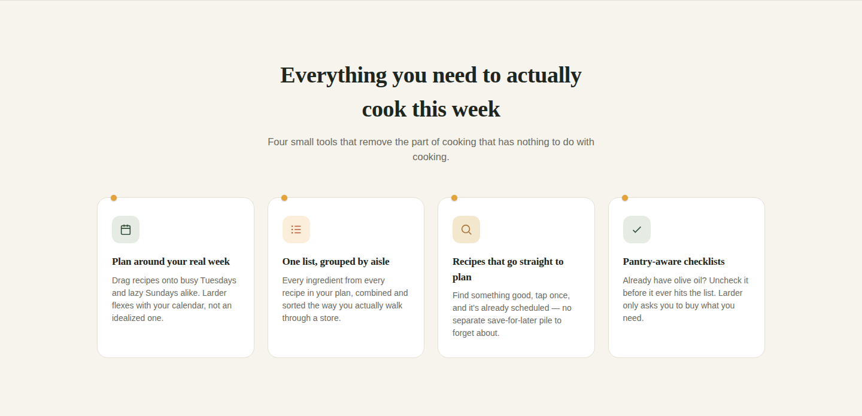
Features — desktop
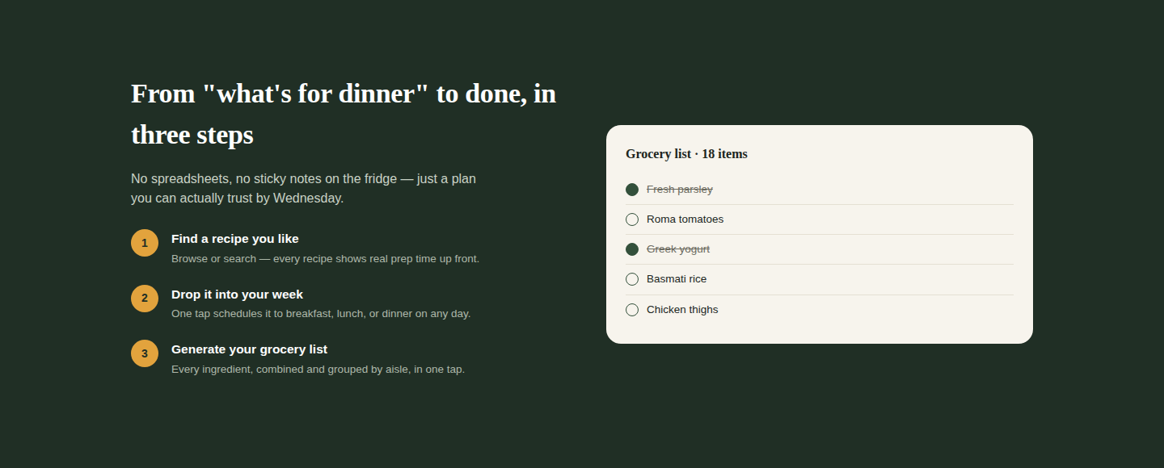
How it works — desktop
This section sits on a dark band to visually separate “how it works” from the lighter feature grid above it, and to make the grocery-list preview's checkboxes pop.

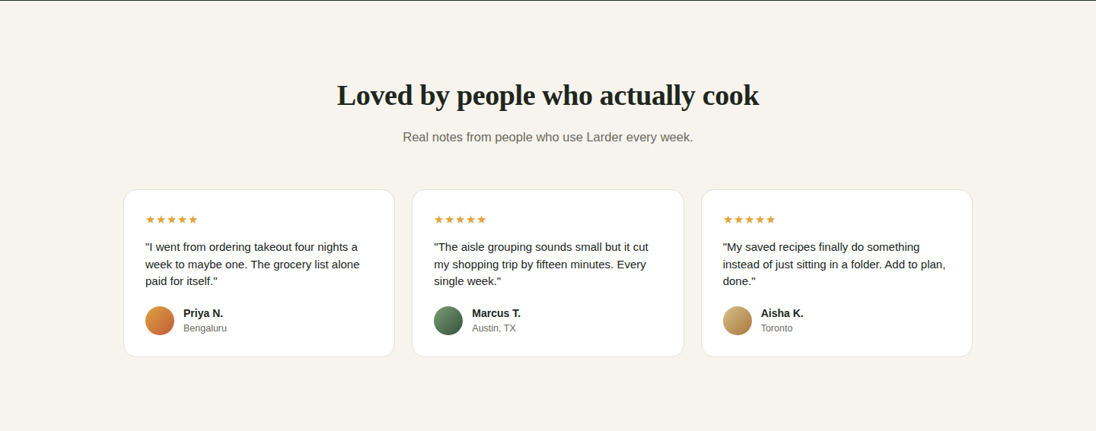
Testimonials — desktop

Final CTA band — desktop
The closing CTA repeats the same button copy as the hero (“Get started — it's free”) deliberately — consistent calls to action reduce the small decision cost of clicking.

4. High-Fidelity Design — Mobile
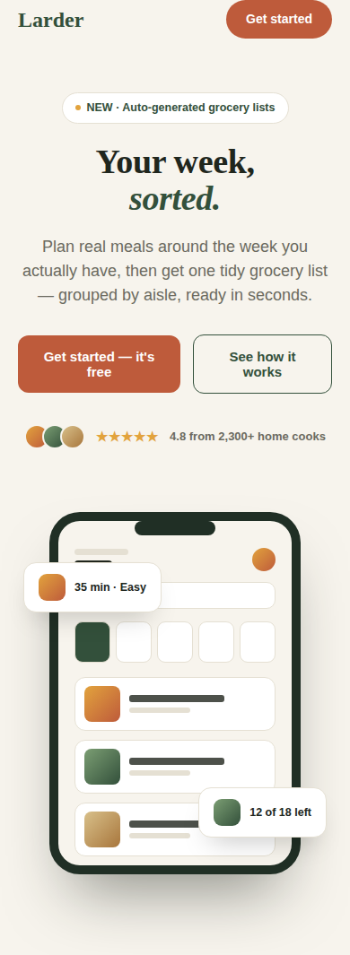
Nav + Hero — mobile
On mobile the headline, sub-copy, and both CTAs are visible without scrolling; the app-screen preview and social proof sit just below the fold as the natural next scroll.
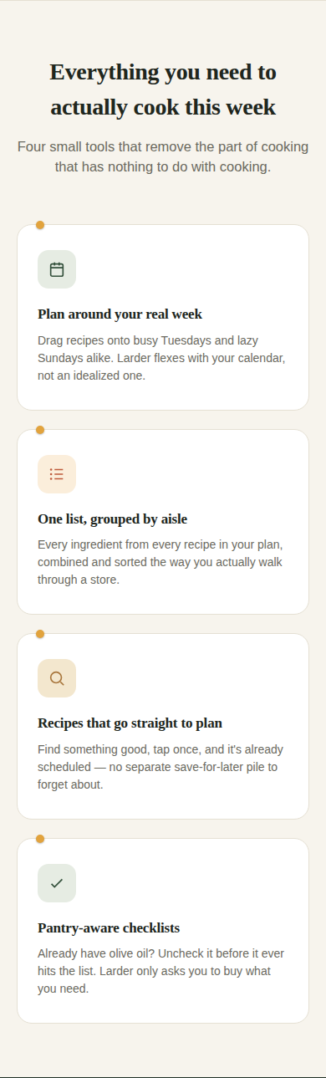
Features — mobile (single column)
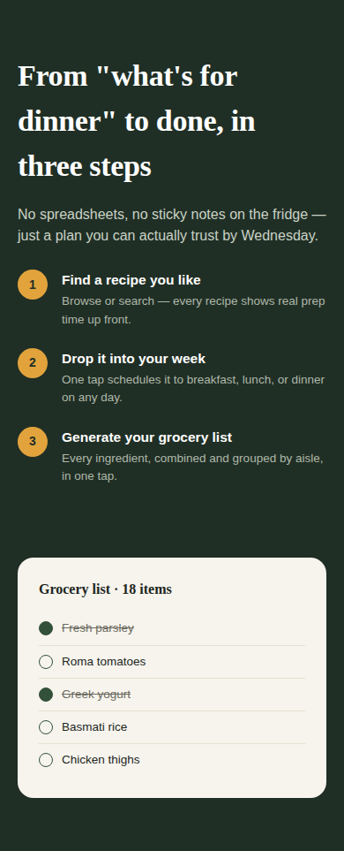
How it works — mobile
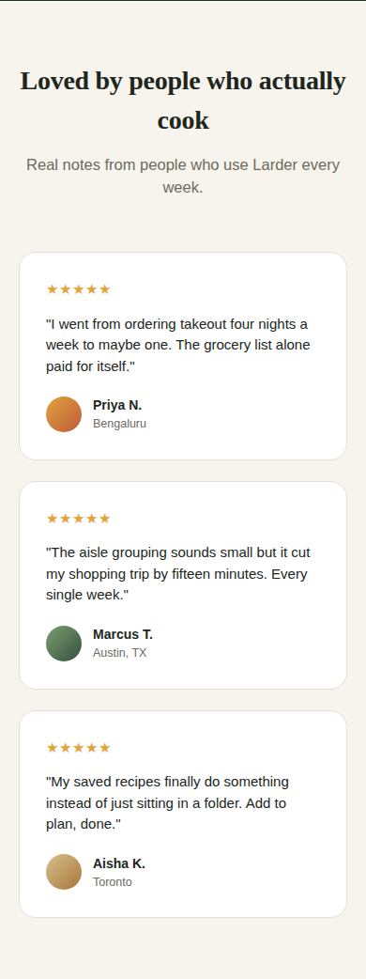
Testimonials — mobile
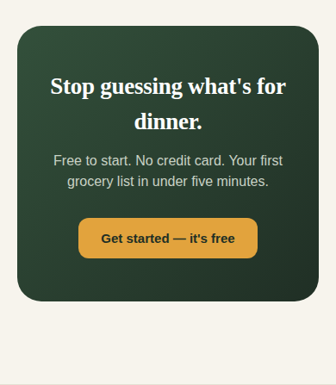
Final CTA band — mobile

5. Design Rationale

Visual consistency with the app
- Same colour system as Task 1 (herb green, amber, rust) so the landing page reads as the same product, not a separate marketing skin.
- The phone mockup in the hero reuses the actual Home screen layout from the Task 1 prototype, so visitors see the real product, not a generic stock illustration.
- The torn-card pin motif from the app's recipe cards reappears on the landing page's feature cards, carrying the brand's signature detail outside the app itself.

Responsive approach
- Breakpoint at 880px: above it, the hero and “how it works” section use side-by-side layouts; below it, everything stacks to a single readable column.
- The 4-column feature grid steps down to 1 column on mobile (skipping an awkward 2-column middle state) since each card has enough copy that 2-up still felt cramped on a phone.
- Decorative-only elements (the soft background blob behind the hero phone) are hidden on mobile rather than shrunk, since they added visual noise without contributing to comprehension at small sizes.

Conversion-focused choices
- Two CTAs in the hero — a primary action (“Get started”) and a low-commitment secondary action (“See how it works”) — for visitors who aren't ready to commit but want more detail before leaving.
- Social proof (rating, usage stats, testimonials) is placed before the final CTA band, so trust is established before the second ask.

6. Deliverables
- Responsive landing page (HTML/CSS, desktop + mobile in one file) — attached as landing.html
- Low-fidelity wireframes, desktop and mobile — Section 2 of this document
- This case study (PDF/DOCX)

Submission note: upload landing.html alongside the Task 1 prototype in the same GitHub repository, and paste both links on the InternSpark Task Submission page, labelled “Task 2.”

