VISVESVARAYA TECHNOLOGICAL UNIVERSITY
“JnanaSangama”, Belgaum -590014, Karnataka.


LAB REPORT

on

Machine Learning (23CS6PCMAL)

Submitted by
Disha H Jain (1BM23CS095)

in partial fulfillment for the award of the degree of

BACHELOR OF ENGINEERING
in

COMPUTER SCIENCE AND ENGINEERING


B.M.S. COLLEGE OF ENGINEERING
(Autonomous Institution under VTU)

BENGALURU-560019

Jan-2026 to May-2026

B.M.S. College of Engineering,
Bull Temple Road, Bangalore 560019
(Affiliated To Visvesvaraya Technological University, Belgaum)
Department of Computer Science and Engineering


CERTIFICATE

This is to certify that the Lab work entitled “Machine Learning (23CS6PCMAL)” carried out by Disha H Jain (1BM23CS095), who is a bonafide student of B.M.S. College of Engineering. It is in partial fulfillment for the award of Bachelor of Engineering in Computer Science and Engineering of the Visvesvaraya Technological University, Belgaum. The Lab report has been approved as it satisfies the academic requirements in respect of an Machine Learning (23CS6PCMAL) work prescribed for the said degree.

Dr. Kavitha Sooda Professor & HOD
Department of CSE, BMSCE
D Chaitra
Assistant Professor Department of CSE, BMSCE

Index

Sl.  No. | Date | Experiment Title | Page No.
1 | 4-2-2026 | Write a python program to import and export data using Pandas library functions
2 | 11-2-2026 | Demonstrate various data pre-processing techniques for a given dataset
3 | 25-2-2026 | Implement Linear and Multi-Linear Regression algorithm using appropriate dataset
4 | 25-3-2026 | Build Logistic Regression Model for a given dataset
5 | 11-3-2025 | Use an appropriate data set for building the decision tree (ID3) and apply this knowledge to classify a new sample.
6 | 25-2-2026 | Build KNN Classification model for a given dataset.
7 | 1-4-2026 | Build Support vector machine model for a given dataset
8 | 1-4-2026 | Implement Random forest ensemble method on a given dataset.
9 | 1-4-2026 | Implement Boosting ensemble method on a given dataset.
10 | 1-4-2026 | Build k-Means algorithm to cluster a set of data stored in a .CSV file.
11 | 8-4-2026 | Implement Dimensionality reduction using Principal Component Analysis (PCA) method.

Github Link:
https://github.com/dishahjain/ML-lab
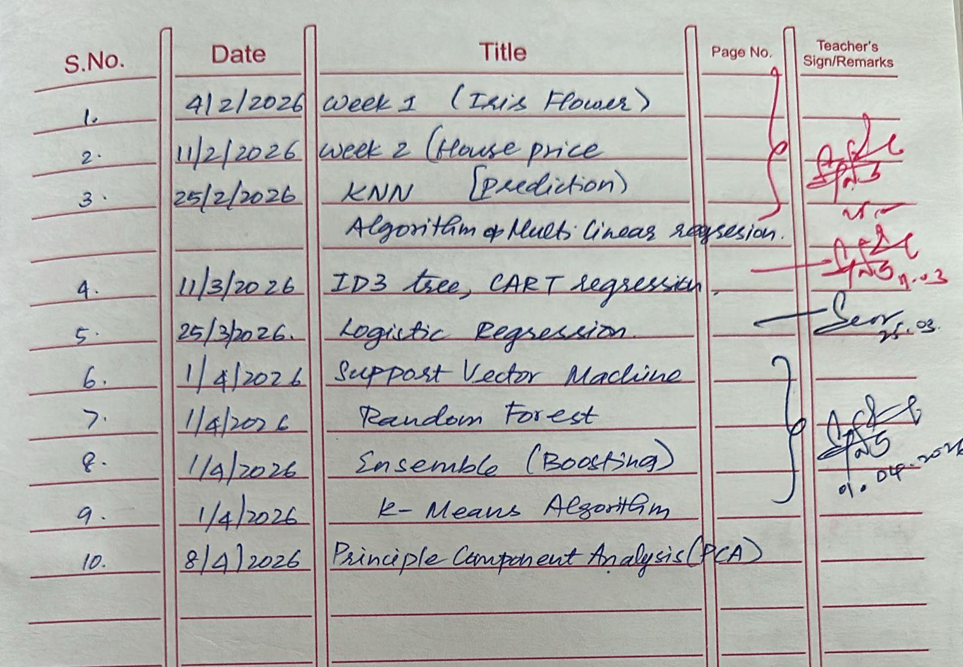

Program 1
Write a python program to import and export data using Pandas library functions
Screenshot
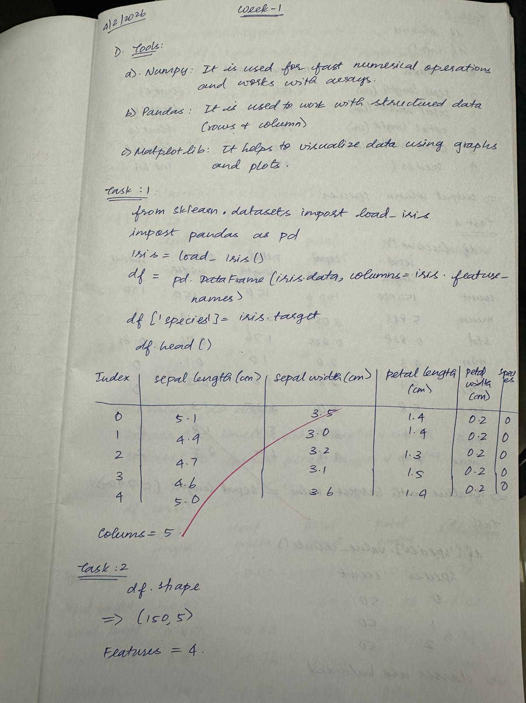
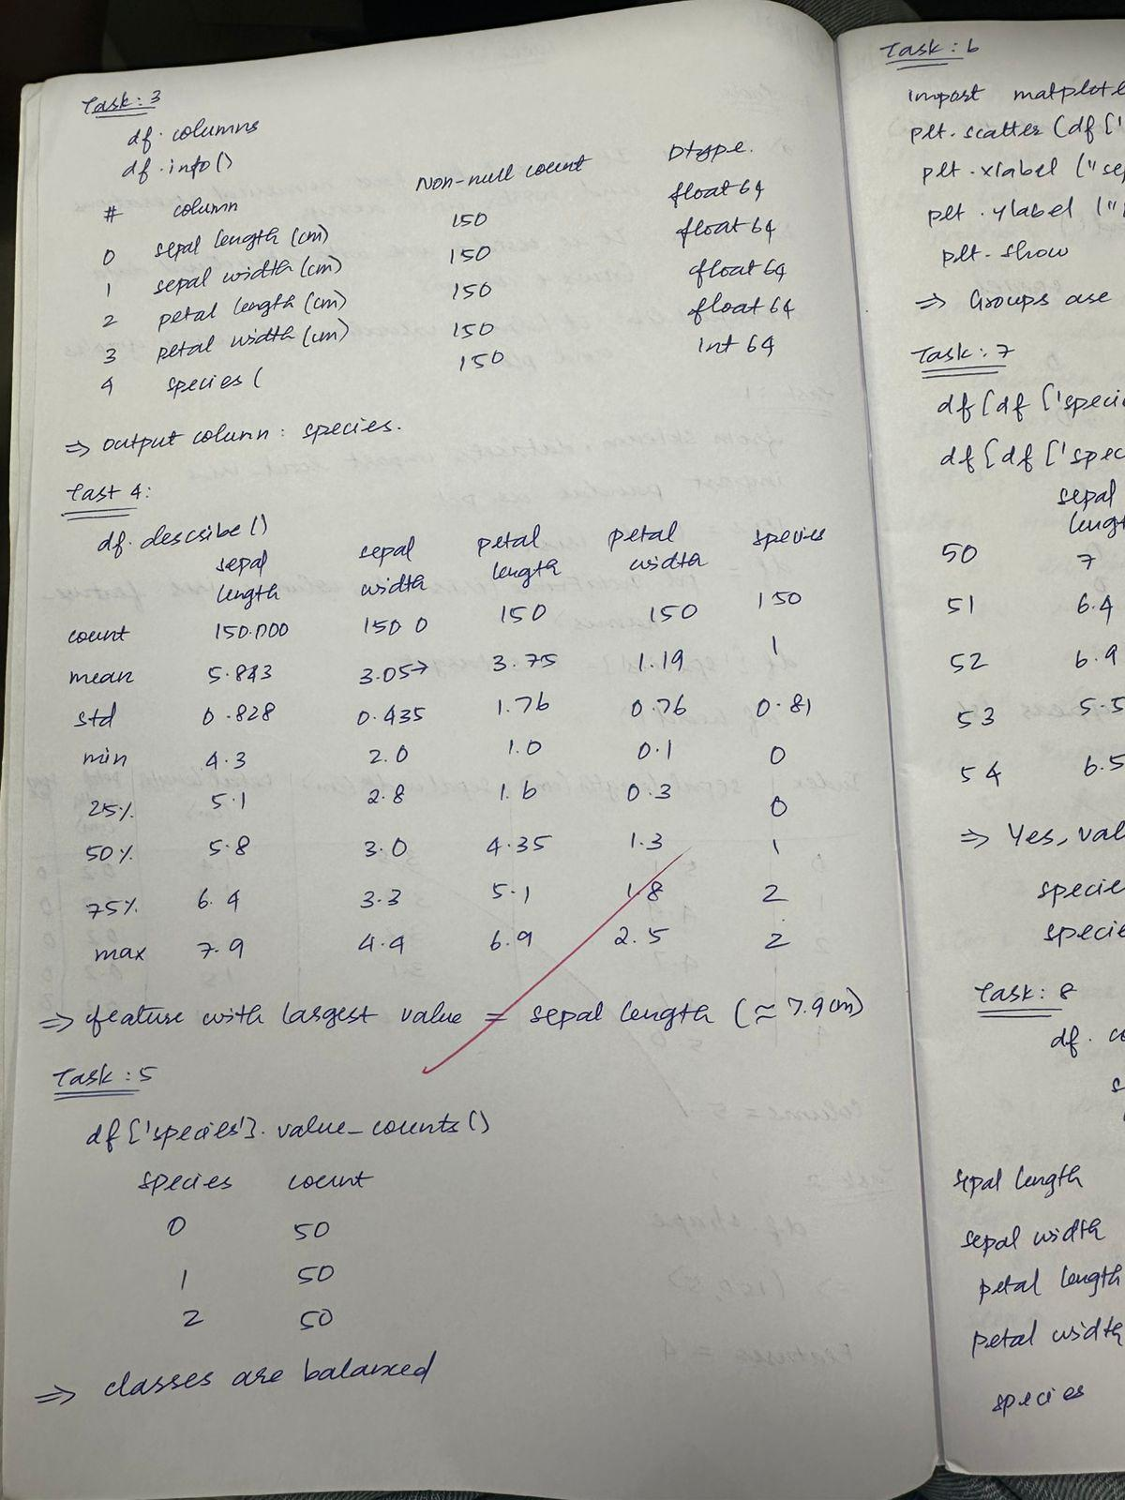
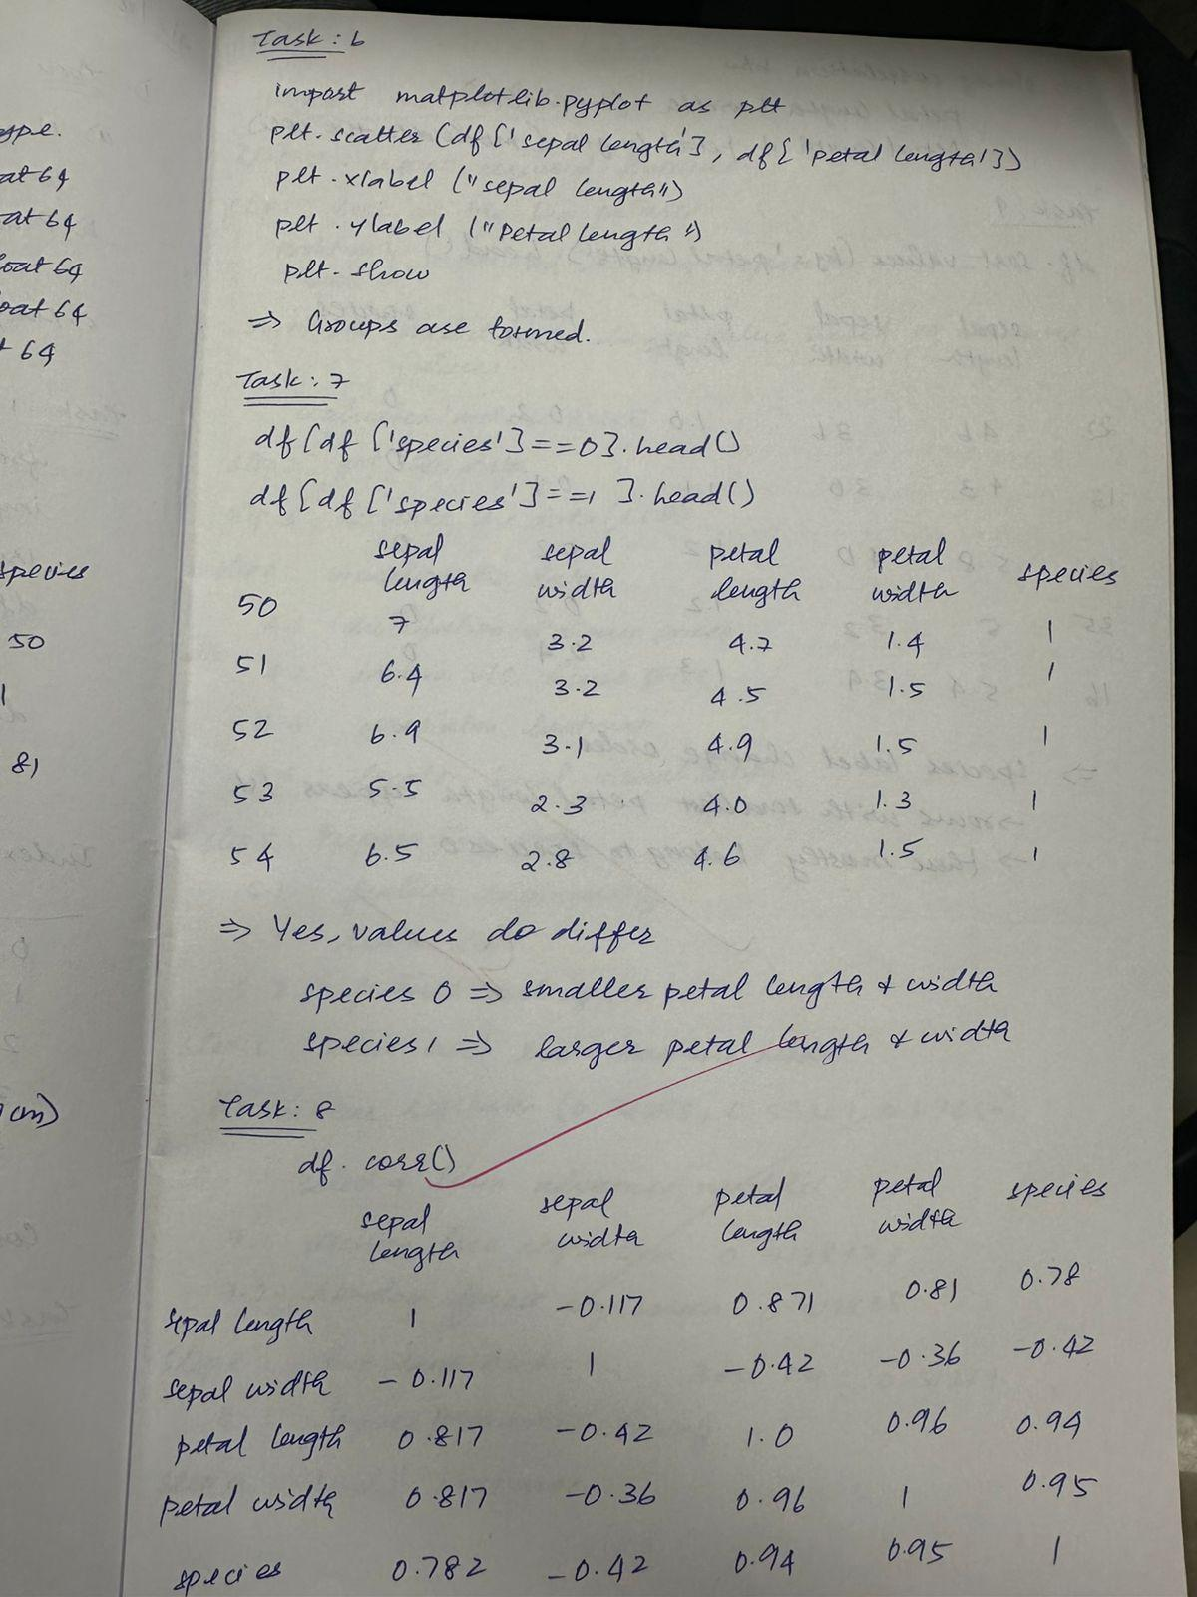
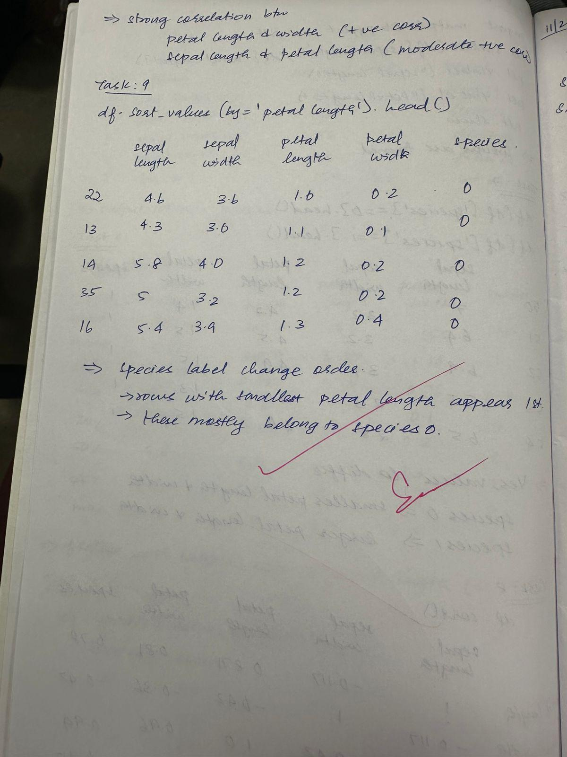

Code:
from sklearn.datasets import load_iris
import pandas as pd
import matplotlib.pyplot as plt

# Load dataset
iris = load_iris()

# Create DataFrame
df = pd.DataFrame(iris.data, columns=iris.feature_names)
df['species'] = iris.target

# Basic info
print(df.head())
print(df.shape)
print(df.columns)
print(df.info())
print(df.describe())

# Class distribution
print(df['species'].value_counts())

# Scatter plot
plt.scatter(df['sepal length (cm)'], df['petal length (cm)'])
plt.xlabel("Sepal Length")
plt.ylabel("Petal Length")
plt.show()

# Filter data
print(df[df['species'] == 0].head())
print(df[df['species'] == 1].head())

# Correlation
print(df.corr())

# Sort values
print(df.sort_values(by='petal length (cm)').head())

Program 2
Demonstrate various data pre-processing techniques for a given dataset
Screenshot
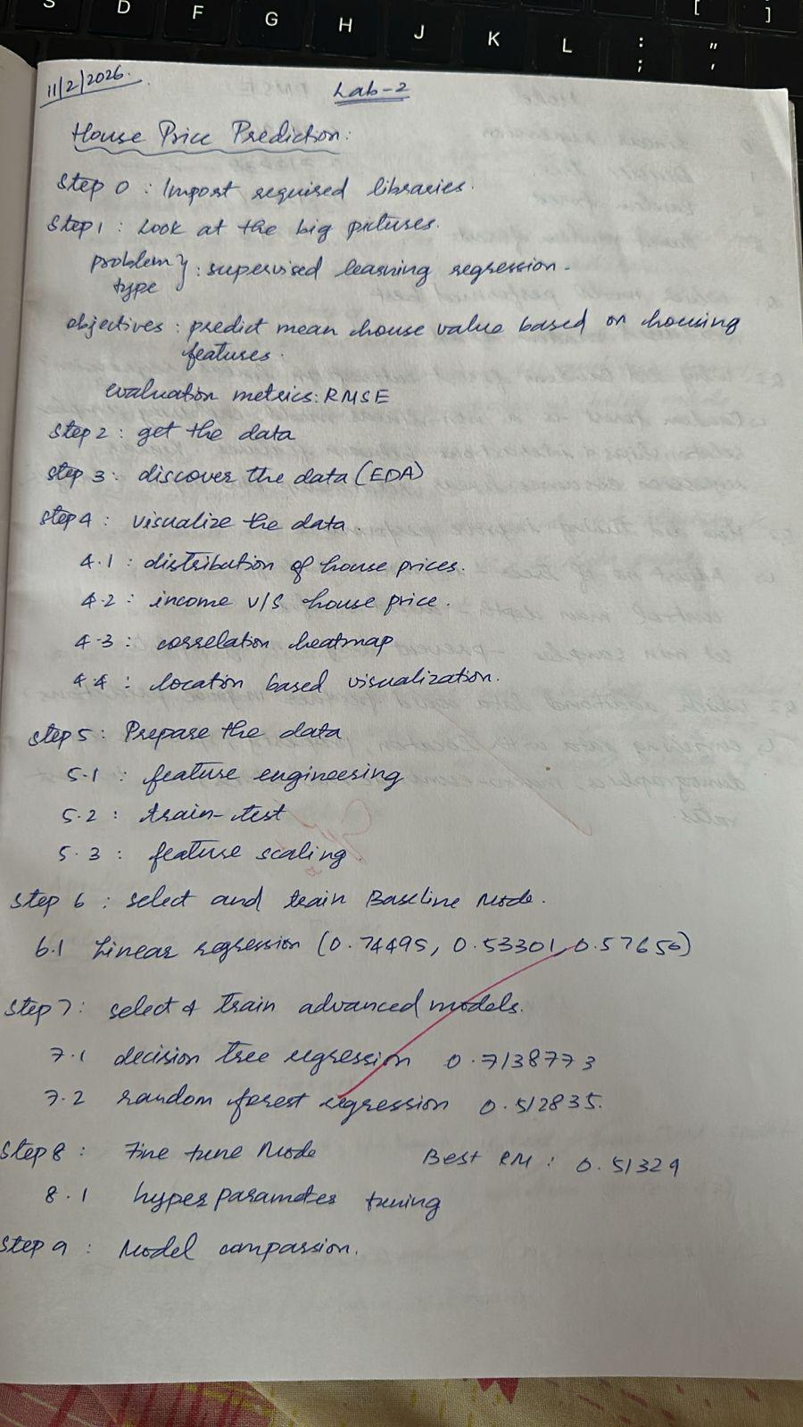
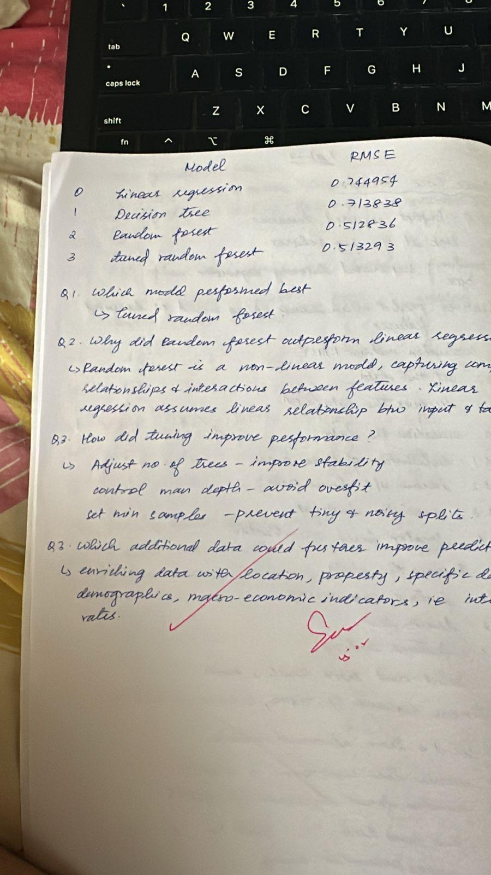

Code:
import numpy as np
import pandas as pd
import matplotlib.pyplot as plt
import seaborn as sns

from sklearn.datasets import fetch_california_housing
from sklearn.model_selection import train_test_split, GridSearchCV
from sklearn.preprocessing import StandardScaler
from sklearn.linear_model import LinearRegression
from sklearn.tree import DecisionTreeRegressor
from sklearn.ensemble import RandomForestRegressor
from sklearn.metrics import mean_squared_error, mean_absolute_error, r2_score

# Load dataset
housing = fetch_california_housing(as_frame=True)

# Create DataFrame
df = housing.frame

# Display basic info
print(df.head())
print(df.shape)
print(df.info())

# Summary statistics
print(df.describe())

# Check missing values
print(df.isnull().sum())

# Distribution plot
plt.figure()
sns.histplot(df['MedHouseVal'], bins=30, kde=True)
plt.xlabel("Median House Value")
plt.ylabel("Frequency")
plt.title("Distribution of House Prices")
plt.show()

# Scatter plot
plt.figure()
sns.scatterplot(x=df['MedInc'], y=df['MedHouseVal'], alpha=0.5)
plt.xlabel("Median Income")
plt.ylabel("Median House Value")
plt.title("Income vs House Price")
plt.show()

Program 3
Use an appropriate data set for building the decision tree (ID3) and apply this knowledge to classify a new sample.
Screenshot
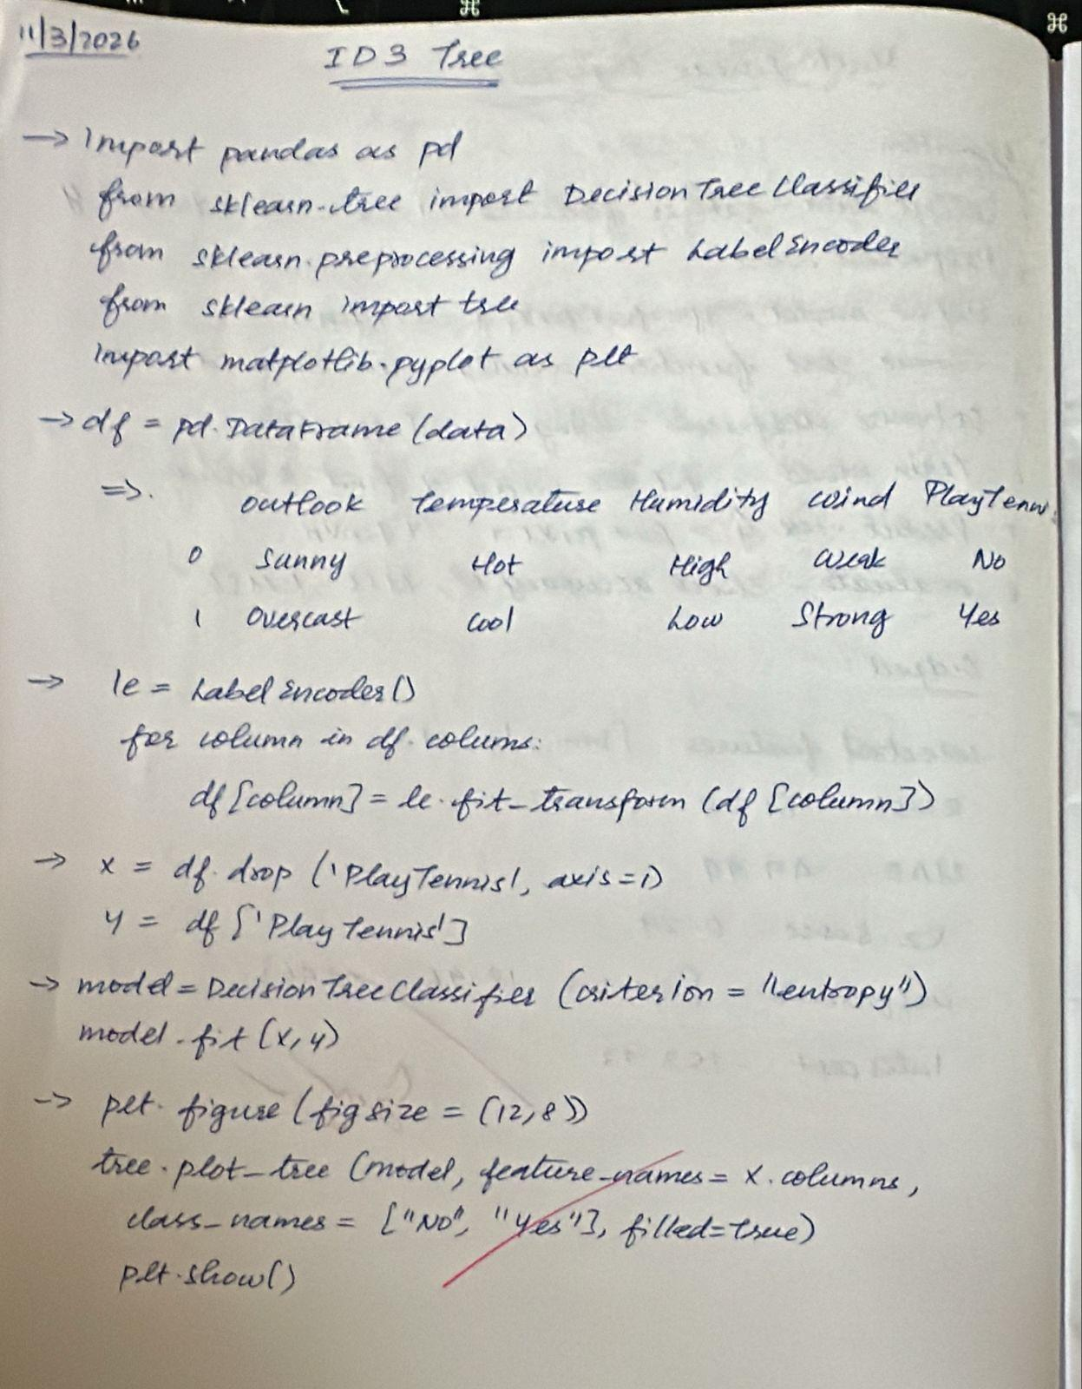
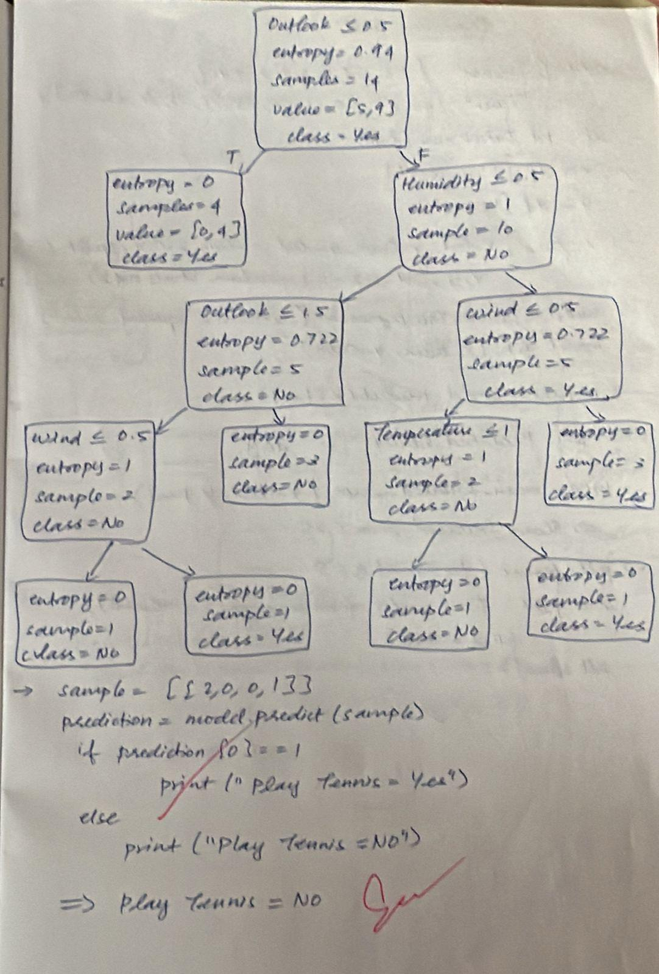

Code:
import pandas as pd
from sklearn.tree import DecisionTreeClassifier
from sklearn.preprocessing import LabelEncoder
from sklearn import tree
import matplotlib.pyplot as plt

data = {
'Outlook': ['Sunny','Sunny','Overcast','Rain','Rain','Rain','Overcast','Sunny','Sunny','Rain','Sunny','Overcast','Overcast','Rain'],
'Temperature': ['Hot','Hot','Hot','Mild','Cool','Cool','Cool','Mild','Cool','Mild','Mild','Mild','Hot','Mild'],
'Humidity': ['High','High','High','High','Normal','Normal','Normal','High','Normal','Normal','Normal','High','Normal','High'],
'Wind': ['Weak','Strong','Weak','Weak','Weak','Strong','Strong','Weak','Weak','Weak','Strong','Strong','Weak','Strong'],
'PlayTennis': ['No','No','Yes','Yes','Yes','No','Yes','No','Yes','Yes','Yes','Yes','Yes','No']
}

df = pd.DataFrame(data)
df

le = LabelEncoder()

for column in df.columns:
df[column] = le.fit_transform(df[column])

df

X = df.drop('PlayTennis', axis=1)
y = df['PlayTennis']

model = DecisionTreeClassifier(criterion="entropy")
model.fit(X, y)

plt.figure(figsize=(12,8))
tree.plot_tree(model, feature_names=X.columns, class_names=["No","Yes"], filled=True)
plt.show()

sample = [[2,0,0,1]] # example encoded values
prediction = model.predict(sample)

if prediction[0] == 1:
print("Play Tennis: YES")
else:
print("Play Tennis: NO")

Program 4
Implement Linear and Multi-Linear Regression algorithm using appropriate dataset
Screenshot
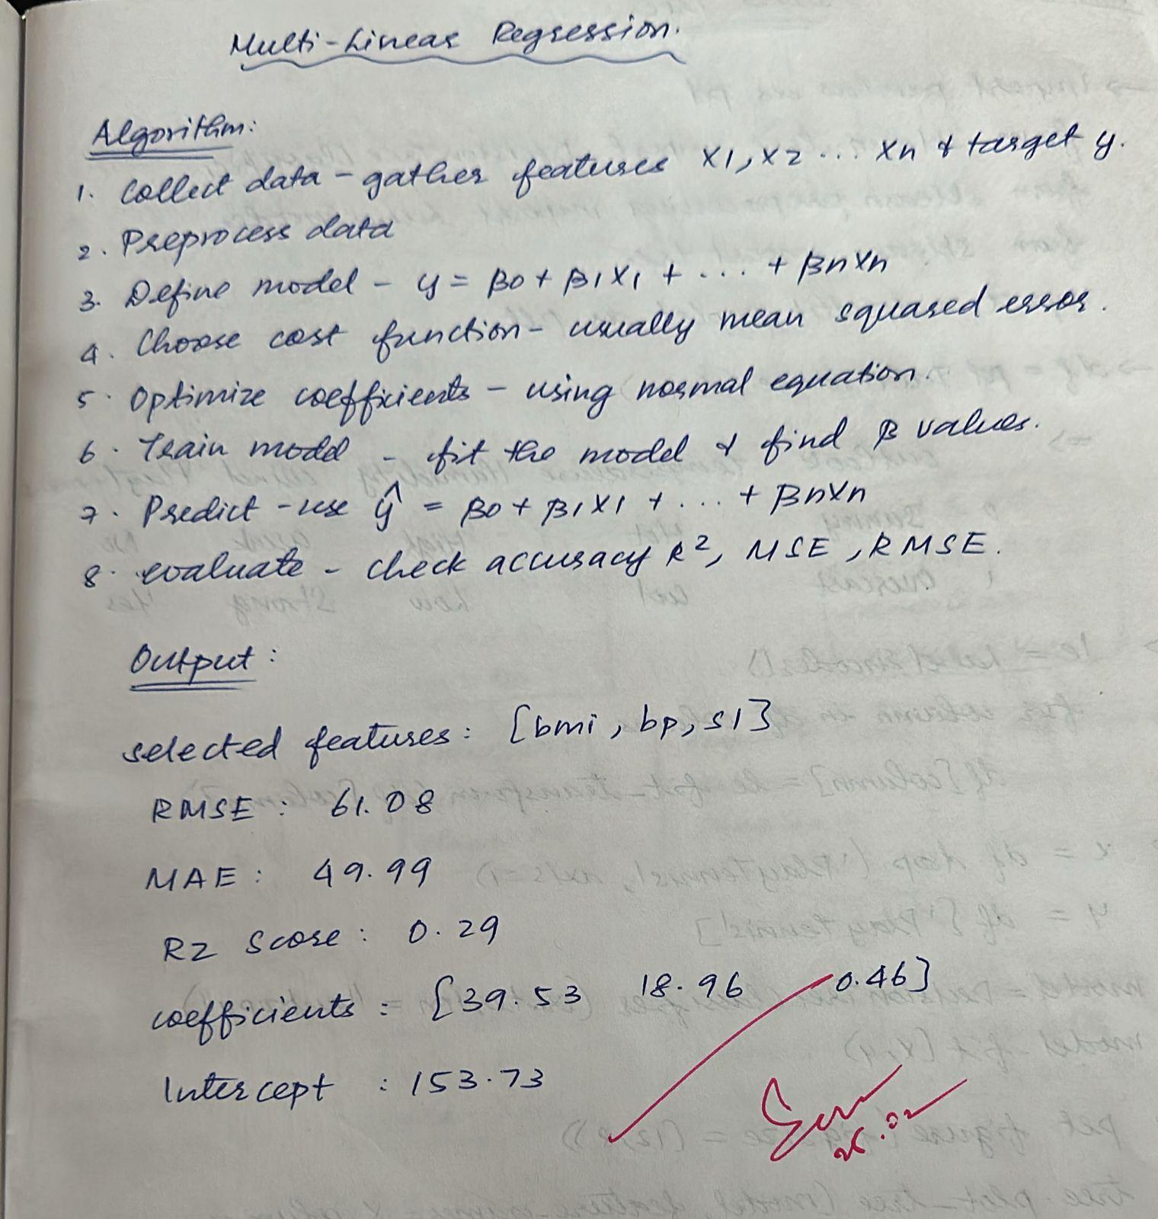

Code:
import numpy as np
from sklearn.datasets import load_diabetes
from sklearn.model_selection import train_test_split
from sklearn.preprocessing import StandardScaler
from sklearn.linear_model import LinearRegression
from sklearn.metrics import mean_squared_error, mean_absolute_error, r2_score

# Load dataset
data = load_diabetes()
X = data.data
y = data.target

# Select features
selected_features = ['bmi', 'bp', 's1']

# Get feature indices
feature_names = data.feature_names
print("All features:", feature_names)

selected_indices = [feature_names.index(f) for f in selected_features]

# Extract selected features
X_selected = X[:, selected_indices]

# Train-test split
X_train, X_test, y_train, y_test = train_test_split(
X_selected, y, test_size=0.2, random_state=42
)

# Standardization
scaler = StandardScaler()
X_train_scaled = scaler.fit_transform(X_train)
X_test_scaled = scaler.transform(X_test)

# Train Linear Regression model
lin_reg = LinearRegression()
lin_reg.fit(X_train_scaled, y_train)

# Predictions
y_pred_lr = lin_reg.predict(X_test_scaled)

# Evaluation
rmse_lr = np.sqrt(mean_squared_error(y_test, y_pred_lr))
mae_lr = mean_absolute_error(y_test, y_pred_lr)
r2_lr = r2_score(y_test, y_pred_lr)

print("Selected features:", selected_features)
print("RMSE:", rmse_lr)
print("MAE:", mae_lr)
print("R2 Score:", r2_lr)
print("Coefficients:", lin_reg.coef_)
print("Intercept:", lin_reg.intercept_)

Program 5
Build Logistic Regression Model for a given dataset
Screenshot
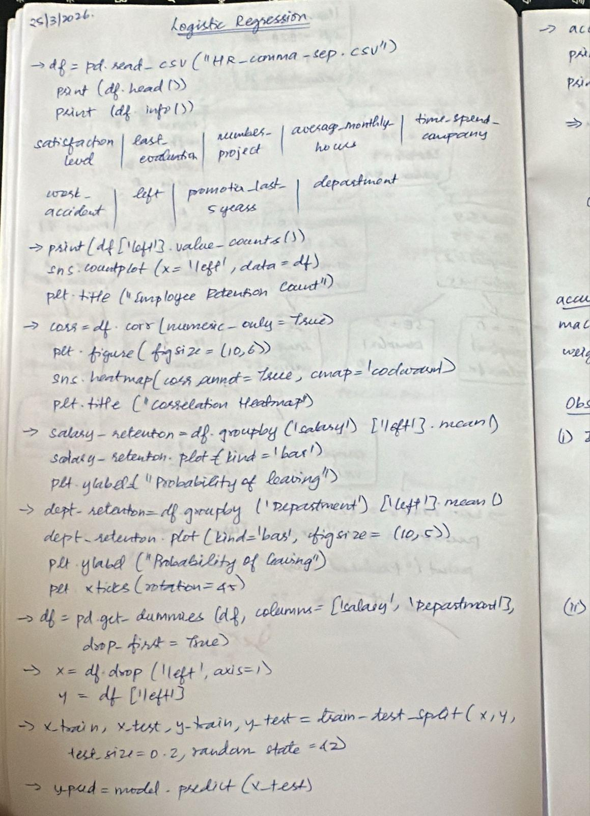
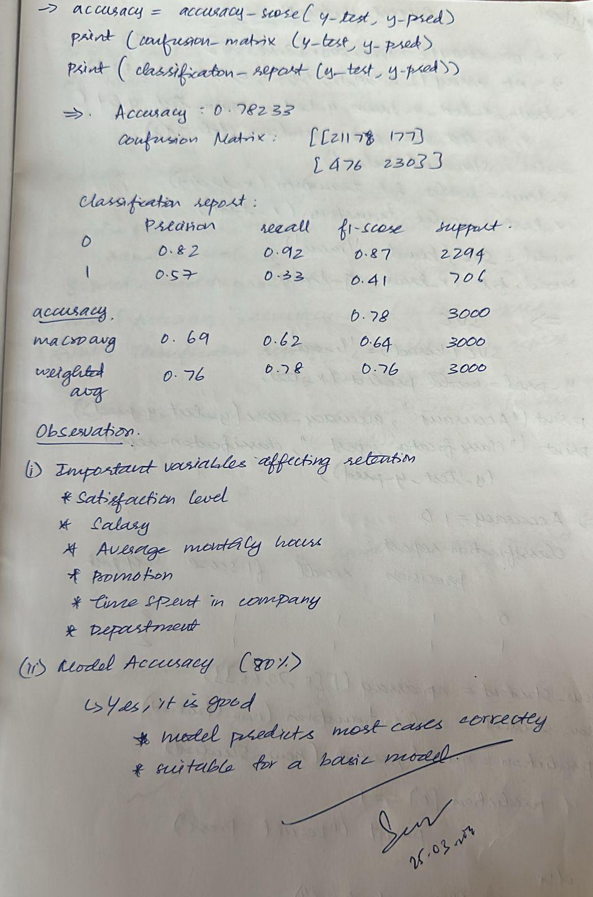

Code:
from google.colab import files
uploaded=files.upload()

import pandas as pd
import numpy as np
import matplotlib.pyplot as plt
import seaborn as sns

# Load dataset
df = pd.read_csv("HR_comma_sep.csv")

# Preview
print(df.head())
print(df.info())

print(df.describe())

print(df['left'].value_counts())
sns.countplot(x='left', data=df)
plt.title("Employee Retention Count (0 = Stayed, 1 = Left)")
plt.show()

corr = df.corr(numeric_only=True)
plt.figure(figsize=(10,6))
sns.heatmap(corr, annot=True, cmap='coolwarm')
plt.title("Correlation Heatmap")
plt.show()

salary_retention = df.groupby('salary')['left'].mean()

salary_retention.plot(kind='bar')
plt.title("Impact of Salary on Employee Retention")
plt.ylabel("Probability of Leaving")
plt.show()

dept_retention = df.groupby('Department')['left'].mean()

dept_retention.plot(kind='bar', figsize=(10,5))
plt.title("Department vs Employee Retention")
plt.ylabel("Probability of Leaving")
plt.xticks(rotation=45)
plt.show()

# One-hot encoding
df = pd.get_dummies(df, columns=['salary', 'Department'], drop_first=True)

X = df.drop('left', axis=1)
y = df['left']

from sklearn.model_selection import train_test_split

X_train, X_test, y_train, y_test = train_test_split(
X, y, test_size=0.2, random_state=42
)

from sklearn.linear_model import LogisticRegression

model = LogisticRegression(max_iter=1000)
model.fit(X_train, y_train)

y_pred = model.predict(X_test)

from sklearn.metrics import accuracy_score, confusion_matrix, classification_report

accuracy = accuracy_score(y_test, y_pred)
print("Accuracy:", accuracy)

print("\nConfusion Matrix:")
print(confusion_matrix(y_test, y_pred))

print("\nClassification Report:")
print(classification_report(y_test, y_pred))

Program 6
Build KNN Classification model for a given dataset.
Screenshot
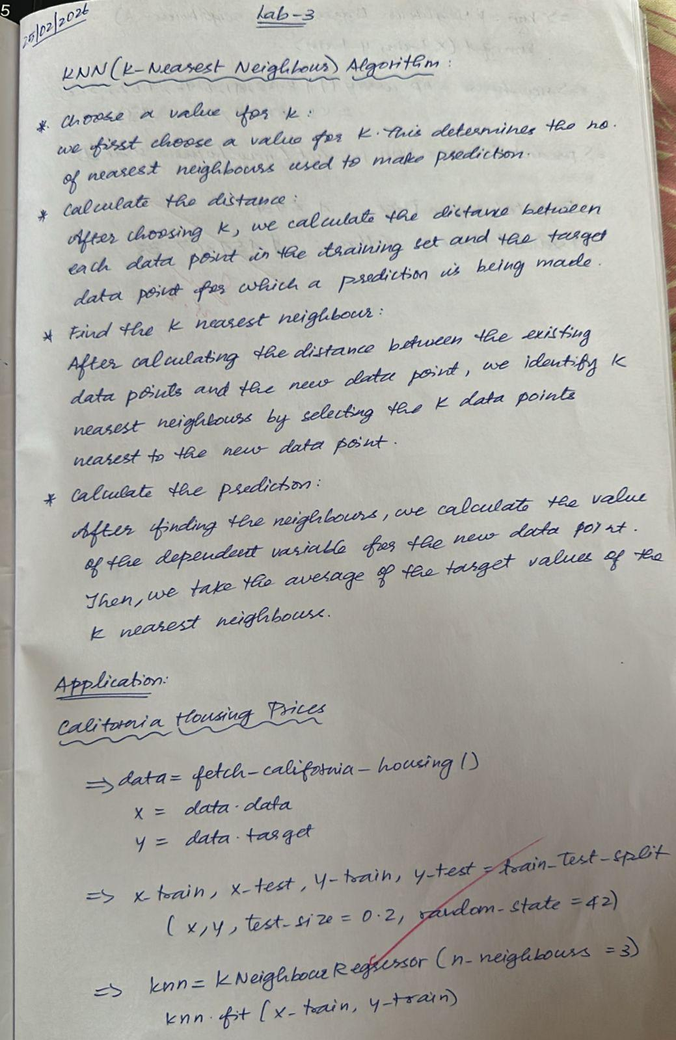

Code:
import numpy as np
from sklearn.datasets import fetch_california_housing
from sklearn.model_selection import train_test_split
from sklearn.preprocessing import StandardScaler
from sklearn.neighbors import KNeighborsRegressor

# Load dataset
data = fetch_california_housing()
X = data.data
y = data.target

# Train-test split
X_train, X_test, y_train, y_test = train_test_split(
X, y, test_size=0.2, random_state=42
)

# Standardization
scaler = StandardScaler()
X_train = scaler.fit_transform(X_train)
X_test = scaler.transform(X_test)

# Train KNN Regressor
knn = KNeighborsRegressor(n_neighbors=3)
knn.fit(X_train, y_train)

# New data prediction
new_house = np.array([[8.3252, 41, 6.984, 1.023,
322, 2.555, 37.88, -122.23]])

new_house_scaled = scaler.transform(new_house)

predicted_price = knn.predict(new_house_scaled)

print("Predicted House Price (in $100,000s):", predicted_price[0])
print("Predicted Price in Dollars: $", predicted_price[0] * 100000)

Program 7
Build Support vector machine model for a given dataset.
Screenshot
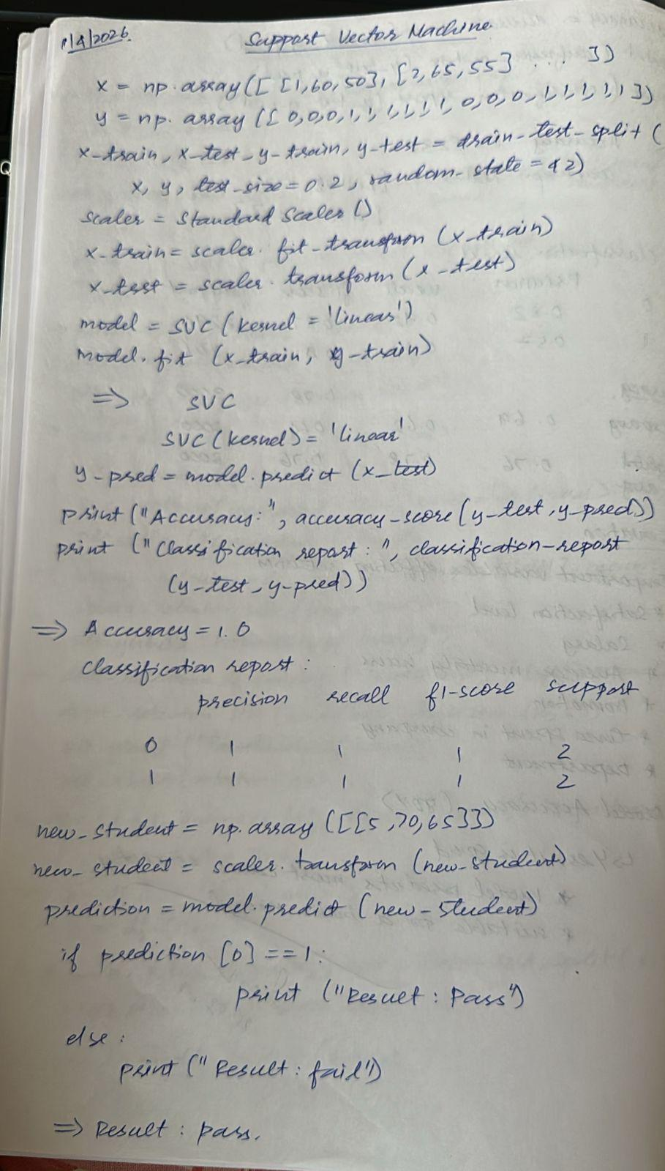

Code:
import numpy as np
from sklearn.model_selection import train_test_split
from sklearn.preprocessing import StandardScaler
from sklearn.svm import SVC
from sklearn.metrics import accuracy_score, classification_report

X = np.array([
[1, 60, 50],
[2, 65, 55],
[3, 70, 60],
[4, 75, 65],
[5, 80, 70],
[6, 85, 75],
[7, 90, 80],
[8, 95, 85],
[2, 50, 45],
[3, 55, 50],
[4, 60, 55],
[5, 65, 60],
[6, 70, 65],
[7, 75, 70],
[8, 80, 75],
[9, 85, 80]
])

y = np.array([
0,0,0,1,1,1,1,1,
0,0,0,1,1,1,1,1
])

X_train, X_test, y_train, y_test = train_test_split(
X, y, test_size=0.2, random_state=42
)

scaler = StandardScaler()
X_train = scaler.fit_transform(X_train)
X_test = scaler.transform(X_test)

model = SVC(kernel='linear') # try 'rbf' also
model.fit(X_train, y_train)

y_pred = model.predict(X_test)

print("Accuracy:", accuracy_score(y_test, y_pred))
print("\nClassification Report:\n", classification_report(y_test, y_pred))

new_student = np.array([[5, 70, 65]]) # example input
new_student = scaler.transform(new_student)

prediction = model.predict(new_student)

if prediction[0] == 1:
print("\nResult: Pass")
else:
print("\nResult: Fail")

Program 8
Implement Random forest ensemble method on a given dataset.
Screenshot
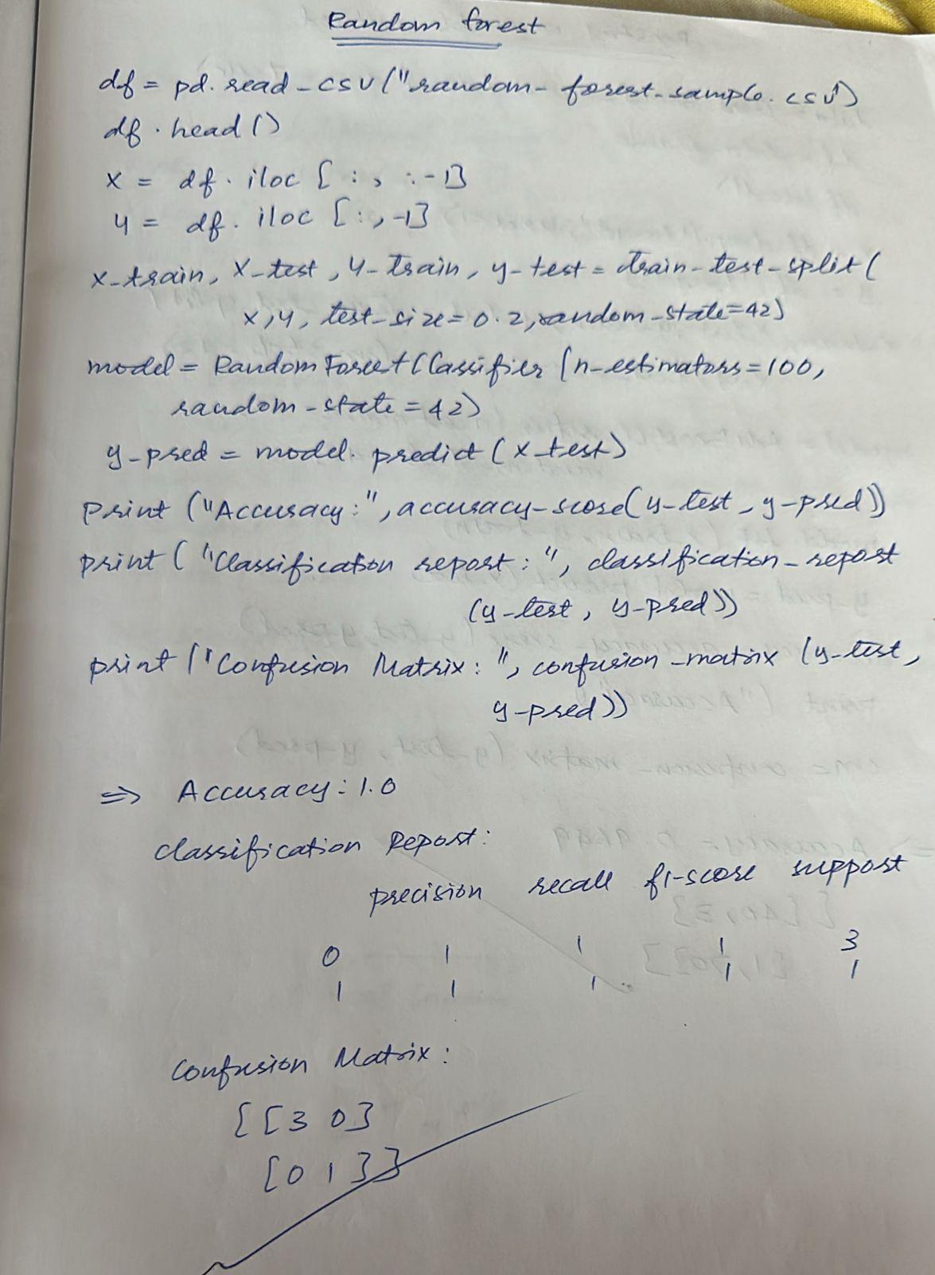

Code:
import numpy as np
import pandas as pd

from sklearn.model_selection import train_test_split
from sklearn.ensemble import RandomForestClassifier
from sklearn.metrics import accuracy_score, classification_report, confusion_matrix

# Load Iris dataset (optional reference)
from sklearn.datasets import load_iris
data = load_iris()
X = data.data
y = data.target

print("Feature shape:", X.shape)
print("Target shape:", y.shape)

# Create sample dataset
data = {
"feature1": [5.1,4.9,4.7,4.6,5.0,5.4,6.4,6.9,5.5,6.5,5.7,6.3,6.5,7.6,4.9,7.3,6.7,7.2],
"feature2": [3.5,3.0,3.2,3.1,3.6,3.9,3.2,3.1,2.3,2.8,2.8,3.3,3.0,3.0,2.5,2.9,2.5,3.6],
"feature3": [1.4,1.4,1.3,1.5,1.4,1.7,4.5,4.9,4.0,4.6,4.5,4.7,5.8,6.6,4.5,6.3,5.8,6.1],
"feature4": [0.2,0.2,0.2,0.2,0.2,0.4,1.5,1.5,1.3,1.5,1.3,1.6,2.2,2.1,1.7,1.8,1.8,2.5],
"target": [0,0,0,0,0,0,1,1,1,1,1,1,2,2,2,2,2,2]
}

df = pd.DataFrame(data)

# Save CSV
file_name = "random_forest_sample.csv"
df.to_csv(file_name, index=False)

# (Colab) Download file
from google.colab import files
files.download(file_name)

# (Colab) Upload file
uploaded = files.upload()

# Load dataset
df = pd.read_csv("random_forest_sample.csv")

print(df.head())
print(df.info())

# Split features and target
X = df.iloc[:, :-1]
y = df.iloc[:, -1]

# Train-test split
X_train, X_test, y_train, y_test = train_test_split(
X, y, test_size=0.2, random_state=42
)

# Train Random Forest model
model = RandomForestClassifier(n_estimators=100, random_state=42)
model.fit(X_train, y_train)

# Predictions
y_pred = model.predict(X_test)

# Evaluation
print("Accuracy:", accuracy_score(y_test, y_pred))
print("\nClassification Report:\n", classification_report(y_test, y_pred))
print("\nConfusion Matrix:\n", confusion_matrix(y_test, y_pred))

Program 9
Implement Boosting ensemble method on a given dataset.
Screenshot
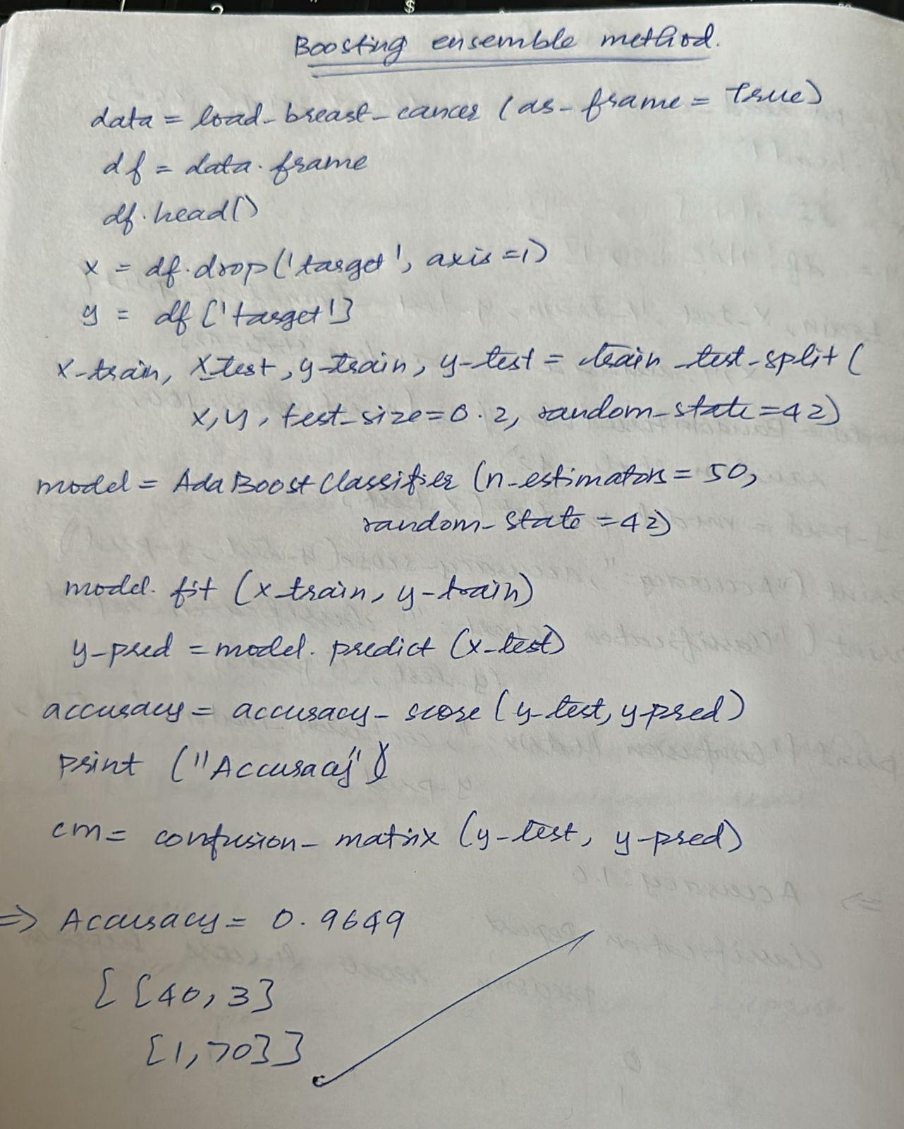

Code:
import pandas as pd
import numpy as np

from sklearn.datasets import load_breast_cancer
from sklearn.model_selection import train_test_split
from sklearn.ensemble import AdaBoostClassifier
from sklearn.metrics import accuracy_score, confusion_matrix

import seaborn as sns
import matplotlib.pyplot as plt

# Load dataset
data = load_breast_cancer(as_frame=True)
df = data.frame

# Features and target
X = df.drop('target', axis=1)
y = df['target']

# Train-test split
X_train, X_test, y_train, y_test = train_test_split(
X, y, test_size=0.2, random_state=42
)

# Train AdaBoost model
model = AdaBoostClassifier(n_estimators=50, random_state=42)
model.fit(X_train, y_train)

# Predictions
y_pred = model.predict(X_test)

# Accuracy
accuracy = accuracy_score(y_test, y_pred)
print("Accuracy:", accuracy)

# Confusion Matrix
cm = confusion_matrix(y_test, y_pred)

plt.figure(figsize=(6, 4))
sns.heatmap(cm, annot=True, fmt='d', cmap='Blues')

plt.xlabel("Predicted")
plt.ylabel("Actual")
plt.title("Confusion Matrix")

plt.show()

Program 10
Build k-Means algorithm to cluster a set of data stored in a .CSV file.
Screenshot
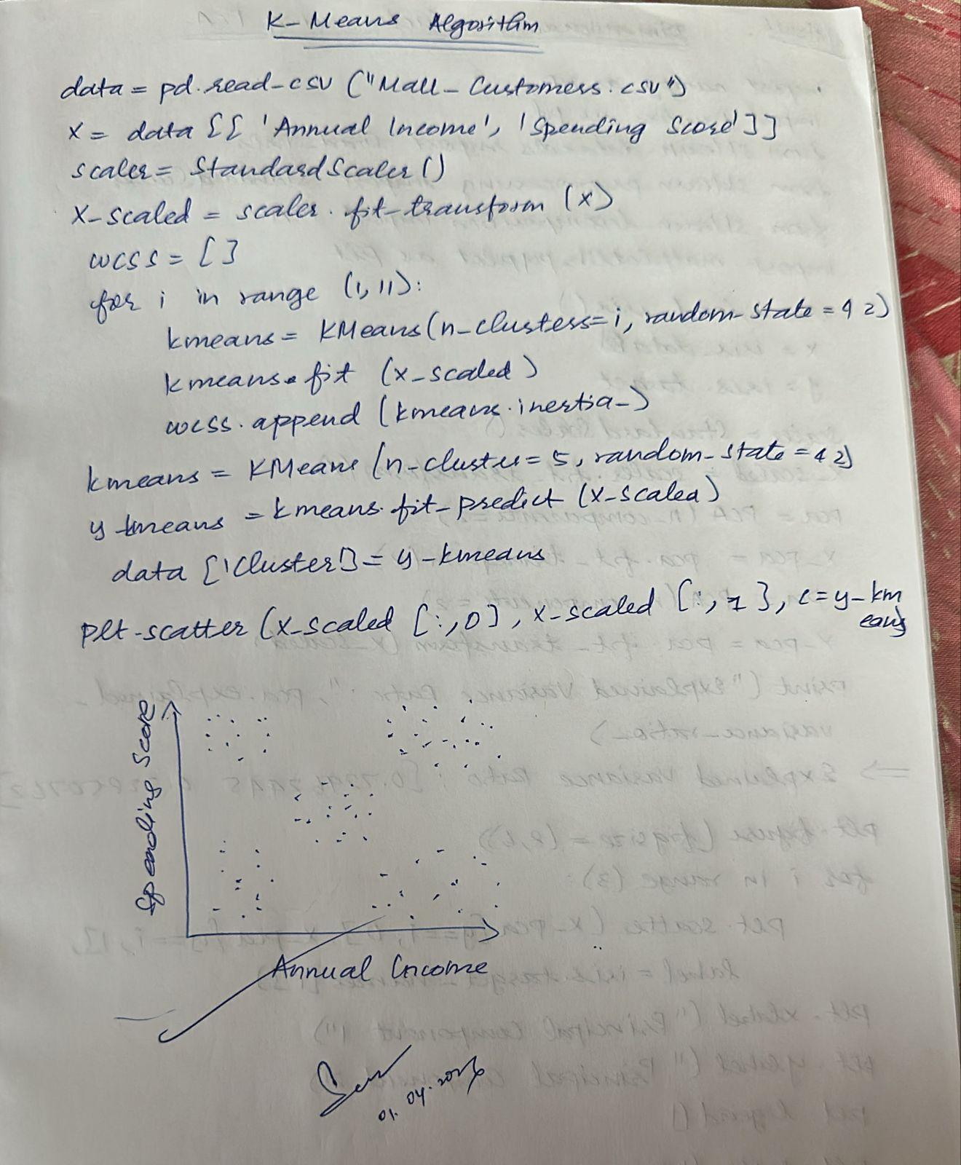

Code:
from google.colab import files
uploaded = files.upload()

import pandas as pd
import matplotlib.pyplot as plt
from sklearn.cluster import KMeans
from sklearn.preprocessing import StandardScaler

# Load dataset
data = pd.read_csv("Mall_Customers.csv")
print(data.head())

# Select features
X = data[['Annual Income (k$)', 'Spending Score (1-100)']]

# Standardize features
scaler = StandardScaler()
X_scaled = scaler.fit_transform(X)

# Elbow method (WCSS)
wcss = []
for i in range(1, 11):
kmeans = KMeans(n_clusters=i, random_state=42)
kmeans.fit(X_scaled)
wcss.append(kmeans.inertia_)

# Plot Elbow Graph
plt.plot(range(1, 11), wcss, marker='o')
plt.title("Elbow Method")
plt.xlabel("Number of Clusters")
plt.ylabel("WCSS")
plt.show()

# Apply KMeans (k=5)
kmeans = KMeans(n_clusters=5, random_state=42)
y_kmeans = kmeans.fit_predict(X_scaled)

# Add cluster labels
data['Cluster'] = y_kmeans
print(data.head())

# Plot clusters
plt.scatter(X_scaled[:, 0], X_scaled[:, 1], c=y_kmeans, cmap='rainbow')
plt.title("Customer Segments")
plt.xlabel("Annual Income (scaled)")
plt.ylabel("Spending Score (scaled)")
plt.show()

Program 11
Implement Dimensionality reduction using the Principle Component Analysis (PCA) method.
Screenshot
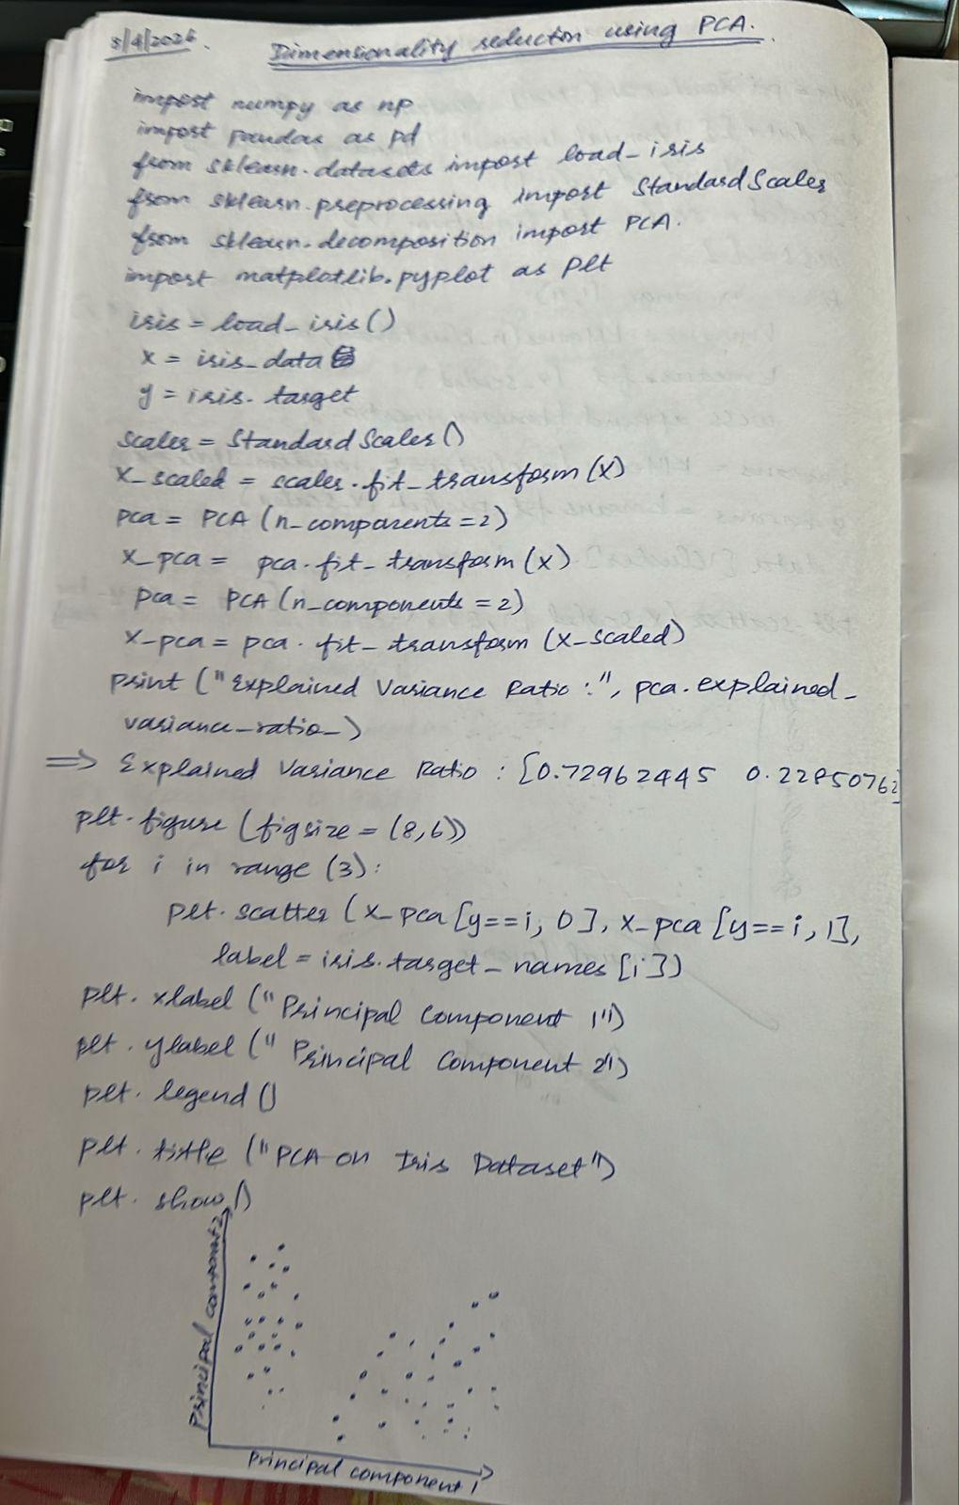

Code:
import numpy as np
import pandas as pd
from sklearn.datasets import load_iris
from sklearn.preprocessing import StandardScaler
from sklearn.decomposition import PCA
import matplotlib.pyplot as plt
iris = load_iris()
X = iris.data
y = iris.target
# Standardize features
scaler = StandardScaler()
X_scaled = scaler.fit_transform(X)
# Apply PCA (2 components)
pca = PCA(n_components=2)
X_pca = pca.fit_transform(X_scaled)
# Explained variance
print("Explained Variance Ratio:", pca.explained_variance_ratio_)
print("Total Variance Retained:", sum(pca.explained_variance_ratio_))

# PCA components (feature contributions)
print("PCA Components:\n", pca.components_)

# Plot
plt.figure(figsize=(8, 6))
for i in range(3):
plt.scatter(X_pca[y == i, 0], X_pca[y == i, 1], label=iris.target_names[i])

plt.xlabel("Principal Component 1")
plt.ylabel("Principal Component 2")
plt.legend()
plt.title("PCA on Iris Dataset")
plt.show()

