**CN LAB-11**

Disha Jain – 220905554 – B2

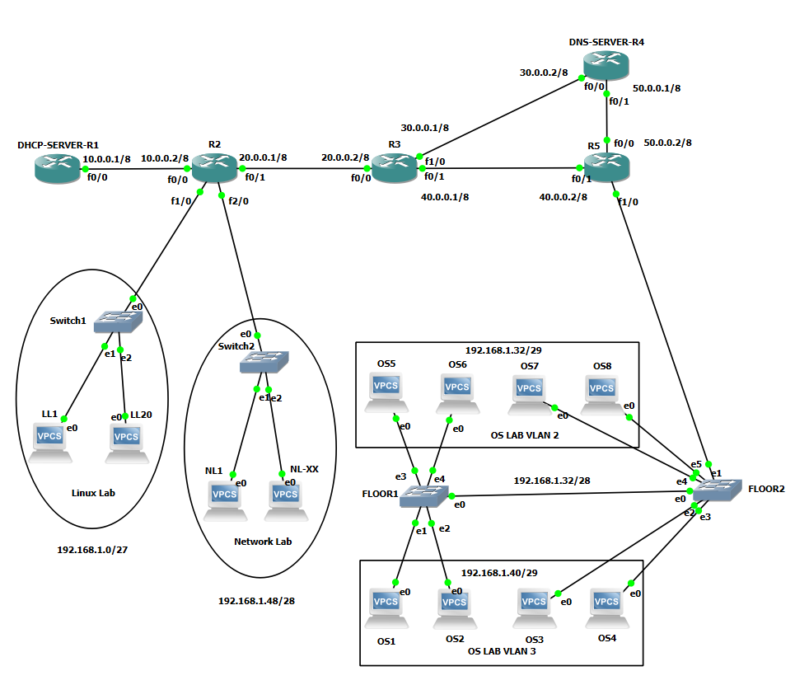

1)Configure each of the router interfaces

2)Configure VLAN

* LL1 – 192.168.1.1/27
* NL1 – 192.168.1.49/28
* **OS LAB VLAN3**

Network address - 192.168.1.32/29

Default gateway - 192.168.1.38/29

Broadcast address – 192.168.1.39/29

OS1 – 192.168.1.34/29

* **OS LAB VLAN2**

Network address - 192.168.1.40/29

Default gateway - 192.168.1.46/29

Broadcast address – 192.168.1.47/29

OS5 – 192.168.1.41/29

* **Floor 1**

* **Floor 2**

* **Configuring R5 interface as trunk port**

* **Configure the servers OS1,OS5,LL1,NL1**

3)Configure DNS

4)Configure routing (dynamic and static)

Note: If network has cycle of routers, don’t just rely on rip. Along with it had to add ip route commands wherever necessary.

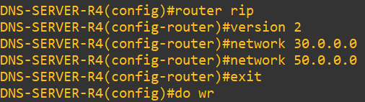

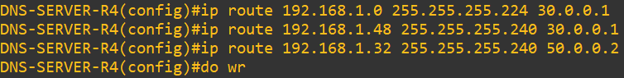

5)Test DNS by pinging

6)Configure DHCP

7)Configure relay agents

8)Final test of DHCP and DNS

