CN LAB-8
Disha Jain – 220905554 – B2

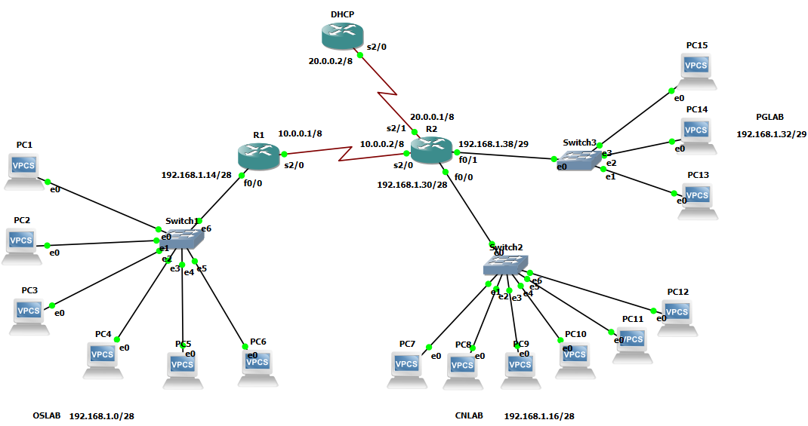

- OSLAB - 192.168.1.0/28 to 192.168.1.15/28 (13 PCs limit)
      - Network address - 192.168.1.0/28
      - Gateway address - 192.168.1.14/28
      - Broadcast address - 192.168.1.15/28

- CNLAB – 192.168.1.16/28 to 192.168.1.31/28 (13 PCs limit)
      - Network address - 192.168.1.16/28
      - Gateway address - 192.168.1.30/28
      - Broadcast address - 192.168.1.31/28

- PGLAB – 192.168.1.32/29 to 192.168.1.39/29 (5 PCs limit)
      - Network address - 192.168.1.32/29
      - Gateway address - 192.168.1.38/29
      - Broadcast address - 192.168.1.39/29

1)Set all interfaces as mentioned and then give the following routing commands

Note: Default next hop is 20.0.0.1 for DHCP router

2)Configure separate DHCP pools for each of the subnets

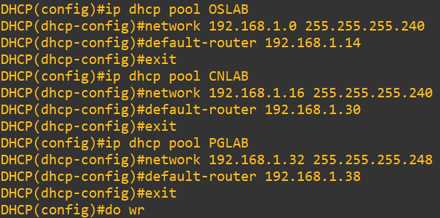
3)Set the appropriate relay agents for each interface

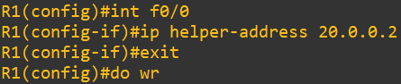

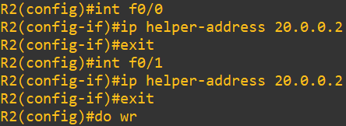

4)Testing DHCP

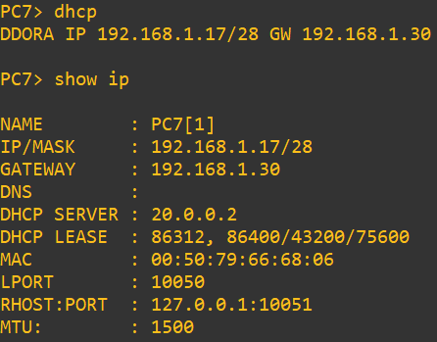

5)Capturing DHCP request from PC2 to DHCP. (link b/w R2 and DHCP is being observed)

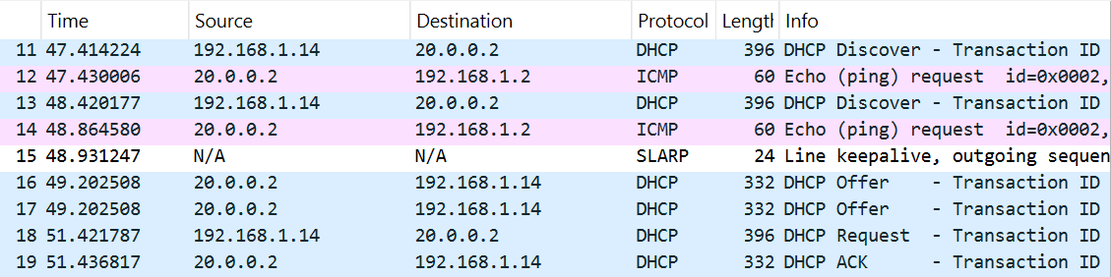

6)Testing Connectivity between subnets

