CN LAB-1
Disha Jain – 220905554 – B2

GNS3
- Open terminal
- $ python -m venv gns3env
- $ source gns3env/bin/activate
- $ pip install pyqt5
- $ pip install gns3 - server
- $ pip install gns3 – gui
- $ gns3
Note: in subsequent labs only step 1,3 and 7 are required
Find the devices shown below from the left-hand side menu and create this network :
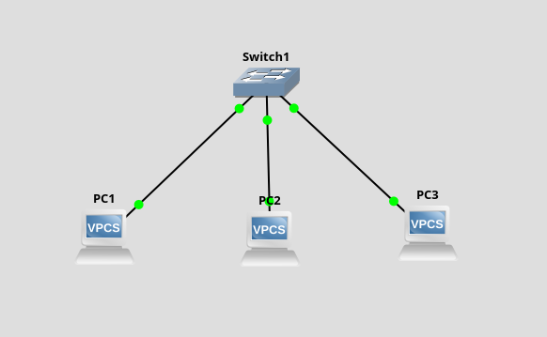


Click on and start all devices
Setting ip address and mask value of PC :
- Right click on PC1 -> Console
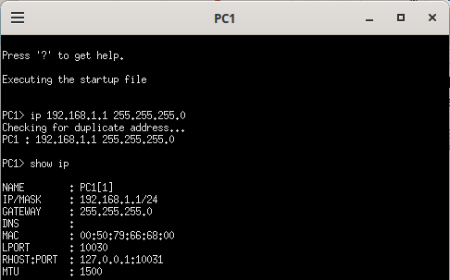

- Similarly set up the rest of the Pcs.
- show ip command shows us all the details.

The ping command :
- Syntax: ping [ip address to ping] (by default 5 packets sent)
When you want to specify number of packets :
- Syntax: ping [ip address to ping] -c [no. of packets]
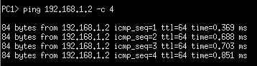

The save command :
- Used to save the PC configurations so that we don’t have to re-enter next time
Wireshark:
- Used to visualise ping packets and do network monitoring
- Right click on any connecting medium -> Start Capture
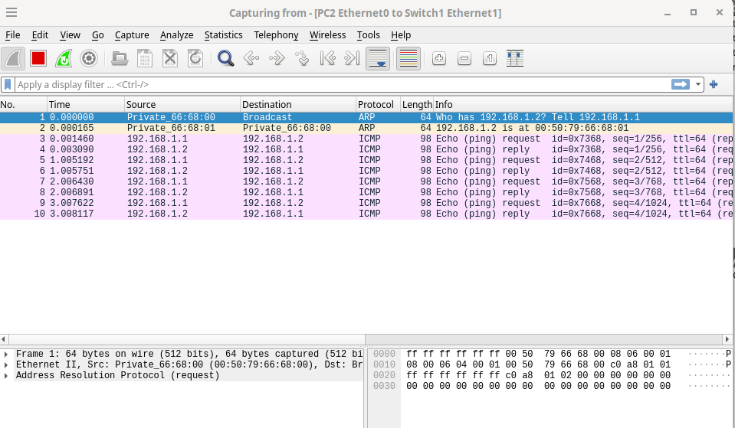
- Observing wireshark for the same ping command as above

ARP – Address Resolution Protocol
ICMP – Internet Control Message Protocol

CISCO PACKET TRACER

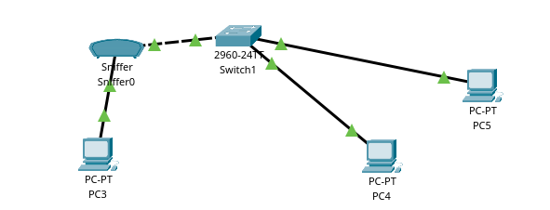
- Create a network as show below using tools available on bottom left corner

- Sniffer here does the same job as Wireshark.

Setting ip address and mask value of PC :
- Click on PC -> Desktop -> IP Configuration
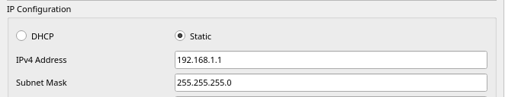
The ping command :

- Click on PC -> Desktop -> Command Prompt
- Syntax: ping [ip address to ping]
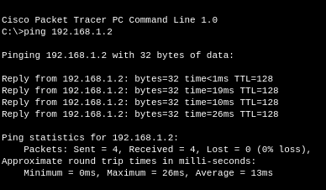

To Connect Sniffer:
- Click on Sniffer -> GUI
- Observing the above ping
