CN LAB-2
Disha Jain – 220905554 – B2

GNS3

How to install a Router ?

- Click on edit -> preferences -> Dynamips -> IOS Routers
- New -> Browse -> Downloads -> C3745 -> open -> (Decompress) yes
- Click Next until you reach Network adapters window
- Slot 1 -> NM-1FE-TX
- Click next until you reach Idle-PC
- Idle PC Finder -> wait until a value found -> OK -> Finish
- Apply -> OK
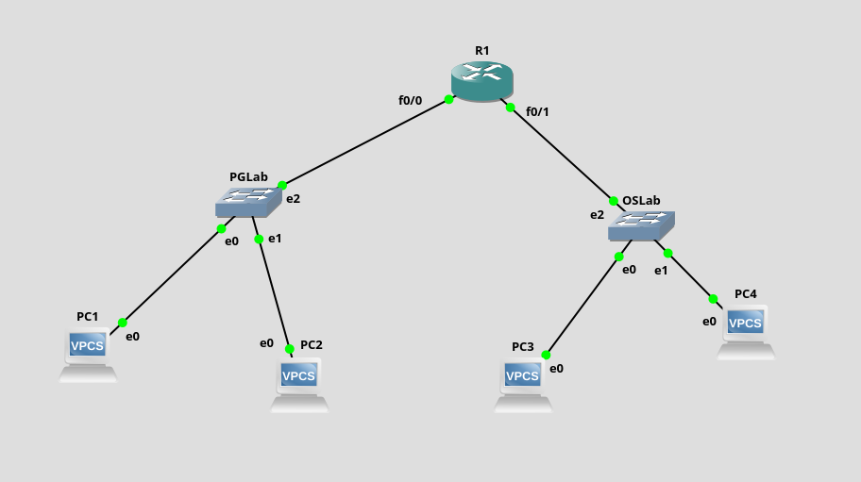
Configuration of PC
Apart from Ip address and Mask we also have default gateway
- Syntax : ip [ip address] [mask] [default gateway]
We can also set Dns value (in lab we gave the PC’s ip address itself)
- Syntax : ip dns [ip address]

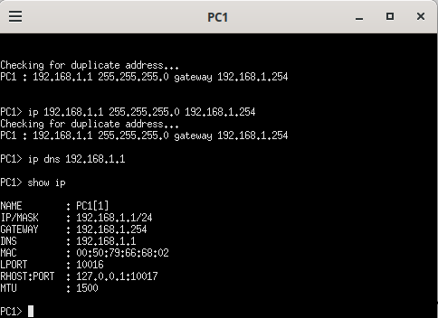

Similarly set up the rest of the Pcs.

Configuration of Router :
- Right Click on Router -> Console
- config t
- int f0/0, to configure the first interface
- ip address 192.168.1.254 255.255.255.0, here the first ip address is the same we gave to PC as gateway
- no shut , makes sure the values stay permanent
- end
To save all the configurations :
- config t
- do wr
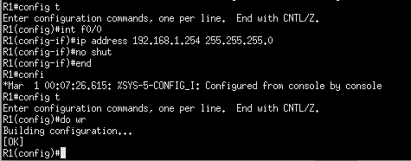

You may ping across Pcs now.

Cisco Packet Tracer

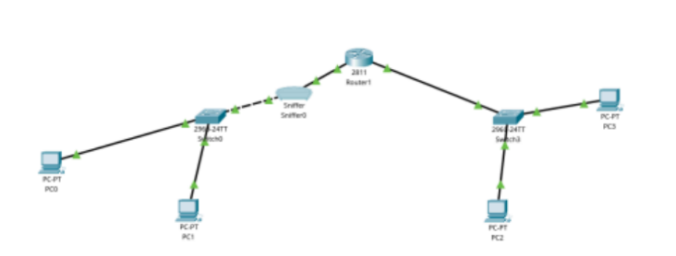

1. To configure the router, click on it and go to desktop.
2. Fill in the details of all the interfaces in the respective FastEthernet component

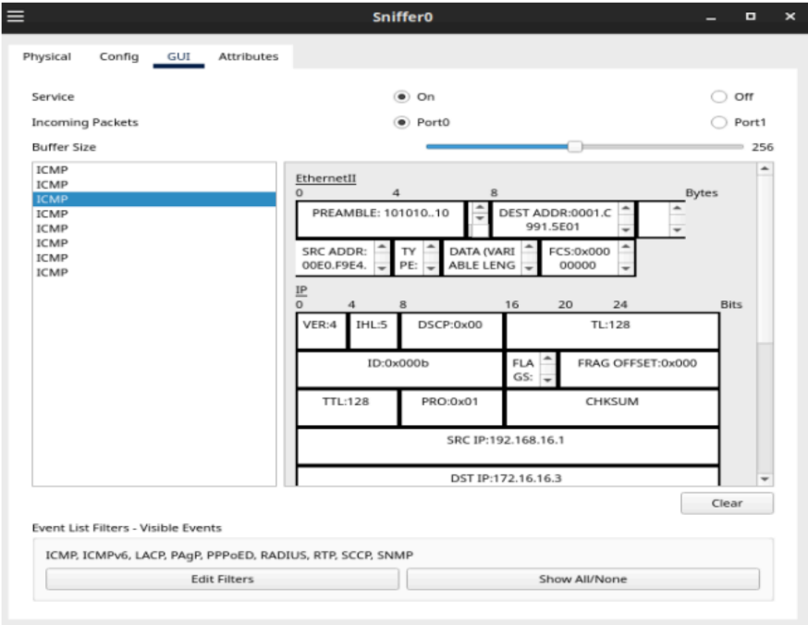

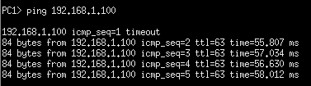
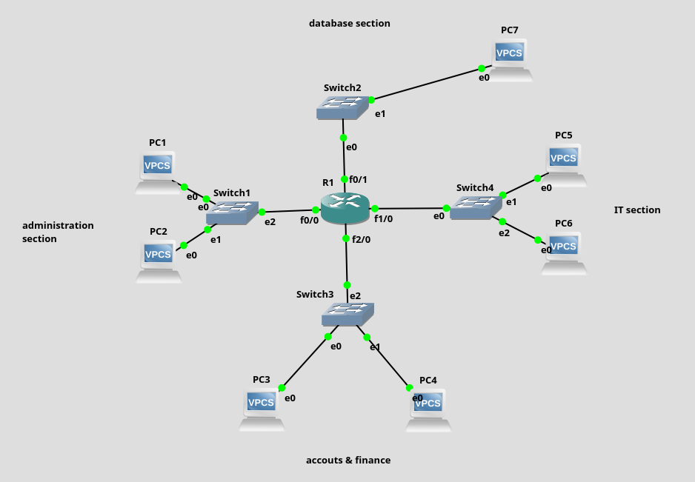
Q2)

GNS3

To increase the number of slots in router:
Right click router > configure > slots > pick an empty slot > NM-1 FE-TX

Ping PC1 to PC7

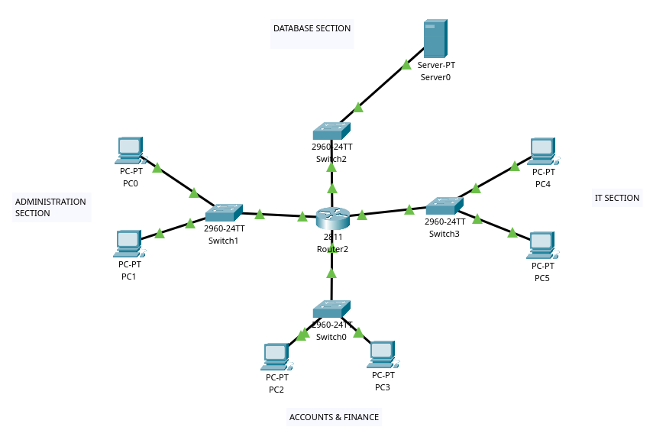
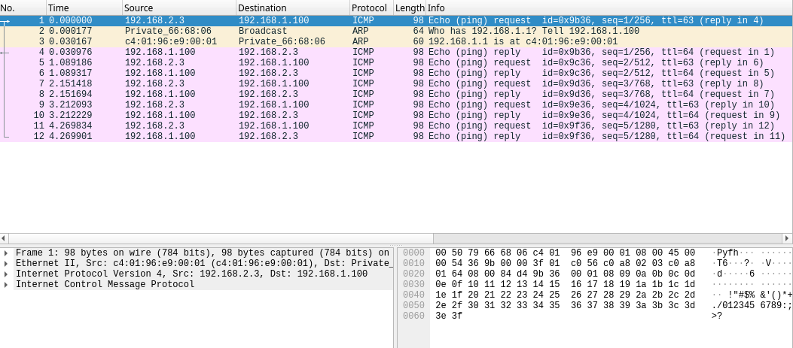
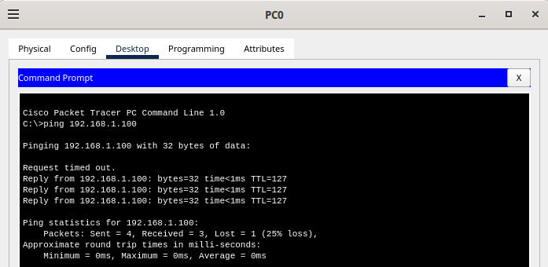
WireShark:

Cisco Packet Tracer

