CN LAB-3
Disha Jain – 220905554 – B2

GNS3
Configuring a router as a web server

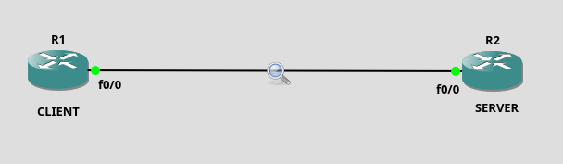

At SERVER end: (using router c3600)
- config t
- ip http server
- ip http path flash: # flash is a directory in server to place files
- ip http max-connections 5
- ip http port 5001
- ip http access-class 1
- access-list 1 permit 192.168.12.0 0.0.0.255
#network address (>1024) and wildcard of mask i.e anyone with mask 255.255.255.0 can access
- username student privilege 15 password student

- ip http authentication local
- do copy running-config flash:startup-config #content of $show running-config copied into flash
- end

- dir flash: #to verify contents
- config t
- int f0/0
- ip address 192.168.12.2 255.255.255.0
- no shut
- do wr
- end

At CLIENT end:
- Config t
- int f0/0
- ip address 192.168.12.1 255.255.255.0
- no shut
- end
- config t
- ip http client username student
- ip http client password student
- do wr
- end
- copy http://192.168.12.2:5001/startup-config null: #asking server for file corresponding to URL

#Note: We can also use a Virtual Machine

Wireshark
- 3 TCP packets to establish connection
- 1 HTTP packet asking for data
- 1 TCP packet containing actual data
- 1 HTTP packet saying transmission done
- 3 TCP packets to terminate connection
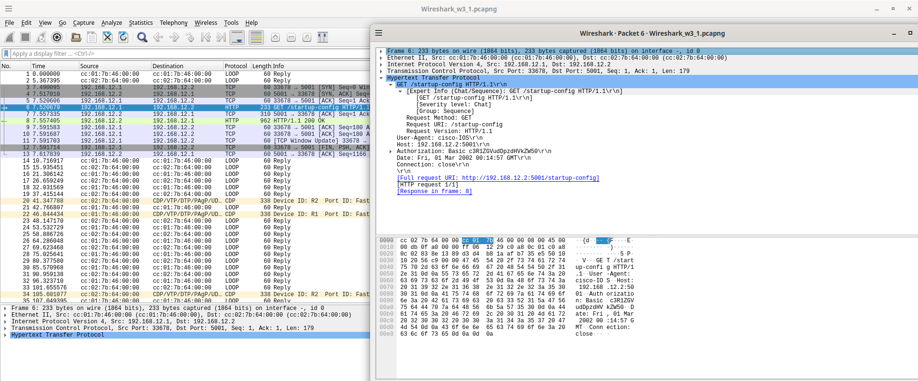

Q1) Using Cisco Packet Tracer

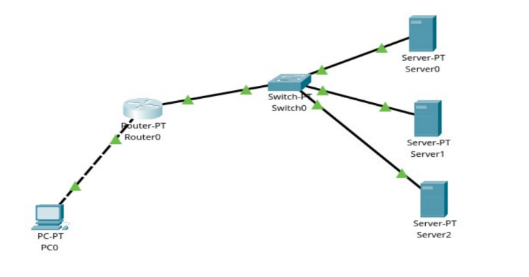

PC Configuration:

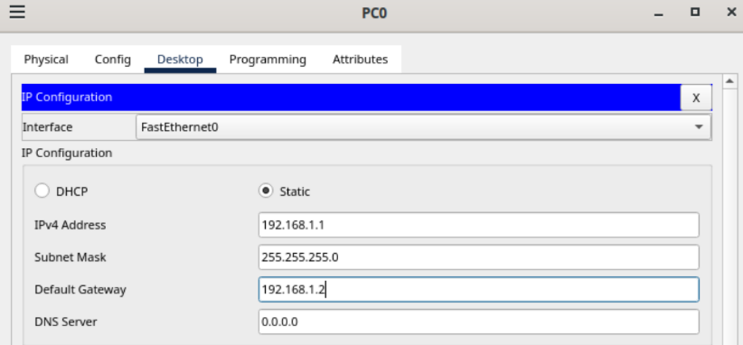

HTTP Server Configuration:

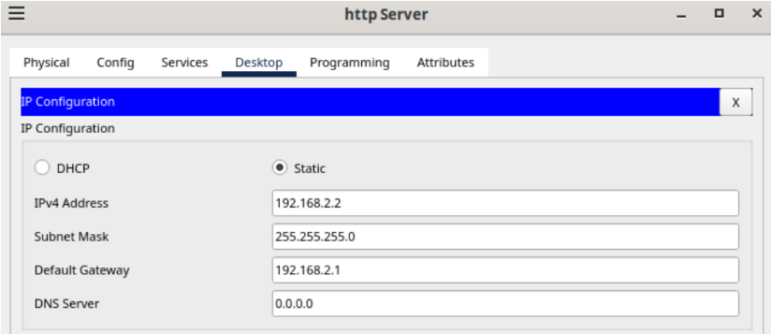

Similarly, configure the other 3 server.

Router Configuration done in CLI:

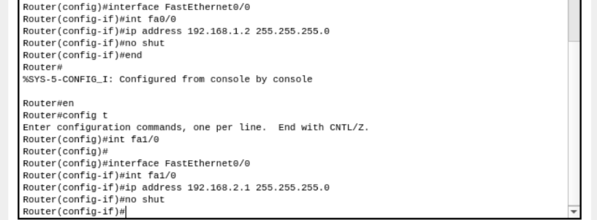

Pinging from HTTP Server to PC:

