CN LAB-9
Disha Jain – 220905554 – B2

Q1)
i)GNS3

1)Network Design
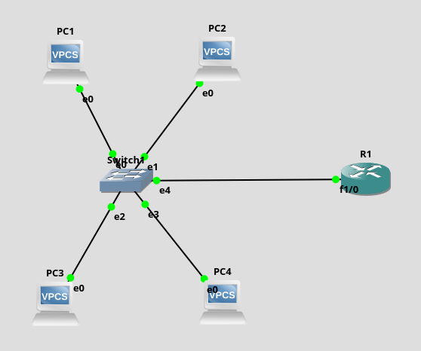

2)Configuring the ports of the Switch with respect to different VLANs. (Trunk port – dot1q, always has default VLAN, here 1)

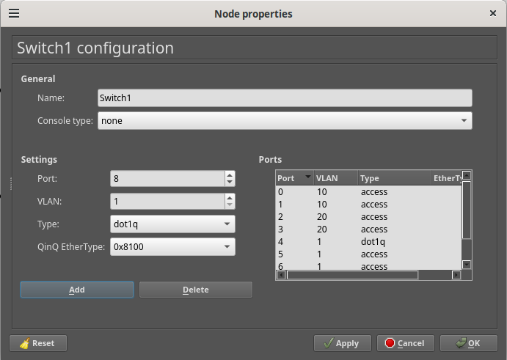

3)Configuring the router to communicate between VLANs. One interface can be configured into multiple interfaces for different VLANs

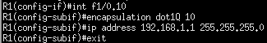

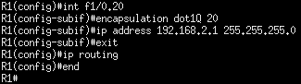

4)Observing router interface f1/0 in wireshark, you can see the VLAN ID attached to each packet.
Ping from PC1 to PC4
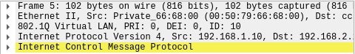

ii)Cisco Packet Tracer

- Network Design in Cisco

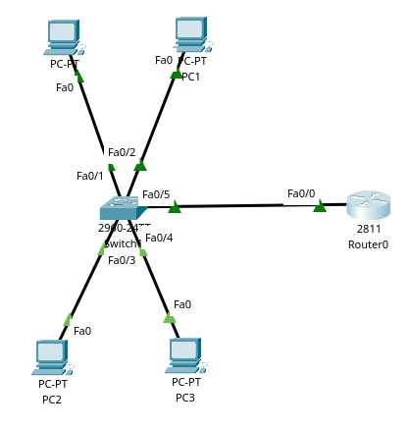

2)Configuring different VLANs and specifying which switchport ( or range of ports) belong to each
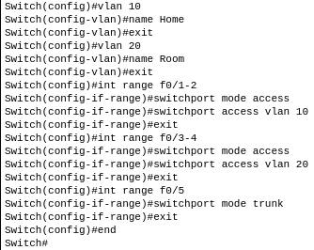

3)Configuring Router interface as trunk port

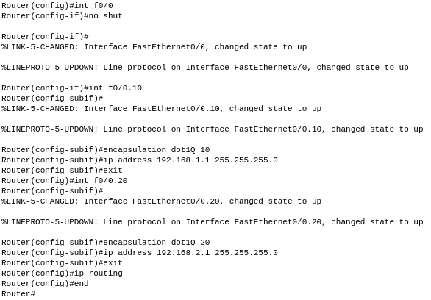

Additional
i)GNS3
Vlan 1 - default
Vlan 2 - HR
Vlan 3 - Admin
Vlan 4 - Actt
Vlan 5 - Staff
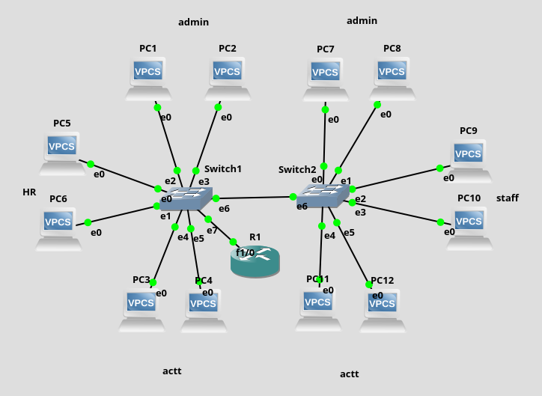

1)Switch 0
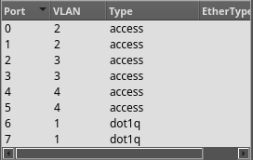

2)Switch 1
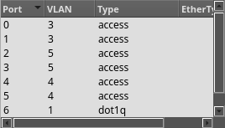

3)Router
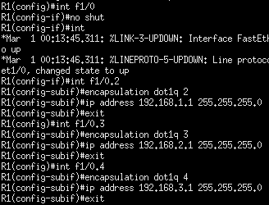

ii)Cisco Packet Tracer

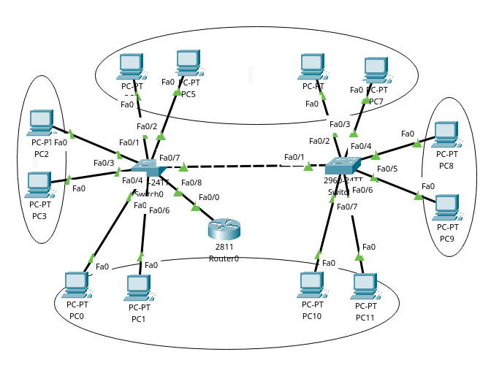

1)Switch 0
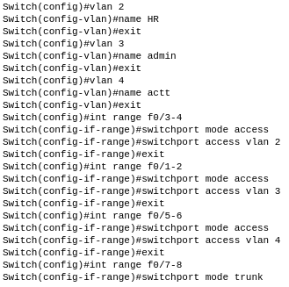

2)Switch 1

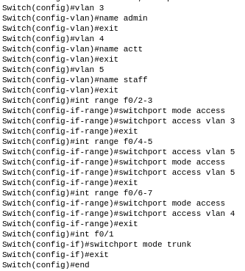

3)Router (does not allow staff to communicate with others)
