CN LAB-4
Disha Jain – 220905554 – B2

Static routing syntax (only at Router):
config t
ip route <network address> <subnet mask> <next hop address>

Example:

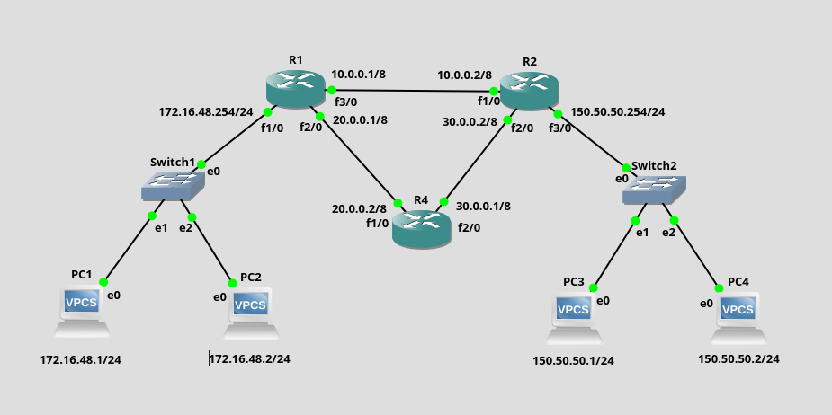

Setup all IP addresses, gateways and router interfaces
To ping from 172.16.48.0/24 network to 150.50.50.0/24 network such that path is Switch1 -> R1 -> R2 -> Switch2

Static routing at R1:
Static routing at R2:

Pinging PC1 to PC4 to check:
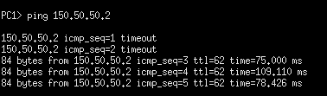

Q1) mistake in manual diagram in second default gateway it should be 192.168.2.1

GNS3

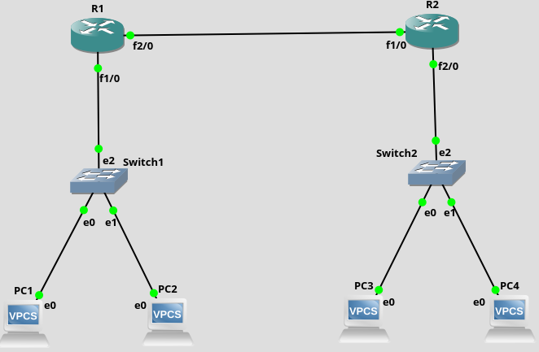

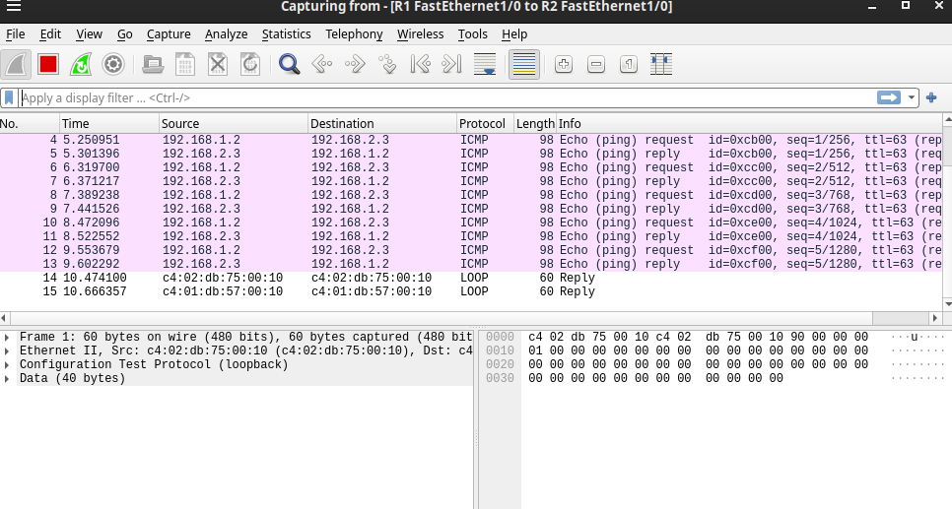

Cisco Packet Tracer

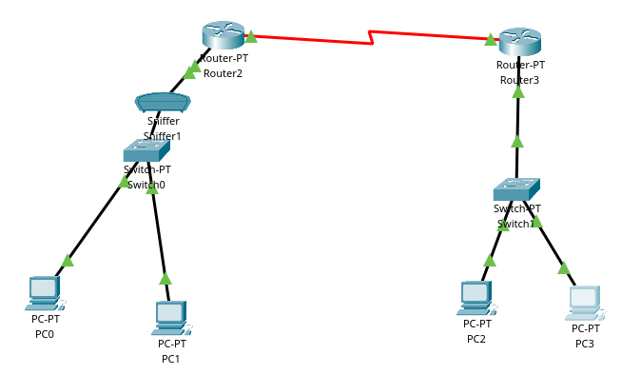

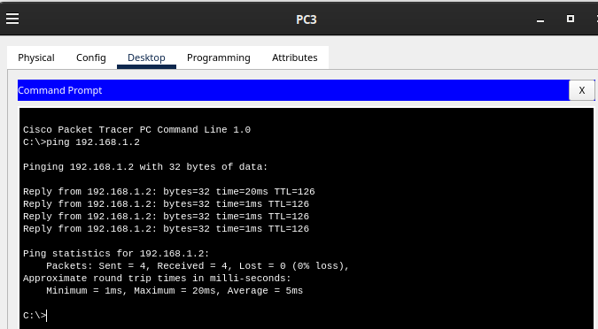

Answers to the manual questions:
a) yes
b) yes
c) no because no routing done

Q2)
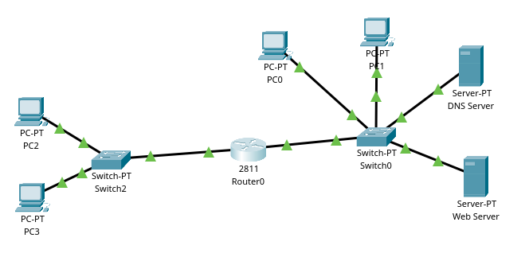

DNS Server Configuration:
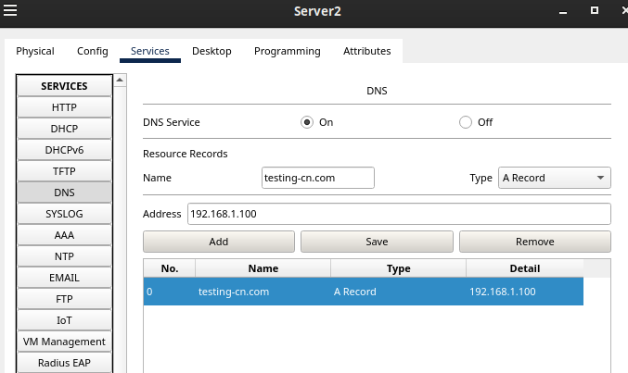

Configure HTTP Server as seen in Lab3.

Accessing HTML Page via Domain Name:
