CN LAB-5
Disha Jain – 220905554 – B2

- Use scanf, printf instead of gets and puts
- Use ctrl+c (terminates) not ctrl+z (stops)

TCPServer

#include<stdio.h>
#include<string.h>
#include<sys/types.h>
#include<sys/socket.h>
#include<netinet/in.h>
#include<unistd.h>
#include<arpa/inet.h>
#define PORTNO 10205
int main()
{
int sockfd,newsockfd,portno,clilen,n=1;
struct sockaddr_in seraddr,cliaddr;
int i,value;
// create an unnamed socket for the server
sockfd = socket(AF_INET,SOCK_STREAM,0);
//Name the socket
seraddr.sin_family = AF_INET;
seraddr.sin_addr.s_addr = inet_addr("172.16.48.122");
seraddr.sin_port = htons(PORTNO);
bind(sockfd,(struct sockaddr *)&seraddr,sizeof(seraddr));
//Create a connection queue and wait for clients
listen(sockfd,5);
while (1) {
char buf[256];
printf("server waiting\n");
//Accept a connection
clilen = sizeof(clilen);
newsockfd=accept(sockfd,(struct sockaddr *)&cliaddr,&clilen);
//Read and write to client on client_sockfd (Logic for problem mentioned here)
n = read(newsockfd,buf,sizeof(buf));
buf[n]='\0';
printf("\nMessage from Client %s \n",buf);
n = write(newsockfd,buf,n);
}
}

TCPClient

#include<sys/types.h>
#include<sys/socket.h>
#include<stdio.h>
#include<netinet/in.h>
#include<arpa/inet.h>
#include<stdlib.h>
#include<unistd.h>
#include<string.h>
int main()
{
int len,result,sockfd,n=1;
struct sockaddr_in address;
char ch[256],buf[256];
//Create a socket for the client
sockfd = socket(AF_INET, SOCK_STREAM, 0);
//Name the socket as agreed with the server
address.sin_family=AF_INET;
address.sin_addr.s_addr=inet_addr("172.16.48.122");
address.sin_port=htons(10205);
len = sizeof(address);
//Connect your socket to the server’s socket
result=connect(sockfd,(struct sockaddr *)&address,len);
if(result==-1)
{
perror("\nCLIENT ERROR");
exit(1);
}
//You can now read and write via sockfd (Logic for problem mentioned here)
printf("\nENTER STRING\t");
scanf("%[^\n]s",ch);
write(sockfd,ch,strlen(ch));
printf("STRING SENT BACK FROM SERVER IS ..... ");
//while(n){
n=read(sockfd,buf,sizeof(buf));
printf("%s\n",buf);
//} //lab manual has this loop but then you have to do forceful termination, my code works fine without the loop as well
return 0;
}

- Open separate terminals for Client and Server, make sure server is running before Client begins

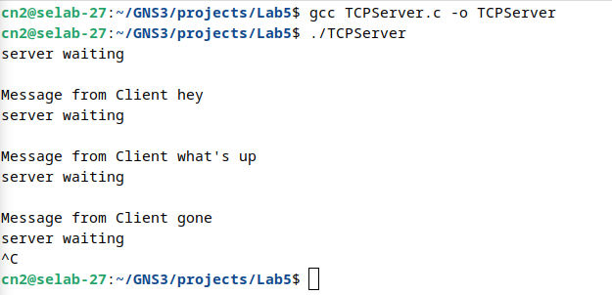
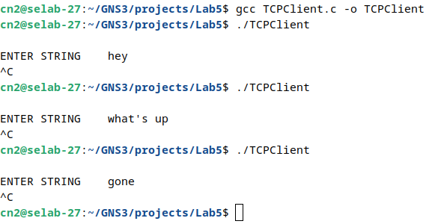

- To have Server and Client in different PCs, IP address in inet_addr() should be of the Server PC in both programs.
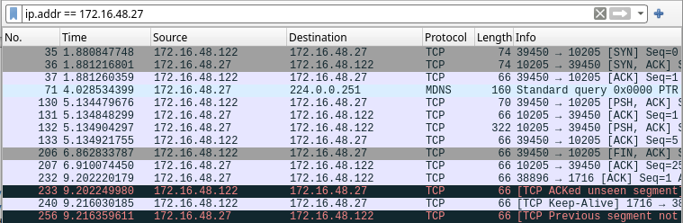

Server IP – 172.16.48.27
Client IP – 172.16.48.122

UDPServer

#include<stdio.h>
#include<fcntl.h>
#include<stdlib.h>
#include<sys/socket.h>
#include<sys/types.h>
#include<netinet/in.h>
#include<arpa/inet.h>
#include<unistd.h>
int main()
{
int sd;
char buf[25];
struct sockaddr_in sadd,cadd;
//Create a UDP socket
sd=socket(AF_INET,SOCK_DGRAM,0);
//Construct the address for use with sendto/recvfrom...
sadd.sin_family=AF_INET;
sadd.sin_addr.s_addr=inet_addr("172.16.48.122");//
sadd.sin_port=htons(9704);
int result=bind(sd,(struct sockaddr *)&sadd,sizeof(sadd));
int len=sizeof(cadd);
int m=recvfrom(sd,buf,sizeof(buf),0,(struct sockaddr *)&cadd,&len);
printf("the server send is\n");
printf("%s\n",buf);
int n=sendto(sd,buf,sizeof(buf),0,(struct sockaddr *)&cadd,len);
return 0;
}

UDPClient

#include<stdio.h>
#include<stdlib.h>
#include<fcntl.h>
#include<sys/socket.h>
#include<sys/types.h>
#include<netinet/in.h>
#include<arpa/inet.h>
#include<unistd.h>
int main()
{
int sd;
struct sockaddr_in address;
sd=socket(AF_INET,SOCK_DGRAM,0);
address.sin_family=AF_INET;
address.sin_addr.s_addr=inet_addr("172.16.48.27");//**
address.sin_port=htons(9704);
char buf[25],buf1[25];
printf("enter buf\n");
scanf("%[^\n]s",buf);
int len=sizeof(address);
int m=sendto(sd,buf,sizeof(buf),0,(struct sockaddr *)&address, len);
int n=recvfrom(sd,buf,sizeof(buf),0,(struct sockaddr *)&address,&len);
printf("the server echo is\n");
printf("%s",buf);
return 0;
}

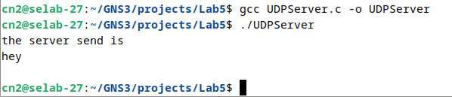

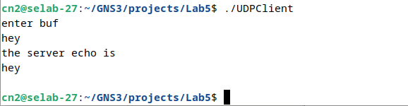

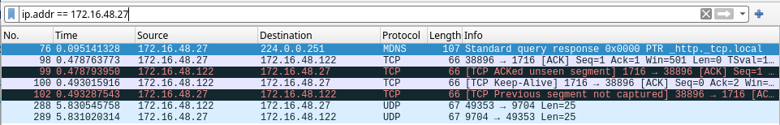

Server IP – 172.16.48.27
Client IP – 172.16.48.122

Q1) Server

#include<stdio.h>
#include<string.h>
#include<sys/types.h>
#include<sys/socket.h>
#include<netinet/in.h>
#include<arpa/inet.h>
#include<stdlib.h>
#include<unistd.h>
#include<stdbool.h>
#include<ctype.h>
#define PORTNO 10200
#define MAX_WORD_LENGTH 100
#define INITIAL_SIZE 10
// Function to check if a word is in the list
bool is_in_list(char **list, int size, const char *word) {
for (int i = 0; i < size; i++) {
if (strcmp(list[i], word) == 0) {
return true;
}
}
return false;
}
// Function to remove duplicate words from a sentence and count duplicates
void remove_duplicate(char str[]) {
char **words = malloc(INITIAL_SIZE * sizeof(char*));
int capacity = INITIAL_SIZE;
int size = 0;
char buffer[MAX_WORD_LENGTH];
char *ptr = str;
char *result = malloc(strlen(str) + 1);
result[0] = '\0';
char *result_ptr = result;
while (*ptr) {
int len = 0;
while (*ptr && !isspace(*ptr)) {
buffer[len++] = *ptr++;
}
buffer[len] = '\0';

while (*ptr && isspace(*ptr)) {
ptr++;
}
if (len > 0) {
if (!is_in_list(words, size, buffer)) {
if (size >= capacity) {
capacity *= 2;
words = realloc(words, capacity * sizeof(char*));
}
words[size] = strdup(buffer);
size++;
if (result_ptr != result) {
*result_ptr++ = ' ';
}
strcpy(result_ptr, buffer);
result_ptr += strlen(buffer);
}
}
}
for (int i = 0; i < size; i++) {
free(words[i]);
}
free(words);
if (result_ptr != result) {
*result_ptr = '\0';
}
strcpy(str, result);
free(result);
}

int main()
{
int sockfd,newsockfd,portno,clilen,n=1;
struct sockaddr_in seraddr,cliaddr;
int i,value;
// create an unnamed socket for the server
sockfd = socket(AF_INET,SOCK_STREAM,0);
//Name the socket
seraddr.sin_family = AF_INET;
seraddr.sin_addr.s_addr = inet_addr("172.16.48.122");
seraddr.sin_port = htons(PORTNO);
bind(sockfd,(struct sockaddr *)&seraddr,sizeof(seraddr));
//Create a connection queue and wait for clients
listen(sockfd,5);
while (1) {
char buf[256];
printf("server waiting\n");
//Accept a connection
clilen = sizeof(clilen);
newsockfd=accept(sockfd,(struct sockaddr *)&cliaddr,&clilen);
//Read and write to client on client_sockfd
while(1){
memset(buf, 0, sizeof(buf)); // Clear the buffer before reading
n = read(newsockfd,buf,sizeof(buf)-1);
buf[n] = '\0';
printf(" Sentence sent from Client is - \"%s\" \n",buf);
if(strcmp(buf,"stop")==0||strcmp(buf,"Stop")==0){
close(newsockfd);
break;
}
remove_duplicate(buf);
printf(" Modified sentence sent to Client is - \"%s\" \n",buf);
n = write(newsockfd,buf,strlen(buf)); // Send only the necessary bytes
}
if(!strcmp(buf,"stop")){
break;
}
}
}

Client

#include <sys/types.h>
#include <sys/socket.h>
#include <stdio.h>
#include <netinet/in.h>
#include <arpa/inet.h>
#include <stdlib.h>
#include <string.h>
#include <unistd.h> // For close()
int main()
{
int len, result, sockfd;
struct sockaddr_in address;
char ch[256], buf[256];
// Create a socket for the client
sockfd = socket(AF_INET, SOCK_STREAM, 0);// SOCK_STREAM used for TCP
// AF_INET is for IPv4 and 0 is the default protocol.
if (sockfd < 0) {

perror("Socket creation failed");
exit(1);
}
// Set up the address structure
address.sin_family = AF_INET; // IPv4 address family
address.sin_addr.s_addr = inet_addr("172.16.48.122"); // Server's IP address
// inet_addr converts the dot representation into binary.
address.sin_port = htons(10200); // Server's port number
// Host to network short: converts port number from host byte order to network byte order.
len = sizeof(address);
// Connect your socket to the server’s socket
result = connect(sockfd, (struct sockaddr *)&address, len);
// Here address is socket address of server and sockfd is file descriptor returned while creating the
socket.
if (result == -1) {
perror("Connection failed");
close(sockfd);
exit(1);
}
// Loop to repeatedly send and receive data
while (1) {
// Prompt user to enter a string
printf("ENTER STRING: ");
if (fgets(ch, sizeof(ch), stdin) == NULL) {// Use fgets instead of gets for safety
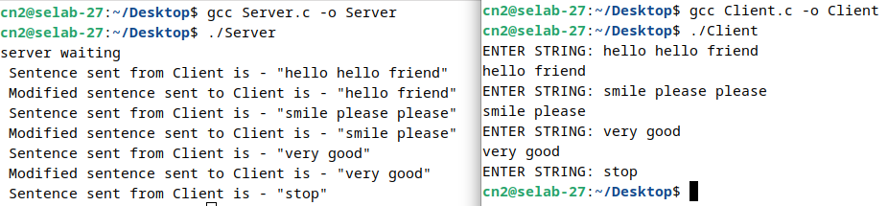
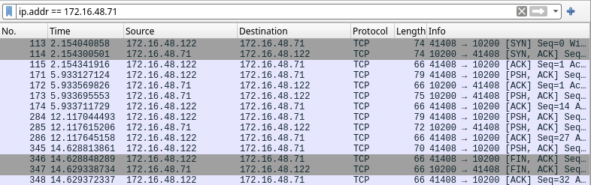
perror("Input error");
close(sockfd);
exit(1);
}// Remove newline character if present
ch[strcspn(ch, "\n")] = '\0';

// Write the input string to the server
write(sockfd, ch, strlen(ch));
// Send "stop" message to terminate both client and server
if (strcmp(ch, "stop") == 0) {
break;// Exit the loop and terminate the client
}
// Read the response from the server
int n = read(sockfd, buf, sizeof(buf) - 1);
if (n < 0) {
perror("Read error");
close(sockfd);
exit(1);
}
buf[n] = '\0';// Null-terminate the buffer
puts(buf); // Print the buffer content to stdout
}
close(sockfd);
return 0;
}

Server IP – 172.16.48.71
Client IP – 172.16.48.122

Q2) Server

#include<stdio.h>
#include<fcntl.h>
#include<stdlib.h>
#include<string.h>
#include<sys/socket.h>
#include<sys/types.h>
#include<netinet/in.h>
#include<arpa/inet.h>
#include<unistd.h>

#define PORT 9704
#define ROWS 3
#define COLS 3

int main() {
int sd;
char buf[100];
struct sockaddr_in sadd, cadd;
int matrix[ROWS][COLS];
int row_counter = 0;

// Create a UDP socket
sd = socket(AF_INET, SOCK_DGRAM, 0);
if(sd < 0) {
perror("Socket creation failed");
exit(EXIT_FAILURE);
}

// Construct the address for the server
sadd.sin_family = AF_INET;
sadd.sin_addr.s_addr = inet_addr("172.16.48.122");
sadd.sin_port = htons(PORT);

// Bind the socket to the address
if(bind(sd, (struct sockaddr *)&sadd, sizeof(sadd)) < 0) {
perror("Bind failed");
close(sd);
exit(EXIT_FAILURE);
}

int len = sizeof(cadd);

printf("Server is waiting for matrix rows...\n");

// Receive matrix rows one at a time
while(row_counter < ROWS) {
int m = recvfrom(sd, buf, sizeof(buf), 0, (struct sockaddr *)&cadd, &len);
if(m < 0) {
perror("Receive failed");
close(sd);
exit(EXIT_FAILURE);
}

buf[m] = '\0'; // Null-terminate the received string

// Convert the received string to matrix row
int i = 0;
char *token = strtok(buf, " ");
while(token != NULL && i < COLS) {
matrix[row_counter][i] = atoi(token); // Convert to integer
token = strtok(NULL, " ");
i++;
}
row_counter++;
}

printf("The received matrix is:\n");
for(int i = 0; i < ROWS; i++) {
for(int j = 0; j < COLS; j++) {
printf("%d ", matrix[i][j]);
}
printf("\n");
}

close(sd);
return 0;
}

Client

#include<stdio.h>
#include<stdlib.h>
#include<fcntl.h>
#include<string.h>
#include<sys/socket.h>
#include<sys/types.h>
#include<netinet/in.h>
#include<arpa/inet.h>
#include<unistd.h>

#define PORT 9704
#define ROWS 3
#define COLS 3

int main() {
int sd;
struct sockaddr_in address;
int matrix[ROWS][COLS];

// Create a UDP socket
sd = socket(AF_INET, SOCK_DGRAM, 0);
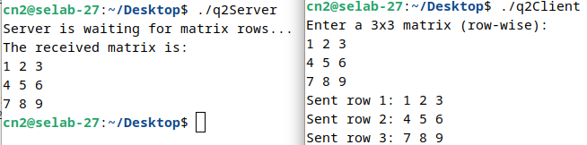
if(sd < 0) {
perror("Socket creation failed");
exit(EXIT_FAILURE);
}

// Construct the address for the server
address.sin_family = AF_INET;
address.sin_addr.s_addr = inet_addr("172.16.48.122");
address.sin_port = htons(PORT);

printf("Enter a %dx%d matrix (row-wise):\n", ROWS, COLS);

// Input matrix from the user
for(int i = 0; i < ROWS; i++) {
for(int j = 0; j < COLS; j++) {
scanf("%d", &matrix[i][j]);
}
}

int len = sizeof(address);

// Send matrix rows one at a time
for(int i = 0; i < ROWS; i++) {
char buf[100];
memset(buf, 0, sizeof(buf));

// Convert the matrix row to a string
sprintf(buf, "%d %d %d", matrix[i][0], matrix[i][1], matrix[i][2]);

// Send the row to the server
int m = sendto(sd, buf, sizeof(buf), 0, (struct sockaddr *)&address, len);
if(m < 0) {
perror("Send failed");
close(sd);
exit(EXIT_FAILURE);
}

printf("Sent row %d: %s\n", i+1, buf);
}

close(sd);
return 0;
}

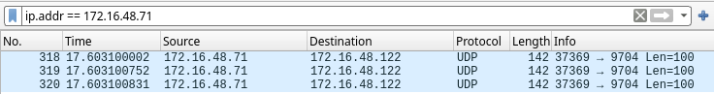

Server IP – 172.16.48.71
Client IP – 172.16.48.122

