CN LAB-6
Disha Jain – 220905554 – B2

- Make 1 client program and then recompile the same code on different terminals with new object code name.

TCP Server

#include<stdio.h>
#include<string.h>
#include<sys/types.h>
#include<sys/socket.h>
#include<netinet/in.h>
#include<unistd.h>
#include<arpa/inet.h>
#include<stdlib.h>
#define PORTNO 10205
int main()
{
int sockfd,newsockfd,portno,clilen,n=1;char buf[256];
struct sockaddr_in seraddr,cliaddr;
int i,value;
sockfd = socket(AF_INET,SOCK_STREAM,0);
seraddr.sin_family = AF_INET;
seraddr.sin_addr.s_addr = inet_addr("172.16.48.122");
seraddr.sin_port = htons(PORTNO);
bind(sockfd,(struct sockaddr *)&seraddr,sizeof(seraddr));
// Create a connection queue, ignore child exit details, and wait for clients
listen(sockfd,5);
printf("Server waiting...\n");
while(1){
//Accept the connection
clilen = sizeof(clilen);
newsockfd=accept(sockfd,(struct sockaddr *)&cliaddr,&clilen);
//Fork to create a process for this client and perform a test to see whether
//you’re the parent or the child:
if(fork()==0){
// If you’re the child, you can now read/write to the client on newsockfd.
n = read(newsockfd,buf,sizeof(buf));
printf(" \nMessage from Client %s \n",buf);
n = write(newsockfd,buf,sizeof(buf));
close(newsockfd);
exit(0);
}
//Otherwise, you must be the parent and your work for this client is finished
else
close(newsockfd);
}
}

TCP Client

#include<sys/types.h>
#include<sys/socket.h>
#include<stdio.h>
#include<netinet/in.h>
#include<arpa/inet.h>
#include<stdlib.h>
#include<unistd.h>
#include<string.h>
int main()
{
int len,result,sockfd,n=1;
struct sockaddr_in address;
char ch[256],buf[256];
//Create a socket for the client
sockfd = socket(AF_INET, SOCK_STREAM, 0);
//Name the socket as agreed with the server
address.sin_family=AF_INET;
address.sin_addr.s_addr=inet_addr("172.16.48.122");
address.sin_port=htons(10205);
len = sizeof(address);
//Connect your socket to the server’s socket
result=connect(sockfd,(struct sockaddr *)&address,len);
if(result==-1)
{
perror("\nCLIENT ERROR");
exit(1);
}
//You can now read and write via sockfd (Logic for problem mentioned here)
printf("\nENTER STRING\t");
scanf("%[^\n]s",ch);
write(sockfd,ch,strlen(ch));
printf("STRING SENT BACK FROM SERVER IS ... ");
//while(n){
n=read(sockfd,buf,sizeof(buf));
printf("%s\n",buf);
//} //lab manual has this loop but then you have to do forceful termination, my code works fine without the loop as well
return 0;
}
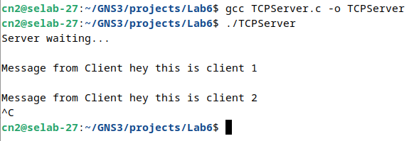

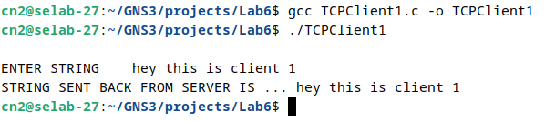

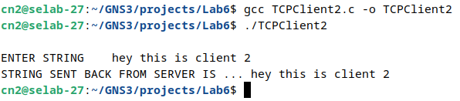

Q1) Math Server

#include<stdio.h>
#include<string.h>
#include<sys/types.h>
#include<sys/socket.h>
#include<netinet/in.h>
#include<unistd.h>
#include<arpa/inet.h>
#include<stdlib.h>
#define PORTNO 10205
int calculate(char*buf)
{
char op;
int num1,num2;
sscanf(buf,"%d %c %d",&num1,&op,&num2);
printf("%d\n",num1);
printf("%d\n",num2);
int sol;
switch (op)
{
case '+': sol=num1+num2;
return sol;
case '-': sol=num1-num2;
return sol;
case '*': sol=num1*num2;
return sol;
case '/': sol=num1/num2;
return sol;
case '%': sol=num1%num2;
return sol;
}
}
int main()
{
int sockfd,newsockfd,portno,clilen,n=1;char buf[256];
struct sockaddr_in seraddr,cliaddr;
int i,value;
sockfd = socket(AF_INET,SOCK_STREAM,0);
seraddr.sin_family = AF_INET;
seraddr.sin_addr.s_addr = inet_addr("172.16.48.122");
seraddr.sin_port = htons(PORTNO);
bind(sockfd,(struct sockaddr *)&seraddr,sizeof(seraddr));
// Create a connection queue, ignore child exit details, and wait for clients
listen(sockfd,5);
printf("Server waiting...\n");
while(1){
//Accept the connection
clilen = sizeof(clilen);
newsockfd=accept(sockfd,(struct sockaddr *)&cliaddr,&clilen);
//Fork to create a process for this client and perform a test to see whether
//you’re the parent or the child:
if(fork()==0){
// If you’re the child, you can now read/write to the client on newsockfd.
n = read(newsockfd,buf,sizeof(buf));
printf(" \nQuestion from Client %s \n",buf);
int solution = calculate(buf);
printf("Solution: %d \n",solution);
sprintf(buf,"%d",solution);
n = write(newsockfd,buf,sizeof(buf));
close(newsockfd);
exit(0);
}
//Otherwise, you must be the parent and your work for this client is finished
else
close(newsockfd);
}
}

Client
#include<sys/types.h>
#include<sys/socket.h>
#include<stdio.h>
#include<netinet/in.h>
#include<arpa/inet.h>
#include<stdlib.h>
#include<unistd.h>
#include<string.h>
int main()
{
int len,result,sockfd,n=1;
struct sockaddr_in address;
char ch[256],buf[256];
//Create a socket for the client
sockfd = socket(AF_INET, SOCK_STREAM, 0);
//Name the socket as agreed with the server
address.sin_family=AF_INET;
address.sin_addr.s_addr=inet_addr("172.16.48.122");
address.sin_port=htons(10205);
len = sizeof(address);
//Connect your socket to the server’s socket
result=connect(sockfd,(struct sockaddr *)&address,len);
if(result==-1)
{
perror("\nCLIENT ERROR");
exit(1);
}
//You can now read and write via sockfd (Logic for problem mentioned here)
printf("\nEquation: ");
scanf("%[^\n]s",ch);
write(sockfd,ch,strlen(ch));
printf("SOLUTION SENT BACK FROM SERVER IS ... ");
//while(n){
n=read(sockfd,buf,sizeof(buf));
printf("%s\n",buf);
//} //lab manual has this loop but then you have to do forceful termination, my code works fine without the loop as well
return 0;
}
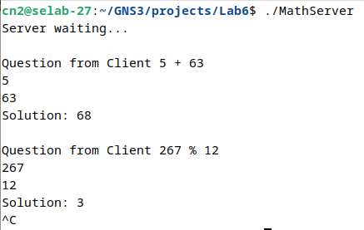

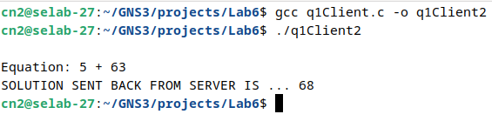

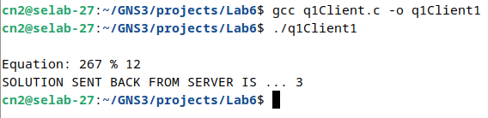

Trying Q1 with
Server IP - 172.16.48.122
Client1 IP (Local) - 172.16.48.122
Client2 IP (Foreign) - 172.16.48.71

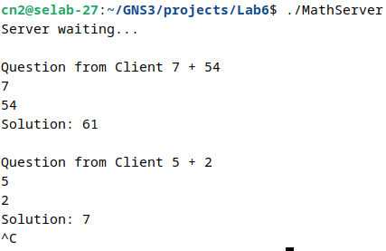

Equation 1 is from Foreign Client

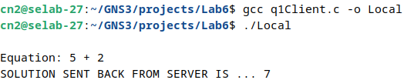
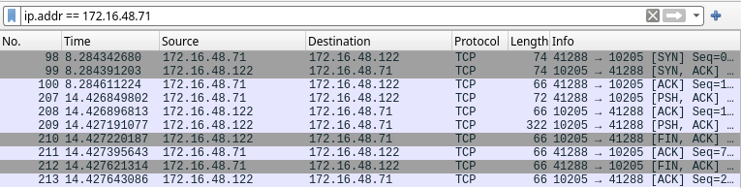

Q2) Server

#include<stdio.h>
#include<string.h>
#include<sys/types.h>
#include<sys/socket.h>
#include<netinet/in.h>
#include<arpa/inet.h>
#include<stdlib.h>
#include<unistd.h>
#include<stdbool.h>
#include<ctype.h>
#define PORTNO 10200
#define MAX_WORD_LENGTH 100
#define INITIAL_SIZE 10
// Function to check if a word is in the list
bool is_in_list(char **list, int size, const char *word) {
for (int i = 0; i < size; i++) {
if (strcmp(list[i], word) == 0) {
return true;
}
}
return false;
}
// Function to remove duplicate words from a sentence and count duplicates
void remove_duplicate(char str[]) {
char **words = malloc(INITIAL_SIZE * sizeof(char*));
int capacity = INITIAL_SIZE;
int size = 0;
char buffer[MAX_WORD_LENGTH];
char *ptr = str;
char *result = malloc(strlen(str) + 1);
result[0] = '\0';
char *result_ptr = result;
while (*ptr) {
int len = 0;
while (*ptr && !isspace(*ptr)) {
buffer[len++] = *ptr++;
}
buffer[len] = '\0';

while (*ptr && isspace(*ptr)) {
ptr++;
}
if (len > 0) {
if (!is_in_list(words, size, buffer)) {
if (size >= capacity) {
capacity *= 2;
words = realloc(words, capacity * sizeof(char*));
}
words[size] = strdup(buffer);
size++;
if (result_ptr != result) {
*result_ptr++ = ' ';
}
strcpy(result_ptr, buffer);
result_ptr += strlen(buffer);
}
}
}
for (int i = 0; i < size; i++) {
free(words[i]);
}
free(words);
if (result_ptr != result) {
*result_ptr = '\0';
}
strcpy(str, result);
free(result);
}

int main()
{
int sockfd,newsockfd,portno,clilen,n=1;
struct sockaddr_in seraddr,cliaddr;
int i,value;
// create an unnamed socket for the server
sockfd = socket(AF_INET,SOCK_STREAM,0);
//Name the socket
seraddr.sin_family = AF_INET;
seraddr.sin_addr.s_addr = inet_addr("172.16.48.122");
seraddr.sin_port = htons(PORTNO);
bind(sockfd,(struct sockaddr *)&seraddr,sizeof(seraddr));
//Create a connection queue and wait for clients
listen(sockfd,5);

while (1) {
char buf[256];
printf("server waiting\n");
//Accept a connection
clilen = sizeof(clilen);
newsockfd=accept(sockfd,(struct sockaddr *)&cliaddr,&clilen);
if(fork()==0)
{
memset(buf, 0, sizeof(buf)); // Clear the buffer before reading
n = read(newsockfd,buf,sizeof(buf)-1);
buf[n] = '\0';
printf(" Sentence sent from Client is - \"%s\" \n",buf);
remove_duplicate(buf);
printf(" Modified sentence sent to Client is - \"%s\" \n",buf);
n = write(newsockfd,buf,strlen(buf)); // Send only the necessary bytes
}
else
close(newsockfd);
}
}

Client

#include <sys/types.h>
#include <sys/socket.h>
#include <stdio.h>
#include <netinet/in.h>
#include <arpa/inet.h>
#include <stdlib.h>
#include <string.h>
#include <unistd.h> // For close()
int main()
{
int len, result, sockfd;
struct sockaddr_in address;
char ch[256], buf[256];
// Create a socket for the client
sockfd = socket(AF_INET, SOCK_STREAM, 0);// SOCK_STREAM used for TCP
// AF_INET is for IPv4 and 0 is the default protocol.
if (sockfd < 0) {

perror("Socket creation failed");
exit(1);
}
// Set up the address structure
address.sin_family = AF_INET; // IPv4 address family
address.sin_addr.s_addr = inet_addr("172.16.48.122"); // Server's IP address
// inet_addr converts the dot representation into binary.
address.sin_port = htons(10200); // Server's port number
// Host to network short: converts port number from host byte order to network byte order.
len = sizeof(address);
// Connect your socket to the server’s socket
result = connect(sockfd, (struct sockaddr *)&address, len);
// Here address is socket address of server and sockfd is file descriptor returned while creating the socket.
if (result == -1) {
perror("Connection failed");
close(sockfd);
exit(1);
}

// Prompt user to enter a string
printf("ENTER STRING: ");
if (fgets(ch, sizeof(ch), stdin) == NULL) {// Use fgets instead of gets for safety
perror("Input error");
close(sockfd);
exit(1);
}// Remove newline character if present
ch[strcspn(ch, "\n")] = '\0';

// Write the input string to the server
write(sockfd, ch, strlen(ch));
// Read the response from the server
int n = read(sockfd, buf, sizeof(buf) - 1);
if (n < 0) {
perror("Read error");
close(sockfd);
exit(1);
}
buf[n] = '\0';// Null-terminate the buffer
printf("%s\n",buf); // Print the buffer content to stdout
close(sockfd);
return 0;
}
