**LAB 1: HTML AND JAVASCRIPT**

Disha Jain - 61 - 220905554

1. Write a simple poem and represent it as a web page. Give a title for the poem.  Make rhyming words in the poem as bold.

<!DOCTYPE html>

<html lang="en">

<head>

    <meta charset="UTF-8">

    <meta name="viewport" content="width=device-width, initial-scale=1.0">

    <title>Fire and Ice</title>

</head>

<body>

    <h1 style="color:rgb(212, 91, 117)">Fire and Ice</h1>

    <p>

        Some say the world will end in <b>fire</b>,<br/>

        Some say in <b>ice</b>.<br/>

        From what I've tasted of <b>desire</b><br/>

        I hold with those who favor <b>fire</b>.<br/>

        But if it had to perish <b>twice</b>,<br/>

        I think I know enough of <b>hate</b><br/>

        To know that for destruction <b>ice</b><br/>

        Is also <b>great</b><br/>

        And would <b>suffice</b>.

    </p>

</body>

</html>

1. Assume you have brought a new car. Write down the list of additional accessories you need for the car as an unordered list in HTML. Also, list the travel plans on the car as an ordered list.

<!DOCTYPE html>

<html lang="en">

<head>

    <meta charset="UTF-8">

    <meta name="viewport" content="width=device-width, initial-scale=1.0">

    <title>New Car</title>

</head>

<body>

    <h1 style="color:rgb(14, 90, 90)">New Car</h1>

    <h2>Additional Car accesories:</h2>

    <ul>

        <li>Interior ambient lighting</li>

        <li>GPS navigator</li>

        <li>Dash Camera</li>

        <li>Seat Cushion</li>

        <li>Neck / Back Support</li>

        <li>Phone Mount</li>

    </ul>

    <h2>Travel Plans:</h2>

    <ol>

        <li>Beach</li>

        <li>Cafe Hopping</li>

        <li>Zoo</li>

        <li>Long Drive at night</li>

    </ol>

</body>

</html>

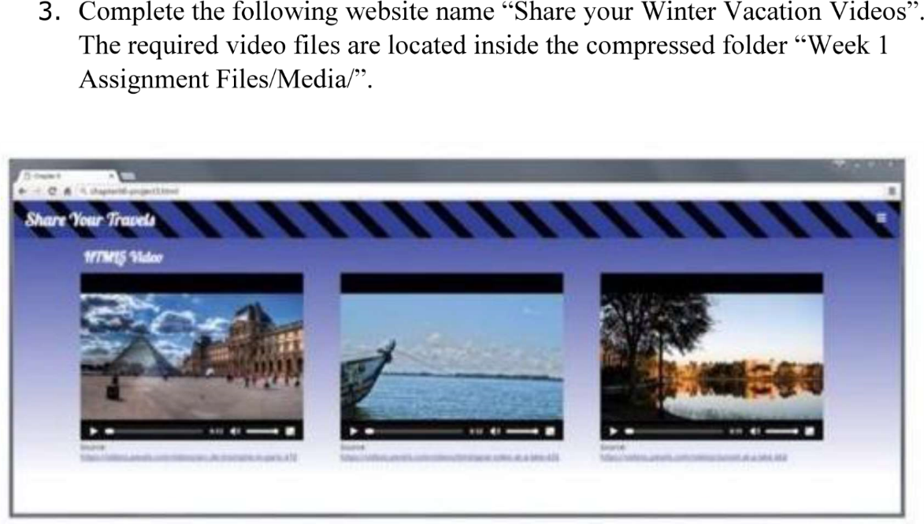



<!DOCTYPE html>

<html lang="en">

<head>

    <meta charset="UTF-8">

    <meta name="viewport" content="width=device-width, initial-scale=1.0">

    <title>Best Winter Videos</title>

    <style>

        body {

            text-align: center;

            background: linear-gradient(to bottom right, rgb(231, 223, 210), rgb(162, 127, 93)); /* Gradient background */

            background-repeat: no-repeat;

            background-size: cover; /*cover the whole viewport*/

            margin: 0;

            min-height: 100vh; /*body takes full viewport height*/

        }

        .videos-container {

            display: flex;

            justify-content: center;

            gap: 20px;

            margin-top: 20px;

        }

        figure {

            margin: 0;

            text-align: center;

        }

        video {

            width: 300px;

            height: auto;

        }

        h1 {

            background-color: rgb(56, 34, 4);

            color: bisque;

            padding: 10px;

        }

    </style>

</head>

<body>

    <h1>Best Videos of All Time</h1>

    <div class="videos-container">

        <figure>

            <video src="./video1.mp4" controls>Seagulls flying over the ocean</video>

            <figcaption>Ocean and Seagulls</figcaption>

        </figure>

        <figure>

            <video src="./video2.mp4" controls>Woman crocheting tea coasters</video>

            <figcaption>Crochet and Tea</figcaption>

        </figure>

        <figure>

            <video src="./video3.mp4" controls>Racoon sticking out its tongue</video>

            <figcaption>Silly Racoon</figcaption>

        </figure>

    </div>

</body>

</html>

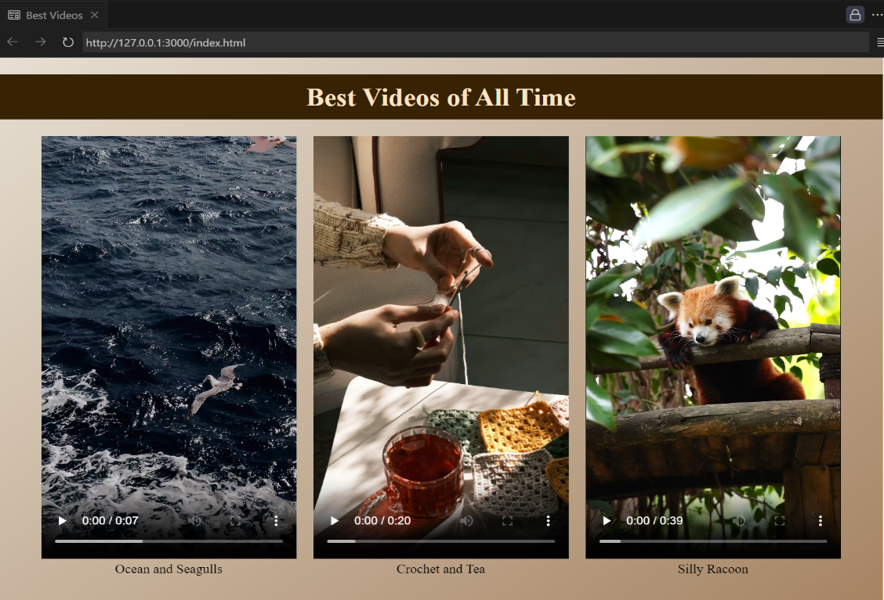

1. Create the following output in HTML

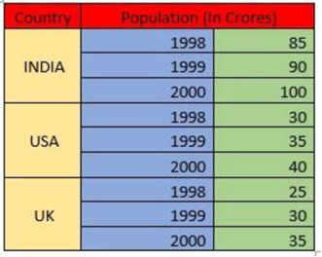

<!DOCTYPE html>

<html lang="en">

<head>

    <meta charset="UTF-8">

    <meta name="viewport" content="width=device-width, initial-scale=1.0">

    <title>Population Table</title>

    <style>

        table {

            margin: 50px auto;

            border-collapse: collapse;

        }

        th, td {

            padding: 3px 3px;

            border: 1px solid #ddd;

            text-align: center;

        }

        th {

            background-color: rgb(162, 55, 233);

            color: white;

            width:30%;

        }

        .head{

            background-color: rgb(162, 55, 233);

        }

        .country{

            background-color: rgb(187, 129, 204);

        }

        .year{

            background-color: rgb(226, 170, 223);

            text-align: right;

            width:45%;

        }

        .population{

            background-color: rgb(235, 186, 216);

            text-align: right;

            width:45%;

        }

    </style>

</head>

<body>

    <table style="margin: 50px auto;">

        <caption>Population Change 1998-2000</caption>

        <tr>

            <th class="head">Country</th>

            <th colspan="2" class="head">Population(In Crores)</th>

        </tr>

        <tr>

            <td rowspan="3" class="country">INDIA</td>

            <td class="year">1998</td>

            <td class="population">85</td>

        </tr>

        <tr>

            <td class="year">1999</td>

            <td class="population">90</td>

        </tr>

        <tr>

            <td class="year">2000</td>

            <td class="population">100</td>

        </tr>

        <tr>

            <td rowspan="3" class="country">USA</td>

            <td class="year">1998</td>

            <td class="population">30</td>

        </tr>

        <tr>

            <td class="year">1999</td>

            <td class="population">35</td>

        </tr>

        <tr>

            <td class="year">2000</td>

            <td class="population">40</td>

        </tr>

        <tr>

            <td rowspan="3" class="country">UK</td>

            <td class="year">1998</td>

            <td class="population">25</td>

        </tr>

        <tr>

            <td class="year">1999</td>

            <td class="population">30</td>

        </tr>

        <tr>

            <td class="year">2000</td>

            <td class="population">35</td>

        </tr>

    </table>

</body>

</html>

1. Create an array of Javascript objects for the data in question 4 and display each row in the table form through Javascript code.

<!DOCTYPE html>

<html lang="en">

<head>

    <meta charset="UTF-8">

    <meta name="viewport" content="width=device-width, initial-scale=1.0">

    <title>Population Table</title>

    <style>

        table {

            margin: 50px auto;

            border-collapse: collapse;

        }

        th, td {

            padding: 2px 2px;

            border: 1px solid #ddd;

            text-align: center;

        }

        th {

            background-color: rgb(162, 55, 233);

            color: white;

            width:30%;

        }

        .country {

            background-color: rgb(187, 129, 204);

        }

        .year {

            background-color: rgb(226, 170, 223);

            text-align: right;

            width:45%;

        }

        .population {

            background-color: rgb(235, 186, 216);

            text-align: right;

            width:45%;

        }

    </style>

</head>

<body>

    <table id="population-table">

        <caption style="padding: 3px; font-size: 20px;">Population Change 1998-2000</caption>

        <thead>

            <tr>

                <th>Country</th>

                <th colspan="2">Population (In Crores)</th>

            </tr>

        </thead>

        <tbody>

            <!-- Rows will be added here dynamically by JavaScript -->

        </tbody>

    </table>

    <script>

        const populationData = [

            { country: 'INDIA', year: 1998, population: 85 },

            { country: 'INDIA', year: 1999, population: 90 },

            { country: 'INDIA', year: 2000, population: 100 },

            { country: 'USA', year: 1998, population: 30 },

            { country: 'USA', year: 1999, population: 35 },

            { country: 'USA', year: 2000, population: 40 },

            { country: 'UK', year: 1998, population: 25 },

            { country: 'UK', year: 1999, population: 30 },

            { country: 'UK', year: 2000, population: 35 }

        ];

        function populateTable() {

            const tableBody = document.querySelector('#population-table tbody');

            let currentCountry = '';

            let countryRowSpanStartIndex = -1;

            let rowCount = 0;

            populationData.forEach((data, index) => {

                const row = document.createElement('tr');

                // Add Country cell only when the country changes

                if (data.country !== currentCountry) {

                    currentCountry = data.country;

                    if (countryRowSpanStartIndex >= 0) {

                        tableBody.rows[countryRowSpanStartIndex].cells[0].rowSpan = rowCount;

                    }

                    countryRowSpanStartIndex = tableBody.rows.length;

                    rowCount = 1;

                    const countryCell = document.createElement('td');

                    countryCell.textContent = data.country;

                    countryCell.className = 'country';

                    row.appendChild(countryCell);

                } else {

                    rowCount++;

                }

                const yearCell = document.createElement('td');

                yearCell.textContent = data.year;

                yearCell.className = 'year';

                row.appendChild(yearCell);

                const populationCell = document.createElement('td');

                populationCell.textContent = data.population;

                populationCell.className = 'population';

                row.appendChild(populationCell);

                // Append the row to the table body

                tableBody.appendChild(row);

                // Apply rowspan to the last country after the loop ends

                if (index === populationData.length - 1) {

                    tableBody.rows[countryRowSpanStartIndex].cells[0].rowSpan = rowCount;

                }

            });

        }

        // Populate the table when the page loads

        populateTable();

    </script>

</body>

</html>

