**LAB 2: JQuery**

Disha Jain - 220905554 – 61

1. **Write a web page which contains table with 3 X 3 dimensions (fill some data) and one image. Style the rows with alternate color. Move the table and image together from right to left when button is clicked.**

<!DOCTYPE html>

<html lang="en">

<head>

<meta charset="UTF-8">

<meta name="viewport" content="width=device-width, initial-scale=1.0">

<title>Table carousel</title>

<script src="https://code.jquery.com/jquery-3.6.0.min.js"></script>

<style>

body {

font-family: Arial, sans-serif;

display: flex;

justify-content: center;

align-items: center;

height: 100vh;

margin: 0;

background-color: #ffffff;

overflow: hidden; /* Prevent overflow caused by elements moving */

}

.container {

position: relative;

text-align: center;

width: 100%;

height: 100%;

overflow: hidden;

}

table {

width: 400px;

height: 400px;

border-collapse: collapse;

margin: 20px 0;

position: absolute;

left: 50%;

top: 50%;

transform: translate(-50%, -50%);

}

table, td {

border: 1px solid #ffffff;

}

th, td {

padding: 8px 12px;

text-align: center;

}

tr:nth-child(odd) {

background-color: #9dc0dd;

}

tr:nth-child(even) {

background-color: #7b9cda;

}

img {

width: 100px;

height: auto;

position: absolute;

left: 50%;

top: 50%;

transform: translate(-50%, -50%); /* Center the image */

}

.button-container {

position: absolute;

bottom: 60px;

width: 100%;

text-align: center;

}

button {

padding: 10px 20px;

font-size: 16px;

cursor: pointer;

margin-top: 20px;

background-color: #6c7075;

}

</style>

</head>

<body>

<div class="container">

<table class="move">

<tr>

<td>Data 1</td>

<td>Data 2</td>

<td>Data 3</td>

</tr>

<tr>

<td>Data 4</td>

<td><img src="https://picsum.photos/200" alt="Sample Image"></td>

<td>Data 6</td>

</tr>

<tr>

<td>Data 7</td>

<td>Data 8</td>

<td>Data 9</td>

</tr>

</table>

<div class="button-container">

<button id="moveButton" >Start Moving Right to Left</button>

</div>

</div>

<script>

$(document).ready(function() {

let isMoving = false;

let moveInterval;

$('#moveButton').click(function() {

if (!isMoving) {

isMoving = true;

$(this).text('Stop Moving');

moveInterval = setInterval(function() {

$('.move').animate(

{

left: '-100vw'

},

2500, // Duration for one full cycle

'linear', // Continuous movement (no easing)

function() {

// After the animation ends, immediately reset the position to the right

$(this).css('left', '100vw');

}

);

}, 0); // Start immediately (no delay)

} else {

isMoving = false;

clearInterval(moveInterval); // Stop continuous animation

$('.move').stop(true, true).css('left', '50%'); // Immediately reset to center without animation

$('#moveButton').text('Start Moving Right to Left');

}

});

});

</script>

</body>

</html>

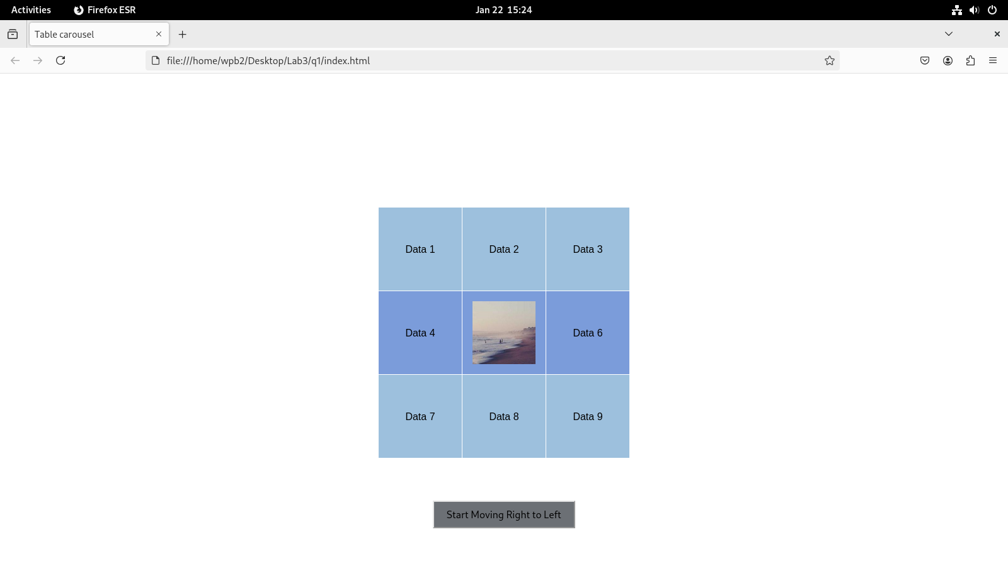

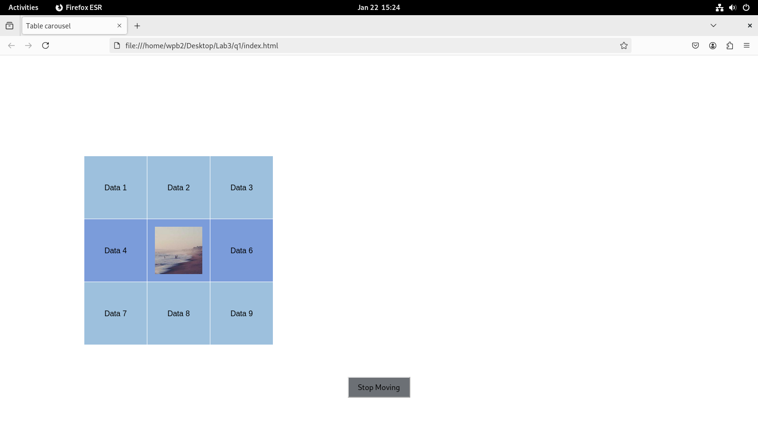

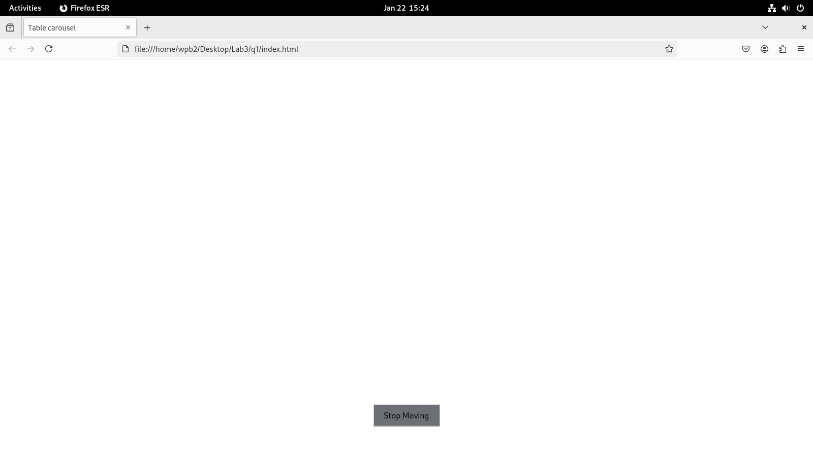

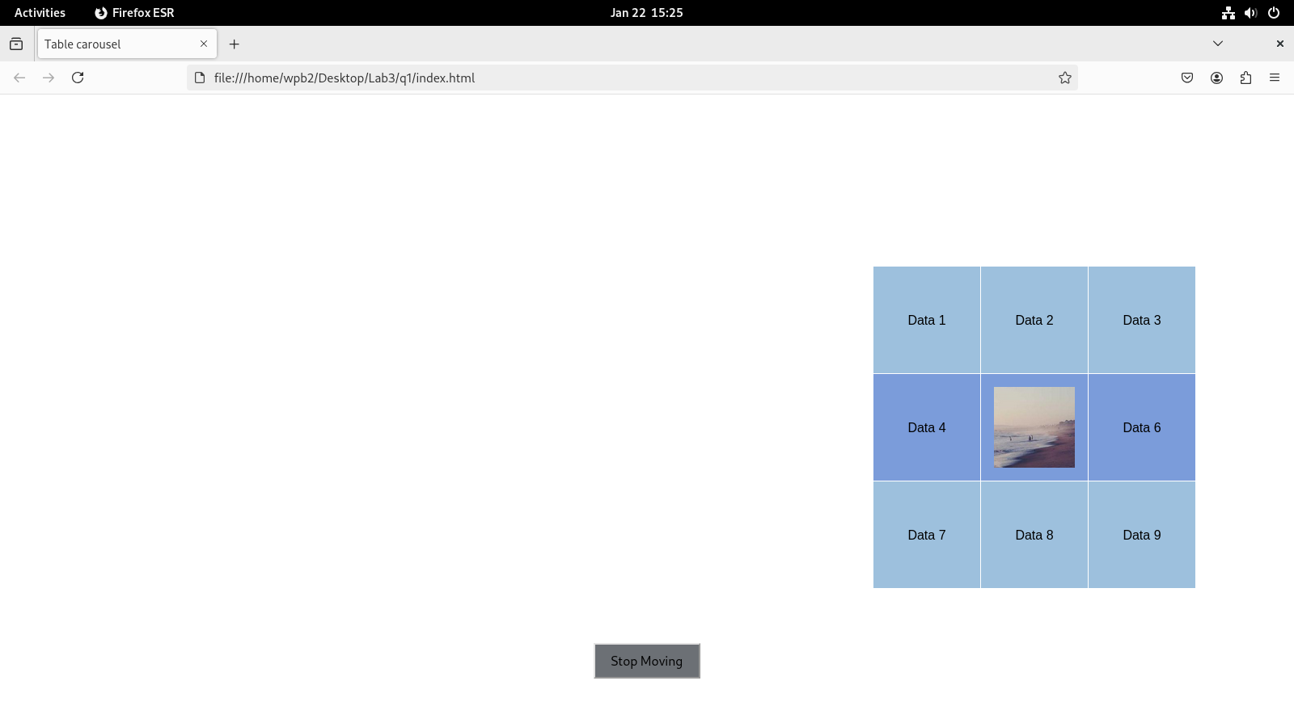

**2) Design a calculator to perform basic arithmetic operations. Use textboxes and buttons to design web page**

<!DOCTYPE html>

<html lang="en">

<head>

<meta charset="UTF-8">

<meta name="viewport" content="width=device-width, initial-scale=1.0">

<title>Basic Calculator</title>

<style>

body {

font-family: Arial, sans-serif;

display: flex;

justify-content: center;

align-items: center;

height: 100vh;

margin: 0;

background-color: #f0f0f0;

}

.calculator {

background-color: #ffffff;

padding: 20px;

border-radius: 10px;

box-shadow: 0px 0px 15px rgba(0, 0, 0, 0.1);

width: 260px;

}

.display {

width: 92%;

height: 50px;

font-size: 24px;

text-align: right;

padding: 10px;

margin-bottom: 20px;

border-radius: 5px;

border: 1px solid #ccc;

background-color: #f9f9f9;

}

.buttons {

display: grid;

grid-template-columns: repeat(4, 1fr);

gap: 10px;

}

button {

padding: 20px;

font-size: 18px;

background-color: #f1f1f1;

border: none;

border-radius: 5px;

cursor: pointer;

transition: background-color 0.2s;

}

button:hover {

background-color: #dcdcdc;

}

button:active {

background-color: #bbb;

}

.equal {

width: 330%;

background-color: #4CAF50;

color: white;

}

.equal:hover {

background-color: #45a049;

}

.clear {

background-color: #f44336;

color: white;

}

.clear:hover {

background-color: #e53935;

}

.backspace {

background-color: #ff9800;

color: white;

}

.backspace:hover {

background-color: #fb8c00;

}

</style>

</head>

<body>

<div class="calculator">

<input type="text" class="display" id="display" disabled>

<div class="buttons">

<button onclick="appendToDisplay('7')">7</button>

<button onclick="appendToDisplay('8')">8</button>

<button onclick="appendToDisplay('9')">9</button>

<button onclick="appendToDisplay('+')">+</button>

<button onclick="appendToDisplay('4')">4</button>

<button onclick="appendToDisplay('5')">5</button>

<button onclick="appendToDisplay('6')">6</button>

<button onclick="appendToDisplay('-')">-</button>

<button onclick="appendToDisplay('1')">1</button>

<button onclick="appendToDisplay('2')">2</button>

<button onclick="appendToDisplay('3')">3</button>

<button onclick="appendToDisplay('*')">*</button>

<button onclick="clearDisplay()" class="clear">C</button>

<button onclick="appendToDisplay('0')">0</button>

<button onclick="appendToDisplay('.')">.</button>

<button onclick="appendToDisplay('/')">/</button>

<button onclick="backspace()" class="backspace">←</button>

<button class="equal" onclick="calculateResult()">=</button>

</div>

</div>

<script>

function appendToDisplay(value) {

document.getElementById('display').value += value;

}

function clearDisplay() {

document.getElementById('display').value = '';

}

function backspace() {

const display = document.getElementById('display');

display.value = display.value.slice(0, -1); // Removes the last character

}

function calculateResult() {

const display = document.getElementById('display');

try {

display.value = eval(display.value);

} catch (error) {

display.value = 'Error';

}

}

</script>

</body>

</html>

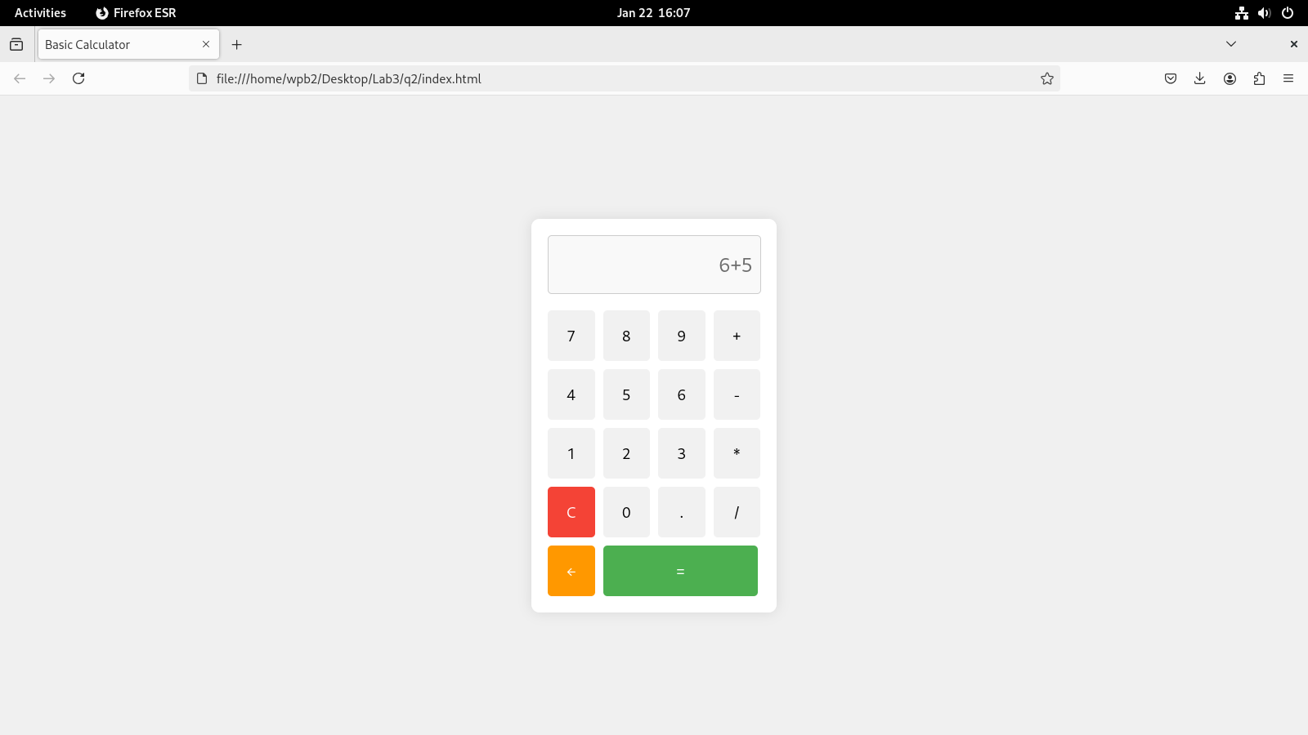 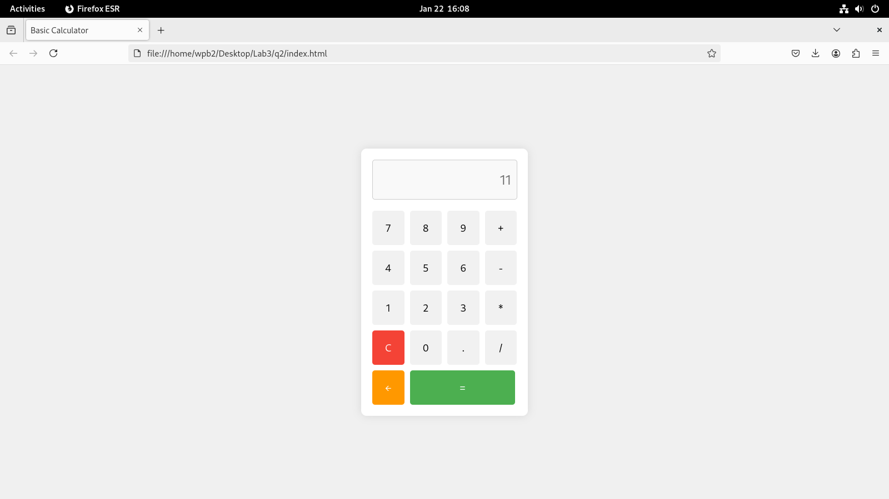

3) Create a web page to design a birthday card shown below.

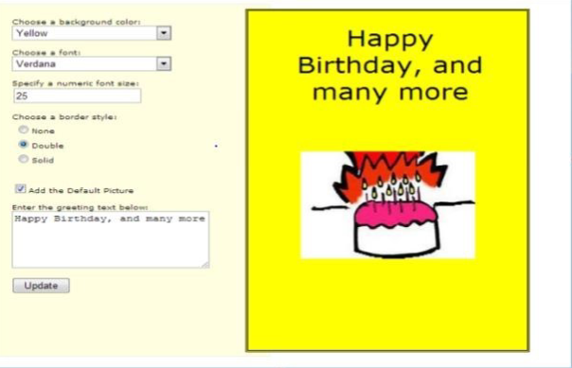

<!DOCTYPE html>

<html lang="en">

<head>

<meta charset="UTF-8">

<meta name="viewport" content="width=device-width, initial-scale=1.0">

<title>Personalized Web Page</title>

<style>

* {

margin: 0;

padding: 0;

box-sizing: border-box;

}

body {

display: flex;

height: 100vh;

}

.left-side, .right-side {

width: 50%;

padding: 20px;

}

.left-side {

background-color: #f4f4f4;

}

.right-side {

background-color: #ffffff;

display: flex;

flex-direction: column;

align-items: center;

justify-content: flex-start;

text-align: center;

}

.input-group {

margin-bottom: 15px;

}

.input-group label {

display: block;

margin-bottom: 5px;

}

.input-group select, .input-group input {

width: 100%;

padding: 10px;

font-size: 16px;

}

.input-group textarea {

width: 100%;

padding: 10px;

font-size: 16px;

height: 100px;

}

.update-btn {

padding: 10px 20px;

background-color: #4CAF50;

color: white;

border: none;

cursor: pointer;

}

.update-btn:hover {

background-color: #45a049;

}

.greeting {

font-size: 2rem;

margin-bottom: 20px;

}

.image-container img {

max-width: 100%;

height: auto;

border: 5px solid black;

}

.checkbox-group {

display: flex;

align-items: center;

}

.checkbox-group input {

margin-left: 10px;

}

.radio-group {

display: flex;

flex-direction: column; /* Vertically align the radio buttons */

}

.radio-group input {

margin-right: 10px;

}

</style>

</head>

<body>

<div class="left-side">

<h2>Customize Your Page</h2>

<div class="input-group">

<label for="background-color">Choose Background Color:</label>

<select id="background-color">

<option value="white">White</option>

<option value="lightblue">Light Blue</option>

<option value="lightgreen">Light Green</option>

<option value="lightyellow">Light Yellow</option>

</select>

</div>

<div class="input-group">

<label for="font-family">Choose Font:</label>

<select id="font-family">

<option value="Arial">Arial</option>

<option value="Verdana">Verdana</option>

<option value="Georgia">Georgia</option>

<option value="Courier New">Courier New</option>

</select>

</div>

<div class="input-group">

<label for="font-size">Specify Font Size (px):</label>

<input type="number" id="font-size" placeholder="Enter font size">

</div>

<div class="input-group">

<label>Choose Border Style:</label>

<div class="radio-group">

<input type="radio" id="none" name="border" value="none">

<label for="none">None</label>

<input type="radio" id="solid" name="border" value="solid">

<label for="solid">Solid</label>

<input type="radio" id="double" name="border" value="double">

<label for="double">Double</label>

</div>

</div>

<div class="input-group checkbox-group">

<label for="default-picture">Use Default Picture:</label>

<input type="checkbox" id="default-picture">

</div>

<div class="input-group">

<label for="greeting-text">Enter Greeting Text:</label>

<textarea id="greeting-text" placeholder="Enter your greeting text here"></textarea>

</div>

<button class="update-btn" onclick="updatePage()">Update</button>

</div>

<div class="right-side" id="right-side">

<div class="greeting" id="greeting-display"></div>

<div class="image-container" id="image-container">

<!-- Image will be displayed here if checkbox is checked -->

</div>

</div>

<script>

function updatePage() {

// Get values from left-side form

const backgroundColor = document.getElementById('background-color').value;

const fontFamily = document.getElementById('font-family').value;

const fontSize = document.getElementById('font-size').value;

const borderStyle = document.querySelector('input[name="border"]:checked').value;

const useDefaultPicture = document.getElementById('default-picture').checked;

const greetingText = document.getElementById('greeting-text').value;

// Apply styles to right-side

const rightSide = document.getElementById('right-side');

rightSide.style.backgroundColor = backgroundColor;

rightSide.style.fontFamily = fontFamily;

rightSide.style.fontSize = fontSize ? fontSize + 'px' : '16px';

rightSide.style.border = borderStyle === 'none' ? 'none' : `${borderStyle} 5px black`;

// Update greeting text

const greetingDisplay = document.getElementById('greeting-display');

greetingDisplay.textContent = greetingText || "Hello, Welcome to your personalized page!";

// Handle the image

const imageContainer = document.getElementById('image-container');

imageContainer.innerHTML = ''; // Clear previous image

if (useDefaultPicture) {

const img = document.createElement('img');

img.src = '<https://picsum.photos/id/237/500/300>'; // Default image URL

imageContainer.appendChild(img);

}

}

</script>

</body>

</html>

