**LAB 4: PYTHON BASICS (HOMEWORK)**

Disha Jain – 220905554 – 61

1. Write a python program to select smallest element from a list in an expected linear time.

arr = list(map(int, input("Enter numbers separated by space: ").split()))  
smallest = arr[0]  
  
for val in arr:  
 if val < smallest:  
 smallest = val  
  
print(f"{smallest} is smallest")

1. Write a python program to implement bubble sort.

def bubble_sort(arr):  
 n = len(arr)  
 for i in range(n - 1):  
 swapped = False  
 for j in range(n - i - 1):  
 if arr[j] > arr[j + 1]:  
 arr[j], arr[j + 1] = arr[j + 1], arr[j] # Swap elements  
 swapped = True  
 if not swapped:  
 break # Optimization: Stop if no swaps were made in a pass  
  
# Example usage  
arr = list(map(int, input("Enter numbers separated by space: ").split()))  
bubble_sort(arr)  
print("Sorted array:", arr)

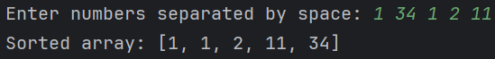

1. Write a python program to multiply two matrices.

def read_matrix(rows, cols):  
 print(f"Enter the elements for a {rows}x{cols} matrix row-wise:")  
 matrix = []  
 for i in range(rows):  
 row = list(map(int, input().split()))  
 if len(row) != cols:  
 print(f"Error: Please enter exactly {cols} values per row.")  
 return read_matrix(rows, cols) # Ask for input again if incorrect  
 matrix.append(row)  
 return matrix  
  
  
def matrix_multiplication(A, B):  
 rows_A, cols_A = len(A), len(A[0])  
 rows_B, cols_B = len(B), len(B[0])  
  
 result = [[0 for _ in range(cols_B)] for _ in range(rows_A)]  
  
 for i in range(rows_A):  
 for j in range(cols_B):  
 for k in range(cols_A): # or rows_B (since cols_A == rows_B)  
 result[i][j] += A[i][k] * B[k][j]  
  
 return result  
  
  
# Read matrix dimensions from user  
rows_A = int(input("Enter number of rows for Matrix A: "))  
cols_A = int(input("Enter number of columns for Matrix A: "))  
  
rows_B = int(input("Enter number of rows for Matrix B: "))  
cols_B = int(input("Enter number of columns for Matrix B: "))  
  
# Ensure matrices can be multiplied  
if cols_A != rows_B:  
 print("Error: Number of columns in Matrix A must be equal to number of rows in Matrix B.")  
else:  
 # Read matrices from user  
 A = read_matrix(rows_A, cols_A)  
 B = read_matrix(rows_B, cols_B)  
  
 # Perform matrix multiplication  
 result = matrix_multiplication(A, B)  
  
 # Print result  
 print("Resultant Matrix:")  
 for row in result:  
 print(" ".join(map(str, row)))

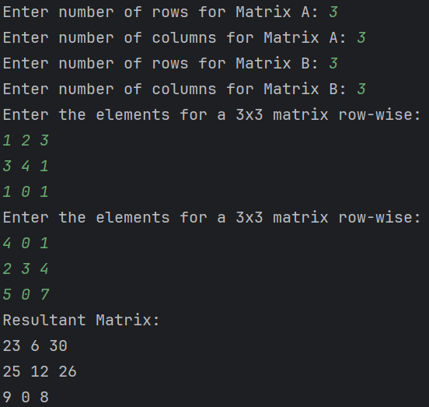

1. Write a Python class to find validity of a string of parentheses, '(', ')', '{', '}', '[' and ']. These brackets must be close in the correct order, for example "()" and "()[]{}" are valid but "[)", "({[)]" and "{{{" are invalid.

class ParenthesesValidator:  
 def is_valid(self, s: str) -> bool:  
 stack = []  
 bracket_map = {')': '(', '}': '{', ']': '['}  
  
 for char in s:  
 if char in bracket_map.values(): # If it's an opening bracket  
 stack.append(char)  
 elif char in bracket_map.keys(): # If it's a closing bracket  
 if not stack or stack.pop() != bracket_map[char]:  
 return False # Mismatched or unbalanced bracket  
 else:  
 return False # Invalid character  
  
 return not stack # Stack should be empty if valid  
  
  
# Example usage  
validator = ParenthesesValidator()  
test_strings = ["()", "()[]{}", "(]", "({[)]", "{{{"]  
for s in test_strings:  
 print(f"{s}: {validator.is_valid(s)}")

1. Write a Python class to reverse a string word by word.

class StringReverser:  
 def reverse_words(self, s: str) -> str:  
 return " ".join(s.split()[::-1]) # Split, reverse, and join back  
  
# Example usage  
reverser = StringReverser()  
str = input("Enter a sentence: ")  
print(f"Reversed: {reverser.reverse_words(str)}")

1. Write a Python class named Circle constructed by a radius and two methods which will compute the area and the perimeter of a circle.

import math  
  
class Circle:  
 def __init__(self, radius):  
 self.radius = radius  
  
 def area(self):  
 return math.pi * self.radius ** 2  
  
 def perimeter(self):  
 return 2 * math.pi * self.radius  
  
# Example usage  
radius = int(input("Enter radius: "))  
circle = Circle(radius)  
print(f"Radius: {circle.radius}")  
print(f"Area: {circle.area():.2f}")  
print(f"Perimeter: {circle.perimeter():.2f}")

