**Lab 5: Developing Web Application using Django - Part I**

Disha Jain – 220905554 – 61

1. Create a web form which allows the teacher to enter the student details like name, date of birth, address, contact number, email id and marks of English, Physics and Chemistry. After filling all the information and on clicking submit button, details should be added to a textarea displayed on the same page. Display the total percentage of marks obtained in a label.

**q1/urls.py**

from django.contrib import admin

from django.urls import path

from django.conf.urls import include

urlpatterns = [

path('admin/', admin.site.urls),

path('', include('studentapp.urls')),

]

**studentapp/urls.py**

from django.urls import path

from . import views

urlpatterns = [

path('', views.student_form, name='student_form'),

]

**studentapp/views.py**

from django.shortcuts import render

def student_form(request):

return render(request, 'student_form.html')

**studentapp/templates/student_form.html**

<!DOCTYPE html>

<html lang="en">

<head>

<meta charset="UTF-8">

<meta name="viewport" content="width=device-width, initial-scale=1.0">

<title>Student Form</title>

<style>

body {

font-family: Arial, sans-serif;

margin: 50px;

}

.container {

width: 50%;

margin: 0 auto;

}

form {

display: flex;

flex-direction: column;

gap: 10px;

}

.result {

margin-top: 20px;

padding: 10px;

border: 1px solid #ccc;

display: none;

}

</style>

</head>

<body>

<div class="container">

<h1>Enter Student Details</h1>

<!-- Form for inputting student details -->

<form id="studentForm">

<label for="name">Name:</label>

<input type="text" id="name" required>

<label for="dob">Date of Birth:</label>

<input type="date" id="dob" required>

<label for="address">Address:</label>

<textarea id="address" required></textarea>

<label for="contact">Contact Number:</label>

<input type="text" id="contact" required>

<label for="email">Email:</label>

<input type="email" id="email" required>

<label for="english_marks">Marks in English:</label>

<input type="number" id="english_marks" min="0" max="100" required>

<label for="physics_marks">Marks in Physics:</label>

<input type="number" id="physics_marks" min="0" max="100" required>

<label for="chemistry_marks">Marks in Chemistry:</label>

<input type="number" id="chemistry_marks" min="0" max="100" required>

<button type="button" onclick="calculateResult()">Submit</button>

</form>

<!-- Display the results after form submission -->

<div class="result" id="resultSection">

<h3>Student Details</h3>

<p><strong>Name:</strong> <span id="resultName"></span></p>

<p><strong>Date of Birth:</strong> <span id="resultDOB"></span></p>

<p><strong>Address:</strong> <span id="resultAddress"></span></p>

<p><strong>Contact Number:</strong> <span id="resultContact"></span></p>

<p><strong>Email:</strong> <span id="resultEmail"></span></p>

<h4>Marks</h4>

<ul>

<li><strong>English:</strong> <span id="resultEnglish"></span></li>

<li><strong>Physics:</strong> <span id="resultPhysics"></span></li>

<li><strong>Chemistry:</strong> <span id="resultChemistry"></span></li>

</ul>

<p><strong>Total Marks:</strong> <span id="resultTotalMarks"></span> / 300</p>

<p><strong>Percentage:</strong> <span id="resultPercentage"></span>%</p>

</div>

</div>

<script>

function calculateResult() {

// Get the form values

const name = document.getElementById('name').value;

const dob = document.getElementById('dob').value;

const address = document.getElementById('address').value;

const contact = document.getElementById('contact').value;

const email = document.getElementById('email').value;

const englishMarks = parseInt(document.getElementById('english_marks').value);

const physicsMarks = parseInt(document.getElementById('physics_marks').value);

const chemistryMarks = parseInt(document.getElementById('chemistry_marks').value);

// Calculate total marks and percentage

const totalMarks = englishMarks + physicsMarks + chemistryMarks;

const percentage = (totalMarks / 300) * 100;

// Display the results

document.getElementById('resultName').textContent = name;

document.getElementById('resultDOB').textContent = dob;

document.getElementById('resultAddress').textContent = address;

document.getElementById('resultContact').textContent = contact;

document.getElementById('resultEmail').textContent = email;

document.getElementById('resultEnglish').textContent = englishMarks;

document.getElementById('resultPhysics').textContent = physicsMarks;

document.getElementById('resultChemistry').textContent = chemistryMarks;

document.getElementById('resultTotalMarks').textContent = totalMarks;

document.getElementById('resultPercentage').textContent = percentage.toFixed(2);

// Show the result section

document.getElementById('resultSection').style.display = 'block';

// Clear the form after submission

document.getElementById('studentForm').reset();

}

</script>

</body>

</html>

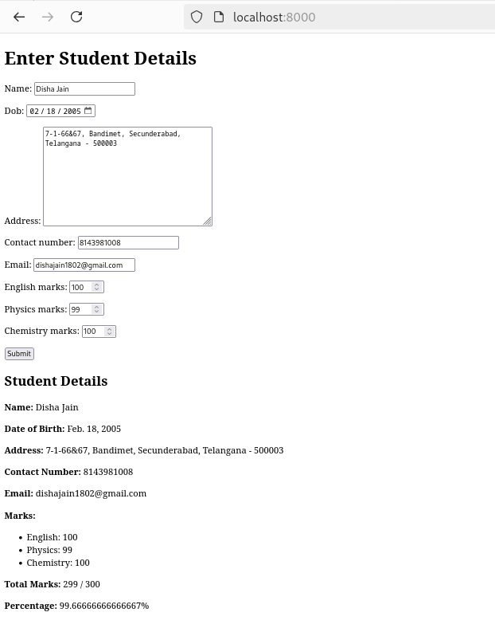

1. Create a web form with employee ids in dropdown list. Use a textbox for accepting date of joining. Add a button named “Am I Eligible for Promotion”. On clicking the button, if he has more than 5 years of experience, then display “YES” else “NO” in the label control.

**q2/urls.py**

from django.contrib import admin

from django.urls import path

from django.conf.urls import include

urlpatterns = [

path('admin/', admin.site.urls),

path('', include('employee.urls')), # This line maps the employee app's URLs

]

**employee/urls.py**

from django.urls import path

from . import views

urlpatterns = [

path('', views.promotion_eligibility, name='promotion_eligibility'),

]

**employee/views.py**

from django.shortcuts import render

def promotion_eligibility(request):

return render(request, 'promotion_form.html')

**employee/templates/promotion_form.html**

<!DOCTYPE html>

<html lang="en">

<head>

<meta charset="UTF-8">

<meta name="viewport" content="width=device-width, initial-scale=1.0">

<title>Employee Promotion Eligibility</title>

<style>

body {

font-family: 'Arial', sans-serif;

background-color: #f4f4f9;

margin: 0;

padding: 0;

display: flex;

justify-content: center;

align-items: center;

height: 100vh;

}

.container {

background-color: #fff;

border-radius: 10px;

padding: 30px;

width: 400px;

box-shadow: 0 4px 6px rgba(0, 0, 0, 0.1);

}

h1 {

text-align: center;

color: #333;

}

label {

font-size: 14px;

color: #555;

margin-bottom: 8px;

display: block;

}

select, input[type="date"] {

width: 100%;

padding: 10px;

margin-bottom: 20px;

border: 1px solid #ddd;

border-radius: 5px;

font-size: 16px;

background-color: #f9f9f9;

}

button {

width: 100%;

padding: 12px;

background-color: #4CAF50;

color: white;

border: none;

border-radius: 5px;

font-size: 16px;

cursor: pointer;

transition: background-color 0.3s;

}

button:hover {

background-color: #45a049;

}

.result {

margin-top: 20px;

padding: 15px;

background-color: #f0f8ff;

border: 1px solid #cce7ff;

border-radius: 5px;

text-align: center;

display: none;

}

.result span {

font-weight: bold;

font-size: 18px;

}

.error {

color: #ff4d4d;

font-size: 14px;

display: none;

}

</style>

</head>

<body>

<div class="container">

<h1>Employee Promotion Eligibility</h1>

<!-- Form for selecting Employee ID and entering Date of Joining -->

<form id="promotionForm">

<label for="employee_id">Select Employee ID:</label>

<select id="employee_id">

<option value="E001">E001</option>

<option value="E002">E002</option>

<option value="E003">E003</option>

<option value="E004">E004</option>

<option value="E005">E005</option>

</select>

<label for="date_of_joining">Date of Joining:</label>

<input type="date" id="date_of_joining" required>

<button type="button" onclick="checkPromotionEligibility()">Am I Eligible for Promotion?</button>

<!-- Error Message -->

<div class="error" id="errorMessage">Please enter the Date of Joining.</div>

</form>

<!-- Result Display Section -->

<div class="result" id="resultSection">

<p><strong>Eligibility:</strong> <span id="eligibilityResult"></span></p>

</div>

</div>

<script>

function checkPromotionEligibility() {

// Get the selected employee ID and Date of Joining

const employeeId = document.getElementById('employee_id').value;

const dateOfJoining = document.getElementById('date_of_joining').value;

const errorMessage = document.getElementById('errorMessage');

const resultSection = document.getElementById('resultSection');

const eligibilityResult = document.getElementById('eligibilityResult');

// Clear previous results

resultSection.style.display = 'none';

errorMessage.style.display = 'none';

if (!dateOfJoining) {

errorMessage.style.display = 'block';

return;

}

// Convert the date of joining to a Date object

const joiningDate = new Date(dateOfJoining);

const currentDate = new Date();

// Calculate the difference in years

let yearsOfExperience = currentDate.getFullYear() - joiningDate.getFullYear();

// Adjust for cases where the employee hasn't had their birthday yet this year

if (currentDate.getMonth() < joiningDate.getMonth() ||

(currentDate.getMonth() === joiningDate.getMonth() && currentDate.getDate() < joiningDate.getDate())) {

yearsOfExperience--;

}

// Check if the employee is eligible for promotion

let eligibility = "NO";

if (yearsOfExperience >= 5) {

eligibility = "YES";

}

// Display the result

eligibilityResult.textContent = eligibility;

resultSection.style.display = 'block';

}

</script>

</body>

</html>

