Practical No 04
Configure IP ACLs to Mitigate Attacks and IPV6 ACLs

Network:
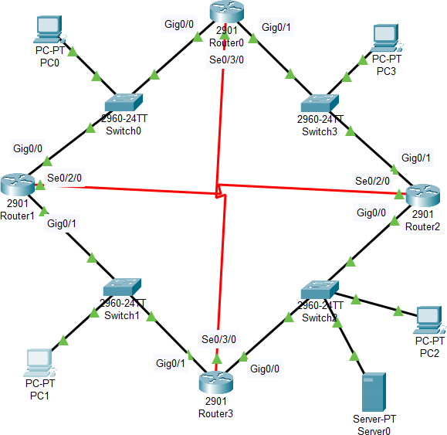

Network ID | Device | Interface | IPv6 Address | Prefix | Default  Gateway
2028:DB8:1::/64 | Router0 | G0/0 | 2028:DB8:1::1 | /64 | —
2028:DB8:1::/64 | Router1 | G0/0 | 2028:DB8:1::2 | /64 | —
2028:DB8:1::/64 | PC0 | NIC | 2028:DB8:1::10 | /64 | 2028:DB8:1::1
2028:DB8:2::/64 | Router0 | G0/1 | 2028:DB8:2::1 | /64 | —
2028:DB8:2::/64 | Router2 | G0/1 | 2028:DB8:2::2 | /64 | —
2028:DB8:2::/64 | PC3 | NIC | 2028:DB8:2::3 | /64 | 2028:DB8:2::1
2028:DB8:3::/64 | Router0 | S0/3/0 | 2028:DB8:3::1 | /64 | —
2028:DB8:3::/64 | Router3 | S0/3/0 | 2028:DB8:3::2 | /64 | —
2028:DB8:4::/64 | Router2 | G0/0 | 2028:DB8:4::1 | /64 | —
2028:DB8:4::/64 | Router3 | G0/0 | 2028:DB8:4::2 | /64 | —
2028:DB8:4::/64 | PC2 | NIC | 2028:DB8:4::3 | /64 | 2028:DB8:4::1
2028:DB8:4::/64 | Server0 | NIC | 2028:DB8:4::4 | /64 | 2028:DB8:4::1
2028:DB8:5::/64 | Router1 | S0/2/0 | 2028:DB8:5::2 | /64 | —
2028:DB8:5::/64 | Router2 | S0/2/0 | 2028:DB8:5::1 | /64 | —
2028:DB8:6::/64 | Router1 | G0/1 | 2028:DB8:6::1 | /64 | —
2028:DB8:6::/64 | Router3 | G0/1 | 2028:DB8:6::2 | /64 | —

IP to the Router:
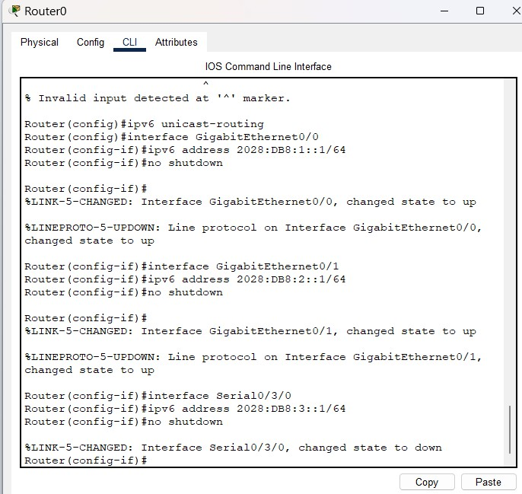
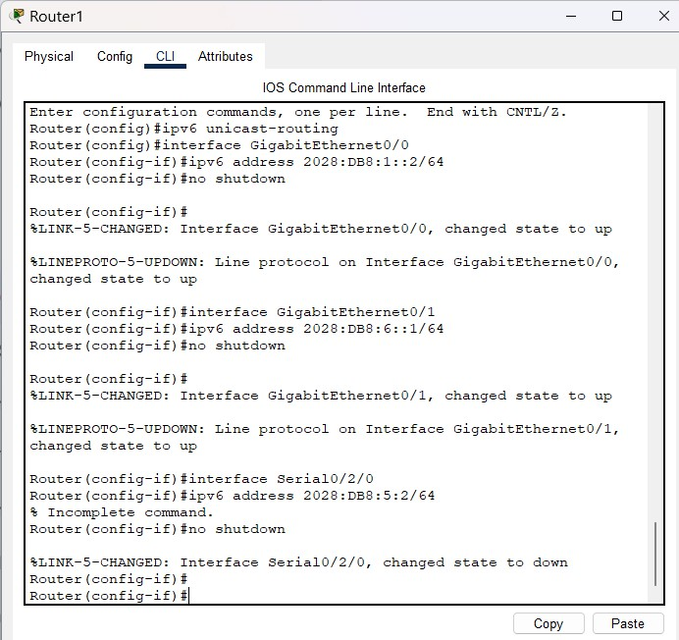

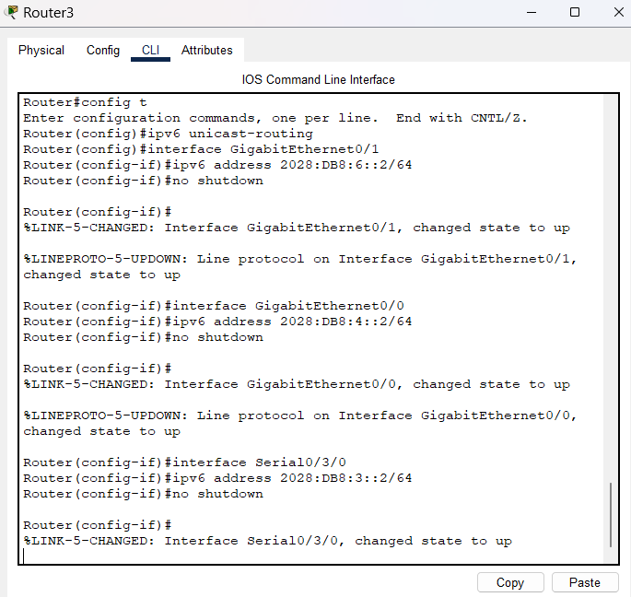
Rip routing:
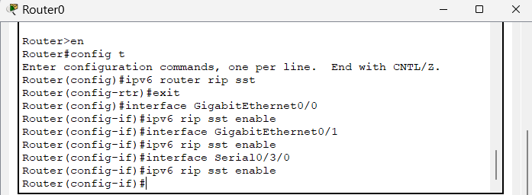
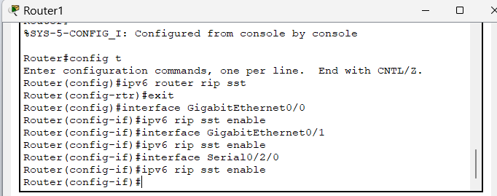
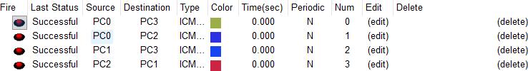
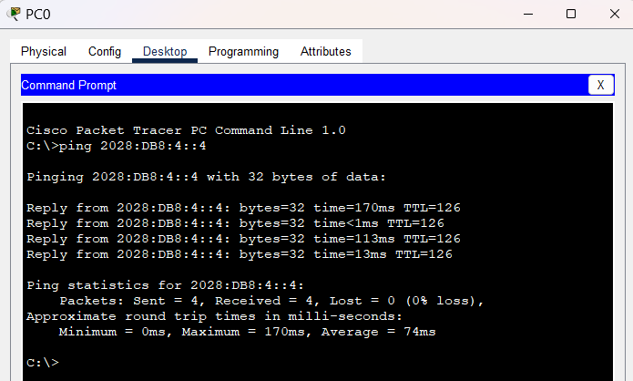

ACL command on Router3:
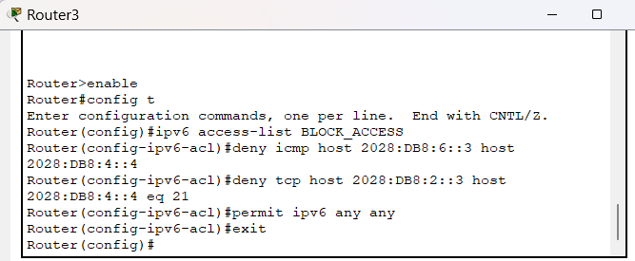
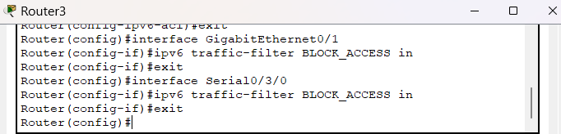

FTP restrict for PC3:
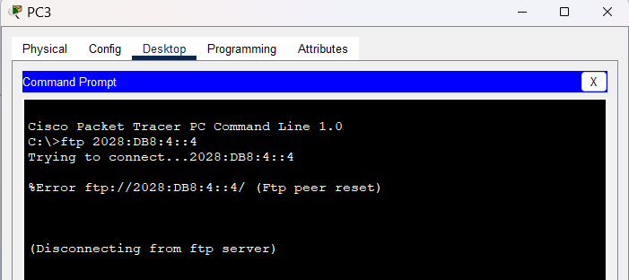
Other pc can access:
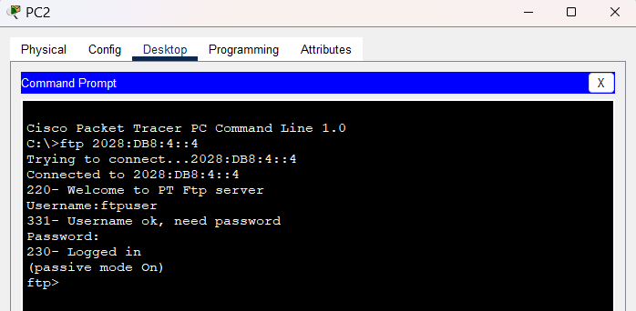
Restrict ping command for PC1:
