**CONTAINER & ORCHESTRATION**

**LAB-ASSIGNMENT NO -2**

**AIM :**  **CREATE YOUR OWN IMAGE ,CONFIGURE YOUR OWN SPACE IN DOCKER HUB AND PUSH YOUR IMAGE INTO DOCKERHUB WORKSPACE.DELETE PREVIOUSLY AVAILABLE IMAGES FROM YOUR LOCAL MACHINE. AND PULL YOUR OWN IMAGE FROM DOCKER HUB.**

**STEP-1 : CREATE & LAUNCH EC2 INSTANCE**

Name – EC2-DOCKER -01

Application & Os Image- Ubuntu Server 20.04 Lts (Hvm) , Ssd Volume Type

Instance Type – T2 Micro

Key Pair – hhh.Pem

Security Group – Docker

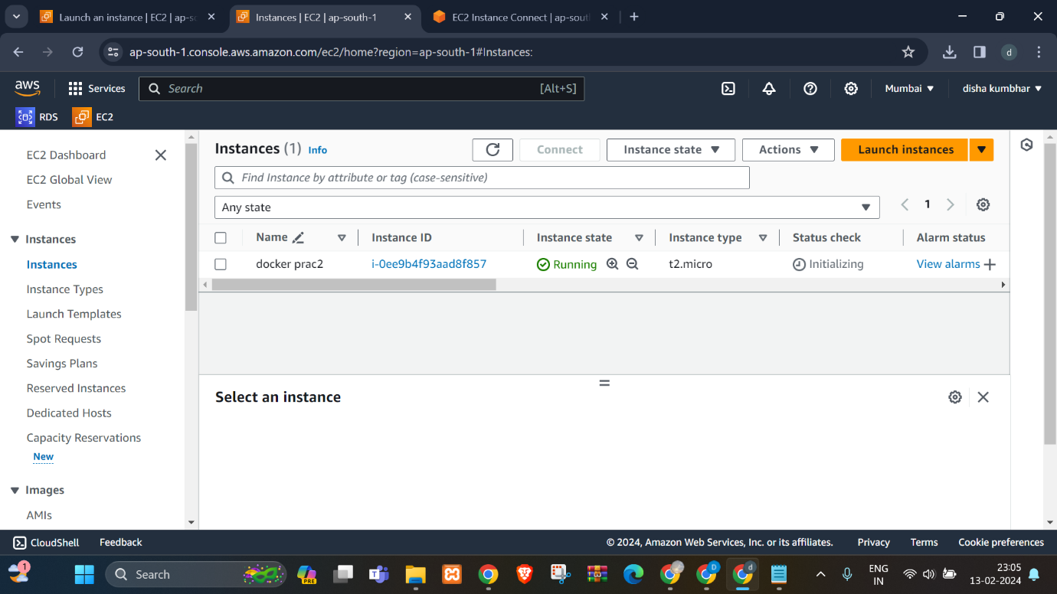

**STEP-2 : INSTALL DOCKER ON EC2 MACHINE**

Set Up Docker Repositories , Add GPG Key & Install Docker Engine :

COMMANDS :

1 Update System:

sudo apt update –y

2 Set Up Repository:

sudo apt install \

apt-transport-https \

ca-certificates \

curl \

gnupg-agent \

software-properties-common

3 Add Dockers Official GPG Key

curl –fsSl <https://download.docker.com/linux/ubuntu/gpg> | sudo apt-key add –

sudo add-apt-repository \

“deb [arch=amd64] [https://download.docker.com/linux/ubuntu \](https://download.docker.com/linux/ubuntu%20\)

$(lsb_release –cs) \

stable “

4 Install Docker Engine

sudo apt install docker-ce docker-ce-cli containerd.io –y

5 Check Containers Status

systemctl status docker

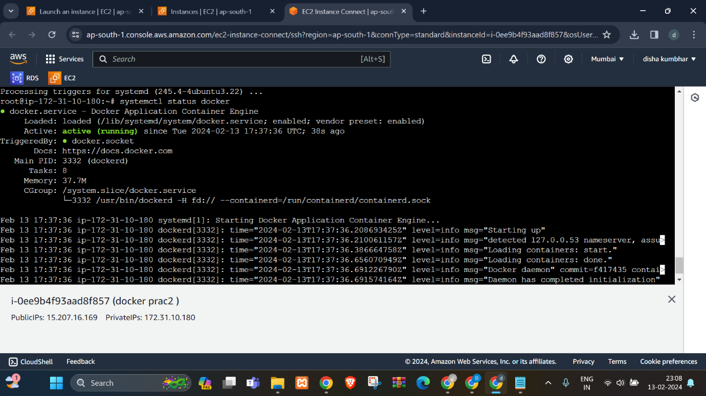

**STEP 3: CREATE DOCKER IMAGE**

Create docker image using following content:

#this is sample image

FROM Ubuntu

MAINTAINER dishapkumbhar@gmail.com

RUN apt update –y

RUN apt install nginx –y

CMD [“echo”,”this image is created by disha”]

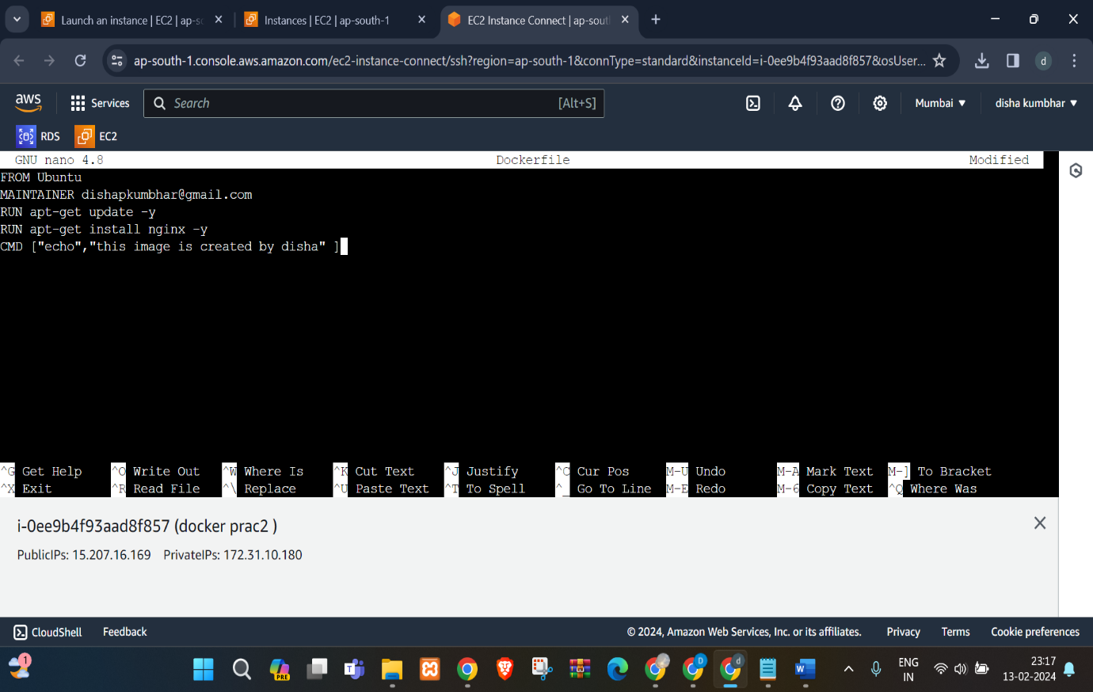

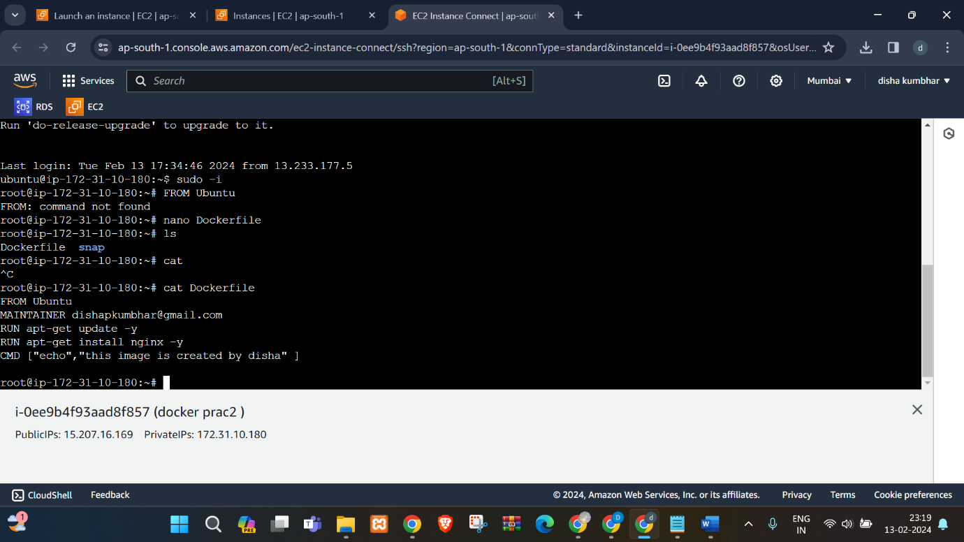

**STEP 4: BUILD DOCKER IMAGE**

COMMAND : docker build –t image_name:tag /path of docker file

$docker build –t disha:01 .

**STEP 5 : CREATE A NEW PU BLIC REPOSITORY ON DOCKER HUB**

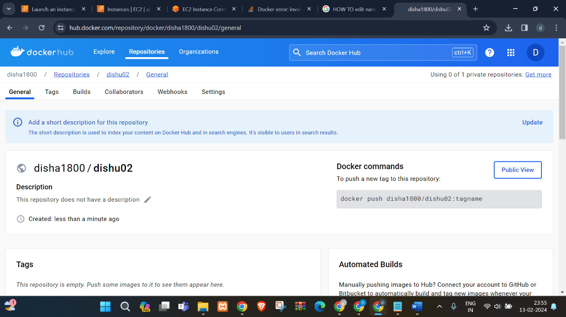

**STEP 6: ADD TAG TO IMAGE**

Command: docker tag image_name:tag docker_repository_name:tag

$sudo docker tag disha:01 disha1800/dishu02

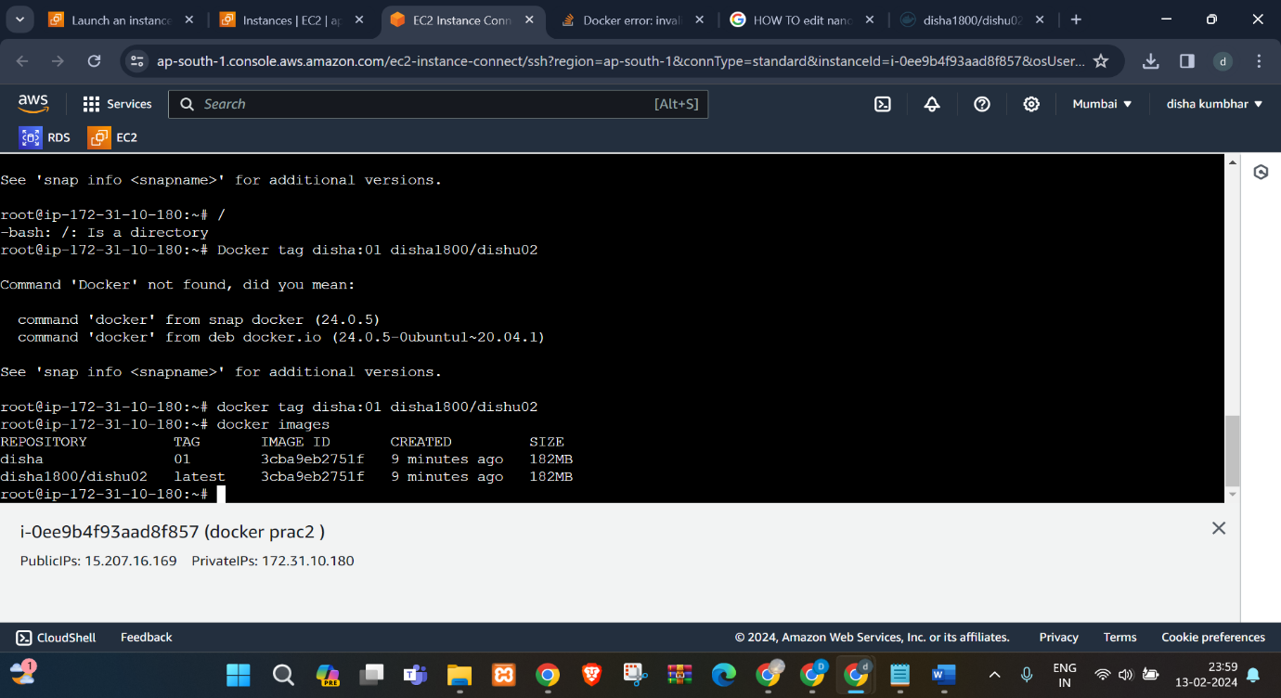

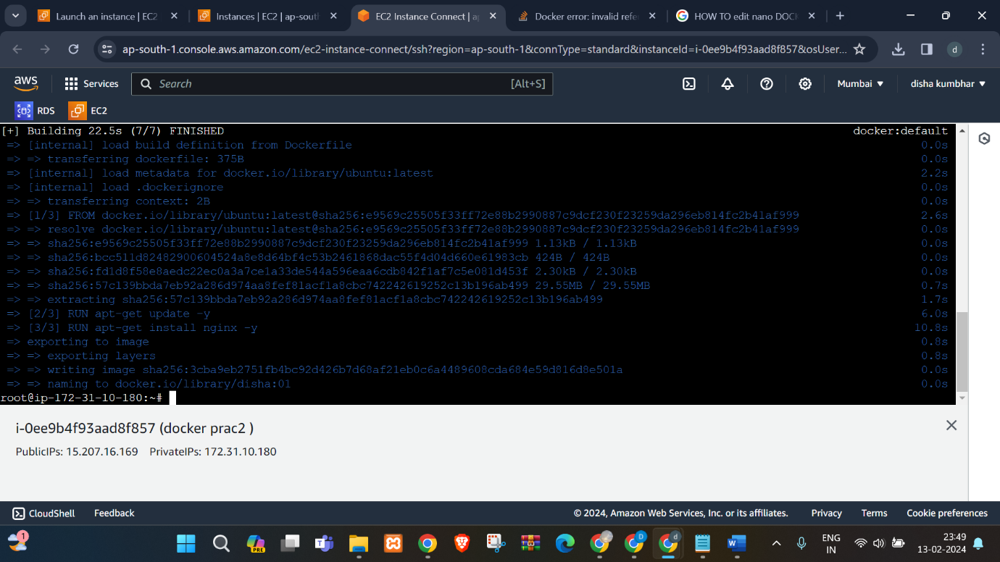

**STEP 7: PUSH IMAGE TO DOCKER HUB**

1-login docker hub in your linux terminal with your credentials

2- push docker image to docker hub :

Command : docker push image_name_with_dockerhub_repository:tag

$docker push disha1800/dishu02

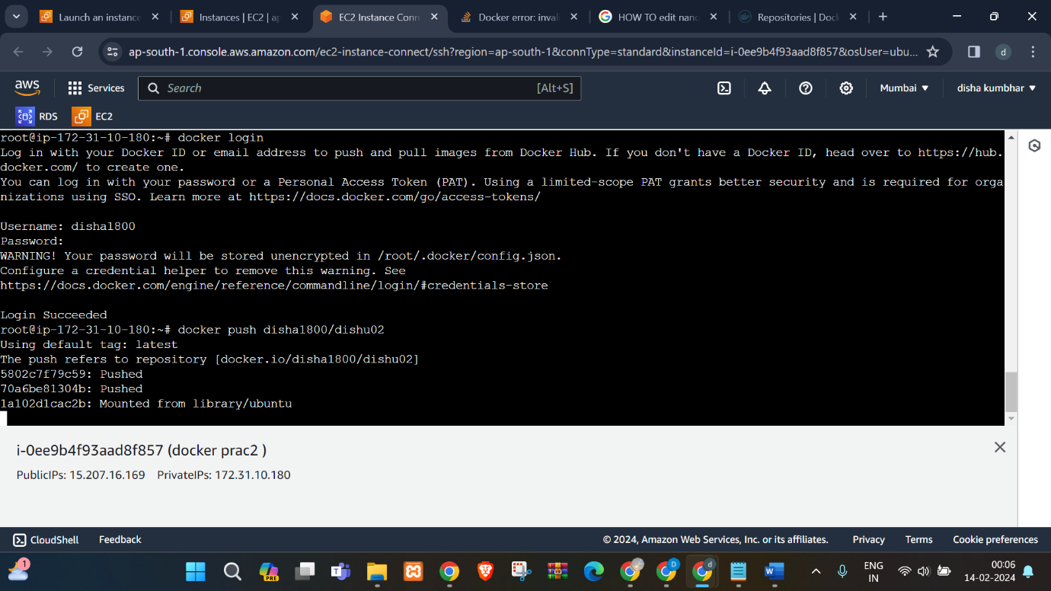

**STEP 8: PULL AND RUN YOUR OWN IMAGE FROM DOCKER HUB**

Pull and run your own images from docker hub:

Command: $docker run disha1800/dishu02

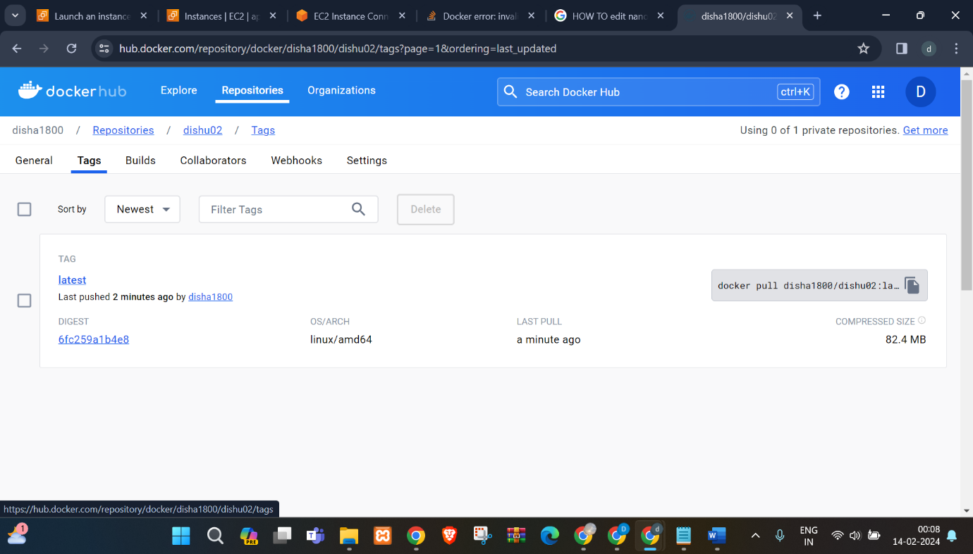

**STEP 9: DELETE AVAILABLE IMAGES FROM LOCAL MACHINE**

Command: docker rmi –f image_id

$docker rmi –f c215d9119d4f

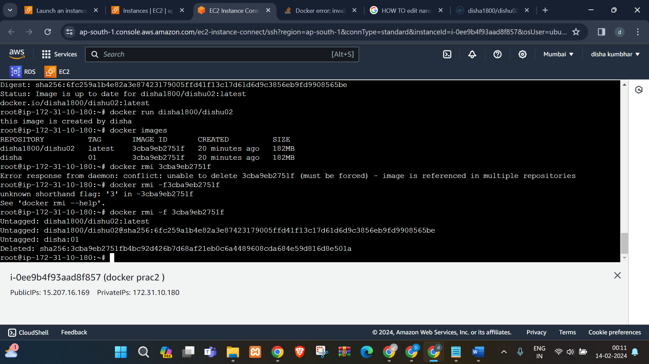

**Sign**

**Subject In charge**

Dr. Swapnil D. Waghmare