**CONTAINER & ORCHESTRATION**

**LAB-ASSIGNMENT NO -03**

**AIM :**  **Pull Jenkins Image from Docker Hub, Expose Data Port & Control Port and align both Ports on Docker Engine**

**STEP -1 : CREATE SECURITY GROUP**

name – docker

inbound rules-

1. ssh
2. http
3. https
4. all traffic

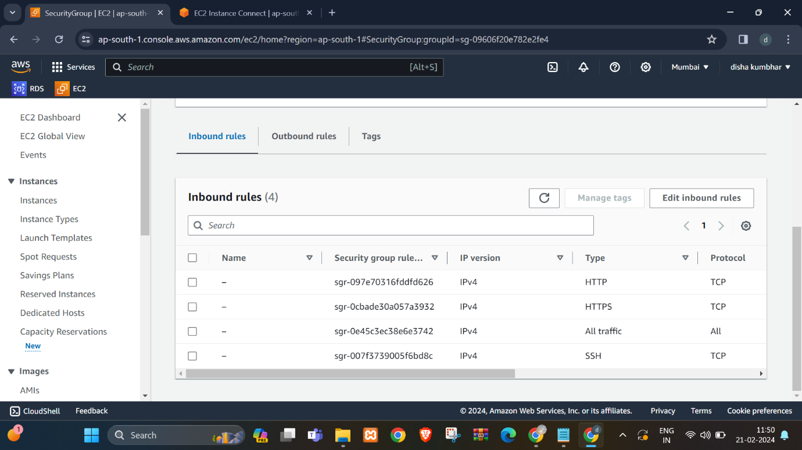

**STEP-2 : CREATE & LAUNCH EC2 INSTANCE**

Name – EC2-DOCKER -01

Application & Os Image- Ubuntu Server 20.04 Lts (Hvm) , Ssd Volume Type

Instance Type – T2 Micro

Key Pair – DISHA.Pem

Security Group – Docker

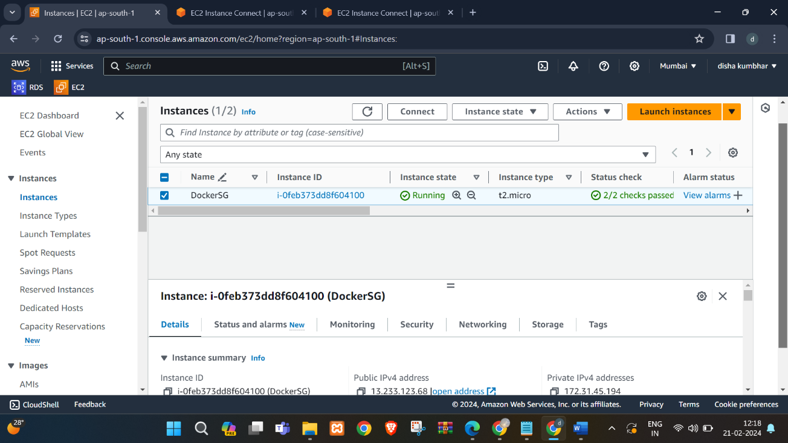

**STEP-3 : INSTALL DOCKER ON EC2 MACHINE**

Set Up Docker Repositories , Add GPG Key & Install Docker Engine :

COMMANDS :

1 Update System:

sudo apt update –y

2 Set Up Repository:

sudo apt install \

apt-transport-https \

ca-certificates \

curl \

gnupg-agent \

software-properties-common

3 Add Dockers Official GPG Key

curl –fsSl <https://download.docker.com/linux/ubuntu/gpg> | sudo apt-key add –

sudo add-apt-repository \

“deb [arch=amd64] [https://download.docker.com/linux/ubuntu \](https://download.docker.com/linux/ubuntu%20\)

$(lsb_release –cs) \

stable “

4 Install Docker Engine

sudo apt install docker-ce docker-ce-cli containerd.io –y

5 Check Containers Status

systemctl status docker

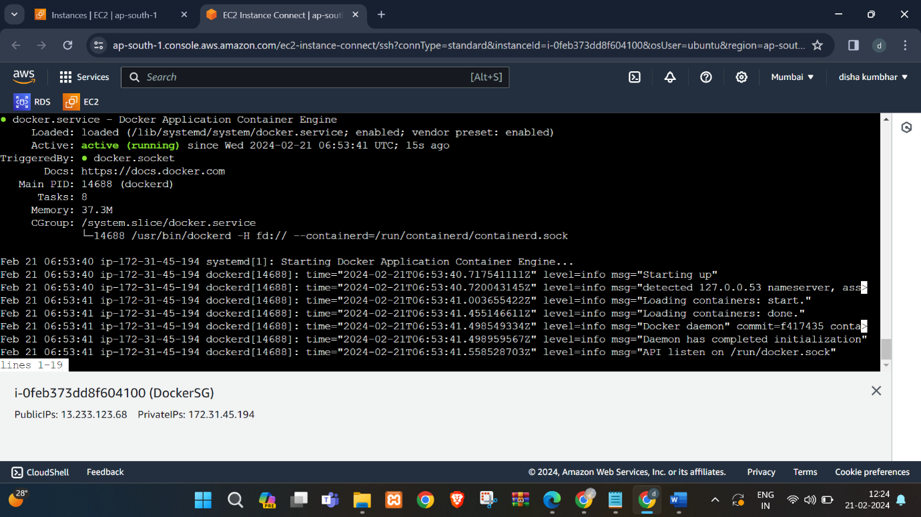

**STEP -4: Docker pull Jenkins**

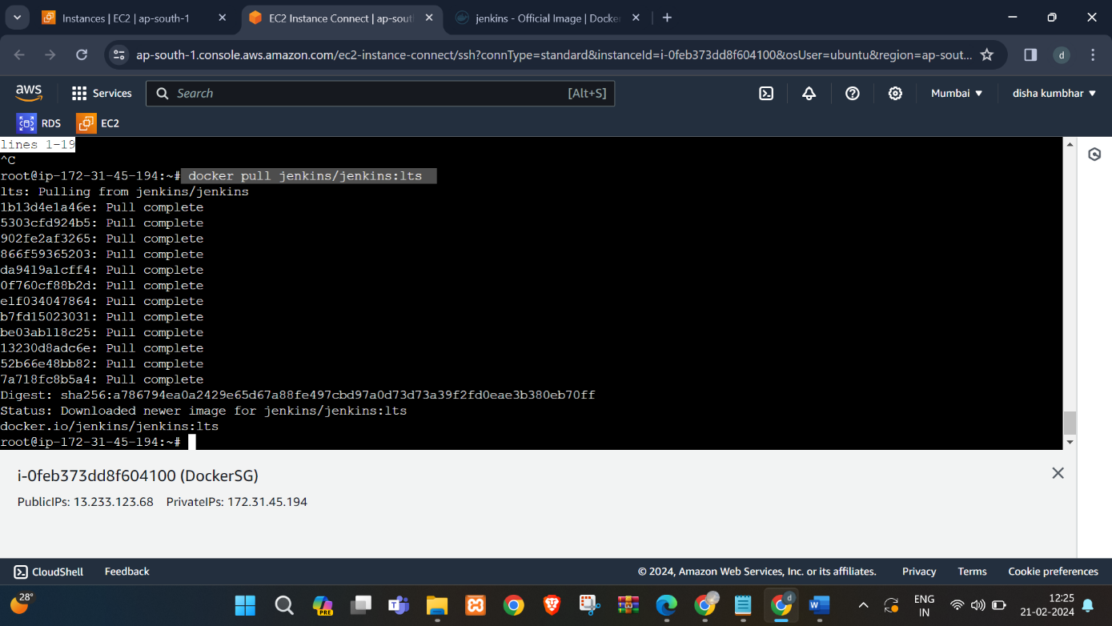

**STEP -5 : Check Docker images and inspect docker**

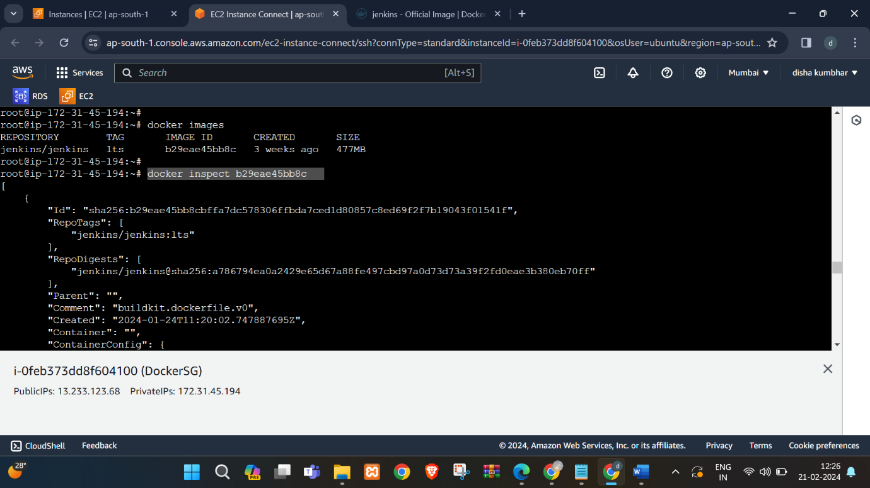

**STEP-6 Run Docker on port 8080 from client side and 50000 from server side**

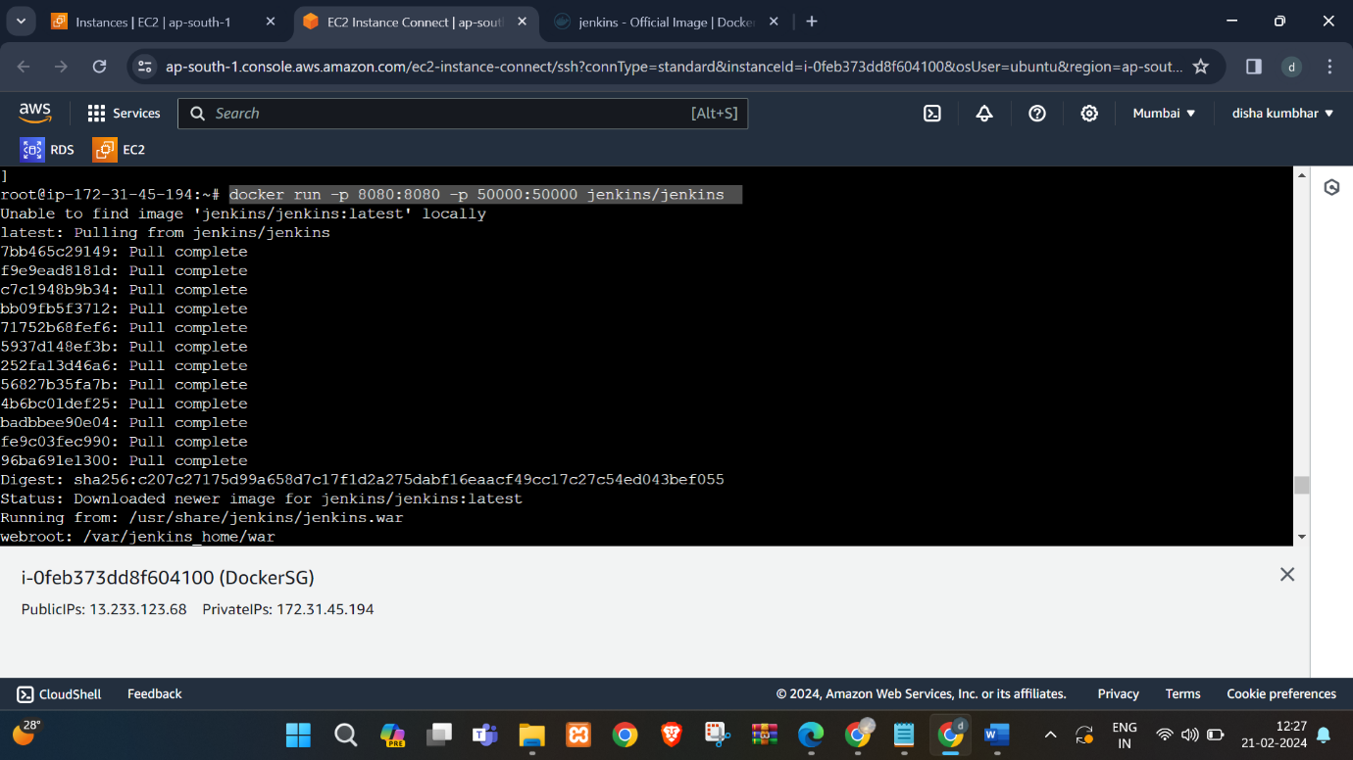

**STEP -7 : : Copy public IP and password paste it new tab with port 8080 and past password**

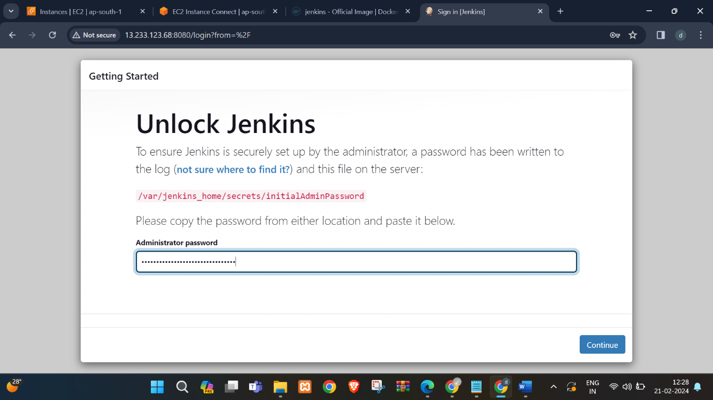

**STEP-8: Login to Jenkins Dashboard**

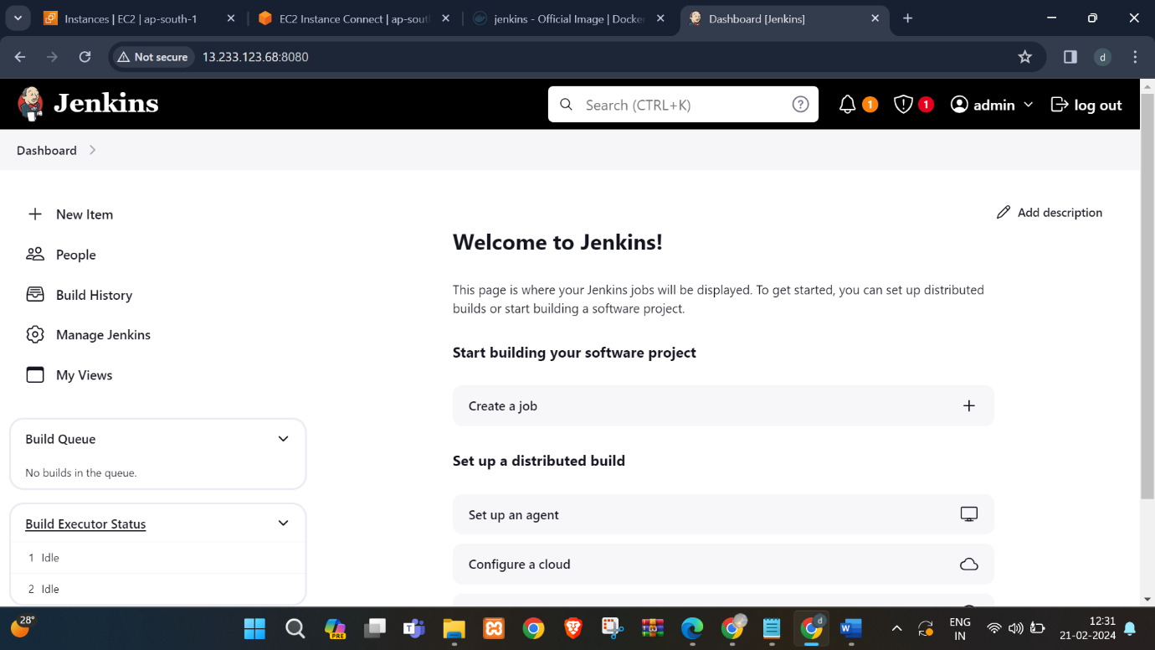

**STEP-9: Create A Job**

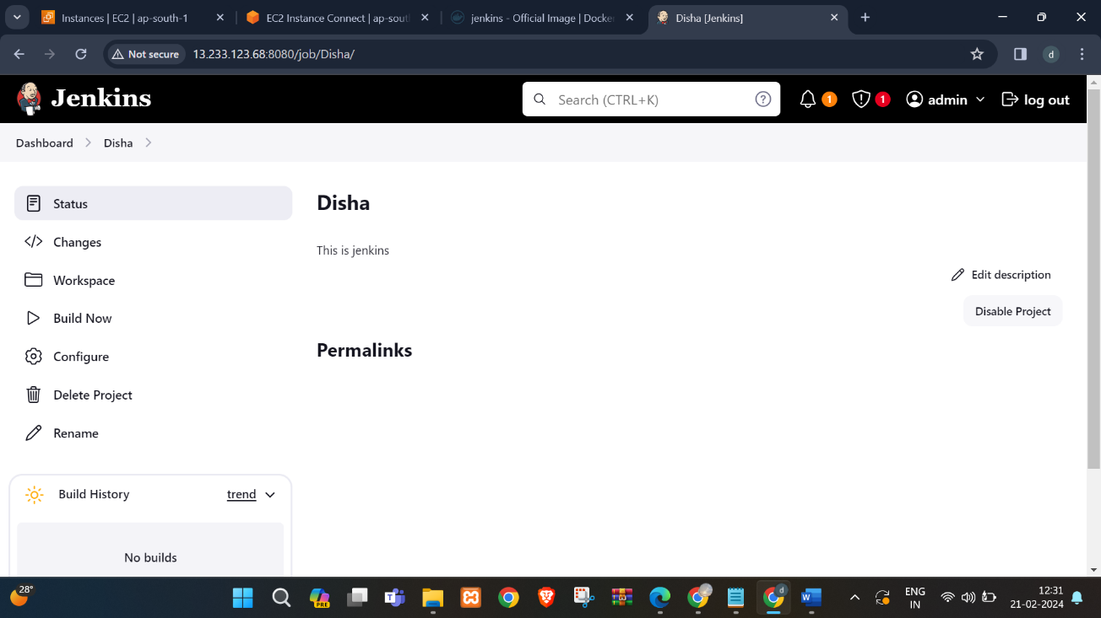

**STEP -10: Copy public IP and past it on new tab with port 50000**

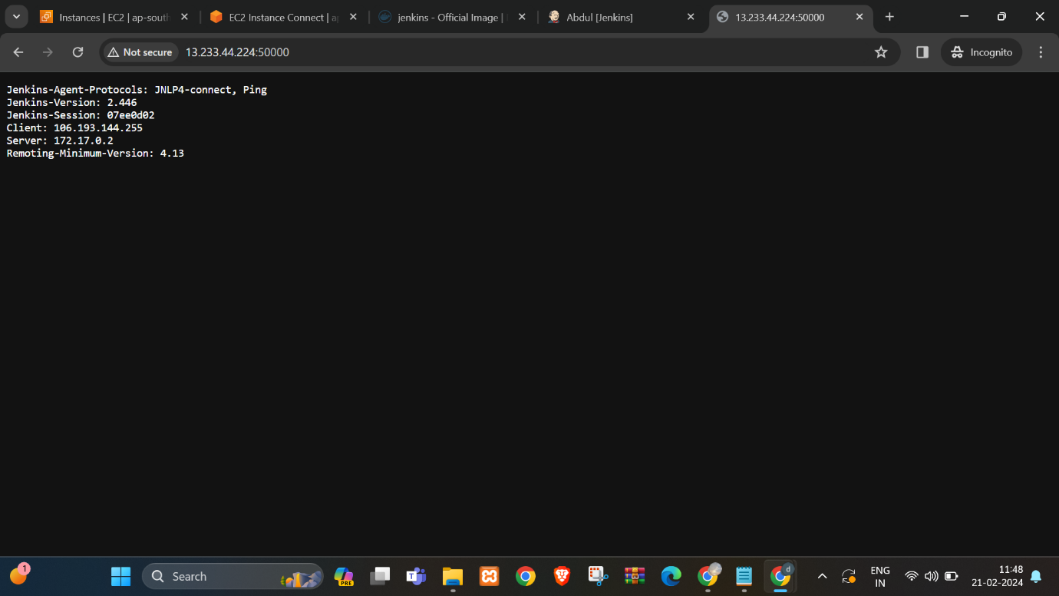

**Sign**

**Subject In charge**

Dr. Swapnil D. waghmare