

**School of Computer Science Engineering and Application**

**BCA TY SEM VI**

**Subject Name: Container and Orchestration Practical**

**Assignment No: 4**

**Aim: - Create private registry on local host and push any image in private registry**

**Submitted By**

**Name: Disha Kumbhar**

**PRN: 20210801140**

**Date: (28-02-2024)**

**Aim: - Create private registry on local host and push any image in private registry**

**Technology Used: Docker, Container, AWS**

**Step 1: Launch the instance and install docker and check its status .**

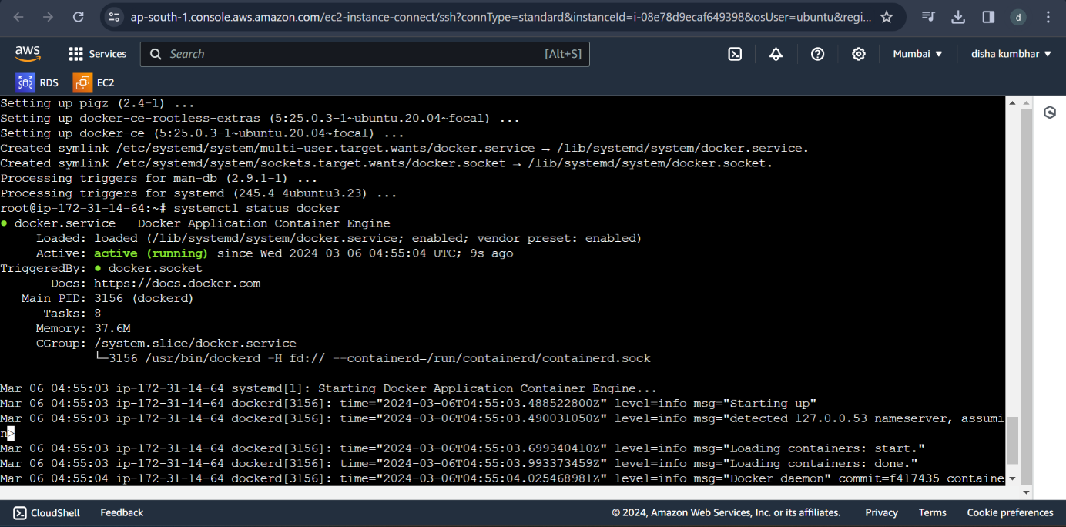

**Step 2: Search registry on docker hub and pull the registry from there**

**Command: $docker pull registry or registry:lastest**

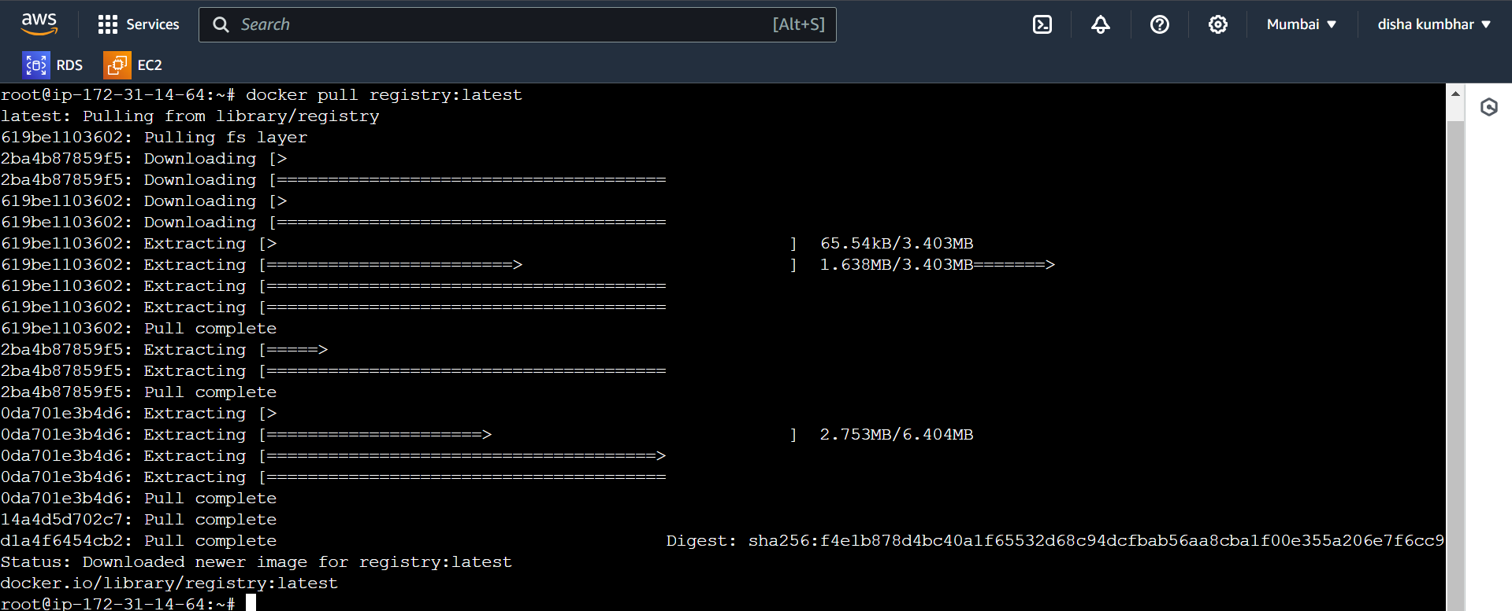

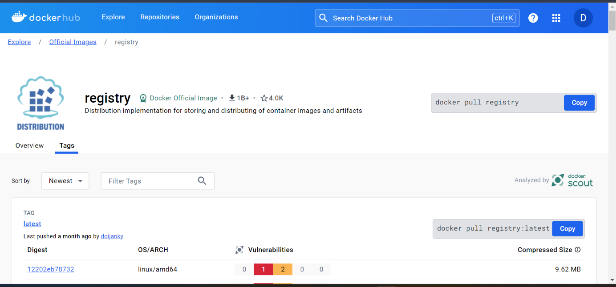

**Step 3: Run the docker**

**Cmd: $docker run -d -p 5000:5000 –name registry registry:latest**

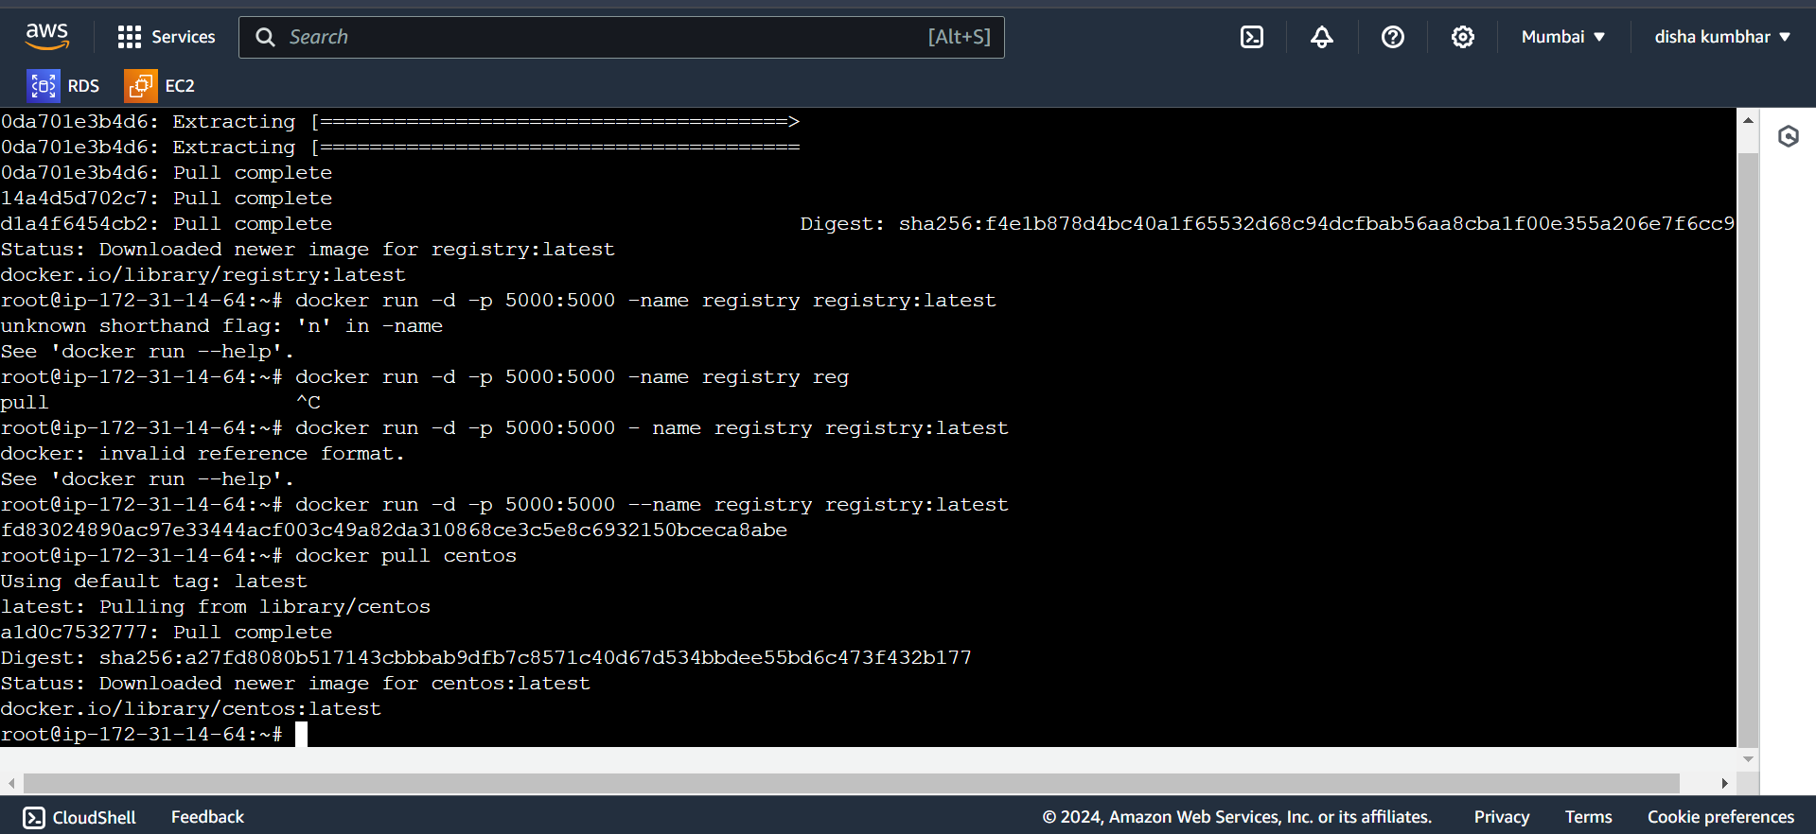

**Step 4: Pull any image from the docker hub**

**Cmd: docker pull centos**



**Step 5: Tag the image centos to private registry**

**Cmd: $sudo docker tag imageid (id of the centos) localhost:5000/centos**

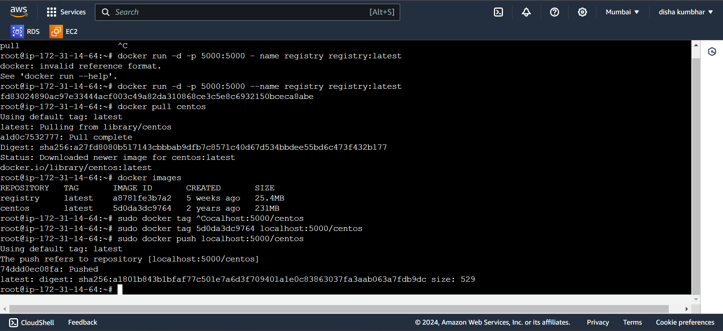

**Step 6: Push the image to the private registry**

**Cmd: $sudo docker push localhost:5000/centos**



**Step 7: After pushing the image in the private registry remove it   
Cmd: docker rmi –force imageid(centos)**

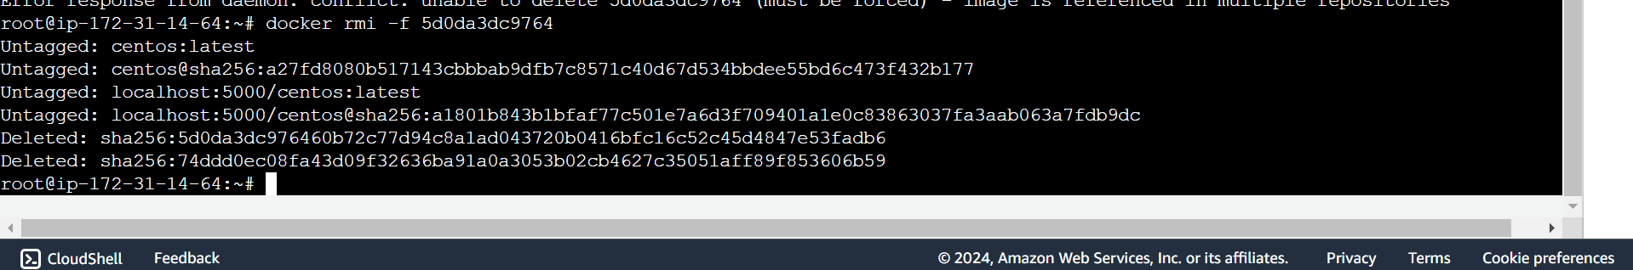

**Step 8: Pull the image from the private registry**

**Cmd: $docker pull localhost:5000/centos**

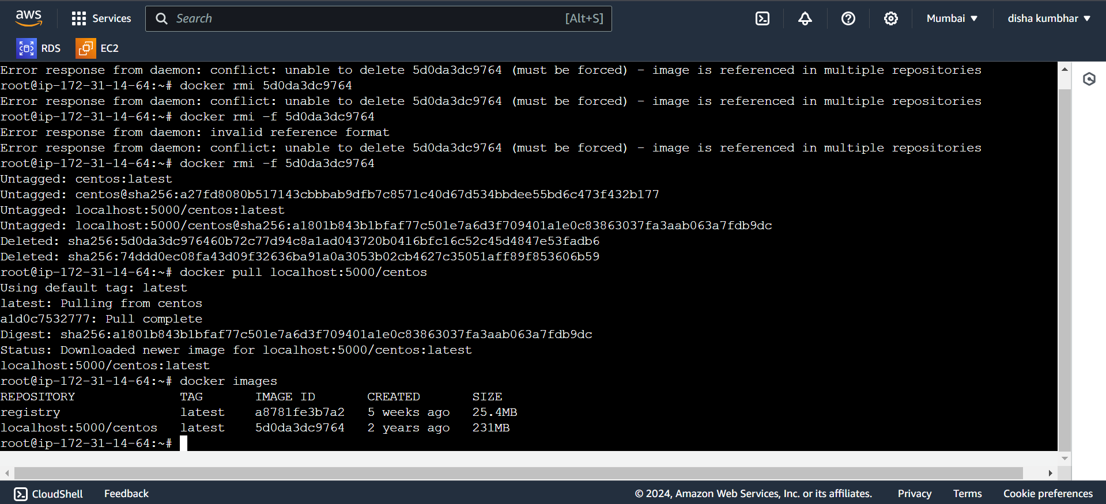

**End**

**Sign**

**Subject In charge: Dr. Swapnil Waghmare**