

**School of Computer Science Engineering and Application**

**BCA TY SEM VI**

**Subject Name: Container and Orchestration Practical**

**Assignment No 5**

**Aim: - Create private registry on local host and push any image in private registry**

**Submitted By**

**Name: Disha Kumbhar**

**PRN: 20210801140**

**Date: (06-03-2024)**

**Aim: - Create private registry on local host and push any image in private registry**

**Technology Used: Docker, Container, AWS**

**Step 1: Browse for ECS (Elastic container service) and create cluster for EC2 instance type**

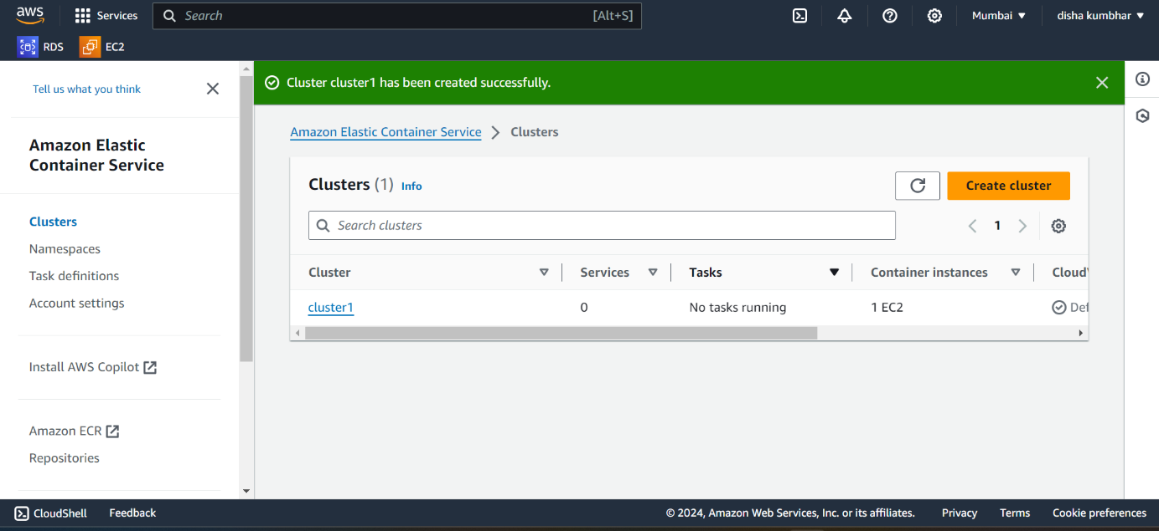

**Step 2: After that create task definitions for the respective cluster**

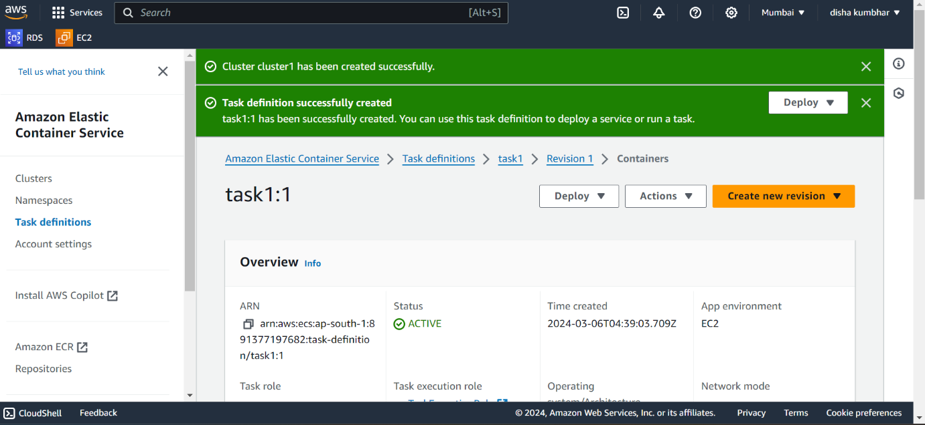

**Step 3: Deploy the created task and check for the running instances in EC2**

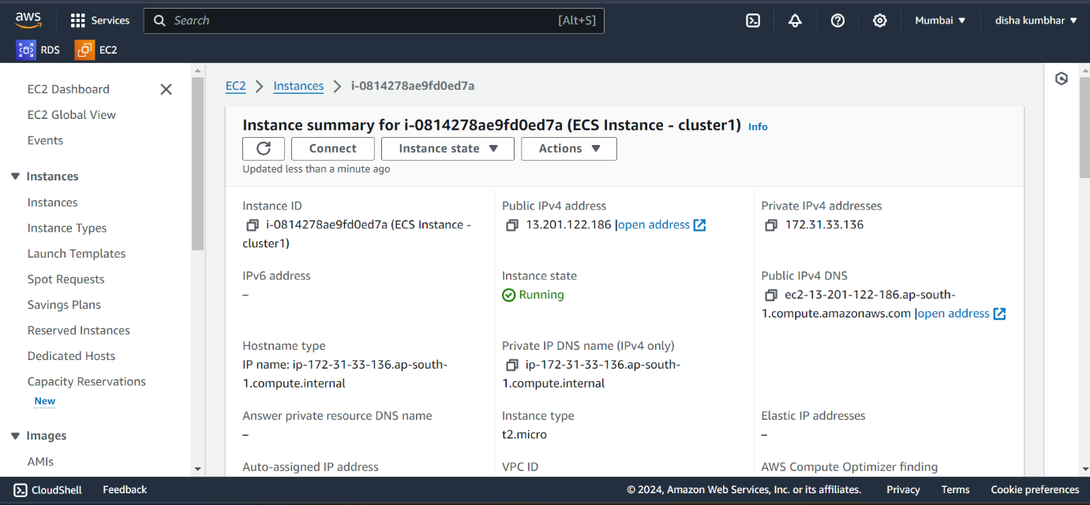

**Step 4: Connect the instance using the third-party connection using the SSH client in your windows powershell**

**Note: - To connect the SSH client the key.pem pair should be installed in your system otherwise it will deny the permission to connect.**

**Cmd: $docker ps**

**To show the image we installed (httpd)**

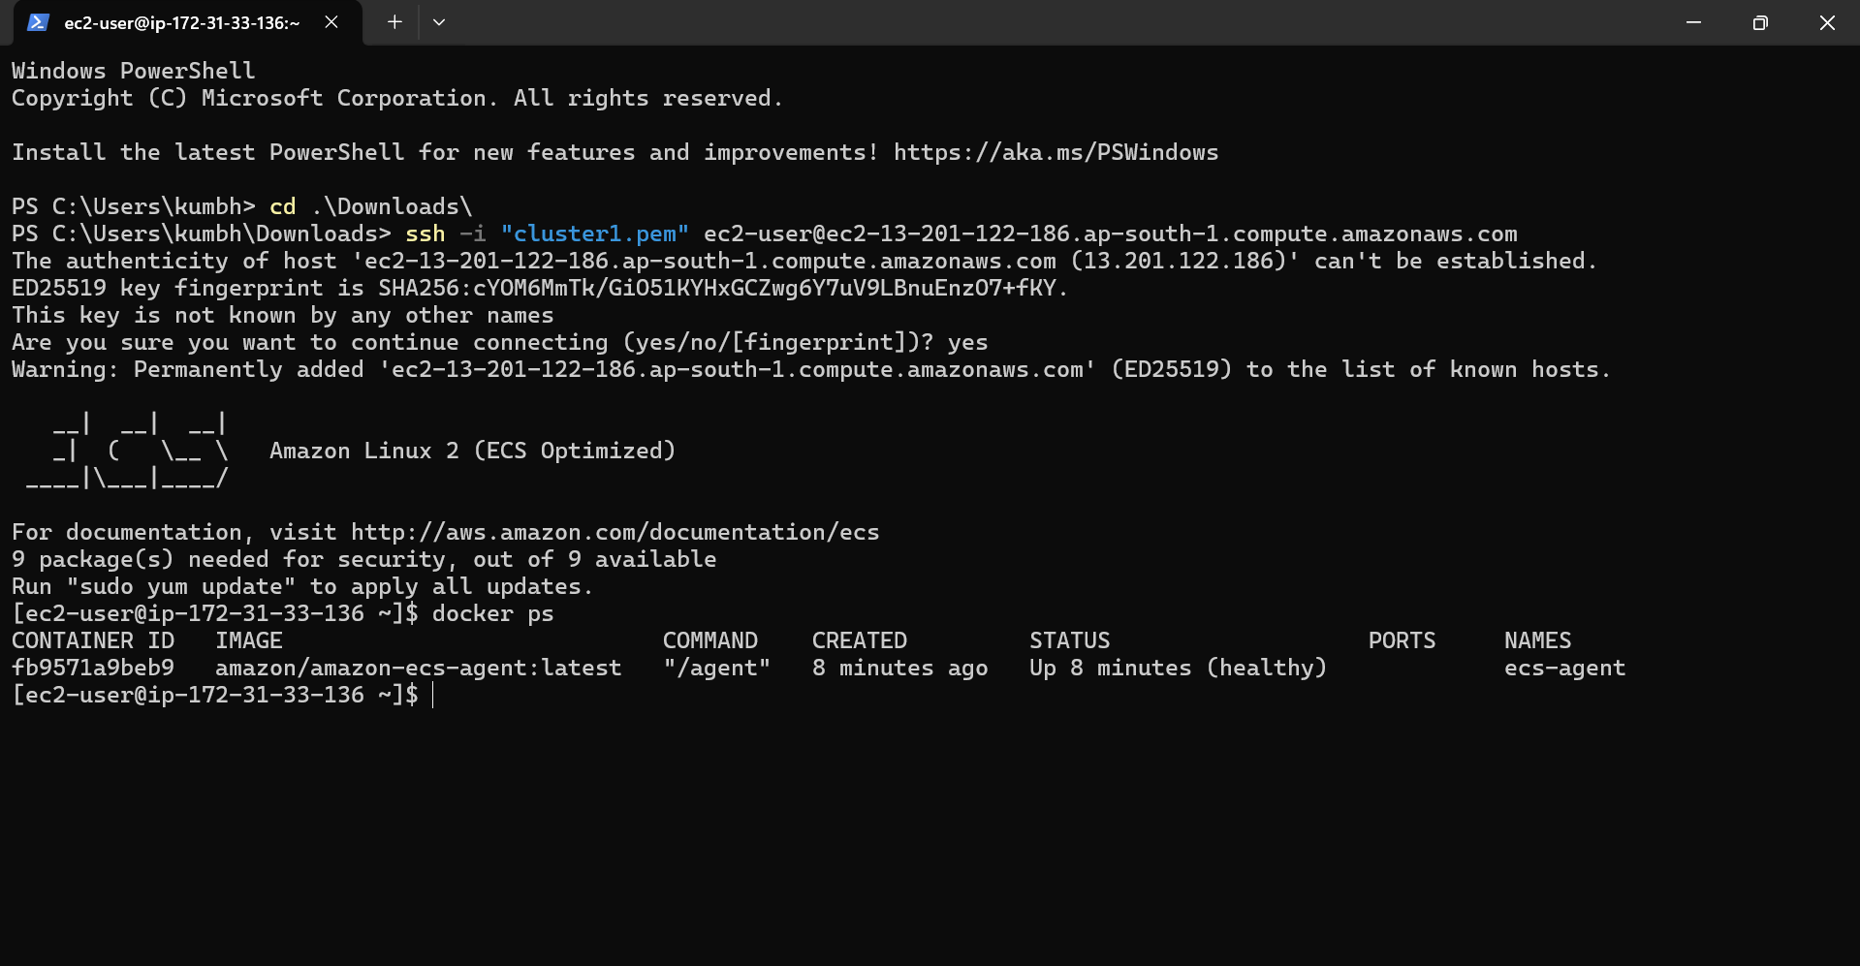

**Step 5: To delete the task first deregister the service it will delete automatically and then delete the cluster until it gets inactive**

**Step 6: Create second cluster for Fargate(serverless)**

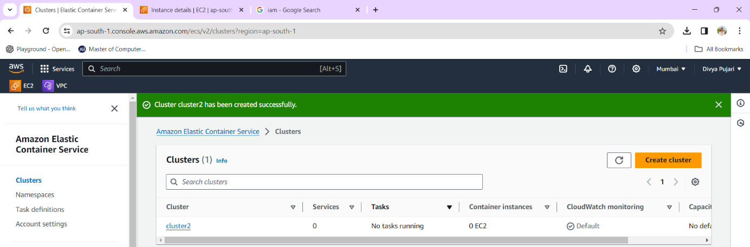

**Step 7: Create task definitions**

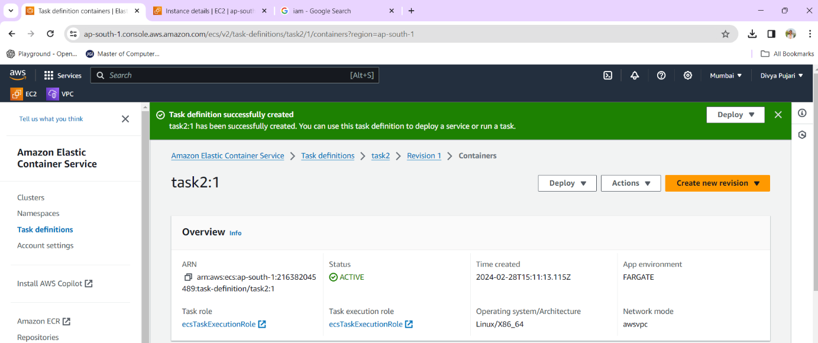

**Step 8: Deploy the task**

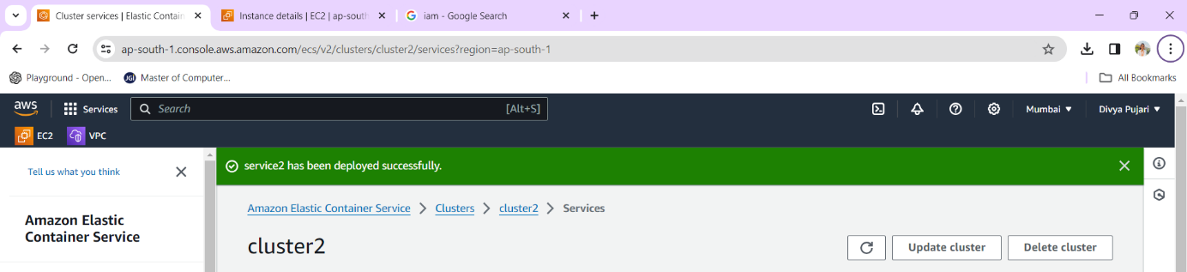

**Step 9: Go to cluster>task>click on the task>open the public ip address to know whether the service is working or not**

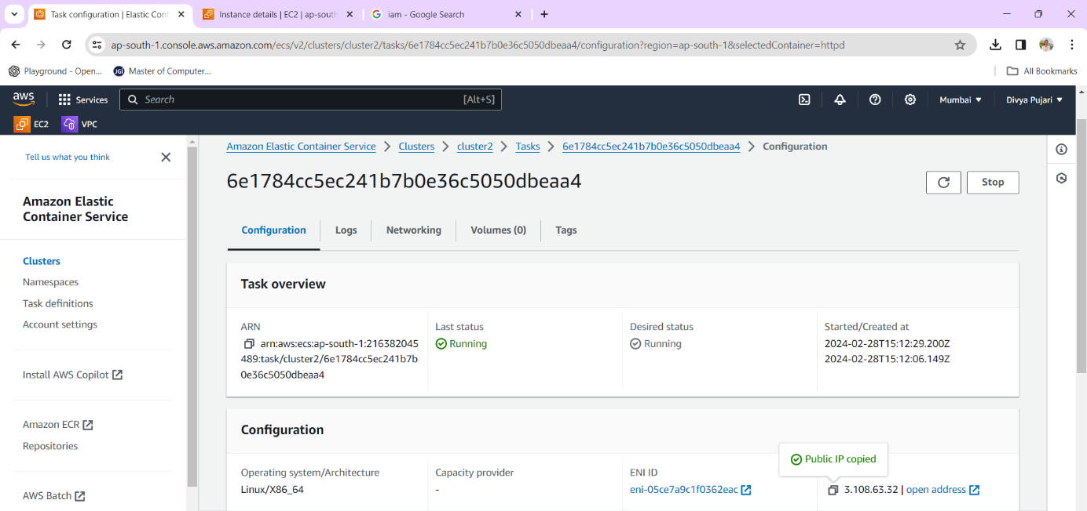

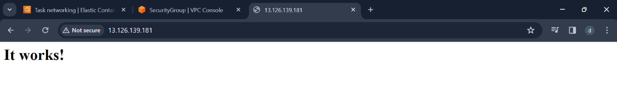

**Step 10: Deregister the task and delete the cluster**

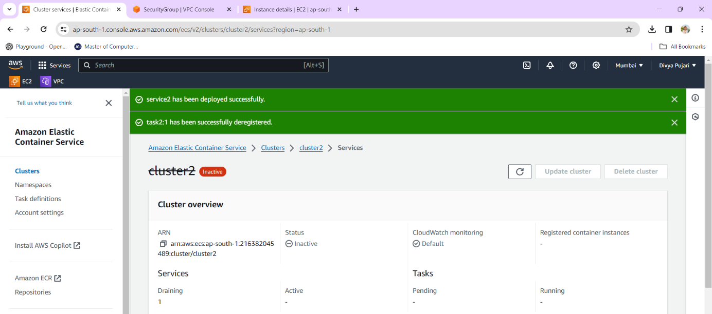

**End**

**Sign**

**Subject In charge: Dr. Swapnil Waghmare**