

Foundations of Programming
Assignment No. : 5
PROBLEM STATEMENT:
Write a program in C to perform basic matrix operations such as:
1. Addition of two matrices
2. Saddle point of a matrix
3. Inverse of a matrix
4. Magic square of a matrix

OBJECTIVE:
• To understand matrix representation in C using two-dimensional arrays.
• To implement various matrix operations using C programming.
• To develop logical thinking for solving matrix-based problems.

THEORY:
Matrix operations are widely used in engineering and scientific applications. Addition of matrices involves adding corresponding elements. A saddle point is an element that is the minimum in its row and maximum in its column. The inverse of a matrix exists only for square matrices with non-zero determinant. A magic square is a square matrix in which the sums of elements in each row, column, and diagonals are equal.
- Addition of two matrices
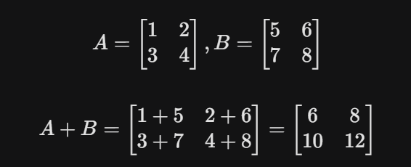

- Saddle point of a matrix
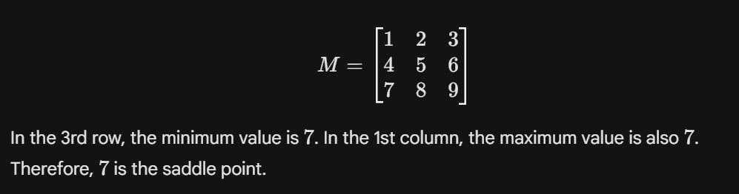
3. Inverse of a matrix
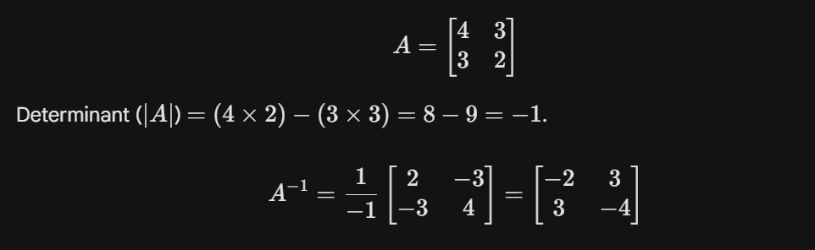
4. Magic square of a matrix
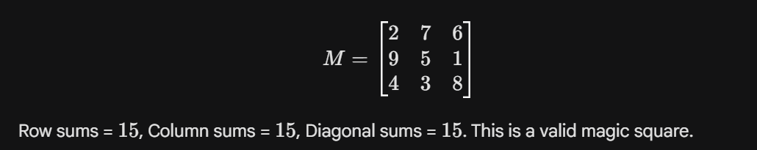

PLATFORM:
Linux

ALGORITHM:
1. Start
2. Read the order of the matrix
3. Read elements of the matrices
4. Perform matrix addition
5. Check for saddle point
6. Find inverse of the matrix (if determinant ≠ 0)
7. Check whether the matrix is a magic square
8. Display results
9. Stop

C PROGRAM: (Type C Program)
#include <stdio.h>
#include <stdlib.h>

void addMatrices() {
int r, c, i, j;
printf("Enter rows and columns: ");
scanf("%d %d", &r, &c);
int a[r][c], b[r][c], sum[r][c];

printf("Enter elements of 1st matrix:\n");
for(i = 0; i < r; i++)
for(j = 0; j < c; j++)
scanf("%d", &a[i][j]);

printf("Enter elements of 2nd matrix:\n");
for(i = 0; i < r; i++)
for(j = 0; j < c; j++)
scanf("%d", &b[i][j]);

printf("Sum of matrices:\n");
for(i = 0; i < r; i++) {
for(j = 0; j < c; j++) {
sum[i][j] = a[i][j] + b[i][j];
printf("%d ", sum[i][j]);
}
printf("\n");
}
}

void saddlePoint() {
int r, c, i, j, k;
printf("Enter rows and columns: ");
scanf("%d %d", &r, &c);
int mat[r][c];

printf("Enter elements of matrix:\n");
for(i = 0; i < r; i++)
for(j = 0; j < c; j++)
scanf("%d", &mat[i][j]);

for (i = 0; i < r; i++) {
int min_row = mat[i][0], col_ind = 0;
for (j = 1; j < c; j++) {
if (mat[i][j] < min_row) {
min_row = mat[i][j];
col_ind = j;
}
}
for (k = 0; k < r; k++) {
if (min_row < mat[k][col_ind]) break;
}
if (k == r) {
printf("Saddle point is %d at (%d, %d)\n", min_row, i, col_ind);
return;
}
}
printf("No saddle point found in the matrix.\n");
}

void inverseMatrix() {
int mat[3][3], i, j;
float determinant = 0;

printf("Enter elements of a 3x3 matrix:\n");
for(i = 0; i < 3; i++)
for(j = 0; j < 3; j++)
scanf("%d", &mat[i][j]);

determinant = mat[0][0] * ((mat[1][1]*mat[2][2]) - (mat[2][1]*mat[1][2])) -
mat[0][1] * (mat[1][0]*mat[2][2] - mat[2][0]*mat[1][2]) +
mat[0][2] * (mat[1][0]*mat[2][1] - mat[2][0]*mat[1][1]);

if(determinant == 0) {
printf("Inverse does not exist (Determinant is 0).\n");
} else {
printf("Inverse of matrix is:\n");
for(i = 0; i < 3; i++) {
for(j = 0; j < 3; j++) {
printf("%.2f\t", ((mat[(j+1)%3][(i+1)%3] * mat[(j+2)%3][(i+2)%3]) -
(mat[(j+1)%3][(i+2)%3] * mat[(j+2)%3][(i+1)%3])) / determinant);
}
printf("\n");
}
}
}

void magicSquare() {
int n, i, j, sum1 = 0, sum2 = 0;
printf("Enter the size of the square matrix (n x n): ");
scanf("%d", &n);
int mat[n][n];

printf("Enter elements of matrix:\n");
for(i = 0; i < n; i++)
for(j = 0; j < n; j++)
scanf("%d", &mat[i][j]);

// Diagonal sums
for (i = 0; i < n; i++) {
sum1 += mat[i][i];
sum2 += mat[i][n - 1 - i];
}
if (sum1 != sum2) {
printf("Not a Magic Square.\n");
return;
}

// Row and Column sums
for (i = 0; i < n; i++) {
int rowSum = 0, colSum = 0;
for (j = 0; j < n; j++) {
rowSum += mat[i][j];
colSum += mat[j][i];
}
if (rowSum != sum1 || colSum != sum1) {
printf("Not a Magic Square.\n");
return;
}
}
printf("The matrix IS a Magic Square.\n");
}

int main() {
int choice;
do {
printf("\n--- Matrix Operations ---\n");
printf("1. Addition of two matrices\n");
printf("2. Saddle point of a matrix\n");
printf("3. Inverse of a matrix (3x3)\n");
printf("4. Magic square of a matrix\n");
printf("5. Exit\n");
printf("Enter your choice: ");
scanf("%d", &choice);

switch(choice) {
case 1: addMatrices(); break;
case 2: saddlePoint(); break;
case 3: inverseMatrix(); break;
case 4: magicSquare(); break;
case 5: printf("Exiting program...\n"); break;
default: printf("Invalid choice!\n");
}
} while(choice != 5);

return 0;
}

INPUT AND OUTPUT:
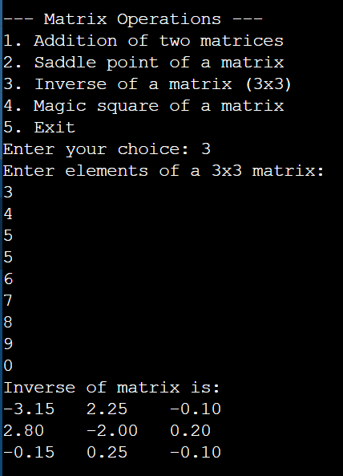

CONCLUSION:
Thus, we have learned how to perform basic matrix operations using C programming and understood their practical applications.

