

Foundations of Programming

Lab Assignment No. : 02

PROBLEM STATEMENT:
Write a menu driven program in C to implement the basic arithmetic operations such as Addition, Subtraction, Multiplication, and Division.

OBJECTIVES:
• To understand the concept of menu driven programming in C.
• To apply conditional statements and switch–case control structures.
• To perform basic arithmetic operations using user-defined input.
• To enhance logical thinking and problem-solving skills.

THEORY:

ALGORITHM:
- Start the program.
- Display a menu with the following options:

  - Addition
  - Subtraction
  - Multiplication
  - Division
- Input the user's choice (integer).
- Input two numbers (num1, num2) for the operation.
- Evaluate the choice:
- If Choice = 1: Calculate result = num1 + num2.
- If Choice = 2: Calculate result = num1 - num2.
- If Choice = 3: Calculate result = num1 * num2.
- If Choice = 4:
  - Check if num2 is 0.
  - If num2 == 0, print "Error: Division by Zero".
  - Else, calculate result = num1 / num2.
- If Choice is Invalid: Print "Invalid option selected".
- Display the calculated result.
- Stop
CODE:
#include <stdio.h>

int main() {
int choice;
float num1, num2, result;

// 1. Display the Menu
printf("--- Arithmetic Menu ---\n");
printf("1. Addition (+)\n");
printf("2. Subtraction (-)\n");
printf("3. Multiplication (*)\n");
printf("4. Division (/)\n");
printf("-----------------------\n");
printf("Enter your choice (1-4): ");
scanf("%d", &choice);

// Input the two numbers
// We ask for numbers only if the choice is valid (1-4) to improve user experience
if (choice >= 1 && choice <= 4) {
printf("Enter two numbers: ");
scanf("%f %f", &num1, &num2);
}

// 3. Process the choice
switch(choice) {
case 1: // Addition
result = num1 + num2;
printf("Result: %.2f + %.2f = %.2f\n", num1, num2, result);
break;

case 2: // Subtraction
result = num1 - num2;
printf("Result: %.2f - %.2f = %.2f\n", num1, num2, result);
break;

case 3: // Multiplication
result = num1 * num2;
printf("Result: %.2f * %.2f = %.2f\n", num1, num2, result);
break;

case 4: // Division
if (num2 != 0) {
result = num1 / num2;
printf("Result: %.2f / %.2f = %.2f\n", num1, num2, result);
} else {
printf("Error: Division by zero is not allowed.\n");
}
break;

default:
printf("Error: Invalid choice! Please enter a number between 1 and 4.\n");
}

return 0;
}

PLATFORM:
Linux

INPUT AND OUTPUT:
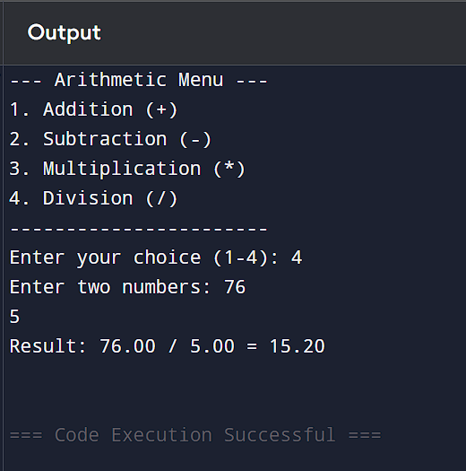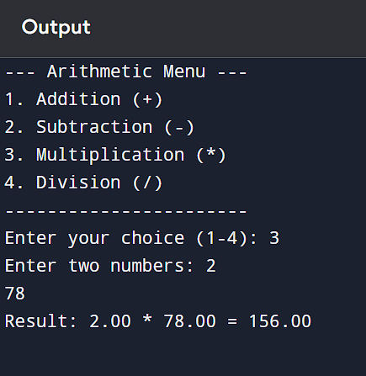

CONCLUSION:
Thus, the menu driven program in C successfully performs basic arithmetic operations using switch–case statements.

