

Foundations of Programming
Assignment No. : 9

PROBLEM STATEMENT:
Write a program in C to check whether the given number is an Armstrong number or not.
An Armstrong number is an integer with three digits such that the sum of the cubes of its digits is equal to the number itself.
Example: 371

OBJECTIVE:
• To understand the concept of Armstrong numbers.
• To practice arithmetic operations in C.
• To develop logical thinking using loops and conditional statements.

THEORY:
An Armstrong number (also called a narcissistic number) is a number that is equal to the sum of the cubes of its digits. For a three-digit number abc, it is an Armstrong number if:
a³ + b³ + c³ = abc
For example, 371 is an Armstrong number because:
3³ + 7³ + 1³ = 27 + 343 + 1 = 371.

PLATFORM:
Linux

ALGORITHM:
Here is the complete solution to check if a number is an Armstrong number, including the algorithm, a visual flowchart reference, and the C code.
1. The Algorithm
An algorithm is a step-by-step procedure to solve a problem. Here is the logic for checking a 3-digit Armstrong number:
- Start the program.
- Input an integer number from the user.
- Assign the input number to a temporary variable (e.g., originalNum) so we can modify the number during calculation but still remember the original value for comparison later.
- Initialize a variable result to 0.
- Loop while the originalNum is greater than 0:
  - Find the remainder (last digit) using the modulo operator (% 10).
  - Cube the remainder and add it to the result.
  - Divide the originalNum by 10 to remove the last digit.
- Compare the final result with the original input number.
- Output:
  - If they are equal, print "It is an Armstrong number."
  - If they are not equal, print "It is not an Armstrong number."
- Stop.

C PROGRAM:
#include <stdio.h>

int main() {
int num, originalNum, remainder, result = 0;
// Input the number
printf("Enter a three-digit integer: ");
scanf("%d", &num);
//Store the number in a temporary variable
originalNum = num;
// Loop to calculate sum of cubes of digits
while (originalNum != 0) {
// remainder contains the last digit
remainder = originalNum % 10;
// Add the cube of the digit to result
result += remainder * remainder * remainder;
// Remove the last digit from originalNum (e.g., 153 becomes 15)
originalNum /= 10;
}

//Check if result equals the input number
if (result == num)
printf("%d is an Armstrong number.\n", num);
else
printf("%d is not an Armstrong number.\n", num);

return 0;
}

INPUT AND OUTPUT:

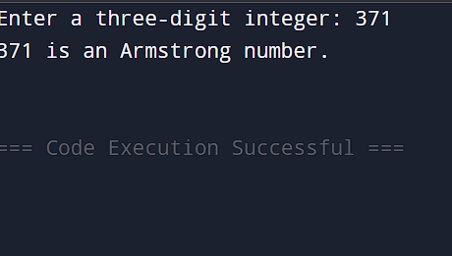

CONCLUSION:
Thus, we have successfully written a C program to check whether a given number is an Armstrong number using loops and arithmetic operations.

