

Foundations of Programming
Assignment No. : 10

PROBLEM STATEMENT:
Write a program in C to simulate a simple calculator that performs basic arithmetic operations such as addition, subtraction, multiplication, and division. The calculator should also perform special operations like computing xʸ (power) and x! (factorial).

OBJECTIVE:
• To understand the use of switch-case statements in C.
• To perform basic arithmetic and special mathematical operations.
• To enhance problem-solving skills using menu-driven programs.

THEORY:
A calculator is a basic computing device used to perform arithmetic operations. In C programming, a simple calculator can be implemented using conditional or switch-case statements. Arithmetic operations like addition, subtraction, multiplication, and division are fundamental operations. Special operations such as power (xʸ) and factorial (x!) require loops for repeated calculations.

PLATFORM:
Linux

ALGORITHM:
- Start the program.
- Display a menu of operations: Addition, Subtraction, Multiplication, Division, Power, and Factorial.
- Input the user's choice (operation).
- Evaluate the choice:
- *If Binary Operation (+, -,* , /, ^):
  - Ask for two operands (num1, num2).
  - Perform the corresponding calculation.
  - Note: For division, check if num2 is 0 to prevent errors.
- If Unary Operation (!):
  - Ask for a single integer (n).
  - Calculate factorial using a loop (multiply $1 \times 2 \times \dots \times n$).
  - Note: Check if the number is negative (factorial is undefined for negative numbers).
- Display the calculated result.
- Stop.

C PROGRAM:
#include <stdio.h>
#include <math.h> // Required for pow() function
int main() {
int choice;
double num1, num2, result;
int n;
unsigned long long fact = 1; // logical type for factorial to hold large numbers
// Display Menu
printf("--- Simple Calculator ---\n");
printf("1. Addition (+)\n");
printf("2. Subtraction (-)\n");
printf("3. Multiplication (*)\n");
printf("4. Division (/)\n");
printf("5. Power (x^y)\n");
printf("6. Factorial (x!)\n");
printf("Enter your choice (1-6): ");
scanf("%d", &choice);
// Process Choice
switch(choice) {
case 1: // Addition
printf("Enter two numbers: ");
scanf("%lf %lf", &num1, &num2);
result = num1 + num2;
printf("Result: %.2lf\n", result);
break;

case 2: // Subtraction
printf("Enter two numbers: ");
scanf("%lf %lf", &num1, &num2);
result = num1 - num2;
printf("Result: %.2lf\n", result);
break;

case 3: // Multiplication
printf("Enter two numbers: ");
scanf("%lf %lf", &num1, &num2);
result = num1 * num2;
printf("Result: %.2lf\n", result);
break;

case 4: // Division
printf("Enter two numbers: ");
scanf("%lf %lf", &num1, &num2);
if (num2 != 0) {
result = num1 / num2;
printf("Result: %.2lf\n", result);
} else {
printf("Error: Division by zero is not allowed.\n");
}
break;

case 5: // Power
printf("Enter base (x) and exponent (y): ");
scanf("%lf %lf", &num1, &num2);
result = pow(num1, num2);
printf("Result: %.2lf\n", result);
break;

case 6: // Factorial
printf("Enter a positive integer: ");
scanf("%d", &n);

// Factorial logic
if (n < 0) {
printf("Error: Factorial of a negative number doesn't exist.\n");
} else {
for (int i = 1; i <= n; ++i) {
fact *= i;
}
printf("Result: %llu\n", fact);
}
break;

default:
printf("Error: Invalid choice! Please enter a number between 1 and 6.\n");
}

return 0;
}

INPUT AND OUTPUT:
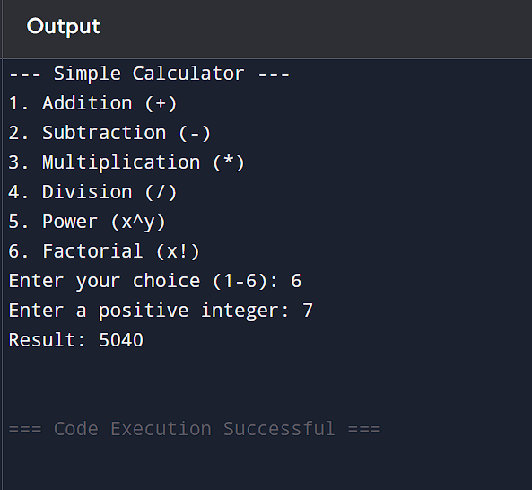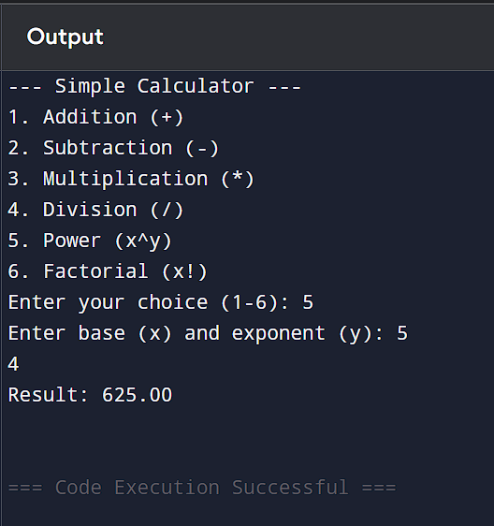

CONCLUSION:
Thus, a simple calculator program was successfully implemented using C programming. The program demonstrates the use of switch-case statements, loops, and arithmetic operations.

