;l

Foundations of Programming

Assignment No. : 4
- PROBLEM STATEMENT: Write a C Program to calculate the salary of an employee given his basic pay (taken as input from the user). Calculate gross salary of employee. Let HRA be 10 % of basic pay and TA be 5% of basic pay. Let employees pay professional tax as 2% of total salary. Calculate net salary payable after deductions.

OBJECTIVE:

- To understand the importance of flowchart for any programming model.
- To learn simple flowchart symbols and arrows to define relationships.
- To understand and develop visual representations of flow of data.

THEORY:
- Define Algorithm.
An algorithm is a step-by-step procedure or a set of well-defined rules to solve a specific problem or perform a computation.
2.What are the different characteristics of an algorithm.
For a procedure to be considered a valid algorithm, it must satisfy the following five key characteristics (often referred to as the criteria defined by computer scientist Donald Knuth):
- Input: An algorithm must have zero or more inputs. These are the values supplied to the algorithm before it begins (like the numbers you type into a calculator).
- Output: An algorithm must produce at least one output. This is the result or the answer generated after processing the inputs.
- Definiteness (Unambiguity): Every step of the algorithm must be clear and unambiguous. Each instruction must have only one distinct meaning so that the computer (or person) executing it knows exactly what to do.
- Finiteness: The algorithm must terminate after a finite number of steps. It cannot run forever; it must eventually reach a "Stop" point.
- Effectiveness: Every step must be basic enough to be carried out in a finite amount of time using available resources. For example, an instruction like "divide by zero" or "calculate the exact value of pi" is not effective because it is mathematically impossible or infinite.

PLATFORM: Linux
CODE:
#include <stdio.h>

int main() {
// Declare variables
float basic_pay, hra, ta, gross_salary, prof_tax, net_salary;
// Input Basic Pay
printf("Enter Basic Pay of the employee: ");
scanf("%f", &basic_pay);
// Calculate Allowances
hra = basic_pay * 0.10; // 10% of basic
ta = basic_pay * 0.05; // 5% of basic
//Calculate Gross Salary
gross_salary = basic_pay + hra + ta;
// Deductions (Professional Tax on Total/Gross Salary)
prof_tax = gross_salary * 0.02; // 2% of gross
// Calculate Net Salary
net_salary = gross_salary - prof_tax;
// Output the results
printf("\n--- Salary Slip ---\n");
printf("Basic Pay: %.2f\n", basic_pay);
printf("HRA (10%%): %.2f\n", hra);
printf("TA (5%%): %.2f\n", ta);
printf("------------------------\n");
printf("Gross Salary: %.2f\n", gross_salary);
printf("Professional Tax: -%.2f\n", prof_tax);
printf("------------------------\n");
printf("Net Salary: %.2f\n", net_salary);

return 0;
}

INPUT AND OUTPUT:
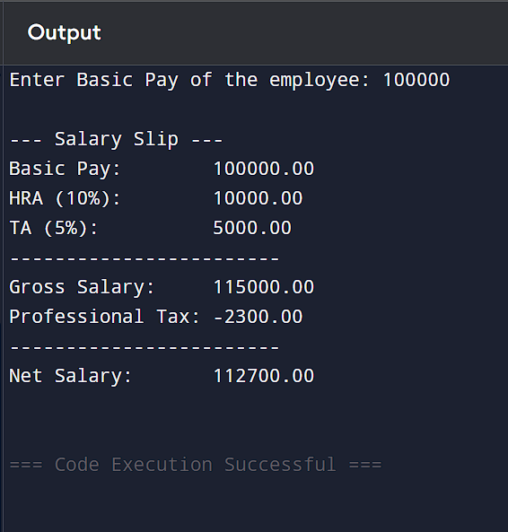
CONCLUSION: Thus, we have learned to write algorithms and to draw its representation in terms of flowchart.

