Q B) Create a Asp .net Web application for storing employee details in database.

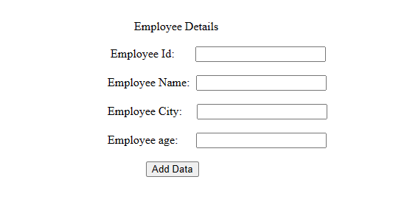

1. Employee Table(empid,empname,empcity,empage)

Code:

using System;

using System.Collections.Generic;

using System.Data.SqlClient;

using System.Linq;

using System.Web;

using System.Web.UI;

using System.Web.UI.WebControls;

using System.Data;

using System.Data.SqlClient;

namespace Employee

{

public partial class WebForm1 : System.Web.UI.Page

{

SqlConnection con = new SqlConnection("Data Source=(LocalDB)\\MSSQLLocalDB;Initial Catalog=Emp;Integrated Security=True");

protected void Page_Load(object sender, EventArgs

{

}

protected void Button1_Click(object sender, EventArgs e)

{

string connectionString = "Data Source=(LocalDB)\\MSSQLLocalDB;Initial Catalog=Emp;Integrated Security=True";

SqlConnection con = new SqlConnection(connectionString);

con.Open();

string Empid = TextBox1.Text;

string empname = TextBox2.Text;

string empcity = TextBox3.Text;

string empage = TextBox4.Text;

string query = "Insert into employee(Empid,empname,empcity,empage) values('" + Empid + "','" + empname + "','" + empcity + "', '"+empage+"')";

SqlCommand cmd = new SqlCommand(query, con);

cmd.ExecuteNonQuery();

con.Close();

ScriptManager.RegisterStartupScript(this, this.GetType(), "alert", "alert('Record inserted') ;", true);

}

}

}

Output:



1. Add employee in database from webform





1. Get all the employee from database as per empcity entered in textbox and show in datagridview

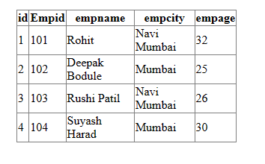

Q c) Design a web client to consume the web service.

Code:-

using System;

using System.Collections.Generic;

using System.Linq;

using System.Web;

using System.Web.Services;

namespace fullname.Properties

{

/// <summary>

/// Summary description for WebService1

/// </summary>

[WebService(Namespace = "http://tempuri.org/")]

[WebServiceBinding(ConformsTo = WsiProfiles.BasicProfile1_1)]

[System.ComponentModel.ToolboxItem(false)]

// To allow this Web Service to be called from script, using ASP.NET AJAX, uncomment the following line.

// [System.Web.Script.Services.ScriptService]

public class WebService1 : System.Web.Services.WebService

{

[WebMethod]

public string Fname()

{

return " Rohit ";

}

[WebMethod]

public string Mname()

{

return " Tanaji ";

}

[WebMethod]

public string Lname()

{

return " Thorat ";

}

[WebMethod]

public string Fullname()

{

return Fname() + Mname() + Lname();

}

}

}

Output:-

