**DSCC Practical 6 and 7 Steps**

1. **Install Java7x64 (64 bit version) file in same folder. (These two programs will not work with 32 bit architecture java7)**
2. **Install MySQL Community (**[**https://dev.mysql.com/downloads/file/?id=512697**](https://dev.mysql.com/downloads/file/?id=512697)**)[MySQL Installer 8.0.30]**
3. **While installing select the following options [including Connector/ODBC].**

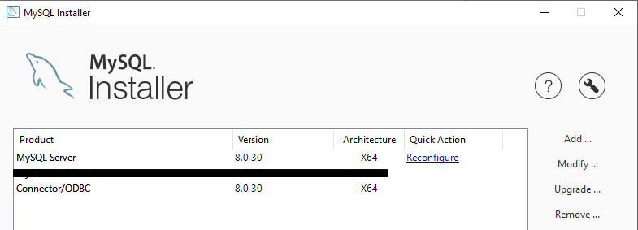

1. **Create Databases in MySQL command line client.**

**create database LibraryDB;**

**use LibraryDB;**

**CREATE TABLE Book(**

**BookID int,**

**Book_Name varchar(15),**

**Author varchar(15),**

**Price int,**

**No_Of_Copies int**

**);**

**INSERT INTO Book VALUES (1, 'C++', 'Balagurusamy', 200, 20);**

**INSERT INTO Book VALUES (2, 'Java', 'Herbert', 400, 30);**

**INSERT INTO Book VALUES (3, 'Let us C', 'Kanetkar', 300, 10);**

**select * from Book;**

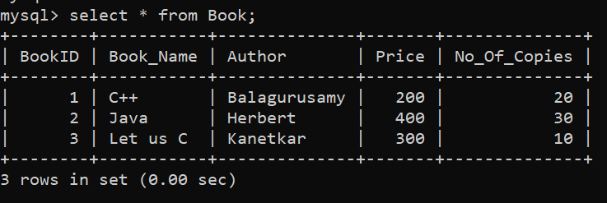

**create database MtnlDB;**

**use MtnlDB;**

**CREATE TABLE Bill(**

**CustID int,**

**Customer_Name varchar(15),**

**Bill_Due_Date date,**

**Bill_Amount int**

**);**

**INSERT INTO Bill VALUES (1, 'Kirtee', '2022-09-21', 200);**

**INSERT INTO Bill VALUES (2, 'Komal', '2022-09-22', 400);**

**INSERT INTO Bill VALUES (3, 'Poonam', '2022-09-23', 300);**

**Select * from Bill;**

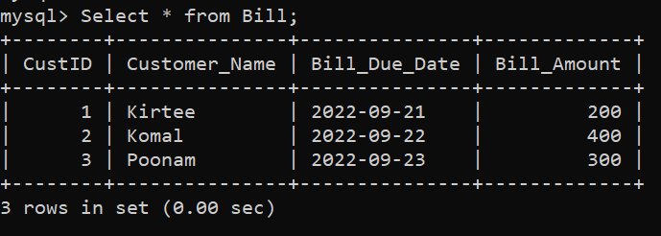

1. **Now Configuring DSN Connection.**
2. **Open ODBC Data Sources (64-bit)**

**[ If Not Found Modify mysql Installation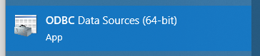 and select (Connector/ODBC).]**

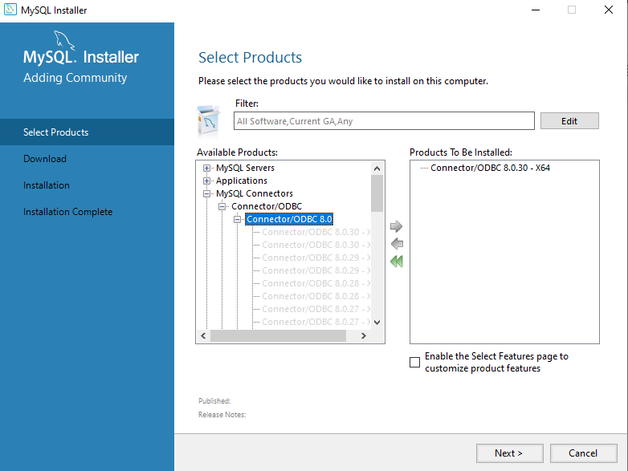

1. **Now in User DSN. Click on Add.**

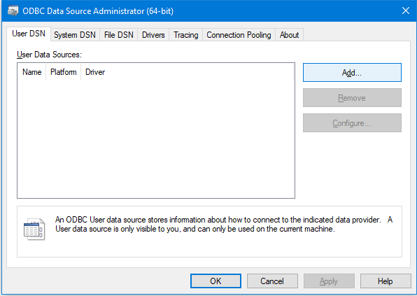

1. **Now select and Click on Finish.**

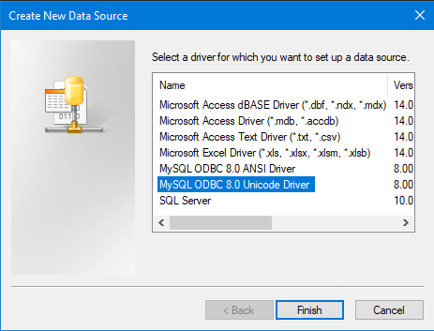

1. **Then do as shown and click on test. LibraryDB**

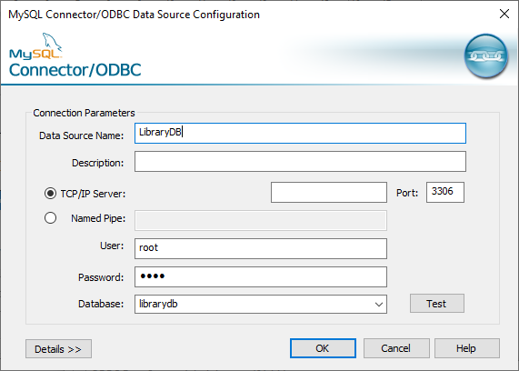

1. 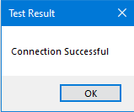**If Connect test successful then click on Ok.**
2. **Repeat same for MtnlDB Connection.**

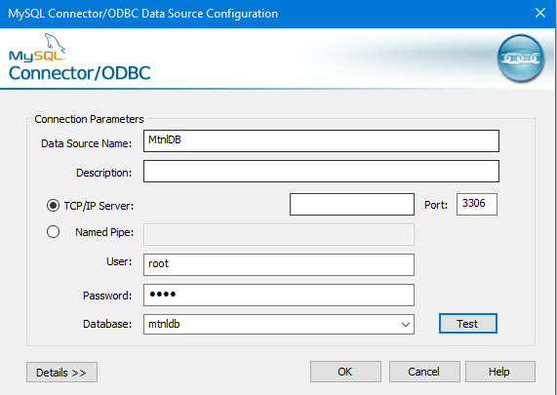

1. **Now Click on OK.**

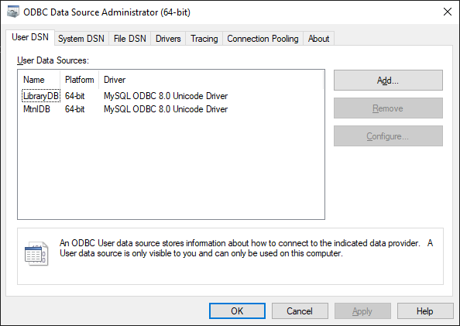

1. **Set Path of java in each terminal after getting into the folder which contains the program. (Path of 64 bit java7)**

**set path=C:\Program Files\Java\jdk1.7.0_51\bin**

1. **Now Start rmiregistry**

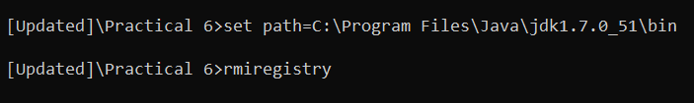

1. **Start DBServer**



1. **Start DBClient_P6**

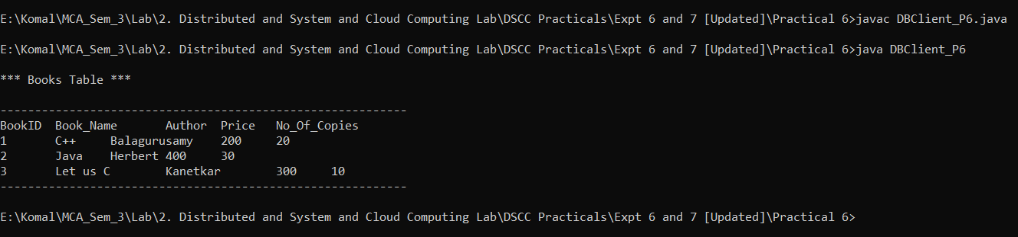

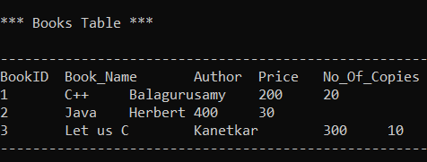

1. **Run Program 7 in same way.**

