OPERATING SYSTEMS
Inter-Process Communication
Shared Memory and Semaphores

TEAM
CodeX
MEMBERS
Disha | Dhanush | Sohan | Bathin

1. Definition
Inter-Process Communication (IPC) is a set of tools and methods that the operating system offers to let different processes share data and coordinate their activities. Each process runs in its own private memory space, so one process cannot directly access or change the memory of another. That is why IPC is needed: it creates controlled ways for processes to talk to each other.

2. Why IPC Is Needed
- Information sharing: Many processes may need the same information at the same time.
- Computation speed-up: A big job can be broken into parts and run concurrently in different processes.
- Modularity: A complex system can be split into smaller, easier-to-manage parts that work together.
- Convenience: Users can run related tasks together, for example by linking commands using pipelines.

3. IPC Techniques
IPC techniques fall into two broad categories: shared memory and message passing. Shared memory lets processes access a common memory region, while message passing sends data through the kernel.
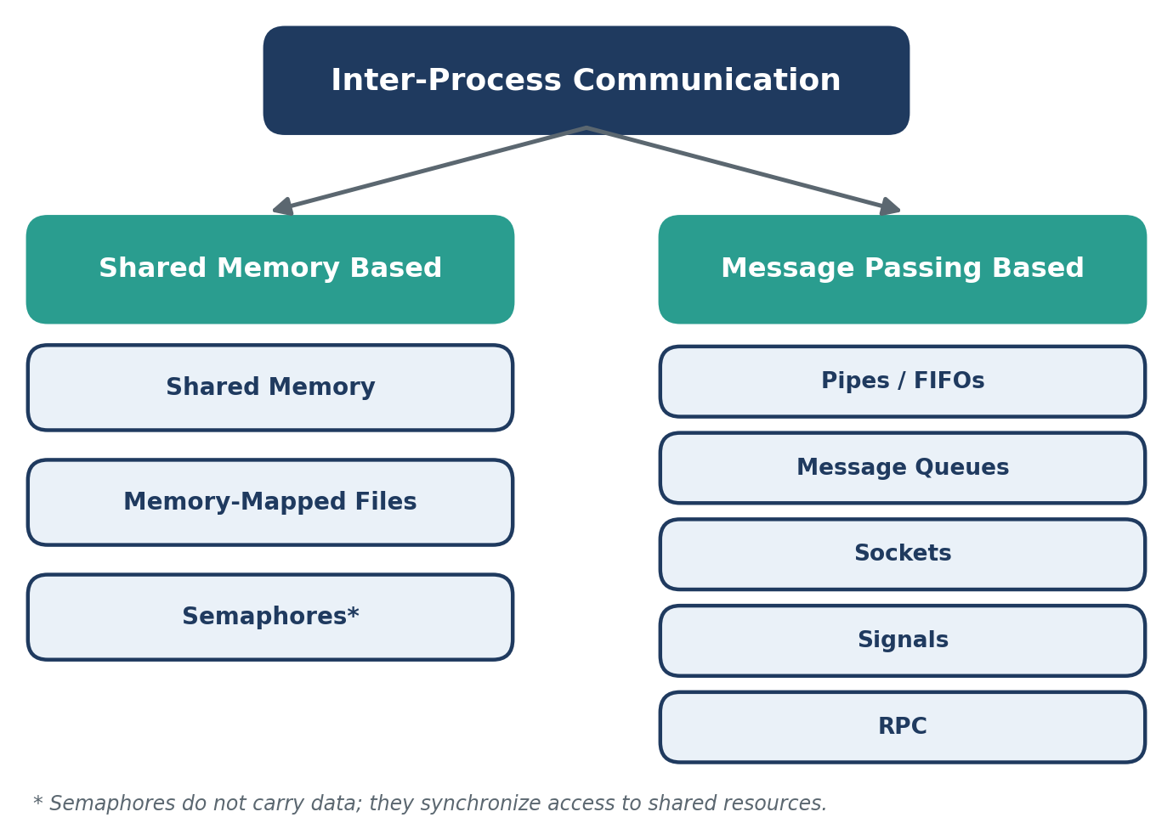
Figure 1: Classification of IPC techniques

3.1 Pipes
A pipe is a one-way communication channel maintained by the kernel. The output of one process is fed directly as the input of another, which is how shell pipelines such as ls | grep foo work.
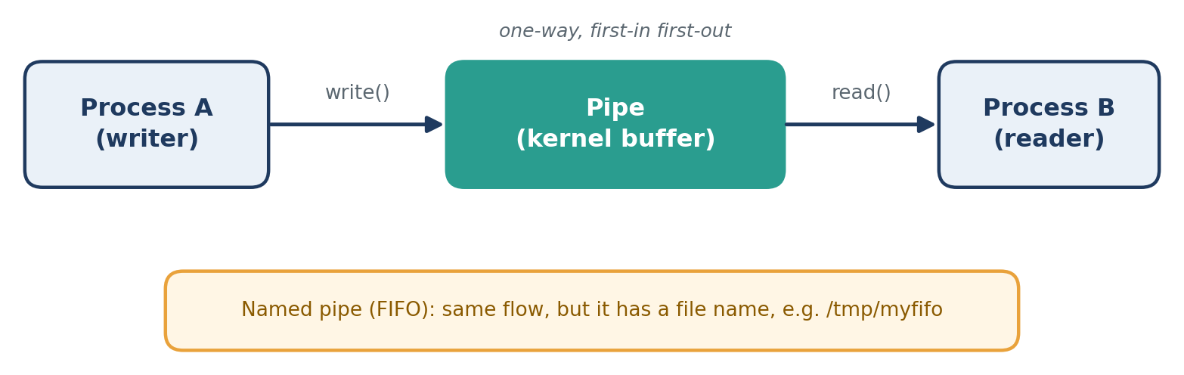
Figure 2: A pipe carrying data from a writer to a reader

Types
- Unnamed (anonymous) pipes: One-way byte streams, typically used between a parent and a child process (for example, ls | grep foo).
- Named pipes (FIFOs): Have a name in the file system, which allows unrelated processes to communicate.

How It Works
- The pipe is created (pipe() for unnamed, mkfifo() for named), giving a read end and a write end.
- The writer process writes bytes to the write end.
- The kernel stores the bytes in a buffer in first-in, first-out order.
- The reader process reads the bytes from the read end.
- If the buffer is empty the reader waits, and if it is full the writer waits.

Advantages
- Simple and easy to use
- Built into the shell (pipelines)
- Kernel handles the waiting, so little extra synchronization is needed

Disadvantages
- Data flows in one direction only (use two pipes for two-way)
- Limited buffer size
- Unnamed pipes work only between related processes
- No message boundaries; it is only a stream of bytes
- Works only on the same machine

3.2 Message Queues
A message queue is a list of messages maintained by the kernel. A process can post a message to the queue and another process can pick it up later, so the two do not have to run at the same time. Messages can be assigned priorities, and both POSIX and System V provide message queue implementations.
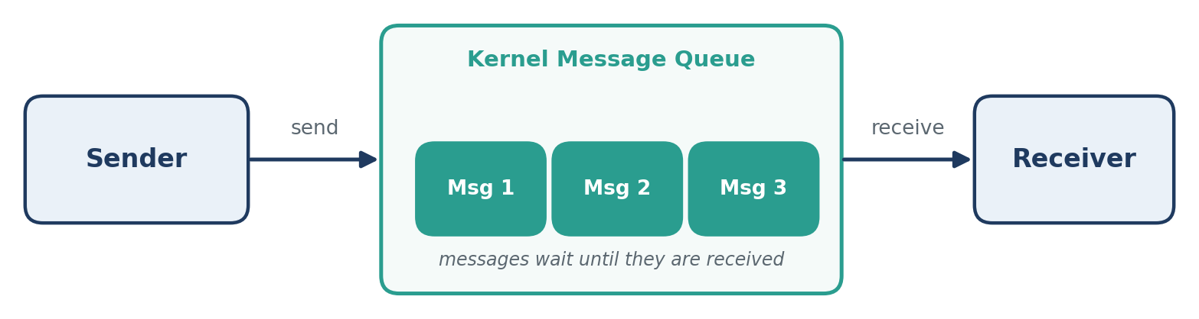
Figure 3: Sender and receiver communicating through a kernel message queue

How It Works
- Create or open a queue (msgget() in System V, mq_open() in POSIX).
- The sender adds a message with a type or priority (msgsnd() / mq_send()).
- The kernel stores the message until it is received.
- The receiver takes a message from the queue (msgrcv() / mq_receive()), by priority or type.
- Remove the queue when finished (msgctl() / mq_unlink()).

Advantages
- Asynchronous: sender and receiver need not run together
- Message boundaries are preserved
- Messages can be prioritized
- Works between unrelated processes

Disadvantages
- Limits on message size and queue length
- Data is copied through the kernel, so it is slower than shared memory
- Queues stay in the kernel until removed
- Works only on the same machine

3.3 Shared Memory
Shared memory is an IPC mechanism that allows two or more processes to access the same region of memory. It is one of the fastest IPC methods because data can be accessed directly without repeated copying.
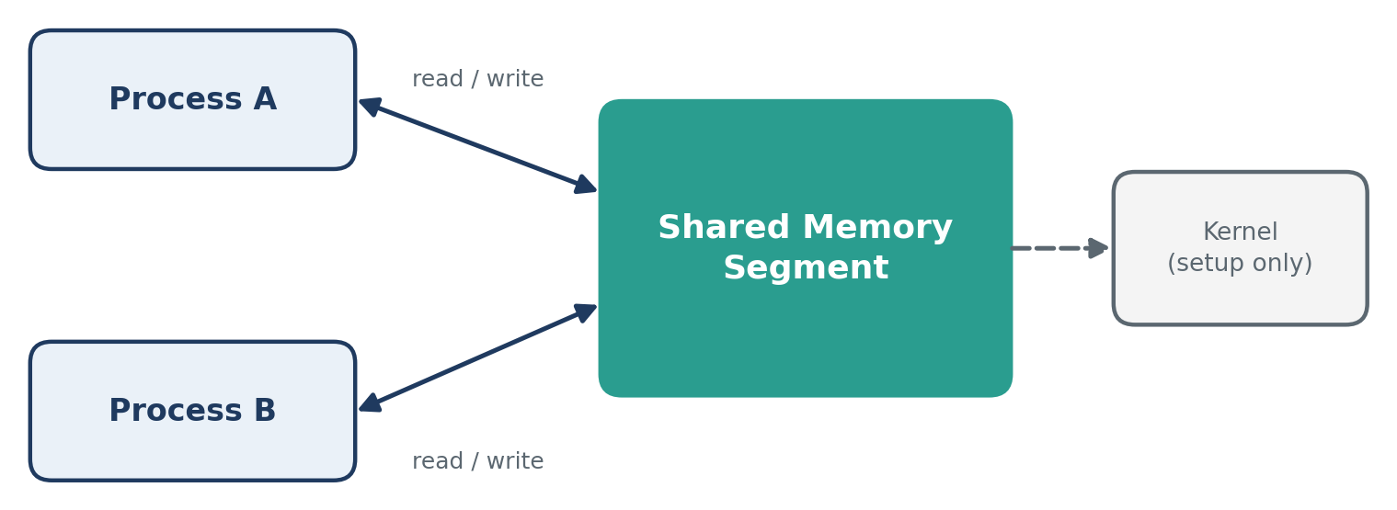
Figure 4: Two processes accessing one shared memory segment

How It Works
- Create a shared memory segment.
- Attach it to the processes.
- Processes read and write data.
- Use synchronization when required.
- Detach and remove the segment when finished.

Advantages
- Very fast communication
- Efficient for large amounts of data
- Reduces data copying

Disadvantages
- Requires synchronization
- Can cause race conditions
- Needs careful access control

3.4 Semaphores
A semaphore is a synchronization mechanism used to control access to shared resources. It prevents processes from interfering with each other when accessing shared data. Semaphores do not pass data themselves.
The two basic operations are:
- Wait (P / down): Acquire a resource.
- Signal (V / up): Release a resource.

Types of Semaphores
- Binary semaphore: Has the value 0 or 1 and is commonly used for mutual exclusion.
- Counting semaphore: Can have values greater than 1 and is used when multiple identical resources are available.

Critical Section
A critical section is the part of a program where shared data is accessed. A semaphore guards it so that only one process enters at a time.
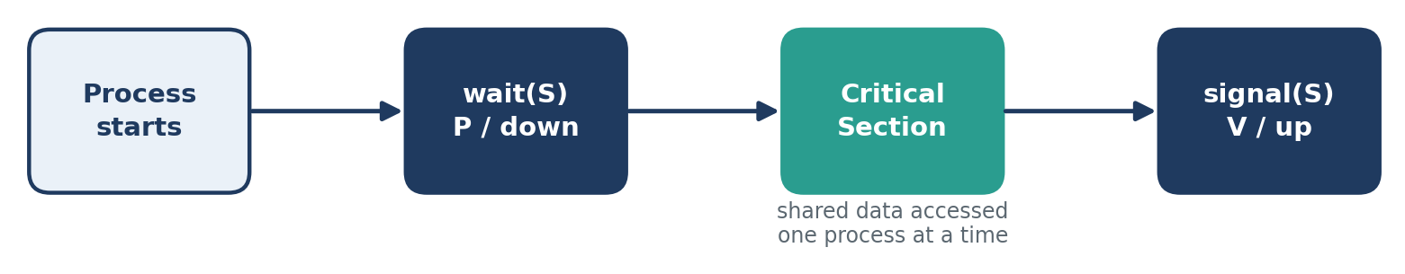
Figure 5: Semaphore protecting a critical section

3.5 Sockets
A socket is an endpoint for two-way communication between processes. Sockets are the foundation of client-server communication.
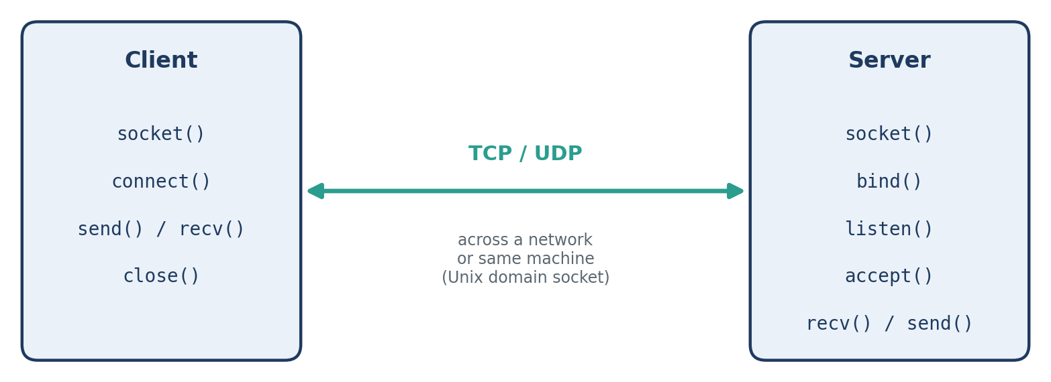
Figure 6: Client and server communicating through sockets

Types
- Unix domain sockets: Fast; used for communication between processes on the same machine.
- Network sockets (TCP/UDP): Work across machines and are the foundation of client-server communication over networks.

How It Works
- The server creates a socket, binds it to an address or port, and listens for connections.
- The client creates a socket and connects to the server.
- The server accepts the connection.
- Both sides exchange data using send() and recv().
- Both sides close the socket when finished.

Advantages
- Two-way communication
- Works on the same machine or across a network
- Standard interface available on almost every system
- One server can handle many clients

Disadvantages
- More setup than pipes or shared memory
- Slower than shared memory on the same machine
- Network sockets must handle lost connections and errors
- Needs security measures when used over a network

3.6 Signals
A signal is an asynchronous notification sent to a process to tell it that an event has happened (such as SIGINT, SIGKILL or SIGUSR1). Signals carry very little data, mainly just the signal number.
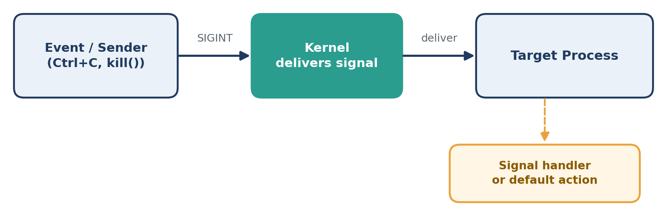
Figure 7: A signal delivered to a process by the kernel

How It Works
- An event generates a signal (for example Ctrl+C, the kill command, or an error such as an invalid memory access).
- The kernel delivers the signal to the target process.
- The process then handles it in one of three ways: runs its own signal handler, ignores it, or takes the default action (usually terminating).
- SIGKILL and SIGSTOP cannot be caught or ignored.

Advantages
- Very lightweight and fast
- Good for notifying a process about events
- Built into the operating system

Disadvantages
- Carry almost no data
- Asynchronous behaviour makes debugging harder
- Only a limited set of signals exists
- Standard signals may be lost if several arrive together
- Handlers can safely call only a few functions

3.7 Memory-Mapped Files
A memory-mapped file connects a file on disk directly to a process's virtual address space using the mmap() system call. Instead of calling read() and write() to move data between the file and a buffer, the process receives a pointer to a region of memory that represents the file's contents. Reading a byte from that region reads the matching byte of the file, and writing to it changes the file.
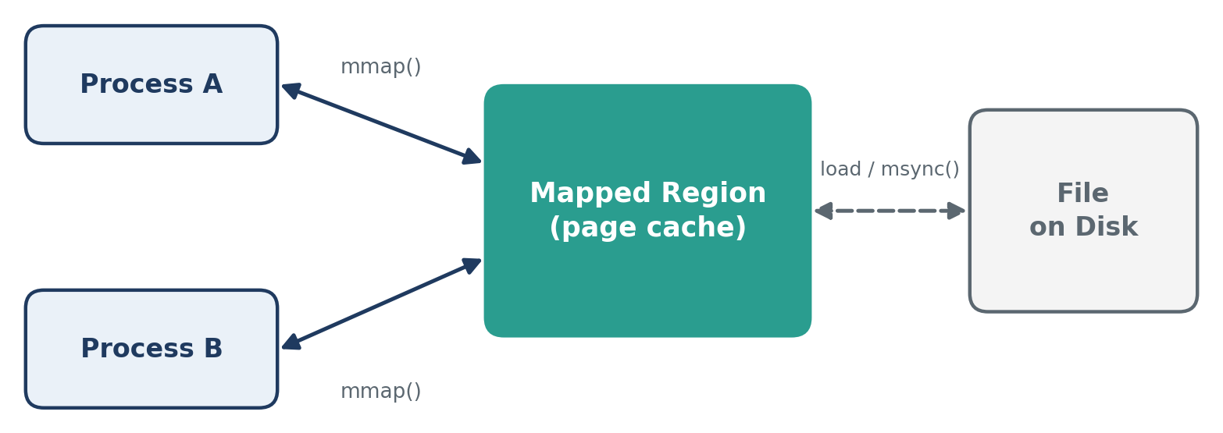
Figure 8: Two processes mapping the same file

Behind the Scenes
Calling mmap() does not load the whole file into memory. It only sets up the mapping in the process's page table. When the process first touches a page, a page fault occurs, and the kernel loads that page from disk into physical memory (the page cache). The process then continues as if the data had always been there. Because pages are loaded only when needed, even very large files can be mapped without using much RAM.

How It Works
- Open the file using open().
- Map it into the process address space using mmap().
- Read and write the mapped region like normal memory.
- The OS loads pages from disk on demand (page fault) and shares them between processes.
- Flush changes with msync() and remove the mapping with munmap().

Mapping Types
- MAP_SHARED: Changes are visible to other processes and written back to the file.
- MAP_PRIVATE: Copy-on-write; changes stay private and are not written to the file.

Sharing Between Processes
When several processes map the same file with MAP_SHARED, the kernel maps the same physical pages into each of their address spaces. A write by one process is therefore visible to the others immediately, with no copying through the kernel. This makes memory-mapped files work like shared memory that is backed by a file. The kernel writes modified (dirty) pages back to disk later, and msync() forces this to happen.
Access is not coordinated automatically, so processes that write to the same region must use semaphores or mutexes to avoid race conditions.

Advantages
- Fast: no repeated read() and write() system calls
- Less data copying between kernel and user space
- Handles large files, since pages load only when needed
- Data persists in the file after the processes exit

Disadvantages
- Needs synchronization (for example, semaphores) when shared
- Changes may not reach the disk until msync() or munmap()
- Mapping size is limited to page-size units and the address space
- Truncating the file while mapped can crash a process (SIGBUS)

Common Uses
- Loading executables and shared libraries
- Databases that work on large data files (for example, SQLite and LMDB)
- Processing very large files without reading them fully into memory
- IPC between unrelated processes through a common file

Memory-Mapped I/O vs Traditional File I/O
Feature | Traditional I/O | Memory-Mapped I/O
Access method | read() / write() calls | Direct memory access
Data copying | Kernel buffer to user buffer | Minimal; pages are shared
Large files | Read in chunks | Loaded on demand
Sharing | Needs pipes or sockets | Map the same file

3.8 Remote Procedure Calls (RPC)
A remote procedure call lets a process call a function that runs in another process or on another machine. The call appears local to the caller, while the system handles all the communication behind the scenes. Examples include gRPC and Java RMI.
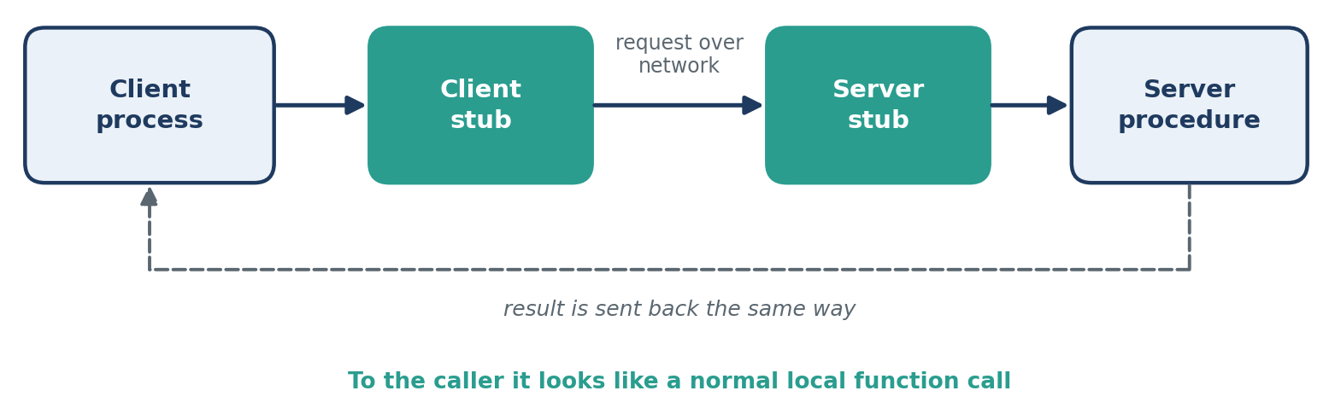
Figure 9: How an RPC request and result travel between client and server

How It Works
- The client calls a function, which is really a local stub.
- The client stub packs the parameters into a message (marshalling).
- The message is sent over the network to the server.
- The server stub unpacks the parameters and calls the real procedure.
- The result is packed, sent back, and the client continues as if it were a normal call.

Advantages
- Looks like a normal function call, so it is easy to program
- Hides network details
- Works across machines and programming languages (for example gRPC)
- Well suited to distributed systems and microservices

Disadvantages
- Slower than a local call because of network delay
- Network or server failures must be handled
- Marshalling adds overhead
- Harder to debug; passing pointers or references is difficult

IPC Techniques at a Glance
Technique | What it carries | Scope | Best for
Pipes | Byte stream, one-way | Same machine | Parent-child pipelines
Message Queues | Discrete messages | Same machine | Asynchronous messaging with priorities
Shared Memory | Direct memory access | Same machine | Fast exchange of large data
Semaphores | No data | Same machine | Synchronizing access
Sockets | Two-way streams or datagrams | Same or different machines | Client-server communication
Signals | Signal number only | Same machine | Event notification
Memory-Mapped Files | File used as memory | Same machine | Large files, sharing through a file
RPC | Function call and result | Usually different machines | Distributed services

Conclusion
Inter-Process Communication lets processes that run in separate memory spaces exchange data and coordinate their work. There is no single best technique; the right choice depends on speed, the amount of data, and whether the processes run on one machine or on several.
- Pipes and message queues are simple ways to pass data through the kernel, with message queues adding asynchronous delivery and priorities.
- Shared memory and memory-mapped files give the fastest communication because processes access the same data directly, but they need synchronization.
- Semaphores provide that synchronization, preventing race conditions, deadlock and starvation.
- Sockets and RPC extend communication across networks and are the basis of client-server and distributed systems.
- Signals are lightweight notifications for events rather than a way to send data.

