**St. Thomas’ College of Engineering and Technology**

Industrial Training report on

**“Android- TODO Application”**

Department of Information Technology

7th Sem , 4th Year

Group No. – 01

Group Member Roll No.

Dishani Sarkar 43

**INDEX**

* About Project
* Technologies Involved
* Methodolgy
* System Design
* Database Schema
* Screenshotsof Application
* Future Scope
* Conclusion

**About the Project :**

In this project , we have created an android based Todo application.

ToDo Application with Realm Database is used asa backend to store task list or multiple users.

Users are able to achieve their task before their due date.

User has to register for the app and once they logged in ,they can see their own task only and the rest of the tasks are hidden from their view.Tasks can be checked to denote that it has been completed and will thus be removed from the task list from the next login session.

**TECHNOLOGIES INVOLVED:**

* Android Sdk(Android 9 API 29)
* Java Programming language
* XML
* Realm Database

**METHODOLOGY**

**SYSTEM DESIGN:**

Our To-Do Application design is following a sequence of steps through moving between different activities.

It starts with the main activity where users are provided with login and sign up options .New users have to moveto the sign up activity where they are enter details like the user name,an email-Id ,a phone number and a password.

These information are stored in the user database and simultaneously a system generated user-Id is provided to the userfor login purpose.Pre-existing users can however move to the login page and enter their username and password which is being searched and matched for in the database and if authentication details are matched user is logged in or appropriate message

is shown for failure.

User enters the dashboard which will be containing the list of tasks pending ranging from zero to as many as desired.The tasks are displayed as a recyclerview list.We have a navigation menu attached to the sidebar connecting to edit profile and logout options.User profile information is sent from the login page to the dashboard.Edit Profile will help tomodify users data and logout exits the user from the app.We can move to the create task activity through the click of a button.

Task details like name of the task,duedate,task details and a holder color for the recyclerview item holder can be chosen by the userand is thus saved as Task information on clicking save button and we move back to the dashboard viewing the newly created task being added to the list.We can also discard the task midway of filling the details and it will take us back to the dashborad.

Each task item also has a clickable imagebutton to record which tasks has been completed and they will be removed fromthe list on beginning our next login session.we can also mark all existing tasks as checked with clicking one button.Pressing back from dashboardwill also log us out from the system.

**DATABASE SCHEMA:**

A single Realm database was sufficient for our application and it consisted of two Tables as follows:

1. User :

attritube datatype

userid int(primary key)

username string

email string

phone string

password string

2.Task

attribute datatype

taskid int(primary key)

taskname string

taskDetails string

colour string

dueDate Date

checked string(in "true" or "false")

userId int(refers to User(userId))

**SCREENSHOTS OF APP**

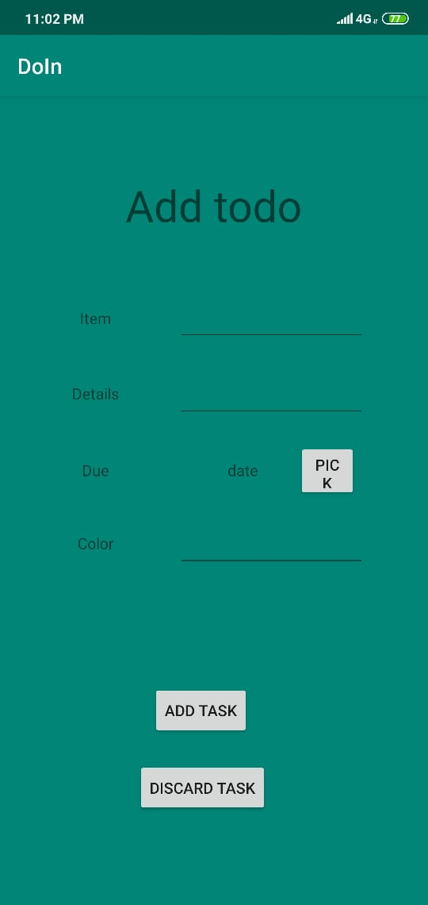

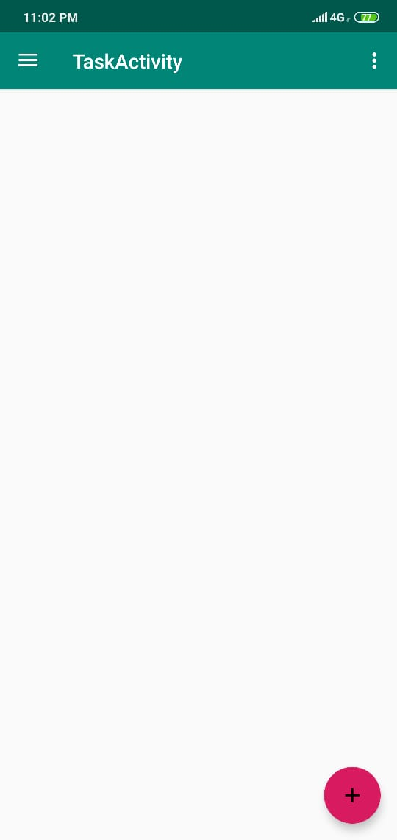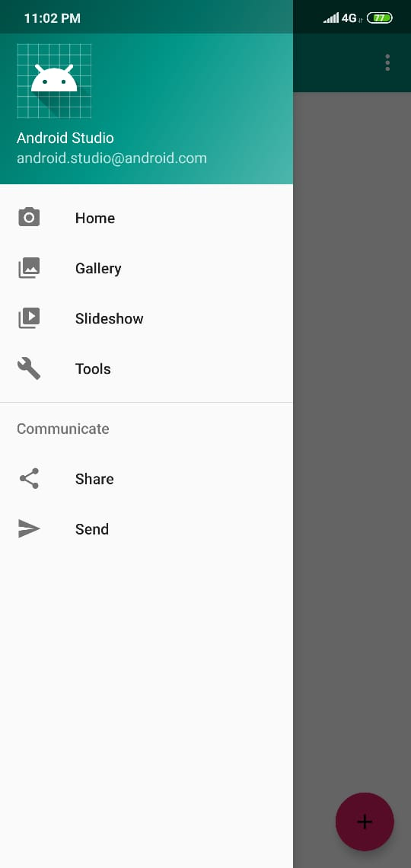

**FUTURE SCOPE**

As future projects, one can imagine many fields, not only directly concerning the TODO application. Of course, some minor adjustments have to be done to this app, if it should be ready to be deployed via the Android market. The UI could be polished a bit to match the design of modern mobile applications. Additionally some system parts can be improved, mainly in the area of routing performance, to guarantee a smother and faster experience for the end user.

Nevertheless one of the big strengths of this project are definitely the amount of easily, reusable Java packages. As the whole code is open sourced, all parts can be used to build other routing related applications. But also integrate with calendar data, build an improved task management application or port the Dayplan optimizing functionality to another routing engine like Google Maps for example.

**CONCLUSION**

Several goals were accomplished while working on this teamproject. First of all an application was created which supports a user’s day planning with the following implemented functionalities:

* Generate a dayplan, which is heavily optimized on completing as many tasks as possible.
* Simple, yet powerful task management system
* Continous checking of the dayplan’s consistency and compliance.

The task management functionality of this app is also strongly encapsulated and can therefore be reused easily in any Java project. The storage mechanism of converting tasks into events and storing them at a specific date can also be adapted easily to an Realm database or any other preferred storage solution.