Module Name: Login Page - Functional & UI Test Cases
Test Case ID: Tutorial_1
Webpage URL: https://www.amazon.in/

Scenario ID: 1a
Scenario: Login with valid mobile number and OTP
Test Steps:
1. Open Amazon login page
2. Enter registered mobile number
3. Click Continue
4. Enter correct OTP
5. Click Sign-In
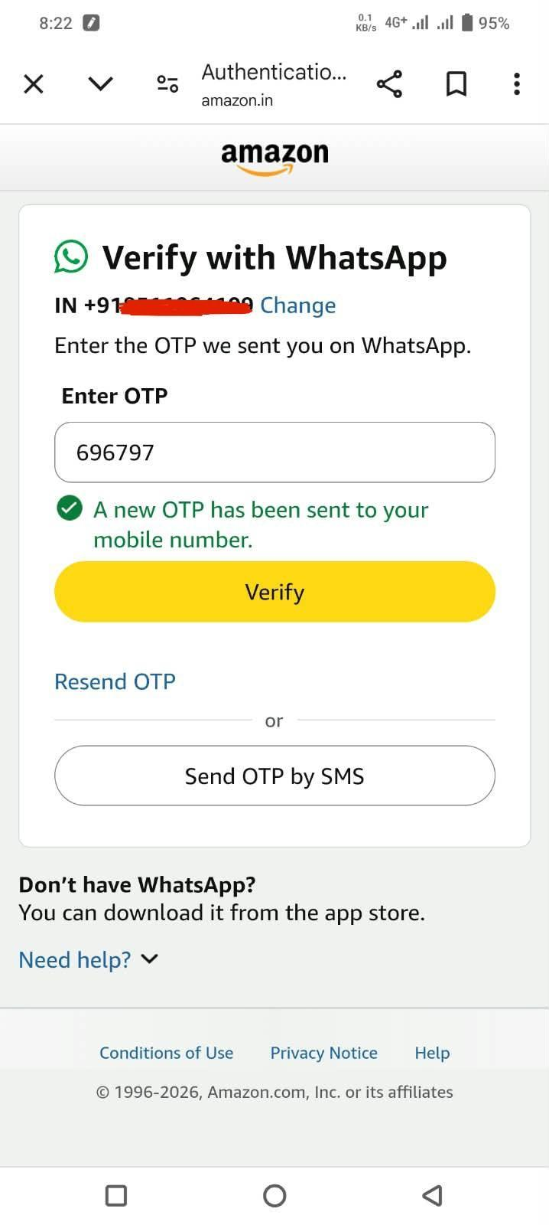
Screenshots: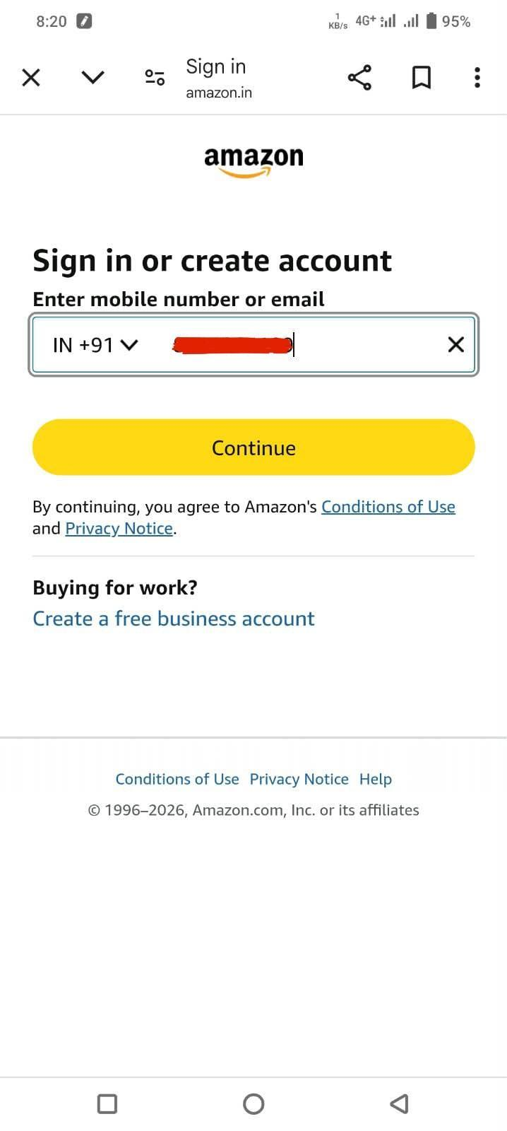

Scenario ID: 1b
Scenario: Login with valid email and OTP
Test Steps:
1. Open login page
2. Enter registered email address
3. Click Continue
4. Enter correct OTP
5. Click Sign-In
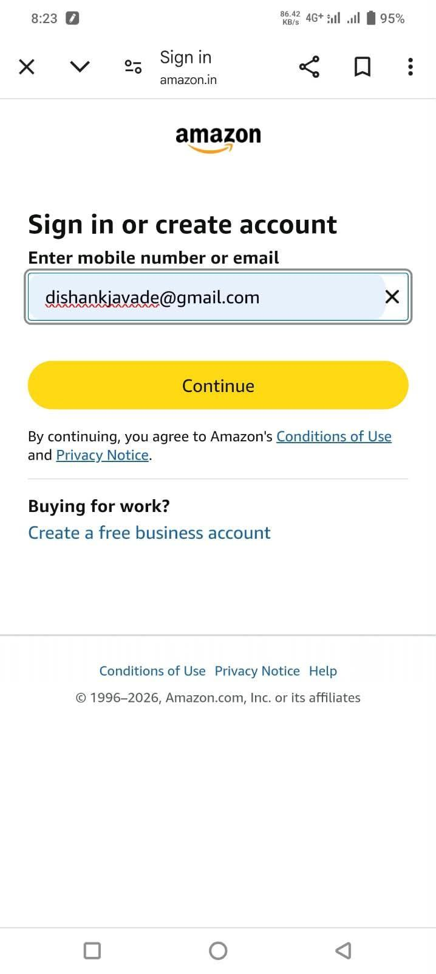
Screenshots: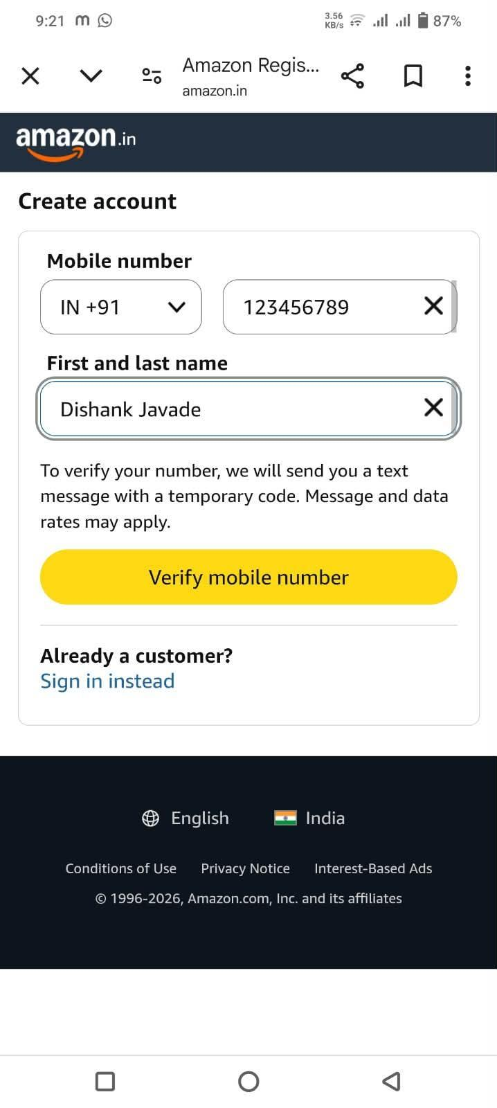

Scenario ID: 1c
Scenario: Login with incorrect OTP
Test Steps:
1. Open Amazon login page
2. Enter registered mobile/email
3. Click Continue
4. Enter incorrect OTP
5. Click Sign-In
Screenshots: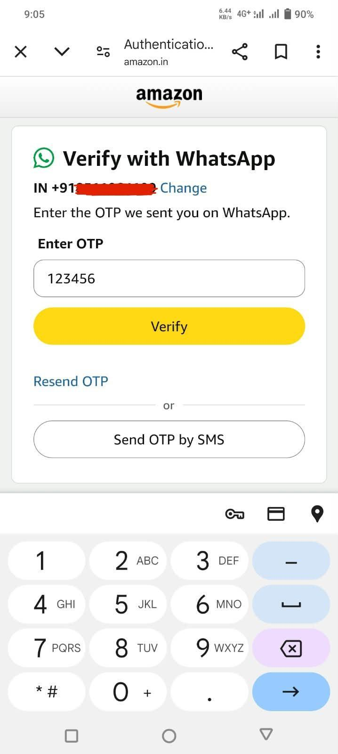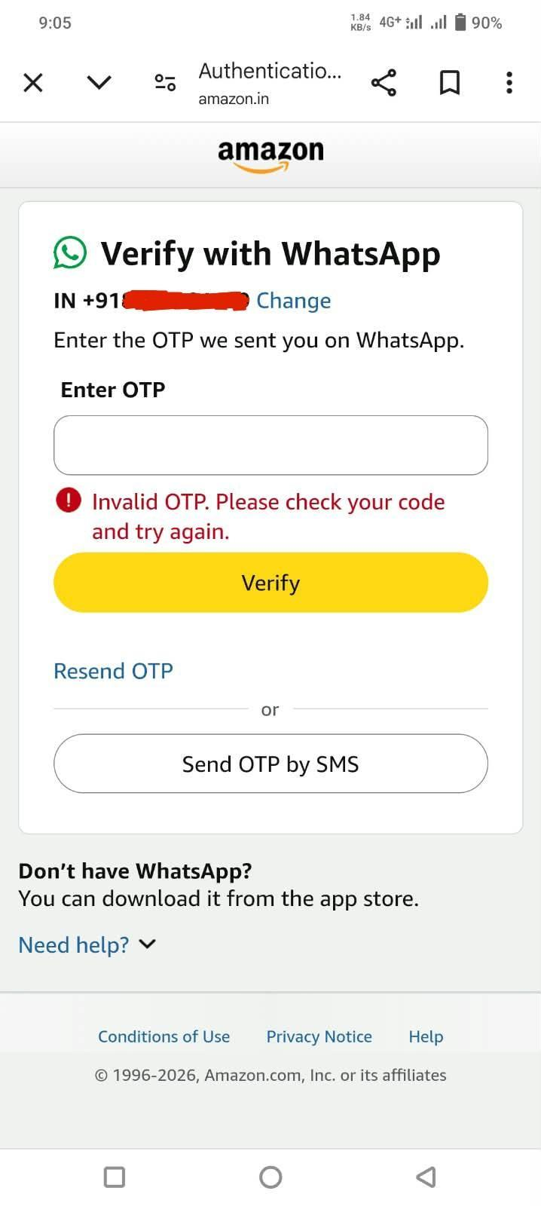

Scenario ID: 1d
Scenario: Login with unregistered mobile number
Test Steps:
1. Open login page
2. Enter mobile number not associated with an account
3. Click Continue
Screenshots: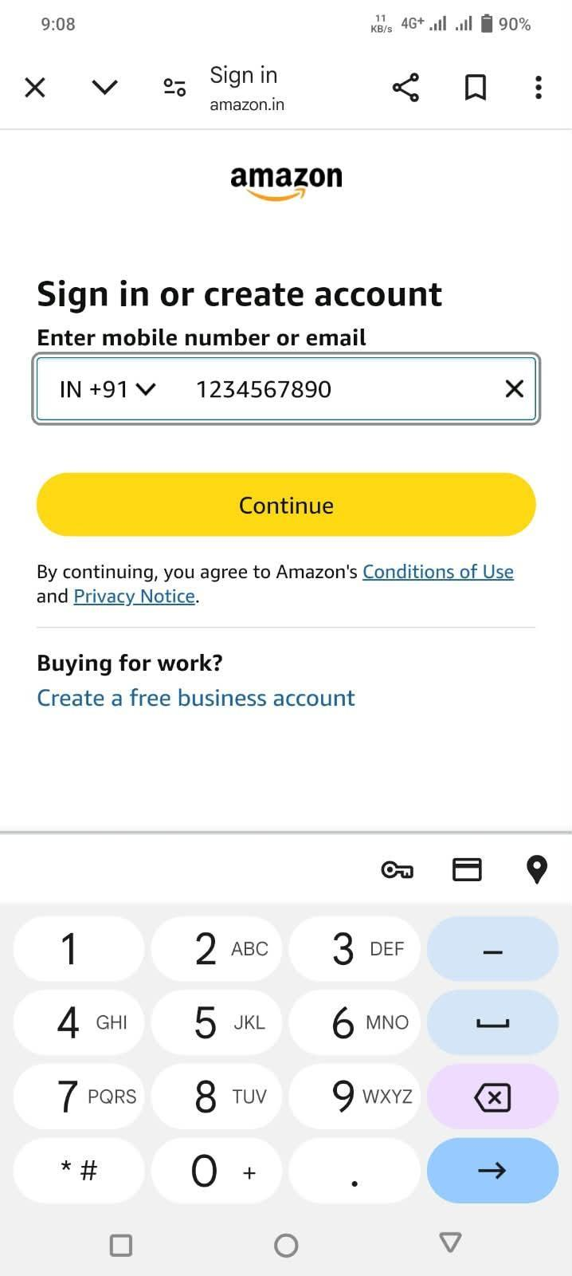

Scenario ID: 1e
Scenario: Login with empty mobile/email field
Test Steps:
1. Open Amazon login page
2. Leave mobile/email field empty
3. Click Continue
Screenshots: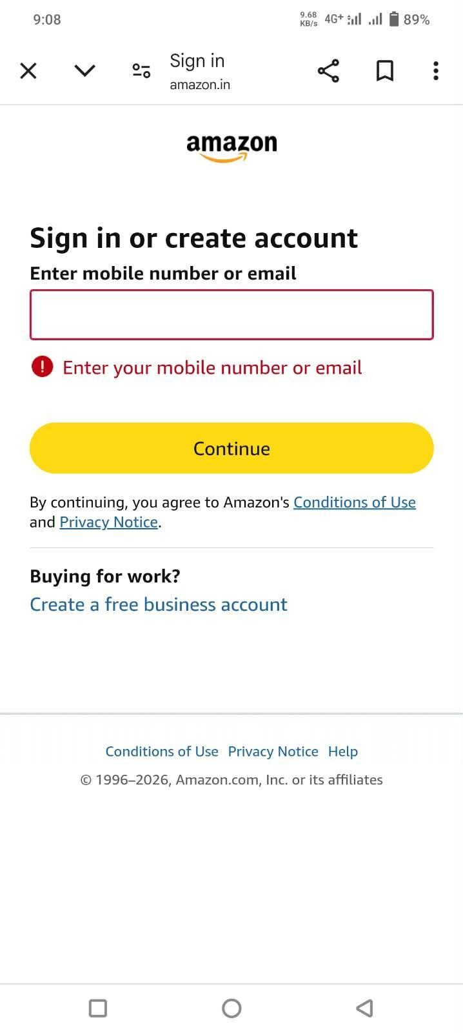

Scenario ID: 1f
Scenario: Enter invalid email format
Test Steps:
1. Open login page
2. Enter an incorrectly formatted email
3. Click Continue
Screenshots: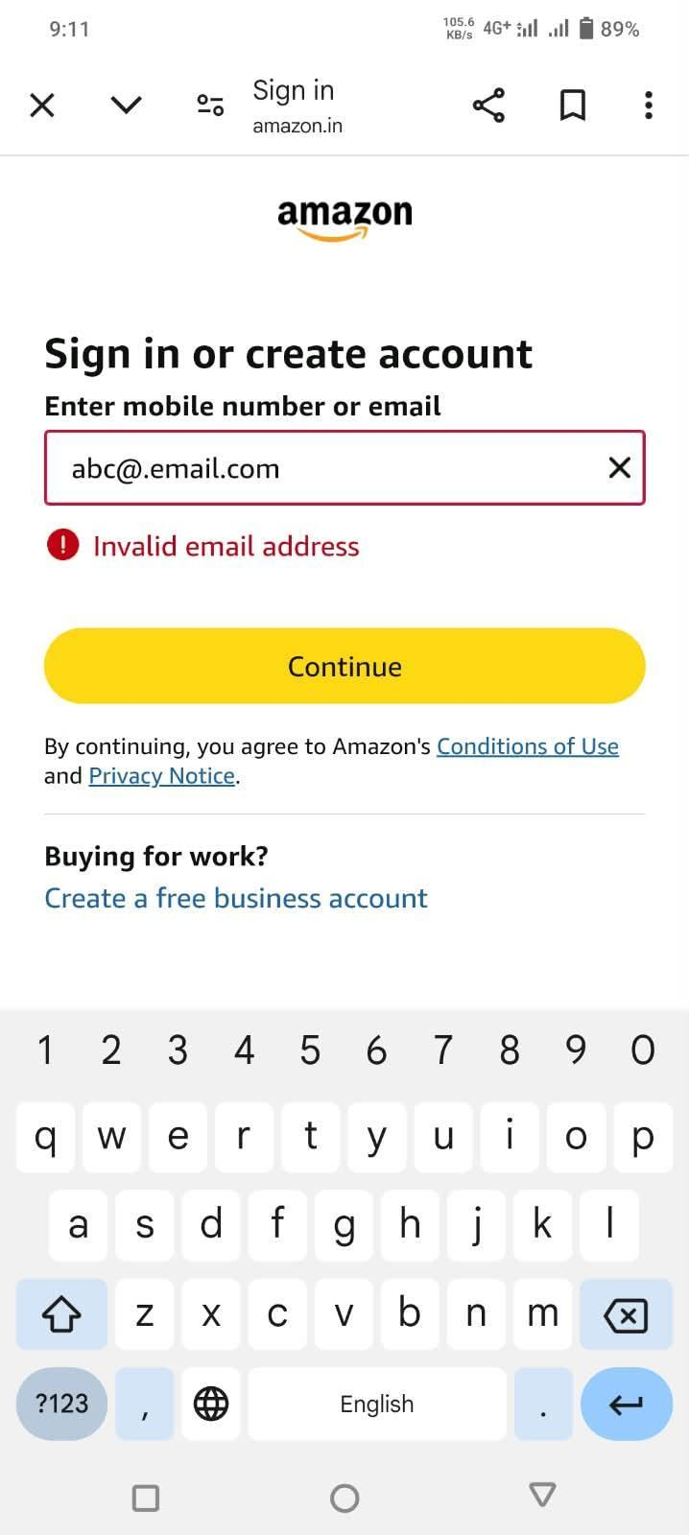

Scenario ID: 1g
Scenario: Enter mobile number with invalid length
Test Steps:
1. Open login page
2. Enter mobile number with fewer/more than required digits
3. Click Continue
Screenshots: