Module Name: Functional Testing – Swiggy
Test Case ID: Tutorial_4
Webpage URL: https://www.swiggy.com/

Scenario ID: 4a
Scenario: Verify restaurant/food search functionality
Test Steps:
1. Open Swiggy website/app
2. Locate the search option
3. Enter a valid food item
4. Submit the search
Screenshots: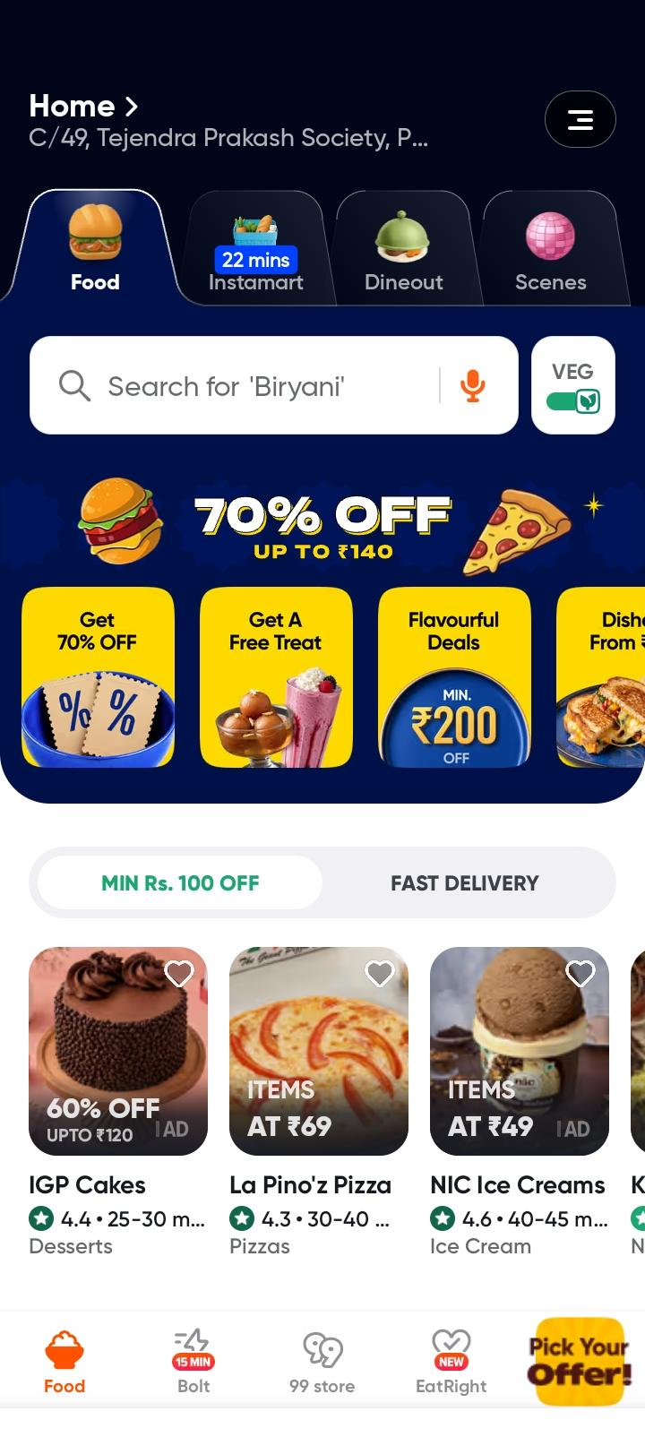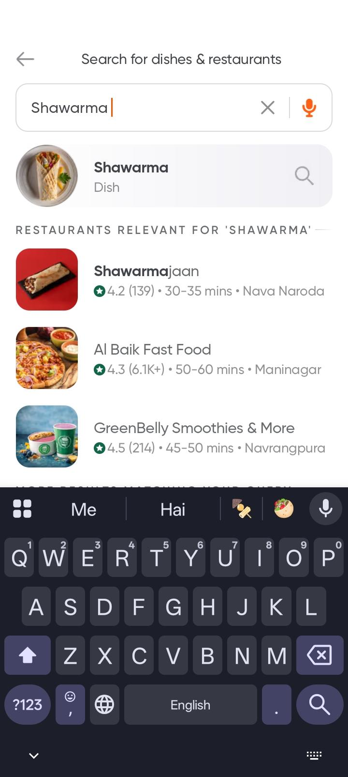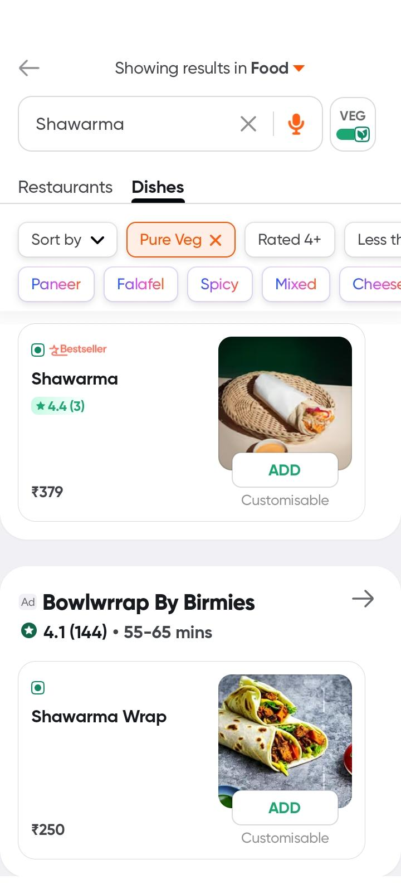

Scenario ID: 4b
Scenario: Verify adding a food item to cart
Test Steps:
1. Open Swiggy
2. Select a restaurant
3. Select an available food item
4. Add the item to the cart
5. Open the cart
Screenshots: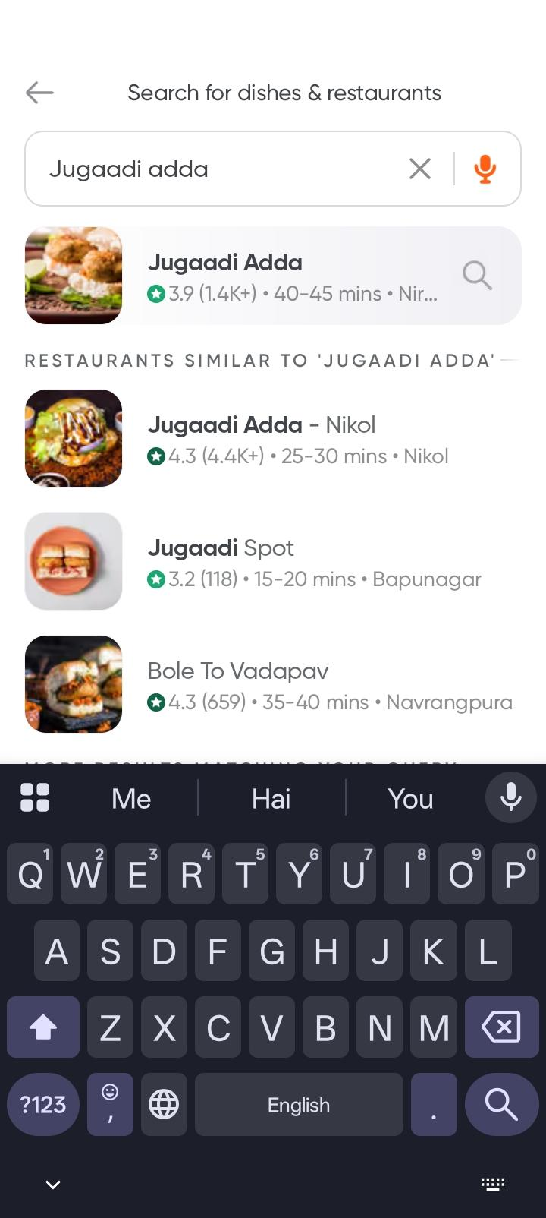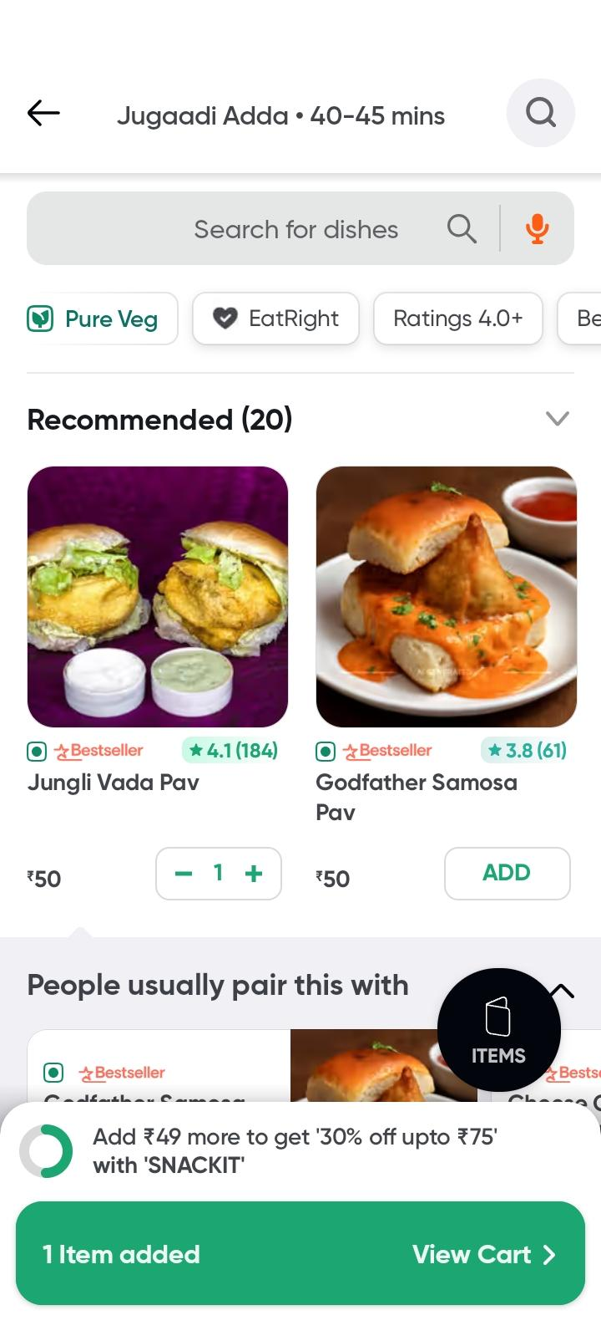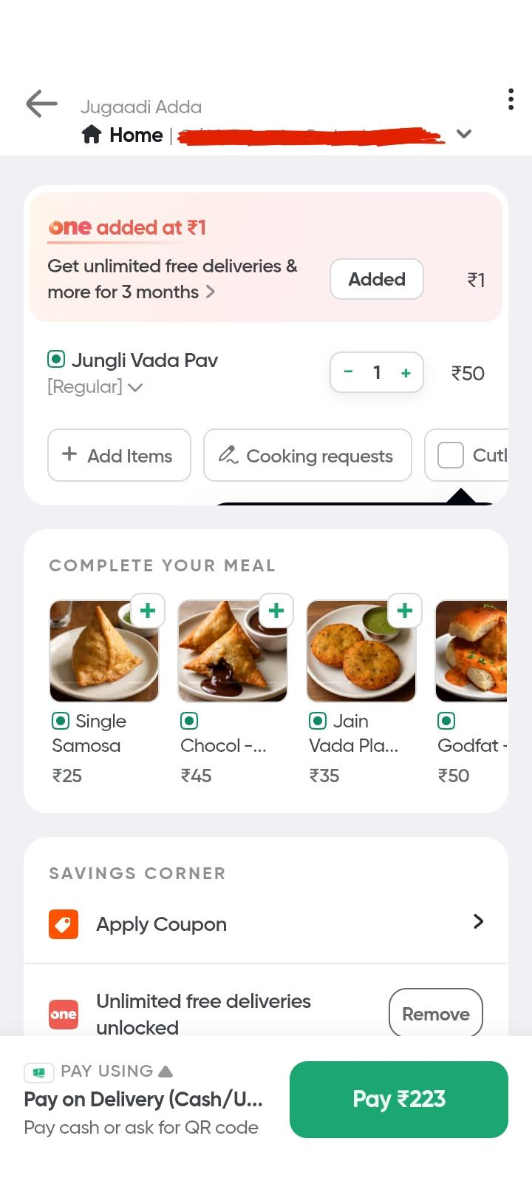

Scenario ID: 4c
Scenario: Verify behavior when searching with invalid input
Test Steps:
1. Open Swiggy
2. Open the search option
3. Enter an invalid/non-meaningful search term
4. Submit the search
Screenshots: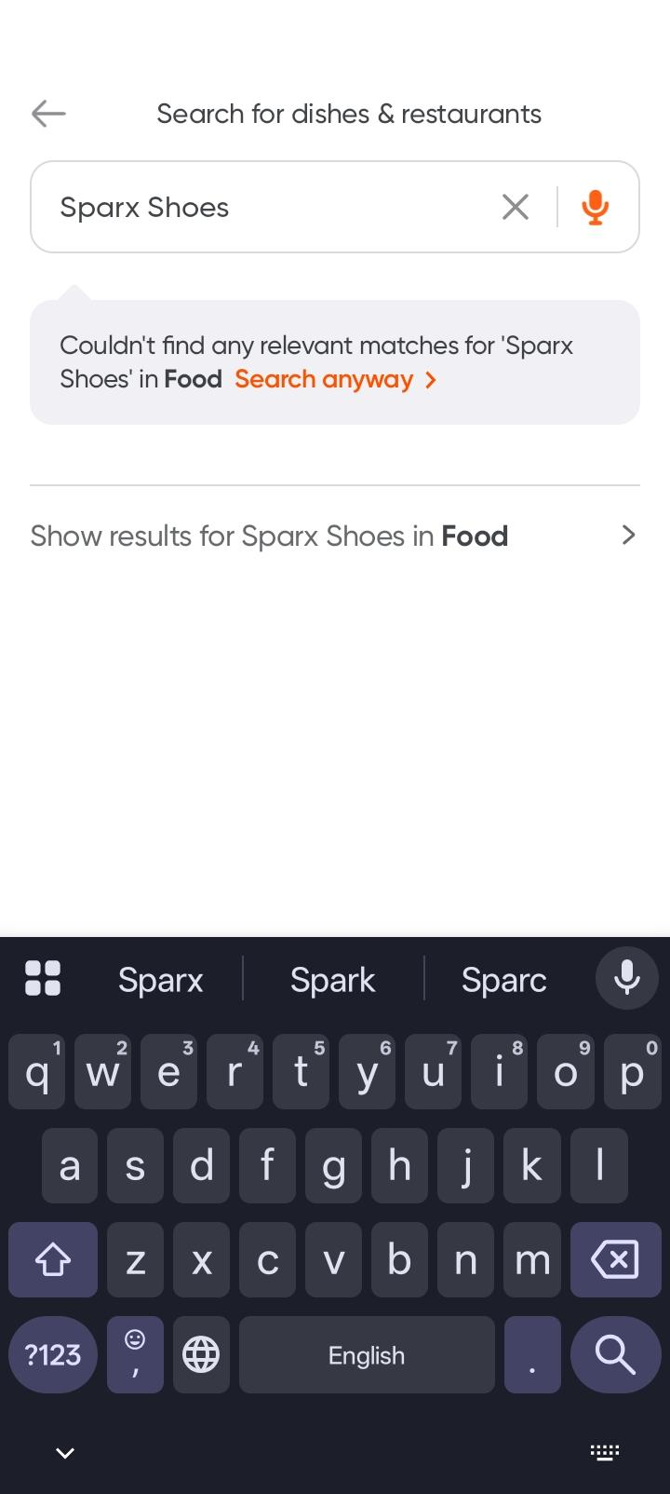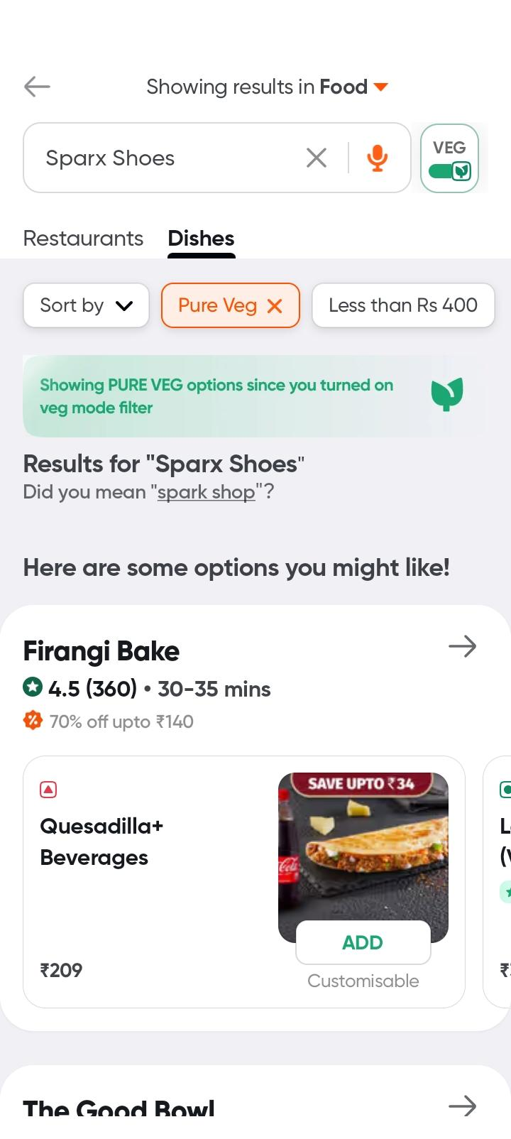

Scenario ID: 4d
Scenario: Verify modification of cart quantity
Test Steps:
1. Add a food item to the cart
2. Open the cart
3. Increase the quantity of the item
4. Observe the cart total
Screenshots: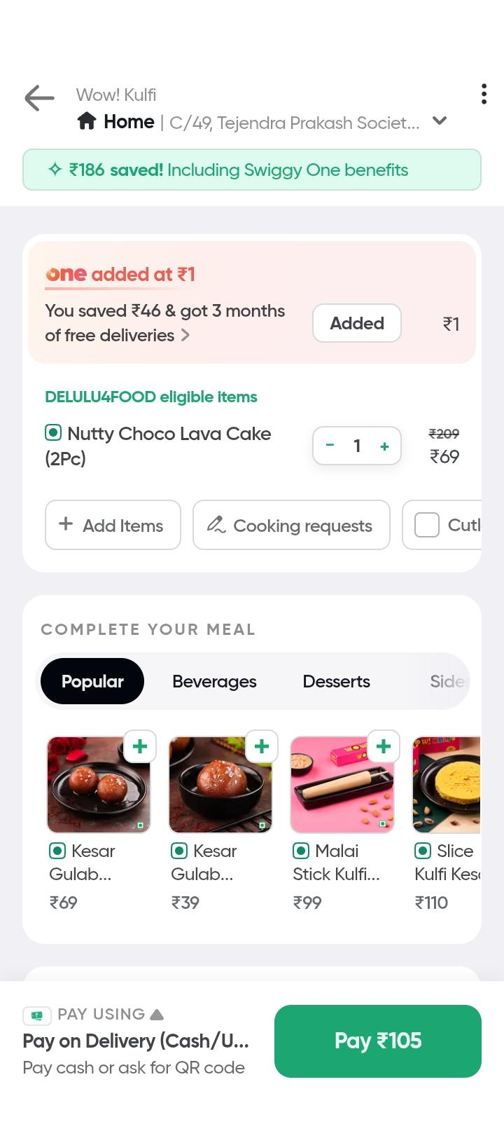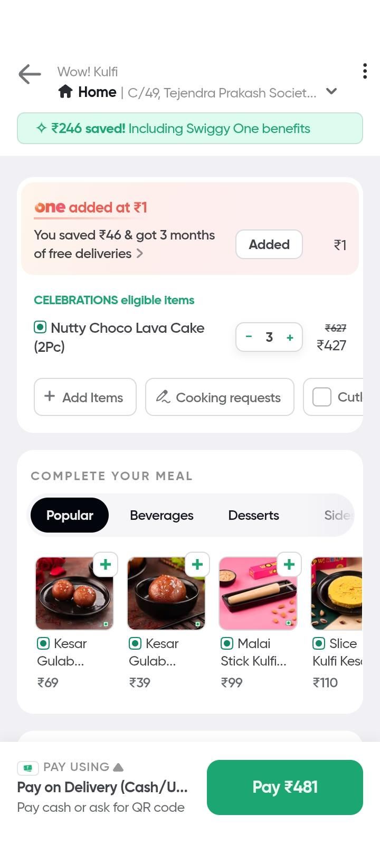

Scenario ID: 4e
Scenario: Verify checkout with incomplete required information
Test Steps:
1. Add a food item to the cart
2. Proceed towards checkout
3. Leave a required delivery detail incomplete
4. Try to continue
Screenshots: