Module Name: Boundary Value Analysis – Zomato
Test Case ID: Tutorial_5
Webpage URL: https://www.zomato.com/

Scenario ID: 5a
Scenario: Verify mobile number at boundary values
Test Steps:
1. Open Zomato
2. Open the login/sign-in option
3. Enter a mobile number with different lengths around the valid boundary
4. Continue with each input
Screenshots: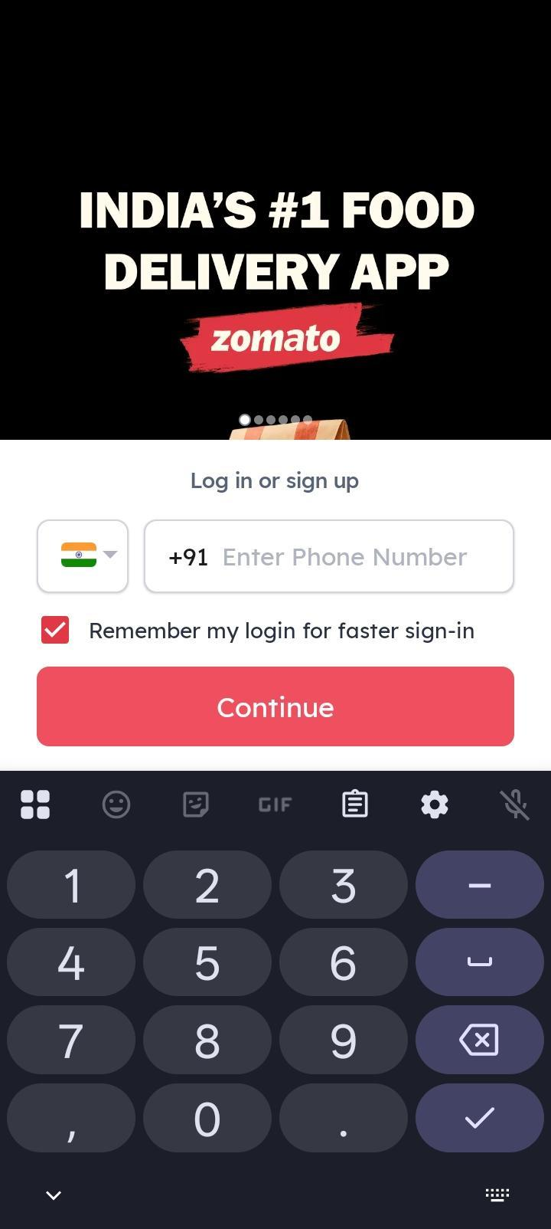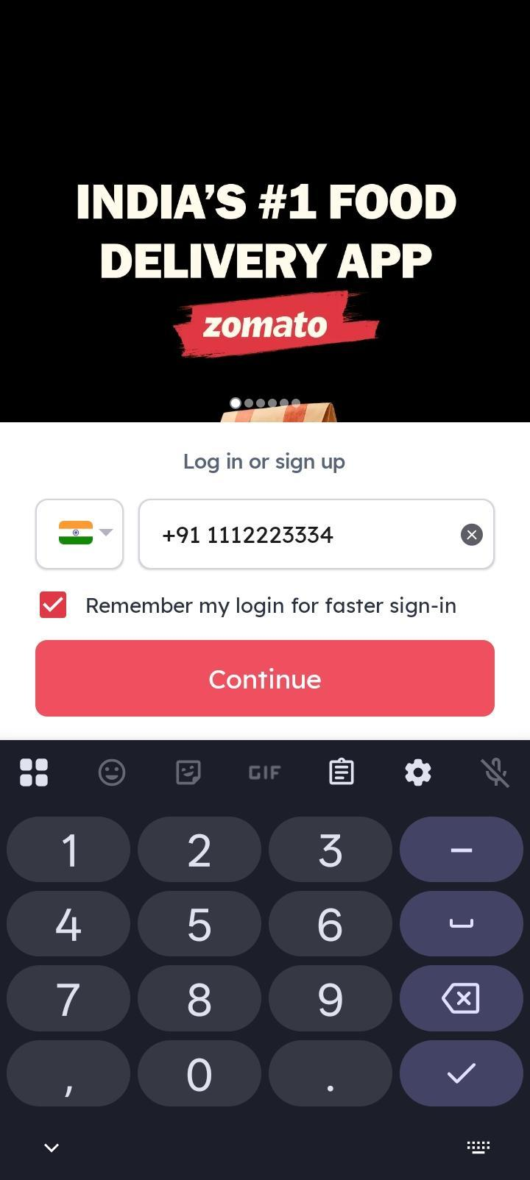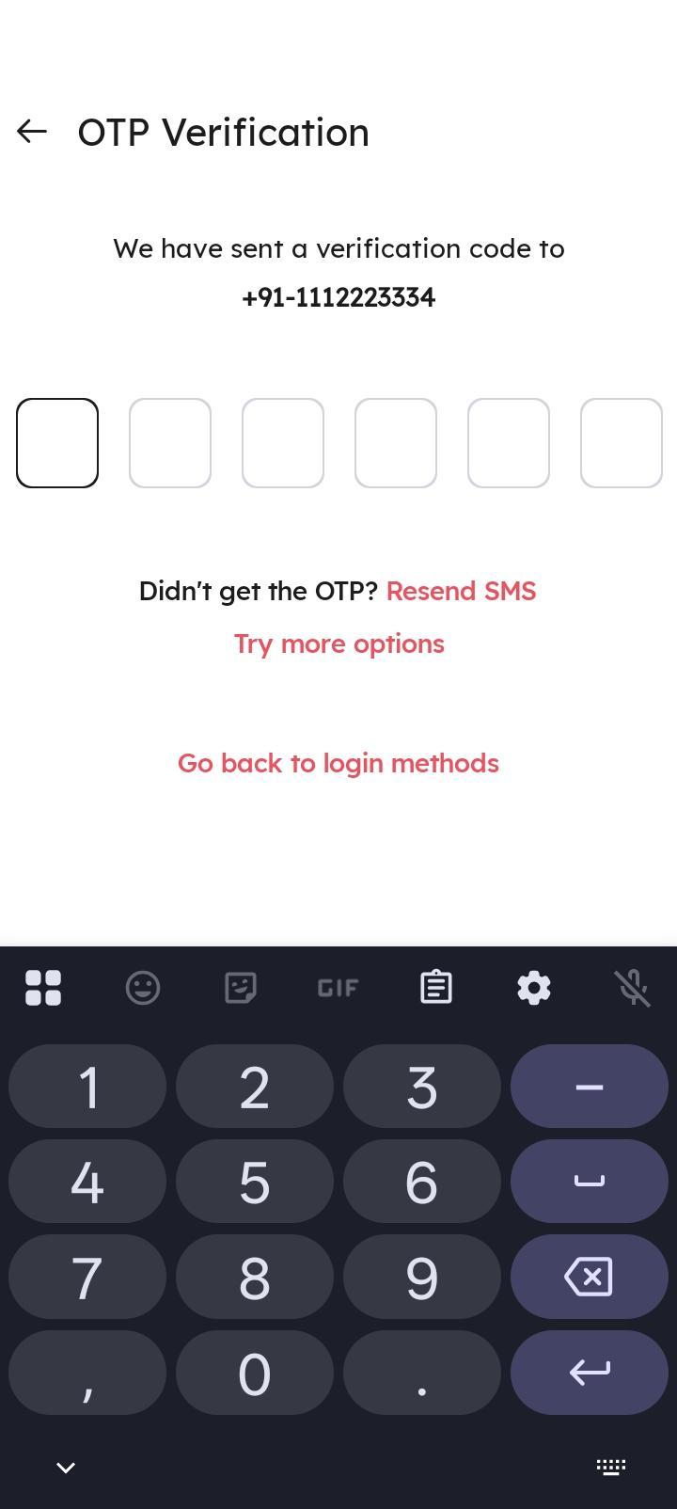

Scenario ID: 5b
Scenario: Verify OTP length at boundary values
Test Steps:
1. Open Zomato login/sign-in
2. Enter a valid mobile number
3. Proceed to OTP verification
4. Enter OTP values with lengths around the expected boundary
Screenshots: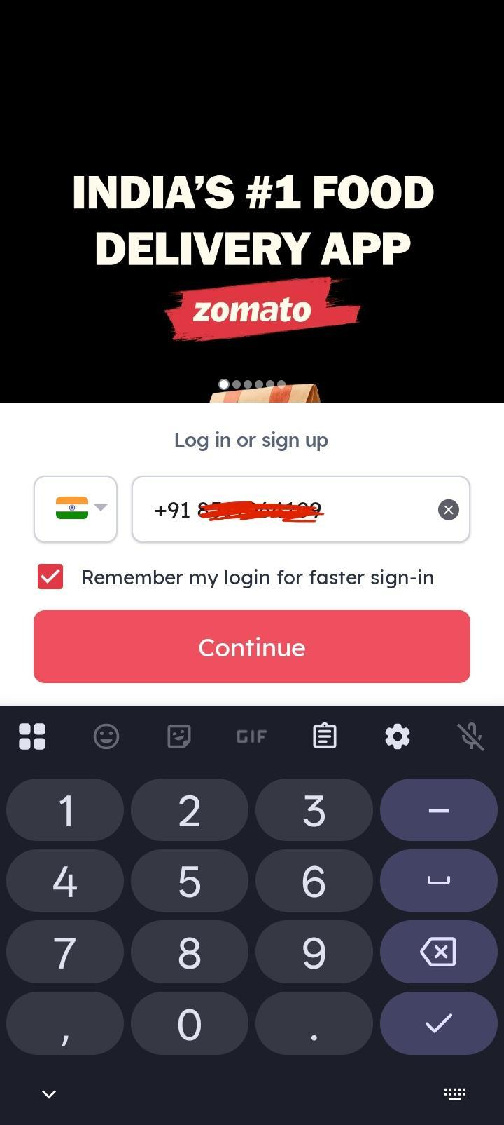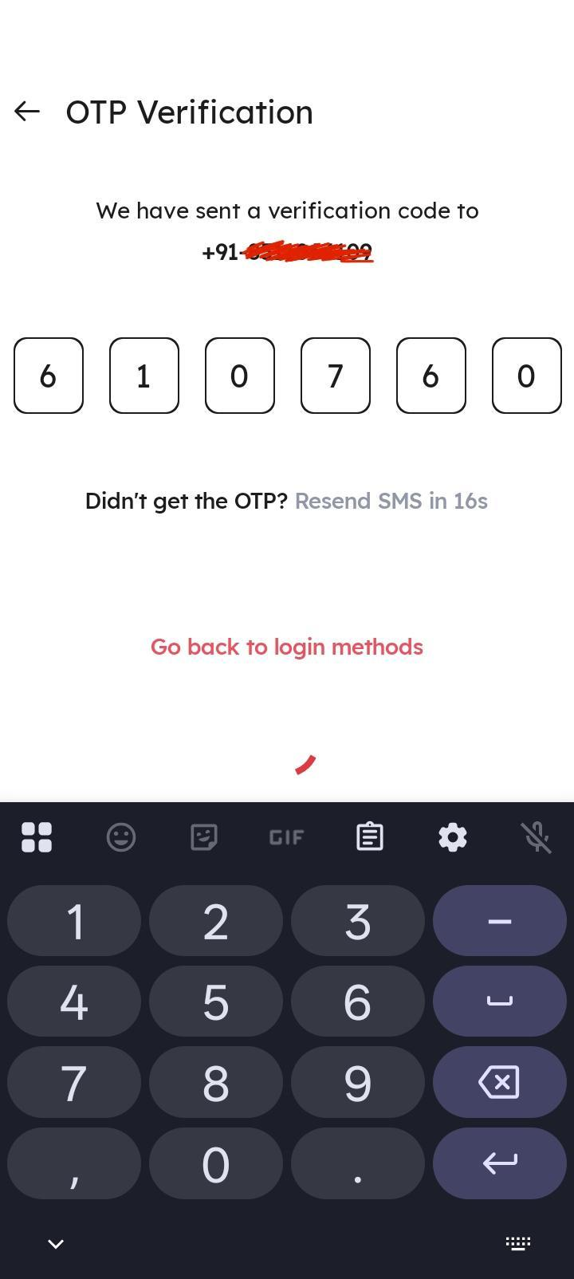

Scenario ID: 5c
Scenario: Verify PIN code at boundary values
Test Steps:
1. Open Zomato
2. Navigate to an address/location form where PIN code is required
3. Enter PIN codes with lengths around the valid boundary
4. Observe validation
Screenshots:

Scenario ID: 5d
Scenario: Verify search input around length boundary
Test Steps:
1. Open Zomato
2. Select the search field
3. Enter a short search query
4. Increase the input length around the supported boundary
5. Observe the search behavior
Screenshots:

Scenario ID: 5e
Scenario: Verify food item quantity at boundary values
Test Steps:
1. Open Zomato
2. Select a restaurant and food item
3. Add the item to cart
4. Increase/decrease quantity around the permitted boundary
5. Observe the cart
Screenshots: