Module Name: Manual Test Execution – Google Search
Test Case ID: Tutorial_6
Webpage URL: https://www.google.com/

Scenario ID: 6a
Scenario: Execute search with valid text input
Test Steps:
1. Open Google Search
2. Enter a normal text query
3. Click Google Search or press Enter
4. Observe the displayed results
Screenshots:

Scenario ID: 6b
Scenario: Execute search with numeric input
Test Steps:
1. Open Google Search
2. Enter a numeric query
3. Click Google Search or press Enter
4. Observe the displayed results
Screenshots: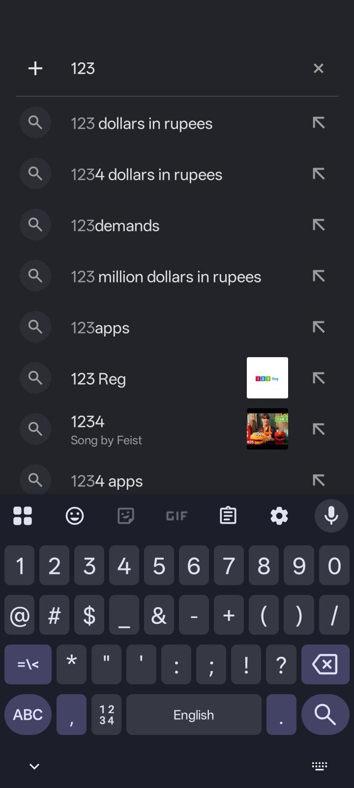

Scenario ID: 6c
Scenario: Execute search with special characters
Test Steps:
1. Open Google Search
2. Enter special characters in the search field
3. Click Google Search or press Enter
4. Observe the displayed results
Screenshots: 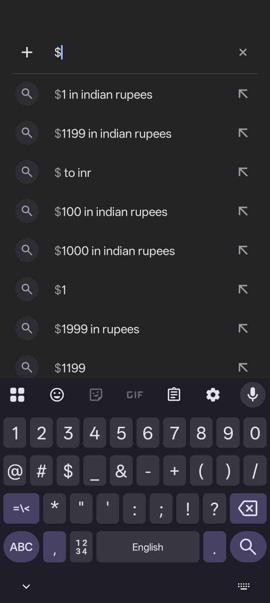

Scenario ID: 6d
Scenario: Execute search with empty input
Test Steps:
1. Open Google Search
2. Leave the search field empty
3. Click Google Search
4. Observe the page behavior
Screenshots:

Scenario ID: 6e
Scenario: Execute search with alphanumeric input
Test Steps:
1. Open Google Search
2. Enter a combination of letters and numbers
3. Click Google Search or press Enter
4. Observe the displayed results
Screenshots: