INTRODUCTION TO PROJECT

The web-based "Airline Reservation System" project aims to simulate the fundamental concepts of an airline reservation system. This platform enables users to perform actions such as searching for available airline flights between two specified travel cities on a designated date. Users can select a suitable flight based on provided details, and subsequently make flight reservations.
The system offers a Quick Search feature that grants users access to flight details without requiring them to log in. However, if a user intends to proceed with ticket booking, a mandatory login is necessary.
This system allows airline passengers to explore flights available for their chosen departure and arrival cities. Specifically, it facilitates the search for flights between the "Departure city" and "Destination city," taking into account specific departure and arrival dates. The system presents comprehensive flight information, including flight number, name, pricing, and departure time.
Furthermore, the system offers a Quick Search function, which furnishes a list of accessible flights, enabling customers to make a selection. Following this, the system evaluates seat availability for the chosen flight. If seats are open, passengers are permitted to reserve a seat. Conversely, if seats are unavailable, the system prompts users to consider alternative flight options.
For flight booking, the system solicits passenger details such as name, address, city, state, credit card number, and contact information. Subsequently, the system verifies the validity of the provided credit card and proceeds to confirm the flight reservation. This involves updating both the airline's database and the user's database.
Through these functionalities, the "Airline Reservation System" endeavors to provide users with a streamlined experience in exploring, selecting, and booking flights while ensuring accuracy and data integrity in the process.

Database Design

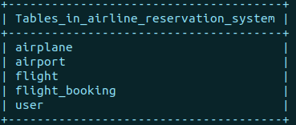

Here we are going by five tables;
The airplane table has the information about the airplane that the company has in its possession. The airport table has the information about the cities that the airline is currently serving to. The flight table has all the scheduling information about the flights. The flight_booking table has the information regarding the bookings made by the customers. And lastly the user table contains the information regarding the user.

Airplane Table

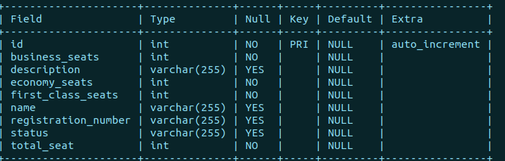
The airplane table consists of several fields that collectively store information about airplanes in the airline reservation system. The table's primary key, labeled as id, is an auto-incrementing integer that uniquely identifies each airplane entry. The table holds details such as the number of business, economy, and first-class seats available, recorded respectively in business_seats, economy_seats, and first_class_seats fields. An optional textual description of the airplane can be stored in the description field.
The name field accommodates the name of the airplane, and the registration_number field holds a unique registration identifier for each aircraft. The status field can be used to indicate the operational status of the airplane, such as 'active' or 'inactive'. Additionally, the total_seat field indicates the overall seat capacity of the airplane.
Collectively, these fields provide essential information about each airplane, enabling efficient search and selection of available flights, management of seat reservations, and overall airline database management. The table structure and fields allow for accurate representation of aircraft attributes, supporting streamlined booking and passenger management processes

Airport table

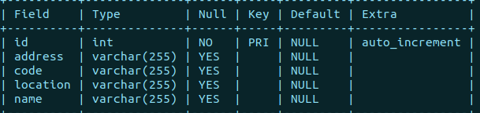

The table named airports encompasses crucial details related to airports, contributing to the efficient functioning of an integrated system. The primary key, labeled as id, is an auto-incrementing integer that uniquely identifies each airport entry. The table features several fields:
- address: This field, of type varchar(255), records the physical address of the airport. It accommodates textual information that identifies the location of the airport within its operational region.
- code: Represented as varchar(255), the code field stores a distinctive identifier assigned to each airport. This code can be used for quick and standardized reference when dealing with multiple airports.
- location: The location field, also of type varchar(255), stores the geographical coordinates or descriptive location information of the airport. It aids in pinpointing the airport's position on a map or within a specific area.
- name: The name field, utilizing varchar(255) data type, holds the name associated with the airport. It provides a recognizable title for the airport, aiding in user identification and navigation.
The arrangement of these fields supports the effective management and retrieval of airport-related data. By containing information ranging from geographical specifics to distinct identifiers, the airports table supports functionalities such as routing flights, mapping locations, and providing users with precise details for booking and travel planning. This table forms a fundamental component of the broader system's capability to seamlessly manage airport-related data within the context of an airline reservation ecosystem.

Flight table

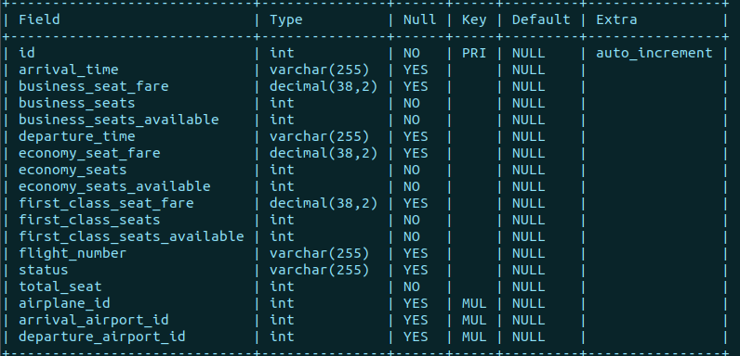
id: An auto-incrementing integer that uniquely identifies each flight entry.
- arrival_time: A varchar(255) field capturing the arrival time of the flight.
- business_seat_fare: A decimal(38,2) field representing the fare for a business class seat.
- business_seats: An integer indicating the total number of business class seats on the flight.
- business_seats_available: An integer representing the count of available business class seats.
- departure_time: A varchar(255) field noting the departure time of the flight.
- economy_seat_fare: A decimal(38,2) field indicating the fare for an economy class seat.
- economy_seats: An integer indicating the total number of economy class seats on the flight.
- economy_seats_available: An integer representing the count of available economy class seats.
- first_class_seat_fare: A decimal(38,2) field denoting the fare for a first-class seat.
- first_class_seats: An integer indicating the total number of first-class seats on the flight.
- first_class_seats_available: An integer representing the count of available first-class seats.
- flight_number: A varchar(255) field storing the flight's unique identifier.
- status: A varchar(255) field conveying the status of the flight.
- total_seat: An integer representing the total number of seats on the flight.
- airplane_id: An integer referencing the airplane associated with the flight.
- arrival_airport_id: An integer referencing the arrival airport for the flight.
- departure_airport_id: An integer referencing the departure airport for the flight.
These fields collectively encompass essential flight-related details, including departure and arrival times, seat availability, fares, and aircraft specifics.
Flight_booking Table

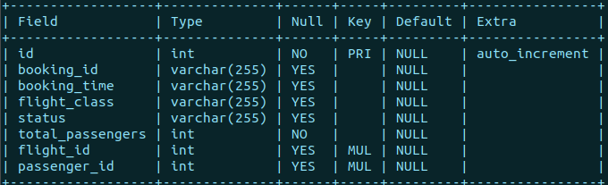
id: An auto-incrementing integer that uniquely identifies each booking entry.
- booking_id: A varchar(255) field that stores a unique identifier for the booking.
- booking_time: A varchar(255) field that denotes the time at which the booking was made.
- flight_class: A varchar(255) field indicating the class of the flight booking (e.g., business, economy, first class).
- status: A varchar(255) field representing the status of the booking (e.g., confirmed, pending, cancelled).
- total_passengers: An integer that signifies the total number of passengers included in the booking.
- flight_id: An integer referencing the flight associated with the booking.
- passenger_id: An integer referencing the passenger associated with the booking.

User table

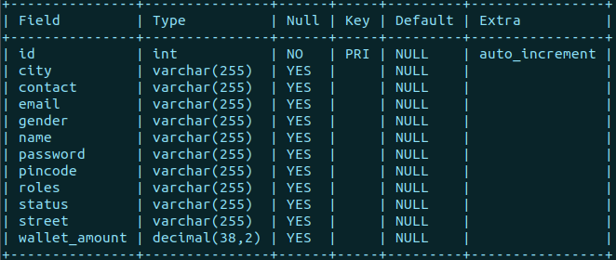
id: An auto-incrementing integer that uniquely identifies each user profile.
- city: A varchar(255) field containing the user's city of residence.
- contact: A varchar(255) field that stores the user's contact information.
- email: A varchar(255) field for the user's email address, used for communication and login purposes.
- gender: A varchar(255) field that denotes the user's gender.
- name: A varchar(255) field for the user's name.
- password: A varchar(255) field containing the user's password for authentication.
- pincode: A varchar(255) field for the user's postal code.
- roles: A varchar(255) field specifying the user's role(s) or permissions within the system.
- status: A varchar(255) field indicating the status of the user account (e.g., active, suspended, deleted).
- street: A varchar(255) field holding the user's street address.
- wallet_amount: A decimal(38,2) field representing the amount available in the user's digital wallet.

Backend

The online airline reservation system’s backed programming has been done in Java using the Springboot. The software used for making the backend is Spring Tool Suite.
Here is a glimpse of backend programming implemented.

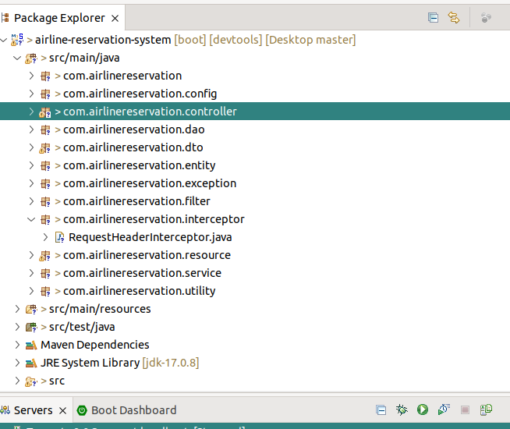
The controller is responsible for interacting with the frontend software which in this case is the React development server. There are multiple api’s programmed to handle different requests that will be sent by the client to the backend server.

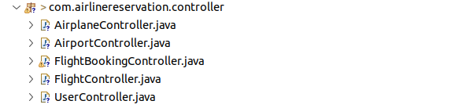

Here we can see the controller package contains a total of 5 controller components that handle the incoming request and reply with a suitable response.

AirplaneController
The class contains two endpoint handling methods:
- addAirplane: This method is annotated with @PostMapping("add") and is responsible for adding a new airplane to the system. It takes a JSON representation of an Airplane object in the request body. The method delegates the actual logic to the AirplaneResource class through the addAirplane method, which returns a CommonApiResponse wrapped in a ResponseEntity.
- fetchAllAirplane: This method is annotated with @GetMapping("/fetch/all") and is used to retrieve information about all airplanes in the system. It calls the fetchAllAirplane method of the AirplaneResource class, which returns an AirplaneResponseDto containing information about all available airplanes. The method returns this data wrapped in a ResponseEntity.

AirportController

This controller contains two endpoint handling methods:
- addAirport: This method is annotated with @PostMapping("add") and is designed to add a new airport to the system. It expects a JSON representation of an Airport object in the request body. The method delegates the actual logic to the AirportResource class through the addAirport method. The response is wrapped in a CommonApiResponse and returned within a ResponseEntity.
- fetchAllAirports: Annotated with @GetMapping("/fetch/all"), this method retrieves information about all airports in the system. It calls the fetchAllAirports method of the AirportResource class, which presumably contains the business logic for fetching airport data. The response, containing airport information, is encapsulated in an AirportResponseDto and returned as a ResponseEntity.

FlightBookingController

This controller offers three distinct endpoint handling methods:
- addFlightBooking: Decorated with @PostMapping("add"), this method accepts a JSON representation of a FlightBookingRequestDto object in the request body. It delegates the actual booking logic to the FlightBookingResource class through the addFlightBooking method. The response is encapsulated in a CommonApiResponse and returned within a ResponseEntity.
- fetchAllFlightBookings: Annotated with @GetMapping("/fetch/all"), this method retrieves information about all flight bookings within the system. It invokes the fetchAllFlightBookings method of the FlightBookingResource class, which presumably handles the underlying business logic. The response, containing flight booking details, is enclosed in a FlightBookingResponseDto and returned as a ResponseEntity.
- fetchUserBookings: Annotated with @GetMapping("/fetch/user"), this method is designed to retrieve flight booking information associated with a specific user. It takes a query parameter "userId" and calls the fetchUserBookings method of the FlightBookingResource class, passing the user ID as a parameter. The method's response, comprising flight booking details for the specified user, is wrapped in a FlightBookingResponseDto and returned as a ResponseEntity.
FlightController

The controller encompasses several distinct endpoint handling methods, each catering to specific functionalities:
- addFlight: Utilizing @PostMapping("add"), this method accepts a JSON representation of a FlightRequestDto object within the request body. The FlightResource class's addFlight method is invoked to handle the logic of adding a new flight. The response is encapsulated in a CommonApiResponse and returned within a ResponseEntity.
- fetchAllFlights: Annotated with @GetMapping("/fetch/all"), this method retrieves information about all flights within the system. It invokes the fetchAllFlights method of the FlightResource class, which presumably handles the underlying business logic. The response, containing flight details, is enclosed in a FlightResponseDto and returned as a ResponseEntity.
- searchFlights: With @GetMapping("/search"), this method facilitates searching for flights based on specific criteria such as departure and arrival airports, as well as time range. It takes query parameters for departure and arrival airport IDs, start time, and end time. The fetchFlightsByTimeRange method of the FlightResource class is called, returning a FlightResponseDto containing relevant flight details.
- fetchFlights: Annotated with @GetMapping("/status/all"), this method retrieves a list of all possible flight statuses. The fetchAllFlightStatus method of the FlightResource class is invoked, and the list of statuses is returned within a ResponseEntity.
- fetchFlightClass: Annotated with @GetMapping("/class/all"), this method fetches all possible flight classes. The fetchAllFlightClass method of the FlightResource class is invoked, and the list of classes is returned within a ResponseEntity.
- updateFlightStatus: Decorated with @PostMapping("update/status"), this method allows updating the status of a flight. It expects a JSON representation of a FlightUpdateStatusRequestDto object in the request body. The FlightResource class's updateFlightStatus method is called, and the response is wrapped in a CommonApiResponse and returned as a ResponseEntity.

UserController

This controller comprises a series of endpoint handling methods, each catering to specific user-related actions:
- registerUser: This @PostMapping method is employed for registering both customer and bank users. It expects a JSON representation of a RegisterUserRequestDto object in the request body. The userResource.registerUser method is invoked to manage the registration process. The response is encapsulated in a CommonApiResponse and returned within a ResponseEntity.
- registerAdmin: Annotated with @PostMapping("/admin/register"), this method handles the registration of administrators. Similar to registerUser, it accepts a RegisterUserRequestDto in the request body and calls userResource.registerAdmin to process the registration.
- login: This @PostMapping method facilitates user login by accepting a JSON UserLoginRequest in the request body. The userResource.login method is invoked to handle the login process. The response is encapsulated in a UserLoginResponse and returned within a ResponseEntity.
- fetchAllBankUsers: Annotated with @GetMapping("/fetch/role"), this method retrieves a list of users based on their roles. It takes a "role" query parameter and invokes userResource.getUsersByRole, returning a UserListResponseDto containing user details.
- updateUserStatus: Utilizing @PostMapping("update/status"), this method allows updating the status of a user. It expects a JSON UserStatusUpdateRequestDto in the request body. The userResource.updateUserStatus method is called, and the response is wrapped in a UserLoginResponse and returned within a ResponseEntity.
- addMoneyInWallet: This @PostMapping method is used to add money to a user's wallet. It accepts a JSON AddWalletMoneyRequestDto in the request body and invokes userResource.addMoneyInWallet to manage the wallet update. The response is wrapped in a CommonApiResponse and returned within a ResponseEntity.
- getCustomerWallet: This @GetMapping method fetches the wallet amount for a specific passenger user. It takes a "userId" query parameter and retrieves the user's wallet amount using the userService. The response is a ResponseEntity containing the wallet amount as a string.

Website Flow

