**BANK LOAN REPORT | QUARY DOCUMENT**

1. **BANK LOAN REPORT | SUMMARY**

**KPI’s:**

1. **Total Loan Applications**

SELECT COUNT(id) AS Total_Loan_Applications

FROM bank_loan_data;



1. **MTD (Month-To-Date) Loan Applications**

SELECT COUNT(id) AS Total_Loan_Applications

FROM bank_loan_data

WHERE MONTH(issue_date) = 12 AND YEAR(issue_date) = 2021;



1. **PMTD (Previous-Month-To-Date) Loan Applications**

SELECT COUNT(id) AS PMTD_Total_Loan_Applications

FROM bank_loan_data

WHERE MONTH(issue_date) = 11 AND YEAR(issue_date) = 2021;



1. **Total Funded Amount**

SELECT SUM(loan_amount) AS Total_Funded_Amount

FROM bank_loan_data;



1. **MTD Total Funded Amount**

SELECT SUM(loan_amount) AS MTD_Total_Funded_Amount

FROM bank_loan_data

WHERE MONTH(issue_date) = 12 AND YEAR(issue_date) = 2021;



1. **PMTD Total Funded Amount**

SELECT SUM(loan_amount) AS PMTD_Total_Funded_Amount

FROM bank_loan_data

WHERE MONTH(issue_date) = 11 AND YEAR(issue_date) = 2021;



1. **Total Amount Received**

SELECT SUM(total_payment) AS Total_Amount_Received

FROM bank_loan_data;



1. **MTD Total Amount Received**

SELECT SUM(total_payment) AS MTD_Total_Amount_Received

FROM bank_loan_data

WHERE MONTH(issue_date) = 12 AND YEAR(issue_date) = 2021;



1. **PMTD Total Amount Received**

SELECT SUM(total_payment) AS PMTD_Total_Amount_Received

FROM bank_loan_data

WHERE MONTH(issue_date) = 11 AND YEAR(issue_date) = 2021;



1. **Average Interest Rate**

SELECT AVG(int_rate) *100 AS AVG_Interest_Rate

FROM bank_loan_data;



1. **MTD Average Interest**

SELECT AVG(int_rate) *100 AS MTD_AVG_Interest_Rate

FROM bank_loan_data

WHERE MONTH(issue_date) = 12 AND YEAR(issue_date) = 2021;



1. **PMTD Average Interest**

SELECT AVG(int_rate) *100 AS PMTD_AVG_Interest_Rate

FROM bank_loan_data

WHERE MONTH(issue_date) = 11 AND YEAR(issue_date) = 2021;



1. **Avg DTI (Debt-to-Income Ratio)**

SELECT ROUND(AVG(dti)*100,2) AS AVG_DTI

FROM bank_loan_data;



1. **MTD Avg DTI**

SELECT ROUND(AVG(dti)*100,2) AS MTD_AVG_DTI

FROM bank_loan_data

WHERE MONTH(issue_date) = 12 AND YEAR(issue_date) = 2021;



1. **PMTD Avg DTI**

SELECT ROUND(AVG(dti)*100,2) AS PMTD_AVG_DTI

FROM bank_loan_data

WHERE MONTH(issue_date) = 11 AND YEAR(issue_date) = 2021;



**GOOD LOAN ISSUED**

1. **Good Loan Percentage**

SELECT

(COUNT(CASE WHEN loan_status = 'Fully Paid' OR loan_status = 'Current' THEN id END)*100) / COUNT(id) AS Good_Loan_Percenatge

FROM bank_loan_data;



1. **Good Loan Applications**

SELECT COUNT(id) AS Good_Loan_Applications

FROM bank_loan_data

WHERE loan_status = 'Fully Paid' OR loan_status = 'Current';



1. **Good Loan Funded Amount**

SELECT SUM(loan_amount) AS Good_Loan_Funded_Amount

FROM bank_loan_data

WHERE loan_status = 'Fully Paid' OR loan_status = 'Current';



1. **Good Loan Amount Received**

SELECT SUM(total_payment) AS Good_Loan_Amount_Received

FROM bank_loan_data

WHERE loan_status = 'Fully Paid' OR loan_status = 'Current';



**BAD LOAN ISSUED**

1. **Bad Loan Percentage**

SELECT

(COUNT(CASE WHEN loan_status = 'Charged Off' THEN id END)*100.0)

/ COUNT(id) AS Bad_Loan_Percenatge

FROM bank_loan_data;



1. **Bad Loan Applications**

SELECT COUNT(id) AS Bad_Loan_Applications

FROM bank_loan_data

WHERE loan_status = 'Charged Off';



1. **Bad Loan Funded Amount**

SELECT SUM(loan_amount) AS Bad_Loan_Funded_Amount

FROM bank_loan_data

WHERE loan_status = 'Charged Off';



1. **Bad Loan Amount Received**

SELECT SUM(total_payment) AS Bad_Loan_Amount_Received

FROM bank_loan_data

WHERE loan_status = 'Charged Off';



**LOAN STATUS**

SELECT

loan_status,

COUNT(id) AS Total_Loan_Applications,

SUM(total_payment) AS Total_Amount_Received,

SUM(loan_amount) AS Total_Funded_Amount,

AVG(int_rate * 100) AS Interest_Rate,

AVG(dti * 100) AS DTI

FROM bank_loan_data

GROUP BY loan_status;

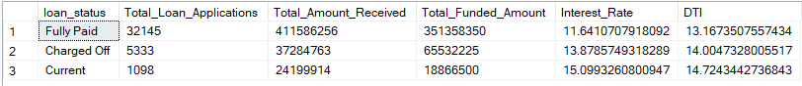

* **Month-to-Date Amount Received and Funded**

SELECT

loan_status,

SUM(total_payment) AS MTD_Total_Amount_Received,

SUM(loan_amount) AS MTD_Total_Funded_Amount

FROM bank_loan_data

WHERE MONTH(issue_date) = 12

GROUP BY loan_status;

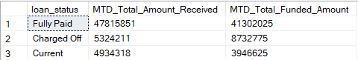

1. **BANK LOAN REPORT | OVERVIEW**

**MONTH**

* **Monthly Trends by Issue Date**

SELECT

MONTH(issue_date) AS Month_Number,

DATENAME(MONTH, issue_date) AS Month_Name,

COUNT(id) AS Total_Loan_Applications,

SUM(loan_amount) AS Total_Funded_Amount,

SUM(total_payment) AS Total_Received_Amount

FROM bank_loan_data

GROUP BY MONTH(issue_date), DATENAME(MONTH, issue_date)

ORDER BY MONTH(issue_date);

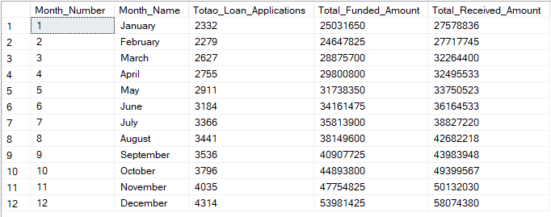

**STATE**

* **Regional Analysis by State**

SELECT

address_state,

COUNT(id) AS Total_Loan_Applications,

SUM(loan_amount) AS Total_Funded_Amount,

SUM(total_payment) AS Total_Received_Amount

FROM bank_loan_data

GROUP BY address_state

ORDER BY SUM(loan_amount) DESC;

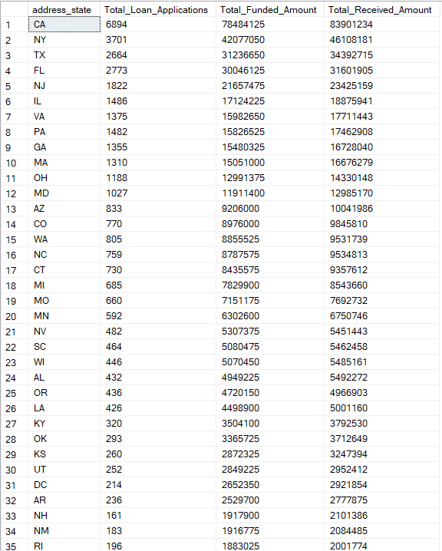

**TERM**

* **Loan Term Analysis**

SELECT

term,

COUNT(id) AS Total_Loan_Applications,

SUM(loan_amount) AS Total_Funded_Amount,

SUM(total_payment) AS Total_Received_Amount

FROM bank_loan_data

GROUP BY term

ORDER BY term DESC;



**EMPLOYEE LENGTH**

* **Employee length Analysis**

SELECT

emp_length,

COUNT(id) AS Total_Loan_Applications,

SUM(loan_amount) AS Total_Funded_Amount,

SUM(total_payment) AS Total_Received_Amount

FROM bank_loan_data

GROUP BY emp_length

ORDER BY COUNT(id) DESC;

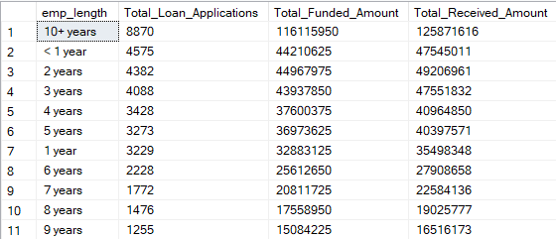

**PURPOSE**

* **Loan Purpose Breakdown**

SELECT

purpose,

COUNT(id) AS Total_Loan_Applications,

SUM(loan_amount) AS Total_Funded_Amount,

SUM(total_payment) AS Total_Received_Amount

FROM bank_loan_data

GROUP BY purpose

ORDER BY COUNT(id) DESC;

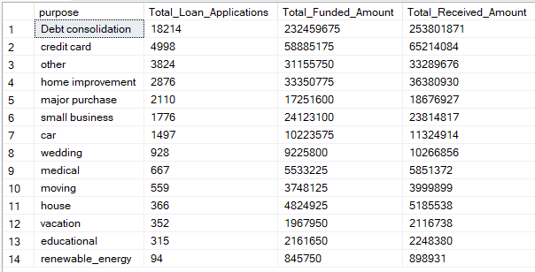

**HOME OWNERSHIP**

* **Home Ownership Analysis**

SELECT

home_ownership,

COUNT(id) AS Total_Loan_Applications,

SUM(loan_amount) AS Total_Funded_Amount,

SUM(total_payment) AS Total_Received_Amount

FROM bank_loan_data

GROUP BY home_ownership

ORDER BY COUNT(id) DESC;

