Project Title
Student Support Chatbot
1. Selected SDG and Reason
SDG 4: Quality Education
This SDG aims to ensure inclusive and equitable quality education and promote lifelong learning opportunities for all. Many students struggle to find accurate academic information and learning resources. An AI chatbot can provide instant educational support and guidance.
2. Problem Statement
Many students have limited access to structured learning resources and educational guidance. They often spend a lot of time searching for information about courses, admissions, fees, and study materials. This creates confusion and delays in decision-making.
- Who is affected?
School students
College students
New admission seekers
- Why is it serious?
Lack of information affects learning.
Students may miss opportunities and deadline
3. Proposed Solution
The proposed solution is a Student Support Chatbot developed using Botpress. The chatbot interacts with users and provides information based on their questions.4. Project Features
The chatbot can:
- Provide course information.
- Guide students about admissions.
- Answer scholarship-related queries.
- Provide placement information.
- Share contact details and college timings.
- Handle unknown questions using fallback responses.

4. Conversation Flow
Welcome Message
Bot: "Welcome to the Student Support Chatbot! I can help you with course information, college finding, placements, and scholarships."
Course Information
User: "What are the courses?"
Bot: "We offer BSc IT, BCom, BMS, BAF and other programs."
Course Selection
User: "BSc IT"
Bot: "Great choice! You can apply through the college admission portal and submit required documents."
Contact Information
User: "How to contact you?"
Bot: "You can contact the college office through email, phone, or by visiting the campus."
College Timings
User: "What is college timing?"
Bot: "College timings vary by course and semester."
Scholarship Information
User: "Can I apply for scholarship?"
Bot: "Yes, eligible students can apply for government and college scholarships."
Placement Information
User: "Is there placement in college?"
Bot: "Yes, the placement cell organizes recruitment drives and career guidance programs."
Fallback Response
User: "What is weather today?"
Bot: "Sorry, I couldn't understand your question. Please ask about admissions, courses, exams, fees, scholarships, or placements."

5. Project Features
1. Course Information
2. Scholarship Assistance
3. Placement Information
4. Contact Information
5. College Timing Information
6. Fallback Response System

6. Technology Stack
- Botpress
- Natural Language Processing (NLP)
- Artificial Intelligence
- GitHub
- Web Browser

7. Screenshots
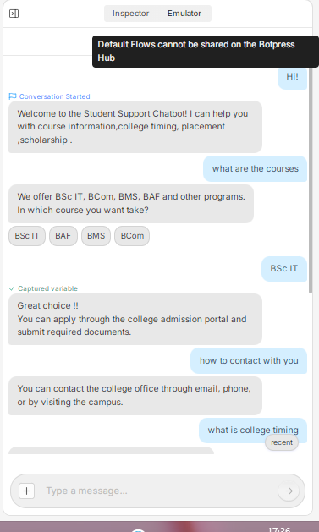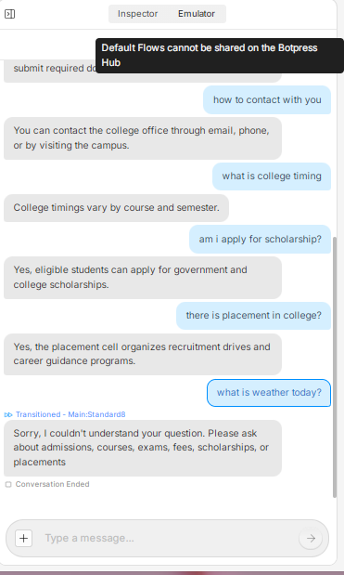

Botpress Flow Diagram
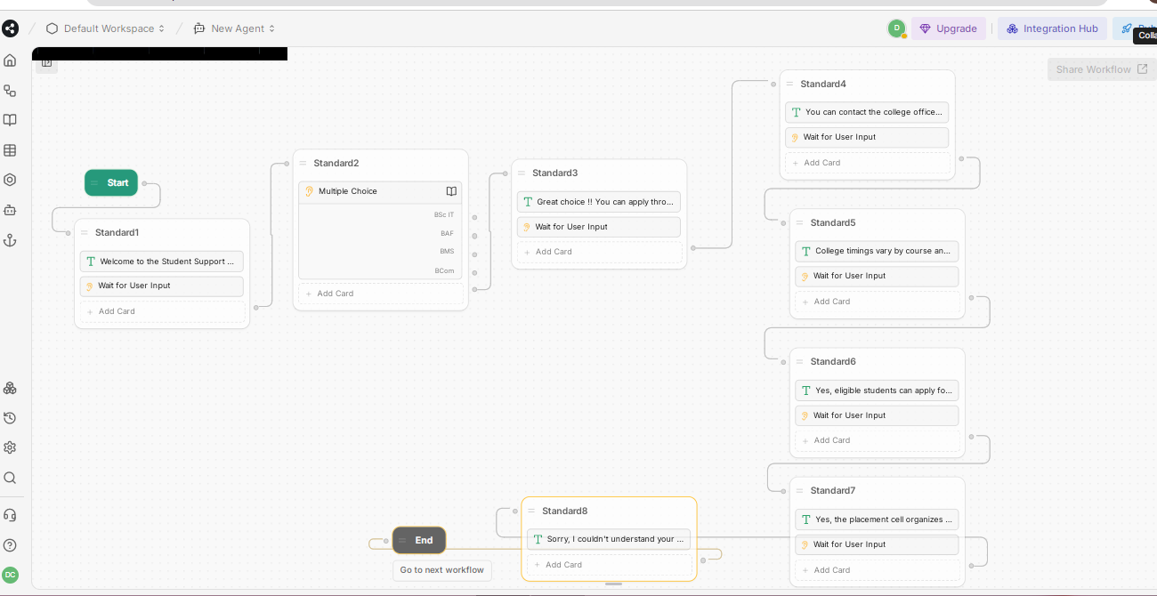

8. Open Source Repository
https://github.com/dishapatare1312-byte/student_support_chatbot.git
Botpress chatbot link:
https://cdn.botpress.cloud/webchat/v3.6/shareable.html?configUrl=https://files.bpcontent.cloud/2026/06/14/09/20260614094805-KD629JIP.json
9. Future Scope
Voice-based interaction
Multiple language support
Student progress tracking
Integration with college databases
Mobile application

