What is SNS?
SNS is highly available, durable with auto scaling, secure, and fully managed pub/sub messaging service that enables you to decouple microservices, distributed systems and event-driven serverless applications.
It is a Push based notification service and sends notifications in two ways: A2A (Application to Application) and A2P (Application to Person).
The pub/sub functionality provides messaging for high-throughput, push-based, many-to-many use cases.
SNS uses a pub-sub model whereby users or applications subscribe to SNS topics.
SNS can send notifications via SMS text message, email, SQS queues or to any HTTP/S endpoint.
SNS notifications can also trigger Lambda functions.
SNS is inexpensive and based on a pay-as-you-go model with no upfront costs.
SNS provides decoupling of your applications so messages can be processed asynchronously.
SNS provides in-transit and at rest data encryption protection.
SNS topic owner can set Topic Access Policy that restrict who can publish and
subscribe to a topic.
You can use a Data Protection Policy to define the sensitive data that should be monitored and protected from being exchanged in your topic.
What is Publisher?
Publisher is also known as Producer who produce and send message to the SNS topic and publish it to the subscriber.
What is Subscription?
An endpoint to a message is sent. Messages are simultaneously pushed to the subscriber.
Subscriber such as
- HTTP/HTTPS.
- Email/Email-JSON.
- Amazon Kinesis Data Firehose.
- Amazon SQS.
- AWS Lambda.
- Platform application endpoint (mobile push).
- SMS.
What is SNS Topic?
SNS topic is a logical access point that acts as a communication channel.
SNS topic is used to enable message communication between publisher and subscriber.
One SNS topic can support deliveries to multiple endpoint types.
SNS topic is immutable, meaning it can't be changed once the topic is created.
Maximum 256 characters. Can include alphanumeric characters, hyphens (-) and underscores (_).
All messages are stored redundantly across multiple availability zones. You can publish from 1 to 10 messages per API request. Each message can contain up to 256KB of data.
There are two types of SNS topics: Standard topic and FIFO topic.
What is Standard Topic?
Highest throughput in publishes/second.
Best-effort message ordering
At-least once message delivery
Multiple subscription protocols: SQS, Amazon Kinesis Data Firehose, Lambda, HTTP, SMS, email, mobile application endpoints
Message fanout: Each account can support 100,000 Standard topics and each topic supports up to 12.5M subscriptions.
Better suited for use cases that require higher message publish and delivery throughput rates, for examples: fanning out messages to media encoding, fraud detection, tax calculation, search index, and critical alerting applications.
What is FIFO Topic?
High throughput, up to 300 publishes/second.
Strictly preserved message ordering
Exactly once message delivery
Subscription protocols: SQS
Message fanout: Each account can support 1,000 FIFO topics and each topic supports up to 100 subscriptions.
A better fit for use cases that require message ordering and deduplication, for example: fanning out messages to bank transaction logging, stock monitoring, flight tracking, inventory management, and price update applications.
What is Message Filtering?
By default, SNS topic subscriber receives every message that's published to the topic.
To receive only a subset of the messages, a subscriber must assign a filter policy to the topic subscription.
A filter policy is a JSON object containing properties that define which messages the subscriber receives.
SNS supports policies that act on the message attributes or on the message body, according to the filter policy scope that you set for the subscription.
What is SNS Fanout?
SNS Fanout means when a message published to an SNS topic is replicated and pushed to multiple endpoints, such as Kinesis Data Firehose delivery streams, SQS queues, HTTP(S) endpoints, and Lambda functions. This allows for parallel asynchronous processing.
What are the benefits of using SNS?
Instantaneous, push-based delivery (no polling)
Simple Architecture: Simple APIs and easy integration with real time alerts and monitoring applications.
Flexible message delivery over multiple transport protocols
Inexpensive, pay-as-you-go model with no up-front costs.
Ease of use: Web-based AWS Management Console offers the simplicity of a point-and-click interface.
What are some common use cases for SNS?
– Mobile push notifications
– Email notifications
– Alerts and alarms
– Social media notifications
– IoT notifications
How to send an Email/a SMS with Amazon SNS?
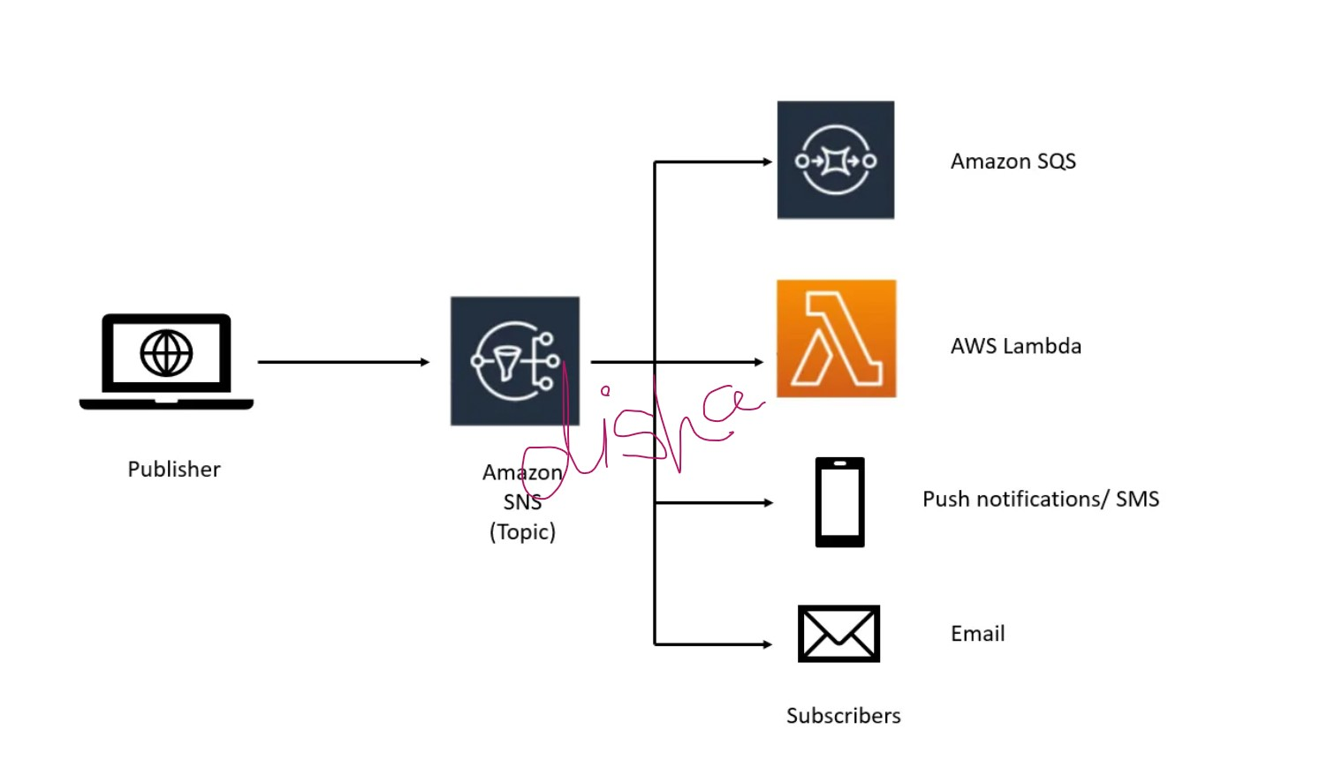
Prerequisites: AWS account.
Step 1: Create a topic.
Sign in to the Amazon SNS console.
In the left navigation pane, choose Topics.
On the Topics page, choose Create topic.
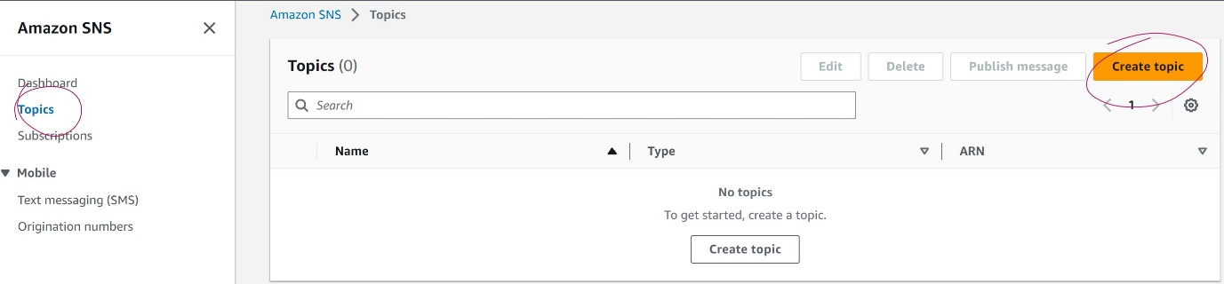
By default, the console creates a FIFO topic. Choose Standard.
In the Details section, enter a Name for the topic “MySNStopic”.
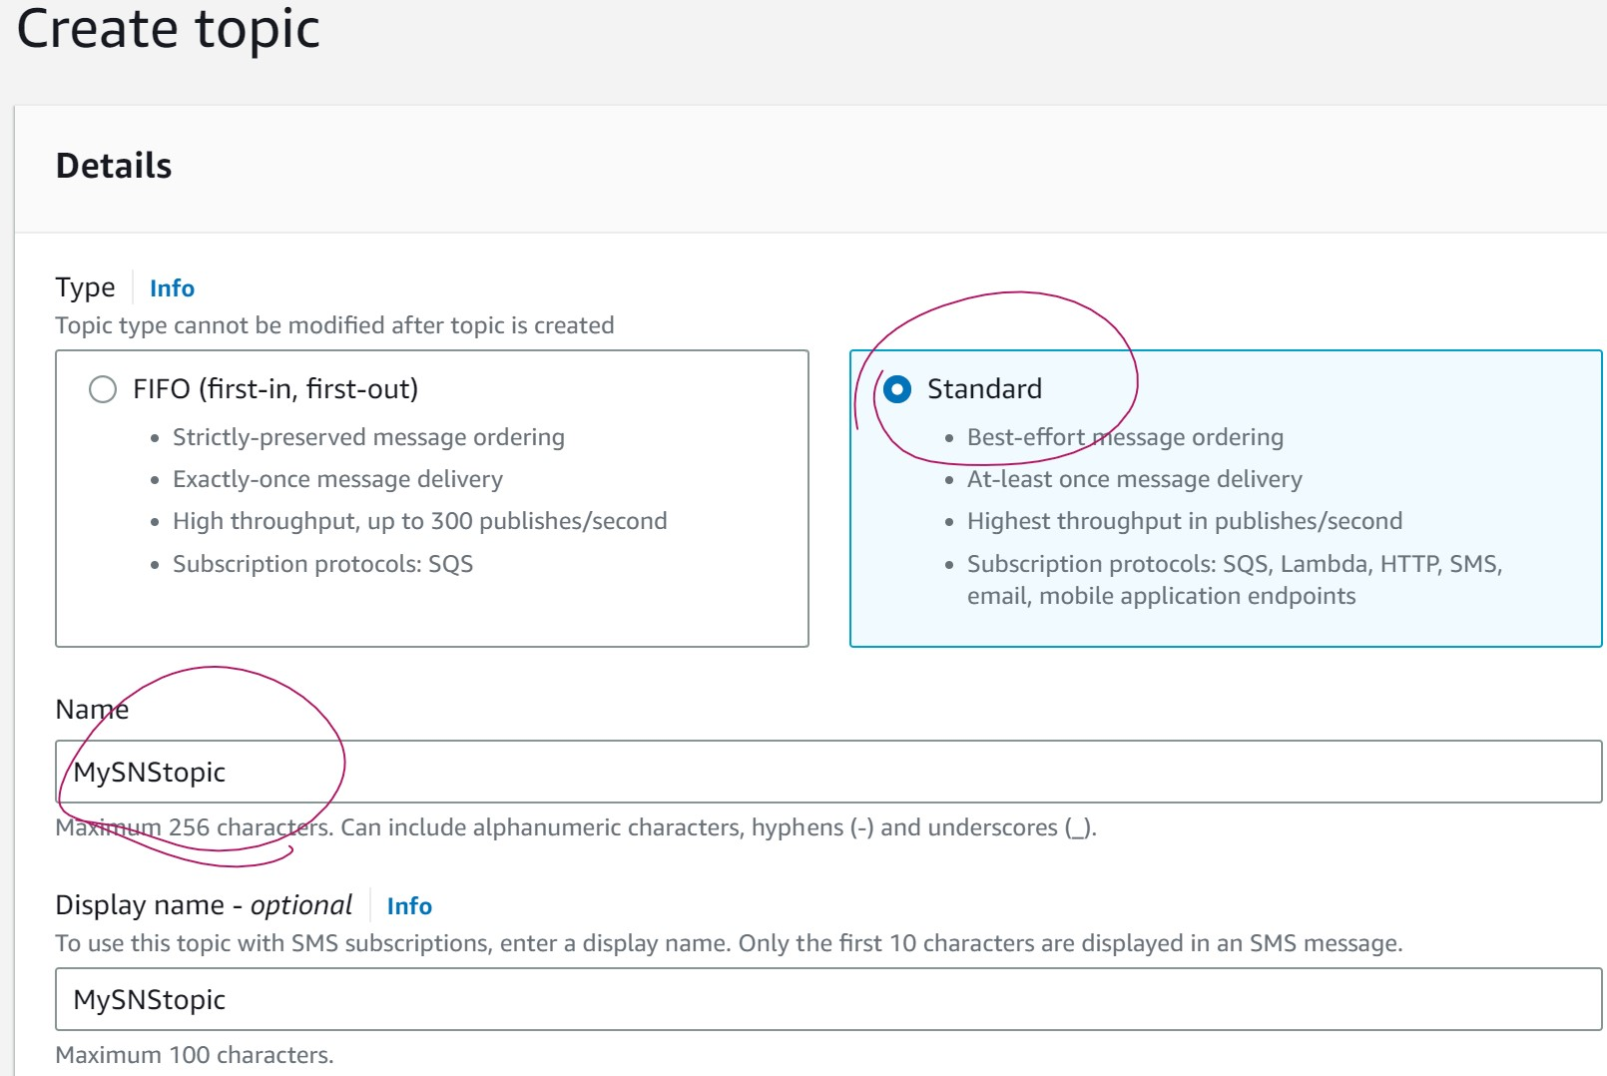
All other parameters are optional:
Encryption: unless you want advanced encryption, you can skip this one.
Access policy: here, you can change who can access your topic.
Retry policy: this specifies the number of retries for HTTP(S) endpoints.
Delivery logging: if you want the delivery to show up in your CloudWatch logs.
Tags: search on topics and track costs.

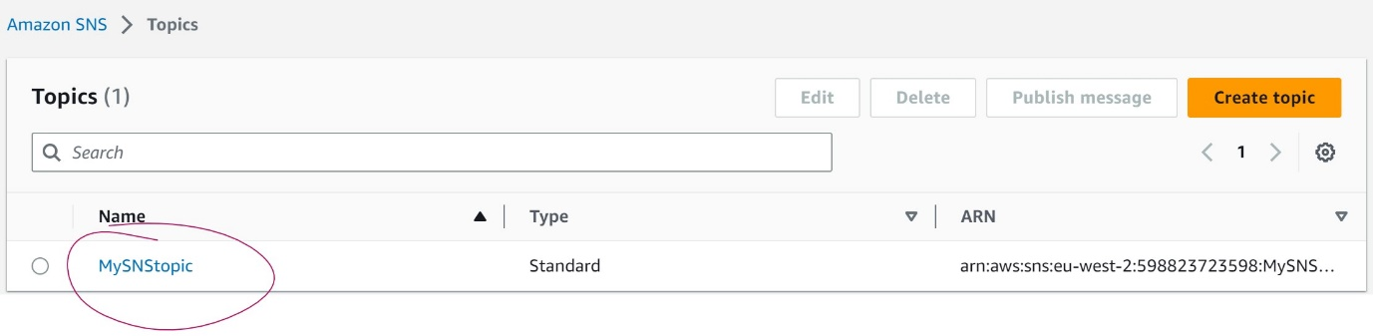
Step 2: Create a subscription to the topic.
In the left navigation pane, choose Subscriptions.
On the Subscriptions page, choose Create subscription.
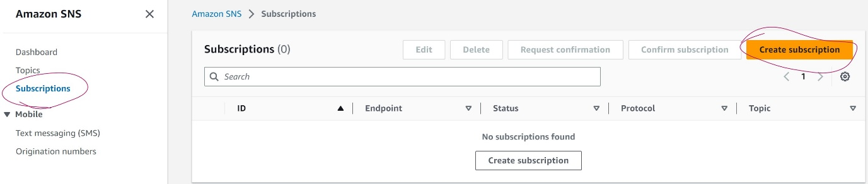
On the Create subscription page, choose the Topic ARN field to see a list of the topics in your AWS account.
Choose the topic that you created in the previous step.
For Protocol, choose Email.
For Endpoint, enter an email address that can receive notifications.
Choose Create subscription.
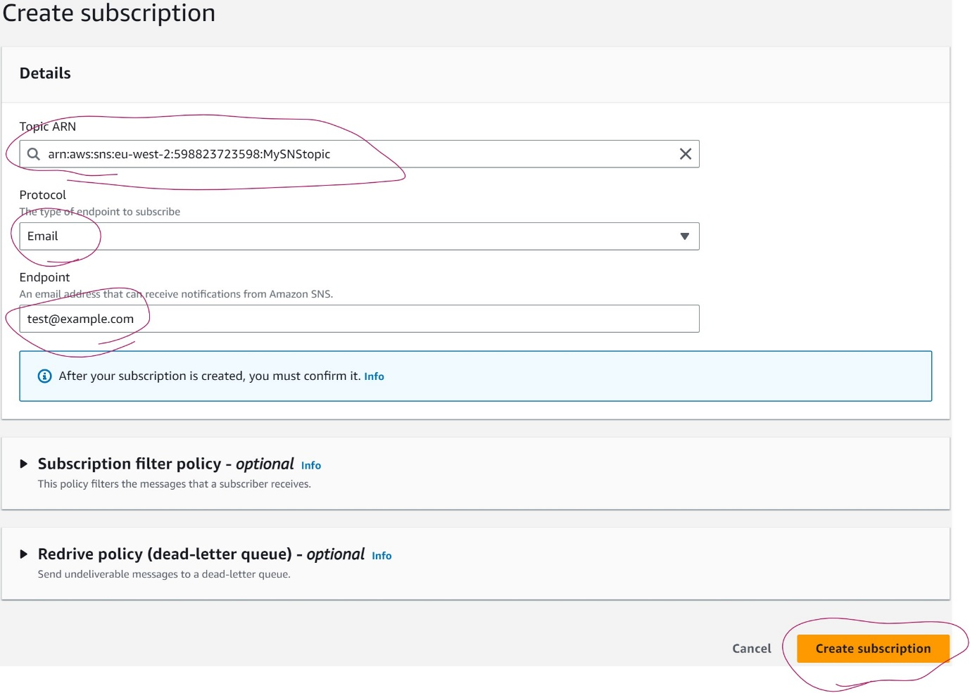
There are two more optional configurations you can use:
- Subscription policy filter: you can filter out specific messages matching a key.
- Redrive policy: if delivery fails, you can send them to a dead-letter queue to retry later.
Check your email inbox and choose Confirm subscription in the email from AWS Notifications. The sender ID is usually "no-reply@sns.amazonaws.com".
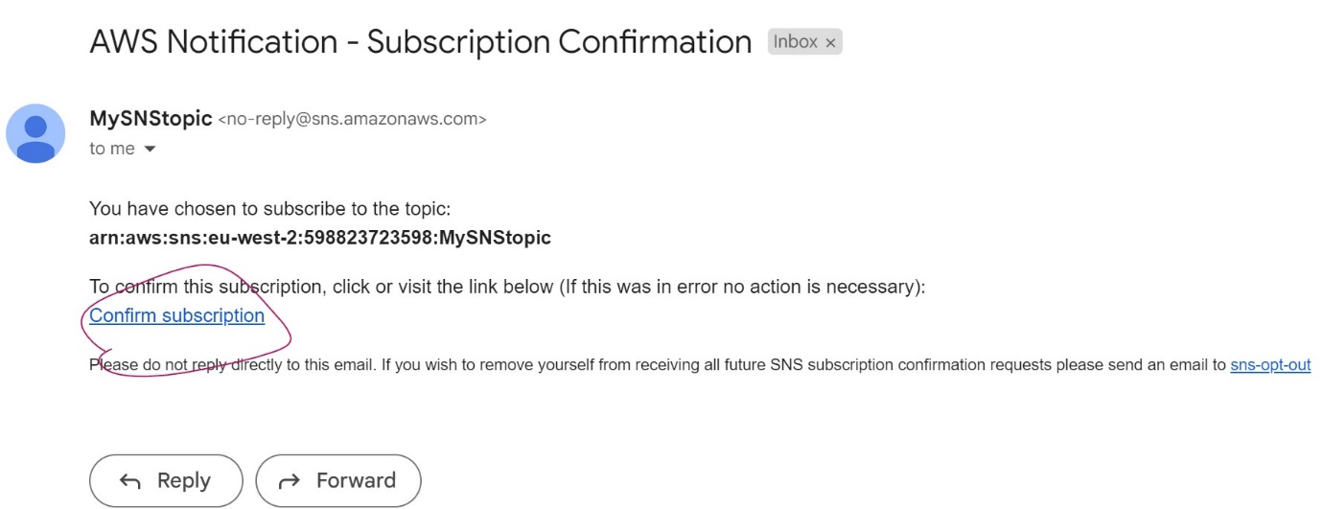
Amazon SNS opens your web browser and displays a subscription confirmation with your subscription ID.
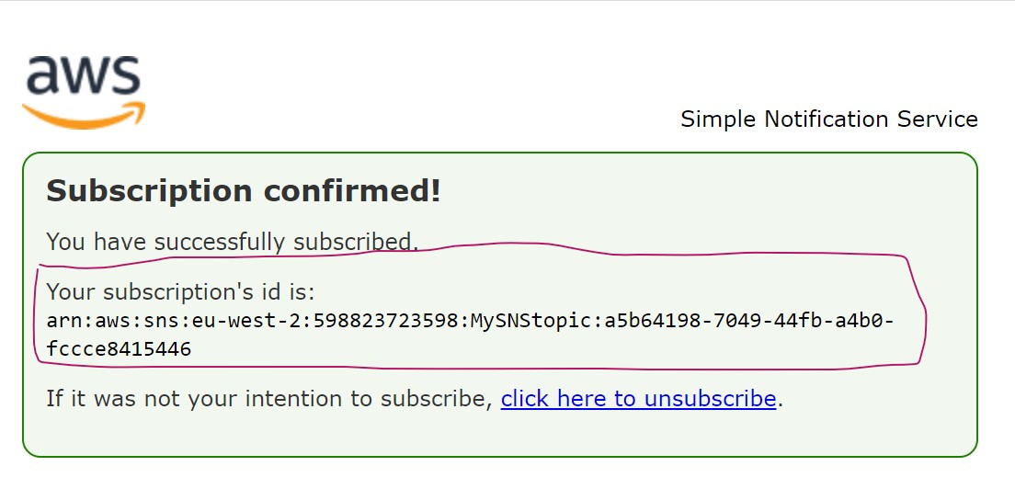
Step 3: Publish a message to the topic.
In the left navigation pane, choose Topics.
On the Topics page, choose the topic that you created earlier, and then choose Publish message.
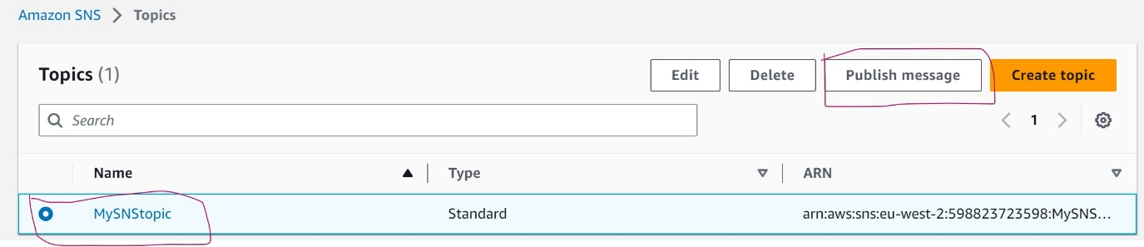
The console opens the Publish message to topic page.
(Optional) In the Message details section, enter a Subject, such as:
“Hello from Amazon SNS!”
In the Message body section, choose Identical payload for all delivery protocols, and then enter a message body, such as:
“Publishing a message to an SNS topic.”
Choose Publish message.
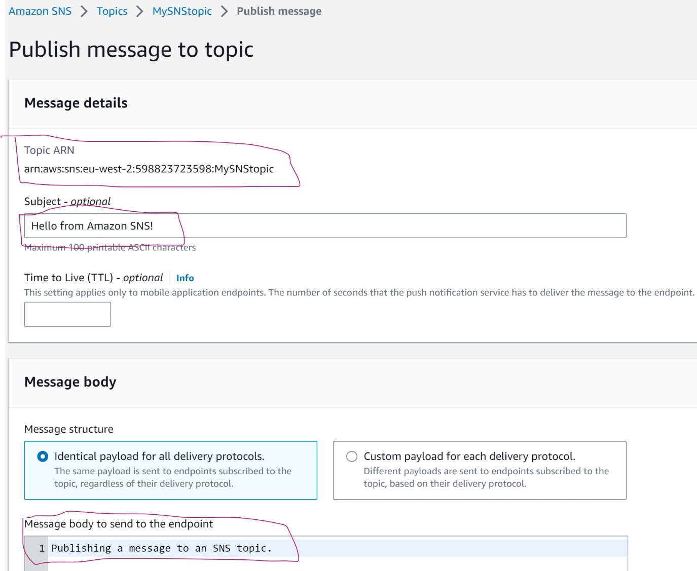Check your email inbox and verify that you received an email from Amazon SNS with the published message.
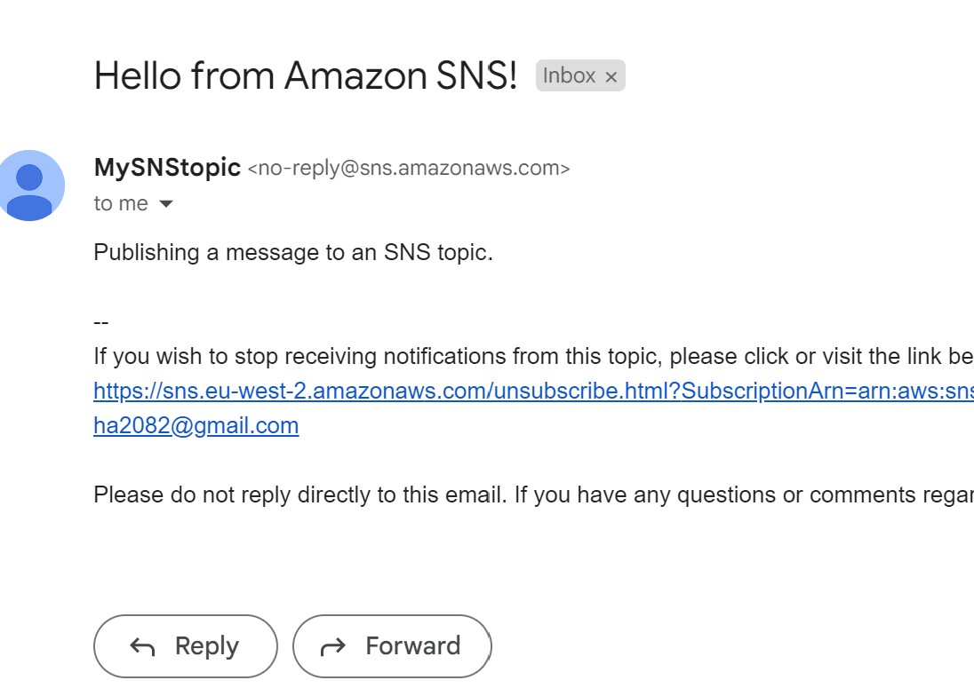
Step 4: Publish a text message to the topic.
In the navigation pane, choose Text messaging (SMS).
On the Mobile text messaging (SMS) page, choose Publish text message.
On the Publish SMS message page, for Message type, choose one of the following:
Promotional – Non-critical messages, such as marketing messages.
Transactional – Critical messages that support customer transactions, such as one-time passcodes for multi-factor authentication.

Choose Publish message.

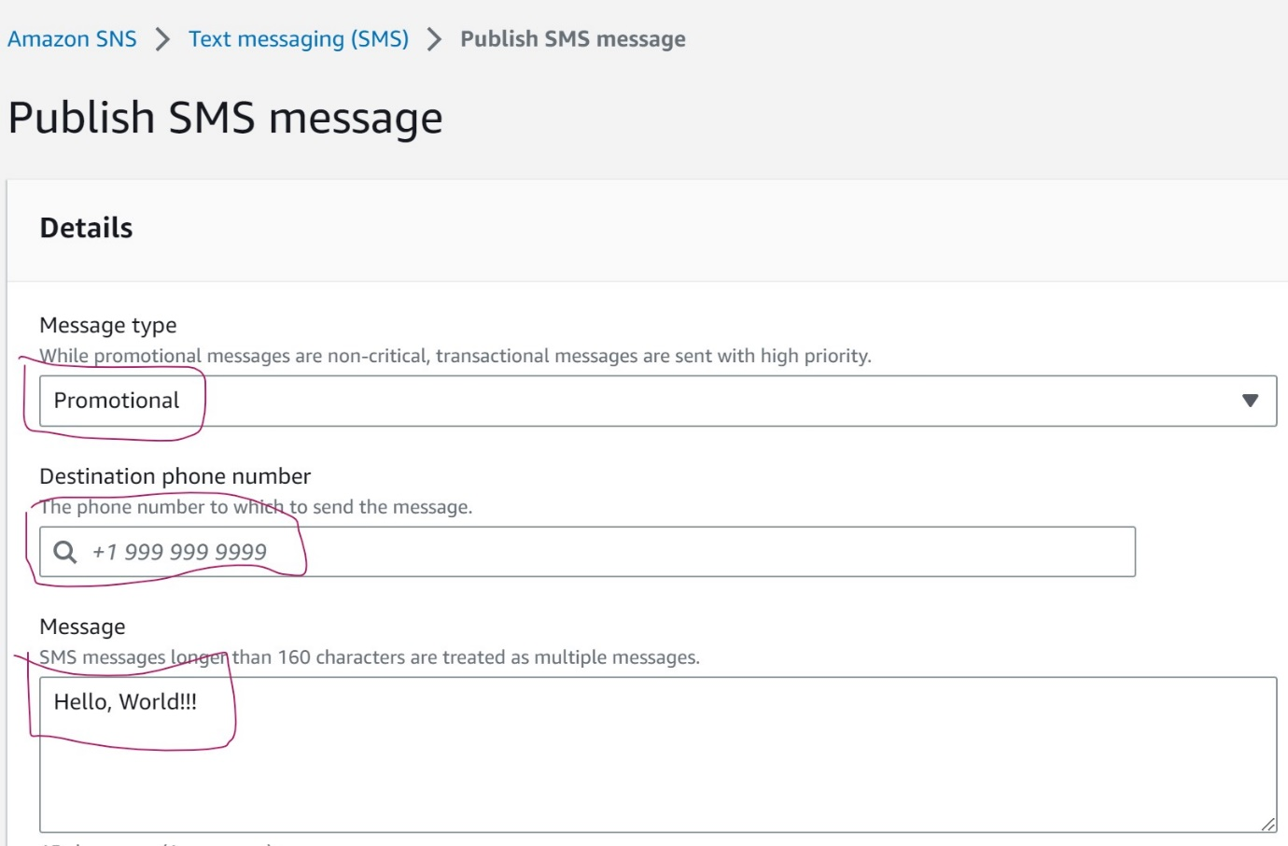
Congratulation. You will receive a SMS to your mobile device.

