LINUX
- Fundaments of Linux
- Different Shells in Linux
- Linux File System Hierarchy
- Package Management in Linux
- Linux Commands
- Linux Admin – Configuring a DNS Server
- Shell Scripting
- Linux vs Windows
- Linux vs Unix
      - Fundaments of Linux
Birth of Linux
Linux is a free, open-source, monolithic, modular, multitasking, Unix-like Operating System (OS) that is made up of the Linux kernel and is developed by Linus Torvalds in 1991.
An operating system is the software that directly manages a system's hardware and resources, like CPU, memory, and storage and it helps with tasks such as process and memory management, file systems, device control and networking.
It provides essential services to users and applications, such as security, multitasking, and communications. It handles essential tasks such as suspending or terminating processes when needed. It improves performance, better security, and increased stability.
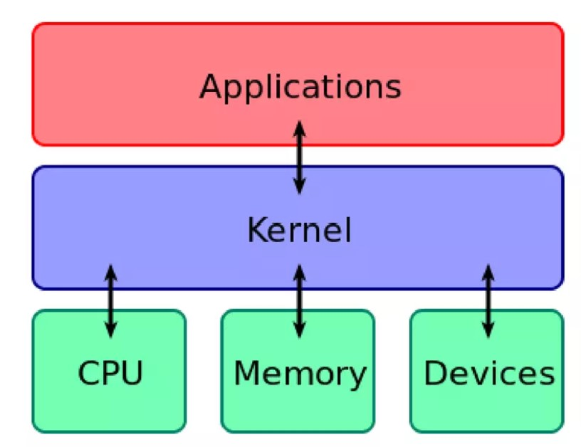
Linux Distribution
Unlike Windows or Mac OS, a Linux operating system consists of many open-source components produced and managed by different organizations. A Linux distribution is a complete operating system that includes the Linux kernel and a collection of software packages. There are many different Linux distributions available, each with its own set of features and software packages. 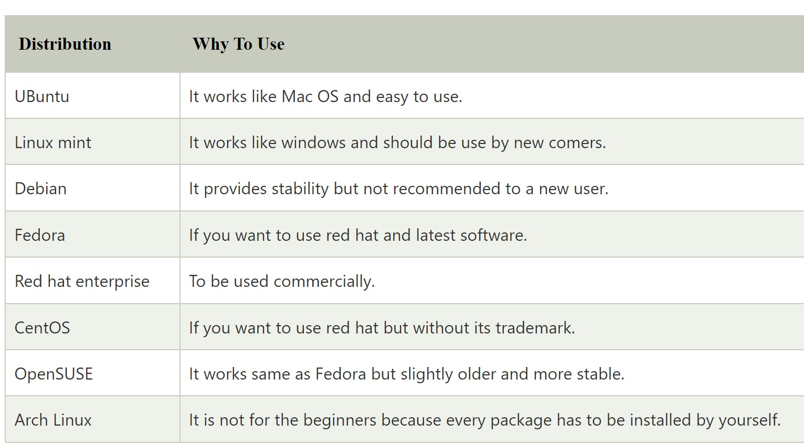
Features/Advantages of Linux
- Open Source.
- Free to use (Low Cost)
- Portability.
- Security.
- Multitasking.
- Multi-User.
- Software Updates.
- GUI.
- Customization.
- Various Distributions.
- Large Community Support
- Flexibility
- Scalability
- Virtualization
- Lightweight
Architecture of a Linux System
The architecture of a Linux System consists of the following layers –
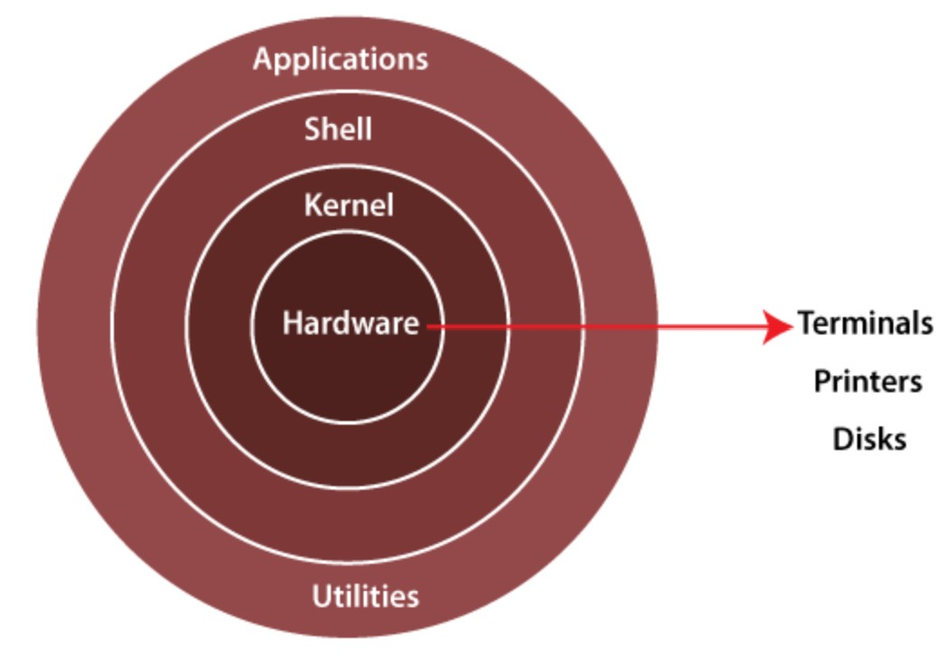
- Hardware layer − Hardware consists of all peripheral devices (RAM/ HDD/ CPU etc).
- Kernel − It is the core component of Operating System, interacts directly with hardware, provides low level services to upper layer components.
- Shell − An interface to kernel, hiding complexity of kernel's functions from users. The shell takes commands from the user and executes kernel's functions.
- Utilities − Utility programs that provide the user most of the functionalities of an operating systems.

      - Different Shells in Linux
What is a Kernal?
Linux kernel refers to the low-level system software. It is used to manage resources and provide an interface for user interaction. It is the core component of the Operating System that manages operations and hardware.
What is Shell?
Shell is a Linux interpreter which is used to execute commands. It translates command entered by the user and convert them into a language that is understood by the kernel.
What is Shell Script?
A shell script is a text file that contains a sequence of commands for a UNIX-based operating system. A good Shell Script will have comments, processed by #sign, describing the steps.
The most common Shells used in Linux are:
bash: Bourne Again Shell is the default for most of the Linux distributions.
- It is versatile and easy to learn.
- Commands are case-sensitive.
- ‘/’ (forward slash) is used as a directory separator.
- ‘\’ (backslash) is used as an escape character.
ksh: Korn Shell is a high-level programming language shell.
csh: C Shell follows C like syntax and provides spelling correction and Job Control
zsh: Z Shell provides some unique features such as filename generation, startup files, login/logout watching, closing comments etc.
fish: Friendly Interactive Shell provides some special features like web-based configuration, auto-suggestions, fully scriptable with clean scripts.
      - Linux File System Hierarchy
The Linux File Hierarchy Structure or the Filesystem Hierarchy Standard (FHS) defines the directory structure and directory contents in Unix-like operating systems. It is maintained by the Linux Foundation. In the FHS, all files and directories appear under the root directory /, even if they are stored on different physical or virtual devices.
Important Directory of Linux
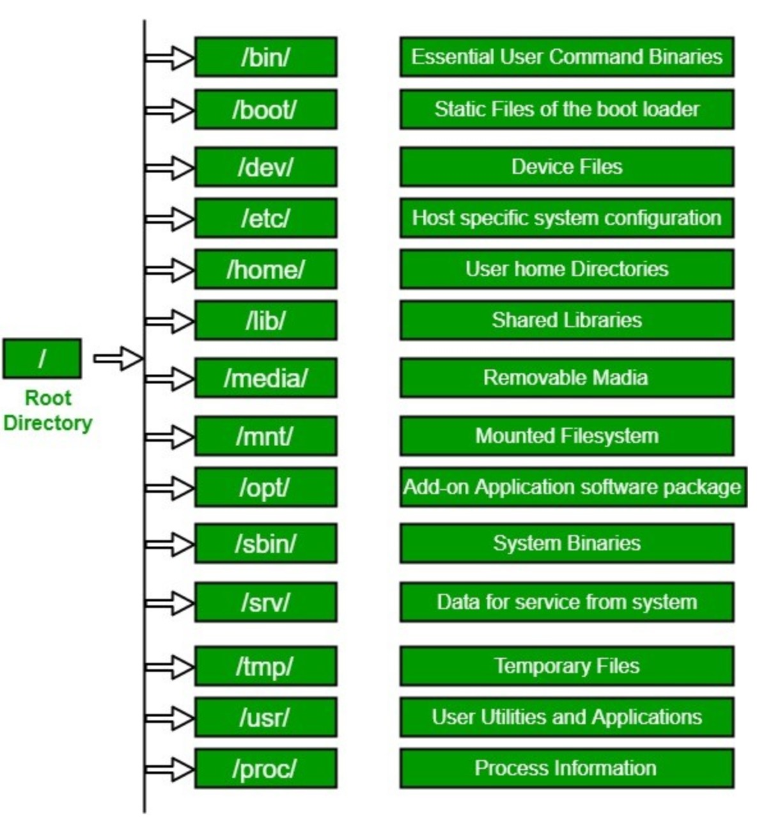
/ (root filesystem): It is the top-level filesystem directory. It must include every file needed to boot the Linux system before another filesystem is mounted. Every other filesystem is mounted on a well-defined and standard mount point because of the root filesystem directories after the system is started.
/boot: It includes the static kernel and bootloader configuration and executable files needed to start a Linux computer.
/bin: This directory includes user executable files.
/dev: It includes the device file for all hardware devices connected to the system. These aren't device drivers; instead, they are files that indicate all devices on the system and provide access to these devices.
/etc: It includes the local system configuration files for the host system.
/lib: It includes shared library files that are needed to start the system.
/home: The home directory storage is available for user files. All users have a subdirectory inside /home.
/mnt: It is a temporary mount point for basic filesystems that can be used at the time when the administrator is working or repairing a filesystem.
/media: A place for mounting external removable media devices like USB thumb drives that might be linked to the host.
/opt: It contains optional files like vendor supplied application programs that must be placed here.
/root: It's the home directory for a root user. Keep in mind that it's not the '/' (root) file system.
/tmp: It is a temporary directory used by the OS and several programs for storing temporary files. Also, users may temporarily store files here. Remember that files may be removed without prior notice at any time in this directory.
/sbin: These are system binary files. They are executables utilized for system administration.
/usr: They are read-only and shareable files, including executable libraries and binaries, man files, and several documentation types.
/var: Here, variable data files are saved. It can contain things such as MySQL, log files, other database files, email inboxes, web server data files, and much more.
Types of Linux File System
When we install the Linux operating system, Linux offers many file systems such as Ext, Ext2, Ext3, Ext4, JFS, ReiserFS, XFS, btrfs, and swap.
Ext, Ext2, Ext3 and Ext4 file system
Ext stands for Extended File System. Ext2 allows managing two terabytes of data. Ext3 contains backward compatibility. Ext4 is the faster file system.
JFS File System
JFS stands for Journaled File System, and it is a handy file system when CPU power is limited.
ReiserFS File System
This file system dynamically supports the file extension, but it has some drawbacks in performance.
XFS File System
This file system was considered as high-speed JFS, which is developed for parallel I/O processing.
Btrfs File System
Btrfs stands for the B tree file system. It is used for fault tolerance, repair system, fun administration, extensive storage configuration, and more. It is not a good suit for the production system.
Swap File System
The swap file system is used for memory paging in Linux operating system during the system hibernation. A system that never goes in hibernate state is required to have swap space equal to its RAM size.
      - Package Management in Linux
A package management system or package manager is a group of software tools. It automates the installation process, upgrading process, configuration process, and removing process of the computer programs for an operating system of the computer in an efficient manner. A package manager works with packages, data within archive files, and software distributions.
YUM Package Manager
Yum (Yellowdog Updater Modified) command is an open-source command-line package-management utility. Yum command is used to install, update, search & remove packages on RPM based system such as RHEL, CentOS, Fedora distributions. It automatically resolve dependencies and make it smooth package installation without any trouble.
RPM Package Manager
RPM stands for Red Hat Package Manager is a powerful, command line Package Management utility for Red Hat based system such as RHEL, CentOS, Fedora, openSUSE & Mageia distributions. The utility allows you to install, upgrade, remove, query & verify the software on your Linux system/server. RPM files comes with .rpm extension. RPM package built with required libraries and dependency which will not conflicts other packages were installed on your system.
APT package manager
Apt-Get stands for Advanced Packaging Tool (APT). apg-get is a powerful command-line tool which is used to automatically download and install new software packages, upgrade existing software packages, update the package list index, and to upgrade the entire Debian based systems.
ZYpp package manager
Zypper is a command line package manager for suse & openSUSE distributions. It’s used to install, update, search & remove packages & manage repositories, perform various queries, and more. Zypper command-line interface to ZYpp system management library (libzypp).
DNF package manager
DNF stands for Dandified yum. It automatically resolves dependencies and make it smooth package installation without any trouble. Dnf command is used to install, update, search & remove packages on Fedora 22 and later system.
DPKG package manager
dpkg stands for Debian package manager (dpkg). dpkg is a command-line tool to install, build, remove and manage Debian packages. dpkg uses Aptitude (primary and more user-friendly) as a front-end to perform all the actions.
      - Linux – Commands
Linux provides a CLI to communicate with the OS. CLI is better for tasks which cannot be performed with the GUI.
FILE AND DIRECTORY COMMANDS
/ | Root Directory
pwd (print working directory) | Displays the current directory of the Terminal
cd or cd ~ | Used to change the current working directory
cd .. | To go to the parent directory (the one just above your current directory in the directory tree).
cd . | To stay in the current directory.
cd / | Move to home directory
ls | Lists all files and directories in the present working directory
ls -a | Lists hidden files as well
ls -al | Lists files and directories with detailed information like permissions, size, owner, etc.
ls path | By specifying the path after ls, the content in that path will be displayed (ls /home/username/Documents)
clear | Clear the terminal display
mkdir | Creates a new directory.
rm filename | Deletes a file
rm -f file | Force removal of file without prompting for confirmation
rmdir | Removes a specified directory(empty)
rmdir -p | Remove both the parent and child directory
rm -r | Remove even non-empty directory recursively
rm -rp | Removes non-empty directories including parent and subdirectories
cat > filename | Creates a new file
cat filename | Displays the file content
cat file1 file2 > file3 | Joins two files (file1, file2) and stores the output in a new file (file3)
cat >> filename | Add new content in a file
cp | Copy file to another location
cut file | Cut out sections of each line of a file or files
diff | Display the differences between two files
touch file | Create an empty file or update the access and modification times of file.
mv | Move/Renames a directory
mv file "new file path" | Moves the files to the new location
mv filename new_file_name | Renames the file to a new filename
less | Browse through a text file
more | To view through relatively lengthy text files one screenful at a time.
head | Display the first 10 lines of file
tail | Display the last 10 lines of file
echo | Prints a text of line provided to it.
man | Gives help information on a command
history | Gives a list of all past commands typed in the current terminal session
ln | Creates links between files and directories
|(pipe command) | Is used to output the result of one command as input to another command. | is used to perform two operations in the same command. ($ grep dh File1.txt File2.txt | sort – Searches for string ‘dh’ from both Files and sorts the result)
grep | Find a particular string/word in a text file
sort | Sort text files either alphabetically or numerically
FILE PERMISSIONS
chmod | To change access permissions of files and directories.
chown | To change owner of files and directories
chgrp | To change group ownership of files and directories
3 kinds of permission:  Read(r) = 4  Write(w) = 2  Execute(e) =1  User = u  Group = g  Other = o  Regular file = _  Directory = d | 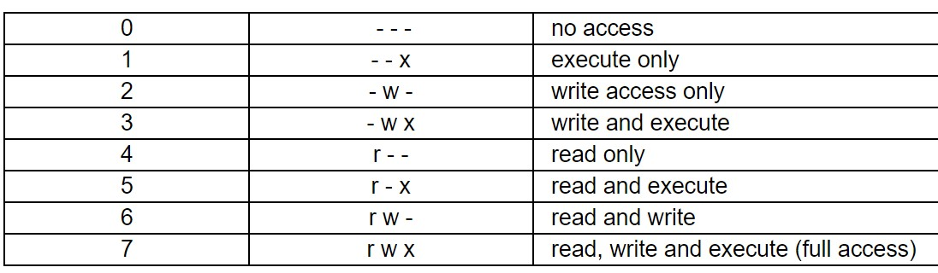
INSTALLING PACKAGES
man yum | Like all Linux commands, the help file
yum list all | Lists all currently available packages
yum install | To install a package
yum remove | To remove a package
yum update | To update a package
service package start | To start a package
service package status | To check package status (Active/Inactive)
yum search | Search for a package by keyword (httpd)
yum info package | Display description and summary information about package.
rpm -i package.rpm | Install package from local file named package.rpm
tar zxvf sourcecode.tar.gz | Install software from source code.
./configure | cd sourcecode
make | make install
gzip | Compress or Extract files
SYSTEM INFORMATION
cat /etc/os-release | Show operating system information such as distribution name and version
uname -a | Display Linux system information
uptime | Show how long the system has been running + load
hostname | Show system host name
last reboot | Show system reboot history
date | Show the current date and time
cal | Show this month calendar
df | display the amount of free space on filesystems
du | display the amount space used in files and directories
free | displays information about free and used memory on the system
w | Show who is online
HARDWARE INFORMATION
cat /proc/cpuinfo | Display CPU information
cat /proc/meminfo | Display memory information
free -h | Display free and used memory ( -h for human readable, -m for MB, -g for GB.)
lspci -tv | Display PCI devices
lsusb -tv | Display USB devices
dmidecode | Display DMI/SMBIOS (hardware info) from the BIOS
hdparm -i /dev/sda | Show info about disk sda
hdparm -tT /dev/sda | Perform a read speed test on disk sda
badblocks -s /dev/sda | Test for unreadable blocks on disk sda
PERFORMANCE MONITORING AND STATISTICS
top | Display system and process information in real time
htop | Interactive process viewer (top alternative)
mpstat 1 | Display processor related statistics
vmstat 1 | Display virtual memory statistics
iostat 1 | Display I/O statistics
tail -100 /var/log/messages | Display the last 100 syslog messages (Use /var/log/syslog for Debian based systems.)
tcpdump -i eth0 | Capture and display all packets on interface eth0
tcpdump -i eth0 'port 80' | Monitor all traffic on port 80 (HTTP)
lsof | List all open files on the system
lsof -u user | List files opened by user
watch df -h | Execute "df -h", showing periodic updates
USER INFORMATION AND MANAGEMENT
id | Display the user and group ids of your current user.
last | Display the last users who have logged onto the system.
whoami | Who you are logged in as
who | Show who is logged into the system.
sudo groupadd test | Create a group named "test".
sudo useradd -c "John Smith" -m john | Create an account named john, with a comment of "John Smith" and create the user's home directory.
sudo userdel -r john | Delete the john account.
usermod -a -G sales john | Add the john account to the sales group
PROCESS MANAGEMENT
ps | Display your currently running processes. displays a snapshot of the current processes
ps -ef | Display all the currently running processes on the system.
ps -ef | grep processname | Display process information for processname
kill pid | Kill process with process ID of pid
killall processname | Kill all processes named processname
program & | Start program in the background
bg | Display stopped or background jobs
fg | Brings the most recent background job to foreground
crontab | Schedule a task to run at a particular time or interval
NETWORKING
ip a | Display all network interfaces and IP address
ip addr show dev eth0 | Display eth0 address and details
ethtool eth0 | Query or control network driver and hardware settings
ping host | Send ICMP echo request to host
whois domain | Display whois information for domain
dig domain | Display DNS information for domain
hostname -i | Display the network address of the host name.
hostname -I | Display all local IP addresses of the host
ifconfig | Configure a network interface
curl [URL] | Download or upload files to remote servers.
wget http://domain.com/file | Download http://domain.com/file
netstat -nutlp | Display listening tcp and udp ports and corresponding programs
scp user1@sourcehost:directory/filename user2@destinationhost:directory/filename | securely copy files between computers
sftp [options] [user@]host-name[:directory] | securely interactively copy files between computers
wget [URL] | Download or upload files from the web non-interactively.
put file | Upload file from local to remote computer
get file | download file from remote to local computer
quit | logout
ARCHIVES (TAR FILES)
tar | Archive or Extract files
tar cf archive.tar directory | Create tar named archive.tar containing directory.
tar xf archive.tar | Extract the contents from archive.tar.
tar czf archive.tar.gz directory | Create a gzip compressed tar file name archive.tar.gz.
tar xzf archive.tar.gz | Extract a gzip compressed tar file.
tar cjf archive.tar.bz2 directory | Create a tar file with bzip2 compression
tar xjf archive.tar.bz2 | Extract a bzip2 compressed tar file.
SEARCH
grep pattern file | Search for pattern in file
grep -r pattern directory | Search recursively for pattern in directory
locate name | Find files and directories by name
find /home/john -name 'prefix*' | Find files in /home/john that start with "prefix".
find /home -size +100M | Find files larger than 100MB in /home
find | Find files
SSH LOGINS
ssh host | Connect to host as your local username
ssh user@host | Connect to host as user
ssh -p port user@host | Connect to host using port
FILE TRANSFERS
scp file.txt server:/tmp | Secure copy file.txt to the /tmp folder on server
scp server:/var/www/*.html /tmp | Copy *.html files from server to the local /tmp folder.
scp -r server:/var/www /tmp | Copy all files and directories recursively from server to the current system's /tmp folder.
rsync -a /home /backups/ | Synchronize /home to /backups/home
rsync -avz /home server:/backups/ | Synchronize files/directories between the local and remote system with compression enabled
DISK USAGE
dh -h | Show free and used space on mounted filesystems
df -i | Show free and used inodes on mounted filesystems
fdisk -l | Display disks partitions sizes and types
du -ah | Display disk usage for all files and directories in human readable format du -ah
du -sh | Display total disk usage off the current directory
SECURITY
passwd | Change the current user's password.
su | Switches to root-user so that superuser permissions can be used to execute commands.
su <username> | Switches to a different user whose name is passed as the argument.
sudo | Executes only that command with root/ superuser privileges.
Environment Variables
Environment variables control the behaviour of the software packages installed in Linux. The path where the packages have been installed will be specified in environment variables.
echo $VARIABLE | To display value of a variable
env | Displays all environment variables
VARIABLE_NAME= variable_value | Create a new variable
Unset | Remove a variable
export Variable=value | To set value of an environment variable
printenv | Prints the list of all environment variables
Regular Expressions
RegEX are used to search through data. It can be piped along with ‘grep’ command to find patterns of text in the file.
. | Replace any character
^ | Matches the start of the string
$ | Matches the end of the string
* | Matches the preceding character zero or more time
? | Matches the preceding character one or more time
() | Groups regular expressions
\ | Represents special characters

      - Linux Admin – Configuring a DNS Server
What is DNS?
DNS – Domain Name System is responsible for translating Internet domain and hostnames to IP addresses and vice versa. It is the phonebook of the Internet.
DNS Clients will be sending the requests (hostname/IP addresses) to the DNS Server and waits for a response.
How DNS works?
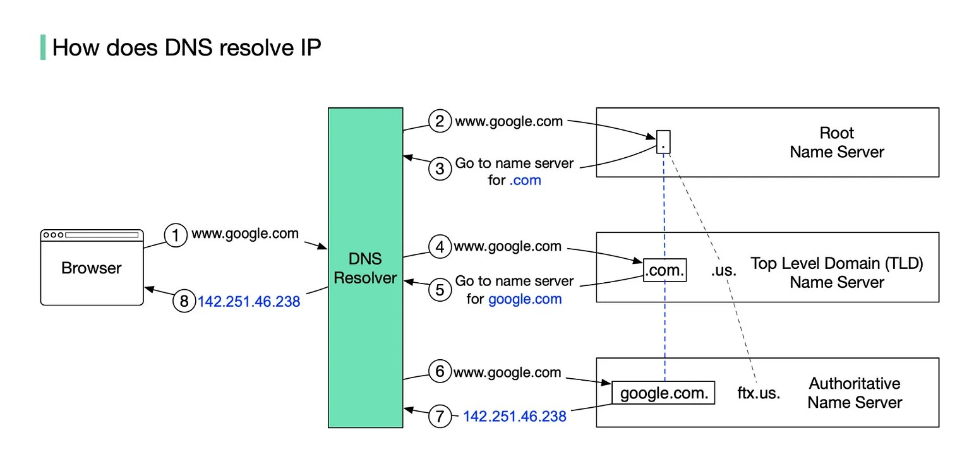
There are 4 basic levels of DNS servers:
DNS Resolver
It also referred to as the DNS recursor is a server that receives the query from the DNS client, and then interacts with other DNS servers to hunt down the correct IP. Once the resolver receives the request from the client, the resolver then actually behaves as a client itself, querying the other three types of DNS servers in search of the right IP.
Root Name Server (.).
It stores the IP addresses of Top-Level Domain (TLD) name servers. There are 13 logical root name servers globally.
TLD name server (.com).
It stores the IP addresses of authoritative name servers.
The Top-Level Domains are divided into 2 categories:
1. Generic TLD (gTLD)
.com – comercial web sites
.org – non-profit organizations web sites
.edu – restricted to schools and institutions.
.net – originally for network infrastructures, now unrestricted
2. Country Code TLD (ccTLD)
.us – United States
.in – India
.uk – United Kingdom
.ru – Russia
Authoritative name server (google.com).
It provides actual answers to the DNS query. Once the resolver has a corresponding IP address for the requested webpage, it’s able to send the information to the web browser, which is then able to display the requested web page. You can register authoritative name servers with domain name registrar such as GoDaddy, Namecheap, etc.
BIND DNS Server Configuration
BIND stands for Berkley Internet Naming Daemon. BIND is the most common program used for maintaining a name server on Linux.
- Install DNS Package
#yum install -y bind*
- Assign a static IP address in Linux OS. Configure network file.
# vim /etc/sysconfig/network-scripts/ifcfg-eth0
- Add a host entry in the host file. Just add your local machine IP address with the domain name of the website which you are hosting on a local server. After the edit, the host file restarts the network and ping the specified IP address to see whether the data is exchanged or not.
# vim /etc/hosts
- Add server IP to the resolv.conf file.
# vim /etc/resolv.conf
- Configure /etc/named.conf file and edit the following lines.
# vim /etc/named.conf
- Open /etc/amed.rfc1912.zones file. Next, we need to add zone records for the forward zone file and reverse zone file. In this file, we set up a master forward record and master reverse DNS record.
- Configure forward and reverse zones. Now create the forward zones and reverse zone files and replace them with your hostname Forward Zone is where the hostname (or FQDN) to IP address relations is stored; it returns an IP address using the hostname. Note that normal DNS queries are forward lookup queries. On the other hand, a Reverse Zone returns the FQDN of a host based on its IP address.
- Change the group ownership for forward zone and reverse zone files.
# chgrp named /var/named/forward. Zone
# chgrp named /var/named/reverse. Zone
- Restart the DNS service.
# Service named restart
- In the next step, you should use the ns lookup utility to query the IP using the hostname and vice versa. You can also use dig to test DNS servers.
      - Shell Scripting

What is Shell?

Shell is a Linux interpreter which is used to execute commands. It translates command entered by the user and convert them into a language that is understood by the kernel.

What is Shell Script?

A shell script is a text file that contains a sequence of commands for a UNIX-based operating system. A good Shell Script will have comments, processed by #sign, describing the steps.

What is CLI?

A command-line interface (CLI) is a text-based user interface (UI) used to run programs, manage computer files and interact with the computer.

What is GUI?

A graphics-based operating system interface that uses icons, menus and a mouse (to click on the icon or pull down the menus) to manage interaction with the system.

Key Differences in CLI and GUI:
Adaptability: For executing CLI, commands need to be memorized and retained in mind which is a challenging task for users. GUI, on the other hand, is a visual concept totally eliminating the need to mug up the commands.
Functioning: Multi-functioning of CLI might or might not be possible whereas, in CLI vs GUI, GUI supports carrying out many tasks at one time. E.g. Chrome, Excel, Word, has the ability to multi-task.
Complexity: Complicated and long tasks can be well handled by writing some commands in CLI. GUI needs some steps to be followed by the user to be able to perform complex tasks.
Resources: In CLI vs GUI Only the keyboard and the system do the work in case of CLI, while GUI can interact with the mouse, keyboard and also some additional resources.
Running: In GUI vs CLI, CLI is faster compared to GUI. CLI performs faster than GUI. Sequence or a script can be prepared of commands to be carried out in CLI while the facility is absent in case of GUI.
Connectivity: Networking with CLI is complicated. GUI can easily connect and create a network with other computers to gain access. In the case of CLI, the user needs to get permission to access other devices.
Screen: The interface in CLI is stable and consistent. GUI interface modifies with the software update.
Execution: In case of CLI, the color strain on eyes is less. Conversely, in GUI strain is more. User can have more control with CLI which is a limitation in GUI.
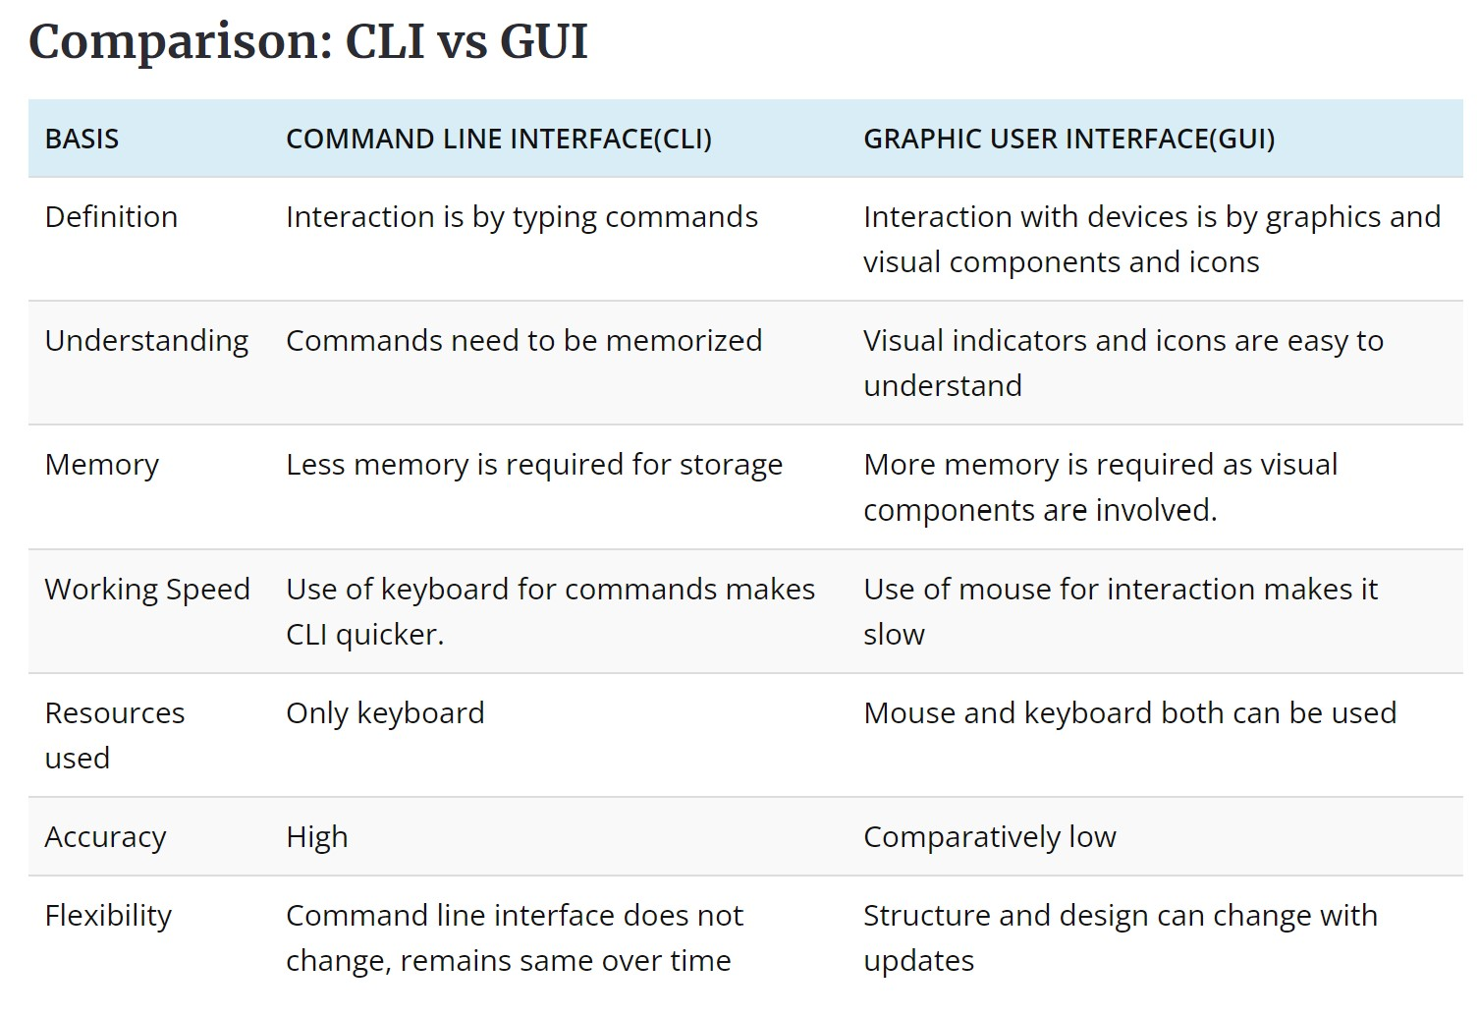
What is Variable?
A variable is a character string to which we assign a value. The value assigned could be a number, text, filename, device, or any other type of data. A variable is nothing more than a pointer to the actual data. The shell enables you to create, assign, and delete variables.
Types of Variables:
- Local Variables
- Global Variables/Environment Variables
- Shell Variables/System Variables
What is Basic Operator?
Operators perform mathematical, string, and logical operations on values. Operands are expressions on which operations are performed.
There are five basic operators in bash/shell scripting:
- Arithmetic Operators.
- Relational Operators.
- Boolean Operators.
- Bitwise Operators.
- File Test Operators.
What is Shell Loop?
A loop is a powerful programming tool that enables you to execute a set of commands repeatedly.
Shell Loop Types:
- The while loop.
- The for loop.
- The select loop.
Shell Scripting Questions? https://www.edureka.co/blog/interview-questions/shell-scripting-interview-questions/
      - Linux vs Windows
Parameters | Linux | Windows
Inception Year | Linux Kernal is released in 1991 | Windows was first released in 1985
Developed by | Linus Torvalds | Microsoft
Standard | Open-source Operating System which is freely available. | Closed source Operating System which is not free.
OS | CLI based | GUI based
Installation | Difficult to install | Easy to install
Size | Linus size is smaller compared to Windows. | Its size quite larger than Linux.
Language | Written in C language | Written in C, C++ and Assembly language
Webserver share | 70% share | 23% share
Filesystem | Hierarchal Filesystem - EXT-4, FAT, NTFS, NFS, ISO 9660, JFS, KFS | Flat filesystem - NTFS, FAT, ISO 9660, UDF, HFS
Case Sensitive | File names are case sensitive | File names are not case sensitive
Cost | Low-cost hardware | High-cost hardware
Security | Stable and Secure | Less stable and Insecure
Virus | 60-100 virus listed | 60,000 viruses listed
Source Code | Full access to source code | No access to source code
Configuration storage | Maintains configuration in files | Maintains a registry to store configurations
Users | Regular  Administrative(root)  Service users | Administrator  Standard  Child  Guest
Software | Free software | Paid software
Distributor | Many distributors | One distributor

      - Linux vs Unix

Parameters | Linux | Unix
Inception Year | 1991 | 1969
Standard | Open-source operating system which is freely available | Operating system can only be used by its copywriters
System type | Just the kernel | Complete Operating system
Target use | Can be used by anyone including home user and developer. | Developed mainly for servers, workstations and mainframes.
Cost | LINUX is freely available and distributed with no associated cost. | UNIX variants come as customized cost.
Security | 60-100 viruses listed till date | 85-120 viruses listed till date
Interface type | Primarily uses GUI with option of CLI | Primarily uses CLI
Portability | Portable | Not portable
Variants | Ubuntu, RedHat, Solaris, OpenSuse, etc. | AIS, HP-UX, BSD, etc
Source code | The source code of Linux is available in general public. | The source code not available in general public.

Linux Questions? https://www.edureka.co/blog/interview-questions/linux-interview-questions-for-beginners/

