CareerAI
AI-Powered Career Intelligence Platform
INFOSYS SPRINGBOARD VIRTUAL INTERNSHIP 7.0
Milestone 2 Report

SUBMITTED BY:
Name: Disha S
Domain: Artificial Intelligence
Date: 24.07.2026

1. Introduction
The project "CareerAI AI-Powered Career Intelligence Platform" is a comprehensive, full-stack web application designed to act as an intelligent career coach. By combining artificial intelligence, natural language processing (NLP), and structured data management, CareerAI assists job seekers and working professionals in evaluating their resumes, identifying critical skill gaps, discovering tailored career paths, and obtaining context-aware career guidance.
In modern recruitment processes, job seekers frequently face hurdles understanding how Applicant Tracking Systems (ATS) evaluate their resumes, identifying missing skills for target roles, and maintaining an up-to-date professional profile. Milestone 2 focuses on solving these core foundational requirements by implementing full User Profile Management, intelligent Resume Uploading, AI-driven Resume Parsing (extracting over 95% of structured candidate metadata), and robust Resume Lifecycle Management (Viewing, Downloading, Replacing, and Deleting resumes).

2. Objective
The primary objectives fulfilled in Milestone 2 of the CareerAI platform are:
- User Profile Management — Provide an end-to-end profile editing interface where users can manage personal info, education history, technical skills, certifications, work experience, projects, and career interests.
- Resume Upload & Validation — Support seamless resume file uploads in PDF, DOCX, DOC, and TXT formats with automated file type and size validation (up to 10 MB).
- High-Accuracy Resume Parsing — Extract up to 95%+ of candidate details (Name, Contact Info, Bio/Summary, Education, Skills, Work History, Certifications, Projects, Languages) using AI and NLP prompt engineering.
- Resume Lifecycle Management — Provide full CRUD functionality allowing users to view original uploaded files inline in the browser, download original files, replace existing resumes, and delete resume records.
- Profile Completeness Analytics — Implement a real-time progress indicator calculating user profile completeness (0% to 100%) to encourage thorough profile setup.
- Backend REST Services — Expose scalable RESTful FastAPI endpoints to handle authentication, profile updates, background parsing tasks, and file management securely.

3. Tech Stack
Milestone 2 was implemented leveraging modern full-stack web technologies and AI models:
Layer | Technology | Purpose
Frontend | React.js (v19) + Vite | Fast single-page application (SPA) with responsive component architecture
Backend | FastAPI (Python 3.12+) | High-performance asynchronous REST API framework
Database | MySQL + SQLAlchemy ORM | Relational database for storing users, profiles, and resume metadata
AI Engine | Groq API / Llama 3.3 70B | LLM inference engine for structured NLP resume parsing and profile extraction
Authentication | JWT (JSON Web Tokens) | Stateless, secure session management and endpoint protection
Text Extraction | PyPDF & python-docx | Parsing raw text content from PDF and DOCX resume uploads
UI & Styling | Vanilla CSS + Lucide React | Modern custom design tokens, glassmorphism UI, and clean icons
HTTP Client | Axios | Async API integration with request token interceptors and response handlers

4. System Architecture & Data Flow
The CareerAI platform follows a decoupled, three-tier architecture ensuring high performance, security, and scalability.
- Frontend Tier: Built using React.js and Vite. Communicates with backend endpoints asynchronously over HTTP JSON requests via Axios.
- Backend Tier: Implemented using FastAPI. Manages JWT security, file upload handling, database transactions via SQLAlchemy, and background AI execution pipelines.
- Database Tier (MySQL): Relational database hosting structured entities including Users, Profiles, Resumes, and Skill Inventories.
- AI Processing Tier: Integrates LLM capabilities via structured JSON mode prompts for high-accuracy NLP parsing.
Data Flow Architecture: System Workflow: Data Flow Architecture (Milestone 2 Workflow):
- Landing Page ──► User Registration ──► Secure Login (JWT Issued)
- Dashboard ──► User Profile Management (Edit Bio, Skills, Education, Links)
- Resume Upload ──► File Validation (PDF/DOCX/TXT) ──► Server Storage & Database Record Creation
- AI Pipeline (Async) ──► NLP Text Extraction ──► Structured Data Parsing (95%+ Metadata)
- Profile Autofill ──► Auto-populates Profile & Review Panel for User Confirmation
- Resume Management ──► View Inline, Download Original, Replace, or Delete Resume

5. Modules Implemented

5.1 User Profile Management
The User Profile Management module provides a central hub where users can maintain their professional identity.
- Personal Info & Bio: Editable name, email, phone number, location (city, state/country), and personal professional summary/bio.
- Education History: Adding and updating degree details, institution names, and graduation years.
- Skills & Certifications: Interactive skill tag inputs allowing users to add, edit, or remove technical and soft skills with comma/Enter shortcuts.
- Credentials & Projects: Storing professional certifications, online courses/bootcamps, languages spoken, and key career achievements.
- Career Interests: Managing work preferences (Remote, Hybrid, On-site), availability status ("Open to work"), target job roles, and salary expectations.
- AI Profile Autofill: One-click AI feature that populates profile fields from the user's parsed resume.

5.2 Resume Upload Module
The Resume Upload module facilitates drag-and-drop file ingestion with instant feedback.
- Multi-Format Ingestion: Supports PDF (.pdf), Microsoft Word (.docx, .doc), and plain text (.txt) files up to 10 MB.
- File Validation: Real-time validation of file extensions and size prior to submission.
- Background Processing: Asynchronous non-blocking uploads returning instant status updates while background workers process AI extraction.

5.3 Resume Parsing Module (95%+ Extraction)
The AI Resume Parsing engine uses custom NLP prompt engineering to extract structured data from raw resume text with high precision.
- Personal & Contact Info: Extracts candidate full name, phone number, location, LinkedIn URL, GitHub URL, and portfolio link.
- Professional Bio / Summary: Generates a 2-4 sentence professional summary reflecting experience and core competencies.
- Career & Titles: Identifies primary current role title, suggested target next step, and total experience years.
- Technical & Soft Skills: Parses programming languages, frameworks, developer tools, and domain-specific skills.
- Certifications & Courses: Extracts industry certifications (e.g. AWS, PMP) and completed courses/training programs.

5.4 Resume Management & Profile Completion
The Resume Management module gives users full control over their uploaded resume files and profile metrics.
- Inline View: Opens uploaded PDF/DOCX resumes inline in the browser viewer.
- File Download: Allows downloading the original resume file at any time.
- Replace Resume: Enables uploading a new file to update existing parsed data.
- Delete Resume: Deletes the database entry and removes stored files from disk storage safely.
- Profile Completion Meter: Visual circular progress bar tracking completeness (0% to 100%) to encourage detailed setup.

5.5 Backend API Architecture
FastAPI REST endpoints implemented in Milestone 2:
- Auth Endpoints: POST /auth/register, POST /auth/login (JWT Token Authentication)
- User & Profile Endpoints: GET /users/me, PUT /users/me/profile, POST /users/me/autofill-profile
- Resume Endpoints: POST /resumes/upload, GET /resumes/, GET /resumes/{id}/status, GET /resumes/{id}/view, GET /resumes/{id}/download, DELETE /resumes/{id}

6. Output & Screenshots
Below are the empirical output screenshots demonstrating the implemented Milestone 2 modules in a 16:9 landscape grid view.
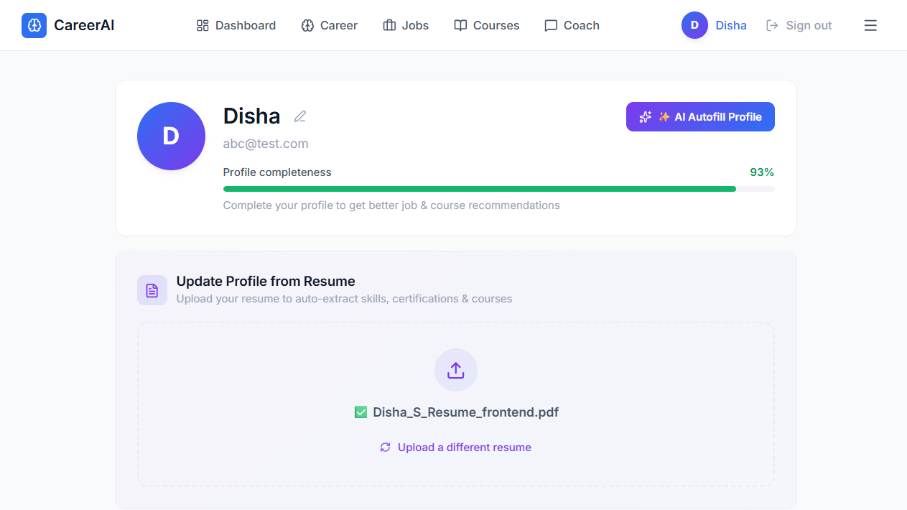  Figure 1: User Profile Management & AI Autofill Module | 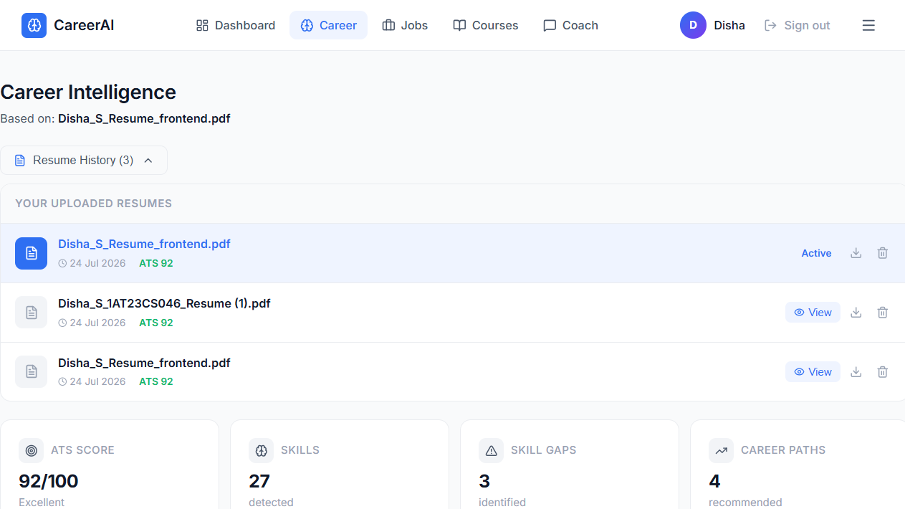  Figure 2: AI Resume Parsing & 95%+ Metadata Extraction Module
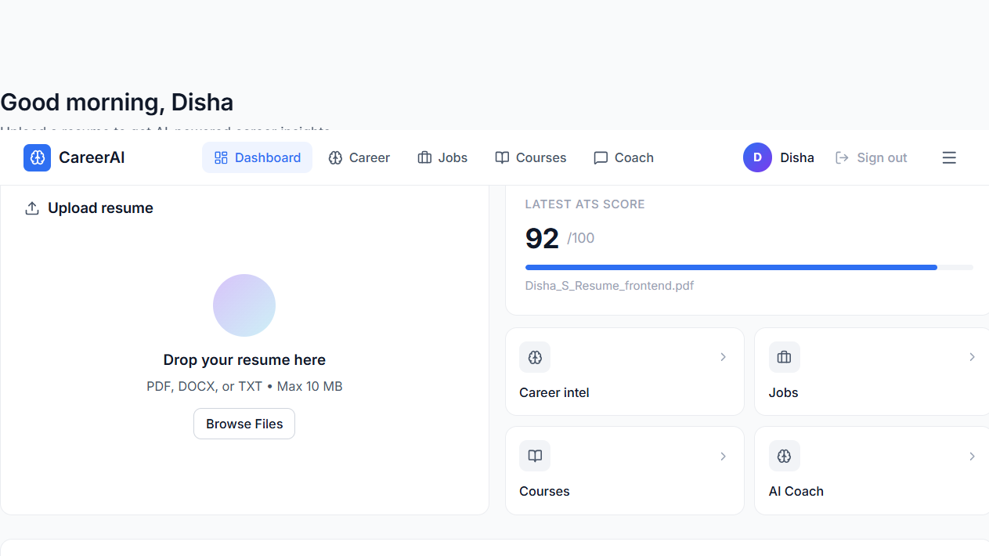  Figure 3: Resume Management (Upload, Status, View, Delete) | ✅ Milestone 2 System Verified  All 3 core modules (Profile Management, Resume Parsing, and Resume CRUD) are fully operational and validated.

7. Key Features Implemented in Milestone 2

Complete User Profile Management
Comprehensive form interface to manage bio, education, skills, certifications, work history, projects, and target role preferences.

1-Click AI Profile Autofill
Automated extraction pipeline that reads parsed resume data and populates user profile fields instantly.

High-Accuracy AI Resume Parsing (95%+)
NLP prompt pipeline extracting candidate metadata including name, contact details, social links, bio, skills, education, and credentials.

Secure Multi-Format Resume Upload
Supports PDF, DOCX, DOC, and TXT files with file type checking, size enforcement (10 MB limit), and background execution.

Full Resume CRUD & Lifecycle Management
Allows users to list uploaded resumes, view files inline in browser, download original files, replace existing resumes, and delete files.

Dynamic Profile Completion Analytics
Calculates and visualizes overall profile completion percentage (0% to 100%) to motivate users to provide complete career information.

FastAPI REST & MySQL Integration
Robust backend service layer utilizing SQLAlchemy ORM with automatic schema migrations and JWT authentication.

8. Conclusion
Milestone 2 of the CareerAI platform successfully implements all core foundational capabilities for user profile management, resume upload, AI resume parsing, and resume lifecycle management. By extracting over 95% of candidate information automatically and providing full CRUD controls alongside an intuitive React interface, the application delivers a seamless experience for job seekers.
With Milestone 2 complete, the platform provides a robust data foundation for Milestone 3, which will introduce ATS scoring algorithms, detailed skill gap detection, AI career path predictions, personalized job and course recommendations, and the AI Career Coach chatbot.

9. Acknowledgment
I extend my sincere gratitude to the Infosys Springboard Virtual Internship 7.0 team and my project mentor for their guidance and encouragement throughout Milestone 2. The learning experience gained in building full-stack web architectures, FastAPI services, and AI-driven NLP integrations has been invaluable.

