CareerAI
  - AI-Powered Career Intelligence Platform

INFOSYS SPRINGBOARD VIRTUAL INTERNSHIP
Project: CareerAI — AI-Powered Career Intelligence Platform
Milestone 1

SUBMITTED BY:
Name: Disha S
Domain: Artificial Intelligence
Date: 08.07.2026

1. Introduction
The project "CareerAI — AI-Powered Career Intelligence Platform" is a full-stack web application that functions as an intelligent career coach. It leverages artificial intelligence to analyze resumes, detect skill gaps, predict career paths, and provide real-time AI-powered guidance to help professionals make informed career decisions.
The platform addresses a common challenge faced by job seekers: understanding how their resume performs against applicant tracking systems (ATS), identifying which skills are missing for their target roles, and finding the right career trajectory. CareerAI automates this analysis using NLP-powered resume parsing and large language model inference, delivering actionable insights in seconds.
Users can upload their resume in PDF or DOCX format, receive an ATS compatibility score, view detected skills and skill gaps, explore AI-recommended career paths with salary estimates, browse personalized job and course recommendations, and interact with an AI career coach chatbot that understands their profile context.

2. Objective
The primary objectives of the CareerAI platform are:
- Resume Analysis & ATS Scoring: Parse uploaded resumes using NLP techniques, extract structured data (skills, roles, experience), and generate an ATS compatibility score benchmarked against industry standards.
- Skill Gap Detection: Identify missing skills relative to the user's target career path and provide prioritized recommendations with explanations for each gap.
- Career Path Prediction: Use AI to generate personalized career trajectory recommendations with match percentages, required skills, salary ranges, and timelines.
- Salary Intelligence: Provide role-aware, location-aware salary estimates based on the user's detected skillset and experience level.
- Job & Course Recommendations: Curate personalized job listings and skill-building courses matched to the user's profile and identified gaps.
- AI Career Coach: Offer a conversational chatbot interface that maintains profile context and delivers personalized, actionable career guidance.
- Secure Authentication: Implement JWT-based user authentication with registration, login, and profile management.
- Clean, Professional UI: Deliver a responsive, accessible interface built with React that prioritizes usability and visual clarity.

3. Tech Stack
The CareerAI platform was built using the following technologies:
Layer | Technology | Purpose
Frontend | React.js + Vite | Single-page application with fast dev server and optimized builds
Backend | FastAPI (Python) | High-performance async API framework for REST endpoints
Database | MySQL + SQLAlchemy | Relational database with ORM for structured data storage
AI Engine | NVIDIA NIM API | AI inference platform for resume analysis, career predictions, ATS scoring, and chatbot responses
Auth | JWT (JSON Web Tokens) | Stateless authentication for secure API access
Resume Parsing | NLP Libraries | PDF/DOCX text extraction and skill entity recognition
Charts | Recharts | Radial and bar charts for ATS score visualization
Icons | Lucide React | Consistent, lightweight icon system
HTTP Client | Axios | Promise-based API communication with request/response interceptors
Version Control | Git & GitHub | Source code management and collaboration

4. System Architecture
The application follows a clean three-tier architecture: a React-based single-page application (SPA) frontend communicates with a FastAPI backend over RESTful JSON APIs, which in turn interacts with a MySQL database through SQLAlchemy ORM. The AI capabilities are provided by an external large language model accessed via the OpenRouter API.
Frontend Layer: Built with React 19 and Vite, the SPA handles routing (react-router-dom), state management (React Context), and API communication (Axios with JWT interceptors). The UI uses a clean design system with CSS custom properties for consistent theming.
Backend Layer: FastAPI serves as the API gateway, handling authentication (JWT token generation and validation), resume file uploads with NLP-based parsing, and AI inference requests. The backend exposes endpoints for auth, users, resumes, jobs, courses, and AI operations.
Data Layer: MySQL stores user accounts, resume data, parsed analysis results, and cached recommendations. SQLAlchemy provides ORM abstraction with automatic table creation on startup.

5. Screenshots and Output
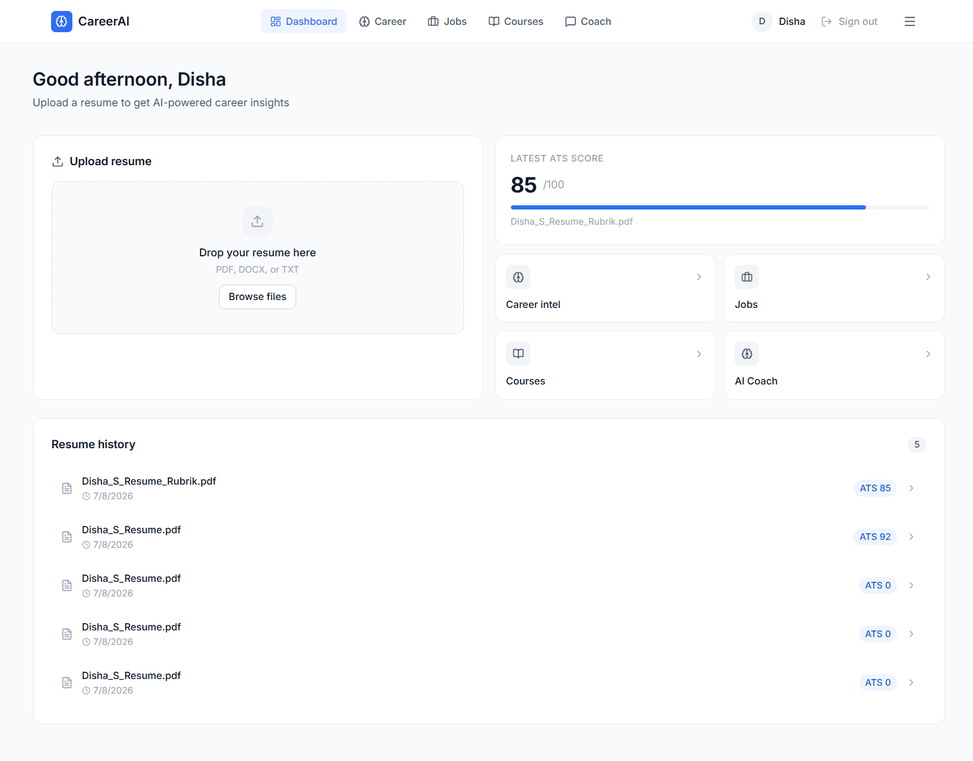
Below are screenshots demonstrating the key features of the CareerAI platform.

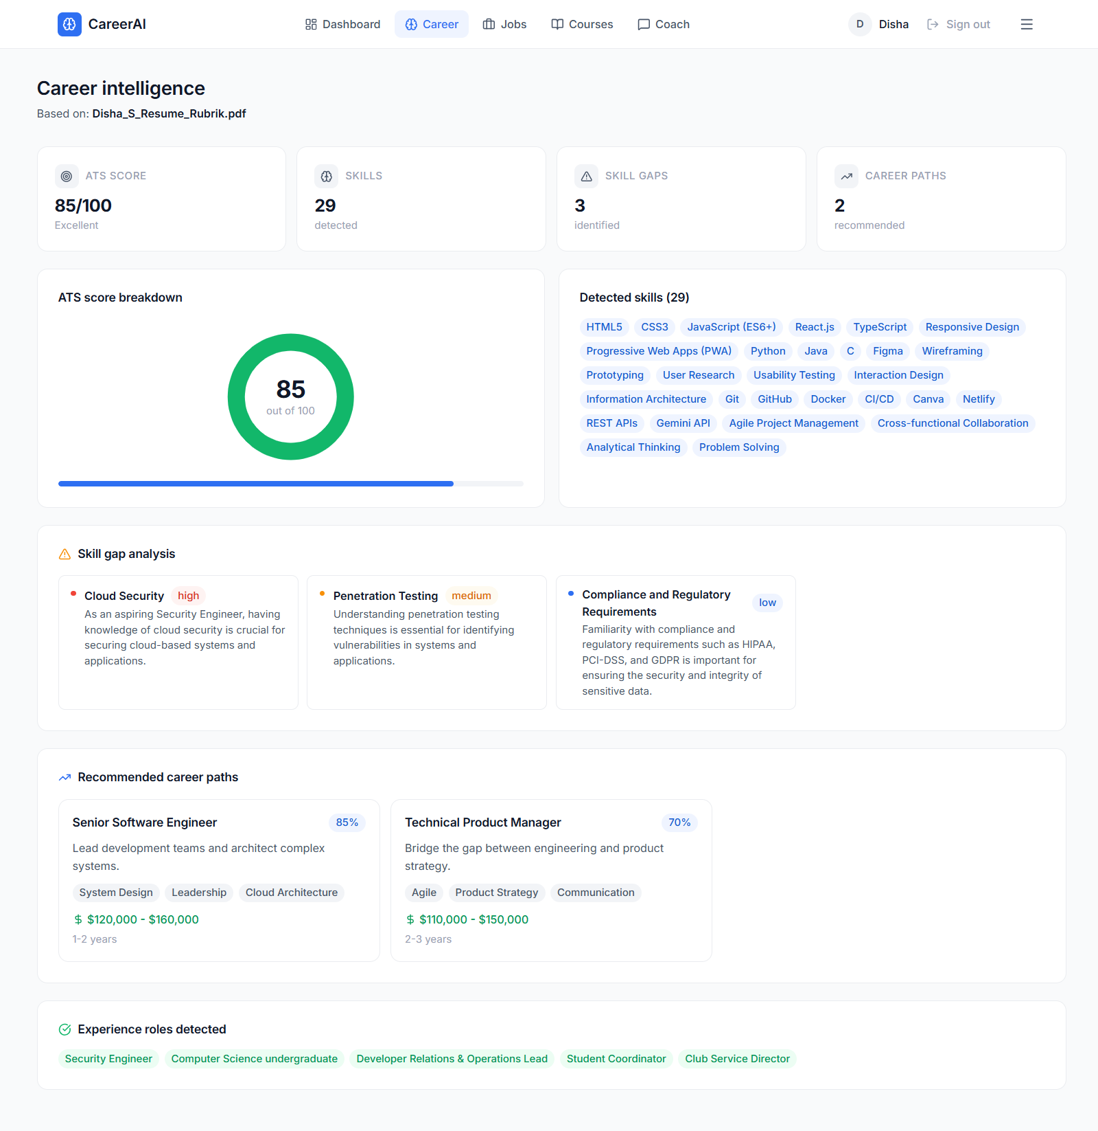
Fig 1: Dashboard — Resume upload, ATS score overview, quick navigation, and resume history

Fig 2: Career Intelligence — ATS score breakdown, detected skills, skill gap analysis, and career paths

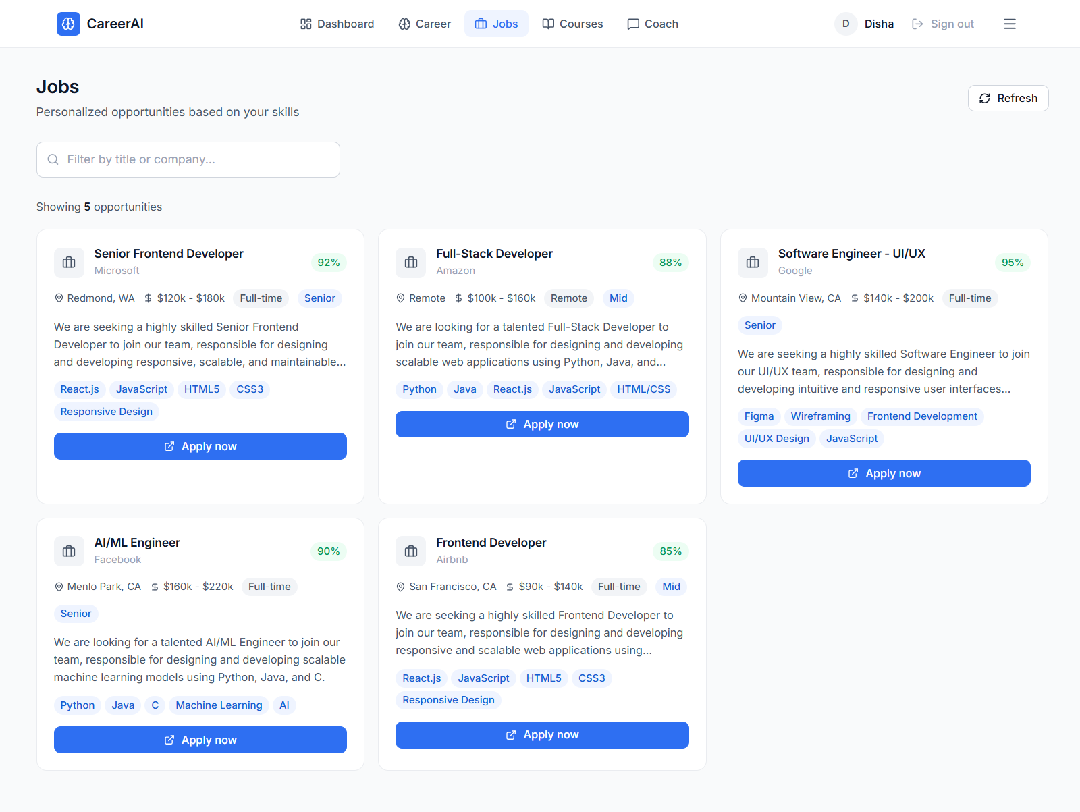
Fig 3: Job Recommendations — AI-curated job listings with match scores and skill tags

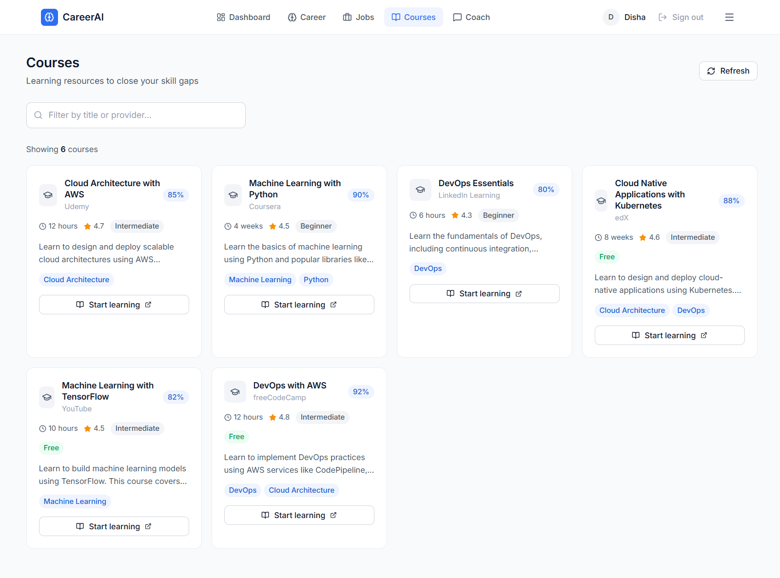
Fig 4: Course Recommendations — Skill-building courses matched to identified gaps
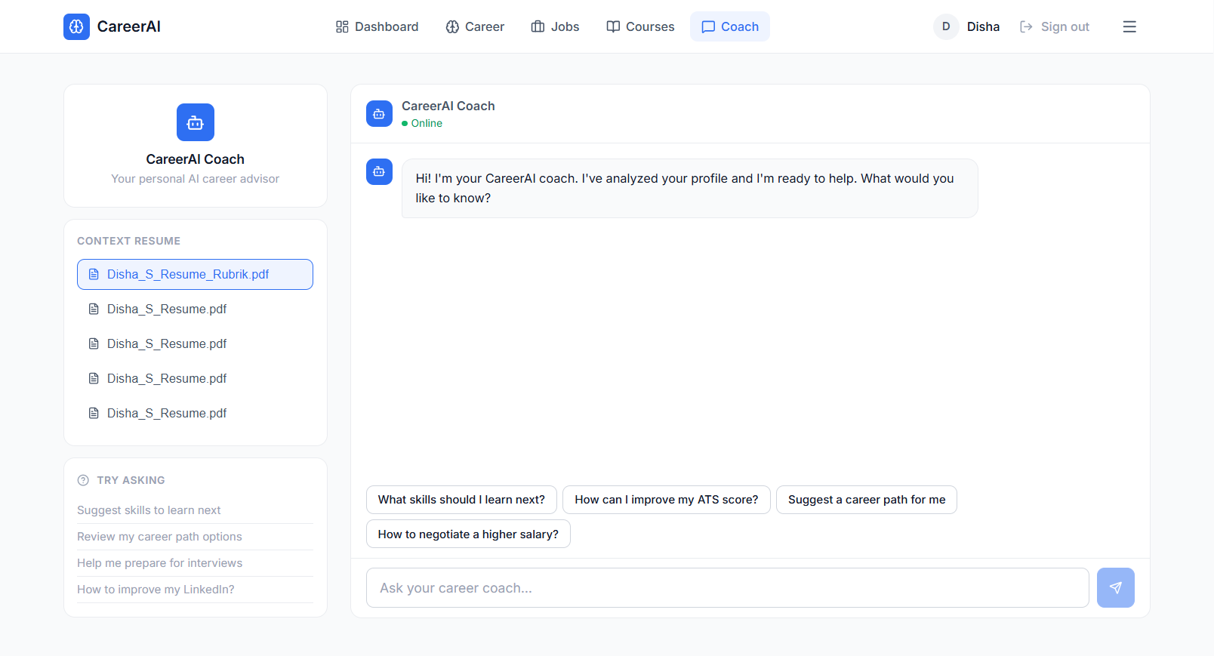
Fig 5: AI Career Coach — Conversational interface with resume context and quick prompts
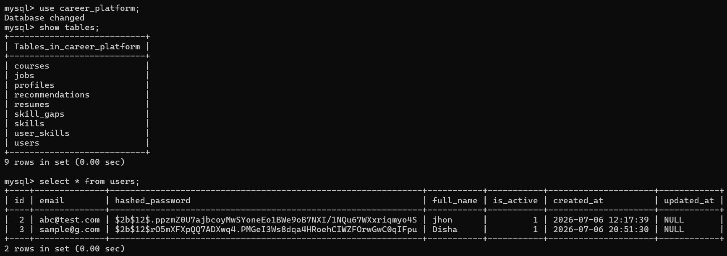
Fig 6: AI Career Coach — Database of users

6. Key Features Summary

Resume Upload & Parsing
Supports PDF, DOCX, and TXT formats. Uses NLP to extract skills, roles, experience, and education from unstructured resume text.

ATS Score Analysis
Generates a compatibility score (0–100) against applicant tracking system benchmarks, displayed with a radial chart and progress bar.

Skill Gap Detection
Compares detected skills against target role requirements. Each gap includes a priority level (high/medium/low) and an explanation.

Career Path Prediction
Recommends career trajectories with match percentages, required skills, salary ranges, and estimated timelines.

Job Recommendations
AI-curated job listings with match scores, company info, location, salary, job type, and direct apply links.

Course Recommendations
Personalized learning resources targeting skill gaps, with match scores, ratings, duration, and provider info.

AI Career Coach
Chatbot interface with resume context awareness, quick prompt suggestions, and conversation history.

Responsive Design
Clean, professional UI that works across desktop and mobile viewports with a consistent design system.

7. Conclusion
The CareerAI platform successfully delivers an integrated, AI-powered career intelligence system that addresses the key challenges job seekers face today. By combining resume parsing, ATS scoring, skill gap analysis, career path prediction, and an interactive AI coach into a single platform, it provides a comprehensive toolkit for career development.
The project demonstrates the practical application of large language models in career services, showing how AI can transform unstructured resume data into structured, actionable insights. The clean architecture — separating concerns across React frontend, FastAPI backend, and MySQL database — ensures the system is maintainable and scalable.
Future enhancements could include integration with live job boards via APIs, LinkedIn profile analysis, multi-language resume support, interview preparation modules, and collaborative features for career mentors and coaches.

8. Acknowledgment
I would like to express my sincere gratitude to the Infosys Springboard team and my mentor for their continuous guidance and support throughout the development of this project. This virtual internship has been a valuable experience in learning full-stack development, AI integration, and building real-world applications that solve meaningful problems.
The mentorship and structured project framework provided by the Infosys Springboard program were instrumental in shaping the direction and quality of this project. I am grateful for the opportunity to work on a project that combines artificial intelligence with practical career development tools.

