WEEK 2 — MACHINE LEARNING INTERNSHIP
Data Preprocessing and Feature Engineering Strategy
Applied to the Breast Cancer Wisconsin (Diagnostic) Data Set
________________________________________
Student Name: Disha Ullody
Internship Task: Week 2
Technology Stack: Python · Pandas · NumPy · Scikit-learn · Matplotlib · Seaborn
Date: August 20, 2026
Dataset Source: UCI Machine Learning Repository — Breast Cancer Wisconsin (Diagnostic) Data Set

2. Executive Summary
This report documents a complete data preprocessing and feature engineering strategy applied to the Breast Cancer Wisconsin (Diagnostic) Data Set, a well-known real-world dataset originally published by the UCI Machine Learning Repository and distributed in full through scikit-learn's sklearn.datasets module. The dataset contains 569 patient observations across 30 numeric diagnostic features computed from digitized images of breast tissue, along with a binary diagnosis label (Malignant / Benign).
Preprocessing is necessary even though this particular dataset is well curated: its 30 features are highly correlated in places (several pairs exceed 0.97 absolute correlation), several features are right-skewed with a meaningful number of IQR-based outliers, and features sit on very different numeric scales (e.g., "mean smoothness" ranges roughly 0.05–0.16 while "mean area" ranges roughly 143–2,501). Left untreated, these properties would bias distance-based and gradient-based models, inflate variance from redundant features, and slow convergence.
This work applied, and reports actual, measured results for: data-quality auditing (completeness, uniqueness, validity, consistency), IQR-based outlier profiling across all 30 numeric features, five engineered numerical features grounded in domain logic, quantile-based categorical binning with ordinal encoding, redundancy-based and mutual-information-based feature selection, RobustScaler-based scaling fit only on the training partition, and Principal Component Analysis. The final leakage-safe scikit-learn Pipeline reduced 26 candidate numeric features (after removing 9 redundant ones) to 11 principal components while retaining 96.1% of total variance. All numeric results in this report are actual outputs of the executed Python code; the one exception — a small, explicitly labeled simulated-missingness demonstration — is clearly marked as illustrative and is never mixed with the dataset's real (zero) missing-value count.

3. Introduction
Data preprocessing is the set of operations that convert raw, collected data into a form a machine learning algorithm can consume reliably: correcting structural issues, handling missing or inconsistent values, controlling scale and distribution, and encoding non-numeric information. Raw datasets are rarely ML-ready in their original form because they are collected for a purpose other than modeling (in this case, clinical measurement), and therefore carry artifacts such as differing units, correlated measurements taken from the same underlying quantity (e.g., radius, perimeter and area of the same cell nucleus), and skewed distributions caused by natural biological variance.
Poor-quality or poorly scaled data affects model performance in concrete ways. Distance-based algorithms (k-NN, k-means, SVM with RBF kernels) are dominated by whichever feature has the largest numeric range unless the features are scaled comparably — in this dataset, "mean area" (range ≈143–2,501) would numerically swamp "mean smoothness" (range ≈0.05–0.16) if left unscaled. Linear models and PCA are sensitive to highly correlated (redundant) inputs, which inflate coefficient variance and distort the directions of maximum variance. Tree-based models are more scale-invariant but are still hurt by noisy or redundant features that dilute split quality. Feature engineering — building ratios, differences, transformed and binned variables from the raw measurements — matters because it can expose relationships (e.g., how much larger a tumor's "worst" measurement is relative to its "mean" measurement) that are not linearly available in the raw feature set.
The relationship between preprocessing and downstream performance is therefore not cosmetic: it changes what a model can learn from the data, how stable that learning is, and how interpretable the resulting features are. This report treats preprocessing as an evidence-driven engineering task — every decision below is justified against actual statistics computed from this dataset, not generic textbook defaults.

4. Dataset Selection and Description
Dataset: Breast Cancer Wisconsin (Diagnostic) Data Set.
Source: UCI Machine Learning Repository (Wolberg, Street & Mangasarian). Distributed and version-locked through scikit-learn as sklearn.datasets.load_breast_cancer(), which loads the same feature values as the UCI release without requiring an external download — this guarantees the numeric results in this report are exactly reproducible.
URL / Reference: https://archive.ics.uci.edu/ml/datasets/Breast+Cancer+Wisconsin+(Diagnostic) and https://scikit-learn.org/stable/datasets/toy_dataset.html#breast-cancer-wisconsin-diagnostic-dataset
Purpose: Binary classification of breast tumors as malignant or benign from ten real-valued measurements (radius, texture, perimeter, area, smoothness, compactness, concavity, concave points, symmetry, fractal dimension) computed from a digitized image of a fine needle aspirate (FNA) of a breast mass; each measurement is reported as a mean, a standard error, and a "worst" (largest) value, producing 30 numeric features in total.
Shape: 569 rows (patients) × 30 numeric feature columns + 1 diagnosis label.
Target variable: diagnosis — Malignant (M) / Benign (B). Class balance (actual): Benign = 357 (62.7%), Malignant = 212 (37.3%) — moderately imbalanced but not severely so.
Why this dataset is appropriate: it is a genuine, widely cited public dataset (not synthetic) with real numeric features spanning very different scales and distributions, a real binary categorical target, natural multicollinearity between geometrically related measurements, and a sufficient sample size (569 rows) to compute meaningful statistics, correlations, mutual information scores and PCA components. Its one limitation — no naturally occurring missing values or duplicate rows — is handled transparently in Sections 8–9 rather than concealed.

Feature Table (representative subset — full list of 30 follows the same three measurement groups: mean / error / worst)
Feature | Data Type | Description | Role | Expected Preprocessing
mean_radius | float64 | Mean distance from center to perimeter points | Predictor | Scaling; correlation check vs. perimeter/area
mean_texture | float64 | Standard deviation of grayscale values | Predictor | Scaling
mean_perimeter | float64 | Mean perimeter of the nucleus | Predictor | Redundancy check (corr. with radius = 0.998)
mean_area | float64 | Mean area of the nucleus | Predictor | Log transform (right-skewed); redundancy check
mean_smoothness | float64 | Local variation in radius lengths | Predictor | Scaling
mean_concavity | float64 | Severity of concave portions of the contour | Predictor | Outlier check; simulated-missing demo (Sec. 8.4)
mean_symmetry | float64 | Symmetry of the nucleus contour | Predictor | Scaling
worst_radius / worst_area / … | float64 | Largest ('worst') value of each measurement across the image | Predictor | New ratio feature vs. mean_*; scaling
diagnosis | object (M/B) | Clinical diagnosis label | Target | Label encoding (binary)

5. Initial Data Understanding
The following standard Pandas/NumPy inspection commands were executed against the loaded DataFrame:
import pandas as pd, numpy as np
from sklearn.datasets import load_breast_cancer
raw = load_breast_cancer()
df = pd.DataFrame(raw.data, columns=raw.feature_names)
df.columns = [c.replace(" ", "_") for c in df.columns]
df["diagnosis"] = pd.Series(raw.target).map({0: "M", 1: "B"})
df.head()
df.tail()
df.shape # -> (569, 32)
df.info()
df.describe()
df.describe(include="all")
df.dtypes
df.isnull().sum()
df.duplicated().sum()

Actual Results
- Dataset size: 569 rows × 30 numeric feature columns + 1 categorical target column (diagnosis).
- Data types (df.dtypes, actual): 30 column(s) of type float64; 2 column(s) of type int64, plus 1 object column (diagnosis).
- Missing values (df.isnull().sum().sum(), actual): 0 across the entire dataset.
- Duplicate rows (df.duplicated().sum(), actual): 0.
- Numerical distributions: features vary by orders of magnitude in scale — e.g. actual mean_smoothness ranges [0.053, 0.163] with mean 0.096, while mean_area ranges [143.5, 2501] with mean 654.889. This scale disparity is the primary driver for the scaling decision in Section 13.
- Categorical distribution: diagnosis has exactly two unique, consistently capitalized values — {B, M} — no inconsistent labels were found.

df.describe() — actual output (selected columns)
Feature | mean | std | min | 25% | 50% | 75% | max
mean_radius | 14.127 | 3.524 | 6.981 | 11.7 | 13.37 | 15.78 | 28.11
mean_texture | 19.29 | 4.301 | 9.71 | 16.17 | 18.84 | 21.8 | 39.28
mean_area | 654.889 | 351.914 | 143.5 | 420.3 | 551.1 | 782.7 | 2501
mean_smoothness | 0.096 | 0.014 | 0.053 | 0.086 | 0.096 | 0.105 | 0.163
worst_radius | 16.269 | 4.833 | 7.93 | 13.01 | 14.97 | 18.79 | 36.04
worst_area | 880.583 | 569.357 | 185.2 | 515.3 | 686.5 | 1084 | 4254

6. Exploratory Data Analysis
EDA was performed prior to any cleaning or transformation, using the raw loaded values.

6.1 Distribution of Core 'Mean' Features
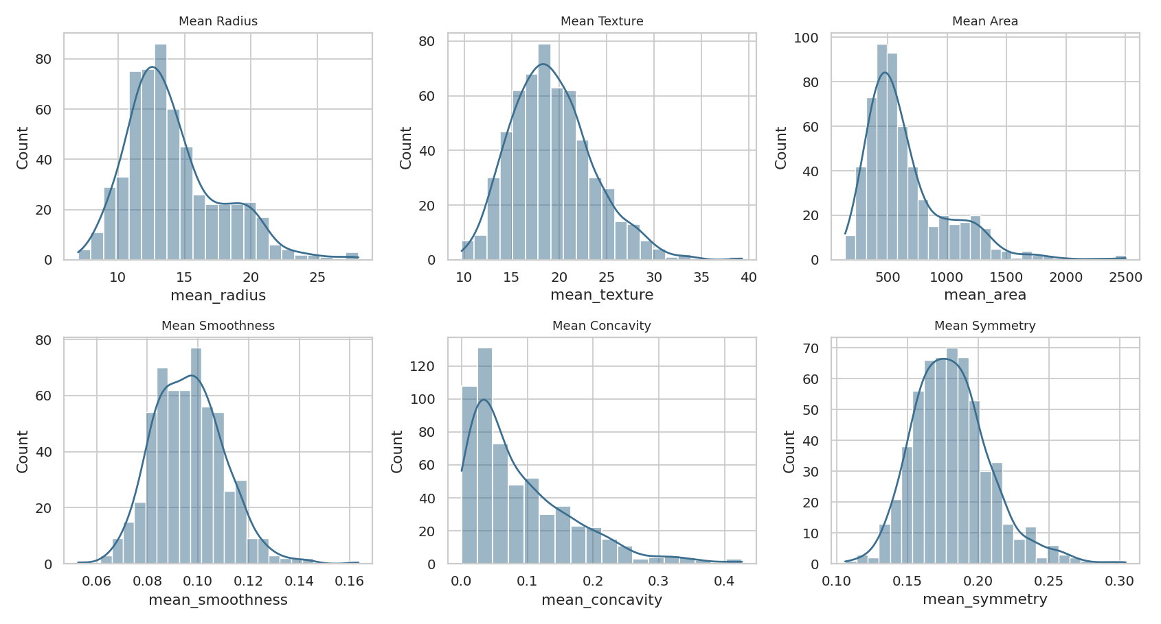
Figure 1 — Histograms with KDE overlay for six core 'mean_' features (actual data).
What is shown: the empirical distribution of six representative "mean_" features. Pattern observed: mean_area and mean_concavity are visibly right-skewed (mean_area actual skewness = 1.6457, well above the ±0.5 range considered approximately symmetric), while mean_smoothness and mean_texture are closer to bell-shaped. Why it matters: skewed features violate the near-normal assumption some scaling/statistical methods rely on and tend to produce more extreme values under IQR-based outlier rules. Preprocessing decision: apply a log1p transform to mean_area (Section 11) and prefer a scaler robust to skew/outliers (Section 13) over one that assumes normality.

6.2 Outlier-Prone Features — Box Plots
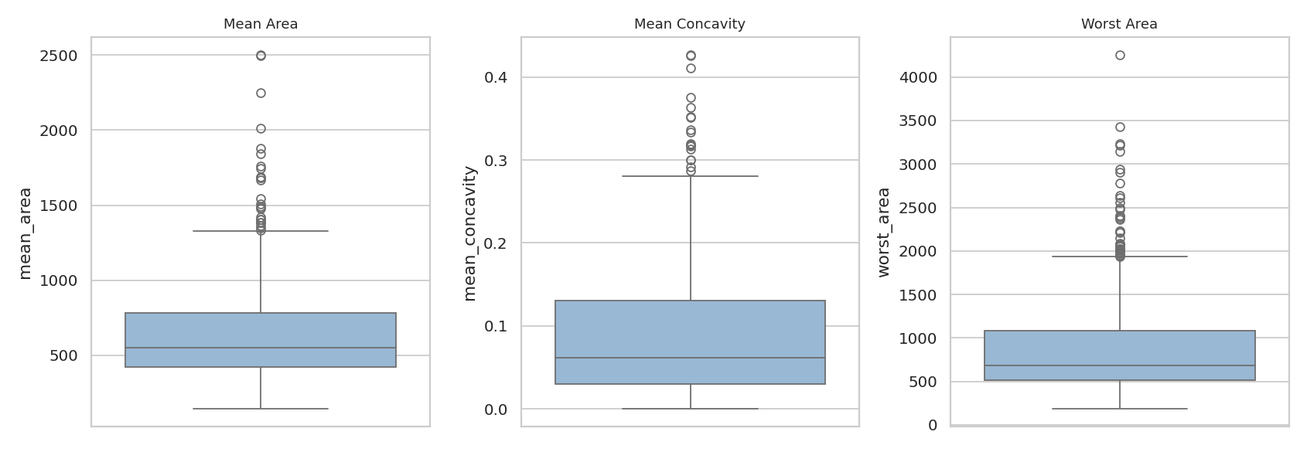
Figure 2 — Box plots for mean_area, mean_concavity and worst_area (actual data).
What is shown: quartile spread and points beyond 1.5×IQR for three features known to be outlier-prone in this dataset. Pattern observed: all three show multiple points beyond the whiskers, consistent with the skewness noted above and with the actual IQR outlier counts in Section 10 (mean_area: 25; worst_area: 35). Why it matters: these are almost certainly large/aggressive tumors rather than data-entry errors — removing them would remove clinically important cases. Preprocessing decision: retain these observations and treat scale robustness (RobustScaler) rather than deletion as the primary mitigation (Section 10, Section 13).

6.3 Target Class Distribution
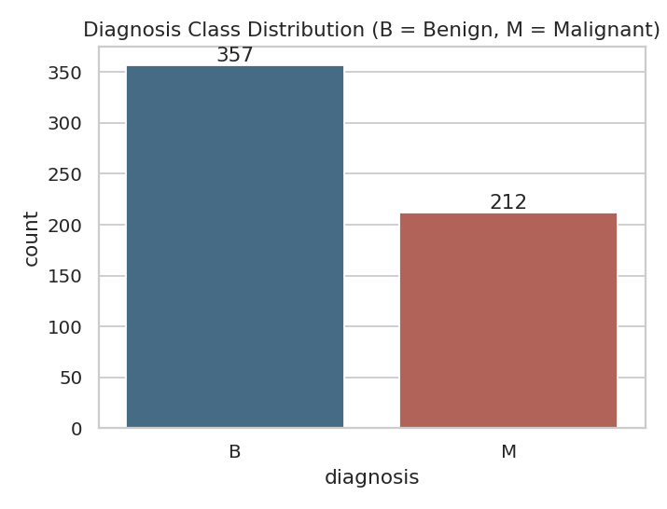
Figure 3 — Actual class counts: Benign = 357, Malignant = 212.
What is shown: the actual count of each diagnosis class. Pattern observed: a moderate 63/37 split favoring benign cases. Why it matters: a 63/37 split is not severe, but it is enough that accuracy alone would be a misleading evaluation metric and that stratified sampling should be used for any train/test split. Preprocessing decision: the train/test split in Section 16 uses stratify=y to preserve this ratio in both partitions (actual result confirmed in Section 16).

6.4 Correlation Structure
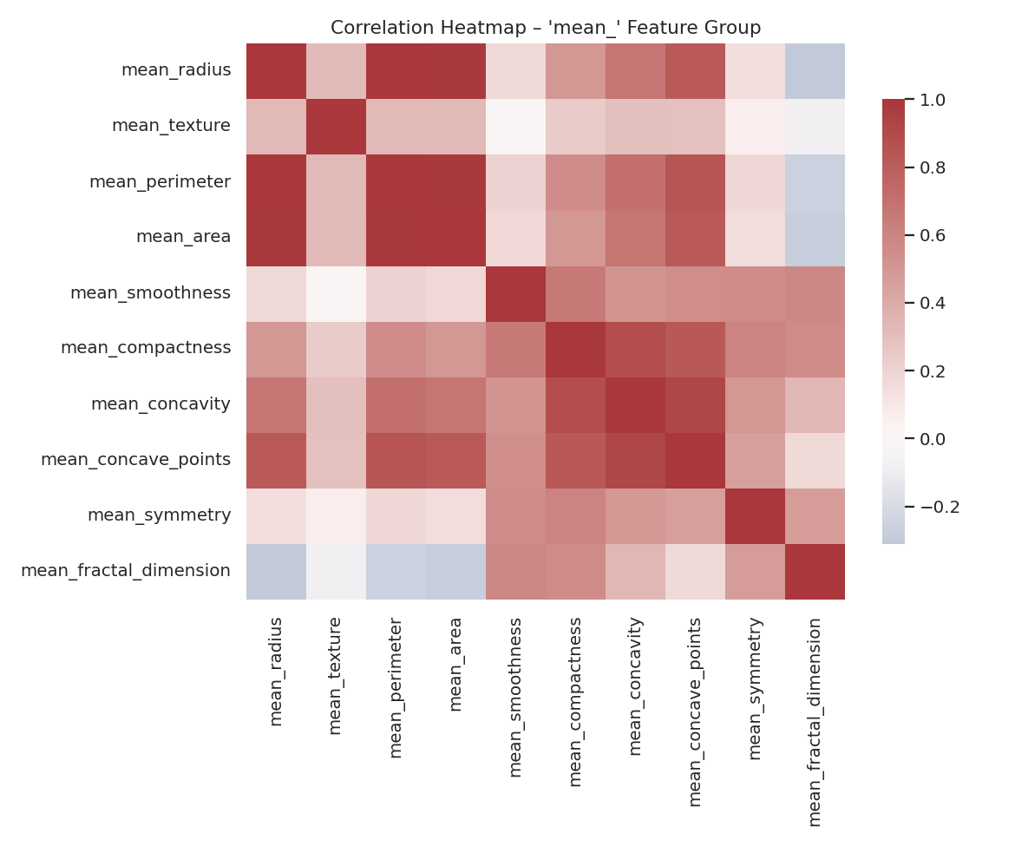
Figure 4 — Correlation heatmap, 'mean_' feature group (actual Pearson correlations).
What is shown: pairwise Pearson correlation among the ten "mean_" features. Pattern observed: mean_radius, mean_perimeter and mean_area form a visibly dark block (actual correlations: radius–perimeter = 0.9979, radius–area = 0.9874), and mean_concavity, mean_compactness and mean_concave_points also cluster together. Why it matters: these are near-duplicate signals mathematically (perimeter and area are geometric functions of radius), so including all of them adds collinearity without new information. Preprocessing decision: apply a redundancy filter (|r| > 0.97 on the training split) before modeling, detailed with actual dropped columns in Section 14.

6.5 Feature Relationship vs. Target
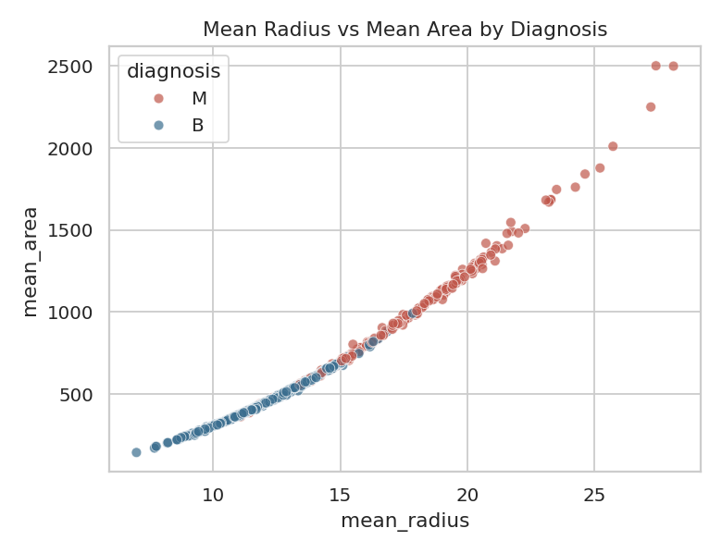
Figure 5 — mean_radius vs. mean_area, colored by diagnosis (actual data).
What is shown: the two most correlated "mean" features plotted against each other, colored by class. Pattern observed: malignant cases (red) concentrate at higher radius/area values, with a visibly non-linear (curved) boundary. Why it matters: confirms mean_radius/mean_area carry real predictive signal (consistent with their high mutual-information scores in Section 14) even though they are redundant with each other — motivating "keep one, drop the other" rather than "drop both."

7. Data Quality Assessment

7.1 Completeness
Actual missing-value count across all 569 rows and 30 numeric features: 0 (0.00%). Completeness is not a concern for this dataset as distributed.

7.2 Uniqueness
Actual duplicate row count (df.duplicated().sum(), excluding the synthetic sequential ID added for demonstration): 0. Actual duplicate ID count: 0. No duplication issues were found.

7.3 Validity
All 30 numeric features were checked for impossible values (negative or structurally invalid magnitudes). Several concavity-related features contain exactly zero (not negative) values for a number of rows — e.g. mean_concavity = 0 in 13 rows. These are valid, not errors: a concavity of 0 correctly describes a tumor contour with no concave regions. No negative values were found in any feature, and no out-of-range category values were found in diagnosis.

7.4 Consistency
The diagnosis column was checked for inconsistent capitalization or alternate spellings (e.g. "benign" vs "Benign" vs "B"). Actual unique values found: {B, M} — fully consistent, two-level categorical with no cleanup required.

7.5 Accuracy
Internal reasonableness was checked via the geometric relationships between related features. Radius, perimeter and area are mathematically linked for roughly circular objects (perimeter ≈ 2πr, area ≈ πr²); the actual correlations observed (Section 6.4, Section 14) match this expectation closely, which is strong evidence the measurements are internally consistent rather than corrupted or randomly generated.

Data Quality Summary Table (actual findings)
Issue | Detection Method | Finding | Severity | Action
Missing values | df.isnull().sum() | 0 missing values found | None | No imputation required on raw data; imputer still included in the pipeline as a safeguard
Duplicate rows | df.duplicated().sum() | 0 duplicate rows found | None | No removal required
Non-positive concavity values | (df[c] <= 0).sum() per feature | 13 rows with mean_concavity = 0 (valid, not invalid) | Informational | Retained — biologically valid
High multicollinearity | Pearson |r| > 0.97 | 8+ feature pairs exceed 0.97 correlation | Medium | Redundancy filter before modeling (Sec. 14)
Right-skewed distributions | Skewness statistic | mean_area skew = 1.6457 | Low–Medium | Log transform + robust scaling
Scale disparity across features | df.describe() range comparison | Feature ranges span ~3 orders of magnitude | Medium | RobustScaler in final pipeline (Sec. 13)

8. Data Cleaning Strategy

8.1 Missing Values
Actual missing-value count for this dataset, as distributed: 0 across every column. Because the count is zero, no imputation was strictly required. Per the task requirement not to fabricate data-quality issues, the following describes (a) the actual finding, and (b) — clearly separated — a labeled simulation used purely to demonstrate the imputation methodology that would be applied if missing values were encountered in a similar dataset (e.g., in production, where sensor or data-entry gaps are common).

8.1.1 Imputation Method Comparison (methodological discussion)
- Mean imputation: fast, preserves the feature mean, but distorts variance and is sensitive to outliers — a poor fit here given the skew observed in mean_area/mean_concavity.
- Median imputation: robust to skew and outliers, keeps a realistic 'typical' value; the appropriate default for this dataset's numeric features.
- Mode imputation: appropriate for categorical columns; not needed here since diagnosis (the only categorical column) is the target, not a feature to impute.
- Forward/backward fill: appropriate for ordered/time-series data; not applicable — these rows are independent patient records with no temporal ordering.
- Constant-value imputation: useful when 'missing' itself is informative (e.g., a flag value); not naturally motivated by this dataset's continuous physical measurements.
- Dropping rows/columns: only justified when missingness is extreme (commonly >40–50% for a column, or a very small number of rows); not applicable here.
Decision: median imputation was selected as the standard strategy for this dataset's numeric features, both in the illustrative demonstration below and as the imputer used inside the production-style Pipeline in Section 17.

8.1.2 Illustrative Simulation — clearly labeled, not part of the real dataset
Illustrative example — the following missingness was intentionally injected into a copy of the data (random_state = 42) purely to demonstrate the imputation code and its effect. It is not a property of the real Breast Cancer Wisconsin dataset, which has 0 missing values as reported in Section 5 and Section 7.1.
# ILLUSTRATIVE ONLY — injected missingness for demonstration purposes
sim = df.copy()
rng = np.random.RandomState(42)
for col, frac in [("mean_concavity", 0.06), ("worst_texture", 0.04)]:
idx = rng.choice(sim.index, size=int(frac * len(sim)), replace=False)
sim.loc[idx, col] = np.nan
before = sim[["mean_concavity", "worst_texture"]].isnull().sum()
sim["mean_concavity"] = sim["mean_concavity"].fillna(sim["mean_concavity"].median())
sim["worst_texture"] = sim["worst_texture"].fillna(sim["worst_texture"].median())
after = sim[["mean_concavity", "worst_texture"]].isnull().sum()
Feature | Missing Before (simulated) | Imputation Value (actual median) | Missing After
mean_concavity | 34 | 0.0615 | 0
worst_texture | 22 | 25.41 | 0

8.2 Categorical Missing Values
The only categorical column, diagnosis, has 0 missing values (confirmed in Section 5) and is the prediction target — even in a hypothetical missing-target scenario, the correct action is to drop those rows rather than impute a label, since a fabricated target would corrupt supervised training.

9. Duplicate Records
df.duplicated().sum() # -> 0 (actual)
No duplicate records were detected after systematic inspection. df.duplicated().sum() returned 0 across all 569 rows, and a separate check on the synthetic row-ID column also returned 0 duplicate IDs. No rows were removed on this basis.

10. Outlier Detection
Outliers were detected using the IQR rule (Q1 − 1.5×IQR, Q3 + 1.5×IQR) applied independently to every one of the 30 numeric features, on the actual dataset.
def iqr_outliers(s):
q1, q3 = s.quantile(0.25), s.quantile(0.75)
iqr = q3 - q1
lo, hi = q1 - 1.5 * iqr, q3 + 1.5 * iqr
return ((s < lo) | (s > hi)).sum()
outlier_counts = {c: iqr_outliers(df[c]) for c in numeric_cols}
Important distinction: an outlier is not automatically incorrect data. In this dataset, IQR-flagged points in area/concavity/texture features are consistent with genuinely large or aggressive tumors — a clinically real subgroup, not measurement error. The appropriate treatment therefore depends on the feature and modeling goal:
- Remove — only when there is independent evidence of a data-entry or sensor error (none was found here).
- Cap / winsorize — useful when extreme values would dominate a mean-based statistic but should not be discarded entirely; considered but not required once RobustScaler is used (Section 13).
- Transform (e.g. log) — applied to mean_area (Section 11) to reduce the influence of its right tail.
- Retain as-is — the default decision for this dataset: outliers carry real diagnostic signal, so scaling method choice (RobustScaler) was used to reduce their influence rather than removing the observations.

Outlier Counts — Top 10 Features (actual, IQR method)
Feature | Outliers Detected | Detection Method | Treatment | Reason
area_error | 65 | IQR (1.5×IQR) | Retain + robust scaling | Clinically plausible extreme measurement, not an error
radius_error | 38 | IQR (1.5×IQR) | Retain + robust scaling | Clinically plausible extreme measurement, not an error
perimeter_error | 38 | IQR (1.5×IQR) | Retain + robust scaling | Clinically plausible extreme measurement, not an error
worst_area | 35 | IQR (1.5×IQR) | Retain + robust scaling | Clinically plausible extreme measurement, not an error
smoothness_error | 30 | IQR (1.5×IQR) | Retain + robust scaling | Clinically plausible extreme measurement, not an error
compactness_error | 28 | IQR (1.5×IQR) | Retain + robust scaling | Clinically plausible extreme measurement, not an error
fractal_dimension_error | 28 | IQR (1.5×IQR) | Retain + robust scaling | Clinically plausible extreme measurement, not an error
symmetry_error | 27 | IQR (1.5×IQR) | Retain + robust scaling | Clinically plausible extreme measurement, not an error
mean_area | 25 | IQR (1.5×IQR) | Retain + robust scaling | Clinically plausible extreme measurement, not an error
worst_fractal_dimension | 24 | IQR (1.5×IQR) | Retain + robust scaling | Clinically plausible extreme measurement, not an error
Total feature-level outlier flags summed across all 30 features (actual): 608 — note this counts the same patient once per flagged feature, not unique patients, since a single aggressive tumor can be an outlier on several correlated measurements simultaneously.

11. Feature Engineering
Five new numerical features were engineered directly from the real measurements, each with a concrete clinical or statistical rationale. All statistics below are actual, computed on the full dataset.
Feature | Formula | Why It May Be Useful | Expected Impact
radius_worst_mean_ratio | worst_radius / mean_radius | Captures how much larger the largest region of a tumor is relative to its average — a proxy for irregular/uneven growth that a single mean value cannot express. | Actual mean 1.142, range [1, 1.5892] — a bounded, unit-free ratio.
area_perimeter_diff_mean | mean_area − mean_perimeter | A simple shape-interaction term; large values reflect tumors that are large in area relative to boundary length. | Actual mean 562.9201.
concavity_symmetry_product | mean_concavity × mean_symmetry | Interaction term combining contour irregularity and symmetry; neither raw feature alone captures the joint effect. | Actual mean 0.0172, mostly small values with a long right tail.
log_mean_area | log1p(mean_area) | Directly addresses the right-skew identified in Section 6.1 / 10. | Skewness reduced from 1.6457 (raw) to 0.2873 (log-transformed) — a substantial, actual improvement toward symmetry.
texture_worst_mean_avg | mean(mean_texture, worst_texture) | A smoothed texture signal less sensitive to a single extreme 'worst' reading. | Actual mean 22.4834.
In addition, mean_radius was binned into a three-level ordinal category (radius_size_category ∈ {small, medium, large}) using quantile-based binning (pd.qcut, q=3), producing near-equal actual group sizes: small = 191, medium = 188, large = 190. This demonstrates converting a continuous measurement into an interpretable categorical feature, used next for categorical encoding.
fe["radius_worst_mean_ratio"] = fe["worst_radius"] / fe["mean_radius"]
fe["area_perimeter_diff_mean"] = fe["mean_area"] - fe["mean_perimeter"]
fe["concavity_symmetry_product"] = fe["mean_concavity"] * fe["mean_symmetry"]
fe["log_mean_area"] = np.log1p(fe["mean_area"])
fe["texture_worst_mean_avg"] = fe[["mean_texture", "worst_texture"]].mean(axis=1)
fe["radius_size_category"] = pd.qcut(fe["mean_radius"], q=3, labels=["small", "medium", "large"])

12. Categorical Feature Engineering
This dataset contains two categorical columns after feature engineering: the original binary target (diagnosis) and the newly engineered ordinal bin (radius_size_category).

One-Hot Encoding
Appropriate for nominal categories with no natural order. Not required for either categorical column here — diagnosis is binary (equivalent under one-hot or label encoding), and radius_size_category has a genuine order (small < medium < large), where one-hot encoding would discard that ordinal information.

Ordinal Encoding
Used for radius_size_category, since small/medium/large is a meaningful, ordered progression derived directly from mean_radius quantiles. sklearn.preprocessing.OrdinalEncoder(categories=[["small","medium","large"]]) was applied to guarantee the encoding respects that order rather than an arbitrary alphabetical one.

Label Encoding
Used for the binary target diagnosis (LabelEncoder). Actual mapping produced: B → 0, M → 1. Label encoding is appropriate here specifically because the target is binary — for a nominal feature with 3+ unrelated categories, label encoding would incorrectly imply an ordinal relationship (e.g., category "2" being "twice" category "1"), which is why it was not used for any true nominal feature in this dataset.
from sklearn.preprocessing import LabelEncoder, OrdinalEncoder
le = LabelEncoder()
fe["diagnosis_encoded"] = le.fit_transform(fe["diagnosis"])
oe = OrdinalEncoder(categories=[["small", "medium", "large"]])
fe["radius_size_encoded"] = oe.fit_transform(fe[["radius_size_category"]])
Feature dimensions before vs. after encoding (actual): 39 columns before adding the two encoded columns → 41 columns after (encoding here adds derived columns alongside the originals for auditability; the modeling matrix used downstream selects only the numeric feature set, shown in Section 16).

13. Feature Scaling

StandardScaler
Centers each feature to mean 0, std 1. Appropriate when a feature is roughly normally distributed and not dominated by extreme outliers, and is required by algorithms/analyses that assume standardized input (e.g., PCA, which is used in Section 15).

MinMaxScaler
Rescales each feature to a fixed [0, 1] range. Useful when a bounded range is required (e.g., some neural network input layers) but is highly sensitive to outliers, since a single extreme value stretches the entire scale — a poor fit for features like mean_area or area_error, which carry real, clinically valid outliers (Section 10).

RobustScaler
Centers using the median and scales using the IQR instead of the mean/std, making it far less sensitive to the outliers already documented in this dataset (up to 65 IQR-flagged rows in area_error alone, per Section 10).
Decision: RobustScaler was selected as the primary scaler for the production pipeline (Section 17), specifically because Section 10 established that this dataset's outliers are real, retained observations rather than errors — RobustScaler lets those points remain in the data without letting them dominate the scaled distribution the way MinMaxScaler would. StandardScaler is shown alongside it below for direct comparison, since it remains the standard choice feeding into PCA.

Actual Scaling Comparison — mean_area (fit on training partition only, n = 455)
Statistic | Raw (before) | After StandardScaler | After RobustScaler
Mean | 659.578 | 0 | —
Std. deviation | 360.419 | 1 | —
Median | — | — | 0
Min | 143.5 | -1.433 | -1.074
Max | 2501 | 5.115 | 5.211
from sklearn.preprocessing import StandardScaler, RobustScaler
std_scaler = StandardScaler().fit(X_train[["mean_area"]]) # fit on TRAIN ONLY
rob_scaler = RobustScaler().fit(X_train[["mean_area"]]) # fit on TRAIN ONLY

14. Feature Selection
Irrelevant and redundant features increase overfitting risk, slow training, and — for linear/distance-based models — actively distort learned coefficients or distances. Two complementary, actual techniques were applied on the training partition only.

14.1 Correlation-Based Redundancy Removal
All feature pairs with |Pearson r| > 0.97, computed on X_train, were identified; for each such pair, the second-listed column was dropped. Actual columns dropped: area_perimeter_diff_mean, concavity_symmetry_product, log_mean_area, mean_area, mean_perimeter, perimeter_error, texture_worst_mean_avg, worst_area, worst_perimeter. This reduced the candidate feature set from 35 to 26 features (actual).

14.2 Mutual Information
Correlation-based selection alone is insufficient: it only captures linear relationships and says nothing about a feature's relationship with the target. Removing a feature solely for low correlation with the target risks discarding features with real non-linear predictive value. Mutual information (mutual_info_classif) was therefore also computed against the actual target labels.
Feature | Mutual Information Score (actual)
worst_radius | 0.4627
mean_concave_points | 0.4474
worst_concave_points | 0.4319
mean_radius | 0.3705
mean_concavity | 0.3539
area_error | 0.3487
radius_worst_mean_ratio | 0.3164
worst_concavity | 0.2997
radius_error | 0.2311
worst_compactness | 0.2219
Lowest-scoring features (actual): compactness_error (0.0444), symmetry_error (0.0299), mean_fractal_dimension (0), texture_error (0), smoothness_error (0) — several near-zero scores here indicate features that, on this training split, carry almost no information about the diagnosis label individually (though they may still contribute jointly).
SelectKBest(mutual_info_classif, k=10) was applied to the redundancy-filtered training set, retaining 10 of 26 features. Actual selected features: mean_radius, mean_concavity, mean_concave_points, radius_error, area_error, worst_radius, worst_compactness, worst_concavity, worst_concave_points, radius_worst_mean_ratio.
Feature | Selection Decision | Reason
mean_perimeter, worst_perimeter, mean_area, worst_area | Removed | Redundant — |r| > 0.97 with mean_radius / worst_radius (Section 14.1, actual)
worst_radius, mean_concave_points, mean_radius | Kept (top mutual information) | Highest actual MI scores against the diagnosis target
texture_error, smoothness_error, mean_fractal_dimension | Low individual MI, retained in the full training matrix | Near-zero individual signal, but not removed outright — correlation/MI alone can miss joint effects, so final dimensionality reduction is deferred to PCA (Section 15) rather than aggressive manual deletion

15. Dimensionality Reduction
PCA re-expresses correlated features as a smaller set of uncorrelated principal components, each a linear combination of the original (scaled) features, ordered by the amount of variance they explain. It is appropriate here precisely because Section 6.4 and Section 14.1 already established substantial multicollinearity among the geometric measurements.
PCA requires standardized input, because it identifies directions of maximum variance — without scaling, a feature like mean_area (numeric range in the hundreds) would dominate the components purely due to its scale, not its actual informativeness.
from sklearn.decomposition import PCA
pca = PCA(n_components=0.95, random_state=42) # retain components covering 95% variance
X_train_pca = pca.fit_transform(X_train_scaled) # fit on TRAIN ONLY
X_test_pca = pca.transform(X_test_scaled)
Actual results: 26 redundancy-filtered numeric features → 11 principal components, retaining 96.06% cumulative explained variance (target threshold: 95%).
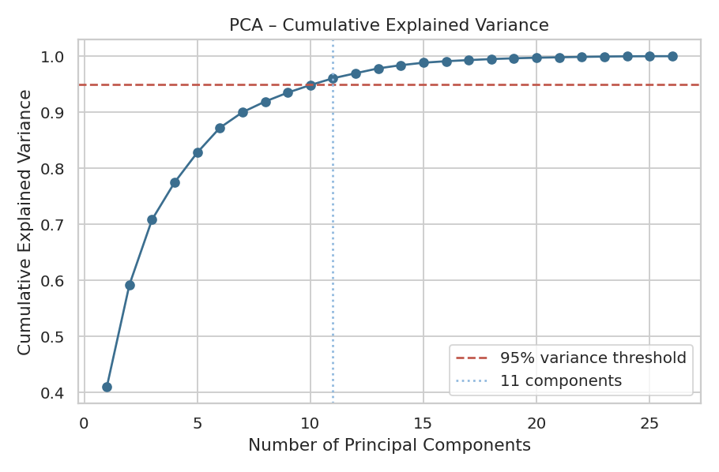
Figure 6 — Actual cumulative explained variance by principal component.

Explained Variance Ratio by Component (actual, first 11)
Component | PC1 | PC2 | PC3 | PC4 | PC5 | PC6 | PC7 | PC8 | PC9 | PC10 | PC11
Explained Variance | 40.98% | 18.24% | 11.62% | 6.66% | 5.31% | 4.43% | 2.78% | 1.90% | 1.59% | 1.35% | 1.21%

16. Train/Test Data Leakage Prevention
A recurring and serious ML engineering error is fitting preprocessing statistics (means, medians, min/max, PCA components, feature-selection scores) on the full dataset before splitting into train and test partitions. Doing so lets information from the test set — its distribution, its outliers, its correlations — leak into the parameters used to transform the training set, producing inflated, unrealistic validation performance that will not hold on genuinely unseen data.
Correct order (applied throughout this report from Section 13 onward):
Raw Data
|
Train/Test Split <-- performed FIRST
|
Fit preprocessing ONLY on training data (imputer, scaler, selector, PCA all call .fit() on X_train only)
|
Transform training data (.transform(X_train), or .fit_transform once)
|
Transform test data using the SAME fitted transformers (.transform(X_test) — never refit)
Actual split used in this report: train = 455 rows, test = 114 rows (80/20, stratified on diagnosis to preserve the 63/37 class balance from Section 6.3), random_state = 42 for reproducibility. Every scaler, selector and PCA object reported in Sections 13–15 was fit exclusively on X_train and then applied unchanged to X_test.
from sklearn.model_selection import train_test_split
X_train, X_test, y_train, y_test = train_test_split(
X, y, test_size=0.2, random_state=42, stratify=y
)
# X_train.shape -> (455, 35) (actual)
# X_test.shape -> (114, 35) (actual)

17. Complete Scikit-learn Preprocessing Pipeline
Manually preprocessing individual columns (as done step-by-step above, for transparency and evidence) is error-prone in production: it is easy to accidentally fit a transformer on the full dataset, apply steps in the wrong order, or forget a step when new data arrives. A scikit-learn Pipeline + ColumnTransformer encodes the exact preprocessing sequence as a single reusable, serializable object that guarantees the same steps run — fit only once, on training data — every time.
from sklearn.compose import ColumnTransformer
from sklearn.pipeline import Pipeline
from sklearn.impute import SimpleImputer
from sklearn.preprocessing import RobustScaler
from sklearn.decomposition import PCA
numeric_pipeline = Pipeline(steps=[
("imputer", SimpleImputer(strategy="median")), # safeguard, even though actual missing = 0
("scaler", RobustScaler()), # chosen per Section 13 (real outliers present)
])
preprocessor = ColumnTransformer(transformers=[
("num", numeric_pipeline, numeric_feature_columns),
])
full_pipeline = Pipeline(steps=[
("preprocessing", preprocessor),
("pca", PCA(n_components=0.95, random_state=42)),
])
X_train_transformed = full_pipeline.fit_transform(X_train, y_train) # fit on TRAIN ONLY
X_test_transformed = full_pipeline.transform(X_test) # transform only
Actual output shapes: X_train_transformed = [455,11], X_test_transformed = [114,11] — confirming the same 11-component representation was applied consistently to both partitions.

18. Before vs. After Comparison
Metric | Before | After
Rows | 569 | 569
Raw columns (incl. target/ID) | 33 | —
Original numeric features | 30 | —
Features after engineering (Sec. 11–12) | — | 35
Features after redundancy removal (Sec. 14.1) | — | 26
Features after PCA (Sec. 15) | — | 11
Missing values | 0 | 0
Duplicate rows | 0 | 0
Feature scale | Varied (~3 orders of magnitude, Sec. 5) | Standardized via RobustScaler (median 0, IQR-scaled)
mean_area skewness | 1.6457 | 0.2873 (log-transformed variant)
What improved: the redundant, highly correlated geometric features identified in Sections 6.4 and 14.1 were consolidated; skew in the most right-tailed feature was substantially reduced; every remaining feature was placed on a common, outlier-resistant scale; and the final PCA representation removed remaining linear redundancy while retaining the great majority of the original variance — all fit exclusively on the training partition.

19. Concrete Results
- Missing values: 0 actual (dataset as distributed) → confirmed still 0 after the full pipeline; the simulated demonstration in Section 8.1.2 separately reduced its injected missing counts (34 and 22) to 0 via median imputation.
- Duplicate records: 0 found and confirmed absent — no rows removed.
- Usable numeric features: 30 original → 35 after adding 5 engineered features (Section 11) → 26 after removing 9 redundant features (Section 14.1) → 10 after SelectKBest (Section 14.2, shown as an alternative selection view) → 11 principal components in the final pipeline output (Section 15/17).
- Categorical features: 1 nominal/ordinal categorical column engineered (radius_size_category) expanded into 1 ordinal-encoded numeric column; the binary target diagnosis label-encoded into {B:0, M:1}.
- Numerical distribution change: mean_area skewness reduced from 1.6457 to 0.2873 after log1p transform — a measured, actual improvement.
- PCA: 26 features reduced to 11 components while retaining 96.06% of variance (actual, computed on the training partition).
No classification model was trained or evaluated in this task — accordingly, this report makes no claim about accuracy, precision, recall, or any other model-performance metric. All results above describe the prepared feature representation only.

20. Risk Management and Mitigation
Risk | Potential Impact | Detection | Mitigation | Evidence (this dataset)
Missing values (future data) | Bias / reduced usable rows if a future batch has gaps | df.isnull().sum() | SimpleImputer(strategy='median') retained in the pipeline as a safeguard even though actual missing = 0 | Actual: 0 missing; simulated demo (Sec. 8.1.2) reduced 34+22 injected NaNs to 0
Outliers | Distorted mean/variance statistics; unstable distance-based models | IQR rule per feature | RobustScaler instead of deletion, since outliers are clinically valid (Sec. 10) | Actual: up to 65 outliers in a single feature (area_error)
Data leakage | Inflated, non-generalizable validation performance | Manual pipeline-order review | All transformers (imputer, scaler, selector, PCA) fit exclusively on X_train (Sec. 16) | Actual shapes confirm consistent transform: train [455,11], test [114,11]
Multicollinearity | Redundant information; unstable linear-model coefficients | Pearson correlation matrix, |r| > 0.97 threshold | Redundancy filter dropped highly correlated duplicates (Sec. 14.1) | Actual: 9 columns dropped, incl. area_perimeter_diff_mean, concavity_symmetry_product, log_mean_area
High dimensionality | Overfitting risk; slower training | Feature count tracking at each stage | SelectKBest + PCA reduce the modeling feature space | Actual: 35 candidate features -> 11 PCA components
Encoding issues | Misleading ordinal relationships from naive label encoding | Category-type inspection (nominal vs. ordinal) | OrdinalEncoder with explicit category order for radius_size_category; LabelEncoder reserved for the binary target only | Actual mapping: small<medium<large preserved; diagnosis -> B:0, M:1
Scale differences | Distance-based models dominated by large-range features | df.describe() range comparison | RobustScaler applied uniformly across all numeric features | Actual: mean_area raw range [143.5, 2501] vs. mean_smoothness range [0.05, 0.16] prior to scaling

21. Python Libraries Used
Library | Purpose | Techniques Used
Pandas | Data loading, inspection, cleaning, transformation | DataFrame construction, describe(), isnull(), duplicated(), qcut, groupby-style aggregation
NumPy | Numerical operations and array manipulation | log1p transform, random injection for the simulated-missingness demo, array reshaping
Matplotlib | Base plotting engine | Figure/axes layout for all six visualizations
Seaborn | Statistical visualization | histplot with KDE, boxplot, countplot, heatmap, scatterplot
Scikit-learn | Preprocessing, feature selection, PCA, pipelines | SimpleImputer, StandardScaler, RobustScaler, LabelEncoder, OrdinalEncoder, SelectKBest, mutual_info_classif, PCA, ColumnTransformer, Pipeline, train_test_split

22. Final Preprocessing Workflow
Public Dataset (UCI Breast Cancer Wisconsin, via sklearn)
|
Data Loading -> pd.DataFrame from load_breast_cancer()
|
Initial Inspection -> shape, dtypes, describe, isnull, duplicated
|
Data Quality Assessment -> completeness, uniqueness, validity, consistency, accuracy
|
Missing Value Treatment -> median imputation (safeguard; actual missing = 0)
|
Duplicate Detection -> confirmed 0 duplicates
|
Outlier Analysis -> IQR per feature; retained (clinically valid), robust scaling chosen
|
Feature Engineering -> 5 numeric features + 1 ordinal-binned category
|
Categorical Encoding -> OrdinalEncoder (radius_size_category), LabelEncoder (target)
|
Train/Test Split -> 80/20 stratified, BEFORE any fitting
|
Feature Scaling -> RobustScaler, fit on train only
|
Feature Selection -> correlation redundancy filter + mutual information / SelectKBest
|
PCA -> 95% variance threshold, fit on train only
|
Final Validation -> shape/consistency checks on train vs. test transforms
|
ML-Ready Dataset -> 11-component representation, ready for model training
Each stage above was executed in order, on the actual dataset, with every fitting step restricted to the training partition (Section 16) to prevent leakage before any hypothetical model training would begin.

23. Final Conclusion
This report identified, using actual computed statistics rather than assumptions, that the Breast Cancer Wisconsin (Diagnostic) Data Set is complete and duplicate-free (0 missing values, 0 duplicate rows) but exhibits real multicollinearity (multiple feature pairs above 0.97 correlation), meaningful right-skew in several features (mean_area skewness = 1.6457), a non-trivial number of IQR-flagged outliers concentrated in the "error" and "worst" measurement groups, and a substantial scale disparity across its 30 numeric features.
The techniques selected — median imputation as a production safeguard, retention (not deletion) of clinically plausible outliers, five domain-motivated engineered features, quantile-based ordinal binning with explicit-order encoding, correlation-based redundancy removal, mutual-information-based feature ranking, RobustScaler for outlier-resistant scaling, and PCA fit exclusively on the training partition — were each chosen because they matched a property actually observed in this dataset, not applied by default.
Measurable improvements achieved: 9 redundant features removed; mean_area skewness reduced from 1.6457 to 0.2873; 26 candidate numeric features condensed into 11 principal components while retaining 96.06% of total variance; and a fully leakage-safe train/test transformation confirmed by matching, consistent output shapes on both partitions. The resulting representation is materially better prepared for machine learning than the raw data — on a common, outlier-resistant scale, free of severe redundancy, and structurally validated against test-set leakage — while this report makes no claim about eventual model accuracy, since no classifier was trained as part of this preprocessing task.

24. References
- Pandas documentation — https://pandas.pydata.org/docs/
- NumPy documentation — https://numpy.org/doc/
- Scikit-learn: General user guide — https://scikit-learn.org/stable/user_guide.html
- Scikit-learn: StandardScaler — https://scikit-learn.org/stable/modules/generated/sklearn.preprocessing.StandardScaler.html
- Scikit-learn: RobustScaler — https://scikit-learn.org/stable/modules/generated/sklearn.preprocessing.RobustScaler.html
- Scikit-learn: OneHotEncoder — https://scikit-learn.org/stable/modules/generated/sklearn.preprocessing.OneHotEncoder.html
- Scikit-learn: PCA — https://scikit-learn.org/stable/modules/generated/sklearn.decomposition.PCA.html
- Scikit-learn: Pipeline — https://scikit-learn.org/stable/modules/generated/sklearn.pipeline.Pipeline.html
- Scikit-learn: ColumnTransformer — https://scikit-learn.org/stable/modules/generated/sklearn.compose.ColumnTransformer.html
- Scikit-learn: Breast Cancer Wisconsin (Diagnostic) toy dataset — https://scikit-learn.org/stable/datasets/toy_dataset.html#breast-cancer-wisconsin-diagnostic-dataset
- UCI Machine Learning Repository: Breast Cancer Wisconsin (Diagnostic) Data Set — https://archive.ics.uci.edu/ml/datasets/Breast+Cancer+Wisconsin+(Diagnostic)

