COLLEGE STUDENT S ASSISTANT

PROJECT REPORT
Submitted as a part of introduction to problem solving and programming

Submitted by: Disha Yadav
Registration no :26BCE11618
Course : B.TECH CSE
VIT Bhopal university
Academic year : 2026-27

ACKNOWLEDGEMENT
I would like to express my gratitude for the opportunity to develop my project , “college student assistant” .
I select this project to learned how to apply concepts such as variables , operators , conditional statements , loops , functions , and input / output in a practical way.
This project help me to improve my problem solving and programming skills and give me practical experiences in developing a simple student oriented application.

Introduction
College student assistant is a python based project designed to provide useful and simple utilities for college student.
The main idea behind this project is to combine different student related task into one simple program. The user can select an option from the menu and provide the required information to get the desired result .
The project also helped in improving logical thinking , problem solving skills , and understanding of program development .

TECHNOLOGIES USED
programming language : python
platform : online GDB compiler
concept used : variables , loops , functions , input and output
FEATURES
Simple menu based interface
Student related utilities
Basic calculations
Easy user input and output
Multiple options in one program
Simple and user friendly design

ALGORITHM
Step1:start the program
Step2:display the college student assistant menu
Step3:ask the user to select an option
Step4:take the required input from the user
Step5:perform the operation according to the selected option
Step6:display the result
Step7:stop

Source code

#COLLEGE STUDENT ASSISTANT
print("1.study time calculator")
print("2.attendance calculator")
print("3.CGPA calculator")
print("4.college expense calculator")
print("5.exit")

choice = int(input("enter your choice:"))
print("your choice" , choice)

if choice == 1:
def study_time():
print("study time calculator selected")
total_hours=int(input("enter the total available study hours:"))
subjects=int(input("enter your number of subjects:"))
time_per_subject = total_hours/subjects
print("study time for each subject=",time_per_subject,"hours")

study_time()
elif choice == 2:
def attendance():
print("attendance calculator selected")
total_classes=int(input("enter total classes:"))
attended_classes = int(input("enter attended classes:"))
attendance_percent=(attended_classes / total_classes)*100
print("your attendance=" , attendance_percent,"%")
attendance()

elif choice == 3:
print("CGPA calculator selected")
subjects=int(input("enter the number of subjects:"))
total=0
for i in range(subjects):
grade = int(input("enter grade point:"))
total=total + grade
cgpa = total/subjects
print("your CGPA" , cgpa)
elif choice == 4:
print(" college expense calculator selected")
monthly_expense=int(input("enter your monthly expense:"))
months=int(input("enter number of months:"))
total_expense=monthly_expense * months
print("your total college expense=" , total_expense)
elif choice == 5:
print("thanku for using college student assistant!")
else:
print("invalide choice")

OUTPUT

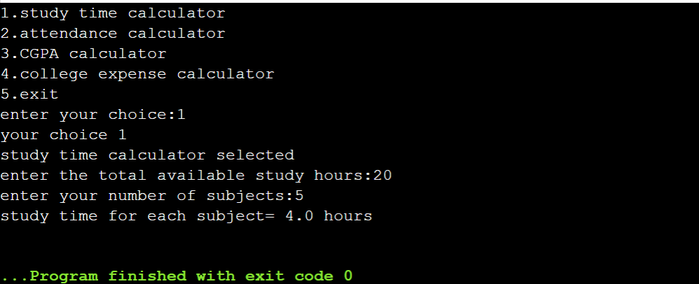

Conclusion
The college student assistant project was developed using python to provide useful utilities for college students
This project helped me understand and apply basic programming concepts.

REFERENCES
Python programming concepts and class notes
Online GDB compiler
Python documentation

