**An early fire detection system using image processing for waste stations**

Dishi Jain, School of Computer Science and Engineering

Vellore Institute of Technology, Vellore, 632014, Tamil Nadu, India

**Abstract:** To decrease fire mishaps, an early fire detection framework is particularly required. The customary fire recognition framework is made utilizing either a smoke sensor to always quantify the measure of CO, CO2 or smoke at a given territory and sign if there is unevenness or a shading based models which matches the shade of the item to that of the fire and if it matches, at that point sounds the caution. The framework proposed in this paper, utilizes Image Processing systems which examine a picture and a signal is used which gives a caution when the mishap will happen, mainly for open environments like waste stations where the earth condition isn't fixed. Image processing strategy recognizes fire as ahead of schedule as contrasted with other framework that don't utilize image processing. The framework utilizes camera to keep a mind the fires so there is no requirement for any sensors. The warmth marks and fire patterns in pictures are recognized to discover that it is a fire or not. The fundamental aim of the proposed model is to maintain a strategic distance from false alerts and to distinguish fire at beginning time.

**Keywords: colour segmentation, computer vision, fire detection, fire video, heat signatures, Image processing**

1. **Introduction**

Fire is very dangerous that can bring great loss in human life. It is one of the most portentous threated for mankind. To reduce these losses, many fire detection systems has been developed. Fire can be controlled by smoke or light or temperature. Ordinary approaches to resort incorporate failure of power, water splashing for disturbing. Be that as it may, alarm is as yet a troublesome issue for enormous space like waste station since there are numerous variables, for example, the large area which is to be covered for the signal transmission, height of the area, and the coverage which is tough to control.

The innovation is being built up every day except the customary alarm framework utilizes sensor to discover the fire. The primary disadvantage of utilizing sensors is that the fire is identified when it arrives at the set degree of the temperature and there is no message or any report produced for the investigation of that region where that fire mishap happened. To distinguish fire, just utilizing shading data may deliver false caution, so shading and fleeting variety data ought to be utilized to get great execution of the fire discovery framework. A few analysts utilized RGB input and the basic and powerful strategy for constant application. Others received all-encompassing camera, wavelet change, neural systems, and so on. For moderately convoluted fire location framework. Furthermore, some were quite certain purposed framework like passage fire, send compartment fire, backwoods fire, and so on.

To improve a fire ready framework, one can utilize picture preparing techniques and raspberry pi to identify the fire. The upsides of utilizing raspberry pi are that it expends less power, savvy and execute quicker to recognize fire. Likewise, this framework can be introduced anyplace. In this way, there is no need of utilizing ordinary sensors. The procedure begins with a camera catching the video and separate the picture into edges. And afterward the casings are contrasted with the first picture. Which is now booted in the rasspberry pi framework. And afterward it scans for the warmth marks and fire designs, if it is a fire, at that point it will on the crisis mode. On identifying fire, the framework will send the SMS to the remote client. The qualities that are utilized in picture handling are shading and movement. If a movement occurs in foundation like when a vehicle enters a waste station to dump trash and the vehicle is a similar shading as fire, at that point it will be considered as fire object along these lines, bringing down the exhibition of the framework. For instance, if a red truck has a development in a carport, the framework will expect the thought process object as fire. In this manner, a picture handling framework utilizes both shading and movement qualities for proposed applications in different conditions.

1. **Literature survey**

One of the risky mishaps are the fire mishaps which can make harm a huge number of sections of land of houses and lives in couple of minutes. There are numerous arrangements given in late investigations to distinguish fire at beginning periods and take required activities. Some of them are quickly talked about here. Fire sensors are integral to ordinary point sensors (e.g., smoke and warmth indicators), which give individuals the early admonitions of fire events [1]. Cameras joined with picture handling procedures recognize fire events rapidly than point sensors. Likewise, they give the size, development, and course of flames more effectively than their traditional finders. A fire discovery framework dependent on light identification and examination for various structures is proposed in [2]. The proposed framework in this paper, utilizes HSV and YCbCr shading models with conditions to isolate orange, yellow, and high brilliance light from foundation and surrounding light. Fire development is dissected and registered dependent on casing contrasts. The HSV shading model is utilized to identify data identified with shading and brilliance. The YCbCr shading model is utilized to recognize data identified with splendour since it can separate splendid pictures more effectively than other shading models. LUV shading modular based fire discovery framework is proposed in [13]. Customary fire discovery was finished by administrators through camcorders in oil and compound offices. In any case, it is incomprehensible for an administrator to discover the fire in time on the grounds that there might be several camcorders introduced in that huge office. In this way, the quick improvement of PC vision, shrewd fire recognition has gotten broad consideration from the scholarly world and industry. In this paper, through camcorders one can distinguish fire along these lines forestalling fire circumstances from leaving control in concoction processing plants and other high-fire-hazard industries [3].

In the paper [4], author gives a continuous checking framework that identifies whether the smoke is available noticeable all around due to fire and catches pictures through a camera that is inside the room when there is a fire. Raspberry Pi is utilized to make this framework. The key element of the framework is the capacity to remotely send a ready when a fire is distinguished. Exactly when the proximity of smoke is perceived, the system will demonstrate an image of the room state in a site page. The structure will require the customer attestation to report the event to the Firefighter using Short Message Service. In [7], the paper presents a picture preparing procedure for programmed constant fire location in video pictures. The hidden calculation depends on the impermanent variety of fire force put away by a visual picture sensor. The full picture arrangements are examined to choose an applicant fire area. Trademark fire highlights are removed from the competitor locale and joined to decide the nearness of fire or non-fire designs. Alarm is activated if the fire example endures over some stretch of time. Fire identification framework which uses PC vision have recently picked up notoriety when contrasted with customary fire recognition framework dependent on sensors [6]. So as to grow the exactness of fire discovery framework, shading location is joined with numerous different methods. Edge discovery, movement recognition, presence of smoke, zone secured by flares, development of fire and foundation division are a few methods which are consolidated by different analysts and used to accurately separate the fire pictures and fire-like non fire pictures in a video [10] [15].

1. **Proposed System**

The proposed framework uses Image preparing technique. Picture preparing in fire identification is the capacity to serve huge and open spaces. In the principal period of the proposed framework, camera will catch the picture and it will send that picture to controller for further assessment. And after that the procedure of further location has been begun. In the subsequent stage, the pictures are changed over into edges and it will analyse those pictures into effectively booted pictures. In the third stage, an alert will be sent to responsible person.

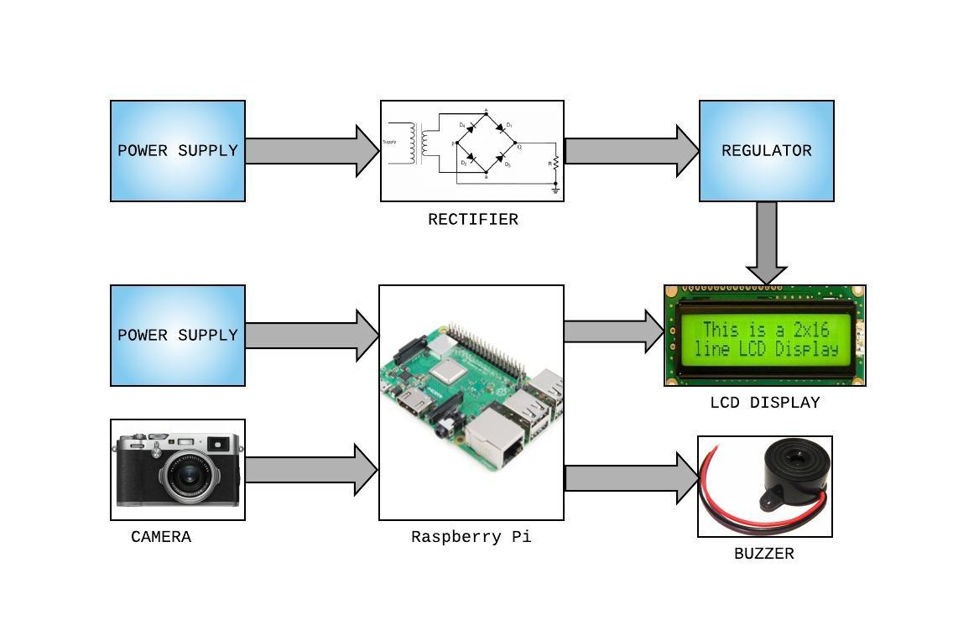

Figure 1: Architecture

1. **Module Description**

The framework is structured into four modules. First module is Video recording and moving to controller. The camera catches consistent edges from the region of its inclusion. The caught pictures or casings are should be move to the controller for applying picture preparing capacity. Shading based division is the second module of the framework. In this module in the wake of isolating the edges as single picture it is exposed to standard shading based division. The fragments are then partitioned into steady estimated squares. In the third module, fire design acknowledgment happens. The squares of the fragmented picture will be breaking down for the nearness of warmth mark or fire designs. Also, the last or fourth module is crisis trigger where if any unconventional example is distinguished in any of the squares for a specific timeframe, it will turn on the crisis mode and will give a caution.

figure 2: Process Outline

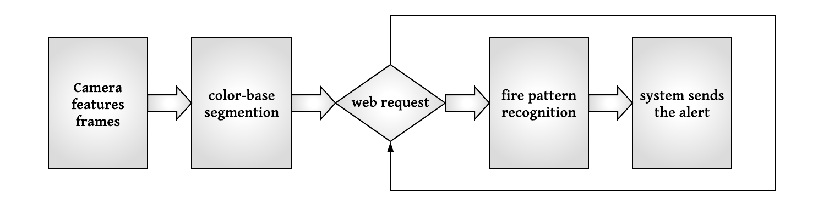

1. **Methodology**

Fire is distinguished utilizing fire designs with warmth Signature. Warmth mark is shading examples to speak to the fire. There are three channels are utilized to discover the warmth signature [4]. They are:

* **RGB filter**

RGB channel is used to Extract Red (R) Green (G) and Blue (B) segment of every pixel. And after that in each pixel two conditions are checked. They are:

* If R >G>B
* If R> Rt (Rt is the red edge an incentive between (0,255). This depends on light in the picture.
* **CieLAB filter**

cieLAB shading model are Highlights red, yellow and related hues like orange. For all pixels in the edge the mean estimation of L, A and B parts are distinguished. For each pixel four channels are utilized.

* If L>L mean
* If A>A mean
* If B>B mean
* If B>A mean
* **RGB filter 2**

It functions admirably around evening time mode. In this technique the R, G, and B segments are contrasted and edge esteems. (rt=140, gt=100, bt=100) Three conditions are verified:

* R>rt
* G>gt
* B<b

**Python** is a programming language that is easy to learn but difficult to actualize. Python gives you a chance to work rapidly and incorporate frameworks all the more adequately. It supports numerous including object-oriented, basic, useful and procedural, and has an extensive standard library.

1. **Experimentations and Result**

The programming language used is python and the IDE used to run the program is Pycharm which is free and available online. The libraries which are installed for this project are OpenCV and numpy.

|  |  |
| --- | --- |
|  |  |

Figure 3,4: fire pattern

|  |  |
| --- | --- |
|  |  |

Figure 5,6: Execution of fire detection

|  |  |
| --- | --- |
|  |  |

Figure 7,8: Screenshots of SMS alert

Image processing systems are progressively helpful in covering enormous regions for fire identification. To quantify the presentation of the proposed model, five recordings were gathered from Internet. Three of these recordings were genuine fire, and two were fire-shading objects. The proposed model flops for one video of fire-shading object. The program indicated fire distinguished for the four recordings.

1. **Conclusion**

This paper proposed a fire identification calculation which is free from sensors as the normal fire location frameworks contain. The target of this paper was to make a framework which would have the option to distinguish fire as ahead of schedule as conceivable from a live video feed. Framework is relied upon to recognize fire while it is still little and has not developed to mammoth extents. Additionally, the equipment is insignificant and has been as of now existent in places, hence sparing capital. It additionally spares cost by disposing of costly temperature and warmth sensors and so forth. In view of the outcomes created, the framework has demonstrated to be successful at recognizing fire. This framework is an amalgamation of different fire location calculations.

**References**

1. Solorzano, A., Fonollosa, J., Fernandez, L., Eichmann, J., & Marco, S. (2017). Fire detection using a gas sensor array with sensor fusion algorithms. 2017 ISOCS/IEEE International Symposium on Olfaction and Electronic Nose (ISOEN). doi: 10.1109/isoen.2017.7968889
2. Seebamrungsat, J., Praising, S., & Riyamongkol, P. (2014). Fire detection in the buildings using image processing. 2014 Third ICT International Student Project Conference (ICT-ISPC). doi: 10.1109/ict-ispc.2014.6923226
3. Wu, H., Wu, D., & Zhao, J. (2019). An intelligent fire detection approach through cameras based on computer vision methods. Process Safety and Environmental Protection, 127, 245–256. doi: 10.1016/j.psep.2019.05.016
4. Bahrudin, Md Saifudaullah Bin, et al. “Development of Fire Alarm System Using Raspberry Pi and Arduino Uno.” 2013 International Conference on Electrical, Electronics and System Engineering (ICEESE), 2013, doi:10.1109/iceese.2013.6895040.
5. Sarvari, A., & Mazinani, S. M. (2019). A new tunnel fire detection and suppression system based on camera image processing and water mist jet fans. Heliyon, 5(6). doi: 10.1016/j.heliyon.2019.e01879
6. Bu, Fengju, and Mohammad Samadi Gharajeh. “Intelligent and Vision-Based Fire Detection Systems: A Survey.” Image and Vision Computing, vol. 91, 2019, p. 103803., doi:10.1016/j.imavis.2019.08.007.
7. Marbach, G., Loepfe, M., & Brupbacher, T. (2006). An image processing technique for fire detection in video images. Fire Safety Journal, 41(4), 285–289. doi: 10.1016/j.firesaf.2006.02.001
8. Yuanbin, W., & Xianmin, M. (2014). Early Fire Detection for High Space Based on Video-Image Processing. 2014 International Symposium on Computer, Consumer and Control. doi: 10.1109/is3c.2014.208
9. Chen, T., Yuan, S., Li, J., Xing, S., Zhang, H., Dong, Y., … Jiao, G. (2018). Image registration for a UV–Visible dual-band imaging system. Optics and Lasers in Engineering, 105, 209–218. doi: 10.1016/j.optlaseng.2018.01.021
10. Yuan, C., Liu, Z., & Zhang, Y. (2015). UAV-based forest fire detection and tracking using image processing techniques. 2015 International Conference on Unmanned Aircraft Systems (ICUAS). doi: 10.1109/icuas.2015.7152345
11. Saghri, J. A., Radjabi, R., & Jacobs, J. T. (2011). Early forest fire detection using principal component analysis of infrared video. Applications of Digital Image Processing XXXIV. doi: 10.1117/12.895512
12. Karakose, E. (2017). Performance evaluation of electrical transmission line detection and tracking algorithms based on image processing using UAV. 2017 International Artificial Intelligence and Data Processing Symposium (IDAP). doi: 10.1109/idap.2017.8090302
13. Pritam, D., & Dewan, J. H. (2017). Detection of fire using image processing techniques with LUV color space. 2017 2nd International Conference for Convergence in Technology (I2CT). doi: 10.1109/i2ct.2017.8226309
14. Khalifa, A. F., Badr, E., & Elmahdy, H. N. (2019). A survey on human detection surveillance systems for Raspberry Pi. Image and Vision Computing, 85, 1–13. doi: 10.1016/j.imavis.2019.02.010
15. Razmi, S. M., Saad, N., & Asirvadam, V. S. (2010). Vision-based flame detection: Motion detection & fire analysis. 2010 IEEE Student Conference on Research and Development (SCOReD). doi: 10.1109/scored.2010.5703999