Face-Filter



**Mini Project**

**BATCH 2021 - 2023**

A PROJECT ON

**FACE-FILTERS**

**SUBMITTED BY**

**Roll No. Student’s Name**

B01 Dhwani Adeshara

B39 Navadiya Manan

B43 Pandya Dishit

B65 Shah Jainam

B70 Thakkar Zeel

**Name of guide:** **Guide Signature:**

DR. Harshal Arolkar

**Acknowledgment**

# ACKNOWLEDGMENT:

“The ability to perceive think differently is more important, then the knowledge gain”. Not everything that we received can be acknowledgement, men’s knowledge never ends. Theory and practice are important in computer filed. We are thankful to assistance received from various or individual person in making this project at success.

We are thankful to our Mender Dr. Harshal Arolkar who really gave a good opportunity to making this project. His guidance and support were constant source of inspiration. We are also thankful to Faculty members who helped us a lot and gave his/her precious time to solve our problem under any circumstances. We are thankful to our faculties who really gave us very good support to develop this project in a right way and encourage to more development. Nobody has been more important to us in the pursue of this project than the member of our families. We would like to thank my parents; whose love and guidance are with us in whatever we pursue. They are the ultimate role models.

Finally, we would like to thanks everybody who was important to the successful realization of the project, as well as expressing our apology that We could not mention personally one by one.

Thank You,

Adeshra Dhwani

Navadiya Manan

Pandya Dishit

Shah Jainam

Thakkar Zeel

**Certificate**

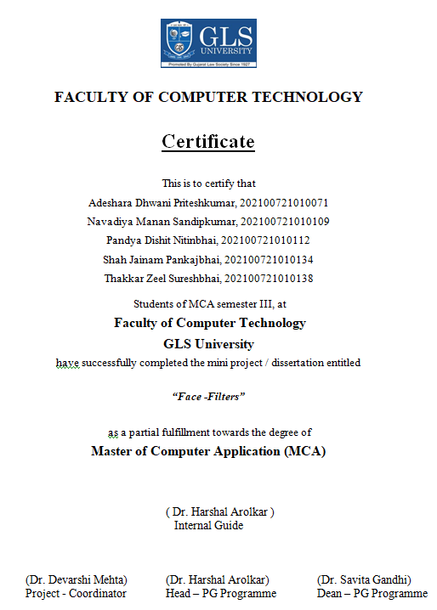

**Index**

**INDEX**:

|  |  |
| --- | --- |
| SR.NO | TITLE |
| 1 | Project Profile |
| 2 | Introduction |
| 3 | Analysis and Designing of the System |
| 4 | System Description |
| 5 | Reports And Test cases |
| 6 | Conclusion And  Future Direction |

Project Profile

# PROJECT PROFILE :

|  |  |  |
| --- | --- | --- |
| Project Title | Face -Filter | |
| Application Type | Desktop Application | |
| Project Guide | DR. Harshal Arolkar | |
| Team Size | 5 | |
| Group No | 1 | |
| Front-End | TK Inter | |
| Back-End | Python,OpenCV | |
| Database | MYSQL | |
| Submitted By | Name | Role |
| Dhwani Adeshara | Planning and Documentation |
| Manan Navadiya | Frontend |
| Dishit Pandya | Backend |
| Jainam Shah | Testing |
| Zeel Thakkar | Backend |

# Introduction:

* Face Filter is a desktop-based application that play around with face filters like hat, Dog Face, moustache and glasses automatic in-face superposition in real time.
* It uses [Haar features](https://en.wikipedia.org/wiki/Haar-like_features) and the [Viola–Jones object detection framework](https://en.wikipedia.org/wiki/Viola%E2%80%93Jones_object_detection_framework) implemented in OpenCV to detect mainly faces positions and inside the faces, eyes and mouth position.
* For each detected face, output the local region coordinates for each member or facial feature of that face. This includes the eyes, bone, lips, nose, and mouth.
* Coordinates are usually in the form of points (X ,Y)After coordinates are placed, model can apply filters on faces.

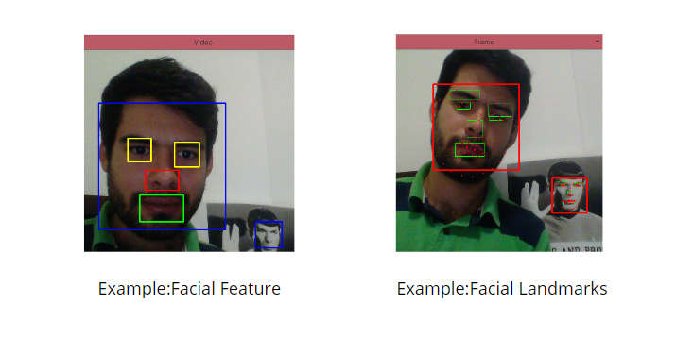

* Harr Cascades technique is very old, so detection is often not so good when the faces are slightly bent for example. It is not possible to estimate the inclination of the head
* The 68 facial landmarks are numbered in the following form. With the points we calculate the inclination so the "accessories" are also bent.
* With the points of the mouth can be detected when the mouth is open and then display some trick, like a rainbow coming out.

**Background**

* Use of Face-Filters application is limited to mobile devices, tablets.
* With the help of this desktop application we can easily use this application in desktop also.

**Objective**

* The main objective of our application is to provide the entertainment to the users.
* Applying filters to images to make more animated and look good

**Scope**

* Face Filter application requires registration.
* In the Face Filter requires web cam and storage access of system.

**Applicability**

* This application is applicable to those users who use filter in daily life.
* Simply they register into the application and use the filters in applications.

Analysis and Designing of the System

**Data Dictionary:**

**Overview:**

* Face Filter is a Desktop based application.
* A desktop application that plays around with face filters like hat, Dog Face, moustache and glasses automatic in-face superposition in real time.
* A data dictionary is a catalog – repository – of the elements in the system, the data dictionary consists of different major elements like data elements, data store, dataflow, processes and other external entities used in the system. The data dictionary stores details and description of these elements.
* Analyst use data dictionary for the following important reason:
* To manage the details in large system.
* To communicate a common meaning for all system elements.
* To document the feature of the system.
* To **facilitate** analysis of the details in order to evaluate the characteristics and determine where system changes should be made.
* To locate errors and omissions in the system.

1. **Table: Registration**.

* Registration can store the different kind of user’s Data which are helpful for user’s login.

|  |  |
| --- | --- |
| Table Name: | Registration |
| Database: | Registration |
| Primary Key: | ID |

|  |  |  |  |  |
| --- | --- | --- | --- | --- |
| Field Name | Data type | Size | Constraint | Description |
| First Name | Varchar | 20 | Not Null | Store First Name of user |
| Last Name | Varchar | 20 | Not Null | Store Last Name of user |
| Age | int | 3 | Not Null | Store Age of the user |
| Gender | Varchar | 6 | Not Null |  |
| City | Varchar | 20 | Not Null | Store ity of user |
| E-mail | Varchar | 20 | Primary Key | Store E-mail address of user |
| User Name | Varchar | 20 | Not Null | Store Username of new user |
| Password | Nvarchar | 250 | Not Null | Store Password of user |

Use Case Diagram:

* A use case diagram is a dynamic or behavior diagram in [UML](https://www.smartdraw.com/uml-diagram/).
* Use case diagrams model the functionality of a system using actors and use cases.
* Use cases are a set of actions, services, and functions that the system needs to perform.
* In this context, a "system" is something being developed or operated, such as a web site.
* The "actors" are people or entities operating under defined roles within the system.
* Let’s see the Use case diagram of the face filter application.

Use case Diagram:

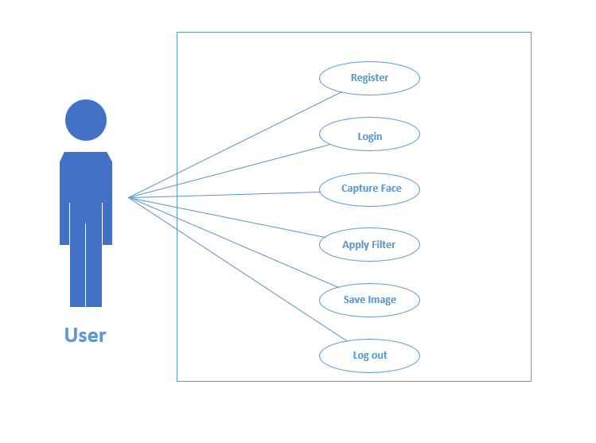

Activity Diagram:

* An activity diagram visually presents a series of actions or flow of control in a system similar to a [flowchart](https://www.smartdraw.com/flowchart/) or a [data flow diagram](https://www.smartdraw.com/data-flow-diagram/).
* Activity diagrams are often used in business process modeling.
* They can also describe the steps in a [use case diagram](https://www.smartdraw.com/use-case-diagram/).
* Activities modeled can be sequential and concurrent. In both cases an activity diagram will have a beginning (an initial state) and an end (a final state).
* Let’s see the Activity diagram of the face filter application.

Activity Diagram:

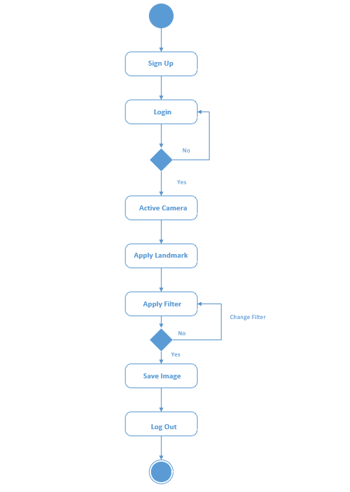

System Description

# Input Screen :

**Screen 1 [Log in ]:**

* The below screen show login page if the user already have account then he/she directly login. If user doesn’t have their account they simply click on sign up to register him/her self to use the application. if the user can’t remember their password so they can easily click on forget the password to their change their password. Here clear button is used for clear the input data.

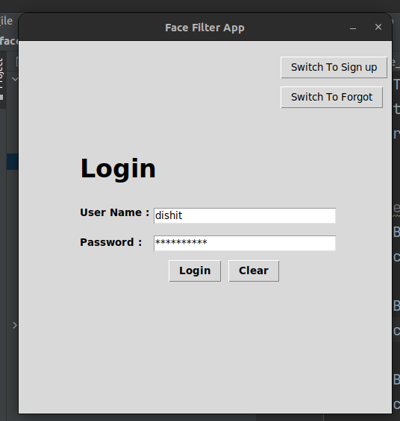

**Screen 2 [Sign up ]:**

* The below page is for Registration. When User clicks on Signup button he/she redirect to the main page of the application. If user has already Account in my application then click on Login.

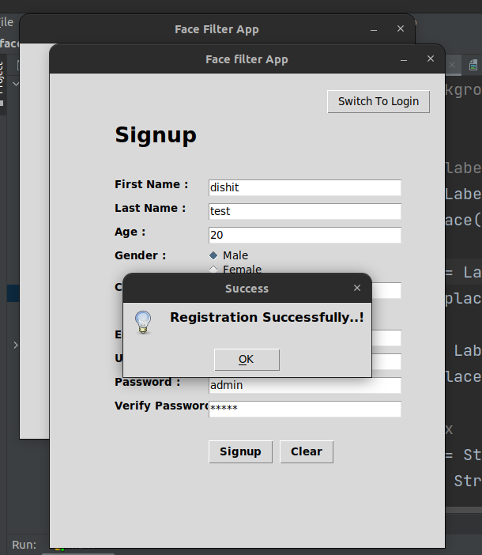

**Screen 3 [Forgot Password]:**

* To reset password first verify user’s email id.

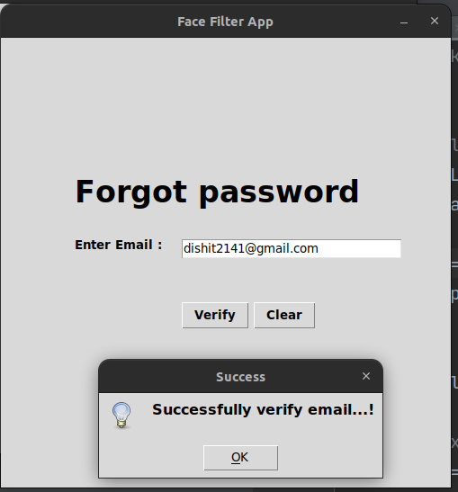

**Screen 4 [Reset Password]:**

* Enter new password and also enter second time to verify it and click on reset to Reset the password.

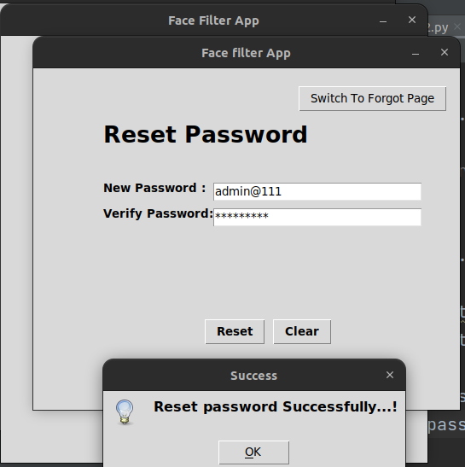

**Screen 5 [Home Screen]:**

* Apply Different filters like hat, mustache, Files, Glasses, Doggy and also save photo of it. To log out account click on Log Out Button.

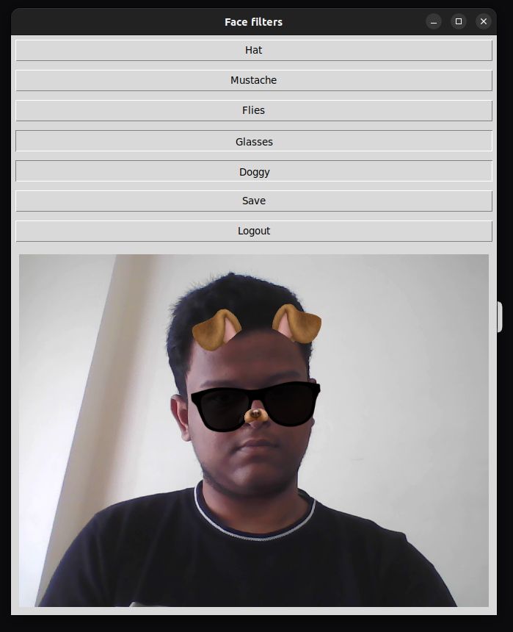

Reports and Test Cases

# REPORTS AND TEST CASES:

**Test Cases:-**

* A test case is a set of conditions or variables under which a tester will determine whether a system under test satisfies requirements or works correctly. The process of developing test cases can also help find problems in the requirements or design of an application.
* Here, we are implement the white box testing for the testing purpose. So following test cases can be implemented based on the white box testing.
* The white box testing is a method of testing software that tests internal structure or workings of an application, as opposed to its functionality (i.e., black box testing). In white-box testing an internal perspective of the system, as well as programming skills, are used to design test cases. The tester chooses inputs to exercise paths through the code and determine the expected outputs.
* Case 1: User Login
* Case 2: User Registration

**Case 1: User Login:-**

|  |  |  |  |  |  |
| --- | --- | --- | --- | --- | --- |
| Test Case Id | Test Description | Expected  Result | Actual Result | Solution | Status |
| 1. | Empty Value For Username | Display error message  “All fields are required!” | Display error message  “All fields are required!” | Enter valid Username | Pass |
| 2. | Empty  Value For  Password | Display error  Message  “All fields are required!” | Display error message  “All fields are required!” | Enter valid Password | Pass |
| 3 | username and password which is not registered | Display error message “Invalid username And Password” | Display error message “Invalid username And Password” | First register yourself then try to login | Pass |

* **Example of Test case 1.1 and 1.2**: Username and password should not be empty at the time of login.

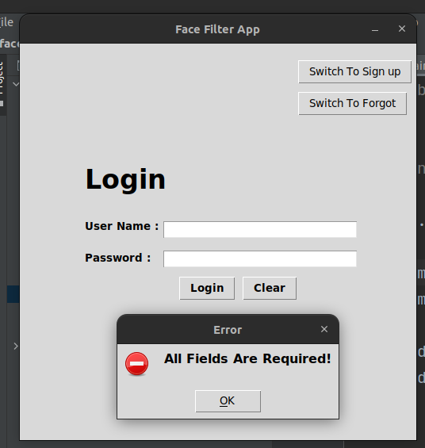

* **Example of Test case 1.3**: Username and password which is not registered.

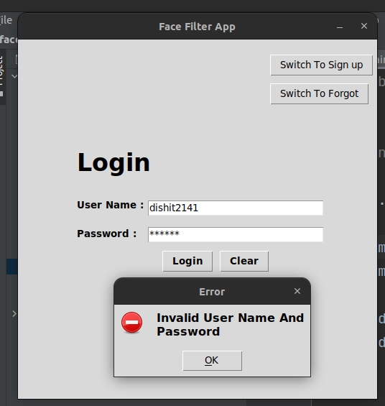

**Case 2: User Registration:-**

|  |  |  |  |  |  |
| --- | --- | --- | --- | --- | --- |
| Test Case Id | Test Description | Expected  Result | Actual Result | Solution | Status |
| 1. | Empty First Name | Display error  Message “All fields are required!” | Display error  Message “All fields are required!” | Enter First name | Pass |
| 2. | Empty Last Name | Display error  Message “All fields are required!” | Display error  Message “All fields are required!” | Enter Last Name | Pass |
| 3. | Empty Age | Display error  Message  “All fields are required!” | Display error  Message  “All fields are required!” | Enter numeric Age | Pass |
| 4. | Empty  Gender | Display error Message  “All fields are required!” | Display error Message  “All fields are required!” | Enter Gender | Pass |
| 5. | Empty  Email | Display error Message  “All fields are required!” | Display error Message  “All fields are required!” | Enter Email | Pass |
| 6. | Empty  User Name | Display error Message  “All fields are required!” | Display error Message  “All fields are required!” | Enter User Name | Pass |
| 7. | Empty  Password | Display error Message “All fields are required!” | Display error Message “All fields are required!” | Enter Password | Pass |
| 8. | Empty Verify  Password | Display error Message “All fields are required!” | Display error Message “All fields are required!” | Enter Verify Password | Pass |
| 9. | Password and confirm password are not same | Display error Message “Password and confirm password are same” | Display error Message “Password and confirm password are same” | Password and confirm password are same | Pass |

**Example of Test case 2.1 to 2.8**: All fields are required

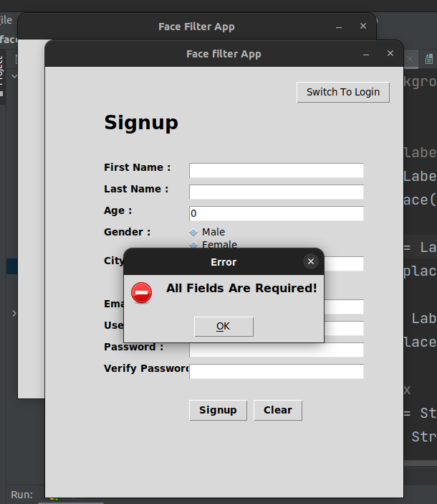

**Example of Test case 2.9**: Password and confirm password are not same

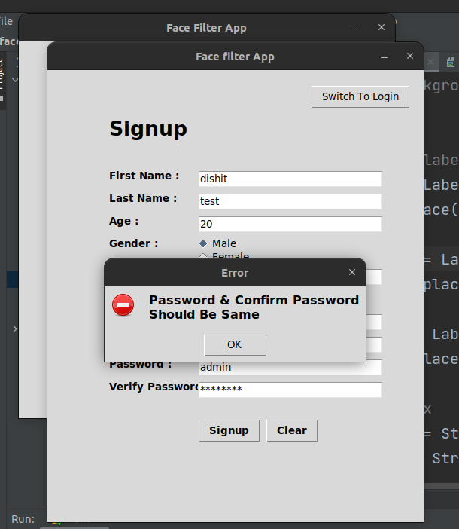

**Case 3: Forgot Password:-**

|  |  |  |  |  |  |
| --- | --- | --- | --- | --- | --- |
| Test Case Id | Test Description | Expected  Result | Actual Result | Solution | Status |
| 1. | Invalid Email ID | Display error message  “Invalid Email ID!” | Display error message  “Invalid Email ID!” | Enter valid Email ID | Pass |

* **Example of Test case 3.1**: Invalid Email Id .

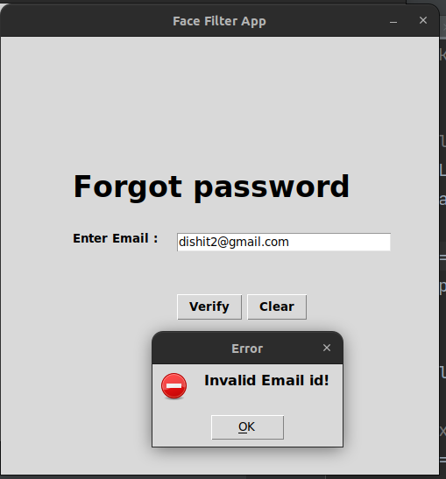

**Case 4: Reset Password:-**

|  |  |  |  |  |  |
| --- | --- | --- | --- | --- | --- |
| Test Case Id | Test Description | Expected  Result | Actual Result | Solution | Status |
| 1. | Empty  Password | Display error Message  “All fields are required!” | Display error Message  “All fields are required!” | Enter Password | Pass |
| 2. | Empty verify Password | Display error Message  “All fields are required!” | Display error Message  “All fields are required!” | Enter verify Password | Pass |

* **Example of Test case 4.1,4.2**: Password and verify password are required.

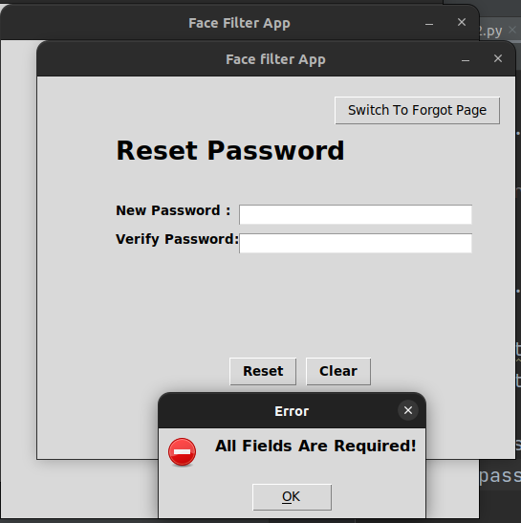

Conclusion and

Future Direction

# CONCLUSION AND FUTURE DIRECTIONS:

* After creating this project, I got valuable and wonderful experience.
* I learned to prepare the requirement specification, design specification, system development life cycle in practical development.
* I also gained the experience of solving the errors.
* I have completed this project work based on system analysis and design approaches. The work that I done with preplanning scheduling related with time constraint and result oriented progress in project development.
* **Limitations of the system**
* Every system has some sort of limitations in them. Any system will never complete. My system has also some limitations. There are following limitations of system:
  + Sometimes multiple faces available so it’s can’t detect all faces properly.
  + Can’t capture properly in low lighting.
* **Future Scope of Project**
* As opposed to my current development, a few more functionalities can be added to further expand the project. Here some of them:
  + - Some cool image level filters will be added so it can be used in video conference Apps (Linux only).
    - They are:
      * Blur faces
      * Background subtraction
      * Color Effects
      * Harry Potter Red invisibility cloak
      * Funny filters
* **References: -**
  1. Learning OpenCV 3.0 by Adrian Kaehler and Gary Bradski.
  2. Core Python Programming by Dr R Rao.
  3. [OpenCV documentation](https://docs.opencv.org/4.x/d1/dfb/intro.html).
  4. Stack overflow.

