A PROJECT REPORT ON
TrustDeploy
Container Image Supply Chain Security
Using Digital Signatures
Submitted in partial fulfilment of the requirements of
ACC
Submitted by
Name of the Students | Roll No.
Archit Singh | 16010123057
Anish Patni | 16010123045
Amrit Nigam | 16010123038
Rishi Shanbhag | 16010123256

Under the guidance of
Prof. Sheetal Pereira
Department of Computer Engineering
K. J. Somaiya School of Engineering
Somaiya Vidyavihar University
Academic Year 2023-27
CERTIFICATE
This is to certify that the project entitled "TrustDeploy: Container Image Supply Chain Security Using Digital Signatures" is a bonafide work carried out by the students Archit Singh (Roll No. 16010123057), Anish Patni (Roll No. 16010123045), Amrit Nigam (Roll No. 16010123038) and Rishi Shanbhag (Roll No. 16010123256) in partial fulfilment of the requirements of ACC in the Department of Computer Engineering, K. J. Somaiya School of Engineering, Somaiya Vidyavihar University, during the academic year 2023-27, under my guidance.
____________________________  Prof. Sheetal Pereira  Project Guide | ____________________________  Head of Department

Date: 21/10/2026
Place: Mumbai
ABSTRACT
Modern software is shipped as container images that pass through build servers, registries and deployment pipelines before they run in production. Each hand-off is an opportunity for an attacker to substitute, modify or re-label an image, and most pipelines deploy whatever a mutable tag such as :1.0.0 happens to point to at that moment. This project, TrustDeploy, implements a local, zero-cost prototype of a container image supply chain that only deploys images which carry a valid digital signature from a trusted release key.
A sample Python web service is built with Docker and pushed to a local OCI registry (registry:2 on localhost:5001). The approved image is signed by its immutable SHA-256 digest with Sigstore Cosign (v3.1.3) using an encrypted ECDSA P-256 key pair whose private half never enters the repository or the image. A verification engine written in standard-library Python resolves every requested tag to its digest, verifies the Cosign signature against the trusted public key, checks that the signed payload names exactly that digest, and hands the result to a fail-closed policy gate. Every decision, accepted or rejected, is appended to a JSON-lines audit log that can be exported as HTML, CSV and JSON. The same trust policy is also enforced at Kubernetes admission time on a local kind cluster using the Sigstore Policy Controller.
Ten end-to-end test cases (TC01 to TC07, with sub-cases) and eight unit tests were executed. The signed image was accepted, while unsigned images, images signed with an attacker's key, a genuine signature copied onto another image, a trusted tag overwritten with a tampered build, a missing verification tool, an unreachable registry and an image from a non-approved registry were all rejected with a specific reason code. The recorded evaluation run produced 15 audit events (4 accepted, 11 rejected) and every outcome matched its expected result. The prototype shows that signature-based admission control is practical to adopt with open-source tools and no cloud spend, while also documenting its limits: a signature proves origin and integrity, not the absence of vulnerabilities.
Keywords: software supply chain security, container images, digital signatures, Sigstore, Cosign, OCI digest, admission control, policy as code, audit logging, Kubernetes.
TABLE OF CONTENTS
Abstract iii
List of Figures vi
List of Tables vii
Chapter 1: Introduction 1
1.1 Background 1
1.2 Supply-Chain Threats to Container Images 1
1.3 Problem Statement 2
1.4 Objectives 2
1.5 Scope 3
1.6 Organisation of the Report 3
Chapter 2: Literature Review and Background 4
2.1 OCI Images, Tags and Digests 4
2.2 Digital Signatures for Software Artefacts 4
2.3 Sigstore and Cosign 4
2.4 Signature Storage: Legacy Tags, Bundles and OCI Referrers 5
2.5 Transparency Logs 5
2.6 Admission Control and the Sigstore Policy Controller 5
2.7 Summary and Research Gap 6
Chapter 3: System Architecture and Design 7
3.1 Architectural Overview 7
3.2 Components 7
3.3 Trust Model 8
3.4 Verification and Decision Flow 8
3.5 Reason Codes 9
3.6 Audit Record Design 10
3.7 Key Design Decisions 10
Chapter 4: Technology Stack 11
Chapter 5: Implementation Methodology 13
5.1 Phase 1: Environment Setup 13
5.2 Phase 2: Building the Sample Application 13
5.3 Phase 3: Key Generation and Signing 14
5.4 Phase 4: Verification Engine 16
5.5 Phase 5: Attack Simulation and Untrusted Images 18
5.6 Phase 6: Policy Enforcement in the Deployment Workflow 19
5.7 Phase 7: Audit Logging and Reporting 22
Chapter 6: Testing 23
6.1 Test Strategy 23
6.2 Test Case Summary 23
6.3 Test Case Details 24
6.4 Unit Tests 30
Chapter 7: Results and Discussion 31
7.1 Summary of Results 31
7.2 Effectiveness Against the Threat Model 31
7.3 Performance 32
7.4 Discussion 32
Chapter 8: Security Considerations and Limitations 33
Chapter 9: Cost Analysis 34
Chapter 10: Future Enhancements 35
Chapter 11: Conclusion 36
References 37
Appendix A: Reproducing the Demonstration 38
LIST OF FIGURES
Figure 3.1: TrustDeploy system architecture 7
Figure 3.2: Verification and decision flow of the policy gate 9
Figure 4.1: Environment: tool versions, local registry and project layout 12
Figure 5.1: Image built, pushed and its immutable digest recorded; smoke test of the service 14
Figure 5.2: Release key pair generated; private key kept outside the repository and image 15
Figure 5.3: Approved image signed by digest; cosign tree shows the .sig tag and the OCI referrer bundle 16
Figure 5.4: TC01: signed image verified with Cosign and accepted by the TrustDeploy gate 18
Figure 5.5: Preparation of the unsigned, attacker-signed, forged and tampered images 19
Figure 5.6: Deployment workflow: attacker image blocked (exit 2), approved image deployed by digest 20
Figure 5.7: kind cluster, Policy Controller release and webhook pod, and the ClusterImagePolicy 21
Figure 5.8: Kubernetes admission: signed image admitted; attacker-signed and unsigned images denied 22
Figure 6.1: TC02: unsigned image rejected (NO_SIGNATURE) 24
Figure 6.2: TC03: image signed with an attacker key rejected (UNTRUSTED_SIGNER) 25
Figure 6.3: TC04a: copied genuine signature rejected (SIGNATURE_IMAGE_MISMATCH) 25
Figure 6.4: TC04b: trusted tag pointed at a tampered build, rejected (NO_SIGNATURE) 26
Figure 6.5: TC05a: Cosign missing, deployment of a valid image blocked (fail closed) 26
Figure 6.6: TC05b: registry unreachable, deployment blocked (IMAGE_RESOLUTION_FAILED) 27
Figure 6.7: TC05c: image from a non-approved registry rejected (REGISTRY_NOT_ALLOWED) 27
Figure 6.8: TC06: four images verified in one batch, four separate audit entries 28
Figure 6.9: TC07: audit report export (HTML, CSV, JSON) with the full audit trail 29
Figure 6.10: TC07: generated HTML audit dashboard 29
Figure 6.11: Unit tests: 8 of 8 passed 30
LIST OF TABLES
Table 1.1: Supply-chain threats addressed by TrustDeploy 1
Table 3.1: System components and their implementation 7
Table 3.2: Reason codes produced by the verification engine 9
Table 3.3: Fields of an audit record 10
Table 4.1: Technology stack 11
Table 6.1: End-to-end test cases and observed outcomes 23
Table 6.2: Unit tests of the fail-closed gate 30
Table 7.1: Distribution of reason codes in the evaluation run 31
Table 7.2: Threat coverage 31
Table 9.1: Cost of the prototype compared with a managed cloud registry 34

CHAPTER 1

INTRODUCTION

1.1 Background
Containers have become the standard unit of deployment for cloud-native applications. A container image bundles an application together with its runtime, libraries and configuration, and is distributed through an OCI registry. The deployment platform (a Docker host, a Kubernetes cluster or a managed service) pulls the image from the registry and runs it. Because the same image moves unchanged from build to production, it is attractive to attackers: compromising one image, or one step that handles it, can compromise every system that runs it.
The path from source code to a running container is called the software supply chain. For container images it typically includes the source repository, the build system, the base images it pulls, the registry that stores the result and the pipeline that deploys it. A deployment platform that simply pulls name:tag trusts every one of those components implicitly. TrustDeploy replaces that implicit trust with an explicit, cryptographically checked one: an image is deployed only if it was signed by the organisation's release key.

1.2 Supply-Chain Threats to Container Images
The threats that motivated the project are summarised in Table 1.1. Each of them is later reproduced as a test case against the prototype.
Table 1.1: Supply-chain threats addressed by TrustDeploy
Threat | How it happens | Test case
Unsigned / unapproved image | An image is pushed to the registry without going through the release process (for example, a developer shortcut or a compromised CI job). | TC02
Image signed by an untrusted party | An attacker builds a malicious image and signs it with their own key so that it looks "signed". | TC03
Signature replay onto another image | An attacker who cannot reach the private key copies a genuine signature from an approved image and attaches it to their own image. | TC04a
Tag hijacking | Tags are mutable. An attacker with push access re-points the trusted tag :1.0.0 to a tampered build; anything that deploys by tag silently runs the new image. | TC04b
Verification infrastructure failure | The verifier is missing, crashes, times out or cannot reach the registry. A naive gate may fail open and deploy anyway. | TC05a, TC05b
Untrusted registry | An image is pulled from a public or unknown registry outside organisational control. | TC05c
Lack of accountability | Without a record of what was checked and why it was allowed or blocked, incidents cannot be investigated. | TC06, TC07

1.3 Problem Statement
Container deployment pipelines commonly trust an image because of where it is (a registry) and what it is called (a tag), not because of who produced it or whether it is the exact artefact that was approved. Tags are mutable, registries can be written to by anyone with credentials, and verification steps, when present, often fail open when something goes wrong. The problem addressed by this project is therefore:
To design and implement a deployment gate that allows a container image to be deployed only when it is the exact, digest-identified artefact that was signed by a trusted release key, that blocks every other case including errors in the verification process itself, and that records an auditable reason for every decision.

1.4 Objectives
- Build and publish a sample containerised application to a local OCI registry and record its immutable digest.
- Generate a protected signing key pair and sign the approved image by digest using Sigstore Cosign.
- Implement a verification engine that resolves tags to digests and verifies signatures against a trusted public key.
- Implement a fail-closed policy gate that accepts only an explicit, successful verification.
- Enforce the gate inside a deployment workflow so that rejected images are never started.
- Reproduce realistic attacks (unsigned image, attacker key, copied signature, tag hijack) and failure conditions (missing tool, registry outage, non-approved registry) and show that each is blocked.
- Record every decision in a structured audit log and export it as HTML, CSV and JSON reports.
- Extend enforcement to Kubernetes admission control with the Sigstore Policy Controller.
- Keep the entire prototype local-first with zero cloud cost.

1.5 Scope
In scope: key-based signing and verification of OCI container images with Cosign; digest pinning; a policy file with trusted keys, allowed registries and a timeout; deployment to a local Docker host and to a local kind Kubernetes cluster; audit logging and reporting; automated end-to-end and unit tests.
Out of scope: vulnerability scanning of image contents, SBOM and provenance attestations (builds use --provenance=false --sbom=false), keyless (OIDC) signing with the public Sigstore infrastructure, transparency-log upload, hardware-backed key storage, and production-grade high availability. These are discussed as limitations and future enhancements.

1.6 Organisation of the Report
Chapter 2 reviews the background technologies. Chapter 3 presents the system architecture and design decisions. Chapter 4 lists the technology stack. Chapter 5 describes the implementation phase by phase with code excerpts. Chapter 6 documents the test cases and their evidence, and Chapter 7 discusses the results. Chapter 8 covers security considerations and limitations, Chapter 9 the cost analysis, Chapter 10 future enhancements and Chapter 11 concludes the report.
CHAPTER 2

LITERATURE REVIEW AND BACKGROUND

2.1 OCI Images, Tags and Digests
An OCI image is described by a manifest, a JSON document that lists the image configuration and its filesystem layers by content hash. The SHA-256 hash of the manifest is the image digest, written sha256:<64 hex>. Because it is derived from the content, a digest is immutable: changing a single byte of any layer changes the layer hash, the manifest and therefore the digest. A reference of the form repo@sha256:... always denotes exactly one image.
A tag such as sample-app:1.0.0 is only a human-friendly pointer stored in the registry. It can be moved to a different manifest at any time by anyone with push access. Deploying by tag therefore means deploying "whatever the tag points to right now", which is the root cause of the tag-hijacking attack (TC04b). Signing and deploying by digest removes this ambiguity, and TrustDeploy always resolves a tag to a digest before verifying and deploys the verified digest rather than the tag.

2.2 Digital Signatures for Software Artefacts
A digital signature scheme uses a private key to produce a signature over a message and the corresponding public key to check it. A valid signature gives two guarantees: integrity (the message has not changed since it was signed) and authenticity (it was signed by the holder of the private key). TrustDeploy uses ECDSA over the NIST P-256 curve, the default key type produced by cosign generate-key-pair. The signed message is not the image itself but a small JSON payload that names the image digest; since the digest commits to every byte of the image, signing the payload is equivalent to signing the image.

2.3 Sigstore and Cosign
Sigstore is an open-source project, hosted by the OpenSSF, that provides tooling for signing and verifying software artefacts. Its command-line tool Cosign signs container images and stores the signatures in the same OCI registry as the image, so no separate signature server is needed [1]. Cosign supports two modes:
- Key-based signing, where the user generates a key pair (cosign generate-key-pair), signs with cosign sign --key cosign.key and verifies with cosign verify --key cosign.pub [1], [2]. This mode works fully offline and is used by TrustDeploy.
- Keyless signing, where a short-lived certificate is issued by the Fulcio certificate authority against an OIDC identity and the signature is recorded in the Rekor transparency log. Verification then checks the certificate identity and issuer rather than a static key [2].
cosign verify checks that a signature exists for the given image, that it validates against the supplied key or identity, and that the signed claims refer to the image being verified [2]. On success it prints the verified payloads as JSON, which TrustDeploy parses for an additional digest check.

2.4 Signature Storage: Legacy Tags, Bundles and OCI Referrers
Historically Cosign stored a signature as a separate image whose tag is derived from the signed digest, sha256-<digest>.sig. Newer releases store a Sigstore bundle (signature, verification material and the signed statement in one document) and attach it to the image through the OCI referrers mechanism, where the signature manifest carries a subject field pointing at the image digest. Registries that do not implement the referrers API, such as the local registry:2, are served through the referrers tag-schema fallback: an index tagged sha256-<digest> lists the referring manifests. Both artefacts are visible in Figure 5.3, and the fallback index is exactly what the attack in TC04a manipulates.

2.5 Transparency Logs
A transparency log is an append-only, cryptographically verifiable ledger. Sigstore's Rekor log records signing events so that anyone can audit which signatures were produced and when, and so that a signature can be shown to have existed while a short-lived certificate was valid. By default Cosign uploads to and verifies against Rekor. Because this prototype is designed to run offline and at zero cost, signing uses --tlog-upload=false and verification uses --insecure-ignore-tlog=true. The trust decision then rests entirely on the protected key, which is acceptable for a closed prototype but is listed as a limitation in Chapter 8.

2.6 Admission Control and the Sigstore Policy Controller
Kubernetes admission controllers intercept requests to the API server after authentication and before objects are persisted. A validating admission webhook can reject a Pod whose image does not meet a policy. The Sigstore Policy Controller is such a webhook: it evaluates ClusterImagePolicy resources that match image globs to authorities (keys or keyless identities) and denies Pods whose images are not signed accordingly [3]. It is installed with Helm into the cosign-system namespace and is enforced only in namespaces carrying the label policy.sigstore.dev/include=true [4]. It also resolves tags to digests at admission time, so the running Pod is pinned to the verified image.

2.7 Summary and Research Gap
The building blocks for signed container images exist and are mature, but a typical student or small-team deployment still pulls images by tag without verification. Documentation tends to show a single successful cosign verify, not how a pipeline should behave when verification fails, when the tool or registry is unavailable, or when an attacker re-uses a genuine signature. TrustDeploy addresses this gap with an end-to-end, reproducible prototype that focuses on the negative paths: it demonstrates that each attack and failure mode is blocked, explains why, and leaves an audit trail.
CHAPTER 3

SYSTEM ARCHITECTURE AND DESIGN

3.1 Architectural Overview
TrustDeploy separates the trusted build and release side, where images are produced and signed, from the deployment side, where images are verified before they are allowed to run (Figure 3.1). The only things the two sides share are the registry and the public half of the release key. An attacker is assumed to be able to write to the registry (push images, push signatures, move tags) but not to read the private key.
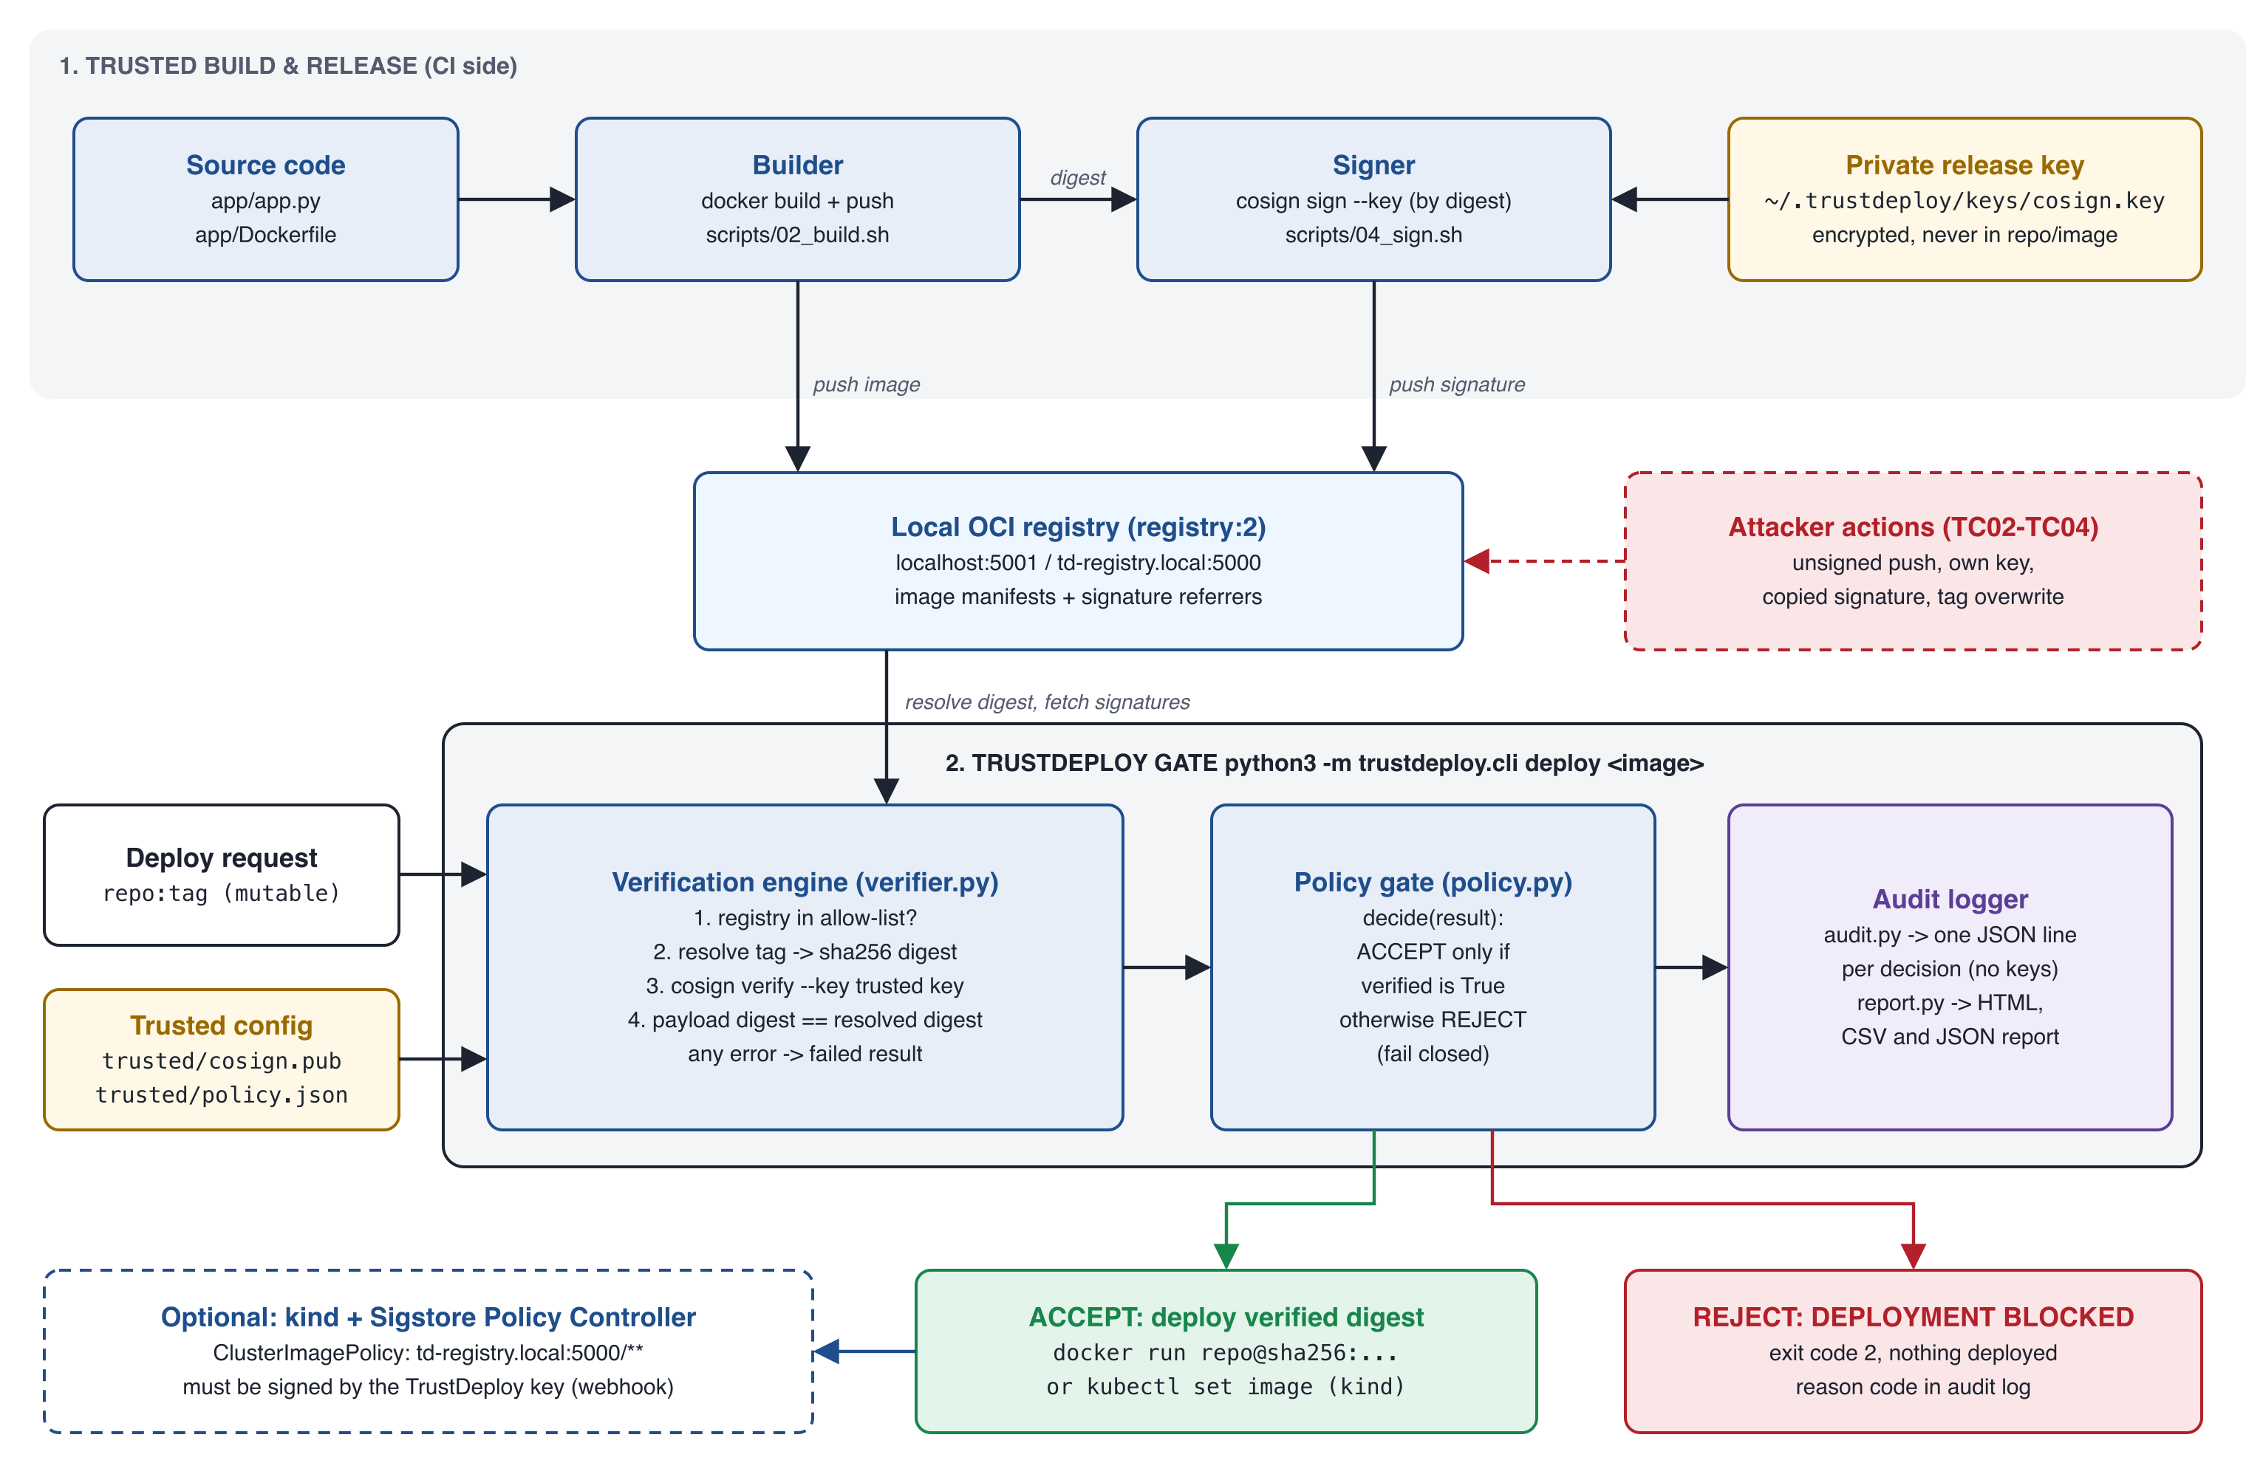
Figure 3.1: TrustDeploy system architecture

3.2 Components
Table 3.1: System components and their implementation
Component | Responsibility | Implementation
Builder | Builds the sample app image, pushes it to the registry and records the immutable digest of the approved release. | scripts/02_build.sh, app/Dockerfile
Signer | Signs the approved image by digest with the private release key in two formats (bundle via OCI referrer, legacy .sig). | scripts/04_sign.sh (Cosign v3.1.3)
Trusted key and policy | Public key, allowed registries and timeout that define what "trusted" means. | trusted/cosign.pub, trusted/policy.json
Verification engine | Allow-list check, tag-to-digest resolution, cosign verify, payload digest check, classification of failures. | trustdeploy/verifier.py
Policy gate | Converts a verification result into ACCEPT or REJECT, failing closed. | trustdeploy/policy.py
Deployment workflow | verify, deploy and report commands; deploys only the verified digest. | trustdeploy/cli.py
Audit logger and reports | Appends one JSON line per decision; exports HTML, CSV and JSON. | trustdeploy/audit.py, trustdeploy/report.py
Kubernetes admission (optional layer) | Denies unsigned or wrongly signed Pods at the API server. | kind + Sigstore Policy Controller, k8s/*.yaml

3.3 Trust Model
- Root of trust: the ECDSA P-256 release key. The private key is encrypted with a random password and stored in ~/.trustdeploy/keys (directory mode 700, files mode 600), outside the project and outside every image. .gitignore excludes *.key.
- Trusted configuration: trusted/cosign.pub and trusted/policy.json are version-controlled; changing them is a reviewable act. The audit log records the SHA-256 fingerprint of each trusted key in use.
- Untrusted inputs: image names, tags, registry contents and the output of external tools. None of these can cause an ACCEPT without a successful cryptographic check.
- Fail-closed principle: any error, timeout, missing tool or unexpected output results in REJECT.

3.4 Verification and Decision Flow
Figure 3.2 shows the order of checks performed for every request. Cheap, local checks come first: an image from a registry outside the allow-list is rejected without any network access. The tag is then resolved to a digest so that the signature is checked, and the deployment later performed, against one immutable image.
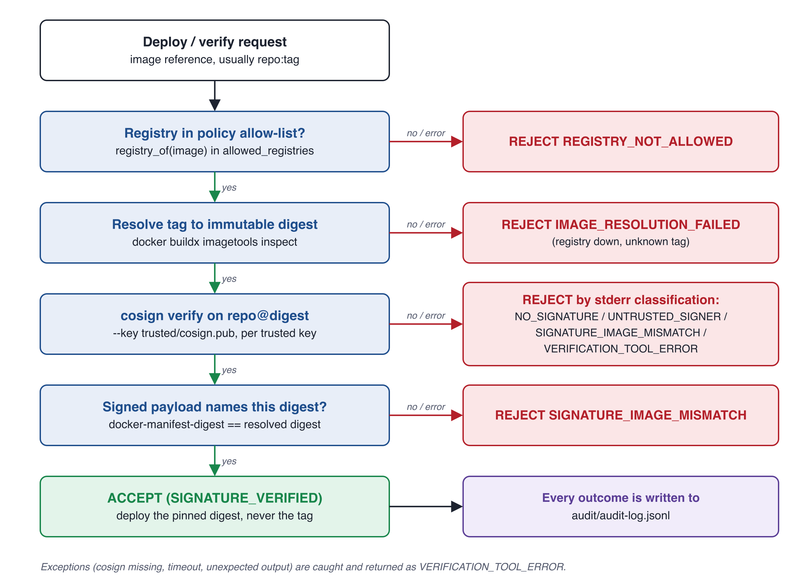
Figure 3.2: Verification and decision flow of the policy gate

3.5 Reason Codes
Each decision carries a machine-readable reason code (Table 3.2). Distinguishing the reasons matters operationally: NO_SIGNATURE usually indicates a process gap, UNTRUSTED_SIGNER or SIGNATURE_IMAGE_MISMATCH indicate an attack, and IMAGE_RESOLUTION_FAILED or VERIFICATION_TOOL_ERROR indicate an infrastructure fault.
Table 3.2: Reason codes produced by the verification engine
Reason code | Decision | Meaning
SIGNATURE_VERIFIED | ACCEPT | A signature from a trusted key validates and its payload names the resolved digest.
NO_SIGNATURE | REJECT | The image has no Cosign signature in the registry.
UNTRUSTED_SIGNER | REJECT | Signatures exist, but none validate against a trusted public key.
SIGNATURE_IMAGE_MISMATCH | REJECT | A signature exists but was issued for a different image digest.
IMAGE_RESOLUTION_FAILED | REJECT | The tag could not be resolved to a digest (registry down, unknown tag).
VERIFICATION_TOOL_ERROR | REJECT | Cosign missing, timed out, or produced unexpected output.
REGISTRY_NOT_ALLOWED | REJECT | The image's registry is not in the policy allow-list.

3.6 Audit Record Design
The audit log is an append-only JSON-lines file, audit/audit-log.jsonl. JSON lines were chosen because each record is independent, the file can be appended to safely by one process, and it is trivially ingested by log tooling. The record never contains key material, only a fingerprint of the trusted public key.
Table 3.3: Fields of an audit record
Field | Description
event_id, timestamp_utc | Random UUID and UTC timestamp of the decision.
action, test_label | verify or deploy, and an optional label such as TC03.
image_ref, resolved_digest, verified_ref | What was requested, the digest it resolved to, and the digest-pinned reference that was verified.
decision, reason_code, reason | ACCEPT or REJECT, the reason code and a human-readable explanation.
policy, trusted_key_sha256 | Policy name and the 16-hex-digit SHA-256 fingerprint of each trusted key.
tool_exit_code, tool_stderr_excerpt | Cosign's exit code and the last 600 characters of its error output, kept as evidence.
duration_ms, operator | Time taken by verification and the local user who ran it.

3.7 Key Design Decisions
- Verify and deploy by digest. The gate resolves the tag once, verifies repo@digest, and deploys exactly that reference, closing the time-of-check to time-of-use gap that a tag would leave open.
- Defence in depth on the payload. Even when Cosign exits successfully, the gate checks that every verified payload's docker-manifest-digest equals the resolved digest.
- Fail closed by construction. decide() returns ACCEPT only when verified is True; every exception path in the verifier returns a failed result rather than raising.
- No third-party Python dependencies. The gate uses only the Python standard library and shells out to the audited cosign and docker binaries, minimising the gate's own supply-chain surface.
- Two enforcement points. A pipeline gate (CLI) and a cluster admission webhook enforce the same key, so an image that bypasses the pipeline is still stopped at the cluster.
CHAPTER 4

TECHNOLOGY STACK
All components run on a single developer laptop (macOS on Apple silicon, darwin/arm64). The versions in Table 4.1 are those reported by the tools in the evaluation run (Figure 4.1 and Figure 5.7).
Table 4.1: Technology stack
Layer | Technology | Version / detail | Purpose
Container runtime | Docker Engine + Buildx | 29.8.1 | Build, push, inspect and run images
Signing / verification | Sigstore Cosign | v3.1.3 | Key generation, signing, verification, cosign tree
Gate implementation | Python 3 (standard library only) | 3.14.2 on host | Verifier, policy gate, CLI, audit, reports
Sample application | Python HTTP server on python:3.12-alpine | 1.0.0 | Image under protection; runs as non-root appuser
Registry | Distribution registry:2 | localhost:5001 (in-cluster alias td-registry.local:5000) | Stores images and signatures
Kubernetes | kind (Kubernetes in Docker), kubectl | kind v0.33.0, Kubernetes v1.37.0 | Local cluster for admission control
Admission control | Sigstore Policy Controller (Helm) | app 0.13.1, chart 0.10.8 | Validating webhook enforcing ClusterImagePolicy
Testing | Bash test runner, Python unittest | tests/cases.sh, tests/test_gate.py | End-to-end and unit tests
Evidence tooling | Pillow (screenshots), headless Chrome | scripts/termshot.py, scripts/htmlshot.sh | Reproducible evidence images (not used by the gate)

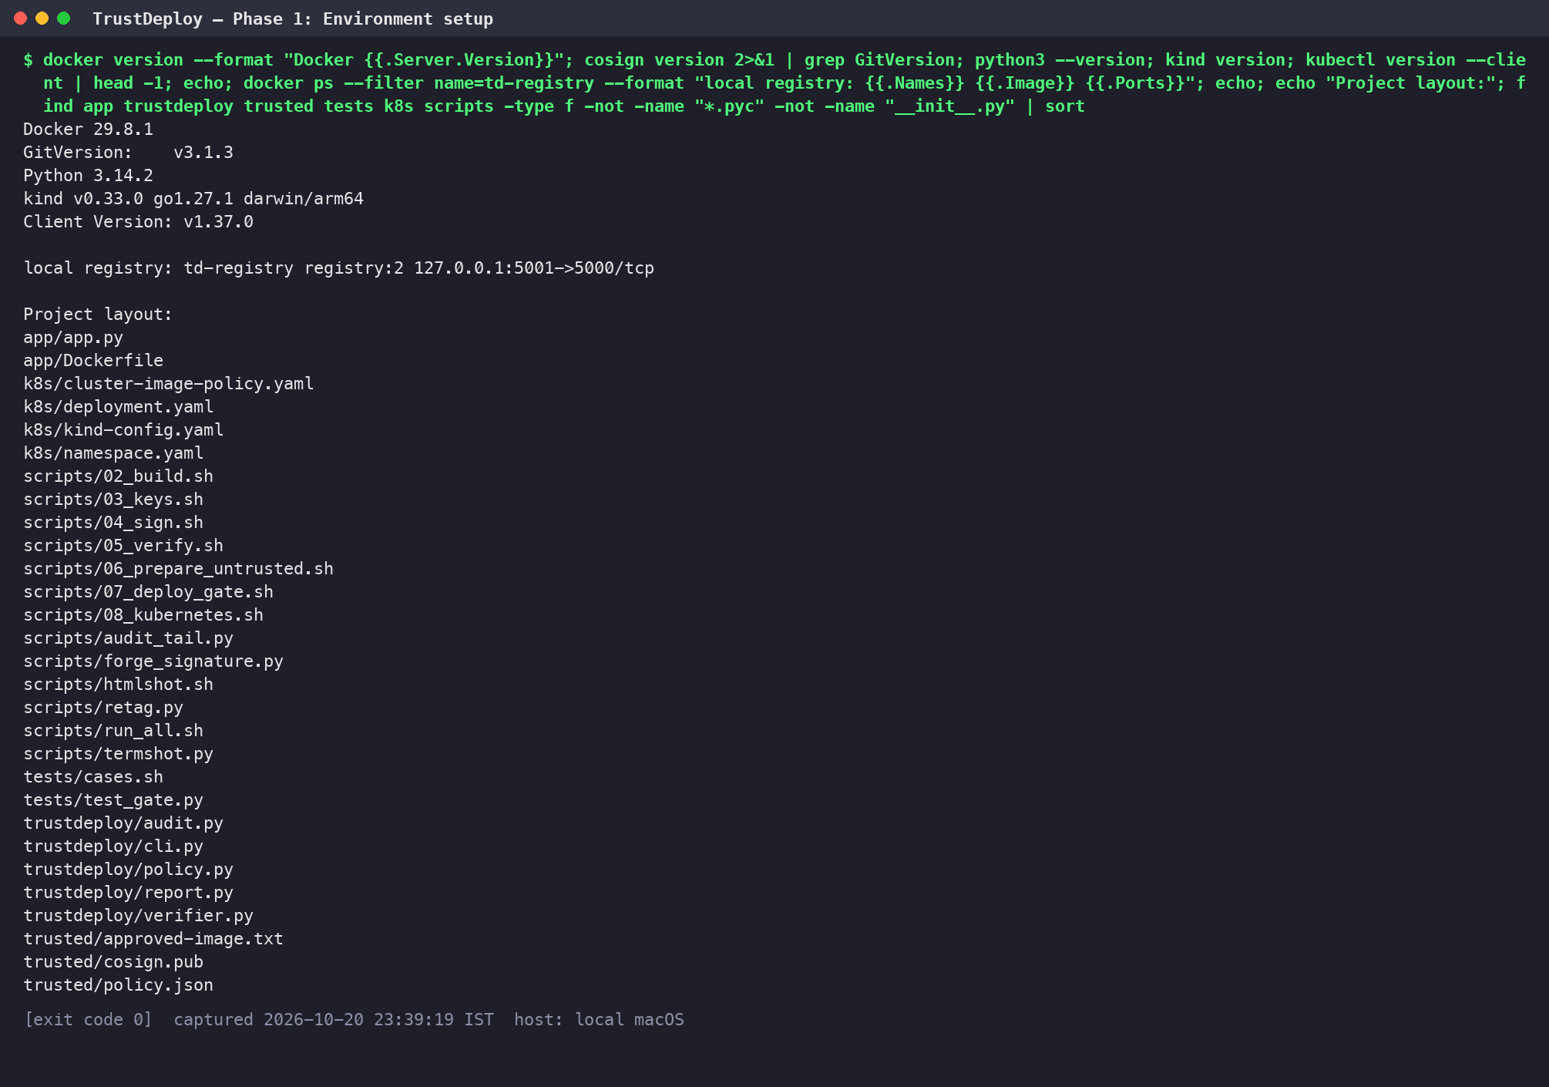
Figure 4.1: Environment: tool versions, local registry and project layout [01-environment.png]
The project layout shown in Figure 4.1 separates the gate (trustdeploy/), the trusted configuration (trusted/), the sample application (app/), automation (scripts/), Kubernetes manifests (k8s/) and tests (tests/). scripts/run_all.sh reproduces the complete demonstration from a clean registry and audit log.
CHAPTER 5

IMPLEMENTATION METHODOLOGY
The implementation was carried out in seven phases. Each phase is automated by a script so that the whole demonstration can be repeated end to end with scripts/run_all.sh, which also captures the evidence figures used in this report.

5.1 Phase 1: Environment Setup
Docker, Cosign, Python, kind and kubectl were installed locally and a private registry was started as a container bound to the loopback interface only:
Listing 5.1: scripts/run_all.sh (excerpt)
docker run -d --restart=always -p 127.0.0.1:5001:5000 --name td-registry registry:2 >/dev/null
docker network connect --alias td-registry.local kind td-registry 2>/dev/null

Connecting the registry container to the kind Docker network under the alias td-registry.local lets the Kubernetes node pull from the same registry that the host uses on localhost:5001.

5.2 Phase 2: Building the Sample Application
The protected workload is a minimal JSON HTTP service. Its Dockerfile uses a small Alpine base and drops root privileges:
Listing 5.2: app/Dockerfile
FROM python:3.12-alpine
ARG APP_VERSION=1.0.0
ENV APP_VERSION=${APP_VERSION}
RUN adduser -D appuser
WORKDIR /srv
COPY app.py .
USER appuser
EXPOSE 8080
CMD ["python", "app.py"]

The build script builds and pushes version 1.0.0, then resolves and records the digest of the approved image in trusted/approved-image.txt. Provenance and SBOM attestations are disabled so that the pushed reference is a single image manifest whose digest is stable and easy to reason about.
Listing 5.3: scripts/02_build.sh (excerpt)
docker build -q --provenance=false --sbom=false --build-arg APP_VERSION=1.0.0 -t $REG/trustdeploy/sample-app:1.0.0 app >/dev/null
docker push -q $REG/trustdeploy/sample-app:1.0.0 >/dev/null
DIGEST=$(docker buildx imagetools inspect $REG/trustdeploy/sample-app:1.0.0 --format '{{json .Manifest}}' | python3 -c 'import json,sys;print(json.load(sys.stdin)["digest"])')
echo "Built and pushed: $REG/trustdeploy/sample-app:1.0.0"
echo "Immutable digest: $DIGEST"
echo "$REG/trustdeploy/sample-app@$DIGEST" > trusted/approved-image.txt

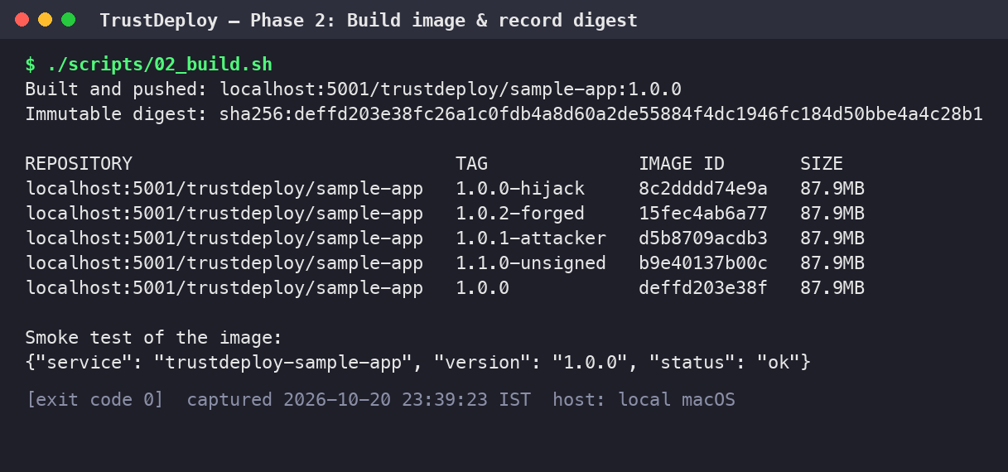
Figure 5.1: Image built, pushed and its immutable digest recorded; smoke test of the service [02-build-image.png]

5.3 Phase 3: Key Generation and Signing
A Cosign key pair is generated once. The private key is encrypted with a random 24-byte password produced by OpenSSL, and both live in ~/.trustdeploy/keys, outside the project. Only the public key is copied into trusted/cosign.pub. The script finishes with an explicit check that no *.key file exists in the project tree or inside the image (Figure 5.2).
Listing 5.4: scripts/03_keys.sh (excerpt)
KEYDIR=$HOME/.trustdeploy/keys
mkdir -p "$KEYDIR" && chmod 700 "$KEYDIR"
[ -f "$KEYDIR/password" ] || (openssl rand -base64 24 > "$KEYDIR/password" && chmod 600 "$KEYDIR/password")
cd "$KEYDIR"
[ -f cosign.key ] || COSIGN_PASSWORD="$(cat password)" cosign generate-key-pair 2>&1
chmod 600 cosign.key
cp cosign.pub "$OLDPWD/trusted/cosign.pub"

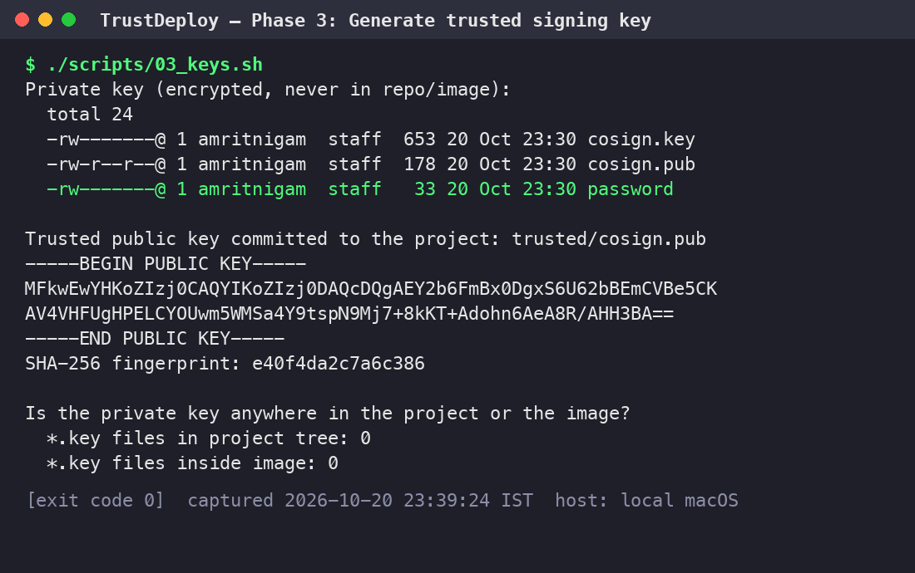
Figure 5.2: Release key pair generated; private key kept outside the repository and image [03-key-generation.png]
The approved image is then signed by digest, never by tag. It is signed twice with the same key: once in the current Sigstore bundle format attached as an OCI referrer, which the TrustDeploy gate verifies, and once in the legacy .sig tag format, which the Kubernetes Policy Controller reads. Transparency-log upload is disabled for offline operation.
Listing 5.5: scripts/04_sign.sh (excerpt)
REF=$(cat trusted/approved-image.txt)
echo "Approved image (digest-pinned): $REF"; echo
export COSIGN_PASSWORD="$(cat $HOME/.trustdeploy/keys/password)"
echo "-- Sigstore bundle format (OCI referrer), used by the TrustDeploy gate"
cosign sign --key $HOME/.trustdeploy/keys/cosign.key --tlog-upload=false --use-signing-config=false -y "$REF" 2>&1 | grep -v deprecated
echo "-- legacy .sig format, read by the Kubernetes Policy Controller admission webhook"
cosign sign --key $HOME/.trustdeploy/keys/cosign.key --tlog-upload=false --use-signing-config=false --new-bundle-format=false -y "$REF" 2>&1 | grep -v deprecated
echo; echo "Signature artifacts now attached to the image in the registry:"
cosign tree "$REF" 2>&1

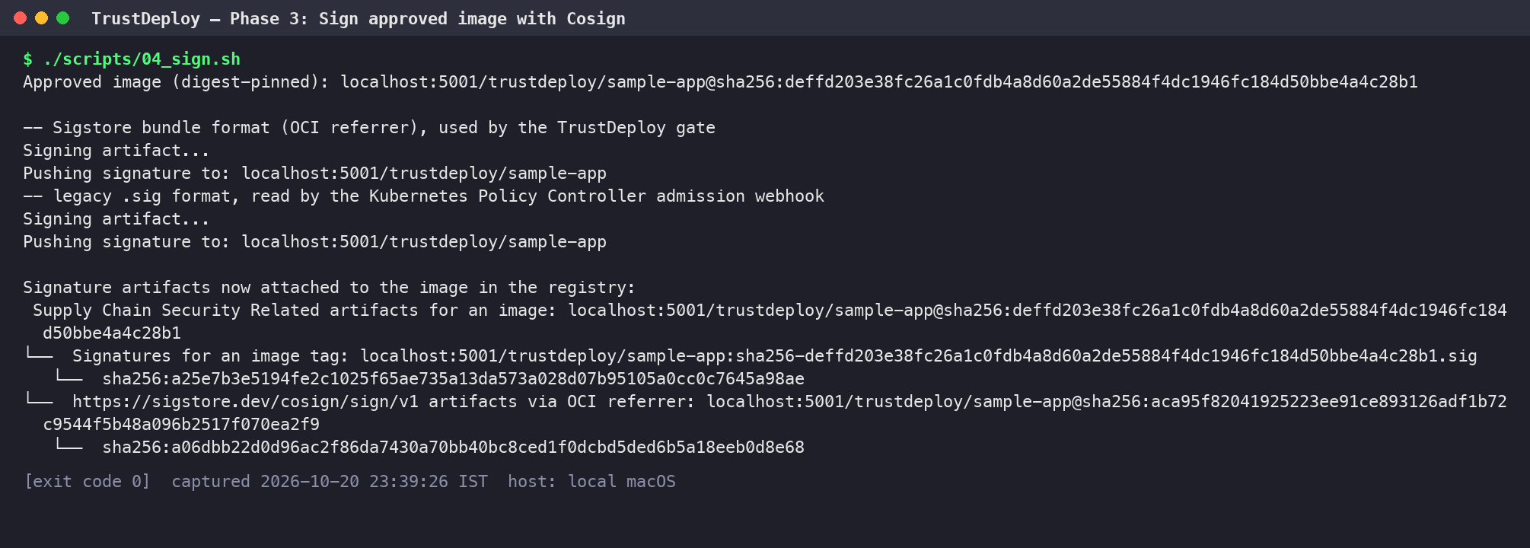
Figure 5.3: Approved image signed by digest; cosign tree shows the .sig tag and the OCI referrer bundle [04-sign-image.png]

5.4 Phase 4: Verification Engine
The verification engine in trustdeploy/verifier.py is the core of the system. It never raises an exception to its caller: every path returns a VerificationResult whose verified flag defaults to False and whose reason code defaults to VERIFICATION_TOOL_ERROR. Tag resolution uses Docker Buildx to read the manifest digest directly from the registry:
Listing 5.6: trustdeploy/verifier.py: tag-to-digest resolution
def resolve_digest(image_ref, timeout):
"""Resolve a (possibly mutable) tag to the immutable manifest digest in the registry."""
repo, _, digest = split_ref(image_ref)
if digest:
return digest, None
proc = subprocess.run(
[DOCKER, "buildx", "imagetools", "inspect", image_ref, "--format", "{{json .Manifest}}"],
capture_output=True, text=True, timeout=timeout,
)
if proc.returncode != 0:
return None, proc.stderr.strip() or proc.stdout.strip()
return json.loads(proc.stdout)["digest"], None

Signature verification calls cosign verify on the digest-pinned reference for each trusted key and then performs an independent check that the verified payload names the resolved digest:
Listing 5.7: trustdeploy/verifier.py: verify_image()
def verify_image(image_ref, policy):
start = time.monotonic()
res = VerificationResult(image_ref=image_ref)
timeout = policy.get("verification_timeout_seconds", 60)
try:
if registry_of(image_ref) not in policy["allowed_registries"]:
res.reason_code = REGISTRY_NOT_ALLOWED
res.message = f"Registry '{registry_of(image_ref)}' is not in the policy allow-list."
return res

digest, err = resolve_digest(image_ref, timeout)
if not digest:
res.reason_code = RESOLVE_ERROR
res.message = "Could not resolve the image to a digest; failing closed."
res.tool_stderr = (err or "")[-600:]
return res
res.digest = digest
res.pinned_ref = f"{split_ref(image_ref)[0]}@{digest}"

failures = []
for key in policy["trusted_public_keys"]:
proc = _cosign_verify(res.pinned_ref, key, timeout)
res.tool_exit_code = proc.returncode
if proc.returncode == 0:
payloads = json.loads(proc.stdout)
# Defence in depth: every accepted payload must name the exact digest we resolved.
claimed = {p["critical"]["image"]["docker-manifest-digest"] for p in payloads}
if claimed != {digest}:
res.reason_code = DIGEST_MISMATCH
res.message = f"Signed payload names {sorted(claimed)}, expected {digest}."
return res
res.verified = True
res.reason_code = VERIFIED
res.message = f"Valid signature from trusted key {os.path.relpath(key)} for {digest[:19]}…"
res.signatures = [p.get("optional") or {} for p in payloads]
return res
failures.append(proc.stderr.strip())

res.tool_stderr = "\n".join(failures)[-600:]
res.reason_code, res.message = classify_failure(res.tool_stderr)
return res
except FileNotFoundError as e:
res.reason_code = TOOL_ERROR
res.message = f"Verification tool not available ({e.filename}); failing closed."
return res
except subprocess.TimeoutExpired:
res.reason_code = TOOL_ERROR
res.message = "Verification timed out; failing closed."
return res
except Exception as e: # any unexpected error must still deny
res.reason_code = TOOL_ERROR
res.message = f"Unexpected verification error ({type(e).__name__}: {e}); failing closed."
return res
finally:
res.duration_ms = int((time.monotonic() - start) * 1000)

When Cosign fails, its error output is classified into a reason code so that the audit log distinguishes an unsigned image from an attack:
Listing 5.8: trustdeploy/verifier.py: classify_failure()
def classify_failure(stderr):
s = stderr.lower()
if "no signatures found" in s or "no matching signatures: no signatures" in s:
return UNSIGNED, "The image has no Cosign signature in the registry."
if "does not match any digest in statement" in s or "invalid or missing digest in claim" in s:
return DIGEST_MISMATCH, "A signature exists, but it was issued for a different image digest."
if any(m in s for m in ("no matching signatures", "no matching attestations", "do not match threshold", "invalid signature")):
return UNTRUSTED_KEY, "Signature(s) exist, but none validate against the trusted public key."
return TOOL_ERROR, "Cosign could not complete verification; failing closed."

The policy gate itself is deliberately tiny, which makes the fail-closed property easy to review:
Listing 5.9: trustdeploy/policy.py: decide()
def decide(result):
# Fail closed: only an explicit, successful verification is accepted.
return ACCEPT if result.verified is True else REJECT

The policy is data, not code, so that the trusted keys and allowed registries can be changed through review without touching the gate:
Listing 5.10: trusted/policy.json
{
"policy_name": "trustdeploy-default",
"description": "Images must be referenced by digest after resolution and carry a valid Cosign signature from the TrustDeploy release key.",
"trusted_public_keys": ["trusted/cosign.pub"],
"allowed_registries": ["localhost:5001", "td-registry.local:5000"],
"transparency_log": "disabled (offline key-based prototype)",
"verification_timeout_seconds": 60
}

Figure 5.4 shows the signed image verified first directly with cosign verify and then through the TrustDeploy gate. The gate is given the mutable tag :1.0.0, resolves it to the approved digest, and accepts it (TC01).
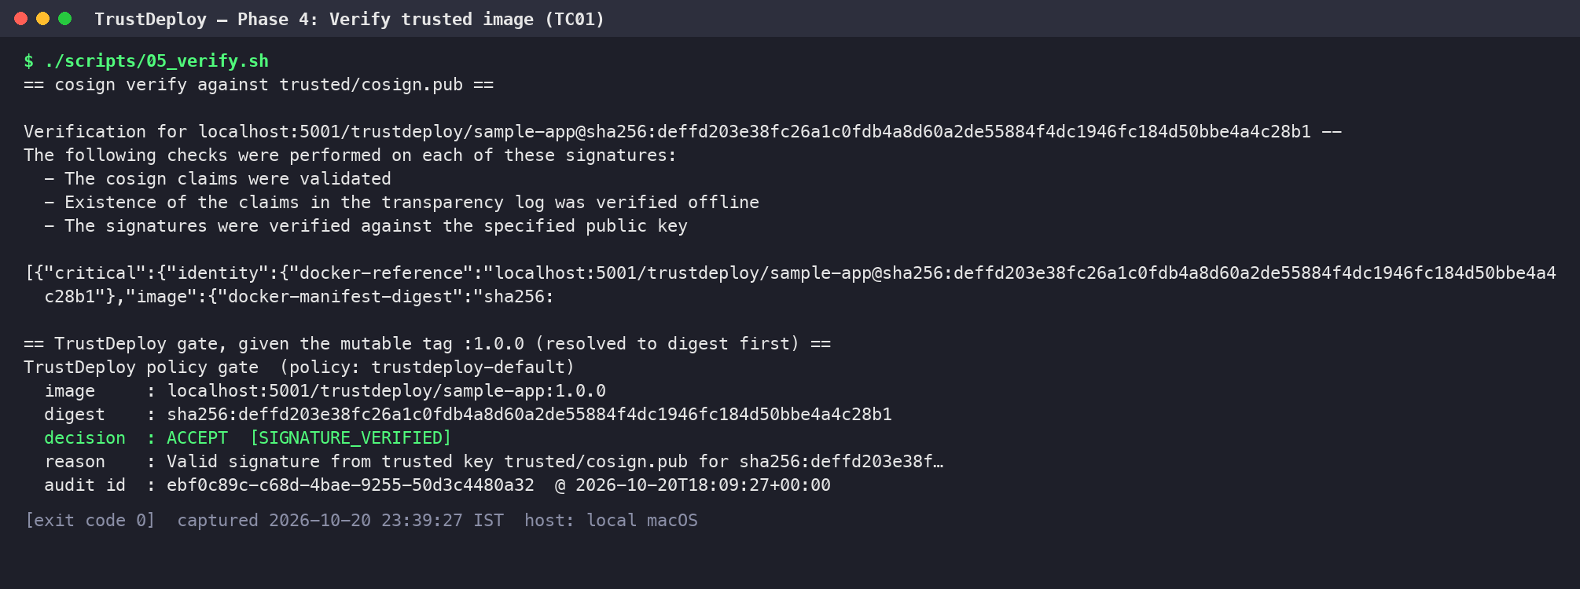
Figure 5.4: TC01: signed image verified with Cosign and accepted by the TrustDeploy gate [05-tc01-verify-trusted.png]

5.5 Phase 5: Attack Simulation and Untrusted Images
To test the negative paths, scripts/06_prepare_untrusted.sh creates one image per attack: an unsigned build (1.1.0-unsigned), a build signed with a separately generated attacker key (1.0.1-attacker), a build carrying a copy of the genuine signature (1.0.2-forged), and a tampered build (tampered-build) that is later moved onto the trusted tag. The attacker key has a different fingerprint from the trusted key (Figure 5.5).
The copied-signature attack is implemented in scripts/forge_signature.py. It talks to the registry API directly, takes the genuine signature manifest attached to the approved image, re-points its subject at the attacker's image and publishes it in the attacker image's referrers fallback index. The signed bundle layer is reused byte for byte, so the signature itself remains cryptographically valid:
Listing 5.11: scripts/forge_signature.py (excerpt)
# 1. find the genuine signature manifest attached to A
index = json.loads(req(base + src.replace(":", "-"))[0])
sig_desc = index["manifests"][0]
sig = json.loads(req(base + sig_desc["digest"], accept=MAN)[0])
# 2. point its subject at B instead of A (the signed bundle layer is reused unchanged)
body, headers = req(base + dst, method="HEAD")
sig["subject"] = {"mediaType": headers["Content-Type"], "size": int(headers["Content-Length"]), "digest": dst}
raw = json.dumps(sig).encode()
new_digest = "sha256:" + hashlib.sha256(raw).hexdigest()
req(base + new_digest, method="PUT", body=raw, ctype=MAN)
# 3. publish it as B's referrer
fake_index = {"schemaVersion": 2, "mediaType": IDX, "manifests": [dict(sig_desc, digest=new_digest, size=len(raw))]}
req(base + dst.replace(":", "-"), method="PUT", body=json.dumps(fake_index).encode(), ctype=IDX)

Tag hijacking (TC04b) uses scripts/retag.py, which copies a manifest byte for byte under a new tag through the registry API, exactly as an attacker with push access could. The same script restores the tag to the approved digest after the test.
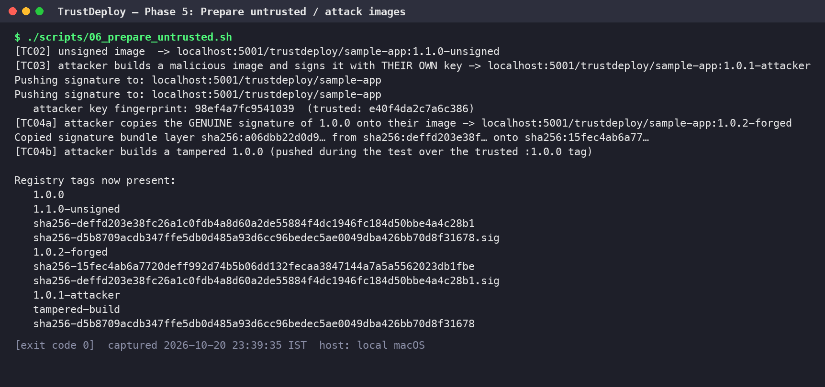
Figure 5.5: Preparation of the unsigned, attacker-signed, forged and tampered images [06-prepare-untrusted-images.png]

5.6 Phase 6: Policy Enforcement in the Deployment Workflow
The deploy command runs the gate and deploys only on ACCEPT. Crucially, it deploys result.pinned_ref, the digest that was verified, rather than the tag the user supplied. A rejected image ends the command with exit code 2 so that a CI pipeline step fails.
Listing 5.12: trustdeploy/cli.py: deploy()
def deploy_command(ref, target):
"""The deployment command for an already verified, digest-pinned reference."""
if target == "docker":
subprocess.run(["docker", "rm", "-f", "trustdeploy-app"], capture_output=True)
return ["docker", "run", "-d", "--name", "trustdeploy-app", "-p", "18088:8080", ref]
incluster = ref.replace("localhost:5001", "td-registry.local:5000")
return ["kubectl", "-n", "trustdeploy", "set", "image", "deployment/sample-app", f"app={incluster}"]

def gate(image, action, label=None):
decision, result, entry, policy = evaluate(image, action, label)
colour = GREEN if decision == ACCEPT else RED
print(f"{BOLD}TrustDeploy policy gate{END} (policy: {policy['policy_name']})")
print(f" image : {image}")
print(f" digest : {result.digest or '-'}")
print(f" decision : {colour}{BOLD}{decision}{END} [{result.reason_code}]")
print(f" reason : {result.message}")
if result.tool_stderr and decision != ACCEPT:
print(f" evidence : {result.tool_stderr.splitlines()[-1][:140]}")
print(f" audit id : {entry['event_id']} @ {entry['timestamp_utc']}")
return decision, result

def deploy(image, target, label=None):
decision, result = gate(image, "deploy", label)
if decision != ACCEPT:
print(f"{RED}{BOLD}DEPLOYMENT BLOCKED{END}: {image} did not satisfy the trust policy. Nothing was deployed.")
return 2
# always deploy the exact digest that was verified, never the tag
cmd = deploy_command(result.pinned_ref, target)
print(f"{GREEN}{BOLD}DEPLOYING{END} verified digest -> {target}: {' '.join(cmd)}")
proc = subprocess.run(cmd, capture_output=True, text=True)
print((proc.stdout + proc.stderr).strip())
return 0 if proc.returncode == 0 else 1

Figure 5.6 shows the gate in a Docker deployment: the attacker-signed image is blocked with exit code 2 and no container is created; the approved image is then deployed by digest and answers on port 18088.
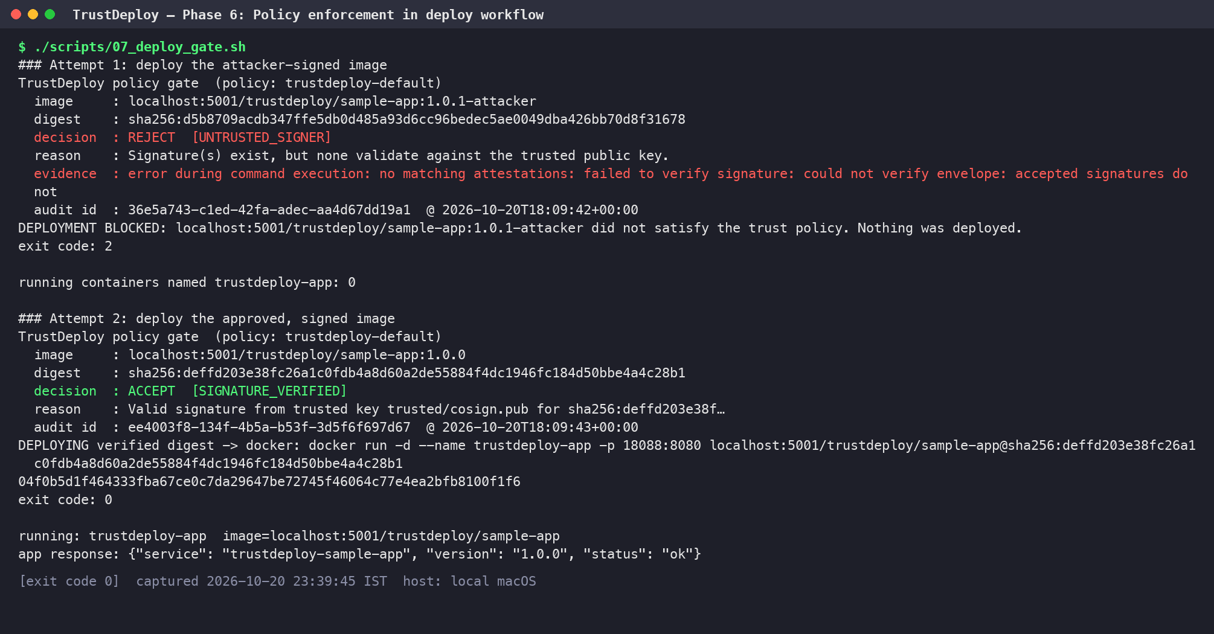
Figure 5.6: Deployment workflow: attacker image blocked (exit 2), approved image deployed by digest [16-deploy-gate-docker.png]

5.6.1 Kubernetes Admission Enforcement
To stop images that bypass the pipeline, the same key is enforced inside a local kind cluster by the Sigstore Policy Controller (Helm chart 0.10.8, application 0.13.1). The node's containerd is configured to read registry host configuration from /etc/containerd/certs.d, so it can pull from the plain-HTTP local registry. The trustdeploy namespace is labelled policy.sigstore.dev/include=true and the following ClusterImagePolicy requires every image from the TrustDeploy registry to be signed by the release key:
Listing 5.13: k8s/cluster-image-policy.yaml
apiVersion: policy.sigstore.dev/v1beta1
kind: ClusterImagePolicy
metadata:
name: trustdeploy-signed-images
spec:
images:
- glob: "td-registry.local:5000/**"
authorities:
- name: trustdeploy-release-key
key:
hashAlgorithm: sha256
data: |
-----BEGIN PUBLIC KEY-----
MFkwEwYHKoZIzj0CAQYIKoZIzj0DAQcDQgAEY2b6FmBx0DgxS6U62bBEmCVBe5CK
AV4VHFUgHPELCYOUwm5WMSa4Y9tspN9Mj7+8kKT+Adohn6AeA8R/AHH3BA==
-----END PUBLIC KEY-----

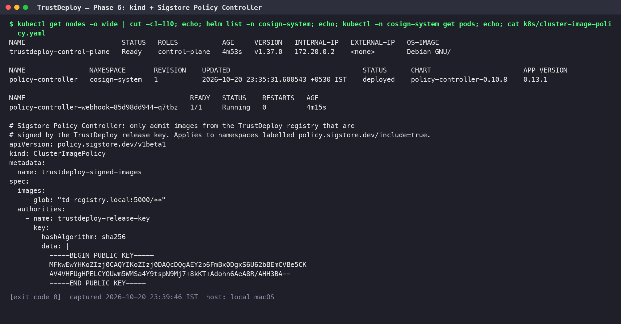
Figure 5.7: kind cluster, Policy Controller release and webhook pod, and the ClusterImagePolicy [17-k8s-setup.png]
Figure 5.8 shows admission enforcement in action. The Deployment that references the signed digest is admitted and its Pod reaches Running. A Pod using the attacker-signed image is denied by the policy.sigstore.dev webhook with "invalid signature when validating ASN.1 encoded signature", and a Pod using the unsigned image is denied with "no signatures found". Only the trusted Pod exists in the namespace afterwards.
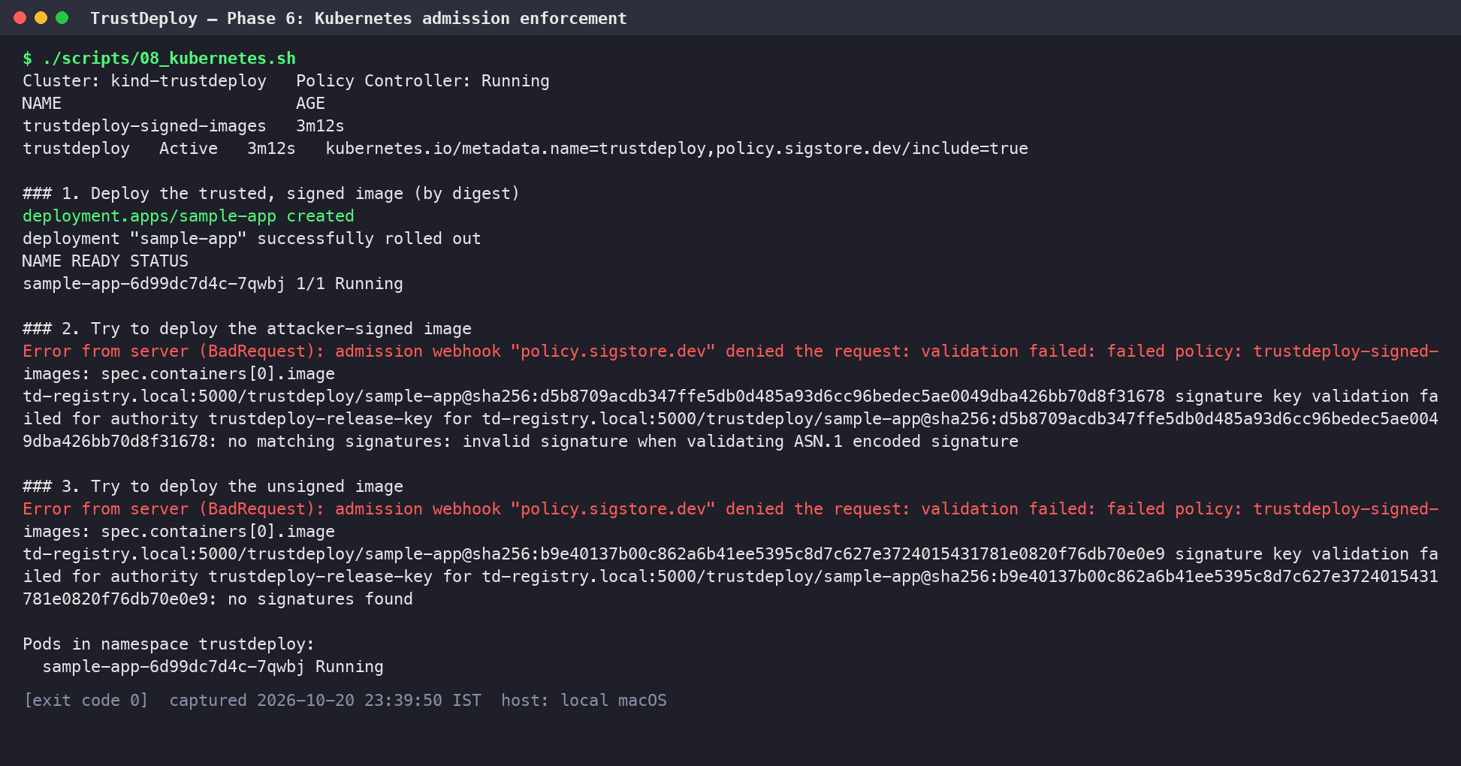
Figure 5.8: Kubernetes admission: signed image admitted; attacker-signed and unsigned images denied [18-k8s-admission.png]

5.7 Phase 7: Audit Logging and Reporting
Every call to the gate, whether verify or deploy, records exactly one audit entry before any deployment action is taken:
Listing 5.14: trustdeploy/audit.py: record()
def record(result, decision, policy, key_fps, action, label=None):
entry = {
"event_id": str(uuid.uuid4()),
"timestamp_utc": datetime.now(timezone.utc).isoformat(timespec="seconds"),
"action": action,
"test_label": label,
"image_ref": result.image_ref,
"resolved_digest": result.digest,
"verified_ref": result.pinned_ref,
"decision": decision,
"reason_code": result.reason_code,
"reason": result.message,
"policy": policy["policy_name"],
"trusted_key_sha256": key_fps,
"tool_exit_code": result.tool_exit_code,
"tool_stderr_excerpt": result.tool_stderr,
"duration_ms": result.duration_ms,
"operator": getpass.getuser(),
}
LOG.parent.mkdir(exist_ok=True)
with LOG.open("a") as f:
f.write(json.dumps(entry) + "\n")
return entry

python3 -m trustdeploy.cli report exports the log as audit/report.json, audit/report.csv and a static, self-contained audit/report.html dashboard with summary cards, a reason-code breakdown and the full event table including Cosign's error excerpt as evidence. The export and the dashboard are shown in Figures 6.9 and 6.10 as test case TC07.
CHAPTER 6

TESTING

6.1 Test Strategy
Testing was performed at two levels. End-to-end tests in tests/cases.sh run the real gate against the real registry and Cosign, and assert the expected decision from the process exit code (0 means ACCEPT, 2 means REJECT). Unit tests in tests/test_gate.py replace the Cosign call with mocks to exercise the fail-closed logic deterministically, without a registry. All test cases were executed in one clean run by scripts/run_all.sh; every figure in this chapter is a capture of that run.
Listing 6.1: tests/cases.sh: the assertion helper
expect() { # expect <ACCEPT|REJECT> <label> <command...>
local want=$1 label=$2; shift 2
"$@"; local code=$?
local got=REJECT; [ $code -eq 0 ] && got=ACCEPT
if [ "$got" = "$want" ]; then echo "RESULT $label: PASS (expected $want, got $got)"; else echo "RESULT $label: FAIL (expected $want, got $got)"; return 1; fi
}

6.2 Test Case Summary
Table 6.1: End-to-end test cases and observed outcomes
ID | Scenario | Expected | Observed (reason code) | Status
TC01 | Correctly signed image, requested by mutable tag :1.0.0 | ACCEPT | ACCEPT (SIGNATURE_VERIFIED) | Pass
TC02 | Unsigned image 1.1.0-unsigned | REJECT | REJECT (NO_SIGNATURE) | Pass
TC03 | Image signed with an attacker's key | REJECT | REJECT (UNTRUSTED_SIGNER) | Pass
TC04a | Genuine signature copied to another image | REJECT | REJECT (SIGNATURE_IMAGE_MISMATCH) | Pass
TC04b | Trusted tag :1.0.0 overwritten with a tampered build | REJECT | REJECT (NO_SIGNATURE) | Pass
TC05a | Cosign binary missing, valid image, deploy | Blocked | Blocked (VERIFICATION_TOOL_ERROR) | Pass
TC05b | Registry stopped, valid image, deploy | Blocked | Blocked (IMAGE_RESOLUTION_FAILED) | Pass
TC05c | Image from docker.io (not in allow-list) | REJECT | REJECT (REGISTRY_NOT_ALLOWED) | Pass
TC06 | Batch of four images | 4 separate audit entries | 4 entries: 1 ACCEPT, 3 REJECT | Pass
TC07 | Audit report export | HTML, CSV and JSON written | All three written; dashboard rendered | Pass

6.3 Test Case Details

6.3.1 TC01: Correctly Signed Image
The gate is given localhost:5001/trustdeploy/sample-app:1.0.0, resolves it to the approved digest sha256:deffd203e38f... and verifies the signature with trusted/cosign.pub. Result: ACCEPT with SIGNATURE_VERIFIED (Figure 5.4).

6.3.2 TC02: Unsigned Image
Image 1.1.0-unsigned was built and pushed but never signed. Cosign reports "no signatures found" and the gate rejects it with NO_SIGNATURE.
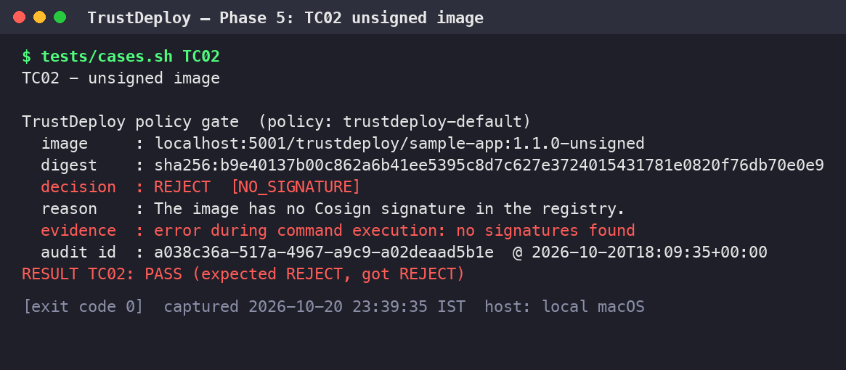
Figure 6.1: TC02: unsigned image rejected (NO_SIGNATURE) [07-tc02-unsigned.png]

6.3.3 TC03: Untrusted Signing Key
Image 1.0.1-attacker is signed, but with the attacker's own key. Cosign finds the signature but it does not validate against the trusted public key, so the gate rejects it with UNTRUSTED_SIGNER. This demonstrates that "signed" is not the same as "trusted".
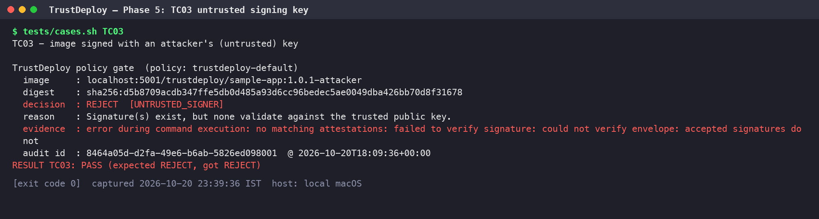
Figure 6.2: TC03: image signed with an attacker key rejected (UNTRUSTED_SIGNER) [08-tc03-untrusted-key.png]

6.3.4 TC04a: Genuine Signature Copied to Another Image
The genuine, valid signature of the approved image was attached to image 1.0.2-forged. Because the signed statement names the approved image's digest, Cosign reports that the provided artefact digest does not match any digest in the statement and the gate rejects with SIGNATURE_IMAGE_MISMATCH. Signatures cannot be transplanted.
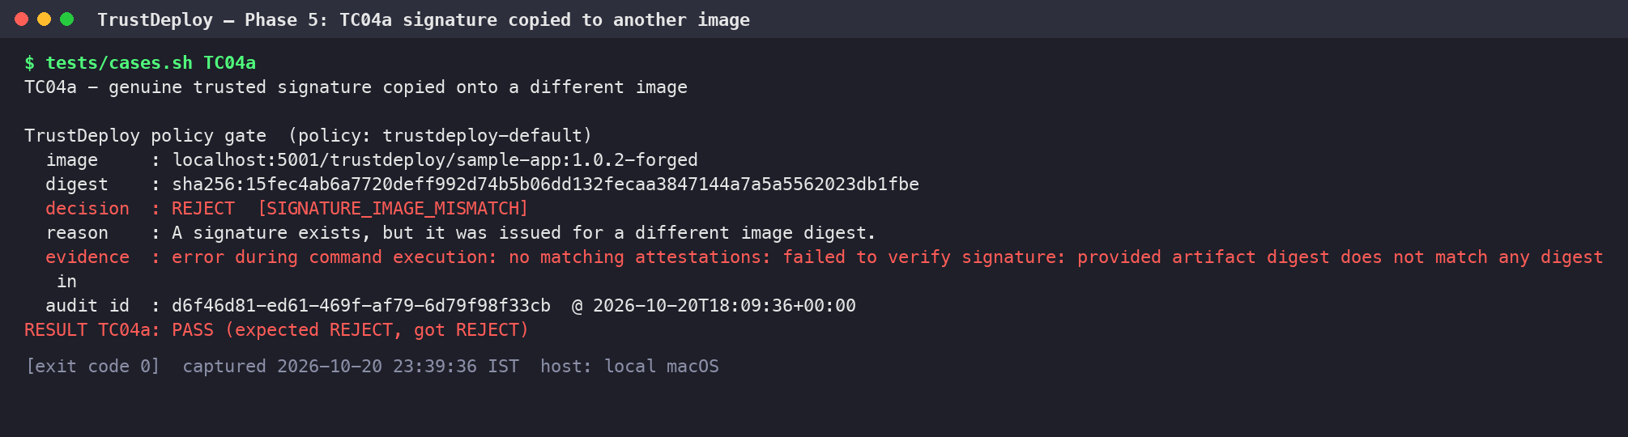
Figure 6.3: TC04a: copied genuine signature rejected (SIGNATURE_IMAGE_MISMATCH) [09-tc04a-copied-signature.png]

6.3.5 TC04b: Trusted Tag Overwritten
The tag :1.0.0 was moved to the tampered build, simulating an attacker with registry push access. The gate resolves the tag, obtains the tampered image's different digest, finds no signature for that digest and rejects it. A tag-based deployment would have run the tampered image; the digest-based gate cannot be fooled. The tag is restored afterwards.
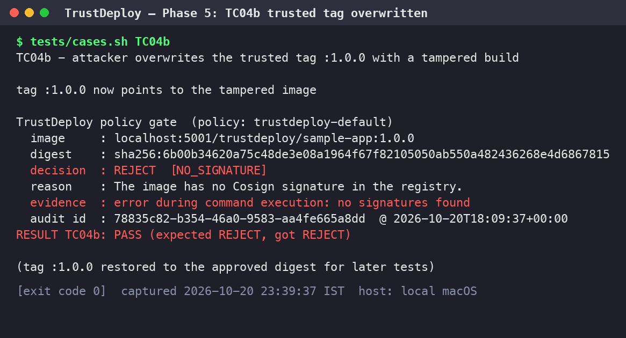
Figure 6.4: TC04b: trusted tag pointed at a tampered build, rejected (NO_SIGNATURE) [10-tc04b-tag-hijack.png]

6.3.6 TC05a: Verification Tool Unavailable
The gate is pointed at a non-existent Cosign binary (TRUSTDEPLOY_COSIGN=/nonexistent/cosign) while deploying the valid image. The verifier catches the FileNotFoundError and returns VERIFICATION_TOOL_ERROR; deployment is blocked. This proves that the gate fails closed even for a legitimate image.
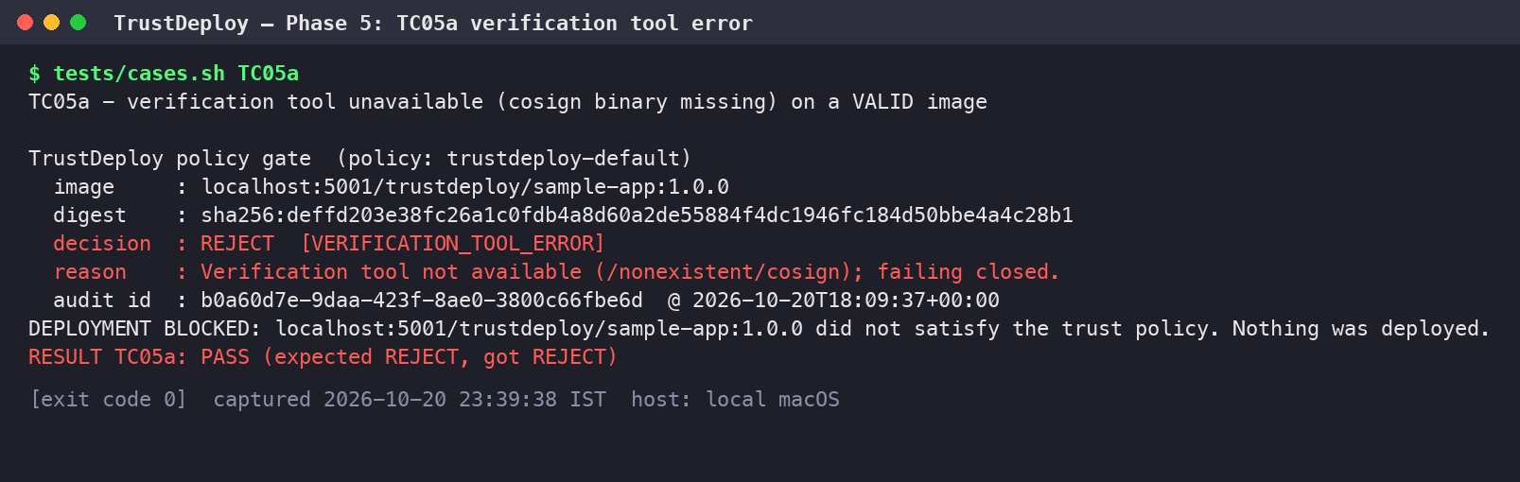
Figure 6.5: TC05a: Cosign missing, deployment of a valid image blocked (fail closed) [11-tc05a-tool-missing.png]

6.3.7 TC05b: Registry Unreachable
The registry container is stopped and the valid image is deployed. Digest resolution fails with a connection error, the gate returns IMAGE_RESOLUTION_FAILED and nothing is deployed. The registry is restarted after the test.
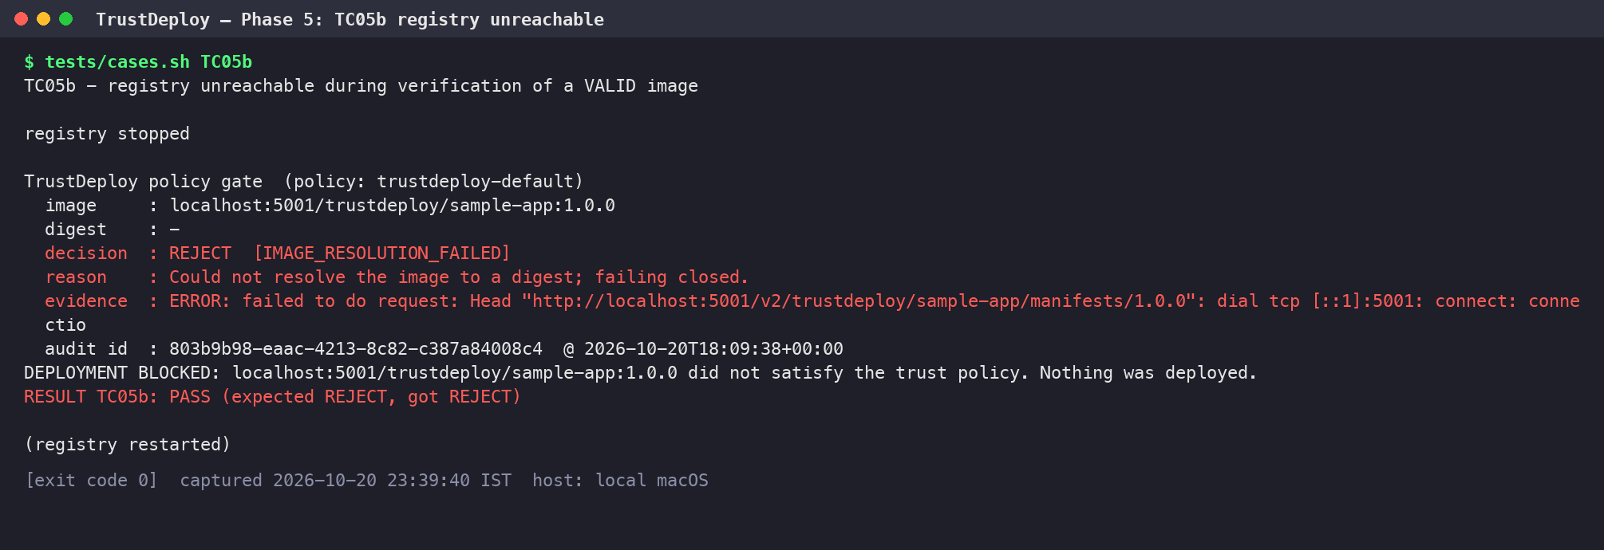
Figure 6.6: TC05b: registry unreachable, deployment blocked (IMAGE_RESOLUTION_FAILED) [12-tc05b-registry-down.png]

6.3.8 TC05c: Registry Not in Allow-list
docker.io/library/nginx:latest is rejected immediately with REGISTRY_NOT_ALLOWED. No network call is made, which is why the audit log records a verification time of 0 ms for this case.
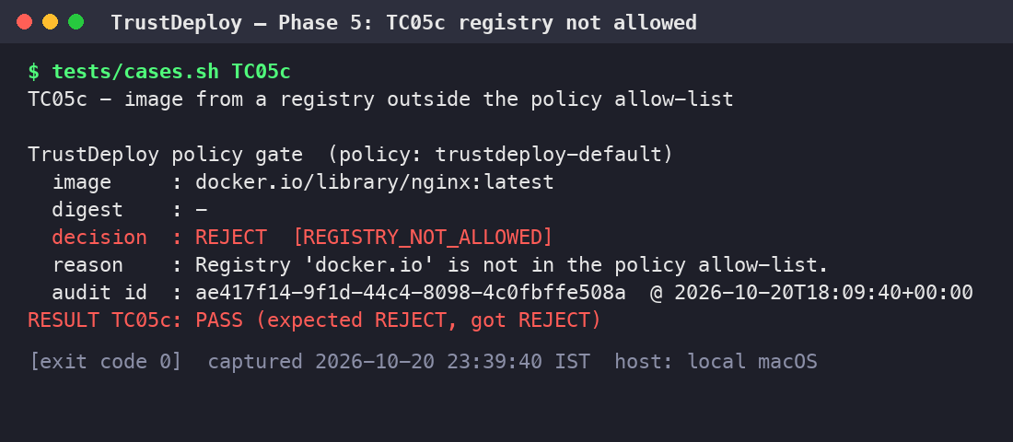
Figure 6.7: TC05c: image from a non-approved registry rejected (REGISTRY_NOT_ALLOWED) [13-tc05c-registry-not-allowed.png]

6.3.9 TC06: Multiple Images, Separate Audit Records
Four images are verified in one batch. The test counts the audit log lines before and after and asserts that exactly four entries were added, each with its own event ID, decision and reason code.
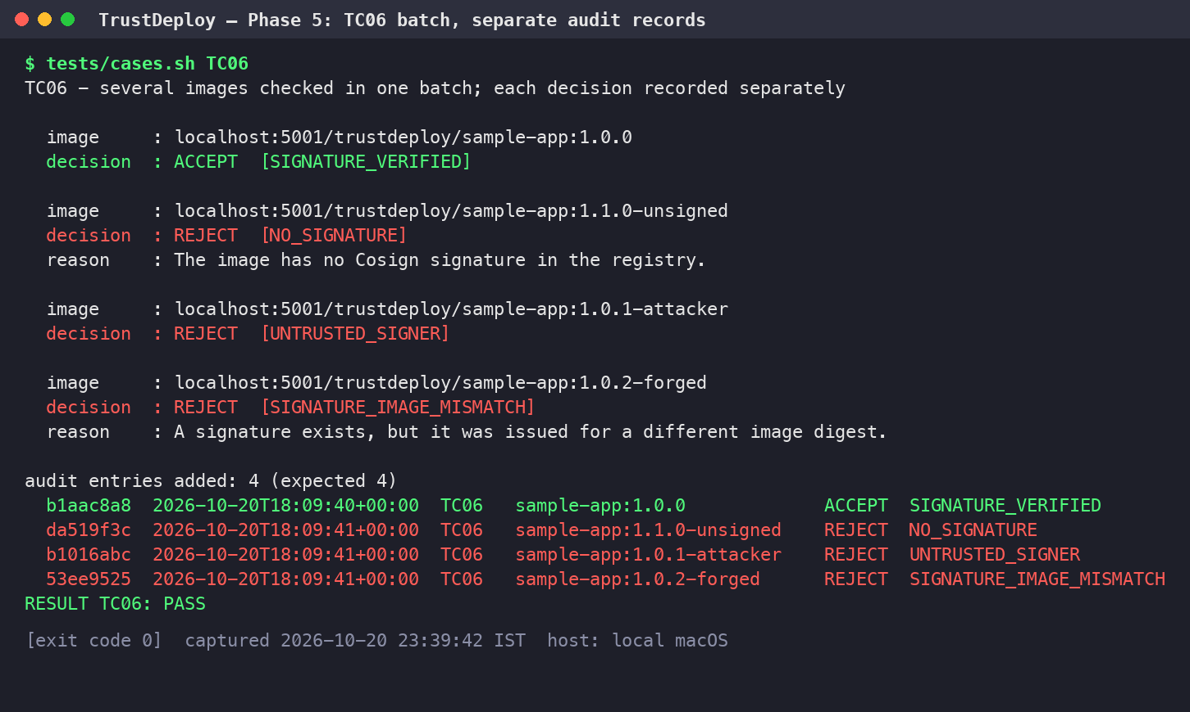
Figure 6.8: TC06: four images verified in one batch, four separate audit entries [14-tc06-multiple-images.png]

6.3.10 TC07: Audit Report Generation
The report command writes the HTML, CSV and JSON reports. Figure 6.9 shows the export with all audit entries of the run and a full sample record; Figure 6.10 shows the generated HTML dashboard.
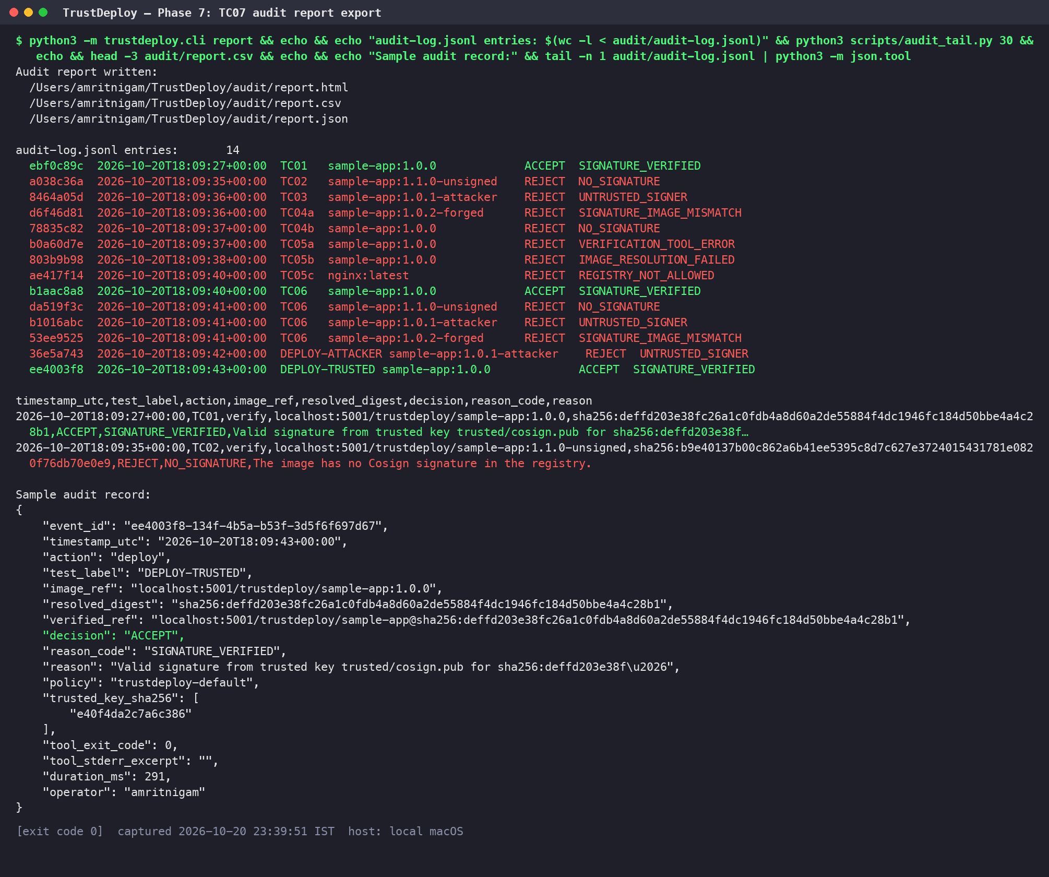
Figure 6.9: TC07: audit report export (HTML, CSV, JSON) with the full audit trail [19-tc07-audit-report.png]
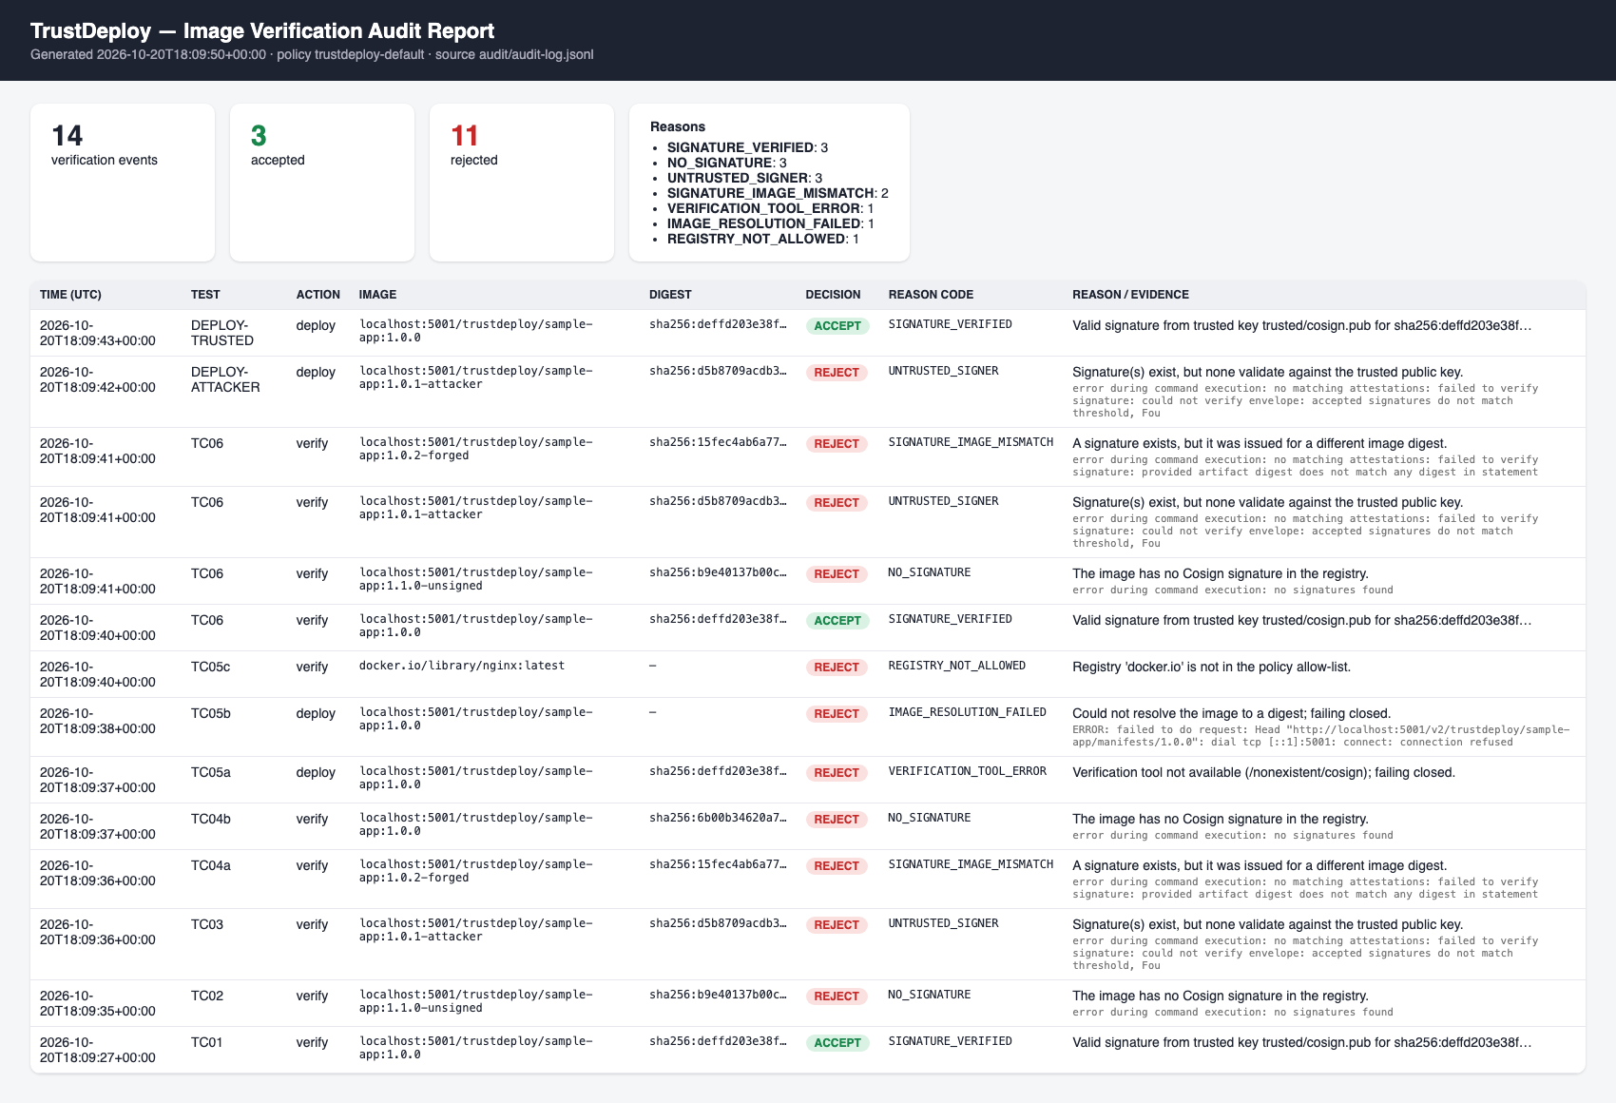
Figure 6.10: TC07: generated HTML audit dashboard [20-audit-dashboard.png]

6.4 Unit Tests
The eight unit tests in tests/test_gate.py target the decision logic with mocked Cosign results. All eight pass (Figure 6.11).
Table 6.2: Unit tests of the fail-closed gate
Test | What it checks
test_valid_signature_accepted | A successful verification whose payload names the digest is accepted.
test_payload_for_other_digest_rejected_even_if_cosign_passes | Even if Cosign exits 0, a payload for another digest is rejected (SIGNATURE_IMAGE_MISMATCH).
test_failure_reasons_classified | Cosign error messages map to NO_SIGNATURE, UNTRUSTED_SIGNER, SIGNATURE_IMAGE_MISMATCH and VERIFICATION_TOOL_ERROR.
test_missing_tool_fails_closed | A missing binary yields REJECT with VERIFICATION_TOOL_ERROR.
test_timeout_fails_closed | A verification timeout yields REJECT.
test_unexpected_exception_fails_closed | Malformed Cosign output yields REJECT with VERIFICATION_TOOL_ERROR.
test_registry_not_allowed | An image from docker.io is rejected with REGISTRY_NOT_ALLOWED.
test_decide_requires_explicit_true | A truthy but non-boolean verified value is still rejected.

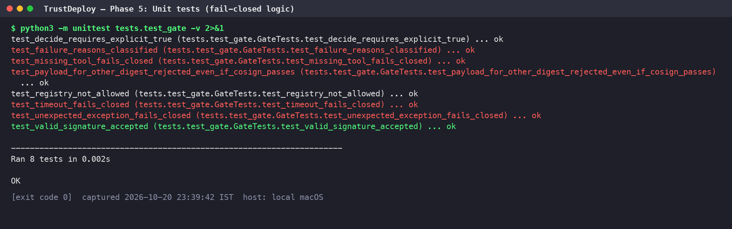
Figure 6.11: Unit tests: 8 of 8 passed [15-unit-tests.png]
CHAPTER 7

RESULTS AND DISCUSSION

7.1 Summary of Results
The evaluation run recorded 15 audit events: 4 ACCEPT and 11 REJECT (Figure 6.10). Every one of the ten end-to-end test cases and all eight unit tests produced the expected outcome. In addition, the Docker deployment workflow and the Kubernetes admission webhook both blocked the attacker-signed image while admitting the approved one. Table 7.1 shows the distribution of reason codes.
Table 7.1: Distribution of reason codes in the evaluation run
Reason code | Events
SIGNATURE_VERIFIED | 4
NO_SIGNATURE | 3
UNTRUSTED_SIGNER | 3
SIGNATURE_IMAGE_MISMATCH | 2
VERIFICATION_TOOL_ERROR | 1
IMAGE_RESOLUTION_FAILED | 1
REGISTRY_NOT_ALLOWED | 1

7.2 Effectiveness Against the Threat Model
Table 7.2: Threat coverage
Threat | Control that stops it | Evidence
Unsigned image | Signature required by policy | TC02, Kubernetes step 3
Attacker-signed image | Only the trusted public key is accepted | TC03, deploy attempt 1, Kubernetes step 2
Copied signature | Signature bound to the digest; payload digest check | TC04a, unit test 2
Tag hijack | Resolve tag to digest, verify and deploy the digest | TC04b
Verifier or registry failure | Fail-closed gate | TC05a, TC05b, unit tests 4 to 6
Untrusted registry | Registry allow-list | TC05c
Missing accountability | Per-decision audit log and reports | TC06, TC07

7.3 Performance
Signature verification of an image in the local registry took between 248 ms and 594 ms per image in the evaluation run (mean 313 ms), including tag resolution and one cosign verify invocation. Failure paths that stop early are faster, and the allow-list check costs effectively nothing. This overhead is negligible compared with pulling and starting a container, so the gate can be placed on every deployment without a noticeable delay.

7.4 Discussion
Three observations stand out. First, the most dangerous attacks in the test set (TC03 and TC04a) both involve valid signatures; a check that merely asks "is this image signed?" would have accepted them. The security property comes from binding the signature to a specific key and a specific digest. Second, TC04b shows that the practice of deploying by tag is itself a vulnerability, and that the fix is cheap: resolve once, verify the digest, deploy the digest. Third, the failure-mode tests (TC05a and TC05b) are what distinguish a security control from a best-effort check. In both cases the image was legitimate, yet the gate correctly refused to deploy because it could not prove legitimacy.
The Kubernetes extension shows that the same trust root can be enforced at more than one layer. The CLI gate gives fast feedback in the pipeline and a detailed audit trail; the admission webhook ensures that a manual kubectl run cannot bypass the policy. One practical lesson was format compatibility: Cosign v3 writes signatures as Sigstore bundles attached through OCI referrers by default, while the Policy Controller version used reads the legacy .sig format, so the release step signs in both formats with the same key.
CHAPTER 8

SECURITY CONSIDERATIONS AND LIMITATIONS
- A signature is not a vulnerability scan. A valid signature proves that the release key holder approved this exact image; it says nothing about whether the image contains vulnerable packages or malicious code introduced before signing. Signing should follow, not replace, scanning and review in the build pipeline.
- Key compromise defeats the scheme. Anyone holding the private key and its password can sign arbitrary images. The prototype stores an encrypted key on a laptop; production use requires a KMS or HSM, restricted signing identities, key rotation and a revocation procedure (removing the key from the policy and re-signing).
- Transparency log disabled. Signing uses --tlog-upload=false and verification --insecure-ignore-tlog=true so the prototype works offline. Without Rekor there is no public, tamper-evident record of signing events, and misuse of a stolen key would be harder to detect.
- Local registry over plain HTTP. registry:2 on localhost:5001 has no TLS and no authentication. This is acceptable on the loopback interface for a demonstration, but registry traffic in production must use TLS and access control. Note that signatures still protect integrity even over an untrusted transport.
- Trust in the gate host. The gate trusts the cosign and docker binaries and the files in trusted/. An attacker who can modify these on the deployment host can bypass the gate; they should be integrity-protected and changes reviewed.
- Audit log integrity. The JSON-lines log is append-only by convention, not cryptographically. It should be shipped to a write-once or centrally managed log store.
- Scope of the CLI gate. The CLI only protects deployments that go through it. The Kubernetes admission webhook closes this gap for the cluster, but only for namespaces labelled for enforcement.
- Classification relies on Cosign error text. Reason codes are derived from Cosign's messages, which may change between versions. Unknown messages safely fall back to VERIFICATION_TOOL_ERROR (still a REJECT), so a wording change can only reduce diagnostic precision, never security.
CHAPTER 9

COST ANALYSIS
TrustDeploy was designed to be local-first. Every component is open source and runs on the developer's own machine, so the prototype incurred zero cloud cost. Table 9.1 compares this with what a comparable cloud-hosted registry would cost.
Table 9.1: Cost of the prototype compared with a managed cloud registry
Item | TrustDeploy (local) | Managed registry (AWS ECR, for comparison)
Registry storage | Free (registry:2 container on local disk) | Private repositories billed per GB-month (USD 0.10 per GB-month in the pricing page example); 500 MB per month free for one year for new customers [5]
Data transfer | None (loopback and Docker network) | Data in free; same-region transfer to AWS compute free; transfer to the internet or other regions billed [5]
Signing and verification | Free (Cosign, open source) | Free tools; optional KMS keys billed separately
Kubernetes cluster | Free (kind on Docker) | Managed cluster and worker nodes billed per hour
Admission controller | Free (Sigstore Policy Controller) | Free (same software)
Total for this project | USD 0 | Small for one image, but grows with images, versions and traffic

The images used in this project are small (about 88 MB each as reported by the local Docker image list), so even on a managed registry the storage cost would be marginal. The point of the comparison is that the security controls themselves (signing, verification, admission control) add no licence cost; the only costs in a production deployment are the hosting of the registry and cluster, and optionally a managed KMS for the key.
CHAPTER 10

FUTURE ENHANCEMENTS
- Keyless signing with Sigstore using OIDC identities from the CI system (for example, GitHub Actions), with verification of the certificate identity and issuer instead of a static key.
- Transparency log upload to Rekor (public or private instance) and mandatory inclusion-proof verification.
- KMS or HSM-backed keys (Cosign supports cloud KMS URIs) with rotation and documented revocation.
- Attestations: sign SLSA provenance, an SBOM and a vulnerability scan result as in-toto attestations, and extend the policy to require them (for example, no critical CVEs).
- CI/CD integration: run the gate as a required pipeline step and publish the HTML report as a build artefact.
- Multiple signers and thresholds: require signatures from both the build system and a human approver.
- Centralised, tamper-evident audit storage with alerting on UNTRUSTED_SIGNER and SIGNATURE_IMAGE_MISMATCH.
- TLS and authentication for the registry, and a single signature format once the admission controller supports Sigstore bundles via OCI referrers.
CHAPTER 11

CONCLUSION
TrustDeploy demonstrates that container image supply chain security based on digital signatures can be built and verified end to end with open-source tools, on a single laptop, at no cost. The prototype builds an image, signs it by digest with a protected Cosign key, and enforces a fail-closed policy that admits only images signed by the trusted key, both in a deployment workflow and at Kubernetes admission time.
The evaluation reproduced the attacks and failure modes that matter in practice. Unsigned images, images signed with an attacker's key, a genuine signature transplanted onto another image, a hijacked tag, a missing verification tool, an unreachable registry and a non-approved registry were all blocked, each with a specific reason code, while the legitimately signed image was accepted and deployed by digest. Every decision was recorded in an audit log and exported as human- and machine-readable reports.
The project also makes the limits explicit: a signature establishes origin and integrity, not safety; the scheme is only as strong as the protection of the signing key; and production use should add a transparency log, hardware-backed keys, TLS and attestations. Within those limits, signing by digest and verifying with a fail-closed gate is a small change to a deployment pipeline that removes a whole class of supply-chain attacks.

REFERENCES
[1] Sigstore, "Quickstart with Cosign," Sigstore Documentation. Available: https://docs.sigstore.dev/quickstart/quickstart-cosign/
[2] Sigstore, "Verifying Signatures," Sigstore Documentation (Cosign). Available: https://docs.sigstore.dev/cosign/verifying/verify/
[3] Sigstore, "Policy Controller Overview," Sigstore Documentation. Available: https://docs.sigstore.dev/policy-controller/overview/
[4] Sigstore, "Policy Controller Installation," Sigstore Documentation. Available: https://docs.sigstore.dev/policy-controller/installation/
[5] Amazon Web Services, "Amazon Elastic Container Registry Pricing." Available: https://aws.amazon.com/ecr/pricing/
All online references were accessed on 20 October 2026.

APPENDIX A: REPRODUCING THE DEMONSTRATION
All commands are run from the project root. The private key password is read from ~/.trustdeploy/keys/password.
Listing 11.1: Command reference
./scripts/run_all.sh # full run: phases 1-7, all tests, all screenshots

python3 -m trustdeploy.cli verify <image> [--label TCxx]
python3 -m trustdeploy.cli deploy <image> [--target docker|kind]
python3 -m trustdeploy.cli report # audit/report.{html,csv,json}

tests/cases.sh TC01 ... TC06 # individual end-to-end cases
python3 -m unittest tests.test_gate -v # unit tests

# exit codes: 0 accepted/deployed, 2 rejected (deployment blocked), 1 usage error

